E
International Union for the Protection of New Varieties of Plants

Technical Working Party for Agricultural Crops  Forty-Sixth Session  Hanover, Germany, June 19 to 23, 2017 | TWA/46/3  Original: English  Date: October 5, 2017
Reports on Developments in Plant Variety Protection from Members and Observers
Document prepared by the Office of the Union
Disclaimer: this document does not represent UPOV policies or guidance
The Technical Committee (TC), at its forty-seventh session held in Geneva, from April 4 to 6, 2011, agreed to request the Office of the Union to invite experts to submit written reports to the Office of the Union in advance of the Technical Working Party (TWP) sessions in order that a document containing those reports could be prepared by the Office of the Union. The TC noted that TWP experts would be invited to make a brief oral summary of their written report at the session and would also be encouraged to make reports under the agenda item “Experiences with new types and species”, as appropriate. The TC also noted that TWP experts would have an opportunity to raise questions concerning matters of interest (see document TC/47/26 “Report on the Conclusions”, paragraphs 9 and 10).

Written reports were requested by the Office of the Union in Circular E-17/082 of May 18, 2017. The following reports were received (in alphabetical order):

- Members of the Union: Annexes I to XI: China, Denmark, European Union, France, Georgia, Japan, Netherlands, Poland, Romania, Turkey, United Kingdom

[Annexes follow]

CHINA

The Development of Protection of New Varieties of Agricultural Plants in China

In recent years, as Chinese government supporting, the protection of new varieties of plants has made important achievements in many aspects, such as laws and regulations system, accepting and examining system and DUS testing system. The main progress in protection of agricultural plants is as follows:

Firstly, the relevant laws and regulations published and implemented promote development for the protection of new varieties of plants.

The revised Seeds Law of the People's Republic of China was released on November 4, 2015, and implemented on January 1, 2016. The law regulates varieties for protection, evaluation and registration that must have Distinctness, Uniformity and Stability (hereinafter referred to as DUS). Therefore, DUS testing becomes technical basis of varieties management. At the same time, it improves the legal level of DUS testing, too.

With the implementation of the seed law, the Ministry of Agriculture has revised and issued a series of rules and regulations in order to improve system of varieties management. For example, the Measures for the Evaluation of Main Agricultural Crops were published on July 8, 2016, and implemented on August 15. The Regulations on the Management on DUS Testing Institutions of the Ministry of Agriculture should be implemented from the date of publish, October 12. The Methods of Registration of Non-main Agricultural Crops were published On March 30, 2017, and are implemented since May 1, 2017. The Regulations of the People's Republic of China on the Protection of New Varieties of Plants are currently being revised.

Secondly, the numbers of applications and breeders’ rights granted have increased significantly.

In order to strengthen the application and protection of agricultural intellectual property and promote the breeding innovation, Chinese government fully canceled the fees of application, annual and examination on plants varieties protection since April 1, 2017. It also further optimizes procedure of examining and testing from May 1, 2017, which the time of submitting materials for DUS testing is earlier for 3 months than before. The cancellation of related fees and the earlier date of submitting testing materials have greatly shortened the examination time, and the numbers of applications and breeders’ rights granted have rapidly increased respectively.

Up to May 31, 2017, a total of 138 genus or species were issued for the protection list of agricultural plant varieties. The number of applications was 19313 cases, with 8962 cases granted. Among them, agricultural crop is main, which the number of applications is 15803 cases and the number of grants is 7514 cases. The totals are accounted for about 81.8% of all applications and 83.8% of all grants. It is status of plant classification on application and varieties granted in table 1.

Table 1 The status of classification on plant varieties of application and granted

Crop | Agricultural | Vegetable | Ornamental | Fruit | Grass | Other | Total
Application (case) | 15803 | 1383 | 1355 | 623 | 21 | 128 | 19313
Grant(case) | 7514 | 521 | 578 | 300 | 2 | 49 | 8962
Among the five main agricultural crops, the order of being arranged is corn, rice, wheat, soybean and cotton.

The numbers of applications and varieties granted are shown in table 2.

Table 2 The numbers of application and varieties granted among the five main crops

Crop | Corn | Rice | Wheat | Soybean | Cotton
Application (case) | 6219 | 5485 | 1534 | 832 | 525
Grant(case) | 2923 | 2675 | 662 | 434 | 298
There are 1166 cases of applications from 19 foreign countries. Among applications from foreign agricultural crop, United States of America is 277 cases, Republic of Korea is 16 cases, Japan is 14 cases, France is 69 cases, Germany is 49 cases, Switzerland is 24 cases, the United Kingdom is 1 case and Ireland is 1 case. Those crops are corn, rice, barley, potato and sweet potato.

Thirdly, it improves DUS testing system and provides technical support for varieties management.

A. It speeds up the construction of DUS testing institutions in order to improve testing conditions and capacities.

With implementation of the new law, the original 14 testing institutions cannot meet the needs of the number of increasing testing. Then, the Ministry of Agriculture has reconstructed testing system of plant varieties since 2015. It currently has a DUS testing center and 27 DUS sub-stations.

B. It standardizes testing management and improves quality and efficiency.

To meet the needs of DUS testing in 2016, the Development Center of Science and Technology, Ministry of Agriculture (short for test center) formulated and published a lot of the test regulations, such as the Management Methods of Entrusted DUS Testing, the Regulations of Breeder on-site Identifying and the Technical Specification of Agricultural plant varieties DUS on-site Inspection. Using different methods of testing, it speeds up procedures of DUS testing, and improves testing quality.

In 2016, testing institutions tested 6632 varieties, and increased 35% than last year, including 1910 varieties by breeders entrusted, 154 varieties for re-examination, identification of administrative and judicial departments. The examination completed 1111 testing reports, which provides technical basis for the protection, approval and registration of these varieties.

C. It strengthens technology research to meet the needs of the testing.

The Ministry of Agriculture encourages social forces to participate research to DUS testing guidelines. 97 testing guidelines of genus or species are completely being developed by breeders who have need for protection of plant varieties.

In 2015, testing center set up a laboratory of DNA fingerprints identification for agricultural plant varieties, with an area of about 1000m² and eight experimenters. The molecular technology standard has completed 9 kinds of crops, established the fingerprint acquisition process, and collected DNA fingerprints of 1000 varieties from corn and soybeans. It is currently developing citrus varieties for molecular identification standards.

Fourthly, it strengthens personnel training and international cooperation to improve testing level.

In 2016, the DUS center held some training courses. For example, DUS database training, uniformity evaluation training of cotton varieties, system training of testing technology and so on. It also strengthened international exchange and cooperation in testing technology. The meeting of 34th UPOV TWC and the seminar on information technology were held in Shanghai on June 2016.

[Annex II follows]

DENMARK

On the 1st of July 2015 the new organization Tystofte Foundation took over the responsibility of the technical examinations of DUS, VCU and Post control from the AgriFish Agency in Ministry of Food, Agriculture and Fisheries.

On the 1st of January 2017 the Seed Certification was transferred to the Tystofte Foundation too. At the same date, the Ministry of Food, Agriculture and Fisheries delegated to the Tystofte Foundation the competence to make administrative decisions in relation VCU, DUS, seed certification and the granting of Danish plant breeders rights.

So now, Tystofte Foundation is operating all the technical examinations and decisions from application to certification in Denmark.

[Annex III follows]

EUROPEAN UNION

Community Plant Variety Office of the European Union (CPVO) report of activities 2016 to the TWA

In June 2016 the Council of the European Union decided on the renewal of the mandate for President Martin Ekvad for a period of 5 years, from 1 September 2016. In December 2016, the CPVO employed 44 persons, twelve nationalities of the Member States of the EU were represented.

Statistics

2016 has been another year of high number of applications received, 3 299, an increase of 6 % from 2015.

In 2016, the Office observed a rather stable number of applications, except a sharp increase in vegetables:
agricultural, 939 applications (+0.6%); vegetable, 721 applications (+22%); ornamental, 1396 applications (+0.9%); fruit 243 applications (-2%).

In 2016, 2980 new titles were granted, an all-time record. Today, over 25 000 plant varieties are now protected under the EU plant variety right (PVR) system.

Administrative Council

In 2016, the Administrative Council (AC) adopted new CPVO-Test Protocols (TPs) of the agricultural species Common vetch and Cotton. The Council furthermore agreed to increase the fees for taking over reports to € 320. In addition, a procedure was adopted to assess non EU-based examination offices before initiating technical cooperation and it revised the so-called novelty guidelines.

Agricultural sector

In the agricultural sector, the 10 most important species represent about 84 % of all applications, starting with maize, wheat, oilseed rape, barley, potato and ending with oats. As in previous years, maize is the most important species in the agricultural sector, whereas there is an important increase as regards wheat, potato, sunflower and durum wheat compared to 2015.

The agricultural experts meeting took place in September 2016 in Angers. With 31 participants, the usually high attendance was continued in 2016. The discussion with experts was essentially turned to the elaboration of new technical protocols. Those concerned the species oilseed rape, potato, Kentucky bluegrass, white mustard and fodder radish.

It further discussed the implementation of the results of the R & D project on the impact of endophytes in Lolium perenne and Festuca arundinacea. Since it could not be proven that an endophyte infection has a significant impact on the expression of the phenotype of a variety, compared to the same variety which is free of endophytes, the request for the submission of seeds for the DUS test will remain unchanged for the purpose of the test of DUS.

The results of the R & D project on the set-up of the continental maize database, created by examination offices in the Czech Republic, Hungary and Slovakia, were discussed. The database is up and running. The CPVO will reflect with the examination offices on a potential merge with the Atlantic maize database which was created more than 10 years ago by the examination offices in Germany, Spain and France.

R&D

The CPVO ad hoc working group for the integration of molecular data into DUS testing (IMODDUS) had its first meeting in April 2016. The working group provided its opinion for 7 project proposals. It furthermore developed a document on the CPVO Strategy for Imoddus which has been endorsed by the AC in 2017. IMODDUS will meet every year alternately with the UPOV-BMT working group.

The following R&D projects with relevance to the agricultural sector have been approved in 2016 for co-funding:

Construction of a European potato database with varieties of common knowledge and its implementation in the potato DUS testing system’ (Potato III)

This project with a duration of 2 years was approved at the beginning of March 2016. It is a follow-up of the previous R & D projects: ‘Construction of an integrated microsatellite and key morphological characteristic database of potato varieties in the EU common catalogue’ and ‘Construction of a European potato database as centralised collection of varieties of common knowledge’.

This project is coordinated by BSA (DE) and involves the nine entrusted examination offices (EOs) for potato: Naktuinbouw (NL), SASA (GB), Coboru (PL), OEVV (ES), DAF (IE), AGES (AT), UKZUZ (CZ), UKSUP (SK), CPVO and the European Seed Association (ESA).

The objective of the project is to continue the work on the set-up of the EU database for potato. The database used will be GEMMA, which has to be adapted to suit the requirements requested by the examination offices. Subsequently, data need to be entered. The morphological characteristics, molecular data and lightsprout pictures to be included have already been agreed. Further details on varieties, administrative data and morphological data still need to be discussed as well as the different agreements which will govern the running of that database.

The EOs will continue to send samples of applications to the labs for molecular profiling. The molecular database will be supplemented with varieties of the EU common catalogue in order to achieve a complete database.

The final report is expected to be delivered in beginning of 2018.

Test of the potential use of SNP markers on oilseed rape varieties

This project has been approved in October 2016 and has a duration of 1 year. The project aims to examine the potential use of single-nucleotide polymorphism (SNP) markers as a tool for the management of oilseed rape (Brassica napus L.) (OSR) reference collection.

The project is coordinated by GEVES (FR), with the following project partners: APHA, NIAB (GB), BSA (DE), Coboru (PL), Department of Variety Testing (DK), INIA (ES), UKSUP (SK), UKZUZ (CZ) and the European Seed Association (ESA).

The objectives are:
- selection and validation of a suitable set of SNP markers from the 1536 free-access SNPs;
- method optimization: assess the use of bulk of plants or seeds instead of individual plants.

Before assessing this new type of molecular marker on a large number of varieties, more knowledge and background are needed. It is necessary to know if these markers can be used easily on partially out-crossing allotetraploid species such as OSR and if a bulking strategy could be considered for future application.

Two laboratories from France and the United Kingdom will participate in this first step. A set of 500 SNP will be tested on different matrices. Only the most efficient markers will be kept and bulking strategy will be assessed.

The main objective of the project is to select a reliable marker set as well as an applicable procedure for routine genotyping. By reviewing the results, a protocol to genotype different varieties with marker combinations could be proposed and a project would follow with the aim of combining genotypic and phenotypic data to optimize OSR reference collection management.

[Annex IV follows]

FRANCE

The activity in the framework of national listing and the activity in the framework of DUS bilateral agreements remain globally stable.

The plant breeding effort remains important and even in development for some crops regarding the capacity of genetic improvement to contribute to the challenges in the field of protection of environment and health.

GEVES has a new website which can be consulted here: www.geves.fr

In total, GEVES studies each year about 1400 new varieties,
around 100 new candidate varieties, a year, in the fruit sector.
around 1000 new candidate varieties, a year, in the agricultural sector.
around 70 new candidate varieties, a year, in the ornemental sector.
around 230 new candidate varieties, a year, in the vegetables sector.

However, the number of application for some species decreases in France (for example sunflower and maize), whereas the number of application for some other species increases (for example cereals, sugar beet, ornamental and fruit species).

GEVES activity is entrusted by the CPVO. GEVES, as an examination office on behalf of CPVO, receives around 600 requests of results each year including about 2/3 of take over reports related to field and vegetable crops tested first for national listing. GEVES also sends each year about 400 reports to other examination offices (about 100 examinations and 300 take-overs) and buy about 120 reports from them in the framework of bilateral agreements.

The International System of Cooperation is active and efficient. For more information, the international cooperation service of GEVES can be contacted here: anne-lise.kouditey@geves.fr

GEVES has recently gained experience on DUS tests of new species: Sesamum indicum, Chenopodium quinoa, Musa acuminata, Vanilla planifolia, Allium tuncelianum, Genista stenopetala, Lathyrus sativus, Deutzia spp., Lonicera L. var. Emphyllocallyx Maxim., Brassica rapa subsp. Nipposinica.

In addition to that, the French National Office for PBR (INOV) has received 94 applications in 2016, out of which 95% were tested for DUS by GEVES.

GEVES has been involved for the last few years in the following topics:

- cooperation between Examination Offices to share common data bases of phenotypic variety descriptions

- the use of molecular markers in the DUS tests for the management of reference collections, for the identification and characterization of varieties, for checking of hybrid conformity. It is routinely used in maize, barley, sorghum, and fruit species

- continuous improvement of our methods and protocols, in line with CPVO TPs and CPVO requirements and UPOV guidance

- the exchange of data and files via electronic platforms, accessible to other Examination Offices, to the CPVO, to DUS examiners or to applicants, such as “Sharing the online application of the CPVO”, “Exchange electronic documents: B2B platform with the CPVO” and web services from the CPVO Variety Finder.

Considering recent recommendations and discussions at UPOV, GEVES supports:

-the optimization of DUS reference collections and especially
. structuration of DUS reference collections in three areas: theoretical, technical and effective collections (TWV/49/29 Add, 2015).
. development of international DUS data bases managed by Examination Offices collaborating to share data and check the Distinctness together. This approach reinforces the DUS expertise and the quality of the Distinctness criteria.
-the development of the use of molecular markers in the DUS examination, as a complementary element, and in the control of conformity of DUS material and materials from granted varieties.

-the optimization of the duration of the DUS examination: consider the one DUS cycle examination as operational as soon as DUS criteria and reliable description are satisfied. In this area, the use of molecular markers, as a complement, could be evaluated as help to shorten the examination,

-the revision on how to assess uniformity by off-types on basis of more than one growing cycle or on the basis of sub samples

GEVES uses in routine genetic disease resistance characteristics, processed in bio tests, for DUS results. It provides also services, facilities, protocols, identified standards and strains for such activities to Examination Offices and seed companies in the world. For more information, please contact: GEVES SNES valerie.grimault@geves.fr.

GEVES will host the UPOV BMT in La Rochelle in 2017.

[Annex V follows]

GEORGIA

Georgia acceded to the 1991 Act of the UPOV Convention on November 29, 2008.

The law on “Plant Variety Protection of Georgia” - entered into force on December 29, 2010, defines the procedures and system of the plant varieties. Georgian legislation on plant breeder’s rights provided for the protection of plant varieties of all plant genera and species.

In the period from January 1, 2012, to the December 31, 2016, 189 applications were filed.
New application forms were under development.

Year | 2012 | 2013 | 2014 | 2015 | 2016
Number of filed applications according to years: | 20 | 36 | 61 | 24 | 48

It should be noted that for the purpose of availability of bibliographic data and software, a new MS ACCESS database of new plant varieties has been created (in Unicode format). In the near future the new database will be accessible not only from the inner network of the office, but also from the Sakpatenti website. Due to the fact that Georgia acceded to the database of new plant varieties (“PLUTO: Plant Variety Database”), our base has been improved and gradually as needed filled with new fields and data, respectively, with PLUTO Database data. Along with this, special software was developed for the generation of bibliographic data (Txt, Xml, Pdf) of new plant varieties and for providing them to the UPOV database according to the relevant standard.

The individual test guidelines are prepared by Sakpatenti for the DUS Examination in Georgian language. And has been approved by Ministry of Justice of Georgia.

Information regarding completed and in progress applications is published in the Official Bulletin For The Protection of New Plant Varieties and Animal Breeds. The exact images of the objects can be viewed in the E-version of Sakpatenti website: www.sakpatenti.org.ge

Participation in Upov Meetings:

1. “Contributing data to the Pluto database”: Geneva, December 9 - 11, 2014

2. Technical Working Party for Ornamental Plants and Forest Trees (session 48) 14-18 Sept. 2015 Cambridge, United Kingdom;

3. Technical Working Party for Fruit Crops, session 47, 14-18 November, 2016, Angers, France

[Annex VI follows]

JAPAN

1. Number of applications in 2016
Year | Number | (2016/2015) | Agricultural crops | (2016/2015)
1978 to 2016 | 31884 | - | 2302 | -
2015  2016 | 912  977 | (107%) | 67  78 | (116%)

Top 5 of application for Agricultural crops in 2016
Rice 25, Maize 12, Sweet potato 6, Soybean 6, Potato 5

2. Number of titles granted in 2016
Year | Number | (2016/2015) | Agricultural crops | (2016/2015)
1978 to 2016 | 25571 | - | 1997 | -
2015  2016 | 847  942 | (111%) | 54  45 | (83%)

Top 5 of granted for Agricultural crops in 2016
Rice 18, Soybean 5, Italian ryegrass 3, Tree cotton 2, Barley 2

3. National test guidelines harmonized with UPOV TGs in 2016
Genera and Species (4)
Adlay, Cosmos, Dianthus, Adzuki bean

4. National test guidelines developed for new types or species in 2016
Genera and Species (11)
Allium ampeloprasum L., Allium karataviense Regel, Allium victorialis L. subsp. platyphyllum Hulten, Chelone L., Hebe Comm. ex Juss., Hemizygia (Benth.) Briq., Iberis L., Lophomyrtus Burret, Pittosporum tenuifolium Gaertn., Thuja occidentalis L., Vaccinium vitis-idaea L.

Web-site: http://www.hinsyu.maff.go.jp/info/sinsakijun/botanical_taxon_e.html

5. Other
We offer UPOV members the examination report at no charge by exchanging the Memorandum of Cooperation (MOC). We have exchanged the MOC documents with 11 member states as of now.

✓ To promote overseas applications for varieties in Japan, we are setting up the manual for applying overseas, the consultation desk, and to assist the cost for them.

✓ We have established the East Asia Plant Variety Protection Forum since 2008, which is held to facilitate the improvement of the implementation and the harmonization of the plant variety protection system based on the UPOV system in the Asian region.

[Annex VII follows]

NETHERLANDS

Short report on developments in plant variety protection in the Netherlands 2016

In January 2017 Mrs. Agnes van Ardenne was appointed by the Minister of Economic Affairs as Chairman of the Board of Naktuinbouw. In this capacity Mrs. van Ardenne (former Minister of Development) succeeded Mr. Henk Lange (former CEO Nunhem Seeds).

Within Naktuinbouw a strategic plan is being developed for the next 5 years. In the new plan more attention will be paid to the clients of Naktuinbouw especially in relation to Quality inspection and Laboratory services. Another important aspect will be increased attention in DNA databases and big data not only for possible use in variety testing but also for inspection services. In the next few years a new R&D laboratory will be constructed in Roelofarendsveen with an investment of € 6-7 million. In addition the Naktuinbouw location at Horst focusing on the production of virus free plant material of soft fruit species will be renewed with an investment of € 2-3 million.

New Head of Variety Research Naktuinbouw
At the first of November Mr. Bert Scholte joined Naktuinbouw. During the transfer period of 2 month he has taken over the duties from Mr. Kees van Ettekoven.

Number of applications received
In 2016, applications were received for testing for the first year for National listing, and for National or European Plant Breeders’ Rights (in brackets the difference with 2015):
Ornamentals 850 (+2%)
Agriculture 135 (-28%)
Vegetables 827 (+10%)
Total 1812 (+3%)

After the all-time high of 2016, this was more or less ‘back to the average’ for Ornamentals and Vegetables, but still a remarkable increase in Agricultural crops. A forecast for 2017 is not yet possible.

UPOV-activities

- OAPI meeting in Ivory Coast

From 25 to 28 September, 2016, Mr. Kees van Ettekoven and Ms. Cécile Marchenay participated in a seminar about Plant Breeders’ Rights organized by OAPI, UPOV and CNRA in Côte d'Ivoire. The opening was done by the DG of the Centre National de Recherche Agricole and by Mrs. Ayté, the vice director general of OAPI and the head of the cabinet of the Minister of Scientific Research in Côte d'Ivoire.

International co-operation.

- Together with Wageningen University and Research Centre, Naktuinbouw is working on a project in Myanmar to develop Plant Breeders’ Rights and improve the cultivation structure.
- In 2016 the Center for Seeds and Seedlings (NCSS), Japan, contacted Naktuinbouw for cooperation on DUS testing. Therefore two Japanese colleagues visited Naktuinbouw to harmonize Testing manuals/Calibration Books. Recently Naktuinbouw and NCSS have signed a Memorandum of Understanding for continuing the cooperation.

Together with colleagues from Bundessortenamt, NIAB and GEVES, Naktuinbouw was present in the joint CPVO stand on the IPM in Essen Germany 2017.

Education and internships

- The well-known PVP-course was held in Wageningen (in 2016 under coordination of Laura Piñán González and Judith Meijles).
- Like in former years, colleagues from different foreign Examination Offices temporarily joined the Naktuinbouw DUS-examinations in the framework of the internship program. This program focuses on exchange of approaches and views between colleagues by working together in practice.
- 7 colleagues followed in success the UPOV DL-305 course in success and 3 colleagues followed the UPOV course DL-205 in success

National Protocol for True Potato Seed (TPS)

There is an increasing interest in the possibilities for protecting TPS-varieties with Breeders’ Rights. In the Netherlands, a new National Protocol was developed for the DUS-examination of TPS. The Protocol was derived from the CPVO-protocol/UPOV Test Guidelines for (vegetatively propagated) potato, but, according to the UPOV principles, this new TPS-Protocol is based on the particular features of the TPS-propagation.

(Living) reference collections in Ornamentals

In an increasing number of ornamental crops, Naktuinbouw keeps a living reference collection according to the CPVO-definitions. In Orchids, much effort was paid to keep the living collection in an optimal condition. For renewing the collection it is very important to have good contact with the breeder because it takes some time to make new plant material. Besides living collections, pictures, variety descriptions and experts knowledge, increasing efforts were made to start the development of ‘DNA-collections’.

Primed seed, also for maintenance control

As mentioned in our newsletter of December 2015, not only for Dutch applications for DUS, but also for samples in the framework of maintenance control of tomato rootstock and eggplant, it is allowed to provide primed seeds to the inspector. The requirements for these maintenance control samples are as follows:

Tomato rootstock (Solanum lycopersicum L. x Solanum habrochaites S. Knapp & D. M. Spooner of Solanum lycopersicum L. x Solanum pimpinellifolium L.)
If not-primed: 480 seeds (was 500 seeds)
If primed: 12 packages of 40 seeds (sealed laminated aluminum foil bags, label indicating ‘primed’)

Eggplant (Solanum melongena L.)
If not-primed: 480 seeds (was 500 seeds)
If primed: 12 packages of 40 seeds (sealed laminated aluminum foil bags, label indicating ‘primed’)

Submission of Dutch national applications via the online system on the CPVO-website

As from now on it is possible to submit online applications for listing in The Netherlands (Board for plant varieties) or France (GEVES) and/or plant breeders’ rights on behalf of the CPVO, GEVES or Dutch board for plant varieties. The online system is available on the website of the CPVO (https://www.plantvarieties.eu).

PVP Development Program

A new tool to help countries to develop their Plant Breeders’ Rights system

For the next four years the Dutch Ministry makes funds available for the implementation of this program. Naktuinbouw is charged to manage the program where they cooperate with the Dutch Agricultural Counsellors and their staff. They can propose projects aimed at the creation or development of a Plant Breeders’ Right system in the territory they work for.

Good varieties to feed the world population

The Netherlands is active in sharing knowledge with third countries.
This open attitude is based on the idea that the world will benefit from the availability of good varieties. To feed the growing world population and also because a range of foods contributes to food security and food quality. This applies mainly for food crops, but ornamental varieties also contribute to quality of life. Only an active breeding sector can meet this need for good varieties. Both publicly and privately. Plant Breeders’ Rights according to the UPOV Convention allows companies and institutions to obtain sufficient revenue for their breeding work. The companies can then invest this in breeding new and even better varieties.

A harmonized system is vital

A harmonized system for the protection of new varieties of plants is vital for the world and for companies who work in the breeding of plant varieties.
This is the focus of the Netherlands when we share Dutch knowledge on Plant Breeders’ Rights systems with other countries. A good example is the annual Plant Variety Protection Course, which we provide at Wageningen University.

How does it work

In the PVP development program, the Netherlands provides a structured response to the requirement to share knowledge in the field of Plant Breeders’ Rights systems around the world.

The road is now open for a fast, specific and continuing response to requests from third countries. Requests to work together with Dutch experts to develop and implement Plant Breeders’ Rights systems.

Naktuinbouw has been tasked with the coordination, design and a large part of the implementation of the activities. Of course we are accountable to the Ministry on this matter.

We work together with the Board for Plant Varieties, the Ministry and other experts and/or sector organizations. International cooperation may also be possible by involving CPVO/UPOV or fellow examination offices.

Proposals for this program?

The network of Agricultural Counsellors working at the Dutch Embassies in different countries is an important source of information. They are the eyes on the ground that know the needs in their territory. Others may also propose projects through this network. There is a large range of tools in the program available, such as:

- awareness missions in the Netherlands for groups of decision makers
- local experts participating in the PVP course in Wageningen
- trainings for experts in the work of crop experts
- help in the establishment of an Office for Plant Breeders’ Right in a country
- advise on organizational and administrative matters
- tailor-made trainings in the country
- awareness programs for farmers and traders

Based on the received proposals Naktuinbouw will select projects for the next year and propose these to a steering committee. When agreement is reached this annual plan will be presented to the Ministry for their consent.
Projects running in 2017

In 2017 projects were approved in India, Indonesia, Cuba, Iran (Islamic republic of), Viet Nam, China, Turkey, Ukraine, Cambodia, United Republic of Tanzania and Ghana and there is a project on the position of small farmers and UPOV PBR.

Please send questions to:
PVPtoolbox@naktuinbouw.nl

CPVO Audit

On 30 and 31 of August the CPVO held the three-yearly audit at Naktuinbouw. During the two days the audit team checked the procedures and the work. The audit team was very satisfied however there was one remark for which a corrective action was needed. This issue has been resolved in the meantime.

[Annex VIII follows]

POLAND

In 2016, 827 applications for national list were received for agricultural species, which represented a reduction of 2,5% with respect to the previous year.

At the end of 2016 there were 636 protected varieties at national level in Poland. There were also 827 candidate varieties in agricultural sector under DUS examination.

New species in DUS examination in 2017 are: Einkorn wheat (Triticum monococcum L.) - 2 applications; and Switch grass (Panicum virgatum) - 3 ornamental applications.

COBORU had CPVO Quality Audit assessment visit in 2016 and received positive recommendation for further agricultural species: Maize (Zea mays L. for hybrid varieties - FAO 190-320), Meadow Fescue (Festuca pratensis Hudson) and Westerwolds Ryegrass (Lolium multiflorum Lam. var. westerwoldicum Wittm.).

[Annex IX follows]

ROMANIA

REPORT ABOUT THE SITUATION IN THE LEGISLATIVE, ADMINISTRATIVE AND TECHNICAL FIELDS
IN ROMANIA 2016

I. PLANT VARIETY PROTECTION

1. Situation in the legislative field

Ministerial Order No. 321/2016 modifying the Ministerial Order No. 1348/2005 for the approval of the Rules regarding the testing and registration of agricultural plants and Order No. 1349/2005 for the approval of the Rules regarding the testing and registration of vegetables.

These orders are in compliance with the new EU Directive 2015/1168/EU from July 15, 2015, regarding testing and registration of varieties.

2. Cooperation in examination

The cooperation with UKZUZ from Czech Republic in the field of DUS testing continued and the exchange of seed samples with other EU authorities also continued.

The sale of DUS technical reports to EU authorities or other European countries continued.

3. Situation in the administrative field

There were no changes in the administrative structure and procedure system.

The administrative center of our institute was rehabilitated. Also, the project for building 2 greenhouses for DUS tests for vegetable species was approved.

4. Situation in the technical field

In 2016, in the field of testing, 538 varieties were tested: 383 agricultural plant species, 83 vegetable, 52 fruit trees, 14 vine and 6 ornamental varieties and 173 varieties were registered in our National Official Catalogue: 129 varieties of agricultural plant species, 22 vegetables, 21 fruit trees and 1 vine.

In addition for PBR, 34 applications for protection, and 26 protection titles were issued

[Annex X follows]

TURKEY

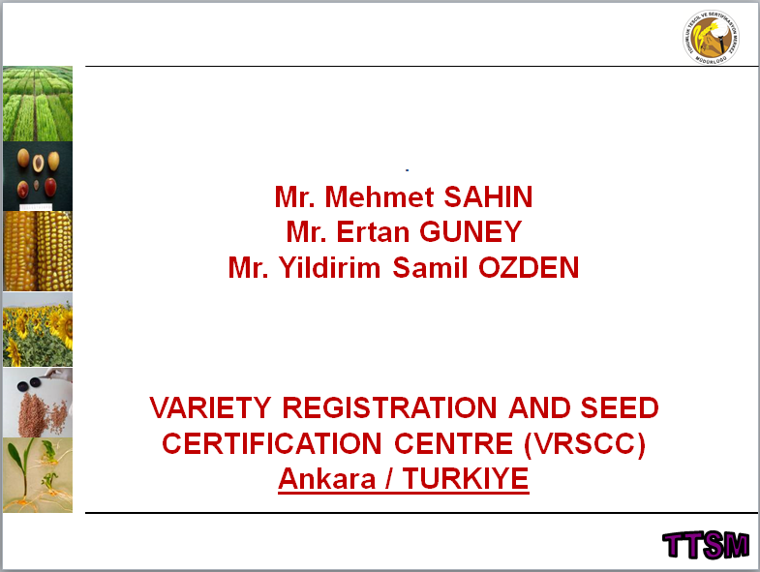

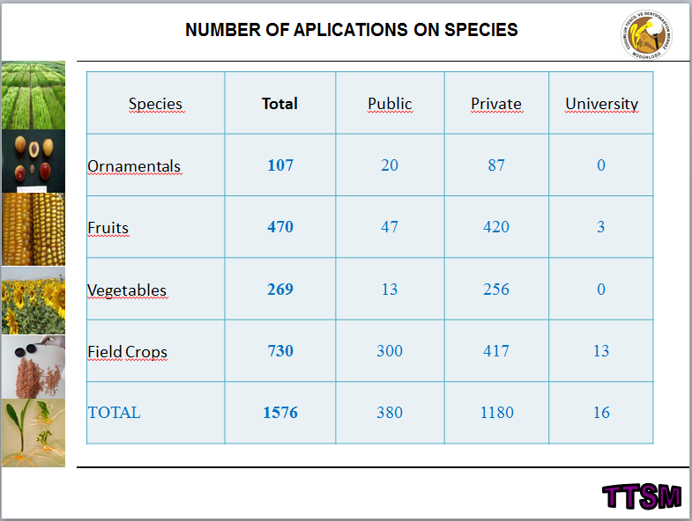

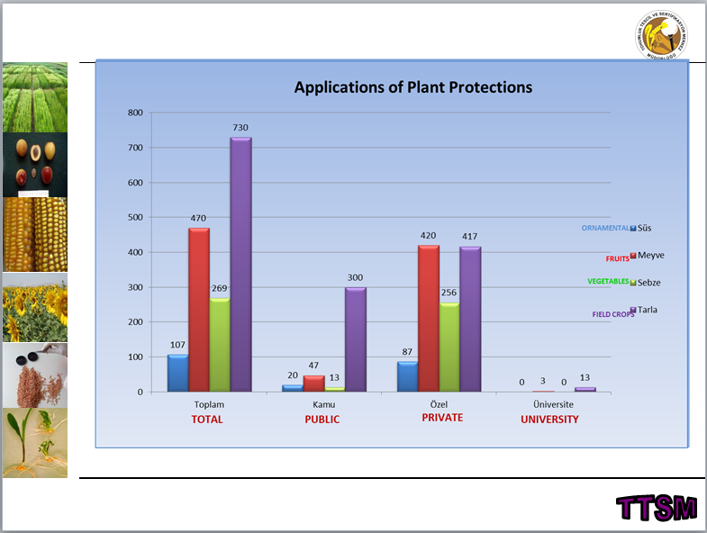

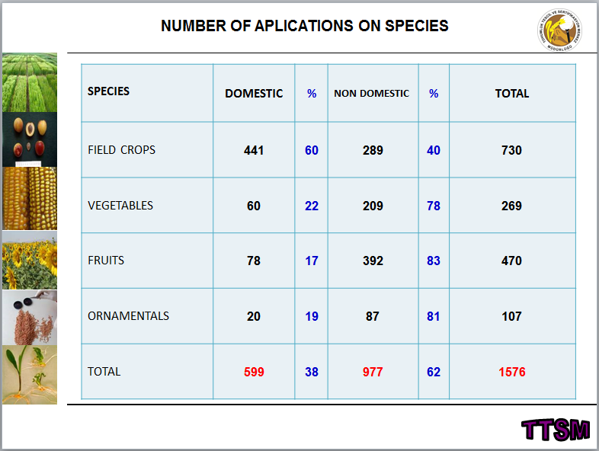

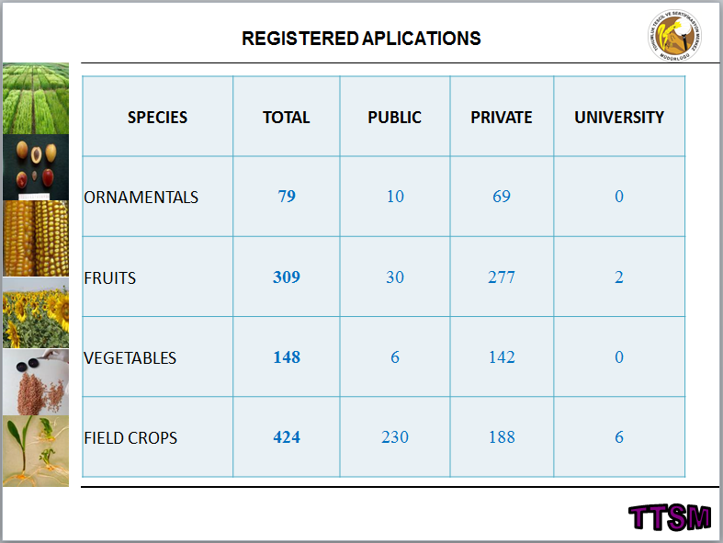

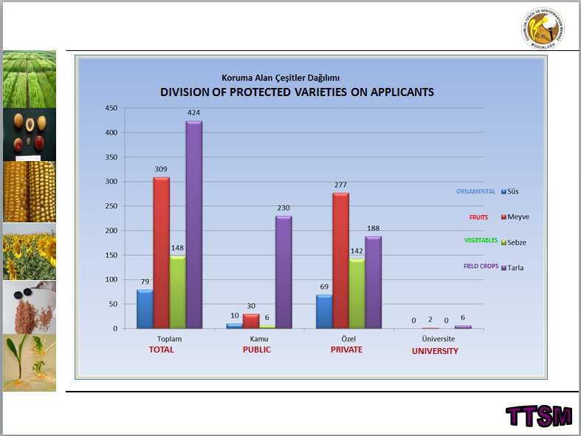

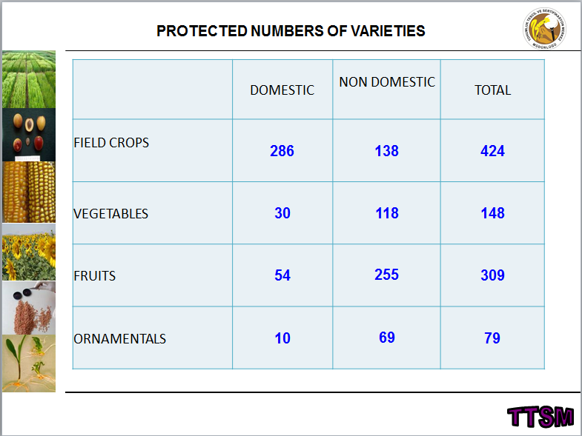

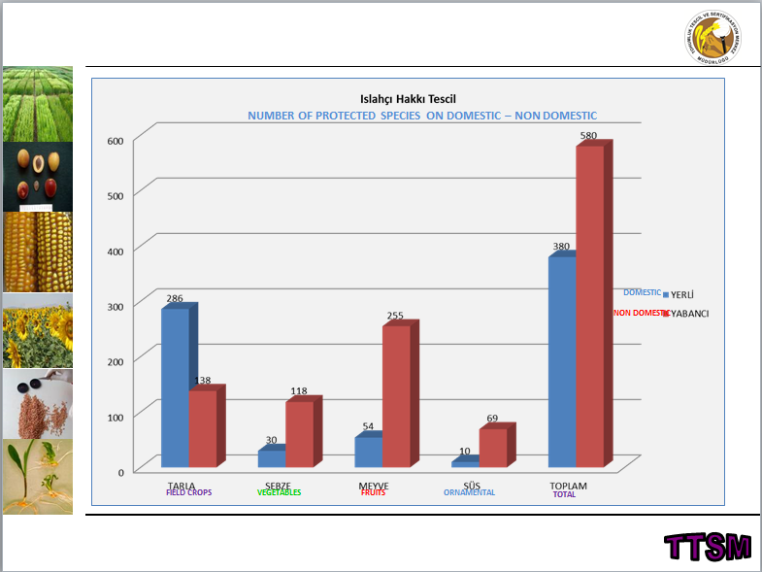

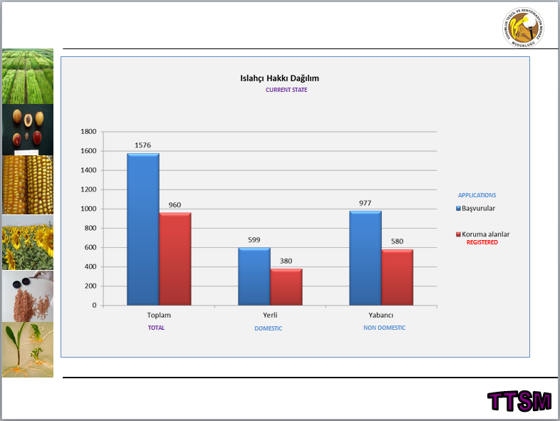

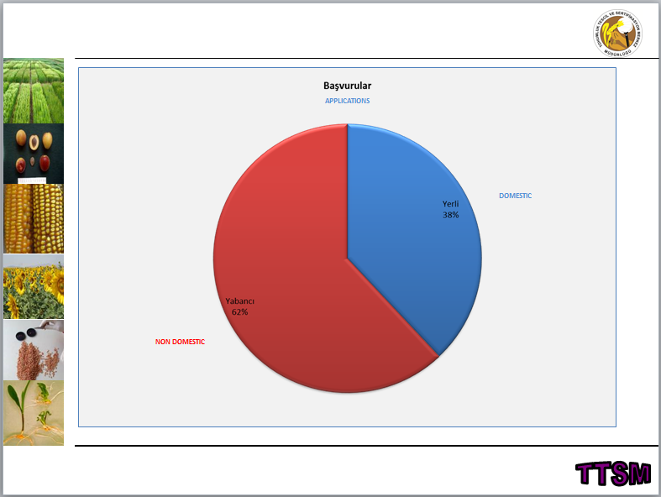

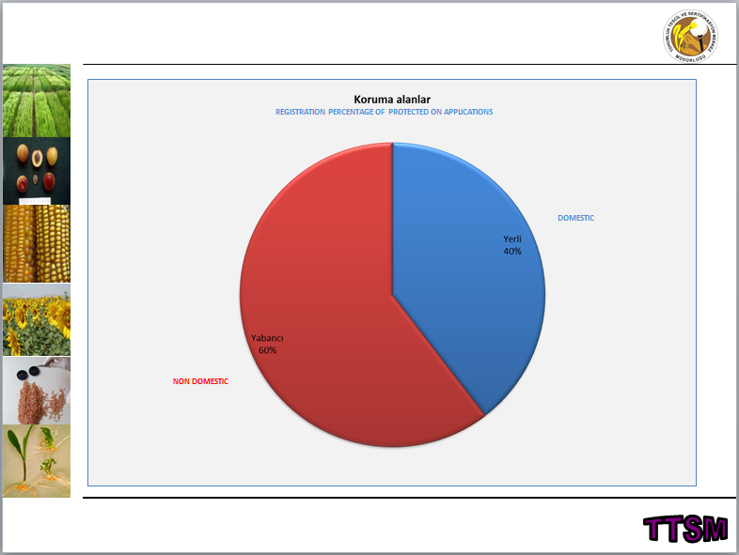

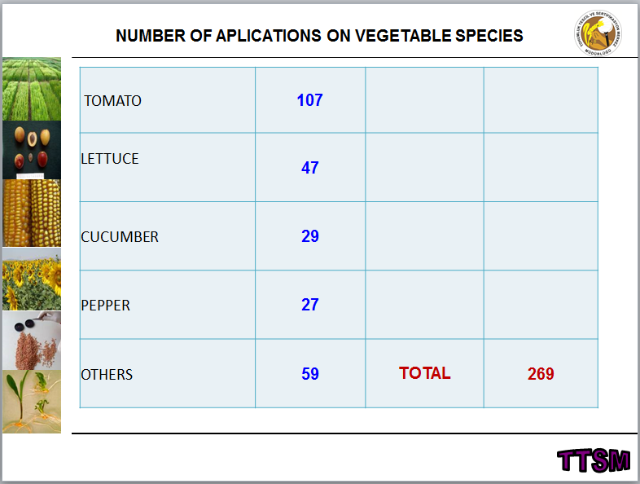

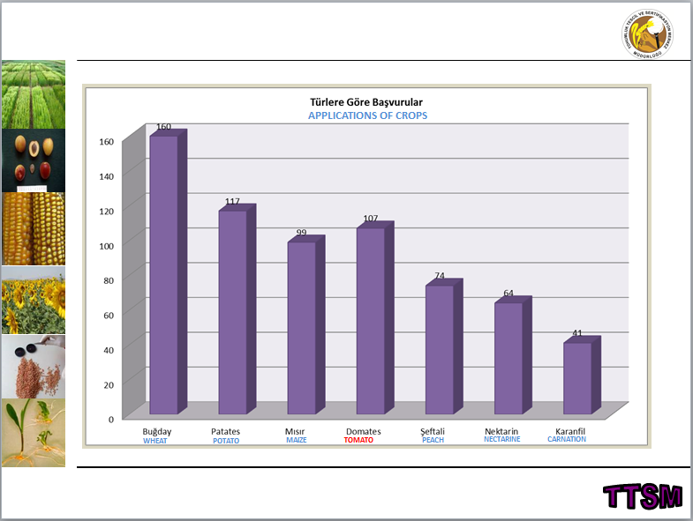

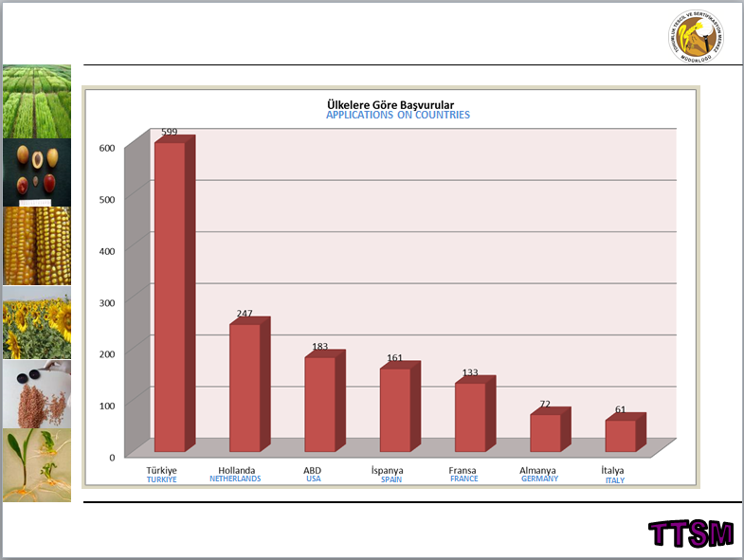

[Annex XI follows]

UNITED KINGDOM

Report on the activity of the United Kingdom Plant Varieties and Seeds Office in Cambridge and the regional examination centers of NIAB, SASA and AFBI.

The Plant Varieties and Seeds Office is part of the Science Directorate of the Animal and Plant Health Agency (APHA), an executive agency of the Department for Environment, Food and Rural Affairs (Defra). We welcomed a new member of staff on November 2016 to concentrate on National List and Plant Breeders Rights technical issues, new contact details and phone numbers are available on Gov.UK website where all Government departments now have their web site details.

Across all United Kingdom trial stations, nearly 1500 candidate varieties were under test for Listing and/or PVR in 2016/17, including 302 winter oilseed rape, 297 cereals, 239 herbage and fodder, >400 ornamentals and the remainder potatoes, field beans, sugar beet, vegetables and kale.

The United Kingdom DUS testing complies with CPVO’s quality requirements and thus can be used by applicants in any subsequent application for EU PVR. APHA and its TQB’s NIAB, SASA and AFBI achieved its Entrustment from CPVO for designated species in October 2016 for the third audit running from 2010.

AFBI looked at the business case for the various options of where their herbage DUS testing would be carried out in 2016 and the decision was made in March 2017 to remain at the Crossnacreevy site.

The United Kingdom is encouraged by the new sense of impetus for molecular techniques as seen from the recent BMT in Russia and the CPVO IMODDUS initiative and is actively looking to move things forwards in this direction. A joint project (in collaboration with GEVES and jointly funded by CPVO) to investigate the use of SNP’s for the management of the OSR reference collections has been initiated. Results will be available by the end of 2018.

To manage the increasing workload in DUS, the United Kingdom routinely look for ways to innovate the process and are currently investigating the greater use of remote sensing techniques using both fixed platforms. They would welcome any exchange of views/experience in this fast developing area.

On 29th March, 2017, the United Kingdom signed article 50 to exit the European Union on 30th March 2019. Negotiations are due to start late June 2017.

[End of Annex XI and of document]

