1. **Subject of these Guidelines**

These Test Guidelines apply to all varieties of *Oryza sativa* L.

1. **Material Required**

2.1 The competent authorities decide on the quantity and quality of the plant material required for testing the variety and when and where it is to be delivered. Applicants submitting material from a Country other than that in which the testing takes place must ensure that all customs formalities and pytosanitary requirements are complied with.

2.2. The material is to be supplied in the form of seed.

2.3 The minimum quantity of seeds, to be supplied by the applicant, should be:

2.3.1 General: **500 grams**

2.3.2 Hybrid varieties: If requested, an additional **500 grams** of seed of each componentshould be submitted.

2.4 Panicles: If requested by the competent authority, at least 50 panicles should also be submitted. The panicles should be well-developed and not affected by any pest or disease. They should contain a sufficient number of viable seeds to establish a satisfactory row of plants for observation.

2.5 The seed should meet the minimum requirements for germination, species and analytical purity, health and moisture content, specified by the competent authority. In cases where the seed is to be stored, the germination capacity should be as high as possible and should be stated by the applicant.

2.6 The seeds should not have undergone any treatment, which would affect the expression of the characteristics of the variety, unless the competent authorities allow or request such treatment. If it has been treated, full details of the treatment must be given.

2.7 The plant material supplied should be visibly healthy, not lacking in vigor, nor affected by any important pest or disease.

1. **Method of Examination**

3.1 Duration of Tests. The minimum duration of tests should be **2 independent growing cycles.**

3.2 Testing Place. The tests should normally be conducted in one place. If any characteristic of the variety, which is relevant for the examination of DUS, cannot be seen in that place, the variety may be tested in an additional place

3.3 Conditions for Conducting the Examination

The tests should be carried out under conditions ensuring satisfactory growth for the expression of the relevant characteristics of the variety and for the conduct of the examination.

3.3.1 Stage of Development for the Assessment

The optimal stage of development for the assessment of each characteristic is indicated by a number in the second column of the Table of Characteristics. The stages of development denoted by each number are described at the end of Chapter 8.

3.3.2 Type of Observation- visual or measurement

The recommended method of observing the characteristics is indicated by the following key in the second column of the Table of Characteristics:

MG: single measurement of a group of plants or parts of plants

MS: measurement of a number of individual plants or parts of plants

VG: visual assessment by a single observation of a group of plants or parts of plants

VS: visual assessment by observation of individual plants or parts of plants

Characteristics containing the following notes in the second column of the Table of Characteristics should be examined as indicated below:

3.4 Test Design

3.4.1 The design of the tests should be such that plants or parts of plants may be removed for measurement or counting without prejudice to the observations which must be made up to the end of the growing cycle.

3.4.2 Each test cycle should be designed to result in a total of, at least 1500 plants, which should be divided between two or more replicates.

Single panicle-rows if test on panicle-rows are conducted, at least 50 panicle-rows should be observed.

3.5 Number of Plants / Parts of Plants to be Examined

Unless otherwise indicated, all observations made on individual plants or determined by measurement or counting should be made on at least 20 plants or parts taken from each of the 20 plants.

3.6 Additional Tests

Additional tests, for examining relevant characteristics, may be established.

* 1. **Assessment of Distinctness, Uniformity and Stability**

4.1 Distinctness

4.1.1 General Recommendation

It is of particular importance for users of this Test Guidelines to consult the General Introduction prior to making decisions regarding distinctness. However, the following points are provided for elaboration or emphasis in these Test Guidelines.

4.1.2 Consistent Differences

The minimum duration of tests recommended in section 3.1 reflects, in general, the need to ensure that any differences in a character are sufficiently consistent.

4.1.3 Clear Differences

Determining whether a difference between two varieties is clear depends on many factors, and should consider, in particular, the type of expression of the characteristic being examined, i.e. whether it is expressed in a qualitative, quantitative, or pseudo-qualitative manner. Therefore, it is important that users of these Test Guidelines are familiar with the recommendations contained in the General Introduction prior to making decisions regarding distinctness.

4.2 Uniformity

4.2.1 It is of particular importance for users of these Test Guidelines to consult the General Introduction prior to making decisions regarding uniformity. However, the following points are provided for elaboration or emphasis in these Test Guidelines.

4.2.2 Self-pollinated varieties

1. Plots: For the assessment of uniformity of characteristics on the plot as a whole, a population standard of 0.1% with an acceptance probability of at least 95% should be applied. In the case of a sample size of 1,500 plants the maximum number of off-types allowed would be 4.
2. Single panicle-rows: For the assessment of uniformity of characteristics on single panicle-rows, plants or parts of plants (visual assessment by observations of a number of individual panicle-rows, plants or parts of plants), a population standard of 1% with an acceptance probability of at least 95% should be applied. In the case of a sample size of 50 panicles the maximum number of aberrant panicle-rows, plants or parts of plants should not exceed 2.

4.2.3 Hybrid varieties

For the assessment of uniformity of single hybrid, a population standard of 1% with an acceptance probability of at least 95% should be applied. In the case of a sample size of 1,500 plants the maximum number of off-types allowed would be 22.

4.3 Stability

4.3.1 In practice, it is not usual to perform tests of stability that produce results as certain as those of the testing of distinctness and uniformity. However, experience has demonstrated that, for many types of variety, when a variety has been shown to be uniform, it can also be considered to be stable.

4.3.2 Where appropriate, or in cases of doubt, stability may be tested, either by growing a further generation, or by testing a new seed stock to ensure that it exhibits the same characteristics as those shown by the previous material supplied.

**5. Grouping of Varieties and Organization of the Growing Trial**

5.1 The selection of varieties of common knowledge to be grown in the trial with the candidate varieties and the way in which these varieties are divided into groups to facilitate the assessment of distinctness is aided by the use of grouping characteristics.

5.2 Grouping characteristics are those in which the documented states of expression, even when produced at different locations, can be used, either individually or in combination with other such characteristics: (a) to select varieties of common knowledge that can be included from the growing trial used for examination of distinctness; and (b) to organize the growing trial so that similar varieties are grouped together.

5.3 The following have been agreed as useful grouping characteristics:

1. Leaf: anthocyanin coloration of auricles (characteristic 9)
2. Time of heading (50% of plants with heads) (characteristic 19)
3. Non-prostrate varieties only: Stem: length (excluding panicle) (characteristic 26)
4. Decorticated grain: length (characteristic 58)
5. Decorticated grain: color (characteristic 61)
6. Decorticated grain: aroma (characteristic 65)

5.4 Guidance for the use of grouping characteristics, in the process of examining distinctness, is provided through the General Introduction

**6. Introduction to the Table of Characteristics**

6.1 Categories of Characteristics

6.1.1 Standard Test Guidelines Characteristics

Standard Test Guidelines characteristics are those which are approved by UPOV for examination of DUS and from which members and non-members of the Union can select suitable characteristics for their particular circumstances.

6.1.2 Asterisked Characteristics

Asterisked characteristics (denoted by *) are those included in the Test Guidelines which are important for the International Harmonization of variety descriptions and should always be examined for DUS and included in the variety descriptions by all members and non-members on the Union, except when the state of expression of a preceding characteristics or regional environmental conditions render this inappropriate.

6.2 States of Expression and Corresponding Notes

States of expression are given for each characteristic to define the characteristic and to harmonize descriptions. Each state of expression is allocated a corresponding numerical note for ease of recording of data and for the production and exchange of the description.

6.3 Types of Expression

An explanation of the types of expression of characteristics (qualitative, quantitative and pseudo-qualitative) is provided in the General Introduction.

6.4 Example or Reference Varieties

Where appropriate, example varieties are provided to clarify the state of expression of each characteristic.

Legend

(*) Asterisked characteristic – see Section 6.1.2

QL Qualitative characteristic – see Section 6.3

QN Quantitative characteristic – see Section 6.3

PQ Pseudo-Qualitative characteristic – see section 6.3

MG Single measurement of a group of plants or plant parts - see section 3.3.1

MS Measurement of a number of individual plants or plant parts -see section 3.3.1

VG Visual assessments by a single observation of a group of plants or plant parts- see section 3.3.1

VS Visual assessment by observation of individual plants or plant parts – see section 3.3.1

(a) See explanations of Table of Characteristics in Chapter 8, Section 8.1

(+) See Explanation on the Table of Characteristics on Chapter 8, Section 8.2

Stage of development: see Section 3.3.2

**7. Table of Characteristics**

|  |  |  |  |  |
| --- | --- | --- | --- | --- |
| **Char. No.** | **Stage** | **Characteristics** | **Example Varieties** | **Note** |
| **1.** | **10** | **Coleoptile: anthocyanin coloration** |  |  |
| (+) | VS | absent or very weak |  | 1 |
| QN |  | weak |  | 3 |
|  |  | strong |  | 5 |
| **2.** | **40** | **Basal leaf: sheath color** |  |  |
| PQ | VS | green |  | 1 |
|  |  | green with purple lines |  | 2 |
|  |  | light purple |  | 3 |
|  |  | purple |  | 4 |
| **3.** | **40** | **Leaf: intensity of green color** |  |  |
| QN | VG | light |  | 3 |
|  |  | medium |  | 5 |
|  |  | dark |  | 7 |
| **4.** | **40** | **Leaf: anthocyanin coloration** |  |  |
| QL | VG | absent |  | 1 |
|  |  | present |  | 9 |
| **5.** | **40** | **Leaf: distribution of anthocyanin coloration** |  |  |
| PQ | VG | on tips only |  | 1 |
|  |  | on margins only |  | 2 |
|  |  | in blotches only |  | 3 |
|  |  | even |  | 4 |
| **6.** | **40** | **Leaf sheath: anthocyanin coloration** |  |  |
| QL | VG | absent |  | 1 |
|  |  | present |  | 9 |

|  |  |  |  |  |
| --- | --- | --- | --- | --- |
| **Char. No.** | **Stage** | **Characteristics** | **Example Varieties** | **Note** |
| **7.** | **40** | **Leaf sheath: intensity of anthocyanin coloration** |  |  |
| QN | VG | very weak |  | 1 |
|  |  | weak |  | 3 |
|  |  | medium |  | 5 |
|  |  | strong |  | 7 |
| **8.** | **40** | **Leaf blade: pubescence of surface** |  |  |
| QN | VS | Absent or very weak |  | 1 |
|  |  | weak |  | 3 |
|  |  | medium |  | 5 |
|  |  | strong |  | 7 |
|  | 40 | **Leaf: auricles** |  |  |
| QL | VG | absent |  | 1 |
|  |  | present |  | 9 |
| **9. (*)** | **40** | **Leaf: anthocyanin coloration of auricles** |  |  |
| QL | VS | absent |  | 1 |
|  |  | present |  | 9 |
|  | 40 | **Leaf: collar** |  | 1 |
| QL | VS | absent |  | 9 |
|  |  | present |  |  |
| **10** | **40** | **Leaf: anthocyanin coloration of collar** |  |  |
| QL | VS | absent |  | 1 |
|  |  | present |  | 9 |
|  | **40** | **Leaf: ligule** |  |  |
| QL | VS | absent |  | 1 |
|  |  | present |  | 9 |
| **11.** | **40** | **Leaf: shape of ligule** |  |  |
| PQ | VS | acute |  | 1 |
|  |  | cleft |  | 2 |
| **12.** | **40** | **Leaf: color of ligule** |  |  |
| PQ | VS | colorless |  | 1 |
|  |  | green |  | 2 |
|  |  | green with purple lines |  | 3 |
|  |  | light purple |  | 4 |
|  |  | purple |  | 5 |

|  |  |  |  |  |
| --- | --- | --- | --- | --- |
| **Char. No.** | **Stage** | **Characteristics** | **Example Varieties** | **Note** |
|  | 40 | **Leaf: length of ligule** |  |  |
| QN | MS | short |  | 3 |
|  |  | medium |  | 5 |
|  |  | long |  | 7 |
| **13.** | **40** | **Leaf blade: length** |  |  |
| QN | MS | short |  | 3 |
|  |  | medium |  | 5 |
|  |  | long |  | 7 |
| **14.** | **40** | **Leaf blade: width** |  |  |
| QN | MS | narrow |  | 3 |
|  |  | medium |  | 5 |
|  |  | broad |  | 7 |
| **15. (*)** | **60** | **Flag leaf: attitude of blade (early observation)** |  |  |
| (+**)** | VG | erect |  | 1 |
| QN |  | semi-erect |  | 3 |
|  |  | horizontal |  | 5 |
|  |  | recurved |  | 7 |
| **16. (*)** | **90** | **Flag leaf: attitude of blade (late observation)** |  |  |
| (+) | VG | erect |  | 1 |
| QN |  | semi-erect |  | 3 |
|  |  | horizontal |  | 5 |
|  |  | recurved |  | 7 |
| **17.** | **70** | **Culm: habit** |  |  |
| (+) | VS | erect |  | 1 |
| PQ |  | semi-erect |  | 3 |
|  |  | open |  | 5 |
|  |  | spreading |  | 7 |
|  |  | prostrate |  | 9 |
| **18.** | **70** | **Prostrate varieties only: Culm: kneeing ability** |  |  |
| (+) | VS | absent |  | 1 |
| QL |  | present |  | 9 |
| **19. (*)** | **55** | **Time of heading (50% of plants halfway with heads)** |  |  |
| QN | VG | very early |  | 1 |
|  |  | early |  | 3 |
|  |  | medium |  | 5 |
|  |  | late |  | 7 |

|  |  |  |  |  |
| --- | --- | --- | --- | --- |
| **Char. No.** | **Stage** | **Characteristics** | **Example Varieties** | **Note** |
| **20.** | **60** | **Male sterility** |  |  |
| (+) | VS/MS | absent |  | 1 |
| PQ |  | partially male sterile |  | 2 |
|  |  | male sterile |  | 3 |
| **21.** | **65** | **Lemma: anthocyanin coloration of keel (early observation)** |  |  |
| (+) | VS | absent of very weak |  | 1 |
| QN |  | weak |  | 3 |
|  |  | medium |  | 5 |
|  |  | strong |  | 7 |
| **22.** | **65** | **Lemma: anthocyanin coloration of area below apex (early observation)** |  |  |
| (+) | VS | absent or very weak |  | 1 |
| QN |  | weak |  | 3 |
|  |  | medium |  | 5 |
|  |  | strong |  | 7 |
| **23.** **(*)** | **65** | **Lemma: anthocyanin coloration of apex (early observation)** |  |  |
| QN | VS | absent or very weak |  | 1 |
|  |  | weak |  | 3 |
|  |  | medium |  | 5 |
|  |  | strong |  | 7 |
|  |  | very strong |  | 9 |
| **24.** **(*)** | **65** | **Spikelet: color of stigma** |  |  |
| PQ | VS | white |  | 1 |
|  |  | light green |  | 2 |
|  |  | yellow |  | 3 |
|  |  | light purple |  | 4 |
|  |  | purple |  | 5 |
|  | 60-65 | **Spikelet: angle between lemma and palea (for CMS and EMS lines only)** |  |  |
| QN | VS | small |  |  |
|  |  | medium |  |  |
|  |  | large |  |  |
|  | 65 | **Spikelet: color of anthers (for CMS and EMS lines at flowering)** |  |  |
| QL | VS | white |  |  |
|  |  | light yellow |  |  |
|  |  | yellow |  |  |

|  |  |  |  |  |
| --- | --- | --- | --- | --- |
| **Char. No.** | **Stage** | **Characteristics** | **Example Varieties** | **Note** |
| **25.** | **70** | **Stem: thickness** |  |  |
| (+) | VS | thin |  | 3 |
| QN |  | medium |  | 5 |
|  |  | thick |  | 7 |
| **26.** (*) | **70** | **Non-prostrate varieties only: stem length (excluding panicle)** |  |  |
| QN | VS | very short |  | 1 |
|  |  | short |  | 3 |
|  |  | medium |  | 5 |
|  |  | long |  | 7 |
|  |  | very long |  | 9 |
| **27.** **(*)** | **70** | **Stem: anthocyanin coloration of nodes** |  |  |
| QL | VS | absent |  | 1 |
|  |  | present |  | 9 |
| **28.** | **70** | **Stem: intensity of anthocyanin coloration of nodes** |  |  |
| QN | VS | weak |  | 3 |
|  |  | medium |  | 5 |
|  |  | strong |  | 7 |
| **29.** | **70** | **Stem: anthocyanin coloration of internodes** |  |  |
| QL | VS | absent |  | 1 |
|  |  | present |  | 9 |
|  | 65 | **Time of flowering (50% of flower opened)** |  |  |
|  |  | early |  |  |
|  |  | medium |  |  |
|  |  | late |  |  |
|  |  | **Panicle: seed setting (seek clarification from China)** | Ask China for example varieties |  |
|  |  | sterile |  |  |
|  |  | low |  |  |
|  |  | medium |  |  |
|  |  | high |  |  |
|  |  | very high |  |  |
| **30. (*)** | **72-90** | **Panicle: length of main axis** |  |  |
| (+) | MS | short |  | 1 |
| QN |  | medium |  | 2 |
|  |  | long |  | 3 |

|  |  |  |  |  |
| --- | --- | --- | --- | --- |
| **Char. No.** | **Stage** | **Characteristics** | **Example Varieties** | **Note** |
| **31.** | **70** | **Panicle: number per plant** |  |  |
| QN | MS | few |  | 1 |
|  |  | medium |  | 3 |
|  |  | many |  | 5 |
| **32..** | **60** | **Panicle: awns** |  |  |
| QL | VS | absent |  | 1 |
|  |  | present |  | 9 |
| **33.** | **60** | **Panicle: color of awns (early observation)** |  |  |
| PQ | VS | light gold |  | 1 |
|  |  | gold |  | 2 |
|  |  | brown |  | 3 |
|  |  | reddish brown |  | 4 |
|  |  | light red |  | 5 |
|  |  | red |  | 6 |
|  |  | light purple |  | 7 |
|  |  | purple |  | 8 |
|  |  | black |  | 9 |
| **34. (*)** | **70-80** | **Panicle: distribution of awns** |  |  |
| PQ | VS | tip only |  | 1 |
|  |  | upper quarter only |  | 2 |
|  |  | upper half only |  | 3 |
|  |  | upper three quarter only |  | 4 |
|  |  | whole length |  | 5 |
| **35.** | **70-80** | **Panicle: length of longest awns** |  |  |
| QN | VS | very short |  | 1 |
|  |  | short |  | 3 |
|  |  | medium |  | 5 |
|  |  | long |  | 7 |
|  |  | very long |  | 9 |
| **36. (*)** | **60-80** | **Spikelet: pubescence of lemma** |  |  |
| QN | VS | absent or very weak |  | 1 |
|  |  | weak |  | 3 |
|  |  | medium |  | 5 |
|  |  | strong |  | 7 |
|  |  | very strong |  | 9 |
| **37.** | **80-90** | **Spikelet: color of apiculus or tip of lemma** |  |  |
| (+) | **VS** | white |  | 1 |
| PQ |  | yellowish |  | 2 |
|  |  | brown |  | 3 |
|  |  | red |  | 4 |
|  |  | purple |  | 5 |
|  |  | black |  | 6 |

|  |  |  |  |  |
| --- | --- | --- | --- | --- |
| **Char. No.** | **Stage** | **Characteristics** | **Example Varieties** | **Note** |
| **38.** | **90** | **Panicle: color of awns (late observation)** |  |  |
| PQ | VS | straw |  | 1 |
|  |  | gold |  | 2 |
|  |  | brown |  | 3 |
|  |  | reddish brown |  | 4 |
|  |  | light red |  | 5 |
|  |  | red |  | 6 |
|  |  | light purple |  | 7 |
|  |  | purple |  | 8 |
|  |  | black |  | 9 |
| **39. (*)** | 90 | **Panicle: attitude in relation to stem** |  |  |
| (+) | VG | upright |  | 1 |
| PQ |  | semi‑upright |  | 2 |
|  |  | slightly drooping |  | 3 |
|  |  | strongly drooping |  | 4 |
| **40..** | **90** | **Panicle: presence of secondary branching** |  |  |
| (+) | **VS** | absent |  | 1 |
| QL |  | present |  | 9 |
| **41.** | **90** | **Panicle: type of secondary branching** |  |  |
| (+) | VS | Type 1 |  | 1 |
| PQ |  | Type 2 |  | 2 |
|  |  | Type 3 |  | 3 |
| **42. (*)** | **90** | **Panicle: Attitude of branches** |  |  |
| (+) | VS | erect |  | 1 |
| QN |  | semi-erect |  | 3 |
|  |  | spreading |  | 5 |
| **43.** | **90** | **Panicle: exsertion** |  |  |
| (+) | VG | enclosed |  | 1 |
| QN |  | partly exserted |  | 3 |
|  |  | just exserted |  | 5 |
|  |  | moderately-well exserted |  | 7 |
|  |  | well exserted |  | 9 |
| **44.** | **90** | **Time of maturity** |  |  |
| QN | VG | very early |  | 1 |
|  |  | early |  | 3 |
|  |  | medium |  | 5 |
|  |  | late |  | 7 |
|  |  | very late |  | 9 |
| **45.** | **92** | **Leaf: time of senescence** |  |  |
| (+) | VG | early |  | 3 |
| QN |  | intermediate |  | 5 |
|  |  | late |  | 7 |

|  |  |  |  |  |
| --- | --- | --- | --- | --- |
| **Char. No.** | **Stage** | **Characteristics** | **Example Varieties** | **Note** |
| **46.** | **92** | **Lemma: color** |  |  |
| PQ | VS | straw |  | 1 |
|  |  | gold |  | 2 |
|  |  | brown |  | 3 |
|  |  | reddish to light purple |  | 4 |
|  |  | purple |  | 5 |
|  |  | black |  | 6 |
| **47.** | **92** | **Lemma: ornamentation** |  |  |
| PQ | VS | absent |  | 1 |
|  |  | gold furrows |  | 2 |
|  |  | brown furrows |  | 3 |
|  |  | purple spots |  | 4 |
|  |  | purple furrows |  | 5 |
| **48.** | **92** | **Lemma: anthocyanin coloration of keel (late observation)** |  |  |
| (+) | VS | absent or very weak |  | 1 |
| QN |  | weak |  | 3 |
|  |  | medium |  | 5 |
|  |  | strong |  | 7 |
| **49.** | **92** | **Lemma: anthocyanin coloration of area below apex (late observation)** |  |  |
| (+) | VS | absent or very weak |  | 1 |
| QN |  | weak |  | 3 |
|  |  | medium |  | 5 |
|  |  | strong |  | 7 |
|  |  | very strong |  | 9 |
| **50..** | **92** | **Lemma: anthocyanin coloration of apex (late observation)** |  |  |
| (+) | VS | absent or very weak |  | 1 |
| QN |  | weak |  | 3 |
|  |  | medium |  | 5 |
|  |  | strong |  | 7 |
|  |  | very strong |  | 9 |
| **51.** | **92** | **Glume: length** |  |  |
| (+) | MS | short |  | 3 |
| QN |  | medium |  | 5 |
|  |  | long |  | 7 |
| **52.** | **92** | **Glume: color** |  |  |
| (+) | MS | straw |  | 1 |
| PQ |  | gold |  | 2 |
|  |  | red |  | 3 |
|  |  | purple |  | 4 |
| **53.** | **92** | **Grain: weight of 1000 grains (fully developed)** |  |  |
| (+) | MS | Low |  | 3 |
| QN |  | Medium |  | 5 |
|  |  | High |  | 7 |
| **Char. No.** | **Stage** | **Characteristics** | **Example Varieties** | **Note** |
| **54.** | **92** | **Grain: length** |  |  |
| QN | MS | Short |  | 3 |
|  |  | Medium |  | 5 |
|  |  | Long |  | 7 |
| **55.** | **92** | **Grain: width** |  |  |
| QN | MS | Narrow |  | 3 |
|  |  | Medium |  | 5 |
|  |  | Broad |  | 7 |
|  | 92 MS | **Grain: length width ratio** |  |  |
| QN |  | low |  | 3 |
|  |  | Medium |  | 5 |
|  |  | high |  | 7 |
| **56..** | **92** | **Lemma: phenol reaction** |  |  |
| (+) | VG | Absent |  | 1 |
| QL |  | Present |  | 9 |
| **57.** | **92** | **Lemma: intensity of phenol reaction** |  |  |
| (+) | VG | Light |  | 3 |
| QN |  | Medium |  | 5 |
|  |  | Dark |  | 7 |
| **58. (*)** | **92** | **Decorticated grain: length** |  |  |
|  | MS | short |  | 3 |
| QN |  | medium |  | 5 |
|  |  | long |  | 7 |
| **59.** | **92** | **Decorticated grain: width** |  |  |
| QN | MS | Narrow |  | 3 |
|  |  | Medium |  | 5 |
|  |  | Broad |  | 7 |
| **60. (*)** | **92** | **Decorticated grain: shape (in lateral view)** |  |  |
| (+) | VS | Round |  | **1** |
| PQ |  | semi-round |  | **2** |
|  |  | half spindle-shaped |  | **3** |
|  |  | spindle-shaped |  | **4** |
|  |  | long spindle-shaped |  | **5** |
| **61. (*)** | **92** | **Decorticated grain: color** |  |  |
| PQ | VS | White |  | **1** |
|  |  | light brown |  | **2** |
|  |  | variegated brown |  | **3** |
|  |  | dark brown |  | **4** |
|  |  | light red |  | **5** |
|  |  | Red |  | **6** |
|  |  | variegated purple |  | **7** |
|  |  | Purple |  | **8** |
|  |  | dark purple/black |  | **9** |

|  |  |  |  |  |
| --- | --- | --- | --- | --- |
| **Char. No.** | **Stage** | **Characteristics** | **Example Varieties** | **Note** |
| **62.** | **92** | **Endosperm: type** |  |  |
| (+) | VS | glutinous |  | **1** |
| PQ |  | non-glutinous |  | **2** |
| **63.** | **92** | **Endosperm: content of amylose** |  |  |
| (+) | MG | State 1 |  | 1 |
| PQ |  | State 2 |  | 2 |
|  |  | State 3 |  | 3 |
|  |  | State 4 |  | 4 |
|  |  | State 5 |  | 5 |
|  |  | State 6 |  | 6 |
|  |  | State 7 |  | 7 |
| **64.** | **92** | **Endosperm: Alkali digestion** |  |  |
| (+) | MG | not digested |  | 1 |
| QN |  | low digested |  | 3 |
|  |  | Intermediate |  | 5 |
|  |  | completely digested |  | 7 |
| **65. (*)** | **92** | **Decorticated grain: aroma** |  |  |
| (+) | MG | absent or very weak |  | 1 |
| QN |  | Weak |  | 2 |
|  |  | Strong |  | 3 |

Note: Blue font color – recommended for adoption

Red font color – needs clarification from China

1. **Explanations on the Table of Characteristics**
   1. Explanations covering several characteristics

Characteristics containing the following key in the second column of the Table of Characteristics should be examined as indicated below:

* 1. Unless otherwise indicated, all observation on the leaf should be made on the penultimate leaf.

Ad.(1): Coleoptile: anthocyanin coloration

Non-dormant grains are placed on moistened filter paper and covered with a Petri-dish lid during germination. After the coleoptiles have reached a length of about 5 mm in darkness they are placed in artificial light (daylight equivalent) at 750-1250 lux continuously for 3 to *A* days, at a temperature of 25 to 30 degrees Centigrade. The color of the coleoptiles is observed when they are fully developed at stage 09-11 (about 6 to 7 days)

Ad.14: Leaf: shape of ligule

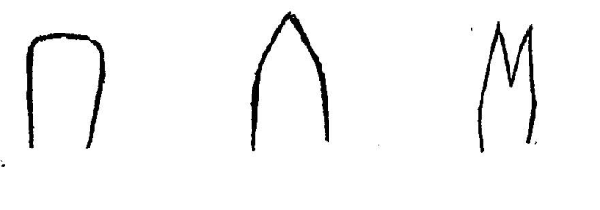

3

cleft

2

acute

1

truncate

Ad/ 15 and 16: Flag leaf: attitude of blade (early and late observation)

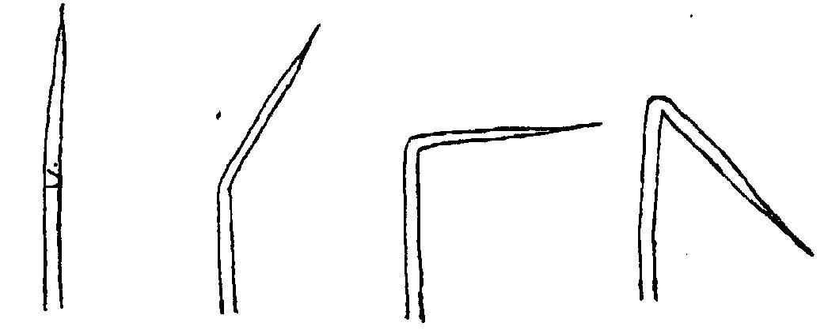

7

recurved

5

horizontal

3

semi- erect

1

erect

Ad.(17): Culm: habit

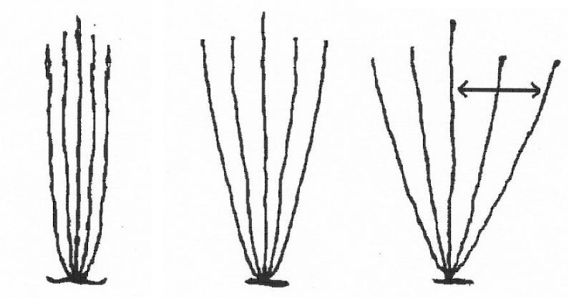

1

erect

5

open

3

semi- erect

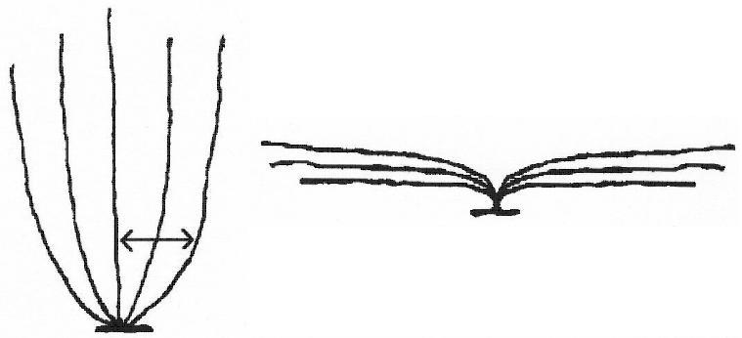

9

prostrate

7

spreading

Ad. 18: Prostrate varieties only: Culm: kneeing ability



Kneeing ability is one of the most important characteristics of deep water and or floating types of rice. After falling flat due to receding water flow, the stem of varieties with kneeing ability starts to grow upright with 304 nodes and bear panicles.

Ad. 20: Male sterility

|  |  |  |
| --- | --- | --- |
| absent | Less than 25% sterile pollen | 1 |
| partially male sterile | 25 to 95% sterile pollen | 2 |
| male sterile | More than 95% sterile pollen | 3 |

Ads.21, 22, 23 and 48, 49, 50: Lemma: anthocyanin coloration (early and late observation);

Ad. 37: Spikelet: color of tip; Ads 51 and 52: Glume: length (51) and color (52)



Ad. 25: Stem thickness

At the lowest internodeAds. 30 and 39: panicle: length of main axis (30) attitude in relation to stem (39)

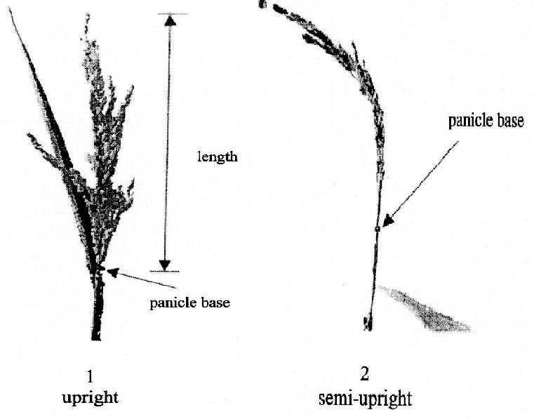

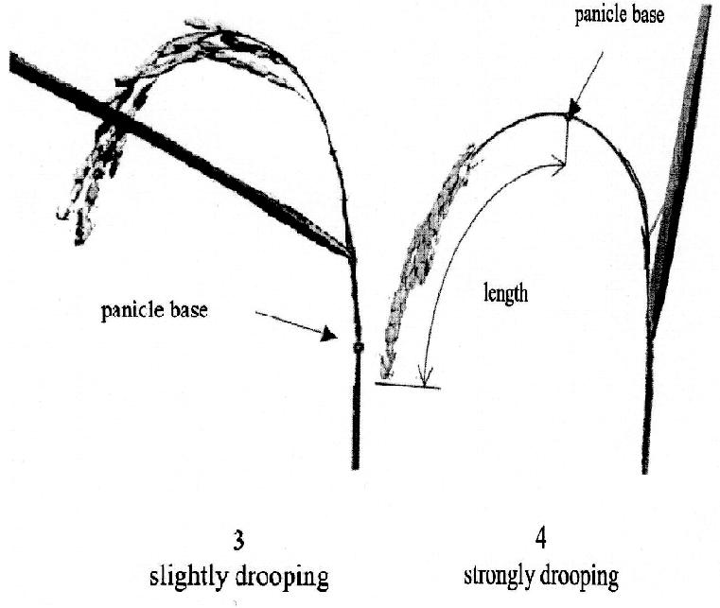

Ad. 40: Panicle: presence of secondary branching

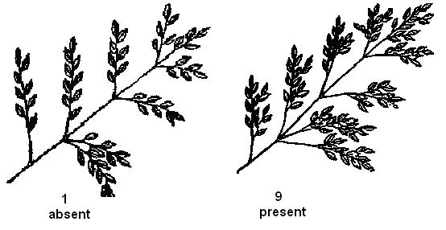

Ad. 41: Panicle: type of secondary branching

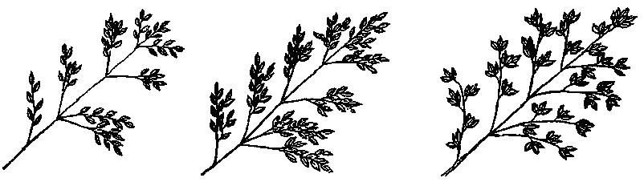

3

Type 3

2

Type2

1

Type 1

Ad. 42: Panicle: attitude of branches: to be observed on a flat, horizontal surface

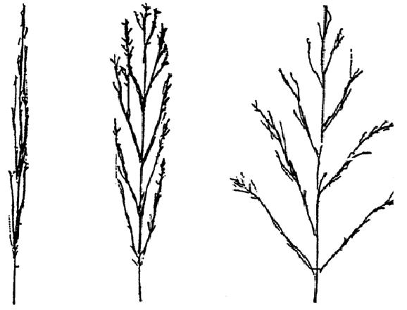

5

spreading

3

semi-erect

1

erect

Ad. 43: Panicle exsertion

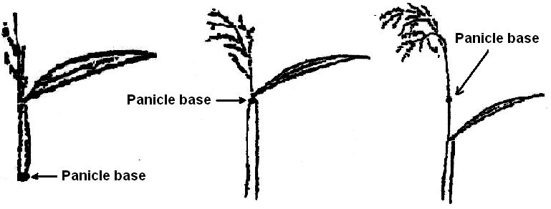

9

Well exserted

5

Just exserted

3

partly exserted

Ad. 45. Leaf: time of senescence

The leaves below the flag leaf are observed at the time of harvest for their retention of greenness. State (3), leaves are dead when the grains have become fully ripened; state (5), intermediate (there must be 1 leaf which retains its color); state (7) , 2 or more leaves retain their color at maturity.

Ad. 51: Glume: length

The measurement is made on each of the two glumes.

Ad. 53: Grain: weight of 1000 fully developed grains

To be calculated at 14% moisture.

Ads. 56 and 57: Lemma: phenol reaction (56) and intensity of phenol reaction (57)

Method of Testing: lace hulls from 10 grains into Petri dish of 5 cm diameter, and add 5ml 1.5% phenol solution; cover the Petri dish, and keep at room temperature (not very cold) for one day.

Ad. 60: Decorticated grain: shape (in lateral view)

(see comment from Japan) length/width

round 1 < 1.50

semi-round 2 1.50-1.99

half spindle-shaped 3 2.00-2.49

spindle-shaped 4 2.50-2.99

long spindle-shaped 5 >3.00

Ad. 62: Endosperm: presence of amylose

How to differentiate: By observation, glutinous rice has waxy grains, and non-glutinous rice are non-waxy to transparent with various grades according to the amylose content of the endosperm. When it is necessary to differentiate glutinous rice and rice with very low amylose content, chemical analysis is needed.

Note: In general, the amylose content of glutinous rice of pure line variety is 0% However, many commercial varieties, especially local, traditional varieties may contain 1-4% of amylose. This is because the waxy gene is recessive, and when outcrossed by ordinary rice pollen, the endosperm becomes non-glutinous. Also, some methods of testing may result in a low % of amylose. Research on chemical structure of waxy rice is still in progress in Japan. Recently various genes (named “dull” genes) for producing semi-waxy rice have been identified At present, amylose content of those semi-waxy rice is not less than 5% though it is not sure if further lower amylose lines will be bred in the future.

The three categories can be simply defined by reaction to KI-I solution; glutinous type endosperm is stained to reddish purple, non-glutinous type to dark blue purple, and intermediate type to reddish – blue purple.

Intermediate rice is non-glutinous but with very low amylose, the type which is recently commanding reputation among consumers in East Asian countries.

KI-I solution is prepared by mixing 0.1 % I2 solution and 0.2 % KI solution.

Ad. 63: Endosperm: content of amylose

Method ISO 6647 should be used.

Modified from IRRI system by rounding due to variability of data especially in cool climates, and adding a rank of very high amylose content considering rice in some area of southern India.

|  |  |
| --- | --- |
| State 1 | <5% |
| State 2 | 5-10% |
| State 3 | 11-15% |
| State 4 | 16-20% |
| State 5 | 21-25% |
| State 6 | 26-30% |
| State 7 | >30%% |

Ad. 64: Alkali digestion

Put 10 milled complete (unbroken) rice grains in a Petri dish with 1.5% solution of KOH, and keep still under room temperature of around 25oC for about 24 hours.

|  |  |
| --- | --- |
| Note 1 (not digested): | Rice grains not digested |
| Note 3 (low digested): | Only the margin of the grains are dissolved |
| Note 5 (intermediate): | Shape of grains become unclear, but incompletely dissolved |
| Note 7 (completely digested): | No margin is identified between the core part and the outer skirt |

Ad. 65: Decorticated grain: aroma

The main component of the aroma in rice is the 2-acetyl-1pyrroline (AcPy). To vaporize this chemical, 10 ml. of a 1.7% solution of KOH should be added to 2 gram of decorticated grains. The aroma, which is similar to that in pop-corn, is released within ten minutes. The level of expression is determined by reference to the example varieties.

### **Decimal Code for the Growth Stages of Cereals**

| **2-digit**  **Code** | **General Description** | **Freekes’**  **Scale** | | **Additional Remarks on Wheat, Barley, Rye, Oats and Rice** |
| --- | --- | --- | --- | --- |
|  | Germination |  |  |  |
| 00 | Dry seed |  |  |  |
| 01 | Start of imbibition |  |  |  |
| 02 | - |  |  |  |
| 03 | Imbibition complete |  |  |  |
| 04 | - |  |  |  |
| 05 | Radicle emerged from caryosis |  |  |  |
| 06 | - |  |  |  |
| 07 | Coleoptile emerged from caryopsis |  |  |  |
| 08 | - |  |  |  |
| 09 | Leaf just at coleoptile tip |  |  |  |
|  | Seedling growth |  |  |  |
| 10 | First leaf through coleoptile | } |  |  |
|  |  | } | 1 | Second leaf visible (Less than 1 cm) |
|  |  | } |  |  |
| 11 | First leaf unfolded | } |  |  |
| 12 | 2 leaves unfolded |  | } |  |
| 13 | 3 leaves unfolded |  | } |  |
| 14 | 4 leaves unfolded |  | } |  |
| 15 | 5 leaves unfolded |  | } | 50% of laminae unfolded |
| 16 | 6 leaves unfolded |  | } |  |
| 17 | 7 leaves unfolded |  | } |  |
| 18 | 8 leaves unfolded |  | } |  |
| 19 | 9 or more leaves unfolded |  | } |  |
|  | Germination |  |  |  |
| 20 | Main shoot only |  |  |  |
| 21 | Main shoot and 1 tiller | 2 | } |  |
| 22 | Main shoot and 2 tillers | } | } |  |
| 23 | Main shoot and 3 tillers | } | } |  |
| 24 | Main shoot and 4 tillers | } | } |  |
| 25 | Main shoot and 5 tillers | } | } |  |
| 26 | Main shoot and 6 tillers | }3 | } |  |
| 27 | Main shoot and 7 tillers | } | } |  |
| 28 | Main shoot and 8 tillers | } | } |  |
| 29 | Main shoot and 9 or more tillers | } | } |  |
|  | Stem elongation |  |  |  |
| 30 | Pseudo stem erection (2) | 4- | 5 | In rice: vegetative lag phase |
| 31 | 1st node detectable | 6} | } |  |
|  |  | } | } | Jointing stage |
| 32 | 2nd node detectable | 7} | } |  |

| **2-digit**  **Code** | **General Description** | **Freekes’**  **Scale** | | **Additional Remarks on Wheat, Barley, Rye, Oats and Rice** |
| --- | --- | --- | --- | --- |
| 33 | 3rd detectable |  | } |  |
|  |  |  | } | Above crown nodes |
| 34 | 4th node detectable |  | } |  |
| 35 | 5th node detectable |  | } |  |
| 36 | 6th node detectable |  | } |  |
| 37 | Flag leaf just visible | 8 |  |  |
| 38 | - |  |  |  |
| 39 | Flag leaf ligule/collar just visible | 9 |  | Pre-boot stage  In rice: opposite auricle stage |
|  | Booting |  |  |  |
| 40 | - |  |  | Little enlargement of the inflorescence,  Early-boot stage |
| 41 | Flag leaf sheath extending |  |  |  |
| 42 | - |  |  |  |
| 43 | Boots just visibly swollen |  | } | Mid-boot stage |
| 44 | - |  | } | 10 |
| 45 | Boots swollen |  | } | Late-boot stage |
| 46 | - |  |  |  |
| 47 | Flag leaf sheath opening |  | } |  |
| 48 | - |  | } |  |
| 49 | First awns visible |  | } | 10.1 In awned forms only |
|  | Inflorescence emergence |  | } |  |
| 50 | } Fist spikelet of | } | N } | N = non-synchronous crops |
|  | } inflorescence just | } | } |  |
| 51 | } visible | } | S } | S = synchronous crops |
| 52 | } | } | N |  |
|  | } ¼ of inflorescence emerged | } |  | 10.2 |
| 53 | } | } | S |  |
|  |  | } | N |  |
| 54 | } ½ of inflorescence emerged | } |  | 10.3 |
| 55 | } | } | S |  |
| 56 | } | } | N |  |
|  | }3/4 of inflorescence emerged | } |  | 10.4 |
| 57 | } | } | S |  |
| 58 | } | } | N |  |
|  | } Emergence of Inflorescence | } |  | 10.5 |
| 59 | } completed | } | S |  |
|  | Anthesis |  |  |  |
| 60 | } | } | N |  |
|  | } beginning of anthesis | } |  | 10.51 |
| 61 | } | } | S | Not easily detectable in barley |
|  |  |  |  | In rice: Usually immediately |
| 62 | - |  |  | Following heading |

| **2-digit**  **Code** | **General Description** | **Freekes’**  **Scale** | | | **Additional Remarks on Wheat, Barley, Rye, Oats and Rice** |
| --- | --- | --- | --- | --- | --- |
| 63 | - |  | |  |  |
| 64 | } | } | | N |  |
|  | }Anthesis half - way | } | |  | 10.52 |
| 65 | } | } | | S |  |
| 66 | - |  | |  |  |
| 67 | - |  | |  |  |
| 68 | } | } | | N |  |
|  | }Anthesis complete | } | |  | 10.53 |
| 69 | } | } | | S |  |
|  | Milk development |  | |  |  |
| 70 | - |  | |  |  |
| 71 | Caryopsis watery ripe |  | |  | 10.54 |
| 72 | - |  | |  |  |
| 73 | Early milk | } | |  |  |
| 74 | - | } | |  |  |
| 75 | Medium milk | } | |  | 11.1 } Increase in solids of liquid endosperm |
|  |  | } | |  | } notable when crushing the caryopsis |
| 76 | - | } | |  | } between fingers |
|  |  | } | |  |  |
| 77 | Late milk | ] | |  |  |
| 78 | - |  | |  |  |
| 79 | - |  | |  |  |
|  | Dough development |  | |  |  |
| 80 | - |  | |  |  |
| 81 | - |  | |  |  |
| 83 | Early dough | } | |  |  |
| 84 | - | } | |  | Fingernail impression not held |
| 85 | Soft dough | } | | 11.2 |  |
| 86 | - | } | |  |  |
| 87 | Hard dough | } | |  |  |
| 88 | - |  | |  | Fingernail impression held, inflorescence |
|  |  |  | |  | Losing chlorophyll |
| 89 | - |  | |  |  |
|  | Ripening |  | |  |  |
| 90 | - |  | |  | In rice: Terminal spikelets ripened. |
| 91 | Caryopsis hard (difficult to divide by thumbnail (3) |  | | 11.3 | In rice: 50 % of spikelets ripened |
| 92 | Caryopsis hard (can no longer be dented by thumbnail) (4) |  | | 11.4 | In rice: Over 90% of spikelets ripened (5) |
| 93 | Caryopsis loosening in daytime |  | |  | Risk of grain loss by shedding |
| 94 | Over-ripe, straw dead and collapsing |  | |  |  |
| 95 | Seed dormancy |  | |  |  |
| 96 | Viable seed giving 50% germination |  | |  |  |
| 97 | Seed not dormant |  | |  |  |
| 98 | Secondary dormancy induced |  | |  |  |
| 99 | Secondary dormancy lost |  | |  |  |
|  | Transplanting and recovery (rice only) | | | | |
| T1 | Uprooting of seedlings | |  |  |  |
| T2 | - | |  |  |  |
| T3 | Rooting | |  |  |  |
| T4 | - | |  |  |  |
| T5 | - | |  |  |  |
| T6 | - | |  |  |  |
| T7 | Recovery of shoots | |  |  |  |
| T8 | - | |  |  |  |
| T9 | Resumption of vegetative growth | |  |  |  |

Notes on the Table

(1) Stage of seedling inoculation with rust in the greenhouse

1. Only applicable to cereals with a prostrate or semi-prostrate early growth habit

(3) Ripeness for binder (ca. 16% water content). Chlorophyll of inflorescence largely lost.

(4) Ripeness for combine harvester (< 16% water content)

(5) Optimum harvest time.

1. **Literature**

“T. Matsuo (ed.) (1993-97): “Science of the Rice Plant (volume 1-3)” Nosan Gyoson Bunka Kyokai (Nobunkyo), Tokyo, Japan.

Vol. 1 Morphology (1993)

Vol. 2 Physiology (1995)

Vol. 3 Genetics (1997)

Indices (1997)

**10. Technical Questionnaire**

|  |  |
| --- | --- |
|  | Application date:  _____________________________  (not to be filled in by the applicant) |
| **TECHNICAL QUESTIONNAIRE**  To be completed in connection with an application for plant breeders’ rights | |
| 1. Subject of the Technical Questionnaire    1. Latin Name    2. Common Name | |
| 1. Applicant   Name  Address  Telephone No.  Fax No.  E-mail address  Breeder (if different from applicant) | |

|  |
| --- |
| 1. Information on the breeding scheme and propagation of the variety   4.1 Breeding Scheme  4.2 Method of Propagating the Variety  4.2.1 Type of material   1. Line   Male fertile line [ ]    Male sterile line [ ]     1. Hybrid 2. other (specify)   In the case of hybrid varieties, the production scheme for the hybrid and for each component, the information according to the following Chapters 5 to 7 should be provided on a separate sheet.  Single Hybrid (SH)  (……female parent……) x (….male parent…..)  N.B. In case of use of male sterility system, please indicate the name of the maintainer line of the parental line.  4.3 other information |

|  |  |  |
| --- | --- | --- |
| 1. Characteristics of the variety to be indicated (the number in brackets refers to the corresponding characteristics in Test Guidelines; please mark the note which best corresponding). | | |
| Characteristics | Example Varieties | Note |
| 5.1 Basal leaf: sheath color  (2)  green  light purple  purple lines  purple |  | 1  2  3  4 |
| 5.2 Leaf: anthocyanin coloration of auricles  (10)  absent  present |  | 1  9 |
| 5.3 Time of healing (50% of plants with heads)  very early  early  medium  late  Very late |  | 1  3  5  7  9 |
| 5.4 Stem: length (excluding panicle; excluding (29) floating rice)  very short  short  medium  long  very long |  | 1  3  5  7  9 |

|  |  |  |  |  |  |
| --- | --- | --- | --- | --- | --- |
| Characteristics | | | Example Varieties | | Note |
| 5.5 Decorticated grain:  (56)  Very short  Short  Medium  Long  Very long | | |  | | 1  3  5  7  9 |
| 5.6 Decorticated grain: color  (59)  White  Light brown  Variegated brown  Dark brown  Light red  Red  Variegated purple  Purple  Dark purple | | |  | | 1  2  3  4  5  6  7  8  9 |
| 1. Similar varieties and difference from these varieties | | | | | |
| Denominations(s) of variety(ies) similar to your candidate variety | Characteristic(s) in which your candidate variety differs from the similar variety(ies) | Describe the expression of the characteristics(s) for the similar variety(ies) | | Describe the expression of the characteristics(s) for your candidate variety | |
| (Example) | Plant: Height | e.g. note 3 | | note 7 | |
|  |  | e.g. short | | Tall | |
|  |  | e.g. 90 cm | | 130 cm | |

|  |
| --- |
| 7. Additional information which may help in the examination of the variety  7.1 In addition to the information provided in section 5 and 6, are there any additional characteristics, which may help to distinguish the variety?   * + 1. Resistance to pest and diseases   Yes [ ] No [ ]  (if yes, please provide details)   * + 1. Other   Yes [ ] No [ ]  (if yes, please provide details)  7.2 Special conditions for the examination of the variety   * + 1. Are there any special conditions for growing the variety or conducting the examination?   Yes [ ] No [ ]   * + 1. If yes, please give details:   7.3 Other information |
| 8. Authorization   1. Does the variety require prior authorization for please under legislation concerning the protection of the environmental, human and animal health?   Yes [ ] No [ ]   1. Has such authorization been obtained?   Yes [ ] No [ ]  If the answer to (b) is yes, please attach a copy of the authorization. |

*(end document)*

