E
TWA/45/15 Add.
ORIGINAL: English
DATE: June 28, 2016
INTERNATIONAL UNION FOR THE PROTECTION OF NEW VARIETIES OF PLANTS
Geneva
Technical working party for Agricultural crops
Forty-Fifth Session
Mexico City, Mexico, July 11 to 15, 2016
Addendum to
number of growing cycles in dus examination
Document prepared by the Netherlands
Disclaimer: this document does not represent UPOV policies or guidance
The Annex to this document contains a copy of the presentation “Minimum Number of Growing Cycles” to be made by an expert from the Netherlands at the forty-fifth session of the Technical Working Party for Agricultural Crops (TWA).

[Annex follows]

TWA/45/15 Add.

ANNEX

MINIMUM NUMBER OF GROWING CYCLES

Presentation by Ms. Lysbeth Hof, on behalf of Mr. Kees van Ettekoven, Netherlands

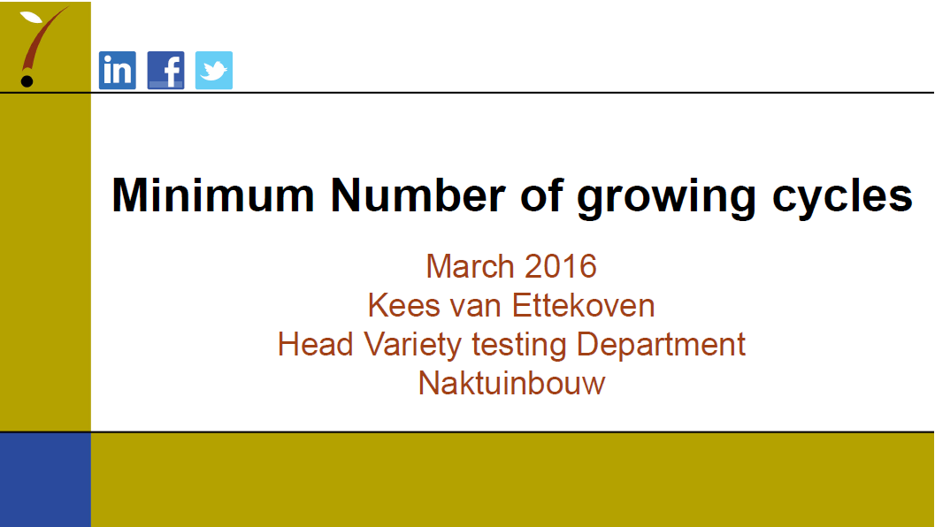

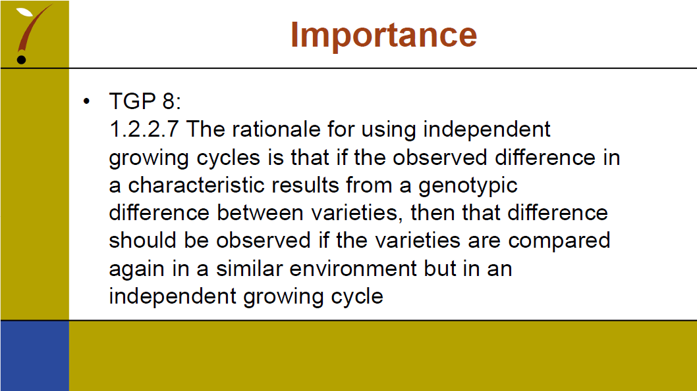

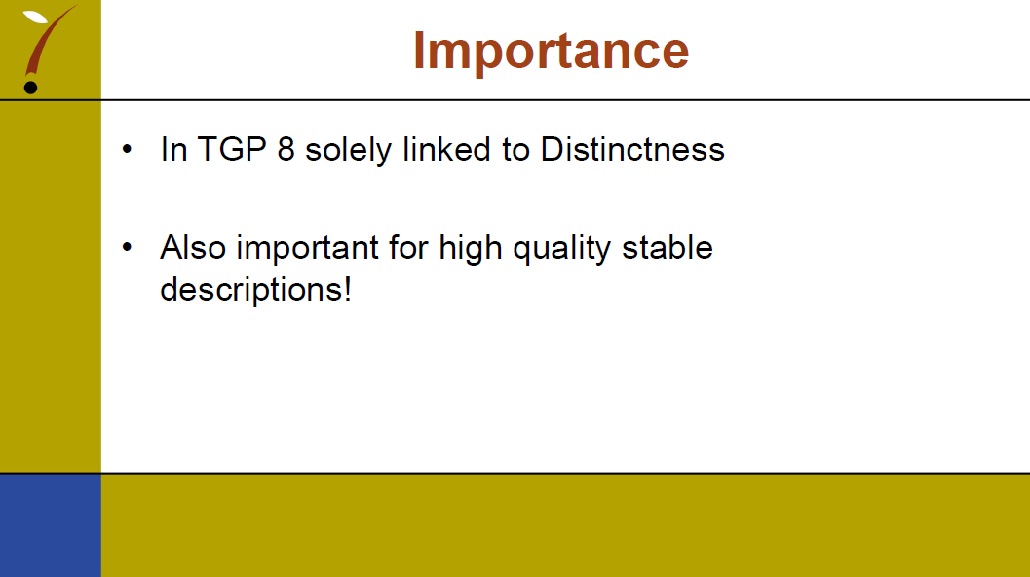

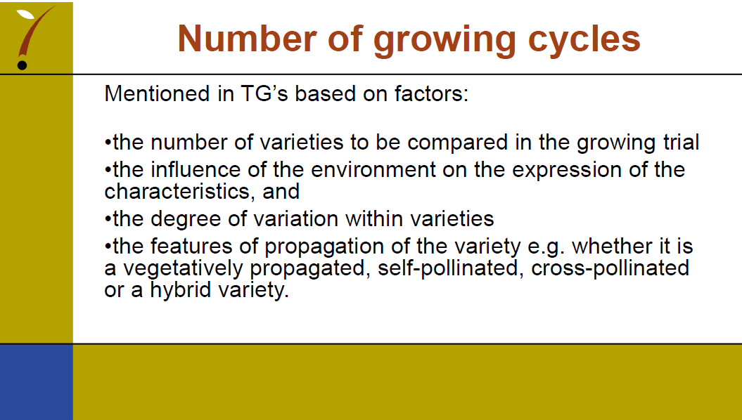

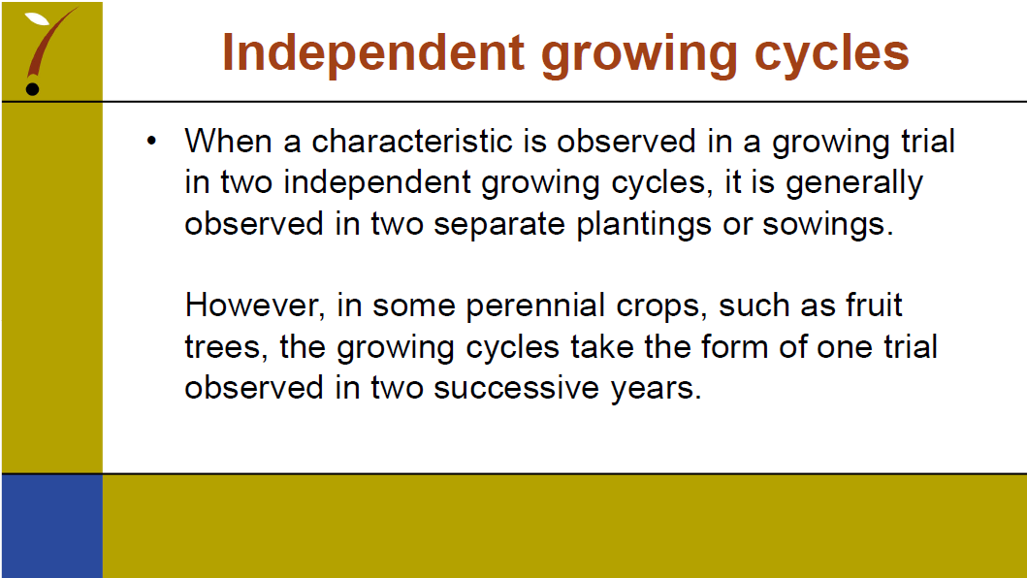

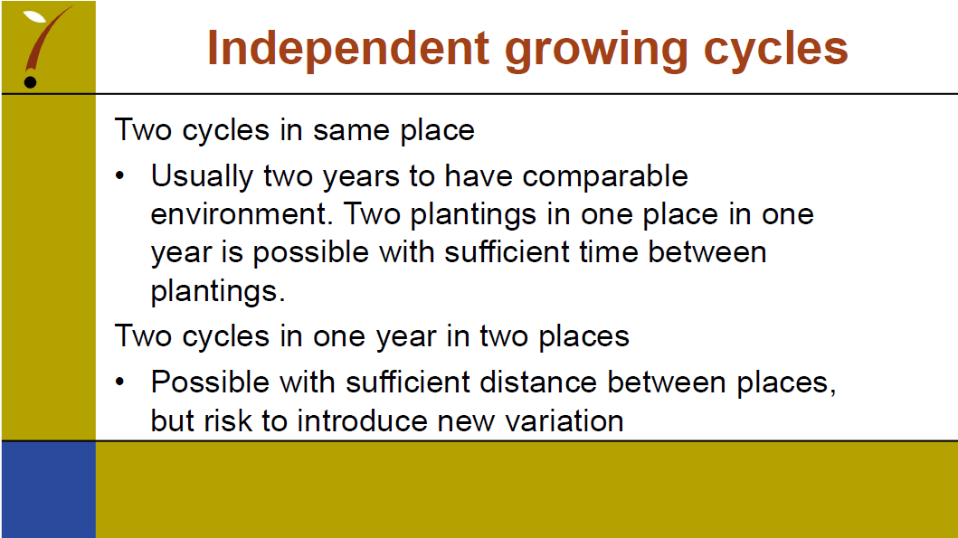

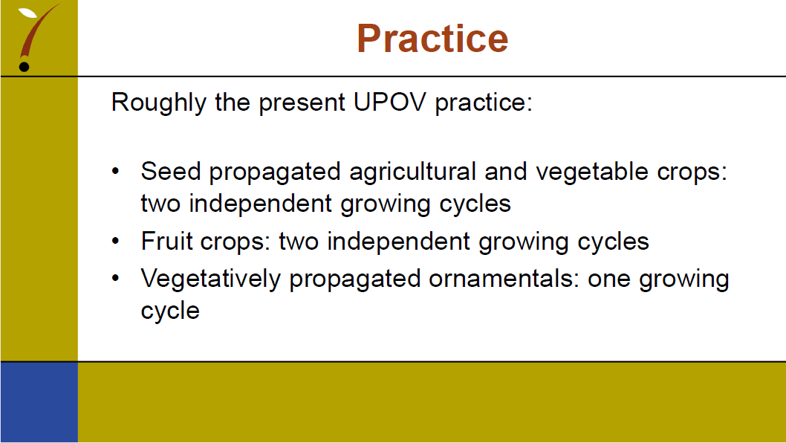

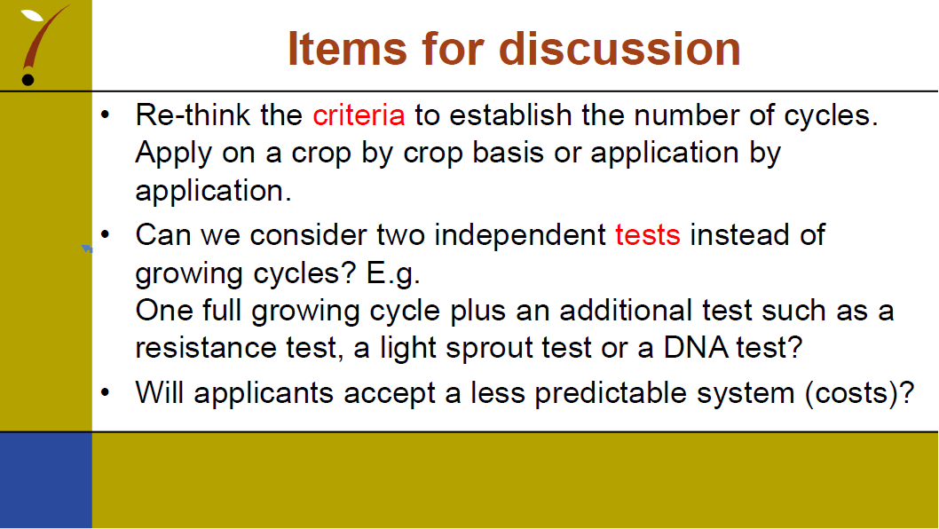

[End of Annex and of document]

