E
TWA/45/10
ORIGINAL: English
DATE: June 2, 2016
INTERNATIONAL UNION FOR THE PROTECTION OF NEW VARIETIES OF PLANTS
Geneva
Technical working party for Agricultural crops
Forty-Fifth Session
Mexico City, Mexico, July 11 to 15, 2016
REVISION OF DOCUMENT TGP/8: PART II: SELECTED TECHNIQUES USED IN DUS EXAMINATION, SECTION 9: THE COMBINED-OVER-YEARS UNIFORMITY CRITERION (COYU)
Document prepared by the Office of the Union
Disclaimer: this document does not represent UPOV policies or guidance
EXECUTIVE SUMMARY

The purpose of this document is to report on developments concerning the method of calculation of the Combined-Over-Years Uniformity Criterion (COYU).

The TWA is invited to note:

(a) that the TC, at its fifty-second session, agreed to request members of the Union to provide larger data sets to the United Kingdom for developing probability levels for the new method that would match results obtained using the previous probability levels, as set out in paragraph 20 of this document; and

(b) that the Office of the Union issued UPOV Circular E-16/098 to invite UPOV members’ experts to provide to the United Kingdom by May 27, 2016, data sets including at least 100 candidate varieties, with a possibility that data for those 100 varieties could be derived from several years.

(c) the report by an expert of the United Kingdom on the results and further progress, including contribution of data to be made at the thirty-fourth session of the TWC.

The following abbreviations are used in this document:

TC: Technical Committee
TC-EDC: Enlarged Editorial Committee
TWA: Technical Working Party for Agricultural Crops
TWC: Technical Working Party on Automation and Computer Programs
TWF: Technical Working Party for Fruit Crops
TWO: Technical Working Party for Ornamental Plants and Forest Trees
TWPs: Technical Working Parties
TWV: Technical Working Party for Vegetables

The structure of this document is as follows:

BACKGROUND 2
DEVELOPMENTS IN 2015 2
DEVELOPMENTS IN 2016 3
ANNEX COMBINED OVER-YEARS UNIFORMITY (COYU) CRITERION

BACKGROUND

The background to this matter is provided in documents TWA/44/16 “Revision of document TGP/8: Part II: Selected Techniques Used in DUS Examination, Section 9: The Combined-Over-Years Uniformity Criterion (COYU)” and TWC/33/16 Add. “Criterion (COYU), Method of Calculation of COYU Addendum to Revision of document TGP/8: Part II: Selected Techniques Used in DUS Examination, Section 9: The Combined-Over-Years Uniformity Criterion (COYU)”.

DEVELOPMENTS IN 2015

At their sessions in 2015, the TWV, TWC, TWA, TWF and TWO considered documents TWV/49/16, TWC/33/16 and TWC/33/16 Add., TWA/44/16, TWF/46/16 and TWO/48/16 “Revision of document TGP/8: Part II: Selected Techniques Used in DUS Examination, Section 9: The Combined-Over-Years Uniformity Criterion (COYU)”, respectively.

The TWV, TWA, TWF and TWO noted that the participants of the exercise to test the software on the new method for the calculation of should cover followings (see documents TWV/49/32 “Report”, paragraph 45, TWA/44/23 “Report”, paragraph 38, TWF/46/29 Rev. “Revised Report”, paragraph 41 and TWO/48/26 “Report”, paragraph 34, respectively):

(i) seek to define probability levels to match decisions using the previous COYU method;
(ii) run the test for rejection probabilities of 1, 2 and 5% levels; and
(iii) assess whether the results are consistent in all crops.

The TWV, TWA, TWF and TWO noted that the expert from the United Kingdom had distributed the new software on COYU and the guidance document to the participants of the exercise (see documents TWV/49/32, paragraph 46, TWA/44/23, paragraph 39, TWF/46/29 Rev., paragraph 42 and TWO/48/26, paragraph 35, respectively).

The TWV, TWA, TWF and TWO noted that the experts from Czech Republic, France, Finland, Germany, Kenya, Poland and United Kingdom would participate in the exercise to test the new software on COYU (see documents TWV/49/32, paragraph 47, TWA/44/23, paragraph 40, TWF/46/29 Rev., paragraph 43 and TWO/48/26, paragraph 36, respectively).

The TWV noted that a report on the practical exercise and the development of DUST module would be presented at the thirty-third session of the TWC by an expert from the United Kingdom (see document TWV/49/32, paragraph 48)

The TWC noted that the experts from Finland, France, Germany, Kenya and the United Kingdom had participated in the exercise to test the new software on COYU (see document TWC/33/33 “Report”, paragraphs 23 to 27).

The TWC considered the report on the practical exercise as presented by an expert from the United Kingdom in the Annex to document TWC/33/16.

The TWC received a presentation on the “Method of calculation of COYU” from an expert from the United Kingdom, a copy of which was provided in an addendum to document TWC/33/16, reproduced as Annex to this document (in English only). The TWC agreed that the new method worked well in practice and requested the expert from the United Kingdom to provide guidance on extrapolation when the candidate had a level of expression outside that seen in the reference varieties.

The TWC noted the need for larger data sets to be tested in order to develop probability levels for the new method. Such data sets should include at least 100 candidate varieties, with a possibility that data for those 100 varieties could be derived from several years.

The TWC agreed to invite the experts from China and France to join in the next steps of the practical exercise and to provide their data sets for use in the testing. The TWC also agreed to invite the TWA to provide large data sets from field crops.

The TWA, TWF and TWO noted that a report on the practical exercise and the development of a DUST module had been presented at the thirty-third session of the TWC by an expert from the United Kingdom (see documents TWA/44/23, paragraph 41, TWF/46/29 Rev., paragraph 44 and TWO/48/26, paragraph 37, respectively).

DEVELOPMENTS IN 2016

The TC, at its fifty-second session, held in Geneva, from March 14 to 16, 2016, considered document TC/52/17 “Revision of document TGP/8: Part II: Selected Techniques Used in DUS Examination, Section 9: the Combined-Over-Years Uniformity Criterion (COYU)” and received a presentation by an expert from the United Kingdom, a copy of which is provided in the Annex to this document (see document TC/52/29 Rev. “Revised Report”, paragraphs 105 to 110).

The TC noted that experts from Finland, France, Germany, Kenya and the United Kingdom had participated in the exercise to test the software module on the new method for calculation of COYU.

The TC noted that the TWC had agreed that the new method for calculation of COYU worked well in practice and had agreed to request the expert from the United Kingdom to provide guidance on extrapolation when the candidate had a level of expression outside that seen in the reference varieties.

The TC agreed to request members of the Union to provide larger data sets to the United Kingdom for developing probability levels for the new method that would match results obtained using the previous probability levels. Such data sets should include at least 100 candidate varieties, with a possibility that data for those 100 varieties could be derived from several years. The TC noted that the Office of the Union would issue a circular inviting contributions of data sets.

The TC noted that the TWC had agreed to invite experts from China and France to join in the next steps of the practical exercise and to provide their data sets for use in the testing.

The TC noted that the TWC had proposed to invite the TWA to provide large data sets from field crops in order to identify suitable probability levels on the new method for calculation of COYU.

On April 13, 2016, the Office of the Union issued UPOV Circular E-16/098 inviting UPOV members’ experts to provide to the United Kingdom by May 27, 2016, data sets including at least 100 candidate varieties, with a possibility that data for those 100 varieties could be derived from several years.

An expert of the United Kingdom will report the results and further progress at the thirty-fifth session of the TWC. The expert will provide an oral report on the contributions to date at the thirty-forth session.

The TWA is invited to note:

(a) that the TC, at its fifty-second session, agreed to request members of the Union to provide larger data sets to the United Kingdom for developing probability levels for the new method that would match results obtained using the previous probability levels, as set out in paragraph 20 of this document;

(b) that the Office of the Union issued UPOV Circular E-16/098 to invite UPOV members’ experts to provide to the United Kingdom by May 27, 2016, data sets including at least 100 candidate varieties, with a possibility that data for those 100 varieties could be derived from several years; and

(c) the report by an expert of the United Kingdom on the results and further progress, including contribution of data to be made at the thirty-fourth session of the TWC.

[Annex follows]
COMBINED OVER-YEARS UNIFORMITY (COYU) CRITERION
(IN ENGLISH ONLY)

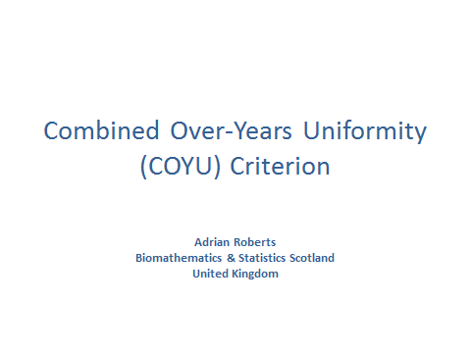

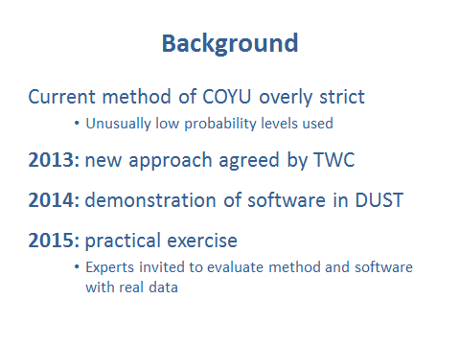

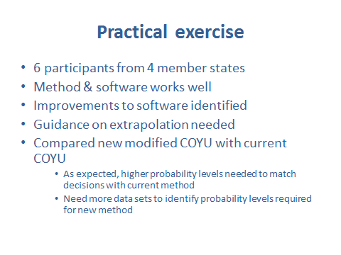

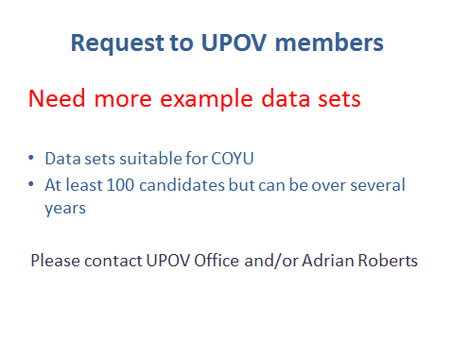

[End of Annex and of document]

