E
TWA/44/11
ORIGINAL: English
DATE: May 29, 2015
INTERNATIONAL UNION FOR THE PROTECTION OF NEW VARIETIES OF PLANTS
Geneva
Technical working party for Agricultural crops
Forty-Fourth Session
Obihiro, Japan, July 6 to 10, 2015
GUIDANCE for Drafters of Test Guidelines
Document prepared by the Office of the Union
Disclaimer: this document does not represent UPOV policies or guidance
EXECUTIVE SUMMARY

The purpose of this document is to present a proposal for updating the content of the TG Drafters’ webpage of the UPOV website on guidance for drafters of Test Guidelines.

The TWA is invited to consider the plan to update the TG drafters’ webpage to provide the following information:

- Additional characteristics
- Summary information on quantity of plant material required on adopted Test Guidelines
- Test Guidelines under development (reference to document TC/[xx]/2
- Shapes extract from document TGP/14
- Web-based TG Template

The following abbreviations are used in this document:

TC: Technical Committee
TC-EDC: Enlarged Editorial Committee
TWA: Technical Working Party for Agricultural Crops
TWC: Technical Working Party on Automation and Computer Programs
TWF: Technical Working Party for Fruit Crops
TWO: Technical Working Party for Ornamental Plants and Forest Trees
TWPs: Technical Working Parties
TWV: Technical Working Party for Vegetables

The structure of this document is as follows:

Current guidance 2
Guidance incorporated in the web-based tg template 2
Information not included in the web-based tg template 2
Additional Characteristics 2
Summary information on quantity of plant material required on adopted Test Guidelines 3

plans for updating the tg drafters’ webpage 3

Current guidance

Guidance for drafters of Test Guidelines is currently available on the TG drafters’ webpage of the UPOV web site as follows:

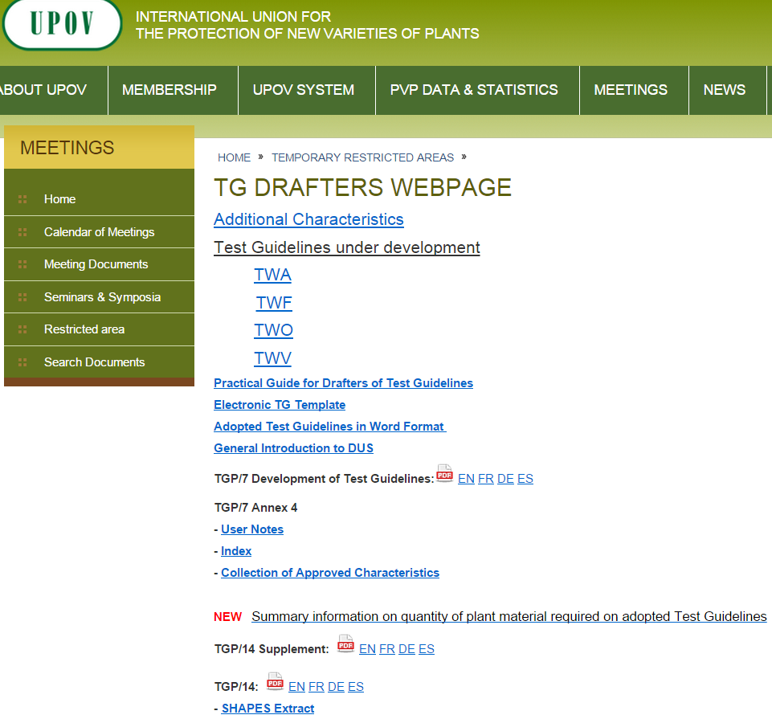

Guidance incorporated in the web-based tg template

Most of the guidance available on the TG drafters’ webpage has been, or will be, incorporated in the web-based TG Template. For example, links to relevant guidance from documents TGP/7 and TGP/14 are provided in the web-based TG Template for each item in the Test Guidelines. A report on developments on the web-based TG Template is provided in the document TWA/49/12 “Revision of document TGP/7: Drafter's Kit for Test Guidelines”.

Information not included in the web-based tg template

Additional Characteristics

Additional characteristics not included in UPOV Test Guidelines that have been used by members of the Union in the examination of DUS and which should be considered for inclusion in future Test Guidelines” should be notified to the Office of the Union by means of document TGP/5 Section 10 (see http://www.upov.int/edocs/tgpdocs/en/tgp_5_section_10.pdf).

Proposals for additional characteristics and states of expression notified to the Office of the Union will be presented to the relevant TWP(s) at the earliest opportunity with information on the extent of use of the characteristic. The characteristics will then, as appropriate, be posted on the TG Drafters’ webpage of the UPOV website on the basis of comments made by the relevant TWP(s), and/or the TWP(s) may initiate a revision or a partial revision of the Test Guidelines concerned.

As of April 2015, the following additional characteristics had been posted on the TG Drafters’ webpage:

- Blueberry: "Leaf: glaucosity"; and "Fruit: ratio height/width"
- Field Bean: "Content of vicine/convicine"
- Mandarin : "Fruit: number of seeds (controlled manual crosspollination)"

Summary information on quantity of plant material required on adopted Test Guidelines

The TG drafters’ webpage provides information on the quantity of plant material required in adopted Test Guidelines in order to allow drafters to consider similar crops and seek consistency as far as that was appropriate. A summary of the following information is available as a Microsoft Excel file on the TG Drafters’ webpage:

Chapter 2.3 Minimum quantity of plant material to be supplied by the applicant
Chapter 3.1 Number of growing cycles
Chapter 3.4.1 Each test should be designed to result in a total of at least X plants
Chapter 3.5 Number of plants for special tests (e.g. disease resistance)
Chapter 4.1.4 Number of plants / parts of plants to be examined for distinctness
Chapter 4.2 Number of plants to be examined for uniformity

plans for updating the tg drafters’ webpage

It is planned that the TG drafters’ webpage will be updated in 2015 to provide the following information:

Web-based TG Template
Additional characteristics
Summary information on quantity of plant material required on adopted Test Guidelines
Test Guidelines under development (reference to document TC/[xx]/2)
Shapes extract from document TGP/14

The TWA is invited to consider the plan to update the TG drafters’ webpage to provide the information as set out in paragraph 11 of this document.

[End of document]

