E
TG/80/7(proj.1)
ORIGINAL: English
DATE: 2015-05-22
INTERNATIONAL UNION FOR THE PROTECTION OF NEW VARIETIES OF PLANTS
Geneva
DRAFT

 | Soya Bean  UPOV Code: GLYCI_MAX  Glycine max (L.) Merr. | *

GUIDELINES
FOR THE CONDUCT OF TESTS
FOR DISTINCTNESS, UNIFORMITY AND STABILITY

prepared by (an) expert(s) from Argentina

to be considered by the
Technical Working Party for Agricultural Crops
at its forty-fourth session
to be held in Obihiro, Japan,
from 2015-07-06
to 2015-07-10

Alternative Names:*
Botanical name | English | French | German | Spanish
Glycine max (L.) Merr., Soja hispida Moench | Soya Bean, Soybean | Soja | Sojabohne | Soja

The purpose of these guidelines (“Test Guidelines”) is to elaborate the principles contained in the General Introduction (document TG/1/3), and its associated TGP documents, into detailed practical guidance for the harmonized examination of distinctness, uniformity and stability (DUS) and, in particular, to identify appropriate characteristics for the examination of DUS and production of harmonized variety descriptions.

ASSOCIATED DOCUMENTS
These Test Guidelines should be read in conjunction with the General Introduction and its associated TGP documents.
TABLE OF CONTENTS PAGE

1. Subject of these Test Guidelines 3
2. Material Required 3
3. Method of Examination 3
3.1 Number of Growing Cycles 3
3.2 Testing Place 3
3.3 Conditions for Conducting the Examination 3
3.4 Test Design 3
3.5 Additional Tests 3
4. Assessment of Distinctness, Uniformity and Stability 4
4.1 Distinctness 4
4.2 Uniformity 5
4.3 Stability 5
5. Grouping of Varieties and Organization of the Growing Trial 5
6. Introduction to the Table of Characteristics 5
6.1 Categories of Characteristics 5
6.2 States of Expression and Corresponding Notes 6
6.3 Types of Expression 6
6.4 Example Varieties 6
6.5 Legend 6
7. Table of Characteristics/Tableau des caractères/Merkmalstabelle/Tabla de caracteres 7
8. Explanations on the Table of Characteristics 17
9. Literature 22
10. Technical Questionnaire 23

Subject of these Test Guidelines

These Test Guidelines apply to all varieties of Glycine max (L.) Merr..

Material Required

2.1 The competent authorities decide on the quantity and quality of the plant material required for testing the variety and when and where it is to be delivered. Applicants submitting material from a State other than that in which the testing takes place must ensure that all customs formalities and phytosanitary requirements are complied with.

  - The material is to be supplied in the form of seed.

2.3 The minimum quantity of plant material, to be supplied by the applicant, should be:

2 kg.

The seed should meet the minimum requirements for germination, species and analytical purity, health and moisture content, specified by the competent authority. In cases where the seed is to be stored, the germination capacity should be as high as possible and should be stated by the applicant.

2.4 The plant material supplied should be visibly healthy, not lacking in vigor, nor affected by any important pest or disease.

2.5 The plant material should not have undergone any treatment which would affect the expression of the characteristics of the variety, unless the competent authorities allow or request such treatment. If it has been treated, full details of the treatment must be given.

Method of Examination

3.1 Number of Growing Cycles

3.1.1 The minimum duration of tests should normally be two similar growing periods.

3.2 Testing Place

Tests are normally conducted at one place. In the case of tests conducted at more than one place, guidance is provided in TGP/9 “Examining Distinctness”.

3.3 Conditions for Conducting the Examination

3.3.1 The tests should be carried out under conditions ensuring satisfactory growth for the expression of the relevant characteristics of the variety and for the conduct of the examination.

3.3.2 The optimum stage of development for the assessment of each characteristic is indicated by a number in the second column of the Table of Characteristics. The stages of development denoted by each number are described in Chapter 8.

3.4 Test Design

3.4.1 Each test should be designed to result in a total of at least 300 plants, which should be divided between at least 2 replicates.

3.4.2 The design of the tests should be such that plants or parts of plants may be removed for measurement or counting without prejudice to the observations which must be made up to the end of the growing cycle.

3.5 Additional Tests

Additional tests, for examining relevant characteristics, may be established.

Assessment of Distinctness, Uniformity and Stability

4.1 Distinctness

4.1.1 General Recommendations

It is of particular importance for users of these Test Guidelines to consult the General Introduction prior to making decisions regarding distinctness. However, the following points are provided for elaboration or emphasis in these Test Guidelines.

4.1.2 Consistent Differences

The differences observed between varieties may be so clear that more than one growing cycle is not necessary. In addition, in some circumstances, the influence of the environment is not such that more than a single growing cycle is required to provide assurance that the differences observed between varieties are sufficiently consistent. One means of ensuring that a difference in a characteristic, observed in a growing trial, is sufficiently consistent is to examine the characteristic in at least two independent growing cycles.

4.1.3 Clear Differences

Determining whether a difference between two varieties is clear depends on many factors, and should consider, in particular, the type of expression of the characteristic being examined, i.e. whether it is expressed in a qualitative, quantitative, or pseudo-qualitative manner. Therefore, it is important that users of these Test Guidelines are familiar with the recommendations contained in the General Introduction prior to making decisions regarding distinctness.

4.1.4 Number of Plants / Parts of Plants to be Examined

Unless otherwise indicated, for the purposes of distinctness, all observations on single plants should be made on 20 plants or parts taken from each of 20 plants and any other observations made on all plants in the test, disregarding any off-type plants.

4.1.5 Method of Observation

The recommended method of observing the characteristic for the purposes of distinctness is indicated by the following key in the second column of the Table of Characteristics (see document TGP/9 “Examining Distinctness”, Section 4 “Observation of characteristics”):

MG: single measurement of a group of plants or parts of plants
MS: measurement of a number of individual plants or parts of plants
VG: visual assessment by a single observation of a group of plants or parts of plants
VS: visual assessment by observation of individual plants or parts of plants

Type of observation: visual (V) or measurement (M)

“Visual” observation (V) is an observation made on the basis of the expert’s judgment. For the purposes of this document, “visual” observation refers to the sensory observations of the experts and, therefore, also includes smell, taste and touch. Visual observation includes observations where the expert uses reference points (e.g. diagrams, example varieties, side-by-side comparison) or non-linear charts (e.g. color charts). Measurement (M) is an objective observation against a calibrated, linear scale e.g. using a ruler, weighing scales, colorimeter, dates, counts, etc.

Type of record: for a group of plants (G) or for single, individual plants (S)

For the purposes of distinctness, observations may be recorded as a single record for a group of plants or parts of plants (G), or may be recorded as records for a number of single, individual plants or parts of plants (S). In most cases, “G” provides a single record per variety and it is not possible or necessary to apply statistical methods in a plant-by-plant analysis for the assessment of distinctness.

In cases where more than one method of observing the characteristic is indicated in the Table of Characteristics (e.g. VG/MG), guidance on selecting an appropriate method is provided in document TGP/9, Section 4.2.

4.2 Uniformity

    - It is of particular importance for users of these Test Guidelines to consult the General Introduction prior to making decisions regarding uniformity. However, the following points are provided for elaboration or emphasis in these Test Guidelines:

4.2.2 For the assessment of uniformity, a population standard of 5% and an acceptance probability of at least 95 % should be applied. In the case of a sample size of 300 plants, 4 off-types are allowed.

4.3 Stability

4.3.1 In practice, it is not usual to perform tests of stability that produce results as certain as those of the testing of distinctness and uniformity. However, experience has demonstrated that, for many types of variety, when a variety has been shown to be uniform, it can also be considered to be stable.

4.3.2 Where appropriate, or in cases of doubt, stability may be further examined by testing a new seed stock to ensure that it exhibits the same characteristics as those shown by the initial material supplied.

Grouping of Varieties and Organization of the Growing Trial

5.1 The selection of varieties of common knowledge to be grown in the trial with the candidate varieties and the way in which these varieties are divided into groups to facilitate the assessment of distinctness are aided by the use of grouping characteristics.

5.2 Grouping characteristics are those in which the documented states of expression, even where produced at different locations, can be used, either individually or in combination with other such characteristics: (a) to select varieties of common knowledge that can be excluded from the growing trial used for examination of distinctness; and (b) to organize the growing trial so that similar varieties are grouped together.

5.3 The following have been agreed as useful grouping characteristics:

(a) Plant: growth type (characteristic 2)
(b) Plant: color of hairs of main stem (on middle third) (characteristic 4)
(c) Flower color (characteristic 12)
(d) Seed: peroxidase test (coloration due to peroxidase activity in seed coat) (characteristic 20)
(e) Seed: hilum color (characteristic 21)
(f) Maturity Group (American Scale) (characteristic 25)

5.4 Guidance for the use of grouping characteristics, in the process of examining distinctness, is provided through the General Introduction and document TGP/9 “Examining Distinctness”.

Introduction to the Table of Characteristics

6.1 Categories of Characteristics

6.1.1 Standard Test Guidelines Characteristics

Standard Test Guidelines characteristics are those which are approved by UPOV for examination of DUS and from which members of the Union can select those suitable for their particular circumstances.

6.1.2 Asterisked Characteristics

Asterisked characteristics (denoted by *) are those included in the Test Guidelines which are important for the international harmonization of variety descriptions and should always be examined for DUS and included in the variety description by all members of the Union, except when the state of expression of a preceding characteristic or regional environmental conditions render this inappropriate.

6.2 States of Expression and Corresponding Notes

6.2.1 States of expression are given for each characteristic to define the characteristic and to harmonize descriptions. Each state of expression is allocated a corresponding numerical note for ease of recording of data and for the production and exchange of the description.

6.2.2 In the case of qualitative and pseudo-qualitative characteristics (see Chapter 6.3), all relevant states of expression are presented in the characteristic. However, in the case of quantitative characteristics with 5 or more states, an abbreviated scale may be used to minimize the size of the Table of Characteristics. For example, in the case of a quantitative characteristic with 9 states, the presentation of states of expression in the Test Guidelines may be abbreviated as follows:

State | Note
small | 3
medium | 5
large | 7

However, it should be noted that all of the following 9 states of expression exist to describe varieties and should be used as appropriate:

State | Note
very small | 1
very small to small | 2
small | 3
small to medium | 4
medium | 5
medium to large | 6
large | 7
large to very large | 8
very large | 9

6.2.3 Further explanation of the presentation of states of expression and notes is provided in document TGP/7 “Development of Test Guidelines”.

6.3 Types of Expression

An explanation of the types of expression of characteristics (qualitative, quantitative and pseudo-qualitative) is provided in the General Introduction.

6.4 Example Varieties

Where appropriate, example varieties are provided to clarify the states of expression of each characteristic.

6.5 Legend

(*) Asterisked characteristic – see Chapter 6.1.2

QL Qualitative characteristic – see Chapter 6.3
QN Quantitative characteristic – see Chapter 6.3
PQ Pseudo-qualitative characteristic – see Chapter 6.3

MG, MS, VG, VS – see Chapter 4.1.5

(a)-(b) See Explanations on the Table of Characteristics in Chapter 8.

(+) See Explanations on the Table of Characteristics in Chapter 8.

Table of Characteristics/Tableau des caractères/Merkmalstabelle/Tabla de caracteres

English | français | deutsch | español | Example Varieties Exemples Beispielssorten Variedades ejemplo | Note/ Nota
1. QL VG 10 (+)
Hypocotyl: color
green |  |  |  | DAVIS | 1
green with bronze |  |  |  | BRAGG | 2
light purple |  |  |  | ESSEX | 3
purple |  |  |  |  | 4
2. QL VG (+) (a)
Plant: growth type | Plante: type de croissance | Pflanze: Wuchstyp | Planta: porte
determinate | déterminée | begrenzt wachsend | determinado | A 5777 RG, A 8000 RG, RA 538 | 1
semi-determinate |  |  |  | NS 6448, RA 625, RMO 75 | 2
semi-determinate to indeterminate |  |  |  |  | 3
indeterminate | indéterminée | unbegrenzt wachsend | indeterminado | A 4505 RG, DON MARIO 5.9I, RA 728 | 4
3. QL VG 66 (+) (a)
Plant: growth habit
erect |  |  |  |  | 1
erect to semi-erect |  |  |  |  | 2
semi-erect |  |  |  |  | 3
semi -erect to horizontal |  |  |  |  | 4
horizontal |  |  |  |  | 5
4. QL VG 65-85 (a)
Plant: color of hairs of main stem (on middle third)
grey |  |  |  | AYELEN 22 | 1
tawny |  |  |  |  | 2

English | français | deutsch | español | Example Varieties Exemples Beispielssorten Variedades ejemplo | Note/ Nota
5. QL VG 65-85 (+)
Plant: intensity of color of hairs of main stem (on middle third)
light |  |  |  | A 4505 RG, ADM 4800, DON MARIO 3700, NS 4009 | 1
medium |  |  |  | A 3550 RG, NIDERA A 4990 RG, NIDERA A3933 RG | 5
dark |  |  |  | A 3901RG, NIDERA A5209 RG, RA 728 | 9
6. QN MG 85 (a)
Plant: height
short |  |  |  | CARLA, PARADIS, SPOT | 3
short to medium |  |  |  | ESSOR, TRUMP | 4
medium |  |  |  | Chandor | 5
medium to tall |  |  |  | Kador | 6
tall |  |  |  | TIROL, TOREADOR | 7
7. QN VG 65 (a)
Leaf: blistering
absent or very weak |  |  |  | Arpège, BAYOU, Chandor | 1
weak |  |  |  | Kador, Quito | 3
medium |  |  |  | Imari, Paoki | 5
strong |  |  |  | Matador | 7
very strong |  |  |  |  | 9
8. PQ VS 65 (a)
Leaf: shape of central leaflet
lanceolate |  |  |  | SP 7X0 | 1
triangular base- elongated leaflet |  |  |  | A 7118 RG | 2
ovoid |  |  |  | Champaquí 5.7 | 3
elliptic |  |  |  | A 3550 RG | 4

English | français | deutsch | español | Example Varieties Exemples Beispielssorten Variedades ejemplo | Note/ Nota
9. QN VS 65 (a)
Leaf: size of lateral leaflet
small |  |  |  | Arcade, Baron, Labrador, TRUMP | 3
medium |  |  |  | Alaric, Kushiro, Talon | 5
large |  |  |  | Williams | 7
10. QL VG 65
Leaf: shape of lateral leaflet
lancelotate |  |  |  |  | 1
triangular |  |  |  |  | 2
pointed ovate |  |  |  |  | 3
rounded ovate |  |  |  |  | 4
11. QN VG 65 (a)
Leaf: intensity of green color
light |  |  |  | Arcade, Chandor, Junior | 3
medium |  |  |  | Alaric, Apache, Imari | 5
dark |  |  |  | Ardir, Cresir, Jedor, SPOT | 7
12. QL VS 66 (a)
Flower color
White |  |  |  | DON MARIO 5.9I | 1
Violet |  |  |  | SP 7X0 | 2
13. QL VG 85 (a)
Pod: color
tan |  |  |  | ALM 4650, AS 4402, AYELEN 22, DON MARIO 6.2I | 1
tawny |  |  |  | A 3901 RG, A 4505 RG, Don Mario 7.0I, NIDERA A 4990 RG, NS 4009 | 2

English | français | deutsch | español | Example Varieties Exemples Beispielssorten Variedades ejemplo | Note/ Nota
14. QN VG 85 (+) (a)
Pod: intensity of color
light |  |  |  |  | 1
medium |  |  |  |  | 5
dark |  |  |  |  | 9
15. QN MG 89 (a)
Seed: size
small |  |  |  | Alba, Aurelia, Flusk GT 512 | 3
medium |  |  |  | Goldor, Queen | 5
large |  |  |  | Cervin, Clédor, Mondor | 7
16. QL VG 89 (a)
Seed: shape
spherical |  |  |  |  | 1
spherical flattened |  |  |  |  | 2
elongated |  |  |  |  | 3
elongated flattened |  |  |  |  | 4
17. PQ VG 89 (a)
Seed: ground color of testa (excluding hilum)
yellow |  |  |  | Paoki, Queen | 1
yellow green |  |  |  |  | 2
green |  |  |  |  | 3
light brown |  |  |  |  | 4
medium brown |  |  |  |  | 5
dark brown |  |  |  |  | 6
dark |  |  |  |  | 7

English | français | deutsch | español | Example Varieties Exemples Beispielssorten Variedades ejemplo | Note/ Nota
18. QN VG 89 (a)
Seed: intensity of yellow ground
light |  |  |  |  | 3
medium |  |  |  |  | 5
dark |  |  |  |  | 7
19. QN MG VG 89 (a)
Seed: glossines of yellow testa
opaque |  |  |  | CH 4308 RG | 1
intermediate |  |  |  |  | 2
bright |  |  |  | RA 732 | 3
20. QL MG 89 (a)
Seed: peroxidase test (coloration due to peroxidase activity in seed coat)
positive (present) |  |  |  | Hood, Hood 75 | 1
mixture (present and absent) |  |  |  |  | 2
negative (absent) |  |  |  | Bragg | 3
21. QL VG 89 (a)
Seed: hilum color
grey |  |  |  | Apache, Major, SPOT | 1
yellow |  |  |  | Imari, Maple Arrow, Talon | 2
light brown |  |  |  | Argenta, Baron, Kingsoy, Opale | 3
intermediate brown |  |  |  |  | 4
dark brown |  |  |  | Aurélia, Fransoy 242, Léman | 5
imperfect black |  |  |  | Folio, Kador, Wells | 6
black |  |  |  | Chandor, Paoki, Queen | 7
light or intermediate brown and imperfect black |  |  |  |  | 8

English | français | deutsch | español | Example Varieties Exemples Beispielssorten Variedades ejemplo | Note/ Nota
22. QL VG 89 (a)
Seed: color of hilum funicle
same as testa |  |  |  | Queen | 1
different to testa |  |  |  | Gieso | 2
23. QN MG 19 (a)
Plant: time of beginning of flowering (50% plants with at least one flower open)
very early |  |  |  | CARLA, PARADIS, Sito, TRUMP | 1
very early to early |  |  |  | Arcade, ESSOR, Labrador | 2
early |  |  |  | Canton, Imari, Queen | 3
early to medium |  |  |  | Alaric, Kador, Niva | 4
medium |  |  |  | Williams | 5
medium to late |  |  |  |  | 6
late |  |  |  |  | 7
late to very late |  |  |  |  | 8
very late |  |  |  |  | 9
24. QN VG 89 (a)
Plant: time of maturity
very early |  |  |  | CARLA, Kola, PARADIS, Soléo, TRUMP | 1
very early to early |  |  |  | Apache, Chandor, Labrador | 2
early |  |  |  | Aurélia, Canton, Paoki, Queen | 3
early to medium |  |  |  | Alaric, Kador, Kingsoy, Niva | 4
medium |  |  |  | Williams | 5
medium to late |  |  |  |  | 6
late |  |  |  |  | 7
late to very late |  |  |  |  | 8
very late |  |  |  |  | 9

English | français | deutsch | español | Example Varieties Exemples Beispielssorten Variedades ejemplo | Note/ Nota
25. QN MG 89 (a)
Maturity Group (American Scale)
000 |  |  |  |  | 1
00 |  |  |  |  | 2
0 |  |  |  |  | 3
I |  |  |  |  | 4
II |  |  |  | AYELEN 22 | 5
III |  |  |  | DON MARIO 3700 | 6
IV |  |  |  | CH 4308 RG | 7
V |  |  |  | Champaquí 5.7, Don Mario 5.2, NIDERA A5209 RG | 8
VI |  |  |  | DON MARIO 6.2I | 9
VII |  |  |  | A 7118 RG, Don Mario 7.0I, RA 728, RA 732 | 10
VIII |  |  |  | Nidera A 8087 RG | 11
IX |  |  |  | A 9000RG | 12
X |  |  |  |  | 13
26. QN MG 10 (a)
Behavior towards the Phytophthora sojae. Race 1
susceptible |  |  |  | 4.85 S | 1
half resistant |  |  |  |  | 5
resistant |  |  |  | DON MARIO 3700 | 9
27. QN MG 10 (a)
Behavior towards the Phytophthora megasperma var. sojae. Race 3
susceptible |  |  |  | Don Mario 4870 | 1
intermediate |  |  |  |  | 5
resistant |  |  |  | A 3302 RG | 9

English | français | deutsch | español | Example Varieties Exemples Beispielssorten Variedades ejemplo | Note/ Nota
28. QN MG 10 (a)
Behavior towards the Phytophthora megasperma var.sojae Race 4
susceptible |  |  |  | Don Mario 4870 | 1
intermediate |  |  |  |  | 5
resistant |  |  |  | A 3550 RG | 9
29. QN MG 10 (a)
Behavior towards the Phytophthora megasperma var. sojae. Race 17
susceptible |  |  |  | FN 4.85 | 1
intermediate |  |  |  |  | 5
high |  |  |  | DON MARIO 3700 | 9
30. QN MG 10 (a)
Behavior towards the Phytophthora megasperma var. sojae. Race 25
susceptible |  |  |  | A 3302 RG, Don Mario 4870 | 1
intermediate |  |  |  |  | 5
resistant |  |  |  | L93-3312 | 9
31. QN MG 10 (a) (b)
Behavior towards the Diaphorte phaseolorum var. meridionalis
highly susceptible |  |  |  |  | 1
susceptible |  |  |  | RA 702 | 3
half susceptible |  |  |  |  | 5
half resistant |  |  |  |  | 7
resistant |  |  |  | DON MARIO 3700 | 9

English | français | deutsch | español | Example Varieties Exemples Beispielssorten Variedades ejemplo | Note/ Nota
32. QN MG 13 (a)
Behiavor towards the Cercospora sojina Hara. Race 11
susceptible |  |  |  |  | 1
intermediate |  |  |  |  | 5
resistant |  |  |  | DAVIS | 9
33. QN MG 13 (a)
Behavior towards the Cercospora sojina Hara. Race 12
susceptible |  |  |  |  | 1
intermediate |  |  |  |  | 5
resistant |  |  |  |  | 9
34. QL MG (a)
Behavior towards Meloidgyne incognita
susceptible |  |  |  |  | 1
intermediate |  |  |  |  | 5
resistant |  |  |  |  | 9
35. QL MG (a)
Behavior towards Meloidogyne javanica
susceptible |  |  |  |  | 1
intermediate |  |  |  |  | 5
resistant |  |  |  |  | 9
36. QL MG (a)
Behavior towards Heterodera glycines
suscpetible |  |  |  |  | 1
intermediate |  |  |  |  | 5
resistant |  |  |  |  | 9

English | français | deutsch | español | Example Varieties Exemples Beispielssorten Variedades ejemplo | Note/ Nota
37. QL MG (a)
Behavior towards Lepidoptera
susceptible |  |  |  |  | 1
intermediate |  |  |  |  | 5
resistant |  |  |  |  | 9

Explanations on the Table of Characteristics

8.1 Explanations covering several characteristics

Characteristics containing the following key in the second column of the Table of Characteristics should be examined as indicated below:

(a)

Methodology to evaluate soybean cultivars´ reaction towards Phytophthora sojae:
Available races: P. sojae R1, R3, R4, R17 and R25.
Income of races: SENASA DCV No. 19-17 March 2008. Dr. Anne Dorrance The Ohio State University ".
Storage of the races: at 15ºC on V8 diluted agar medium. Was requested a permission to SENASA to transfer races´ copies in cryovials for deposit in the CEREMIC (Mycology Reference Centre, Fac. Of Cs. Bioq. And Farm., UNR, Rosario) in liquid nitrogen.
Example of resistant (R) and suscetible (S) varieties of soybean: seed samples provided by the companies.
Soybean varieties: samples of pure seed and high physiological quality provided by the companies.
Inoculation technique: 3 pots are planted with 5 seeds each genotype. All normal seedlings, with a properly developed hypocotyle, are inoculated. For this, on a 1 cm. maden slit by an hypodermic needle syringe into the subcotiledonar area of 5-7 days old seedlings are inoculated with 40 µl of the pathogen grown in LBAS. Pots are placed in wet chamber for 18 hours and then are kept at 24ºC for 5 days, in that moment the number of dead seedlings on total inoculated seedlings are registered. For each race of pathogen, resistant and susceptible genotypes are considered as cultivars examples.
Any reaction resulting in an intermediate reaction (I) is repeated (2 pots are planted with 5 seedlings each).
Evaluation: Resistant (0-25% plants dead); intermediate (26-75% plants killed); and susceptible (76-100% plants dead).
Example resistants varieties to R1: DM3700, to R3 A3302RG, to R4 A3550RG, to R17 DM3700, to R25 L93-3312.
Example susceptibles varieties to R1: FN4.85, to R3 and R4 DM4870, to R17 FN4.85, to R25 A3302 or DM4870.
(b)

Description of the methodology and the scale for the behavior towards stem canker (Diaphorte phaseolorum var. meridionalis)
Test of soybean genotype to Diaphorte phaseolorum var. meridionalis by the toothpick inoculation technique.
This protocol is based on two parts: preparation of fungal pathogen isolates and isolates-evaluation. The first part should be conduced in a sterile condition and the second in cleaned and desinfected conditions.
PART 1:
Preparation of Diaphorte phaseolorum var. meridionalis isolates:
Substrate: The substrate should be prepared in a petri plate of 90 mm in diametre. It consist of a filter paper where 150 pointed ends of toothpicks are inserted.
Paper: Boeco 3W-65 g/m2 from Germany. Insert into a puncture whith a sterile needle in a uniform way.
Toothpicks: The pointed ends of the toothpicks are cut to a length of 1.2-1.5 centimetre. The toothpicks are boiled three times, air-dried and then it is put into the oven by two hours with a temperature over 100 degrees centigrade.
Method: The toothpicks are inserted in the paper where the sharp end is looking up into petri plate. The paper must be soaked by the culture medium. Then it is put into a autoclave to be sterilized for twenty minutes with a temperature over 120°C.
The culture medium: 20 ml potato glucose agar (PGA) o dextrose.
Diaphorte phaseolorum var. meridionalis isolates are repeated in other petri plates during five days at 28°C. 5 pieces of paper of 5 mm in diametre are inolutated in the culture medium and then put over filtered paper with the toothpicks in similar distances. It incubates during 7-10 days at 20 °C, when the sharp end of toothpicks are colonizated.
PART 2:
Inoculation:
2 repeats of 10-15 seedling are inoculated by genotype. 7-12 days after sowing the toothpick is inserted in the hypocotyl. Then they are put in a wet chamber (100% relative humidity and 27 °C during 72 hours).
Evaluation:
The evaluation is measured 25 days afeter the inoculation:
R: resistant 0-25% Death plants (DP)
MR: middle resistant 26-50% DP
MS: middle suceptible 51-75% DP
S: suceptible 76-90% DP
HS: Higly suceptible more than 90% DP

8.2 Explanations for individual characteristics

Ad. 1: Hypocotyl: color
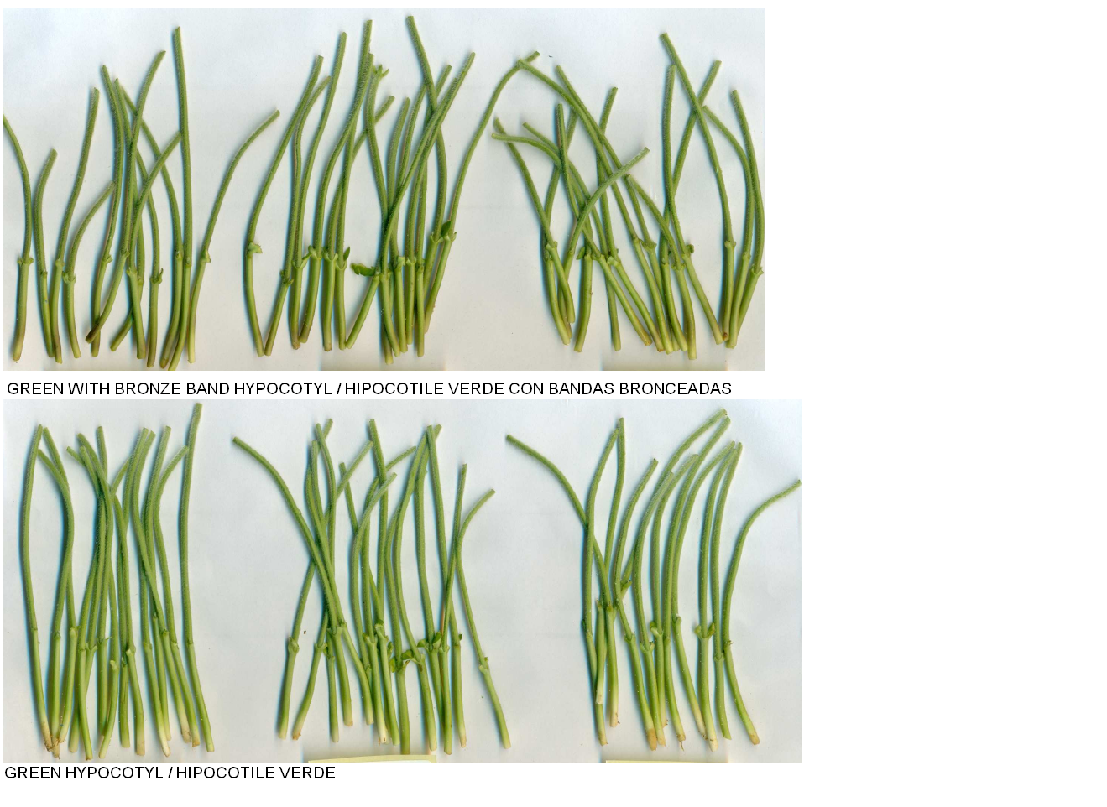

Ad. 2: Plant: growth type
Layout: This characteristic should preferably be assessed in a special trial with 3 or 4 replicates of 20 plants each with about 9 cm between plants in the rows. Any border effect must be avoided.
– Plant material: Candidate and example varieties must be grown in groups according to their earliness at maturity (characteristic 20).
– Observation:
At the beginning of flowering time (1 flower at any level of the main stem), the apex of the plant must be identified with a mark.
At maturity (free kernels in the pod), the number of nodes between the mark and the top of the plant is counted. The average number per variety gives–in comparison with standard varieties–the state of expression of the characteristics.
In addition, the characteristic “Size of the terminal leaf” could also be considered to separate more clearly the state of expression “determinate” (Note 1) from other states. The terminal leaf on the main stem of determinate varieties is more or less equal to other leaves at lower levels. For other types, the terminal leaf is clearly smaller.

Ad. 3: Plant: growth habit
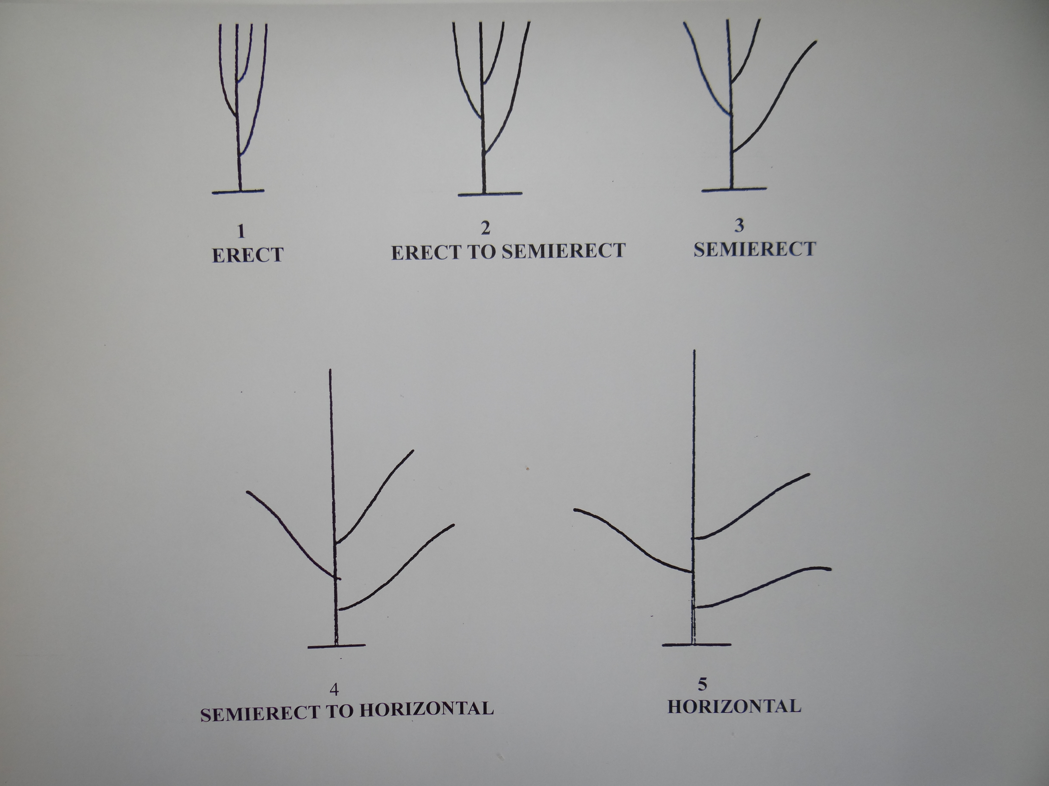

Ad. 5: Plant: intensity of color of hairs of main stem (on middle third)
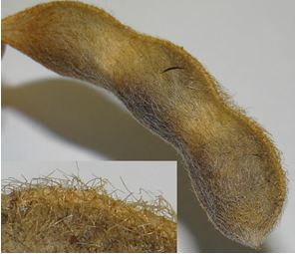
1 - light
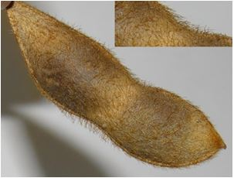
5 - medium
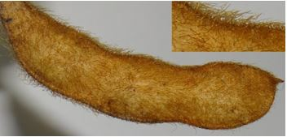
9 - dark
Ad. 14: Pod: intensity of color
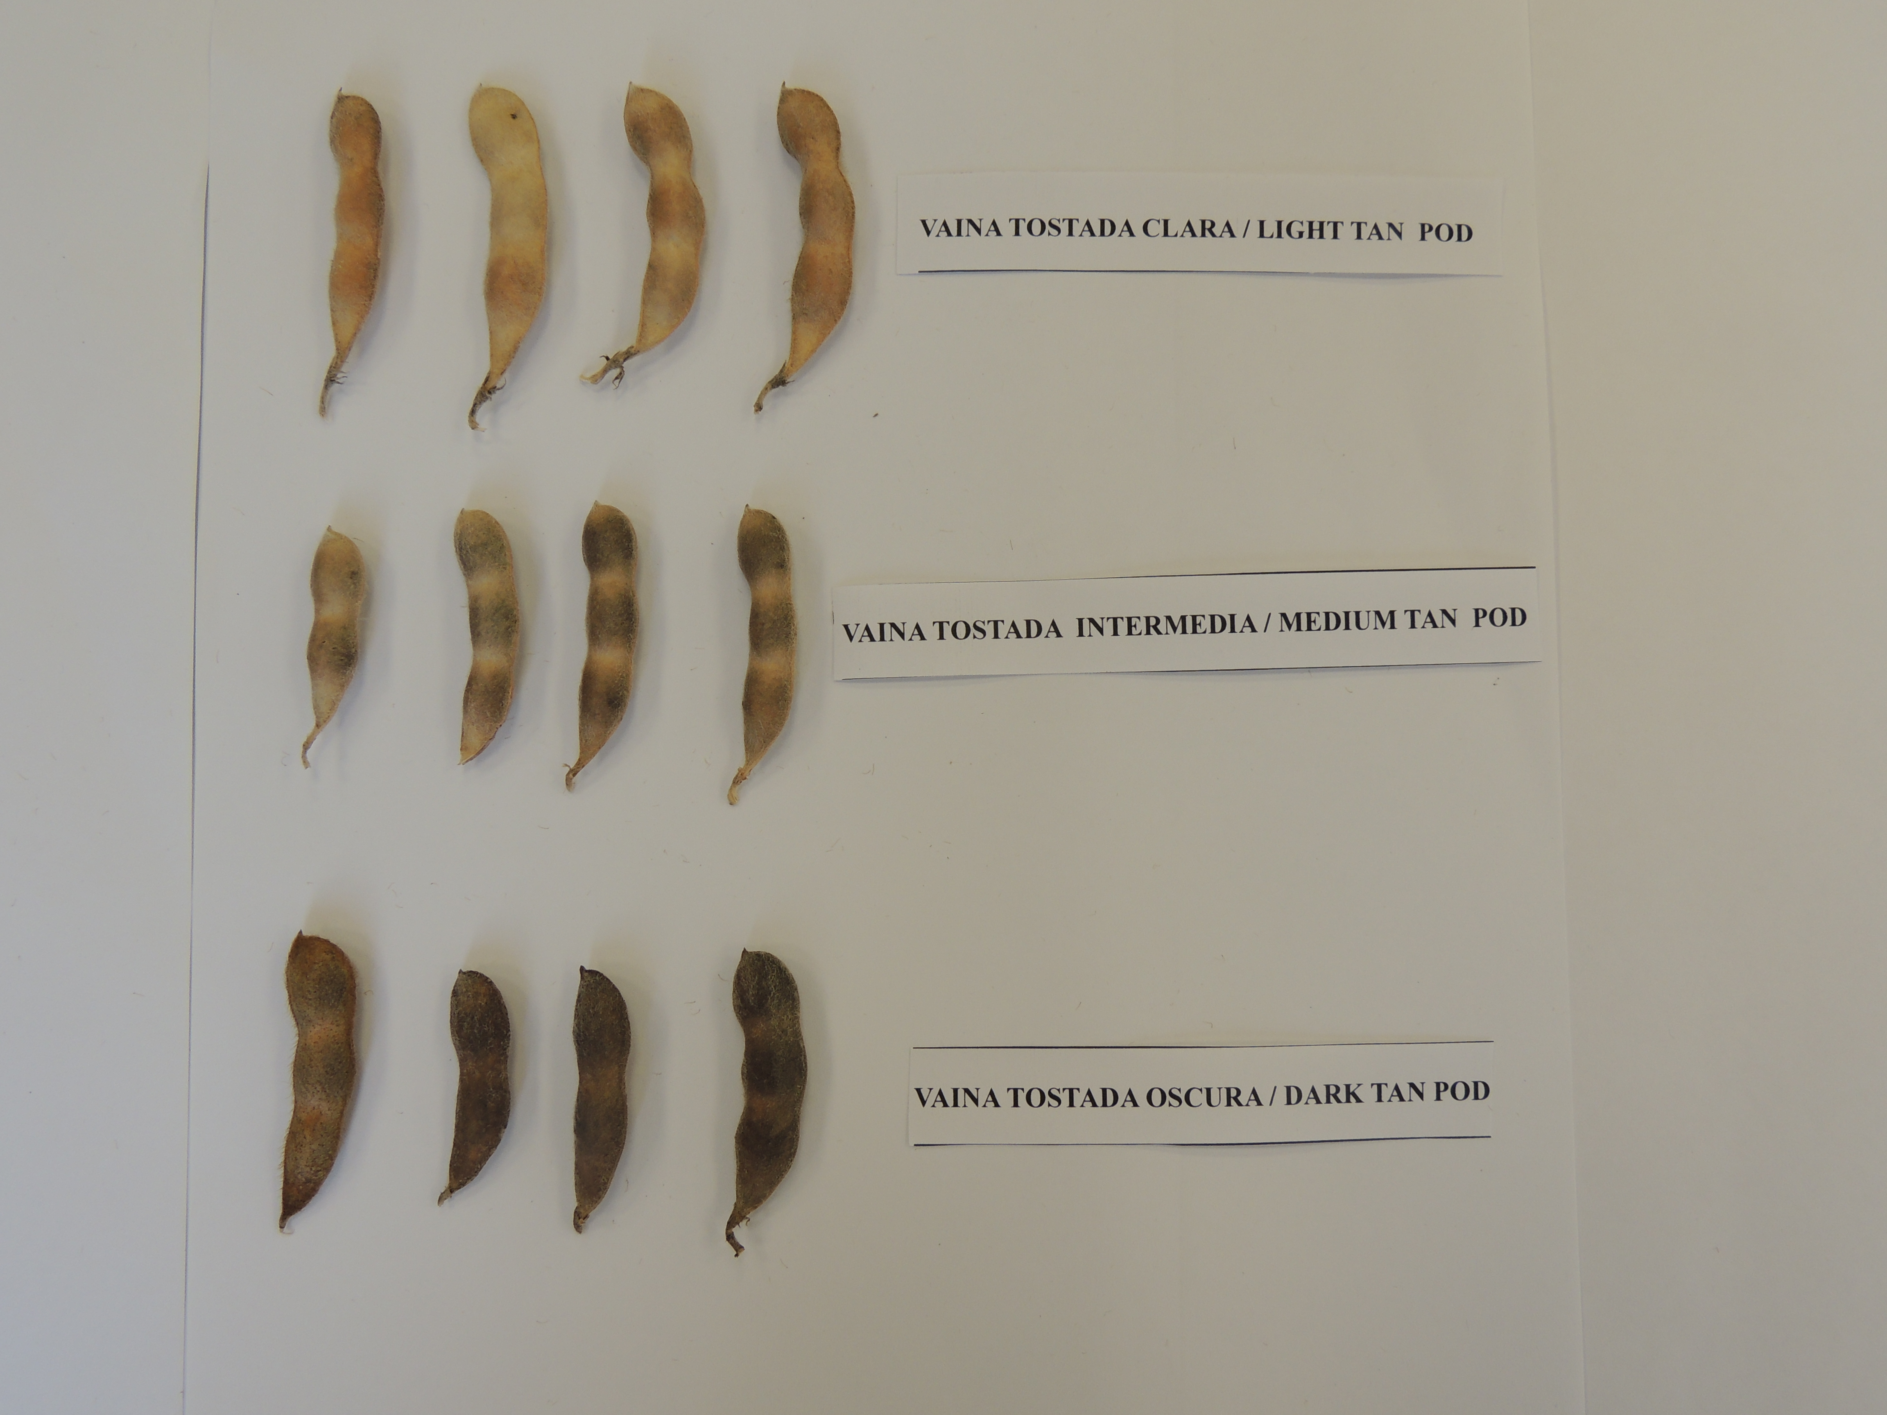
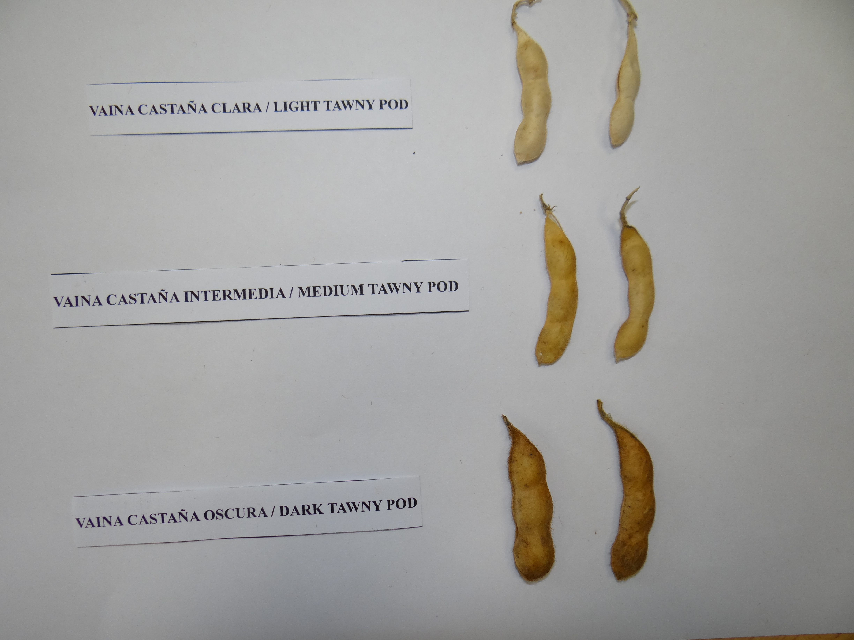

Literature

Taylor, B.H, Caviness C.E, MAY - JUNE 1982, Hilum color variation in soybean seed with Imperfect Black genotype, Crop Science Vol. 22.

Pioli R.N, Morandi E.N. 2003 Morphologic, molecular, and pathogenic characterization of Diaphorthe phaseolorum viariability in the core soybean-producing area of Argentina. Vol 93, Nº 2 136-146.

Dorrance A., Berry S.A.. 2008. Isolation, Storage, Pathotype Characterization, and Evoluation of Resistance for Phytophthora sojae in soybean. Plant Management Network.

Technical Questionnaire

TECHNICAL QUESTIONNAIRE |  | Page {x} of {y} | Reference Number:
 |  |  | Application date:
 |  |  | (not to be filled in by the applicant)
TECHNICAL QUESTIONNAIRE
to be completed in connection with an application for plant breeders’ rights

1. Subject of the Technical Questionnaire
1.1.1 | Botanical Name | Glycine max (L.) Merr.
1.1.2 | Common Name | Soya Bean, Soybean

2. Applicant
Name
Address
Telephone No.
Fax No.
E-mail address
Breeder (if different from applicant)
3. Proposed denomination and breeder’s reference
Proposed denomination
(if available)

Breeder’s reference

TECHNICAL QUESTIONNAIRE |  | Page {x} of {y} | Reference Number:
4. Information on the breeding scheme and propagation of the variety

4.1 Breeding scheme

Variety resulting from:

4.1.1 Crossing

(a) controlled cross [ ]
(please state parent varieties)

(…………………..……………..…) x (……………..…………………..…)
female parent male parent

(b) partially known cross [ ]
(please state known parent variety(ies))

(…………………..……………..…) x (……………..…………………..…)
female parent male parent

(c) unknown cross [ ]

4.1.2 Mutation [ ]
(please state parent variety)

4.1.3 Discovery and development [ ]
(please state where and when discovered and how developed)

4.1.4 Other [ ]
(please provide details)

4.2 Method of propagating the variety

4.2.1 Other [ ]

(please provide details)
..................................................................................................................................................
: :
: :
:................................................................................................................................................:

5. Characteristics of the variety to be indicated (the number in brackets refers to the corresponding characteristic in Test Guidelines; please mark the note which best corresponds).

 | Characteristics | Example Varieties | Note
5.1 (4) | Plant: color of hairs of main stem (on middle third)
 | grey | AYELEN 22 | 1[ ]
 | tawny |  | 2[ ]
5.2 (20) | Seed: peroxidase test (coloration due to peroxidase activity in seed coat)
 | positive (present) | Hood, Hood 75 | 1[ ]
 | mixture (present and absent) |  | 2[ ]
 | negative (absent) | Bragg | 3[ ]

6. Similar varieties and differences from these varieties

Please use the following table and box for comments to provide information on how your candidate variety differs from the variety (or varieties) which, to the best of your knowledge, is (or are) most similar. This information may help the examination authority to conduct its examination of distinctness in a more efficient way.

Denomination(s) of variety(ies) similar to your candidate variety | Characteristic(s) in which your candidate variety differs from the similar variety(ies) | Describe the expression of the characteristic(s) for the similar variety(ies) | Describe the expression of the characteristic(s) for your candidate variety
Example
Comments:

7. Additional information which may help in the examination of the variety

7.1 In addition to the information provided in sections 5 and 6, are there any additional characteristics which may help to distinguish the variety?

Yes [ ] No [ ]

(If yes, please provide details)

7.2 Are there any special conditions for growing the variety or conducting the examination?

Yes [ ] No [ ]

(If yes, please provide details)

7.3 Other information

8. Authorization for release

(a) Does the variety require prior authorization for release under legislation concerning the protection of the environment, human and animal health?

Yes [ ] No [ ]

(b) Has such authorization been obtained?

Yes [ ] No [ ]

If the answer to (b) is yes, please attach a copy of the authorization.

TECHNICAL QUESTIONNAIRE | Page {x} of {y} | Reference Number:
9. Information on plant material to be examined or submitted for examination

9.1 The expression of a characteristic or several characteristics of a variety may be affected by factors, such as pests and disease, chemical treatment (e.g. growth retardants or pesticides), effects of tissue culture, different rootstocks, scions taken from different growth phases of a tree, etc.

9.2 The plant material should not have undergone any treatment which would affect the expression of the characteristics of the variety, unless the competent authorities allow or request such treatment. If the plant material has undergone such treatment, full details of the treatment must be given. In this respect, please indicate below, to the best of your knowledge, if the plant material to be examined has been subjected to:

(a) Microorganisms (e.g. virus, bacteria, phytoplasma) Yes [ ] No [ ]

(b) Chemical treatment (e.g. growth retardant, pesticide) Yes [ ] No [ ]

(c) Tissue culture Yes [ ] No [ ]

(d) Other factors Yes [ ] No [ ]

Please provide details for where you have indicated “yes”.

10. I hereby declare that, to the best of my knowledge, the information provided in this form is correct:

Applicant’s name

Signature Date

[End of document]

* These names were correct at the time of the introduction of these Test Guidelines but may be revised or updated. [Readers are advised to consult the UPOV Code, which can be found on the UPOV Website (www.upov.int), for the latest information.]

