E
TWA/43/26
ORIGINAL: English
DATE: October 14, 2014
INTERNATIONAL UNION FOR THE PROTECTION OF NEW VARIETIES OF PLANTS
Geneva
Technical working party for Agricultural crops
Forty-Third Session
Mar del Plata, Argentina, November 17 to 21, 2014
comments by the technical working party for vegetables (twv) on the draft TEST GUIDELINES FOR CASSAVA
Document prepared by the Office of the Union
Disclaimer: this document does not represent UPOV policies or guidance
At its forty-eighth session, held in Paestum, Italy, from June 23 to 27, 2014, the Technical Working Party for Vegetables (TWV) considered the draft Test Guidelines for Cassava (Manihot esculenta Crantz.) on the basis of document TG/CASSAV(proj.5), as presented by Mr. Ricardo Zanatta (Brazil) and agreed the following (see document TWV/48/43 “Report”, paragraph 94):

1. | second sentence to read “In the case of ornamental varieties, in particular, it may be necessary to use additional characteristics or additional states of expression to those included in the Table of Characteristics in order to examine Distinctness, Uniformity and Stability.”
Table of Chars. | spelling of example varieties not in capitals (only first letters)
Char. 3 | to add (*)
Char. 12 | - to read “Stipule: division”  - state 2 to read “divided”
Char. 13 | to check whether QL (information to be provided at TWA)  Leading Experts: to be indicated as QL
Char. 15 | to read: “Stem: color of bark”
Char. 16 | to replace “cream” with appropriate color  Leading Experts: to replace “cream” by “light yellow”
Char. 17 | to read “Stem: alignment”
Char. 20 | to read: “Stem: color of end branches”  to add (+) and explanation indicating the top of plant  Leading Experts provided illustration:  “To be observed on the top of the plant.”  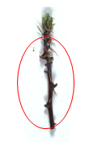
Char. 21 | state 1 to read “absent or short”
Char. 22 | to check wording of state 1 “whitish”  Leading Experts: to keep “whitish”
Char. 23 | to check whether QL until TWA  Leading Experts: to be indicated QL  to delete (+)  state “rough” to have note 2
Chars. 24, 25 | Leading Experts: to keep “cream”
Char. 27 | - to delete MS  - to check whether example varieties and data over years can be provided until TWA or whether the characteristic can be deleted  Leading Experts: no information provided, to be discussed at TWA
Char. 28 | to have notes 1, 3, 5
Ad. 2 | to delete photos but describe where to be observed  Leading Experts: to read “Observations should be made on the upper and lower sides of the apical leaves.”
Ad. 3 | to put the base upside down (i.e. to reverse pictures)
Ad. 7, 8 | to replace photos by drawings  Leading Experts: provided combined illustrations for Ad. 7 and Ad. 8:  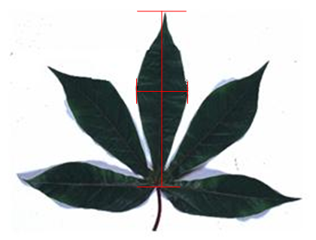
Ad. 11 | to have only one illustration with arrows indicating where to observe  Leading Experts: provided illustration:  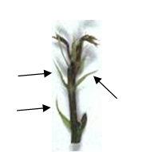
Ad. 12 | to have illustrations of entire and divided stipule only  Leading Experts: no information provided, to be discussed at TWA
Ad. 13 | - to use illustration of one plant only  - to check whether really to be observed on the upper third  Leading Experts: no change
Ad. 14, 15, 16 | to keep only one photo to illustrate what should be observed, but not to illustrate colors  Leading Experts: to keep the first illustrations only
Ad. 18, 19 | to read “The characteristic should be observed at the middle third of the plant. The distance between leaf scars should be observed on two scars in the same alignment.”
Ad. 21 | - to delete column for state 2  - state 1 to read “absent or short”
Ad. 22, 24, 25 | to move reference to website to chapter 9
Ad. 27 | - to delete first sentence.  - to indicate example varieties to determine content  Leading Experts: no information provided, to be discussed at TWA
TQ 5 | to update according to grouping characteristics
TQ 9.3 | to be added

The TWV agreed that the draft Test Guidelines for Cassava, subject to agreement by the TWA at its forty-third session, should be submitted to the Technical Committee for adoption at its fifty-first session, to be held in Geneva from March 23 to 25, 2015 (see document TWV/48/43 “Report”, Annex IV).

[End of document]

