E
TWA/42/29
ORIGINAL: English
DATE: May 14, 2013
INTERNATIONAL UNION FOR THE PROTECTION OF NEW VARIETIES OF PLANTS
Geneva
Technical working party for Agricultural crops
Forty-Second Session
Kyiv, Ukraine, June 17 to 21, 2013
Comments Concerning the Draft Test Guidelines for Wheat
(Document TG/3/12(proj.2))
Document prepared by experts from France
The structure of the document is as follows:

I DRAFT WITH COMMENTS RECEIVED BY THE SUBGROUP
II GENERAL COMMENTS AND PROPOSALS OF NEW OR ADDITIONAL INFORMATION RECEIVED BY THE SUBGROUP
III SUBGROUP PROPOSALS FOR EXAMPLE VARIETIES

[Chapter I “DRAFT WITH COMMENTS RECEIVED BY THE SUBGROUP” only available in pdf version of the document.]

II GENERAL COMMENTS AND PROPOSALS OF NEW OR ADDITIONAL INFORMATION RECEIVED BY THE SUBGROUP

These comments have not been included in TG/3/12 (proj.2). They must be considered by TWA during the meeting:

- ESA proposes to improve the paragraph 3.4.4 with the introduction of specific text concerning the uniformity assessment of uniformity of male sterile parental lines of hybrid varieties.
- Comment from UK about characteristics 18 and 19: We feel that it would be clearer if Characteristics 18 and 19 were re worded completely eg: Bearded – Yes/No. Non Bearded – Scurs present yes/no and scur length

- UK Method for Determination of Phenol reaction
Number of grains per test: 105 untreated grains initially then reduced to a sample of 100 non-germinated grains.
Preparation of grains: Soak in tap water on filter paper for a maximum of 16 hours.
Concentration of solution: 1 per cent Aqueous Phenol
Amount of solution: 4 ml
Place: Laboratory
Light: Out of direct sunlight
Temperature: 15ºC
Time of recording: 4 hours after Phenol application
Scale of recording: As in UPOV TG/3/11
Note: Seeds are placed in a petri dish crease side down so that none are touching (see below).
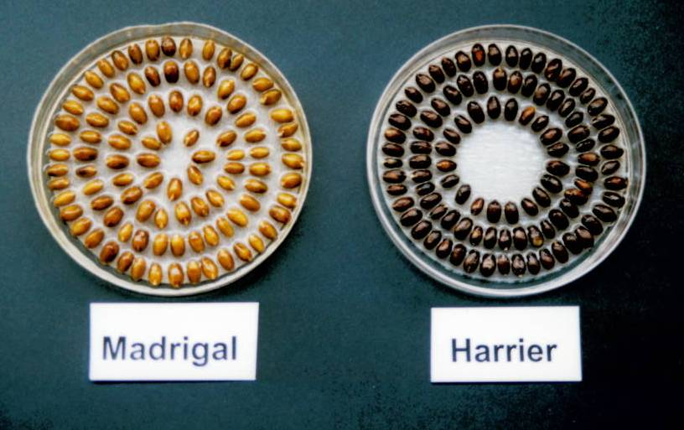

- Comment from Italy on characteristic 19
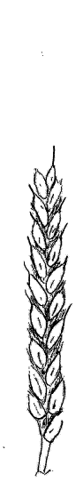 | 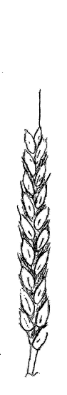 | 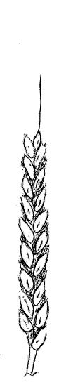 | 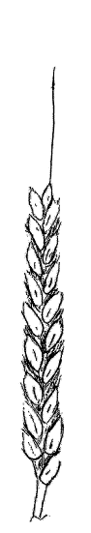 | 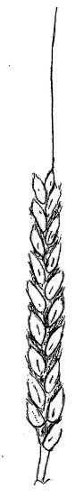
1 | 3 | 5 | 7 | 9
very short | short | medium | long | very long
Very short  Scurs developed with length less then spikelet | Short  Scurs in upper part of ear developed with length more then spikelet but less then the triple one | Medium  Scurs developed with length more then spikelet but less then the triple one | Long  Awns developed with length more then triple one of spikelet but less of the ear | Very long  Awns developed with length more of the ear

- Comments on characteristics not presently introduced in the draft. These characteristics have been proposed by one or more interesting countries during the meeting last year.

- Lowest lemma: beak shape: Characteristic proposed by UK. All the comments received (AT, CZ, ES, FR, JP; and SK ) are not in favor to introduce this characteristic.
UK proposes illustrations:

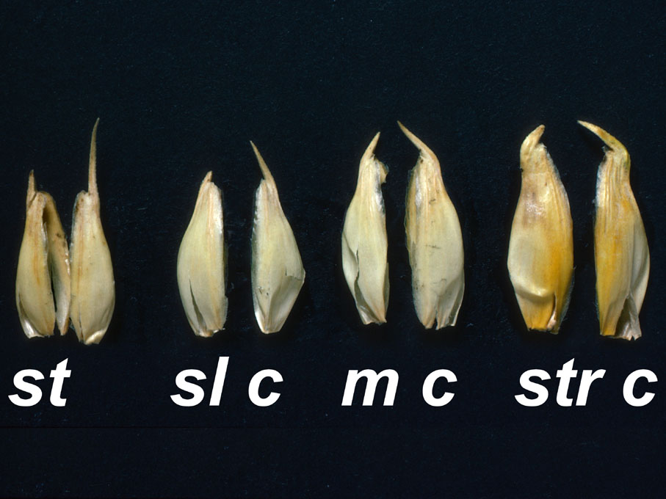

1 3 5 7
straight slightly moderately strongly
curved curved curved

- Lower glume: surface texture (roughness): Characteristic proposed by UK. All the comments received ( AT, CZ, ES, FR, HU, JP, SK) are not in favor to introduce this characteristic.
- Grain: shape: Characteristic proposed by Chili. Among the comments, ES and IT are in favor to introduce this characteristic. AT and CZ would like to have more time to test the usefulness of this characteristic. JP proposes a scale with 4 notes: round, round oval, oval, slender). FR, HU, SK and UK are not in favor to introduce it.
- Characteristics revealed by electrophoresis of proteins: HR and SK are in favor to keep it as supporting characteristics. UK is in favor to keep it because useful in some cases for distinguishing varieties and controlling VCU samples.
AT, CZ, FR, HU and JP are not in favor to keep it in the guidelines.
HR proposes to consider the possibility to introduce DNA polymorphism.

- Example varieties:

The set of varieties listed in the table of characteristics of TG/3/12 (proj.2) corresponds to the proposal which can be made by France. All varieties are winter type varieties except the variety Josselin for the note 3 of characteristic 28.

Comments on that set of example varieties have been received.
They are listed in the table joined in the attached annex with the comment made by France concerning the description of varieties newly proposed.
DE and FI propose that a set of example varieties is established separately. FR supports this proposal. No list of spring example varieties has been submitted.
ESA proposes that regional sets of example varieties are established.

- Proposal about a possible reduction of the number of plants for the assessment of unioformity of B-characteristics

In the current guidelines, the uniformity of these characteristics is assessed on 2000 plants with a population standard at 0.1 % and a probability of acceptance at 95%.
In the draft guidelines , there is a proposal to change the population standard from 0.1 to 0.3%. With this change, it is possible to consider a decrease of the number of plants which have to be examined subject to a control of the evolution of the risks in terms of wrond decisions.The risk to reject a variety which is uniform (risk alpha) according to the fixed rule is not more than 5% (the probality of acceptance is kept at 95%). The risk to accept a varierty which is non uniform (risk beta) varies. Depending on the level of non uniformity of the candidate variety (see the explanations in TGP/8- part II- text plus tables and figures).
When we consider the case of varieties which are just close to the threshold of uniformity but non uniform, the lowest level of quality which will be accepted with a probality of 95% on a sample of 2000 plants is 0.85%.
If the sample size is reduced to 1500 plants, this level becomes 0.97% and with 1000 plants, 1.2% (see the table below)
Depending on the opinión of the expert son the level of these values, the new sample size can be defined.
In order to help the experts to take a decision, it would be interesting to check the same figures in case of species for which the population standard is 1% with a simple size of 100 plants or even less.
It is important to consider the economy which can be done in terms of trial size and time of observation.
New or additional illustrations

New illustration for characteristic 1 (proposal from France)

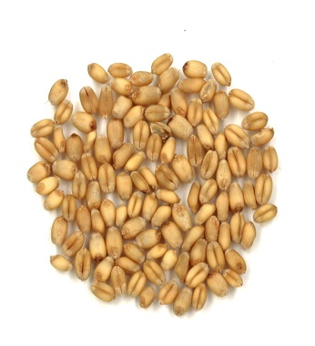 | 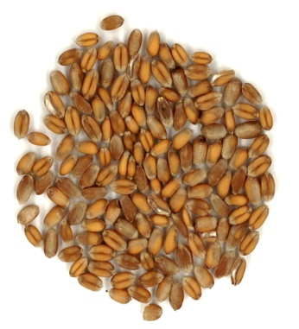
1 | 2 | 3
White | Light red | Dark red

New illustration for characteristic 3 (proposal from France)
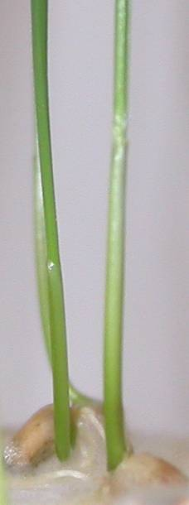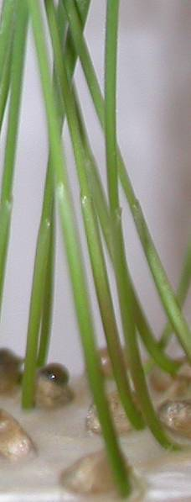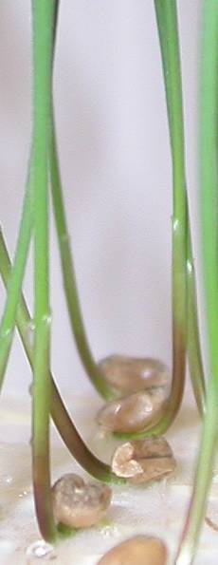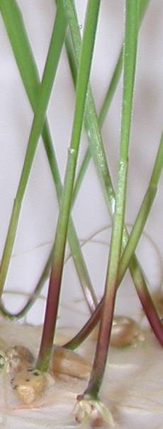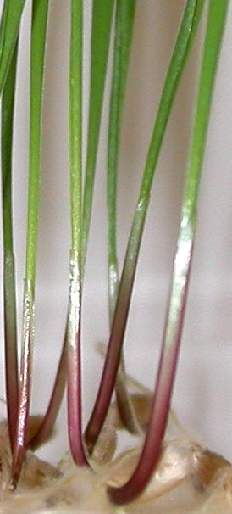
1 3 5 7 9

New drawing for characteristic 4 (proposal from France)
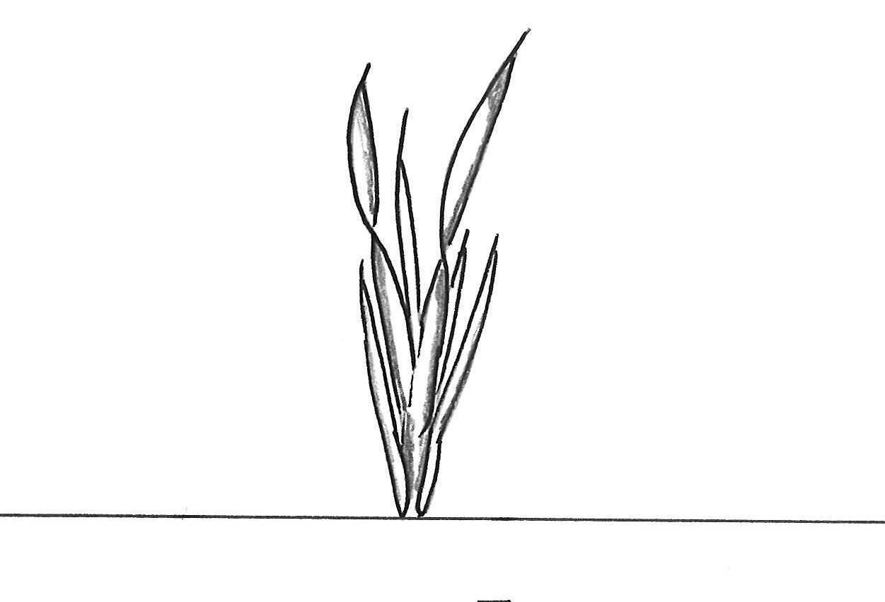 | 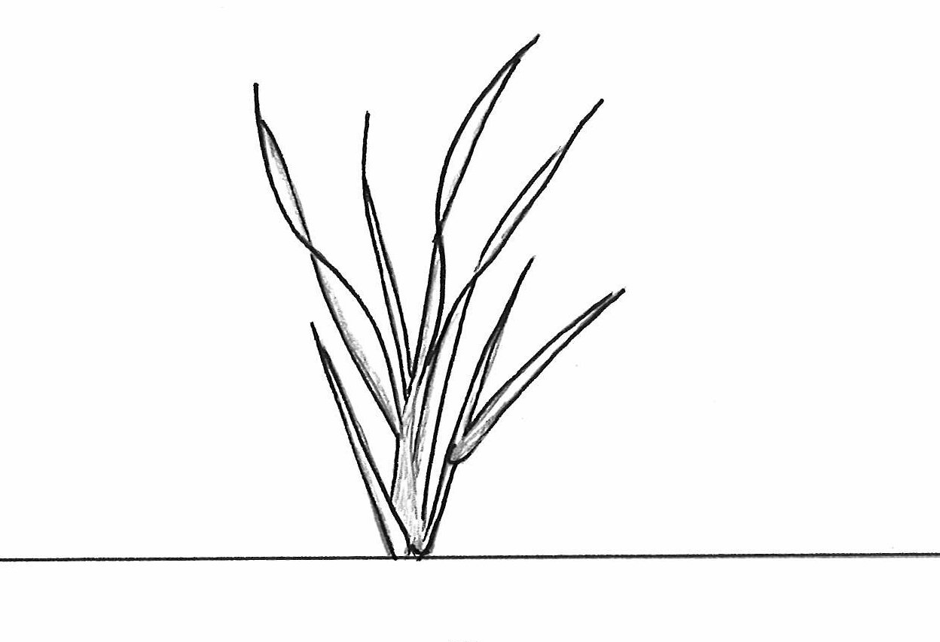 | 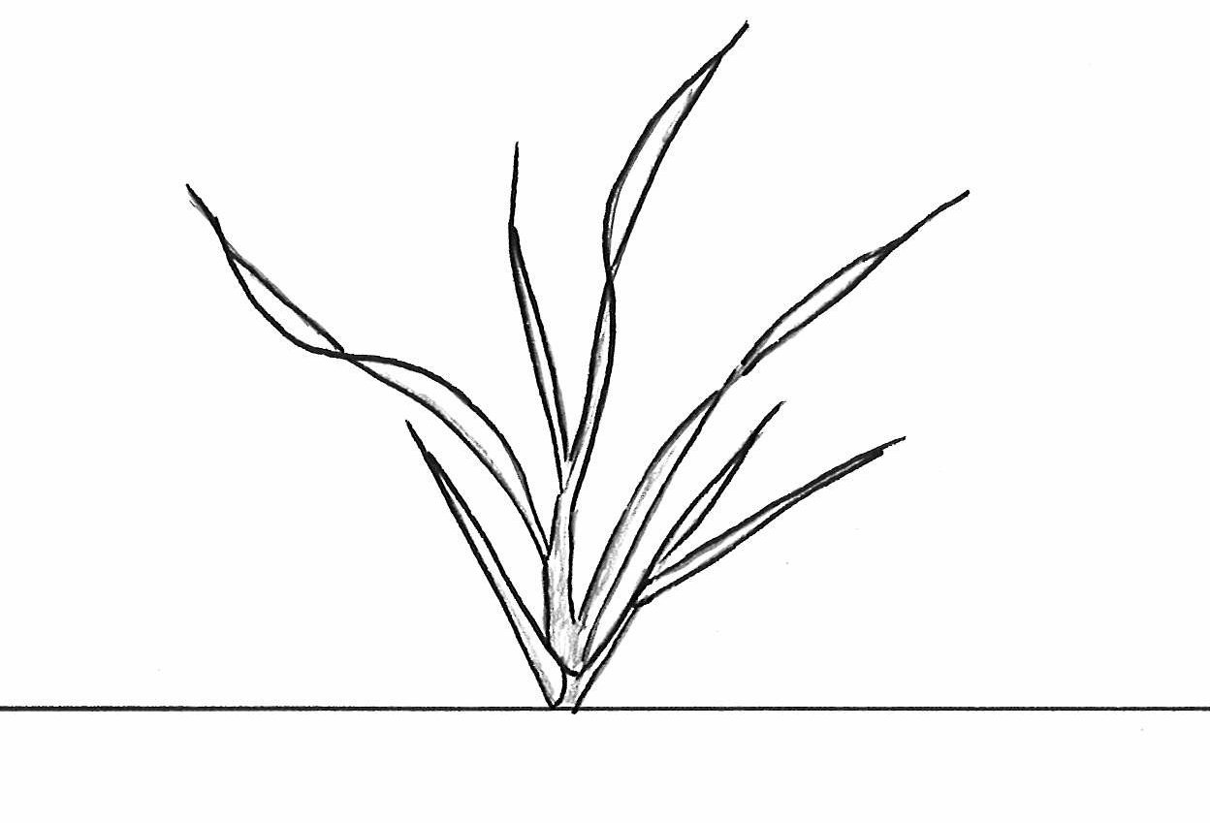 | 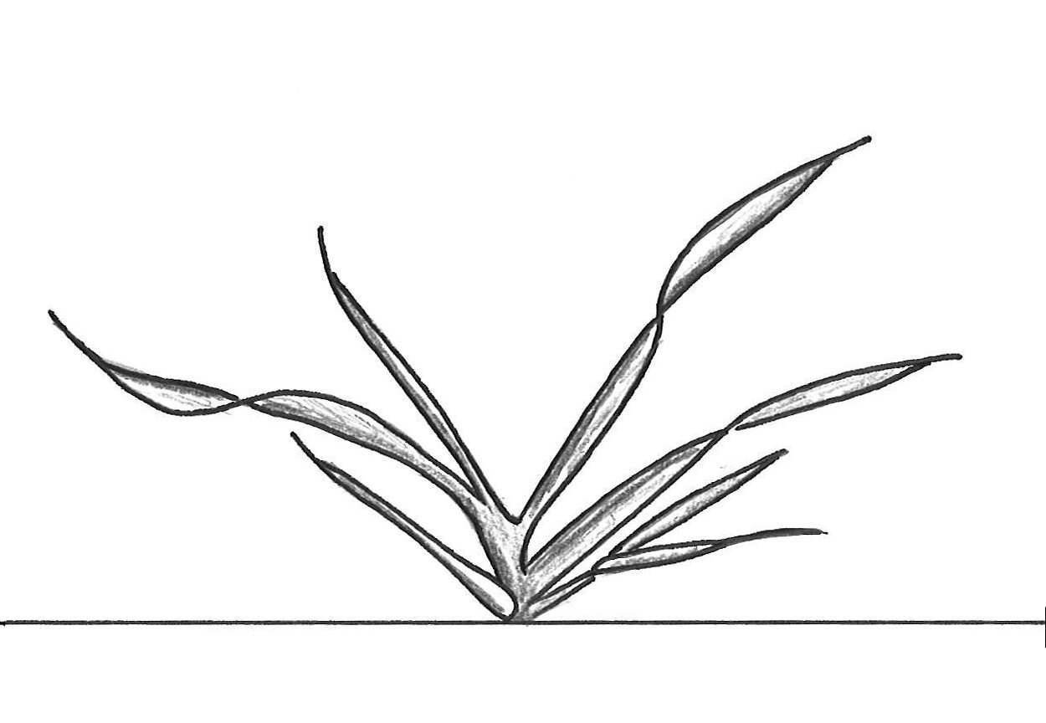 | 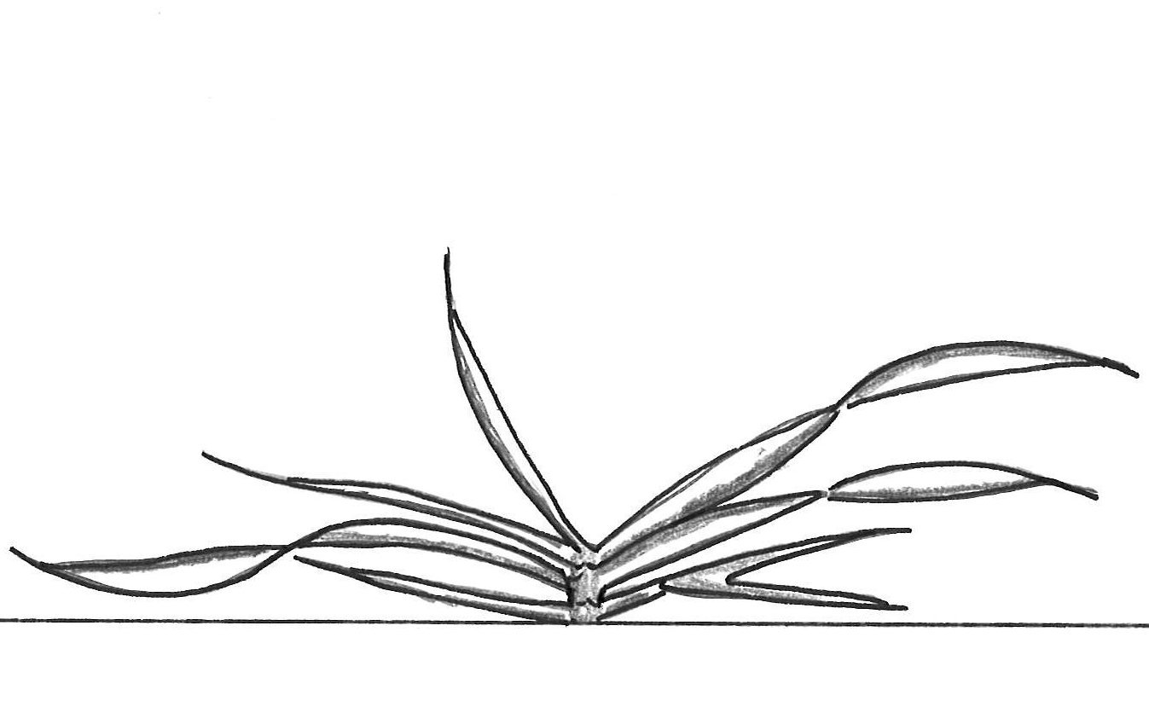
1 | 3 | 5 | 7 | 9
Erect | Semi-erect | Intermediate | Semi-prostrate | Prostrate

New illustration for characteristic 14 (proposal from Slovakia)
Straw: pith in cross section
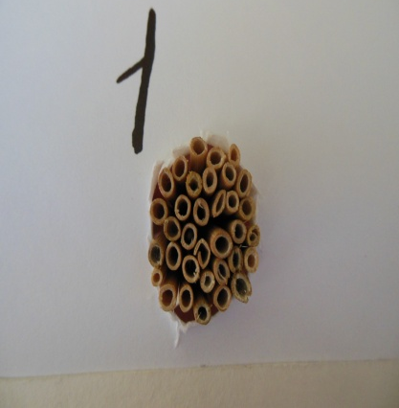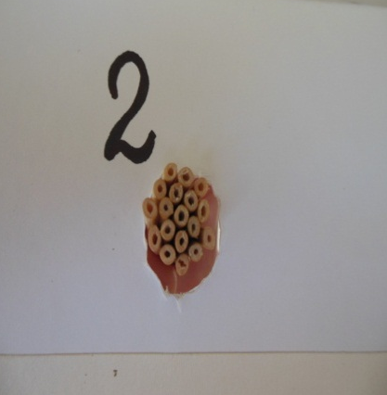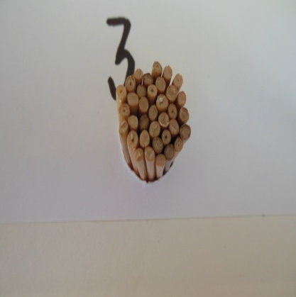
1 | 2 | 3
absent or thin | medium | thick or filled

New illustration for characteristic 15 (proposal from France)
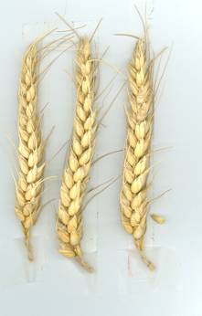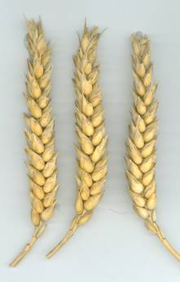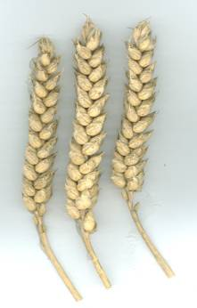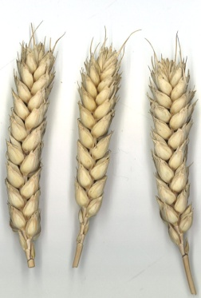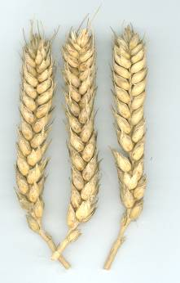
1 | 2 | 3 | 4 | 5
tapering | fusiform | parallel sided | semi clavate | clavate

New illustration for characteristic 15 (proposal from Slovakia)

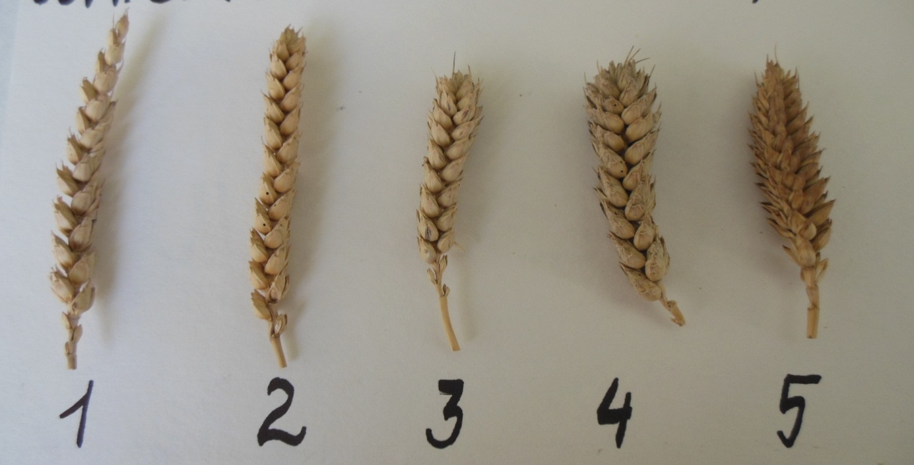

New illustration for characteristic 16 (proposal from United Kingdom)
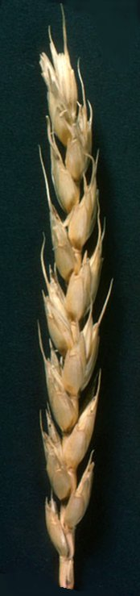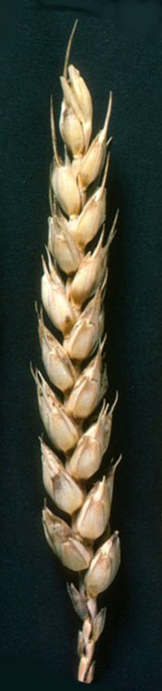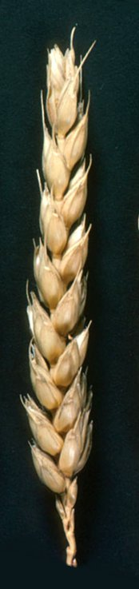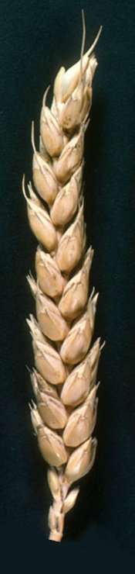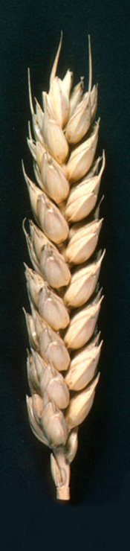
1 3 5 7 9
New illustration for characteristic 20 (proposal from United Kingdom)
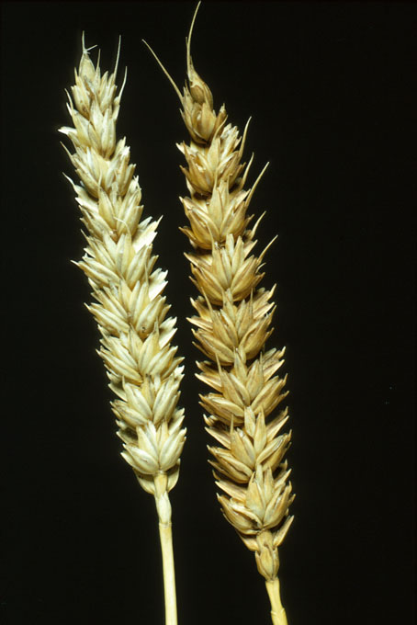
1 2
white coloured
New illustration for characteristic 21 (proposal from Spain)
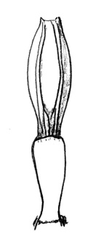
1 | 3 | 5 | 7 | 9
Absent | 1/4 rachis segment | 1/2 rachis segment | 3/4 rachis segment | Full of hairiness
Absent or very weak | Weak | Medium | Strong | Very strong

New illustration for characteristic 26 (proposal from Spain)
1 | 3 | 5 | 7 | 9
Very weak | Weak | Medium | Strong | Very strong

New illustration for characteristic 27 (proposal by United Kingdom)
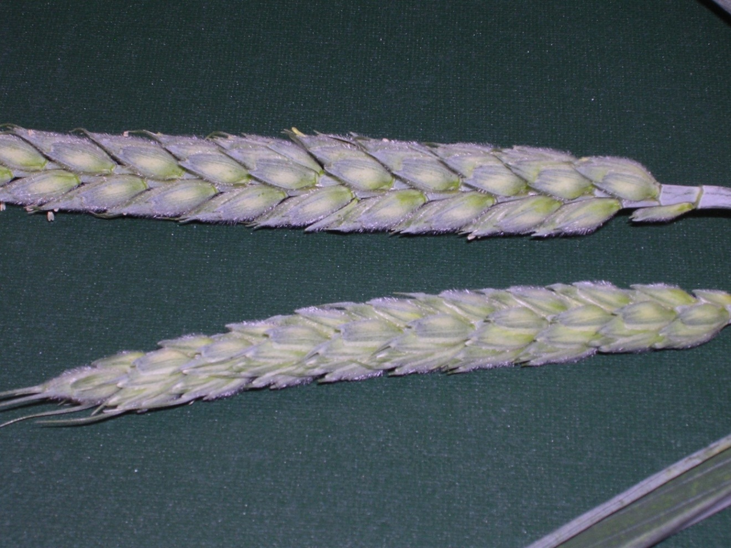

New illustration for characteristic 27 (proposal by France)
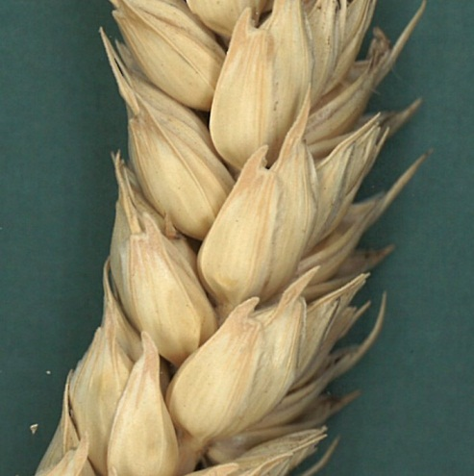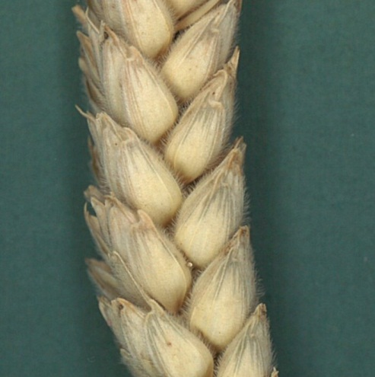
- 9

III SUBGROUP PROPOSALS FOR EXAMPLE VARIETIES

N° UPOV | Characteristics | Note | Country | Example varieties | French remark
1 | Grain : color | 3 | DE proposes | Indigo, Rosso
2 | Seed : coloration with phenol | 1 | DE proposes | Proxy | Proxy = 6
 |  | 9 | DE proposes | Attlass, Siala | Attlass = 3, Siala = 3
3 | Coleoptile : anthocyanin coloration | 5 | DE proposes | Boisseau, Scor | Boisseau = OK,  Scor = 8
 |  | 9 | DE proposes | Pitbull | Pitbull = 7
4 | Plant : growth habit | 1 | SP proposes | Alceo
 |  | 3 | SP proposes | Platero
6 | Flag leaf : anthocyanin coloration of auricles | 1 | SP proposes | Estero
 |  | 3 | SP proposes | Astral
 |  | 5 | SP proposes | Antille
 |  | 7 | SP proposes | Bancal
 |  | 9 | SP proposes | Dollar
7 | Time of emergence | 3 | SP proposes | Gazul
10 | Culm : density of hairiness of uppermost node | 1 | SP proposes | Gazul
 |  | 3 | SP proposes | Nogal
 |  | 5 | SP proposes | Astral
 |  | 7 | SP proposes | Etecho
 |  | 9 | SP proposes | Generale 09
14 | Straw : Pith in cross section | 1 | UK proposes | Alchemy | Alchemy = OK
 |  | 2 | UK proposes | Zircon
 |  | 3 | UK proposes | Forest | Forest = 4
15 | Ear : shape in profile | Tapering | DE proposes | Sansara
 |  | Fusiform | DE proposes | Apache | Apache = OK
 |  | Parallel sided | DE proposes | Arezzo | Arezzo = OK
 |  | Slightly clavate | DE proposes | Viscount | Viscount = à bords parallèles
 |  | Strongly clavate | DE proposes | Aura (cf remarque Finlande) | Aura = demi massue
 |  | Strongly clavate | FR proposes | Vulcanus
19 | Awns or scurs at tip of ear : length | 1 | DE proposes | Laurin | Laurin = 3
 |  | 2 | UK proposes | Claire | Claire = OK
 |  | 3 | UK proposes | Soissons | Soissons = OK
20 | Ear : color | 1 | UK proposes | Claire | Claire = OK
24 | Lower glume : beak length | 9 | SP proposes | Yecora
25 | Lower glume : beak shape | 9 | DE proposes that ex. var. should be checked | Velocity | Velocity = 8
26 | Lower glume : extent of hairiness of internal surface | 3 | SP proposes | Gazul
27 | Lower glume : hairiness on external surface | 1 | IT proposes | Aubusson, Centauro,Soissons
 |  | 1 | SP proposes | Craklin
 |  | 9 | IT proposes | Salmone,Spada, Spartan
 |  | 9 | UK proposes | Gatsby
 |  | 9 | SP proposes | Gazul, Galera
28 | Seasonal type | 1 | UK proposes | Zebedee | Zebedee = OK
 |  | 2 | DE proposes | Buteo or Duxford | Buteo = 1
 |  | 2 | UK proposes | Fidel
 |  | 3 | UK proposes | Ashby
 | Lower glume surface : roughness | 1 Smooth | UK proposes a new character | Cordiale
 |  | 2 Smooth to slightly rough | UK proposes a new character | Viscount or Claire
 |  | 3 Rough | UK proposes a new character | JB Diego

[End of document]

