E
TWA/42/24
ORIGINAL: English
DATE: May 10, 2013
INTERNATIONAL UNION FOR THE PROTECTION OF NEW VARIETIES OF PLANTS
Geneva
Technical working party for Agricultural crops
Forty-Second Session
Kyiv, Ukraine, June 17 to 21, 2013
guidance for drafters of test guidelines
Document prepared by the Office of the Union
The purpose of this document is to report on guidance available on the “TG Drafters’ webpage”, the current status of the project for the development of a web-based TG Template and the new “Summary of information on quantity of plant material required on adopted Test Guidelines”.

The following abbreviations are used in this document:

TC: Technical Committee
TC-EDC: Enlarged Editorial Committee
TWA: Technical Working Party for Agricultural Crops
TWC: Technical Working Party on Automation and Computer Programs
TWF: Technical Working Party for Fruit Crops
TWO: Technical Working Party for Ornamental Plants and Forest Trees
TWPs: Technical Working Parties
TWV: Technical Working Party for Vegetables

The structure of this document is as follows:

GUIDANCE for leading experts ON THE TG Drafters’ webpage 1
Web-based TG Template 2
SUMMARY INFORMATION ON QUANTITY OF PLANT MATERIAL REQUIRED ON ADOPTED TEST GUIDELINES 2

ANNEX I Revised practical guide for drafters (Leading Experts) of UPOV Test Guidelines
ANNEX II Summary information on preparation of Test Guidelines
ANNEX III Sample information provided in the file “Summary of information on quantity of plant material required on adopted Test Guidelines;
ANNEX IV Information provided in the file “Summary of information on quantity of plant material required on adopted Test Guidelines

GUIDANCE for leading experts ON THE TG Drafters’ webpage

The TG Drafters’ webpage provides information for Leading Experts such as the Electronic Test Guidelines template, document TGP/7 Annex 4 (User Notes, Index, Collection of Approved Characteristics), document TGP/14 (Shapes Extract) and the Revised Practical Guide for Drafters (Leading Experts) of UPOV Test Guidelines, as presented in Annex I to this document.

The TG Drafters’ webpage also contains specific information for Leading Experts from each of the different UPOV TWPs, with word versions of draft Test Guidelines discussed during the last session of each TWP, comments by Interested Experts on the draft Test Guidelines in the agenda for the following TWP session and a list with e-mail addresses of the Interested Experts. Summary information on the preparation of Test Guidelines is provided in Annex II to this document.

The TWA is invited to note the information content in the TG Drafters’ webpage of the UPOV website, including the Revised Practical Guide for Drafters (Leading Experts) of UPOV Test Guidelines.

Web-based TG Template

The TC, at its forty-ninth session held in Geneva from March 18 to 20, 2013, received a presentation on the project for the development of a web-based TG Template by the Office of the Union and an expert from Australia and noted that a copy of the presentation was provided in an addendum to document TC/49/3. The Vice Secretary-General reported that it was planned to develop a prototype for testing by interested experts by the end of 2013 (see document TC/49/21 “Report on the Conclusions” paragraph 13).

The TC expressed its support for the project, noting that the template would provide sufficient flexibility for drafters of Test Guidelines to introduce proposals that were not covered by existing standard wording. It noted the comments of the TWPs at their sessions in 2012 on the project and noted the need to retain flexibility in the structure for further development of Test Guidelines by UPOV members.

The TWA is invited to note:

- the plan for the development of a prototype web-based TG Template for testing by interested experts by the end of 2013;

- that the template would provide sufficient flexibility for drafters of Test Guidelines to introduce proposals that were not covered by existing standard wording and would retain flexibility in the structure for further development of Test Guidelines by UPOV members.

SUMMARY INFORMATION ON QUANTITY OF PLANT MATERIAL REQUIRED ON ADOPTED TEST GUIDELINES

The TC, at its forty-seventh session held in Geneva from April 4 to 6, 2011, agreed that the guidance in document TGP/7, GN 7 should be extended to encourage Leading Experts to consider the quantity of plant material required for similar crops in order to seek consistency as far as that was appropriate. In that regard, it agreed that a summary of the following information should be prepared by the Office of the Union for all adopted Test Guidelines and made available to Leading Experts on the TG Drafters’ webpage in order that information on Test Guidelines for similar crops could be presented to the Subgroup of Interested Experts by the Leading Expert (see document TC/47/26 “Report on the Conclusions”, paragraph 57):

(a) Chapter 2.3 Minimum quantity of plant material to be supplied by the applicant
(b) Chapter 3.1 Number of growing cycles
(c) Chapter 3.4.1 Each test should be designed to result in a total of at least X plants
(d) Chapter 4.1.4 Number of plants / parts of plants to be examined for distinctness
(e) Chapter 4.2 Number of plants to be examined for uniformity
(f) Number of plants for special tests (e.g. disease resistance)

The TC, at its forty-ninth session held in Geneva from March 18 to 20, 2013, noted that a summary of information on adopted Test Guidelines would be prepared by the Office of the Union for presentation to the Subgroups of Interested Experts (see document TC/49/41 “Report on the Conclusions”, paragraph 37).

The “Summary information on quantity of plant material required on adopted Test Guidelines” (Summary information) has been provided as a Microsoft Excel file available at the TG Drafters’ webpage on the UPOV website (http://upov.int/resource/en/dus_guidance.html). Data can be filtered or sorted according to the user’s needs, e.g. by Technical Working Party, drafting country, UPOV Code, key word or others.

The Summary information file compiles data from Test Guidelines currently on the UPOV website and also from draft Test Guidelines under discussion in 2013, updated as of April 17, 2013.

Annex III to this document provides an example of the information available in the Summary information file available on the TG Drafters’ webpage of UPOV website.

Annex IV to this document presents the content structure of the Summary information.

The TWA is invited to note the file “Summary information on quantity of plant material required on adopted Test Guidelines” available on the TG Drafters’ webpage of the UPOV website.

[Annexes follow]

REVISED PRACTICAL GUIDE FOR DRAFTERS (LEADING EXPERTS)
OF UPOV TEST GUIDELINES (April 2013)

TEST GUIDELINES FOR DISCUSSION AT THE TECHNICAL WORKING PARTY
(a) Test Guidelines to be re-discussed by the TWP
• Please use the Word version of the draft Test Guidelines prepared by the Office for the TWP session as the starting point for the subsequent year’s draft (it will be correctly formatted) and incorporate all agreed changes as recorded in the TWP report; then repeat the process in (b) and (c) below
• The necessary information is provided in the UPOV website at http://www.upov.int/restricted_temporary/tg/index.html

Unless otherwise agreed at the TWP session, or thereafter by the TWP Chairperson, the timetable for the consideration of draft Test Guidelines by the Technical Working Parties is as follows:

- Draft for circulation to the subgroup of interested experts
Timing: | The deadline for circulation by the Leading Expert to the Interested Experts (Subgroup) is provided in an Annex to the TWP report
Circulation of Subgroup draft by Leading Expert |  | 14 weeks before TWP session
Format: | Draft Test Guidelines should be prepared using the Electronic TG Template (http://www.upov.int/restricted_temporary/tg/index.html)
Sources of information: | Drafter’s webpage (http://www.upov.int/restricted_temporary/tg/index.html):  – adopted TGs in Word format & Word versions of TWP drafts  – TGP/7 Annex 4 “Collection of Approved Characteristics”  – Subgroup of Interested Experts
Circulation and comments: | The Leading Expert (not the Office) circulates the draft to the Interested Experts.  The list of Interested Experts is provided in an Annex to the TWP report and on the Drafter’s webpage. A deadline for comments to be made by the subgroup of Interested Experts is provided in the same Annex to the TWP report.
Comments to be received from Subgroup: |  |  | 10 weeks before TWP session

- Draft for the TWP session
Timing: | The deadline for the draft to be submitted to the Office of the Union (Office) is provided in the Annex to the TWP report
Sending of draft to the Office by the Leading Expert |  |  | 6 weeks
Format: |  | Draft Test Guidelines should be prepared with the Electronic TG Template (http://www.upov.int/restricted_temporary/tg/index.html)  A “clean” version of the draft should be provided: the draft should not contain any comments within the document. If necessary, any comments should be included in an annex or in a separate document  All characteristics in the Table of Characteristics should be numbered in sequence without letters (i.e. 1, 2, 3, not 1, 2, 2(a), 3) (previous numbering can be shown in brackets, e.g. “5. (old 4.)”  Revisions (track change) mode should not be used:  Additions can be indicated (manually) by highlighting & underlining  Deletions can be indicated (manually) by highlighting & strikethrough  Different colored text should not be used to indicate comments / changes  Illustrations should be inserted as shown on the following page
Posting of draft on the website by the Office |  |  | 4 weeks
“Final” drafts: | Drafts at the “final” stage should have no missing information from any chapter of the Test Guidelines and should include, for example, explanations of characteristics contained in the Table of Characteristics and an appropriate set of example varieties.

In cases where either of the deadlines for circulation of the Subgroup draft or for the sending of the draft to the Office by the Leading Expert is not met, the Test Guidelines would be withdrawn from the TWP agenda and the Office would inform the TWP accordingly at the earliest opportunity (i.e. not later than 4 weeks before the TWP session). In those cases where draft Test Guidelines are withdrawn from the TWP agenda because of failure by the Leading Expert to meet the relevant dates, it would be possible for specific matters concerning those Test Guidelines to be discussed at the TWP session. However, to consider specific matters it would be necessary for a document to be provided to the Office at least 6 weeks before the TWP session.

TEST GUIDELINES TO BE SUBMITTED TO THE TECHNICAL COMMITTEE (TC)
• The Office will prepare the draft Test Guidelines for the Enlarged Editorial Committee (TC-EDC) and the TC.
• Please provide all missing information requested in the TWP report by the date specified in the Annex to the TWP report, but please do not provide that information in the form of revised Test Guidelines containing that information.

INSERTING IMAGES INTO THE TEST GUIDELINES

In order to avoid distortions of the illustrations and to minimize the size of the files, please:

(a) – Use: JPG, JPEG or PNG format to reduce the size of the images.
Please do not use: TIF, TIFF, BMP, TGA, PCX or JP2.

(b) – Insert the illustration for each individual state into an individual cell of a table (e.g. by using the command edit; copy and then “paste” or “paste special”). Please see Annex for further guidance.

Example

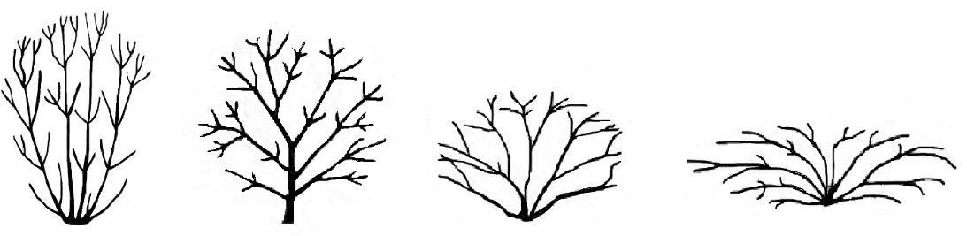
1 | 2 | 3 | 4
upright | semi upright | spreading | horizontal

(c) – When an illustration contains several elements (e.g. drawings, arrows, figures, text, etc.) please, fix them in place, by “grouping” or by incorporating them into an image (e.g. by using the command edit; copy and inserting it using “paste special” and PNG format).

Ad. 21: Corolla: reflexing of lateral lobes
Ad. 22: Corolla: length in relation to width

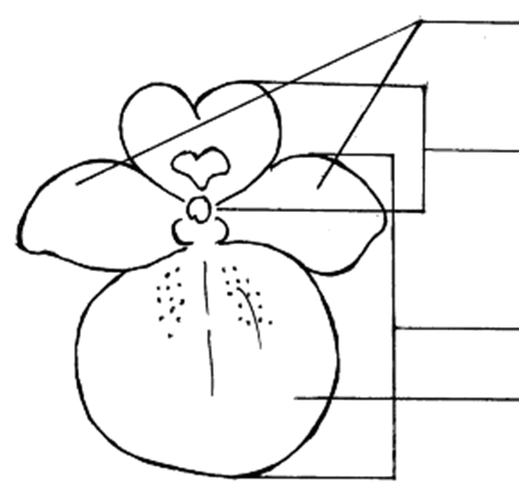 | lateral lobes of corolla  upper lip of corolla  lower lip of corolla  lower lobe of corolla

IN WORD 2003 (AND ALIKE), CHECK THAT THE FOLLOWING SETTINGS ARE ACTIVATED:

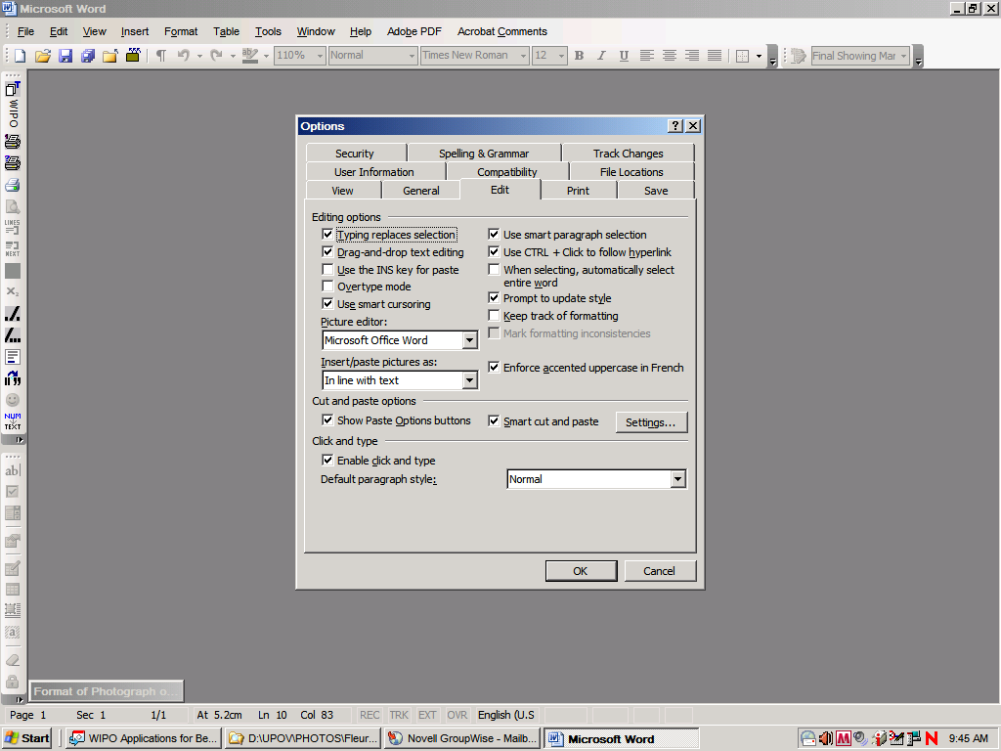
Menu > Tools > Options > Edit

and

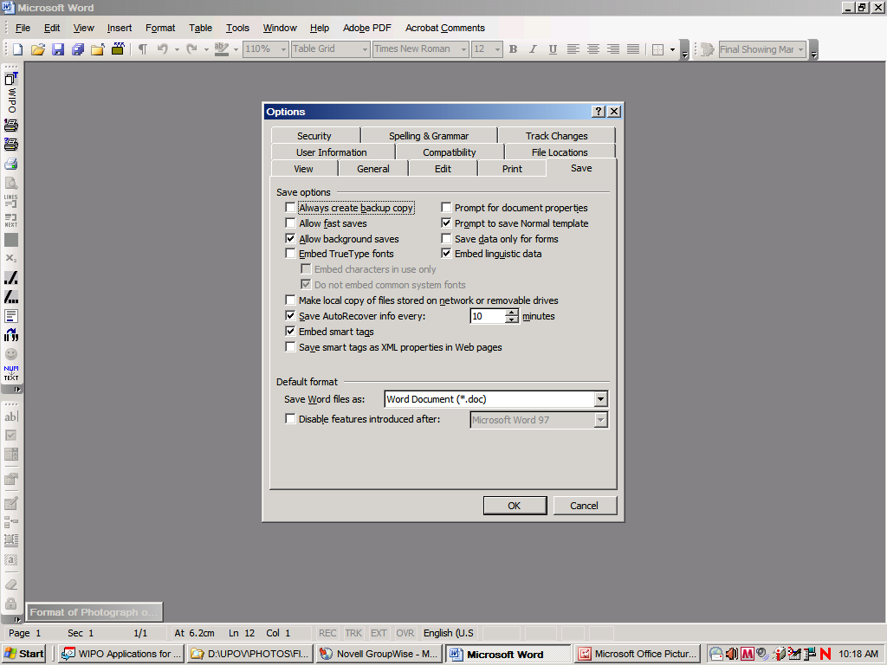

Once the cursor is inside the table, insert the picture (Menu > insert > picture > from file >…).

If the picture is already in a Word document, cut and paste it in the table.

In previous versions of Word (Word 6.0 1995, or Word 97), use “Paste special” and uncheck the option “floating over text” on the right hand in order to paste the picture inside the table.

[Annex II follows]

SUMMARY INFORMATION ON PREPARATION OF TEST GUIDELINES

Test Guidelines Template

Use the Electronic TG Template available on the TG drafters website, including for revision of previously adopted Test Guidelines (http://www.upov.int/restricted_temporary/tg/index.html).

Test Guidelines to be re-discussed by the TWP

Use the Word version prepared by the Office for the TWP session (available on the UPOV website) to incorporate agreed changes as recorded in the TWP report.

Draft for circulation to the subgroup of interested experts

Action | Latest date before the TWP session
Circulation of Subgroup draft by Leading Expert: | 14 weeks
Comments to be received from Subgroup: | 10 weeks
Sending of draft to the Office by the Leading Expert: | 6 weeks
Posting of draft on the website by the Office: | 4 weeks

The deadlines can be consulted in the last Annex of each TWP report.

Circulation of drafts to the Subgroup

The drafts are circulated by the Leading Expert, not the Office. The list of Interested Experts is provided on the Drafter’s webpage.

Draft for the TWP session

A “clean” version of the draft should be provided to the Office of UPOV. The draft should not contain any comments within the document. Any comments should be included in an annex or a separate document.

Do not use track changes mode. Indicate changes manually by highlighting and underlining and strikethrough.

Final drafts for submission to the TC

To be prepared by the Office. Any further information required should not be provided as a revised draft Test Guidelines.

Inserting images into the Test Guidelines

Use JPG, JPEG or PNG format to reduce the size of the images.

In case of the addition of lines, arrows, circles etc., please group your images.

Useful Documents

TGP/7 “Development of Test Guidelines” including
- Procedure for the Introduction and Revision of UPOV Test Guidelines
- Additional Standard Wording (ASW) for the TG template
- Guidance Notes (GN) for the TG template

TGP/14 “Glossary of Terms used in UPOV Documents”
- Shapes and structures
  - standardized wording and illustrations for states of expressions
  - models of grids for use in explanations

[Annex III follows]

SAMPLE Information provided in the file “Summary of information on quantity of plant material required on adopted Test Guidelines”
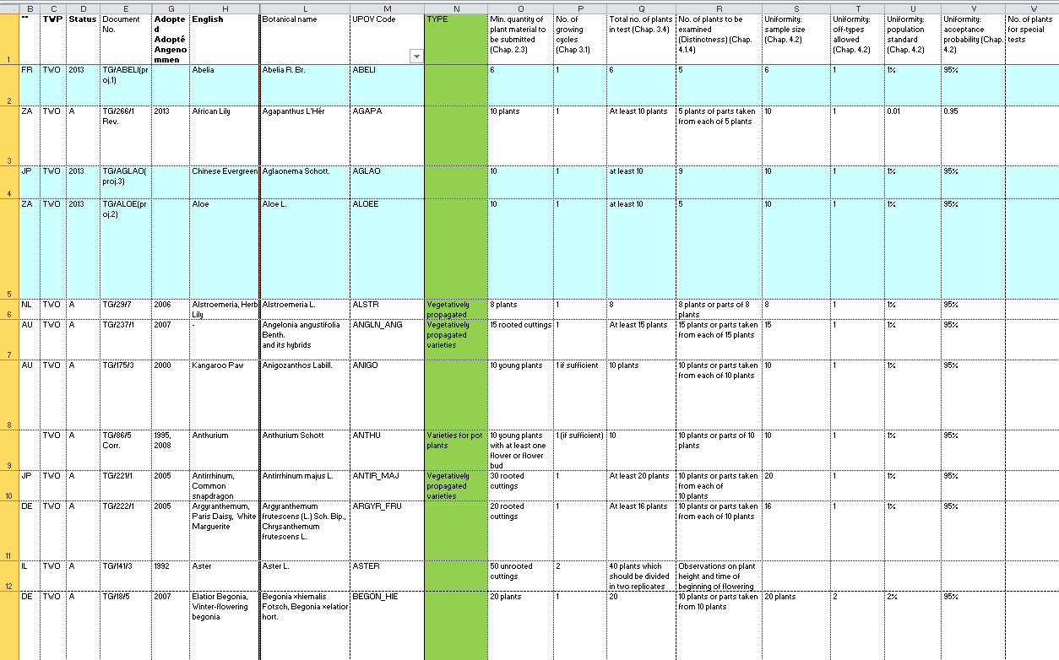
[Annex IV follows]
Information provided in the file “Summary of information on quantity of plant material required on adopted Test Guidelines”

Header | Description
Ref. | UPOV sequential reference number of adopted Test Guidelines
** | ISO Code of drafting UPOV member
TWP | Technical Working Party responsible
Status | A = adopted Test Guidelines;  2013 = to be discussed by TWP in 2013  2013* = possible final draft Test Guideline to be discussed by TWP in 2013  TC/49 = adopted by the Technical Committee at its forty-ninth session, not yet posted on UPOV website subject to complementary information to be provided by Leading Expert
Document No. | Test Guidelines reference constructed as follows: TG / [sequential number allocated to the TG - fixed] / [version number – updated at adoption]  e.g. TG/100/6
Languages | E, F, G, S = English, French, German and Spanish  Tril. = Trilingual (English, French and German)
Adopted | Year of adoption of the Test Guidelines
English | Common names for the species in English (see GENIE database)
Français | Common names for the species in French (see GENIE database)
Deutsch | Common names for the species in German (see GENIE database)
Español | Common names for the species in Spanish (see GENIE database)
Botanical name | Genus or species covered by the Test Guidelines
UPOV Code | A Code System to enhance the usefulness of the UPOV Plant Variety Database by overcoming the problem of synonyms for plant taxa. It attributes each taxa a code according to the UPOV Code System (“UPOV code”). Synonyms for the same plant taxa are attributed the same UPOV code. The UPOV Code System is employed in the GENIE database.
TYPE | Test Guidelines that cover more than one type of plant material (e.g. seed and cuttings) have their respective quantity of plant material presented separately.
Min. quantity of plant material to be submitted (Chap. 2.3) | Material Required: Chapter 2.3: Minimum quantity of plant material to be supplied by the applicant
No. of growing cycles (Chap. 3.1) | Method of Examination: Chapter 3.1: Number of growing cycles
Total no. of plants in test (Chap. 3.4) | Test Design: Chapter 3.4.1: Each test should be designed to result in a total of at least X plants
No. of plants to be examined (Distinctness) (Chap. 4.1.4) | Assessment of Distinctness: Chapter 4.1.4: Number of plants / parts of plants to be examined for distinctness
Uniformity: sample size (Chap. 4.2) | Assessment of Uniformity: Chapter 4.2: Paragraph: 4.2.3: Number of plants to be examined for uniformity
Uniformity: off-types allowed (Chap. 4.2) | Assessment of Uniformity: Chapter 4.2: Paragraph: 4.2.3: number of off-types allowed according to sample size
Uniformity: population standard (Chap. 4.2) | Assessment of Uniformity: Chapter 4.2: Paragraph: 4.2.3: population standard
Uniformity: acceptance probability (Chap. 4.2) | Assessment of Uniformity: Chapter 4.2: Paragraph: 4.2.3: acceptance probability level
No. of plants for special tests | Number of plants for special tests (e.g. disease resistance)
General Notes: | Empty field for notes by user

[End of Annex IV end of document]

