E
TG/SOL_TUB_AND(proj.1)
ORIGINAL: English
DATE: 2013-05-22
INTERNATIONAL UNION FOR THE PROTECTION OF NEW VARIETIES OF PLANTS
Geneva
DRAFT

 | YELLOW POTATO  UPOV Code:  Solanum tuberosum L. spp andigena spp phureja | *

GUIDELINES
FOR THE CONDUCT OF TESTS
FOR DISTINCTNESS, UNIFORMITY AND STABILITY

prepared by an expert from Columbia

to be considered by the
Technical Working Party for Agricultural Crops
at its forty-second session, to be held in Kyiv, Ukraine, from June 17 to 21, 2013

Alternative Names:*

Botanical name | English | French | German | Spanish
Solanum tuberosum L.,  S. tuberosum L. sensu lato | Potato | Pomme de terre | Kartoffel | Papa, Patata

The purpose of these guidelines (“Test Guidelines”) is to elaborate the principles contained in the General Introduction (document TG/1/3), and its associated TGP documents, into detailed practical guidance for the harmonized examination of distinctness, uniformity and stability (DUS) and, in particular, to identify appropriate characteristics for the examination of DUS and production of harmonized variety descriptions.

ASSOCIATED DOCUMENTS
These Test Guidelines should be read in conjunction with the General Introduction and its associated TGP documents.
TABLE OF CONTENTS PAGE

1. Subject of these Test Guidelines 3
2. Material Required 3
3. Method of Examination 3
3.1 Number of Growing Cycles 3
3.2 Testing Place 3
3.3 Conditions for Conducting the Examination 3
3.4 Test Design 3
3.5 Additional Tests 3
4. Assessment of Distinctness, Uniformity and Stability 3
4.1 Distinctness 4
4.2 Uniformity 5
4.3 Stability 5
5. Grouping of Varieties and Organization of the Growing Trial 5
6. Introduction to the Table of Characteristics 5
6.1 Categories of Characteristics 5
6.2 States of Expression and Corresponding Notes 6
6.3 Types of Expression 6
6.4 Example Varieties 6
6.5 Legend 6
7. Table of Characteristics/Tableau des caractères/Merkmalstabelle/Tabla de caracteres 8
8. Explanations on the Table of Characteristics 16
“8.1 Explanations covering several characteristics 16
“8.2 Explanations for individual characteristics 16
9. Literature 24
10. Technical Questionnaire 25

Subject of these Test Guidelines

These Test Guidelines apply to all vegetatively propagated varieties of Solanum tuberosum L. ssp andigena, spp phureja.

Material Required

2.1 The competent authorities decide on the quantity and quality of the plant material required for testing the variety and when and where it is to be delivered. Applicants submitting material from a State other than that in which the testing takes place must ensure that all customs formalities and phytosanitary requirements are complied with.

2.2 The material is to be supplied in the form of tubers, within the size range 35 to 50 mm.

2.3 The minimum quantity of plant material, to be supplied by the applicant, should be:

100 tubers for each year of testing.

2.4 The plant material supplied should be visibly healthy, not lacking in vigor, nor affected by any important pest or disease.

2.5 The plant material should not have undergone any treatment which would affect the expression of the characteristics of the variety, unless the competent authorities allow or request such treatment. If it has been treated, full details of the treatment must be given.

Method of Examination

3.1 Number of Growing Cycles

The minimum duration of tests should normally be two independent growing cycles.

3.2 Testing Place

Tests are normally conducted at one place. In the case of tests conducted at more than one place, guidance is provided in TGP/9 “Examining Distinctness”.

3.3 Conditions for Conducting the Examination

3.3.1 The tests should be carried out under conditions ensuring satisfactory growth for the expression of the relevant characteristics of the variety and for the conduct of the examination.

3.3.2 The optimum stage of development for the assessment of each characteristic is indicated by a number in the second column of the Table of Characteristics. The stages of development denoted by each number are described in Chapter 8.3.

3.4 Test Design

3.4.1 Each test should be designed to result in a total of at least 60 plants, which should be divided between two or more replicates.

3.4.2 The design of the tests should be such that plants or parts of plants may be removed for measurement or counting without prejudice to the observations which must be made up to the end of the growing cycle.

3.5 Additional Tests

Additional tests, for examining relevant characteristics, may be established.

Assessment of Distinctness, Uniformity and Stability

4.1 Distinctness

4.1.1 General Recommendations

It is of particular importance for users of these Test Guidelines to consult the General Introduction prior to making decisions regarding distinctness. However, the following points are provided for elaboration or emphasis in these Test Guidelines.

4.1.2 Consistent Differences

The differences observed between varieties may be so clear that more than one growing cycle is not necessary. In addition, in some circumstances, the influence of the environment is not such that more than a single growing cycle is required to provide assurance that the differences observed between varieties are sufficiently consistent. One means of ensuring that a difference in a characteristic, observed in a growing trial, is sufficiently consistent is to examine the characteristic in at least two independent growing cycles.

4.1.3 Clear Differences

Determining whether a difference between two varieties is clear depends on many factors, and should consider, in particular, the type of expression of the characteristic being examined, i.e. whether it is expressed in a qualitative, quantitative, or pseudo-qualitative manner. Therefore, it is important that users of these Test Guidelines are familiar with the recommendations contained in the General Introduction prior to making decisions regarding distinctness.

4.1.4 Number of Plants / Parts of Plants to be Examined

Unless otherwise indicated, for the purposes of distinctness, all observations on single plants should be made on 60 plants or parts taken from each of 60 plants and any other observations made on all plants in the test, disregarding any off-type plants.

4.1.5 Method of Observation

The recommended method of observing the characteristic for the purposes of distinctness is indicated by the following key in the second column of the Table of Characteristics (see document TGP/9 “Examining Distinctness”, Section 4 “Observation of characteristics”):

MG: single measurement of a group of plants or parts of plants
MS: measurement of a number of individual plants or parts of plants
VG: visual assessment by a single observation of a group of plants or parts of plants
VS: visual assessment by observation of individual plants or parts of plants

Type of observation: visual (V) or measurement (M)

“Visual” observation (V) is an observation made on the basis of the expert’s judgment. For the purposes of this document, “visual” observation refers to the sensory observations of the experts and, therefore, also includes smell, taste and touch. Visual observation includes observations where the expert uses reference points (e.g. diagrams, example varieties, side-by-side comparison) or non-linear charts (e.g. color charts). Measurement (M) is an objective observation against a calibrated, linear scale e.g. using a ruler, weighing scales, colorimeter, dates, counts, etc.

Type of record: for a group of plants (G) or for single, individual plants (S)

For the purposes of distinctness, observations may be recorded as a single record for a group of plants or parts of plants (G), or may be recorded as records for a number of single, individual plants or parts of plants (S). In most cases, “G” provides a single record per variety and it is not possible or necessary to apply statistical methods in a plant-by-plant analysis for the assessment of distinctness.

In cases where more than one method of observing the characteristic is indicated in the Table of Characteristics (e.g. VG/MG), guidance on selecting an appropriate method is provided in document TGP/9, Section 4.2.

4.2 Uniformity

4.2.1 It is of particular importance for users of these Test Guidelines to consult the General Introduction prior to making decisions regarding uniformity. However, the following points are provided for elaboration or emphasis in these Test Guidelines:

4.2.2 For the assessment of uniformity, a population standard of 1 % and an acceptance probability of at least 95 % should be applied. In the case of a sample size of 60 plants, 2 off-types are allowed. In the case of a sample size of 6 plants, 1 off-type is allowed.

4.3 Stability

4.3.1 In practice, it is not usual to perform tests of stability that produce results as certain as those of the testing of distinctness and uniformity. However, experience has demonstrated that, for many types of variety, when a variety has been shown to be uniform, it can also be considered to be stable.

4.3.2 Where appropriate, or in cases of doubt, stability may be further examined by testing a new plant stock to ensure that it exhibits the same characteristics as those shown by the initial material supplied.

Grouping of Varieties and Organization of the Growing Trial

5.1 The selection of varieties of common knowledge to be grown in the trial with the candidate varieties and the way in which these varieties are divided into groups to facilitate the assessment of distinctness are aided by the use of grouping characteristics.

5.2 Grouping characteristics are those in which the documented states of expression, even where produced at different locations, can be used, either individually or in combination with other such characteristics: (a) to select varieties of common knowledge that can be excluded from the growing trial used for examination of distinctness; and (b) to organize the growing trial so that similar varieties are grouped together.

5.3 The following have been agreed as useful grouping characteristics:

- Subespecies: Spp andigena, Spp Phureja, Cross S. Andigena x Phureja x
S tuberosum.
(b) Lightsprout: proportion of blue in anthocyanin coloration of base (characteristic 4)
(c) Flower corolla: intensity of anthocyanin coloration on inner side (characteristic 29)
(d) Flower corolla: proportion of blue in anthocyanin coloration on inner side (characteristic 30)
(e) Plant: time of maturity (characteristic 32)
(f) Tuber: color of skin (characteristic 36)
(g) Tuber: color of flesh (characteristic 28)

5.4 Guidance for the use of grouping characteristics, in the process of examining distinctness, is provided through the General Introduction and document TGP/9 “Examining Distinctness”.

Introduction to the Table of Characteristics

6.1 Categories of Characteristics

6.1.1 Standard Test Guidelines Characteristics

Standard Test Guidelines characteristics are those which are approved by UPOV for examination of DUS and from which members of the Union can select those suitable for their particular circumstances.

6.1.2 Asterisked Characteristics

Asterisked characteristics (denoted by *) are those included in the Test Guidelines which are important for the international harmonization of variety descriptions and should always be examined for DUS and included in the variety description by all members of the Union, except when the state of expression of a preceding characteristic or regional environmental conditions render this inappropriate.

6.2 States of Expression and Corresponding Notes

6.2.1 States of expression are given for each characteristic to define the characteristic and to harmonize descriptions. Each state of expression is allocated a corresponding numerical note for ease of recording of data and for the production and exchange of the description.

6.2.2 In the case of qualitative and pseudo-qualitative characteristics (see Chapter 6.3), all relevant states of expression are presented in the characteristic. However, in the case of quantitative characteristics with 5 or more states, an abbreviated scale may be used to minimize the size of the Table of Characteristics. For example, in the case of a quantitative characteristic with 9 states, the presentation of states of expression in the Test Guidelines may be abbreviated as follows:

State | Note
small | 3
medium | 5
large | 7

However, it should be noted that all of the following 9 states of expression exist to describe varieties and should be used as appropriate:

State | Note
very small | 1
very small to small | 2
small | 3
small to medium | 4
medium | 5
medium to large | 6
large | 7
large to very large | 8
very large | 9

6.2.3 Further explanation of the presentation of states of expression and notes is provided in document TGP/7 “Development of Test Guidelines”.

6.3 Types of Expression

An explanation of the types of expression of characteristics (qualitative, quantitative and pseudo-qualitative) is provided in the General Introduction.

6.4 Example Varieties

Where appropriate, example varieties are provided to clarify the states of expression of each characteristic.

6.5 Legend

(*) Asterisked characteristic – see Chapter 6.1.2

QL Qualitative characteristic – see Chapter 6.3
QN Quantitative characteristic – see Chapter 6.3
PQ Pseudo-qualitative characteristic – see Chapter 6.3

MG, MS, VG, VS – see Chapter 4.1.5

(a)-(d) See Explanations on the Table of Characteristics in Chapter 8.1

(+) See Explanations on the Table of Characteristics in Chapter 8.2.

1-4 See Chapters 3.3.2 and 8.3

Table of Characteristics/Tableau des caractères/Merkmalstabelle/Tabla de caracteres

 |  | English | français | deutsch | español | Example Varieties  Exemples  Beispielssorten  Variedades ejemplo | Note/  Nota
(+) | VG | Lightsprout: size | Germe: taille | Lichtkeim: Größe | Brote: tamaño
QN | (a) | small | petit | klein | pequeño | Criolla yema de huevo | 3
 |  | medium | Moyen | mittel | medio |  | 5
 |  | large | Grand | groß | grande |  | 7
(*)  (+) | VG | Lightsprout: shape | Germe: forme | Lichtkeim: Form | Brote: forma
PQ | (a) | spherical | sphérique | kugelförmig | esférica |  | 1
 |  | ovoid | Ovoïde | eiförmig | ovoide |  | 2
(*)  (+) | VG | Lightsprout: intensity of anthocyanin coloration of base | Germe: intensité de la pigmentation anthocyanique de la base | Lichtkeim: Intensität der Anthocyanfärbung des Unterteils | Brote: intensidad de la pigmentación antociánica de la base
QN | (a) | absent or very weak | absente ou très faible | fehlend oder sehr gering | ausente o muy débil |  | 1
 |  | weak | Faible | gering | débil |  | 3
 |  | medium | moyenne | mittel | media |  | 5
 |  | strong | Forte | stark | fuerte |  | 7
 |  | very strong | très forte | sehr stark | muy fuerte |  | 9
(*)  (+) | VG | Lightsprout: proportion of blue in anthocyanin coloration of base | Germe: proportion de bleu dans la pigmentation anthocyanique de la base | Lichtkeim: Blauanteil der Anthocyanfärbung des Unterteils | Brote: proporción de azul en la pigmentación antociánica de la base
QN | (a) | absent or low | absente ou faible | fehlend oder gering | ausente o baja |  | 1
 |  | medium | moyenne | mittel | media |  | 2
 |  | high | Elevée | hoch | elevada |  | 3
(*)  (+) | VG | Lightsprout: pubescence of base | Germe: pubescence de la base | Lichtkeim: Behaarung des Unterteils | Brote: pubescencia de la base
QN | (a) | absent or very weak | absente ou très faible | fehlend oder sehr gering | ausente o muy débil |  | 1
 |  | weak | faible | gering | débil |  | 3
 |  | medium | moyenne | mittel | media |  | 5
 |  | strong | forte | stark | fuerte |  | 7
 |  | very strong | très forte | sehr stark | muy fuerte |  | 9
(+) | VG | Lightsprout: size of tip in relation to base | Germe: taille du sommet par rapport à la base | Lichtkeim: Größe des Oberteils im Verhältnis zum Unterteil | Brote: tamaño del extremo en relación con la base
QN | (a) | small | petit | klein | pequeño |  | 3
 |  | medium | moyen | mittel | medio |  | 5
 |  | large | grand | groß | grande |  | 7
(+) | VG | Lightsprout: habit of tip | Germe: aspect du sommet | Lichtkeim: Wuchsform des Oberteils | Brote: porte del extremo
QN | (a) | closed | fermé | geschlossen | cerrado |  | 1
 |  | intermediate | intermédiaire | mittel | intermedio |  | 3
 |  | open | ouvert | offen | abierto |  | 5
(+) | VG | Lightsprout: anthocyanin coloration of tip | Germe: pigmentation anthocyanique du sommet | Lichtkeim: Anthocyanfärbung des Oberteils | Brote: pigmentación antociánica del extremo
QN | (a) | absent or very weak | absente ou très faible | fehlend oder sehr gering | ausente o muy débil |  | 1
 |  | weak | faible | gering | débil |  | 3
 |  | medium | moyenne | mittel | media |  | 5
 |  | strong | forte | stark | fuerte |  | 7
 |  | very strong | très forte | sehr stark | muy fuerte |  | 9
(+) | VG | Lightsprout: pubescence of tip | Germe: pubescence du sommet | Lichtkeim: Behaarung des Oberteils | Brote: pubescencia del extremo
QN | (a) | absent or very weak | absente ou très faible | fehlend oder sehr gering | ausente o muy débil |  | 1
 |  | weak | faible | gering | débil |  | 3
 |  | medium | moyenne | mittel | media |  | 5
 |  | strong | forte | stark | fuerte |  | 7
 |  | very strong | très forte | sehr stark | muy fuerte |  | 9
(*)  (+) | VG | Lightsprout: number of root tips | Germe: nombre de radicelles | Lichtkeim: Anzahl der Wurzelhöcker | Brote: número de radículas
QN | (a) | few | petit | gering | bajo |  | 3
 |  | medium | moyen | mittel | medio |  | 5
 |  | many | grand | groß | alto |  | 7
(+) | VG | Lightsprout: length of lateral shoots | Germe: longueur des ramifications latérales | Lichtkeim: Länge der Seitentriebe | Brote: longitud de las ramificaciones laterales
QN | (a) | short | courtes | kurz | cortas |  | 3
 |  | medium | moyennes | mittel | medias |  | 5
 |  | long | longues | lang | largas |  | 7
(+) | 1  VG | Plant: foliage structure | Plante: structure du feuillage | Pflanze: Laubstruktur | Planta: estructura del follaje
QN |  | stem type | type à tiges | Stengeltyp | tipo ramificado |  | 1
 |  | intermediate type | type intermédiaire | Zwischentyp | tipo intermedio |  | 2
 |  | leaf type | type à feuilles | Blatttyp | tipo foliar |  | 3
(*)  (+) | 1  VG | Plant: growth habit | Plante: port | Pflanze: Wuchsform | Planta: porte
QN |  | upright | dressé | aufrecht | erecto |  | 3
 |  | semi-upright | semi-dressé | halbaufrecht | semierecto |  | 5
 |  | spreading | étalé | breitwüchsig | rastrero |  | 7
(*)  (+) | 1  VG | Stem: anthocyanin coloration | Tige: pigmentation anthocyanique | Stengel: Anthocyanfärbung | Tallo: pigmentación antociánica
QN |  | absent or very weak | absente ou très faible | fehlend oder sehr gering | ausente o muy débil |  | 1
 |  | weak | faible | gering | débil |  | 3
 |  | medium | moyenne | mittel | media |  | 5
 |  | strong | forte | stark | fuerte |  | 7
15  (*)  (+) | 1  VG | Stem: Fly Presence of wings | Tige: | Stengel: | Tallo: presencia de alas
QN |  | absent |  |  | Ausentes |  | 1
 |  | present |  |  | Presentes |  | 9
16.  (*)  (+) | 1  VG | stem: ondulation of wings | Tige: | Stengel: | Tallo: ondulacion de las alas
QN |  | absent or very weak | absente ou très faible | fehlend oder sehr gering | ausente o muy débil |  | 1
 |  | weak | faible | gering | débil |  | 3
 |  | medium | moyenne | mittel | media |  | 5
 |  | strong | forte | stark | fuerte |  | 7
(+) | 1  VG | Leaf: openness | Feuille: ouverture | Blatt: Offenheit | Hoja: apertura
QN | (b) | closed | fermée | geschlossen | cerrada |  | 1
 |  | intermediate | intermédiaire | mittel | intermedia |  | 3
 |  | open | ouverte | offen | abierta |  | 5
(+) | 1  VG | Leaf: presence of secondary leaflets | Feuille: présence de folioles secondaires | Blatt: Vorhandensein von sekundären Blattfiedern | Hoja: presencia de folíolos secundarios
QN | (b) | weak | faible | gering | débil |  | 3
 |  | medium | moyenne | mittel | media |  | 5
 |  | strong | forte | stark | fuerte |  | 7
(+) | VG | Leaf: green color | Feuille: couleur verte | Blatt: Grünfärbung | Hoja: color verde
QN | (c) | light | légère | hell | claro |  | 3
 |  | medium | moyenne | mittel | medio |  | 5
 |  | dark | foncée | dunkel | oscuro |  | 7
(+) | VG | Leaf: anthocyanin coloration on midrib of upper side | Feuille: pigmentation anthocyanique sur la nervure médiane de la face supérieure | Blatt: Anthocyanfärbung an der Mittelrippe der Oberseite | Hoja: pigmentación antociánica del nervio central  del haz
QN | (c) | absent or very weak | absente ou très faible | fehlend oder sehr gering | ausente o muy débil |  | 1
 |  | weak | faible | gering | débil |  | 3
 |  | medium | moyenne | mittel | media |  | 5
 |  | strong | forte | stark | fuerte |  | 7
 |  | very strong | très forte | sehr stark | muy fuerte |  | 9
21.  (+) | VG | Second pair of lateral leaflets: size | Seconde paire de folioles latérales: taille | Zweites Paar Seitenblattfiedern: Größe | Segundo par de folíolos laterales: tamaño
QN | (b) | very small | très petite | sehr klein | muy pequeño |  | 1
 |  | small | petite | klein | pequeño |  | 3
 |  | medium | moyenne | mittel | medio |  | 5
 |  | large | grande | groß | grande |  | 7
 |  | very large | très grande | sehr groß | muy grande |  | 9
(+) | VG | Second pair of lateral leaflets: width in relation to length | Seconde paire de folioles latérales: largeur par rapport à la longueur | Zweites Paar Seitenblattfiedern: Breite im Verhältnis zur Länge | Segundo par de folíolos laterales: anchura en relación con la longitud
QN | (c) | narrow | étroite | schmal | Estrecha |  | 3
 |  | medium | moyenne | mittel | Media |  | 5
 |  | broad | large | breit | Ancha |  | 7
(+) | VG | Terminal and lateral leaflets: frequency of coalescence | Folioles terminales et latérales: fréquence de la coalescence | End- und Seitenblattfiedern: Häufigkeit von Verwachsungen | Folíolos terminales y laterales: frecuencia de la coalescencia
QN | (c) | absent or very low | absente ou très faible | fehlend oder sehr gering | ausente o muy baja |  | 1
 |  | low | faible | gering | Baja |  | 3
 |  | medium | moyenne | mittel | Media |  | 5
 |  | high | élevée | hoch | Elevada |  | 7
 |  | very high | très élevée | sehr hoch | muy elevada |  | 9
(+) | VG | Leaflet: waviness of margin | Foliole: ondulation du bord | Blattfieder: Randwellung | Folíolo: ondulación del borde
QN | (c) | absent or very weak | absente ou très faible | fehlend oder sehr gering | ausente o muy débil |  | 1
 |  | weak | faible | gering | Débil |  | 3
 |  | medium | moyenne | mittel | Media |  | 5
 |  | strong | forte | stark | Fuerte |  | 7
 |  | very strong | très forte | sehr stark | muy fuerte |  | 9
25.  (+) | VG | Leaflet: depth of veins | Foliole: profondeur des nervures | Blattfieder: Tiefe der Adern | Folíolo: profundidad de los nervios
QN | (c) | shallow | peu profondes | flach | poco profundos |  | 3
 |  | medium | moyennes | mittel | Medios |  | 5
 |  | deep | profondes | tief | Profundos |  | 7
26.  (+) | VG | Leaflet: glossiness of the upperside | Foliole: brillance de la face supérieure | Blattfieder: Glanz der Oberseite | Folíolo: brillo del haz
QN | (c) | dull | mâte | matt | Mate |  | 3
 |  | medium | moyenne | mittel | Medio |  | 5
 |  | glossy | brillante | glänzend | Brillante
(+)  PEND | 1  VG | Leaflet: pubescence of blade at apical rosette | Foliole: pubescence du limbe à la rosette apicale | Blattfieder: Behaarung der Blattspreite an der Spitzenrosette | Folíolo: pubescencia del haz en la roseta apical
QL | (c) | absent | absente | fehlend | Ausente |  | 1
 |  | present | présente | vorhanden | Presente |  | 9
(+) | 1  VG | Flower bud: anthocyanin coloration | Bouton: pigmentation anthocyanique | Blütenknospe: Anthocyanfärbung | Botón floral: pigmentación antociánica
QN |  | absent or very weak | absente ou très faible | fehlend oder sehr gering | ausente o muy débil |  | 1
 |  | weak | faible | gering | Débil |  | 3
 |  | medium | moyenne | mittel | Media |  | 5
 |  | strong | forte | stark | Fuerte |  | 7
 |  | very strong | très forte | sehr stark | muy fuerte |  | 9
 | 2  VG | Plant: height | Plante: hauteur | Pflanze: Höhe | Planta: altura
QN |  | very short | très courte | sehr niedrig | muy corta |  | 1
 |  | short | courte | niedrig | Corta |  | 3
 |  | medium | moyenne | mittel | Media |  | 5
 |  | tall | haute | hoch | Larga |  | 7
 |  | very tall | très haute | sehr hoch | muy larga |  | 9
(*) | 2  VG | Plant: frequency of flowers | Plante: fréquence des fleurs | Pflanze: Häufigkeit von Blüten | Planta: frecuencia de flores
QN |  | absent or very low | absente ou très faible | fehlend oder sehr gering | ausente o muy baja |  | 1
 |  | low | faible | gering | Baja |  | 3
 |  | medium | moyenne | mittel | Media |  | 5
 |  | high | élevée | hoch | Elevada |  | 7
 |  | very high | très élevée | sehr hoch | muy elevada |  | 9
(+) | 2  VG | Inflorescence: size | Inflorescence: taille | Blütenstand: Größe | Inflorescencia: tamaño
QN |  | small | petite | klein | Pequeña |  | 3
 |  | medium | moyenne | mittel | Media |  | 5
 |  | large | grande | groß | Grande |  | 7
(+) | 2  VG | Inflorescence: anthocyanin coloration on peduncle | Inflorescence: pigmentation anthocyanique sur le pédoncule | Blütenstand: Anthocyanfärbung am Stiel | Inflorescencia: pigmentación antociánica del pedúnculo
QN |  | absent or very weak | absente ou très faible | fehlend oder sehr gering | ausente o muy débil |  | 1
 |  | weak | faible | gering | Débil |  | 3
 |  | medium | moyenne | mittel | Media |  | 5
 |  | strong | forte | stark | Fuerte |  | 7
 |  | very strong | très forte | sehr stark | muy fuerte |  | 9
(+) | 2  VG | Flower corolla: size | Corolle de la fleur: taille | Blütenkrone: Größe | Corola de la flor: tamaño
QN |  | small | petite | klein | Pequeña |  | 3
 |  | medium | moyenne | mittel | Media |  | 5
 |  | large | grande | groß | Grande |  | 7
(*)  (+) | 2  VG | Flower corolla: intensity of anthocyanin coloration on inner side | Corolle de la fleur: intensité de la pigmentation anthocyanique sur la face intérieure | Blütenkrone: Intensität der Anthocyanfärbung an der Innenseite | Corola de la flor: intensidad de la pigmentación antociánica de la cara interna
QN | (d) | absent or very weak | absente ou très faible | fehlend oder sehr gering | ausente o muy débil |  | 1
 |  | weak | faible | gering | Débil |  | 3
 |  | medium | moyenne | mittel | Media |  | 5
 |  | strong | forte | stark | Fuerte |  | 7
 |  | very strong | très forte | sehr stark | muy fuerte |  | 9
(*)  (+) | 2  VG | Flower corolla: proportion of blue in anthocyanin coloration on inner side | Corolle de la fleur: proportion de bleu dans la pigmentation anthocyanique sur la face intérieure | Blütenkrone: Blauanteil der Anthocyanfärbung an der Innenseite | Corola de la flor: proporción de azul en la pigmentación antociánica de la cara interna
QN | (d) | absent or low | absente ou faible | fehlend oder gering | ausente o baja |  | 1
 |  | medium | moyenne | mittel | Media |  | 2
 |  | high | forte | hoch | Elevada |  | 3
(*)  (+) | 2  VG | Flower corolla: extent of anthocyanin coloration on inner side | Corolle de la fleur: étendue de la pigmentation anthocyanique sur la face intérieure | Blütenkrone: Ausdehnung der Anthocyanfärbung an der Innenseite | Corola de la flor: extensión de la pigmentación antociánica de la cara interna
QN | (d) | absent or very small | absente ou très petite | fehlend oder sehr gering | ausente o muy pequeña |  | 1
 |  | small | petite | gering | Pequeña |  | 3
 |  | medium | moyenne | mittel | Media |  | 5
 |  | large | grande | groß | Grande |  | 7
 |  | very large | très grande | sehr groß | muy grande |  | 9
(*)  (+) | 3  MG | Plant: time of maturity | Plante: époque de maturité | Pflanze: Zeitpunkt der Reife | Planta: época de madurez
QN |  | very early | très précoce | sehr früh | muy temprana |  | 1
 |  | early | précoce | früh | Temprana |  | 3
 |  | medium | moyenne | mittel | Media |  | 5
(*)  (+)  PEND | 4  VG | Root:Frecuency of secundari stolons |  |  | Raiz Estolones secundarios
QN |  | absent or very low | absente ou très faible | fehlend oder sehr gering | ausente o muy baja |  | 1
 |  | low | faible | gering | Baja |  | 3
 |  | medium | moyenne | mittel | Media |  | 5
 |  | high | élevée | hoch | Elevada |  | 7
 |  | very high | très élevée | sehr hoch | muy elevada |  | 9
(*)  (+) | 4  VG | Tuber: shape | Tubercule: forme | Knolle: Form | Tubérculo: forma
QN |  | round | Arrondie | rund | Redondo |  | 1
 |  | short-oval | oblongue courte | rundoval | ovalado corto |  | 2
 |  | oval | Oblongue | oval | Ovalado |  | 3
 |  | long-oval | oblongue allongée | langoval | ovalado largo |  | 4
 |  | long | Allongée | lang | Alargado |  | 5
 |  | very long | très allongée | sehr lang | muy alargado |  | 6
 | 4  VG | Tuber: depth of eyes | Tubercule: profondeur des yeux | Knolle: Augentiefe | Tubérculo: profundidad de los ojos
QN |  | very shallow | très peu profonds | sehr flach | muy poco profundos |  | 1
 |  | shallow | peu profonds | flach | poco profundos |  | 3
 |  | medium | Moyens | mittel | Medios |  | 5
 |  | deep | Profonds | tief | Profundos |  | 7
 |  | very deep | très profonds | sehr tief | muy profundos |  | 9
(*) | 4  VG | Tuber: color of skin | Tubercule: couleur de la peau | Knolle: Farbe der Schale | Tubérculo: color de la piel
PQ |  | light beige | beige clair | hellbeige | beige claro |  | 1
 |  | yellow | Jaune | gelb | amarillo |  | 2
 |  | red | Rouge | rot | rojo |  | 3
 |  | red parti-colored | rouge panaché | rot gescheckt | parcialmente rojo |  | 4
 |  | blue | Bleue | blau | azul |  | 5
 |  | blue parti-colored | bleu panaché | blau gescheckt | parcialmente azul |  | 6
 |  | reddish brown | brun rougeâtre | rötlich braun | marrón rojizo |  | 7
(*) | 4  VG | Tuber: color of base of eye | Tubercule: couleur de la base de l’œil | Knolle: Farbe des Augengrundes | Tubérculo: color de la base del ojo
PQ |  | white | Blanche | weiß | blanco |  | 1
 |  | yellow | Jaune | gelb | amarillo |  | 2
 |  | red | Rouge | rot | rojo |  | 3
 |  | blue | Bleue | blau | azul |  | 4
(*) | 4  VG | Tuber: color of flesh | Tubercule: couleur de la chair | Knolle: Farbe des Fleisches | Tubérculo: color de la pulpa
PQ |  | white | Blanche | weiß | blanco |  | 1
 |  | cream | Crème | cremefarben | crema |  | 2
 |  | light yellow | jaune clair | hellgelb | amarillo claro |  | 3
 |  | medium yellow | jaune moyen | mittelgelb | amarillo medio |  | 4
 |  | dark yellow | jaune foncé | dunkelgelb | amarillo oscuro |  | 5
 |  | red | Rouge | rot | rojo |  | 6
 |  | red parti-colored | rouge panaché | rot gescheckt | parcialmente rojo |  | 7
 |  | blue | Bleue | blau | azul |  | 8
 |  | blue parti-colored | bleu panaché | blau gescheckt | parcialmente azul |  | 9
(+) | 4  VG | Light beige and yellow skinned varieties only: Tuber: anthocyanin coloration of skin in reaction to light | Variétés à peau beige clair et jaune seulement: Tubercule: pigmentation anthocyanique de la peau en réaction à la lumière | Nur Sorten mit hellbeiger und gelber Schale: Knolle: Anthocyanfärbung der Schale nach Lichteinfluß | Variedades de piel beige claro y amarillo únicamente: Tubérculo: pigmentación antociánica de la piel como reacción a la luz
QN |  | absent or very weak | absente ou très faible | fehlend oder sehr gering | ausente o muy débil |  | 1
 |  | weak | faible | gering | débil |  | 3
 |  | medium | moyenne | mittel | media |  | 5
 |  | strong | forte | stark | fuerte |  | 7
 |  | very strong | très forte | sehr stark | muy fuerte |  | 9

Explanations on the Table of Characteristics

8.1 Explanations covering several characteristics

Characteristics containing the following key in the second column of the Table of Characteristics should be examined as indicated below:

(a) Lightsprout: All observations on the lightsprout should be made on a total of 6 tubers as a minimum according to the following method:

The spectrum and the intensity of the light source are the most important factors for the expression of lightsprouts characteristics. This spectrum is defined by the type of lamps and the voltage used. When extremes of temperature are avoided, the influence of the temperature on the speed of development is small. A good expression of the characteristics is obtained when the lightsprouts are grown in a light-sealed cabinet at room temperature under continuous light provided by small incandescent bulbs (6V AC/0.05 A) giving an intensity of 5 to 10 lux (approximately 8 bulbs per square meter, 25-40 cm above the tubers).

(b) Leaf: All observations should be made on fully developed leaves from the center of the plant. One leaf from each of 20 plants should be picked from a main stem midway between the top and the bottom of the plant.

(c) Leaf: All observations on the leaf should be made on fully developed leaves from the center of the plant.

(d) Flower: All observations of flower color should be made on the inner side of freshly opened flowers.

8.2 Explanations for individual characteristics

Ads. 1 to 11: Lightsprout

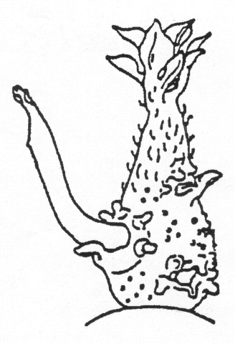
hairs
tip
Lateral shoot

Ad. 2: Lightsprout: shape

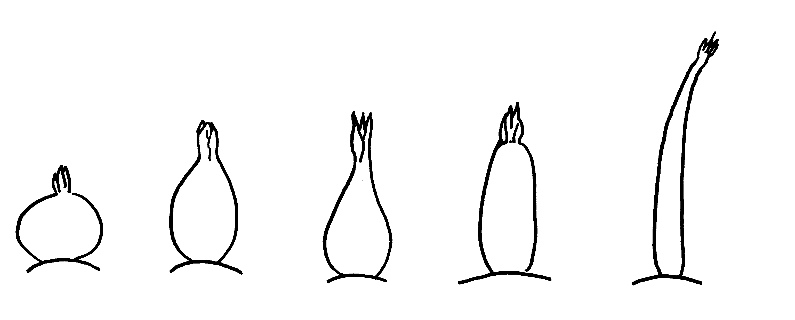
base
root tips
1 | 2 | 3 | 4 | 5
spherical | ovoid | conical | broad cylindrical | narrow cylindrical

Ad. 3: Lightsprout: intensity of anthocyanin coloration of base

If the intensity of the anthocyanin coloration is “absent”, the lightsprout appears green.

Ad. 4: Lightsprout: proportion of blue in anthocyanin coloration of base
Ad. 31: Flower corolla: proportion of blue in anthocyanin coloration on inner side

The color of anthocyanin results from a red and a blue component. If the proportion of blue is low the anthocyanin appears red-violet. If the proportion of blue is high the anthocyanin appears blue-violet.

Ad. 7: Lightsprout: habit of tip

 | 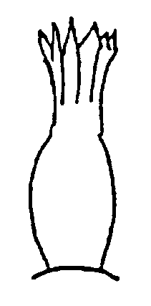 | 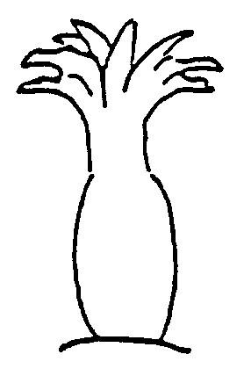
1 | 3 | 5
closed | intermediate | open

Ad. 11: Lightsprout: length of lateral shoots

3 | 5 | 7
short | medium | long

Ad. 12: Plant: foliage structure

Stem type: foliage open, stems clearly visible
Intermediate type: foliage half open, stems partly visible
Leaf type: foliage closed, stems not, or hardly, visible

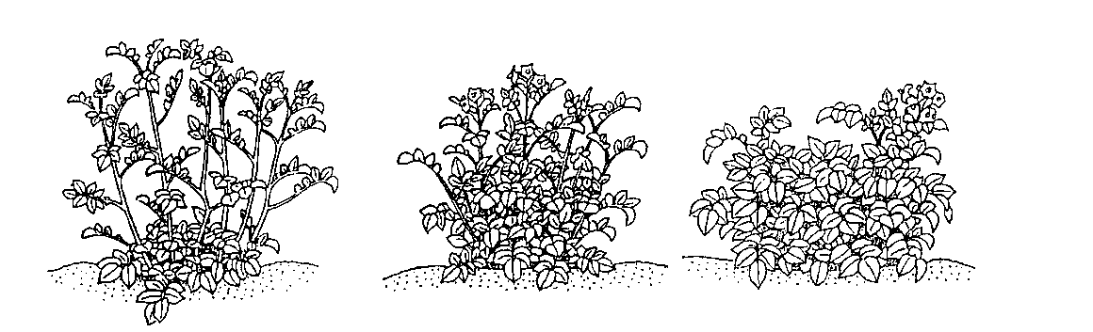
1 | 2 | 3
stem type | intermediate type | leaf type

Ad. 13: Plant: growth habit

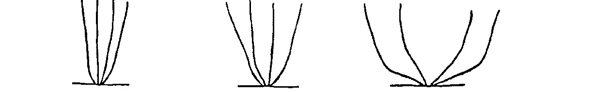
3 | 5 | 7
upright | semi upright | spreading

Ads. 14, 19, 27, 31, 35: Anthocyanin coloration

The extent of anthocyanin coloration should be observed in relation to the total area. Distribution and intensity should not be considered.
The extent of anthocyanin coloration of flower buds should be observed on fully developed buds before the corolla is visible.

Ads. 15 to 25

Ads:15 steem characteristic

Stem: Fly Presence of wings

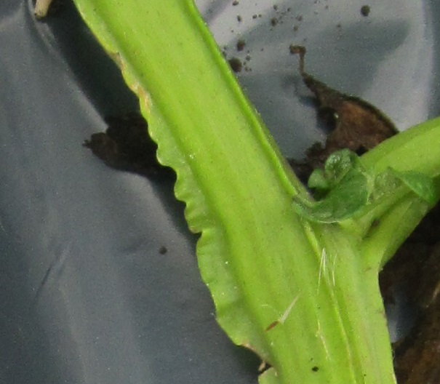

Ads 16: Ads:15 steem characteristic Stem: Fly ondulation of wings

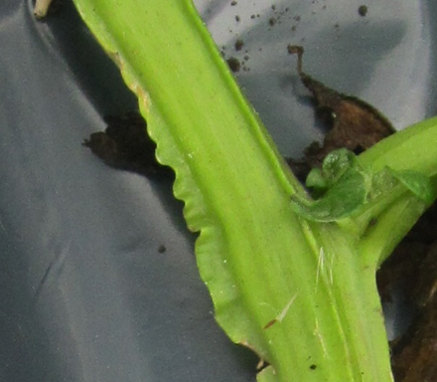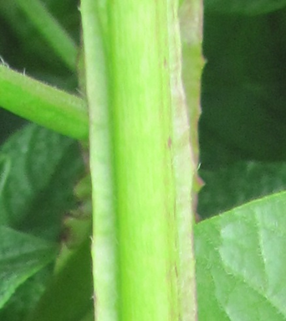

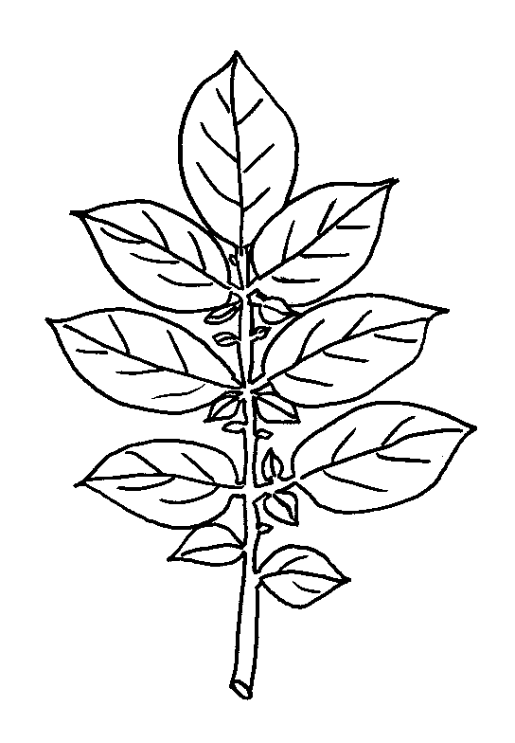
terminal leaflet

secondary
leaflets
1st pair of
lateral leaflets

2^{nd.} pair of
lateral leaflets
outline
leaf

Ad. 15: Leaf: openness

1 | 3 | 5
closed | intermediate | open

Ad. 16: Leaf: presence of secondary leaflets

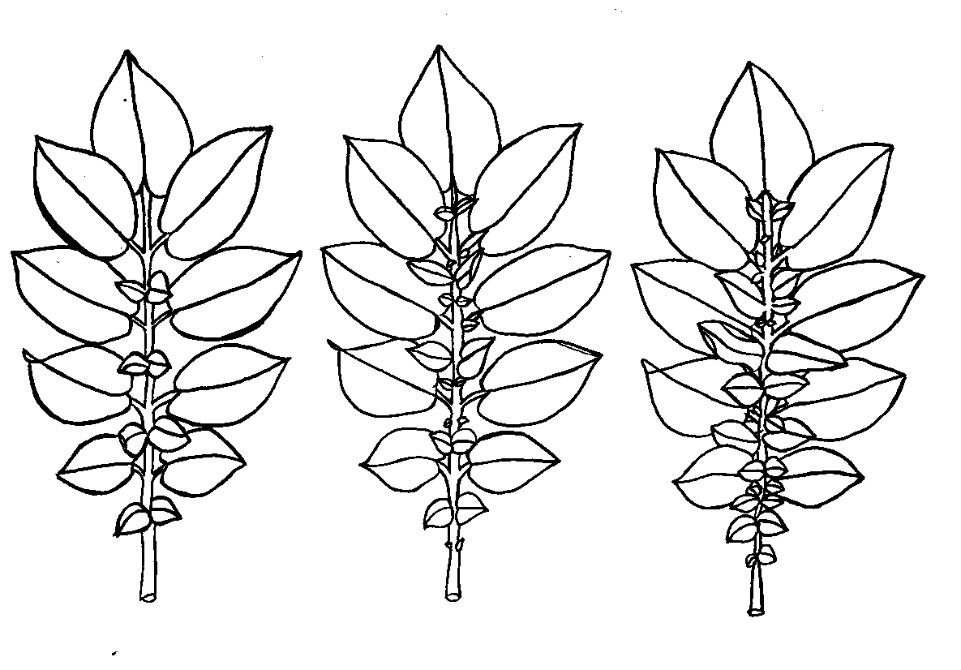
3 | 5 | 7
weak | medium | strong

Ad. 19: Second pair of lateral leaflets: width in relation to length

3 | 5 | 7
narrow | medium | broad

Ad. 20: Terminal and lateral leaflets: frequency of coalescence

not coalescent | coalescent

Ads. 26–31: Inflorescence and flower characteristics

inflorescence
flower corolla
peduncle

Ad. 29: Flower corolla: intensity of anthocyanin coloration on inner side
If the intensity of the anthocyanin coloration on the inner side is “absent”, the flower corolla appears white.

Ad. 32: Plant: time of maturity

The time of maturity is reached when 80% of the leaves are dead.

Ad. 34: Tuber: shape

1 | 2 | 3 | 4 | 5 | 6
round | short-oval | oval | long-oval | long | very long

The predominant shape should be observed on the harvested material from each plot.

Ad. 39: Light beige and yellow skinned varieties only: Tuber: anthocyanin coloration of skin in reaction to light

The anthocyanin development in the skin of light beige and yellow skinned varieties should be assessed after 10 days of exposure to full daylight or after 150 hours of exposure to artificial light.

8.3 Optimal Stage of Development for the Assessment of Characteristics

1 | = | bud stage
2 | = | flowering stage
3 | = | ripening stage of tubers
4 | = | after harvest

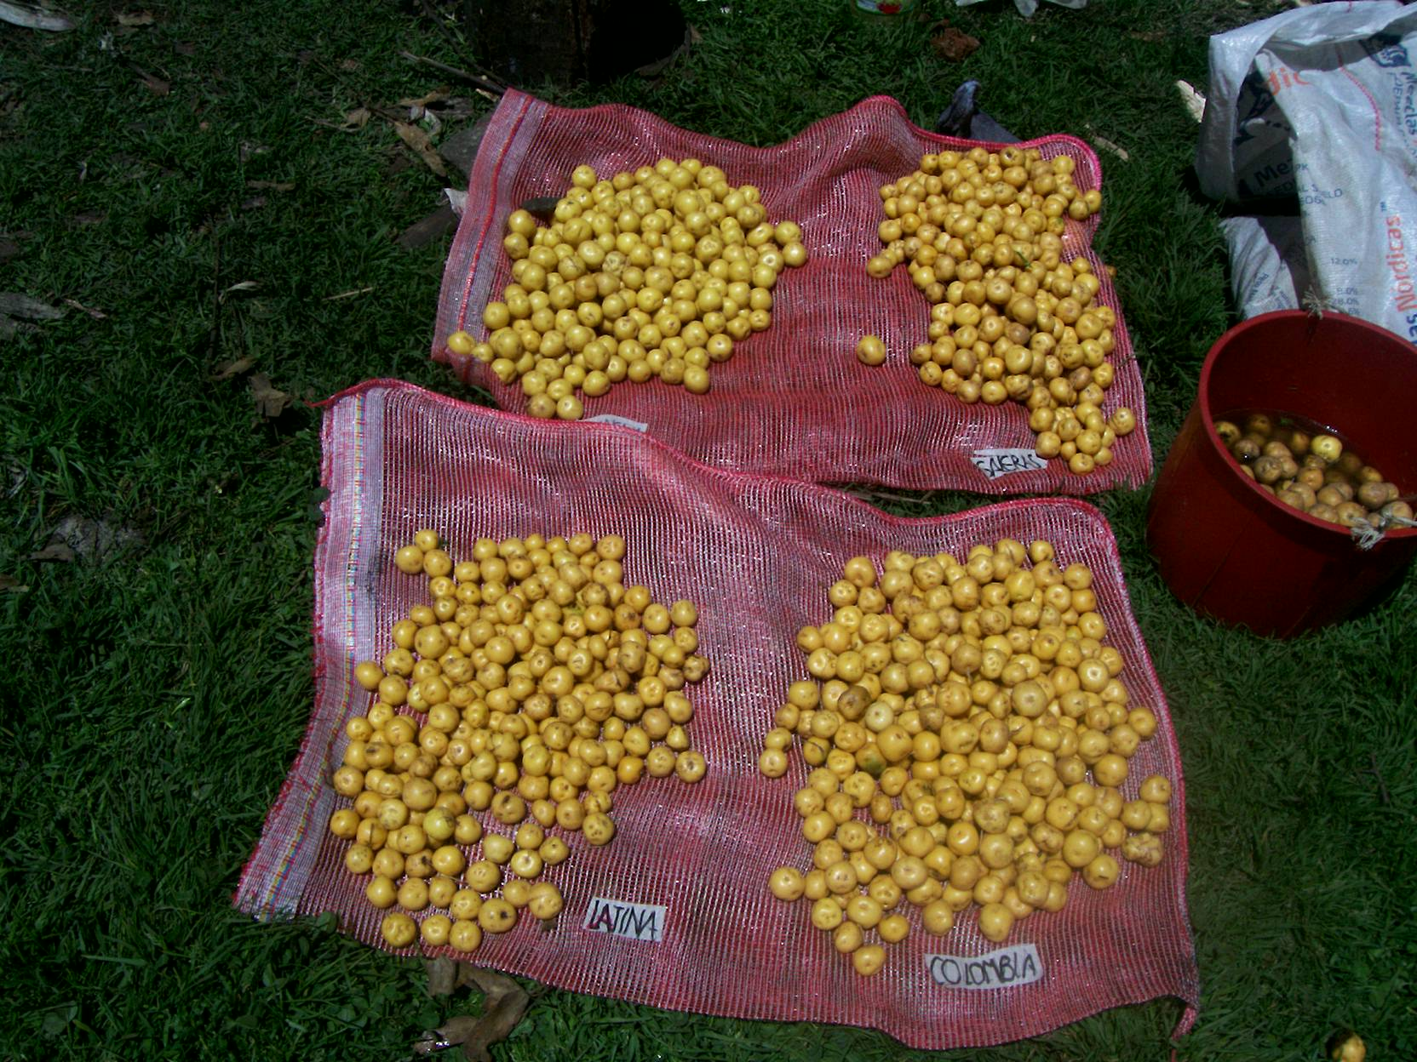

Literature

Houwing, A., R. Suk and B. Ros, 1986: Generation of lightsprouts suitable for potato variety identification by means of artificial light. Acta Hort 182: 359-363

Technical Questionnaire

TECHNICAL QUESTIONNAIRE |  |  |  | Page {x} of {y} |  | Reference Number:
 |  |  |  |  |  | Application date:
 |  |  |  |  |  | (not to be filled in by the applicant)
TECHNICAL QUESTIONNAIRE
to be completed in connection with an application for plant breeders’ rights

1. Subject of the Technical Questionnaire
1.1 Botanical name |  |  | Solanum tuberosum L.spp andigena spp phureja
1.2 Common name |  |  | Potato
2. Applicant
Name
Address
Telephone No.
Fax No.
E-mail address
Breeder (if different from
applicant)
3. Proposed denomination and breeder’s reference
Proposed denomination
(if available)
Breeder’s reference
#4. Information on the breeding scheme and propagation of the variety

4.1 Breeding scheme

Variety resulting from:

4.1.1 Crossing

(a) controlled cross [ ]
(please state parent varieties)

(…………………..…………………………) x (……………..…………..………………..…)
female parent male parent

(b) partially known cross [ ]
(please state known parent variety(ies))

(…………………..……………………....…) x (……………..………………..…………..…)
female parent male parent

(c) unknown cross [ ]
4.1.2 Mutation [ ]
(please state parent variety)

4.1.3 Discovery and development [ ]
(please state where and when discovered and how developed)

4.1.4 Other [ ]
(please provide details)

4.2 Method of propagating the variety

4.2.1 Vegetatively propagated varieties

(a) tuber [ ]
(b) other (state method) [ ]

4.2.2 Other [ ]
(please provide details)

5. Characteristics of the variety to be indicated (the number in brackets refers to the corresponding characteristic in Test Guidelines; please mark the note which best corresponds).

 | Characteristics |  |  |  |  |  | Example Varieties |  |  |  | Note
5.1  (4) | Lightsprout: proportion of blue in anthocyanin coloration of base
 | absent or low |  |  |  |  |  |  |  |  |  | 1[ ]
 | medium |  |  |  |  |  |  |  |  |  | 2[ ]
 | high |  |  |  |  |  |  |  |  |  | 3[ ]
5.2  (25) | Plant: frequency of flowers
 | absent or very low |  |  |  |  |  |  |  |  |  | 1[ ]
 | very low to low |  |  |  |  |  |  |  |  |  | 2[ ]
 | low |  |  |  |  |  |  |  |  |  | 3[ ]
 | low to medium |  |  |  |  |  |  |  |  |  | 4[ ]
 | medium |  |  |  |  |  |  |  |  |  | 5[ ]
 | medium to high |  |  |  |  |  |  |  |  |  | 6[ ]
 | high |  |  |  |  |  |  |  |  |  | 7[ ]
 | high to very high |  |  |  |  |  |  |  |  |  | 8[ ]
 | very high |  |  |  |  |  |  |  |  |  | 9[ ]
5.3  (29) | Flower corolla: intensity of anthocyanin coloration on inner side
 | absent or very weak |  |  |  |  |  |  |  |  |  | 1[ ]
 | very weak to weak |  |  |  |  |  |  |  |  |  | 2[ ]
 | weak |  |  |  |  |  |  |  |  |  | 3[ ]
 | weak to medium |  |  |  |  |  |  |  |  |  | 4[ ]
 | medium |  |  |  |  |  |  |  |  |  | 5[ ]
 | medium to strong |  |  |  |  |  |  |  |  |  | 6[ ]
 | strong |  |  |  |  |  |  |  |  |  | 7[ ]
 | strong to very strong |  |  |  |  |  |  |  |  |  | 8[ ]
 | very strong |  |  |  |  |  |  |  |  |  | 9[ ]
 | Characteristics |  |  |  |  |  | Example Varieties |  |  |  | Note
5.4  (30) | Flower corolla: proportion of blue in anthocyanin coloration on inner side
 | absent or low |  |  |  |  |  |  |  |  |  | 1[ ]
 | medium |  |  |  |  |  |  |  |  |  | 2[ ]
 | high |  |  |  |  |  |  |  |  |  | 3[ ]
5.5  (32) | Plant: time of maturity
 | very early |  |  |  |  |  |  |  |  |  | 1[ ]
 | very early to early |  |  |  |  |  |  |  |  |  | 2[ ]
 | early |  |  |  |  |  |  |  |  |  | 3[ ]
 | early to medium |  |  |  |  |  |  |  |  |  | 4[ ]
 | medium |  |  |  |  |  |  |  |  |  | 5[ ]
 | medium to late |  |  |  |  |  |  |  |  |  | 6[ ]
 | late |  |  |  |  |  |  |  |  |  | 7[ ]
 | late to very late |  |  |  |  |  |  |  |  |  | 8[ ]
 | very late |  |  |  |  |  |  |  |  |  | 9[ ]
5.6  (37) | Tuber: shape
 | round |  |  |  |  |  |  |  |  |  | 1[ ]
 | short-oval |  |  |  |  |  |  |  |  |  | 2[ ]
 | oval |  |  |  |  |  |  |  |  |  | 3[ ]
 | long-oval |  |  |  |  |  |  |  |  |  | 4[ ]
 | long |  |  |  |  |  |  |  |  |  | 5[ ]
 | very long |  |  |  |  |  |  |  |  |  | 6[ ]
 | Characteristics |  |  |  |  |  | Example Varieties |  |  |  | Note
5.7  (36) | Tuber: color of skin
 | light beige |  |  |  |  |  |  |  |  |  | 1[ ]
 | yellow |  |  |  |  |  |  |  |  |  | 2[ ]
 | red |  |  |  |  |  |  |  |  |  | 3[ ]
 | red parti-colored |  |  |  |  |  |  |  |  |  | 4[ ]
 | blue |  |  |  |  |  |  |  |  |  | 5[ ]
 | blue parti-colored |  |  |  |  |  |  |  |  |  | 6[ ]
 | reddish brown |  |  |  |  |  |  |  |  |  | 7[ ]
5.8  (37) | Tuber: color of base of eye
 | white |  |  |  |  |  |  |  |  |  | 1[ ]
 | yellow |  |  |  |  |  |  |  |  |  | 2[ ]
 | red |  |  |  |  |  |  |  |  |  | 3[ ]
 | blue |  |  |  |  |  |  |  |  |  | 4[ ]
5.9  (38) | Tuber: color of flesh
 | white |  |  |  |  |  |  |  |  |  | 1[ ]
 | cream |  |  |  |  |  |  |  |  |  | 2[ ]
 | light yellow |  |  |  |  |  |  |  |  |  | 3[ ]
 | medium yellow |  |  |  |  |  |  |  |  |  | 4[ ]
 | dark yellow |  |  |  |  |  |  |  |  |  | 5[ ]
 | red |  |  |  |  |  |  |  |  |  | 6[ ]
 | red parti-colored |  |  |  |  |  |  |  |  |  | 7[ ]
 | blue |  |  |  |  |  |  |  |  |  | 8[ ]
 | blue parti-colored |  |  |  |  |  |  |  |  |  | 9[ ]
6. Similar varieties and differences from these varieties

Please use the following table and box for comments to provide information on how your candidate variety differs from the variety (or varieties) which, to the best of your knowledge, is (or are) most similar. This information may help the examination authority to conduct its examination of distinctness in a more efficient way.

Denomination(s) of variety(ies) similar to your candidate variety |  | Characteristic(s) in which your candidate variety differs from the similar variety(ies) |  |  | Describe the expression of the characteristic(s) for the similar variety(ies) |  |  | Describe the expression of the characteristic(s) for your candidate variety
Example
Comments:

#7. Additional information which may help in the examination of the variety

7.1 In addition to the information provided in sections 5 and 6, are there any additional characteristics which may help to distinguish the variety?

Yes [ ] No [ ]

(If yes, please provide details)

7.2 Are there any special conditions for growing the variety or conducting the examination?

Yes [ ] No [ ]

(If yes, please provide details)

7.3 Other information

8. Authorization for release

(a) Does the variety require prior authorization for release under legislation concerning the protection of the environment, human and animal health?

Yes [ ] No [ ]

(b) Has such authorization been obtained?

Yes [ ] No [ ]

If the answer to (b) is yes, please attach a copy of the authorization.

9. Information on plant material to be examined or submitted for examination

9.1 The expression of a characteristic or several characteristics of a variety may be affected by factors, such as pests and disease, chemical treatment (e.g. growth retardants or pesticides), effects of tissue culture, different rootstocks, scions taken from different growth phases of a tree, etc.

9.2 The plant material should not have undergone any treatment which would affect the expression of the characteristics of the variety, unless the competent authorities allow or request such treatment. If the plant material has undergone such treatment, full details of the treatment must be given. In this respect, please indicate below, to the best of your knowledge, if the plant material to be examined has been subjected to:

(a) Microorganisms (e.g. virus, bacteria, phytoplasma) Yes [ ] No [ ]

(b) Chemical treatment (e.g. growth retardant, pesticide) Yes [ ] No [ ]

(c) Tissue culture Yes [ ] No [ ]

(d) Other factors Yes [ ] No [ ]

Please provide details for where you have indicated “yes”.

10. I hereby declare that, to the best of my knowledge, the information provided in this form is correct:

Applicant’s name

Signature Date

[End of document]

* These names were correct at the time of the introduction of these Test Guidelines but may be revised or updated. [Readers are advised to consult the UPOV Code, which can be found on the UPOV Website (www.upov.int), for the latest information.]
# Authorities may allow certain of this information to be provided in a confidential section of the Technical Questionnaire.
# Authorities may allow certain of this information to be provided in a confidential section of the Technical Questionnaire.

