 |  |  |  |  |  |  | E  TG/3/12(proj.2)  ORIGINAL: English  DATE: 2013-04-29
INTERNATIONAL UNION FOR THE PROTECTION OF NEW VARIETIES OF PLANTS
Geneva
 |  |  | DRAFT
 |  | WHEAT  UPOV Code: TRITI_AES  Triticum aestivum L. emend. Fiori et Paol. |  |  | *

GUIDELINES

FOR THE CONDUCT OF TESTS

FOR DISTINCTNESS, UNIFORMITY AND STABILITY

prepared by experts from France

to be considered by the
Technical Working Party for Agricultural Crops
at its forty-second session, to be held in Kyiv, Ukraine, from June 17 to 21, 2013

Alternative Names:*

Botanical name | English | French | German | Spanish
Triticum aestivum L. emend. Fiori et Paol. | Wheat

The purpose of these guidelines (“Test Guidelines”) is to elaborate the principles contained in the General Introduction (document TG/1/3), and its associated TGP documents, into detailed practical guidance for the harmonized examination of distinctness, uniformity and stability (DUS) and, in particular, to identify appropriate characteristics for the examination of DUS and production of harmonized variety descriptions.

ASSOCIATED DOCUMENTS
These Test Guidelines should be read in conjunction with the General Introduction and its associated TGP documents.
TABLE OF CONTENTS PAGE

1. Subject of these Test Guidelines 3
2. Material Required 3
3. Method of Examination 3
3.1 Number of Growing Cycles 3
3.2 Testing Place 3
3.3 Conditions for Conducting the Examination 3
3.4 Test Design 3
3.5 Additional Tests 4
4. Assessment of Distinctness, Uniformity and Stability 4
4.1 Distinctness 4
4.2 Uniformity 5
4.3 Stability 6
5. Grouping of Varieties and Organization of the Growing Trial 6
6. Introduction to the Table of Characteristics 6
6.1 Categories of Characteristics 6
6.2 States of Expression and Corresponding Notes 7
6.3 Types of Expression 7
6.4 Example Varieties 7
6.5 Legend 7
7. Table of Characteristics/Tableau des caractères/Merkmalstabelle/Tabla de caracteres 8
8. Explanations on the Table of Characteristics 15
8.1 Explanations covering several characteristics 15
8.2 Explanations for individual characteristics 15
8.3 The descriptions of the growth stages of the Zadoks decimal code for cereals 23
9. Literature 24
10. Technical Questionnaire 25

Subject of these Test Guidelines

These Test Guidelines apply to all varieties of Triticum aestivum L. emend. Fiori et Paol..

Material Required

2.1 The competent authorities decide on the quantity and quality of the plant material required for testing the variety and when and where it is to be delivered. Applicants submitting material from a State other than that in which the testing takes place must ensure that all customs formalities and phytosanitary requirements are complied with.

2.2 The material is to be supplied in the form of seed.

2.3 The minimum quantity of plant material, to be supplied by the applicant, should be:

Seeds: 3 kg
Ears (if requested): 120

The seed should meet the minimum requirements for germination, species and analytical purity, health and moisture content, specified by the competent authority. In cases where the seed is to be stored, the germination capacity should be as high as possible and should, be stated by the applicant.

If ear is requested, it should contain a sufficient number of viable seeds to establish a satisfactory row of plants for observation.

2.4 The plant material supplied should be visibly healthy, not lacking in vigor, nor affected by any important pest or disease.

2.5 The plant material should not have undergone any treatment which would affect the expression of the characteristics of the variety, unless the competent authorities allow or request such treatment. If it has been treated, full details of the treatment must be given.

Method of Examination

3.1 Number of Growing Cycles

The minimum duration of tests should normally be two independent growing cycles.

3.2 Testing Place

Tests are normally conducted at one place. In the case of tests conducted at more than one place, guidance is provided in TGP/9 “Examining Distinctness”.

3.3 Conditions for Conducting the Examination

3.3.1 The tests should be carried out under conditions ensuring satisfactory growth for the expression of the relevant characteristics of the variety and for the conduct of the examination.

3.3.2 Stage of development for the assessment

The optimum stage of development for the assessment of each characteristic is indicated by a number in the second column of the Table of Characteristics. The stages of development denoted by each number are described in the descriptions of the growth stages of the Zadoks Decimal Code for Cereals in Chapter 8.3.

3.4 Test Design

3.4.1 Each test should be designed to result in a total of at least 2000 plants. The assessment for the characteristics “Seasonal type” should be carried out on at least 300 plants.

3.4.2 The design of the tests should be such that plants or parts of plants may be removed for measurement or counting without prejudice to the observations which must be made up to the end of the growing cycle.

3.4.3 Single ear rows: if tests on ear rows are conducted, at least 100 ear rows should be observed.

3.4.4 In case of hybrids, the parent lines have to be included in the test and should be tested and assessed as any other self-pollinating variety. The observations on the hybrid variety itself should be made on at least 200 plants.

3.5 Additional Tests

Additional tests, for examining relevant characteristics, may be established.

Assessment of Distinctness, Uniformity and Stability

4.1 Distinctness

4.1.1 General Recommendations

It is of particular importance for users of these Test Guidelines to consult the General Introduction prior to making decisions regarding distinctness. However, the following points are provided for elaboration or emphasis in these Test Guidelines.

To assess distinctness of hybrids, the parent lines and the formula may be used according to the following recommendations:

(i) description of parent lines according to the Test Guidelines;

(ii) check of the originality of the parent lines in comparison with the variety collection, based on the characteristics in Chapter 7, in order to identify similar parent lines;

(iii) check of the originality of the hybrid formula in relation to the hybrids in the variety collection, taking into account the most similar lines; and

(iv) assessment of the distinctness at the hybrid level for varieties with a similar formula.

Further guidance is provided in documents TGP/9 “Examining Distinctness” and TGP/8 “Trial Design and Techniques Used in the Examination of Distinctness, Uniformity and Stability”.

4.1.2 Consistent Differences

The differences observed between varieties may be so clear that more than one growing cycle is not necessary. In addition, in some circumstances, the influence of the environment is not such that more than a single growing cycle is required to provide assurance that the differences observed between varieties are sufficiently consistent. One means of ensuring that a difference in a characteristic, observed in a growing trial, is sufficiently consistent is to examine the characteristic in at least two independent growing cycles.

4.1.3 Clear Differences

Determining whether a difference between two varieties is clear depends on many factors, and should consider, in particular, the type of expression of the characteristic being examined, i.e. whether it is expressed in a qualitative, quantitative, or pseudo-qualitative manner. Therefore, it is important that users of these Test Guidelines are familiar with the recommendations contained in the General Introduction prior to making decisions regarding distinctness.

4.1.4 Number of Plants / Parts of Plants to be Examined

Unless otherwise indicated, for the purposes of distinctness, all observations on single plants should be made on 20 plants or parts taken from each of 20 plants and any other observations made on all plants in the test, disregarding any off-type plants. In the case of observations of parts taken from single plants, the number of parts to be taken from each of the plants should be 1.

4.1.5 Method of Observation

The recommended method of observing the characteristic for the purposes of distinctness is indicated by the following key in the second column of the Table of Characteristics (see document TGP/9 “Examining Distinctness”, Section 4 “Observation of characteristics”):

MG: single measurement of a group of plants or parts of plants
MS: measurement of a number of individual plants or parts of plants
VG: visual assessment by a single observation of a group of plants or parts of plants
VS: visual assessment by observation of individual plants or parts of plants

Type of observation: visual (V) or measurement (M)

“Visual” observation (V) is an observation made on the basis of the expert’s judgment. For the purposes of this document, “visual” observation refers to the sensory observations of the experts and, therefore, also includes smell, taste and touch. Visual observation includes observations where the expert uses reference points (e.g. diagrams, example varieties, side-by-side comparison) or non-linear charts (e.g. color charts). Measurement (M) is an objective observation against a calibrated, linear scale e.g. using a ruler, weighing scales, colorimeter, dates, counts, etc.

Type of record: for a group of plants (G) or for single, individual plants (S)

For the purposes of distinctness, observations may be recorded as a single record for a group of plants or parts of plants (G), or may be recorded as records for a number of single, individual plants or parts of plants (S). In most cases, “G” provides a single record per variety and it is not possible or necessary to apply statistical methods in a plant-by-plant analysis for the assessment of distinctness.

In cases where more than one method of observing the characteristic is indicated in the Table of Characteristics (e.g. VG/MG), guidance on selecting an appropriate method is provided in document TGP/9, Section 4.2.

4.2 Uniformity

4.2.1 It is of particular importance for users of these Test Guidelines to consult the General Introduction prior to making decisions regarding uniformity. However, the following points are provided for elaboration or emphasis in these Test Guidelines:

4.2.2 The recommended sample size for the assessment of uniformity is indicated by the following key in the table of characteristics:

A sample size of 100 plants/parts of plants/ear-rows
B sample size of 2000 plants or parts of plants

4.2.3 For the assessment of uniformity in a sample of 2000 plants, a population standard of 0.3% and an acceptance probability of at least 95% should be applied. In the case of a sample size of 2000 plants, 10 off-types are allowed.

4.2.4 For the assessment of uniformity in a sample of 100 ear-rows, plants or parts of plants, a population standard of 1% and an acceptance probability of at least 95% should be applied. In the case of a sample size of 100 ear-rows, plants or parts of plants, 3 off-types are allowed.

An ear-row is considered to be an off-type ear-row if there is more than 1 off-type plant within that ear-row.

For “A” characteristics, with the exception of characteristic 1 and 2, the assessment of uniformity can be done in 2 steps. In a first step, 20 plants are observed. If no off-types are observed, the variety is declared to be uniform. If more than 3 off-types are observed, the variety is declared not to be uniform. If 1 to 3 off-types are observed, an additional sample of 80 plants or parts of plants must be observed.

4.2.5 For the assessment of uniformity of hybrids, a population standard of 10% and an acceptance probability of at least 95% should be applied. In the case of a sample size of 200 plants, 27 off-types are allowed.

4.3 Stability

4.3.1 In practice, it is not usual to perform tests of stability that produce results as certain as those of the testing of distinctness and uniformity. However, experience has demonstrated that, for many types of variety, when a variety has been shown to be uniform, it can also be considered to be stable.

4.3.2 Where appropriate, or in cases of doubt, stability may be further examined by testing a new seed stock to ensure that it exhibits the same characteristics as those shown by the initial material supplied.

4.3.3 Stability assessment: hybrid varieties

Where appropriate, or in cases of doubt, the stability of a hybrid variety may, in addition to an examination of the hybrid variety itself, also be assessed by examination of the uniformity and stability of its parent lines.

Grouping of Varieties and Organization of the Growing Trial

5.1 The selection of varieties of common knowledge to be grown in the trial with the candidate varieties and the way in which these varieties are divided into groups to facilitate the assessment of distinctness are aided by the use of grouping characteristics.

5.2 Grouping characteristics are those in which the documented states of expression, even where produced at different locations, can be used, either individually or in combination with other such characteristics: (a) to select varieties of common knowledge that can be excluded from the growing trial used for examination of distinctness; and (b) to organize the growing trial so that similar varieties are grouped together.

5.3 The following have been agreed as useful grouping characteristics:

- Straw: pith in cross section (characteristic 14)
- Awns or scurs: presence (characteristic 18)
- Ear: color (characteristic 20)
- Seasonal type (characteristic 28)

5.4 Guidance for the use of grouping characteristics, in the process of examining distinctness, is provided through the General Introduction and document TGP/9 “Examining Distinctness”.

Introduction to the Table of Characteristics

6.1 Categories of Characteristics

6.1.1 Standard Test Guidelines Characteristics

Standard Test Guidelines characteristics are those which are approved by UPOV for examination of DUS and from which members of the Union can select those suitable for their particular circumstances.

6.1.2 Asterisked Characteristics

Asterisked characteristics (denoted by *) are those included in the Test Guidelines which are important for the international harmonization of variety descriptions and should always be examined for DUS and included in the variety description by all members of the Union, except when the state of expression of a preceding characteristic or regional environmental conditions render this inappropriate.

6.2 States of Expression and Corresponding Notes

6.2.1 States of expression are given for each characteristic to define the characteristic and to harmonize descriptions. Each state of expression is allocated a corresponding numerical note for ease of recording of data and for the production and exchange of the description.

6.2.2 In the case of qualitative and pseudo-qualitative characteristics (see Chapter 6.3), all relevant states of expression are presented in the characteristic. However, in the case of quantitative characteristics with 5 or more states, an abbreviated scale may be used to minimize the size of the Table of Characteristics. For example, in the case of a quantitative characteristic with 9 states, the presentation of states of expression in the Test Guidelines may be abbreviated as follows:

State | Note
small | 3
medium | 5
large | 7

However, it should be noted that all of the following 9 states of expression exist to describe varieties and should be used as appropriate:

State | Note
very small | 1
very small to small | 2
small | 3
small to medium | 4
medium | 5
medium to large | 6
large | 7
large to very large | 8
very large | 9

6.2.3 Further explanation of the presentation of states of expression and notes is provided in document TGP/7 “Development of Test Guidelines”.

6.3 Types of Expression

An explanation of the types of expression of characteristics (qualitative, quantitative and pseudo-qualitative) is provided in the General Introduction.

6.4 Example Varieties

Where appropriate, example varieties are provided to clarify the states of expression of each characteristic.

6.5 Legend

(*) Asterisked characteristic – see Chapter 6.1.2

QL Qualitative characteristic – see Chapter 6.3
QN Quantitative characteristic – see Chapter 6.3
PQ Pseudo-qualitative characteristic – see Chapter 6.3

MG, MS, VG, VS – see Chapter 4.1.5

A, B – see Chapter 4.2

(a) See Explanations on the Table of Characteristics in Chapter 8.1.

(+) See Explanations on the Table of Characteristics in Chapter 8.2.

Table of Characteristics/Tableau des caractères/Merkmalstabelle/Tabla de caracteres

 |  | English | français | deutsch | español | Example Varieties  Exemples  Beispielssorten  Variedades ejemplo | Note/  Nota
1.  (+) | 00  VG | Grain: color | Graine: couleur | Korn: farbe
QL | A | white |  |  |  | Recital | 1
 |  | light red or slightly colored |  |  |  | Apache | 2
 |  | dark red or strongly colored |  |  |  | Indigo, Rosso | 3
2.  (+) | 00  VG | Seed: coloration with phenol | Semence : coloration au phenol | Samen: Phenolfärbung | Semilla: color con phenol
QN | A | absent or very light | absent ou très faible | fehlend oder sehr hell |  |  | 1
 |  | light | faible | hell | claro | Soissons | 3
 |  | medium | moyenne | mittel | medio | Aerobic | 5
 |  | dark | forte | dunkel | oscuro | Excelcior | 7
 |  | very dark | très foncée | dehr dunkel | muy oscuro | Sideral | 9
3.  (+) | 09-11  VG | Coleoptile: anthocyanin coloration | Coléoptile: pigmentation anthocyanique | Keimscheide: Anthocyanfärbung | Coleóptilo: pigmentación antociánica
QN | A | absent or very weak | absente ou très faible | fehlend oder sehr gering | ausente o muy débil | Altigo | 1
 |  | weak | faible | gering | débil | Accor | 3
 |  | medium | moyenne | mittel | media | Premio | 5
 |  | strong | forte | stark | fuerte | Arezzo | 7
 |  | very strong | très forte | sehr stark | muy fuerte | Caphorn | 9
4.  (*)  (+) | 25-29 VG | Plant: growth habit | Plante: port au tallage | Pflanze: Wuchsform | Planta: porte
QN | B | erect | dressé | aufrecht | erecto | Bandera | 1
 |  | semi erect | demi-dressé | halbaufrecht | semierecto | Esperia | 3
 |  | intermediate | intermédiaire | mittel | medio | Crousty | 5
 |  | semi prostrate | demi-étalé | halbliegend | semipostrado | Euclide | 7
 |  | prostrate | étalé | liegend | postrado | Instinct | 9
5.  (+) | 47-51 VG | Plant: frequency of plants with recurved flag leaves | Plante : fréquence de plantes avec la dernière feuille retombante | Pflanze: Häufigkeit von Pflanzen mit gebogenen obersten Blättern | Planta: frequencia de plantas con ¿
QN | B | absent or very low | nulle ou très faible | fehlend oder sehr gering | ausente o muy débil | Sorrial | 1
 |  | low | faible | gering | débil | Arezzo | 3
 |  | medium | moyenne | mittel | media | Courtot | 5
 |  | high | forte | stark | fuerte | Saturnus | 7
 |  | very high | très forte | sehr stark | muy fuerte | MV kolo | 9
6. | 49-51 | Flag leaf: anthocyanin coloration of auricles
QN | A | absent or very weak |  |  |  | ? | 1
 |  | weak |  |  |  | ? | 3
 |  | medium |  |  |  | ? | 5
 |  | strong |  |  |  | ? | 7
 |  | very strong |  |  |  | ? | 9
7.  (*)  (+) | 50-52 MG | Time of ear emergence | Époque d’épiaison | Zeitpunkt des Ährenschiebens | Época de ¿
QN | B | very early | très précoce | sehr früh | muy temprana | Accor | 1
 |  | early | précoce | früh | temprana | Caphorn | 3
 |  | medium | moyenne | mittel | media | Richepain | 5
 |  | late | tardive | spät | tardía | Boncap | 7
 |  | very late | très tardive | sehr spät | muy tardía |  | 9
8.  (*) | 60-65 VG | Flag leaf: glaucosity of sheath | Dernière feuille : glaucescence de la gaine | Oberstes Blatt: Bereifung der Blattscheide | Ultima hoja: ¿ de la vaina
QN | B | absent or very weak | absente ou très faible | fehlend oder sehr gering | ausente o muy débil | Benedict | 1
 |  | weak | faible | gering | débil | Aerobic | 3
 |  | medium | moyenne | mittel | medio | Pakito | 5
 |  | strong | forte | stark | fuerte | Solehio | 7
 |  | very strong | très forte | sehr stark | muy fuerte | Illico | 9
9. | 60-65 VG | Flag leaf: glaucosity of blade (lower side) | Dernière feuille : glaucescence du limbe (face inférieure) | Oberste Blatt: Bereifung der Blattspreite | Ultima hoja: ¿ del limbo
QN | B | absent or very weak | absente ou très faible | fehlend oder sehr gering | ausente o muy débil | Courtot | 1
 |  | weak | faible | gering | débil | Bologna | 3
 |  | medium | moyenne | mittel | medio | Amador | 5
 |  | strong | forte | stark | fuerte | Cezanne | 7
 |  | very strong | très forte | sehr stark | muy fuerte | Goncourt | 9
10. | 60-65  VG | Culm: density of hairiness of uppermost node
QN | A | very low | très faible |  |  |  | 1
 |  | low | faible |  |  |  | 3
 |  | medium | Moyenne |  |  |  | 5
 |  | high | Forte |  |  |  | 7
 |  | very high | Très forte |  |  |  | 9
11.  (*) | 60-69 VG | Ear: glaucosity | Epi : glaucescence | Aehre: Bereifung
QN | B | absent or very weak | absente ou très faible | fehlend oder sehr gering | ausente o muy débil | Soissons | 1
 |  | weak | faible | gering | débil | Bologna | 3
 |  | medium | moyenne | mittel | medio | Solehio | 5
 |  | strong | forte | stark | fuerte | Premio | 7
 |  | very strong | très forte | sehr stark | muy fuerte | Exelcior | 9
12. | 60-69 VG | Culm: glaucosity of neck | Tige : glaucescence du col de l’épi | Halme: Bereifung des obersten Internodiums
QN | B | absent or very weak | absente ou très faible | fehlend oder sehr gering | ausente o muy débil | Benedict | 1
 |  | weak | faible | gering | débil | Saturnus | 3
 |  | medium | moyenne | mittel | medio | Aubusson | 5
 |  | strong | forte | stark | fuerte | Arezzo | 7
 |  | very strong | très forte | sehr stark | muy fuerte | Exelcior | 9
13.  (*)  (+) | 75-92  MG | Plant: length | Plante: longueur | Pflanze: Lange | Planta: altura (?)
QN | B | very short | très courte | sehr niedrig | muy corta | Cordiale | 1
 |  | short | courte | niedrig | corta | Renan | 3
 |  | medium | moyenne | mittel | media | Intérêt | 5
 |  | long | longue | lang | larga | Bagatelle 007 | 7
 |  | very long | très longue | sehr lang | muy larga |  | 9
14.  (+) | 80-92  VG | Straw: pith in cross section | Paille : moëlle en section transversale | Halm: Füllung im Querschnitt | Tallo: grosor
PQ | A | absent or thin | absente ou mince | fehlend oder dünn | ausente o muy delgado | Pakito | 1
 |  | medium | moyenne | mittel | medio | Saturnus | 2
 |  | thick or filled | épaisse ou pleine | dick oder gefüllt | muy grueso o ¿ | Aerobic | 3
15.  (+) | 92  VG | Ear: shape in profile | Epi: forme en vue de profil | Aehre : form in Seiten-ansicht
PQ | B | tapering | pyramidal | pyramidenförmig |  | Sankara | 1
 |  | fusiform | fusiforme | spindelförmig |  | Arezzo | 2
 |  | parallel sided | à bords parallèles | parallel |  | Viscount | 3
 |  | slightly clavate | en demi-massue | halb keulenförmig |  | Aura | 4
 |  | strongly clavate | en massue | keulenförmig |  | Apache | 5
16.  (*)  (+) | 80-92  VG/  MS | Ear: density | Epi: compacité | Aehr: Dichte
QN | B | very lax | très lâche | sehr locker |  | Magno | 1
 |  | lax | lâche | locker |  | Sponsor | 3
 |  | medium | moyen | mittel |  | Aubusson | 5
 |  | dense | compact | dicht |  | Premio | 7
 |  | very dense | très compact | sehr dicht |  | Rehti | 9
17.  (+) | 80-92  VG/  MS | Ear: length | Epi: longueur | Aehre : länge
QN | B | very short | très court | sehr kurz |  |  | 1
 |  | short | court | kurz |  | Ambello | 3
 |  | medium | moyen | mittel |  | Soissons | 5
 |  | long | long | lang |  | Aubusson | 7
 |  | very long | très long | sehr lang |  | Folklor | 9
18.  (*)  (+) | 80-92  VG | Awns or scurs: presence | Barbes ou arêtes: présence | Grannen oder Spelzen-spitzen: Vorhandensein
QL | B | both absent | toutes les deux absentes | beide fehlend |  | Genoveva | 1
 |  | scurs present | arêtes présentes | Spelzenspitzen vorhanden |  | Aubusson | 2
 |  | awns present | barbes présentes | Grannen vorhanden |  | Arezzo | 3
19.  (*)  (+) | 80-92  VG/  MS | Awns or scurs at tip of ear: length | Barbes ou arêtes à l’extrémité de l’épi: longueur | Grannen oder Spelzen-spitzen an der Aehrenspitze : länge
QN | B | very short | très courtes | sehr kurz |  | Ephoros | 1
 |  | short | courtes | kurz |  | Graindor | 3
 |  | medium | moyennes | mittel |  | Pakito | 5
 |  | long | longues | lang |  | As de cœur | 7
 |  | very long | très longues | sehr lang |  | Arezzo | 9
20.  (*)  (+) | 80-92  VG | Ear: color | Epi: couleur | Aehre: Farbe
QL | B | white | blanc | weiss |  | Arezzo | 1
 |  | colored | coloré | gefärbt |  | Segor | 2
21.  (+) | 80-92  VG | Apical rachis segment: extent of hairiness of convex surface | Article terminal du rachis: étendue de la pilosité de la face externe | Oberstes Spindelglied : äussere Behaarung
QN | A | absent or very small | nulle ou très petite | fehlend oder sehr gering |  | Graindor | 1
 |  | small | petite | gering |  | Crousty | 3
 |  | medium | moyenne | mittel |  | Sirtaki | 5
 |  | large | grande | stark |  | Cadenza | 7
 |  | very large | très grande | sehr stark |  | KWS Scirocco | 9
22.  (+) | 80-92  VG | Lower glume: shoulder width | Glume inférieure: largeur de la troncature | Hüllspelze : Schulter-breite
QN | A | absent or very narrow | nulle ou très étroite | fehlend oder sehr schmal |  | Courtot | 1
 | (a) | narrow | étroite | schmal |  | Altigo | 3
 |  | medium | moyenne | mittel |  | Apache | 5
 |  | broad | large | breit |  | Orvantis | 7
 |  | very broad | très large | sehr breit |  | Aglika | 9
23.  (+) | 80-92  VG | Lower glume: shoulder shape | Glume inférieure: forme de la troncature | Hüllspelze : chulterform
QN | A | strongly sloping | fortement inclinée | abfallend |  | Ambello | 1
 | (a) | slightly sloping | légèrement inclinée | leicht abfallend |  | Soissons | 3
 |  | straight | droite | gerade |  | Apache | 5
 |  | slightly elevated | légèrement échancrée | gehoben |  | Aubusson | 7
 |  | strongly elevated with 2nd point present | fortement échancrée avec présence d’un 2ème bec | stark gehoben mit vorhandener zweiter spitze |  | Fiorenzo | 9
24.  (+) | 80-92  VG/  MG | Lower glume: beak length | Glume inférieure: longueur du bec | Hüllspelze : Zahnlänge
QN | A | very short | très court | sehr kurz |  | Graindor | 1
 | (a) | short | court | kurz |  | Sollario | 3
 |  | medium | moyen | mittel |  | Quality | 5
 |  | long | long | lang |  | Soissons | 7
 |  | very long | très long | sehr lang |  | Bandera | 9
25.  (*)  (+) | 80-92  VG | Lower glume: beak shape | Glume inférieure: forme du bec | Hüllspelze : zahnform
QN | A | straight | droit | gerade |  | Premio | 1
 | (a) | slightly curved | légèrement coudé | leicht gebogen |  | Altigo | 3
 |  | moderately curved | demi-coudé | mittel gebogen |  | Sponsor | 5
 |  | strongly curved | fortement coudé | stark gebogen |  | Quebon | 7
 |  | geniculate | genouillé | geknickt |  | Velocity | 9
26.  (*)  (+) | 80-92  VG | Lower glume: extent of hairiness of internal surface | Glume inférieure: étendue de la pilosité de la face interne | Hüllspelze : verbreitung der inneren behaarung
QN | A | small | petite | gering |  | Altigo | 1
 | (a) | medium | moyenne | mittel |  | Alixan | 3
 |  | large | grande | stark |  | Quality | 5
27. | 80-92  VG | Lower glume: hairiness on external surface
QL | A | absent | absente |  |  |  | 1
 |  | present | présente |  |  |  | 9
28.  (*)  (+) | -  VG | Seasonal type | Type de développement | Wechselverhalten
PQ |  | winter type | type hiver | Winterform |  | Aubusson | 1
 |  | alternative type | type alternatif | Wechselform |  | Cezanne | 2
 |  | spring type | type printemps | Sommerform |  | Josselin | 3

Explanations on the Table of Characteristics

8.1 Explanations covering several characteristics

Characteristics containing the following key in the second column of the Table of Characteristics should be examined as indicated below:

(a) Characteristics on lower glume must be observed at midthird of ear spikelet.

8.2 Explanations for individual characteristics

Ad. 1: Grain: color

This characteristic can be observed on dry seeds or by using NaOH solution.

Ad. 2: Seed: coloration with phenol

Method for Determination of Phenol Reaction

Number of grains per test: 20 grains for distinctness, 100 grains for homogeneity. The grains should not have been treated chemically
Preparation of grains: Soak in tap water for 16 to 20 hours, drain and remove surface water, place the grains with crease downwards, cover dish with lid
Concentration of solution: 1 per cent Phenol-solution (freshly made up)
Amount of solution: The grains should be about 3/4 covered
Place: Laboratory
Light: Daylight - out of direct sunshine
Temperature: 18 to 20°C
Time of recording: 4 hours (after adding solution)
Scale of recording: See characteristic 25 in the Table of Characteristics
Note: At least two of the example varieties should be included as a control

Any alternative method may be used if it has been validated and gives the same results.

 | 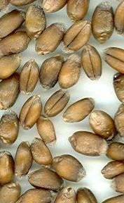 | 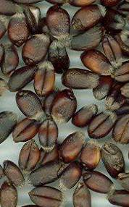 | 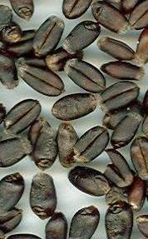 | 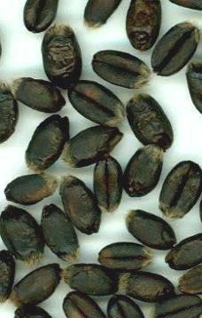
1 | 3 | 5 | 7 | 9
absent or very light | light | medium | dark | very dark

Ad. 3: Coleoptile: anthocyanin coloration

Method for the Determination of Anthocyanin Coloration

Number of grains per test: 100 grains
Preparation of grains: Set up non-dormant grains on moistened filter paper covered with a Petri dish lid during germination
Place: Laboratory or greenhouse
Light: After the coleoptiles have reached a length of about 1 cm in darkness, they are placed in artificial light (daylight equivalent) at 15000 lux continuously for 3 – 4 days
Temperature: 15 to 20°C
Time of recording: Coleoptiles fully developed (about 1 week) at stage 09-11
Note: At least two of the example varieties should be included as a control when testing for distinctness

Any alternative method may be used if it has been validated and gives the same results.

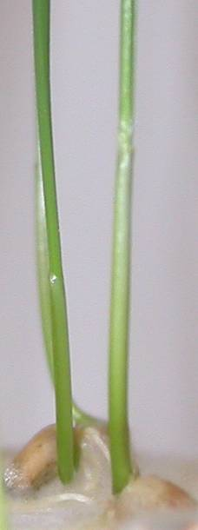 | 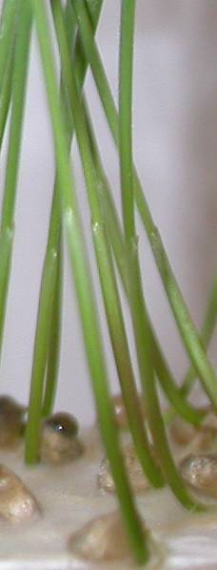 | 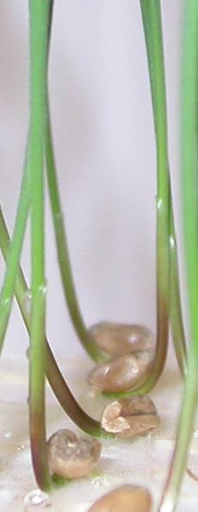 | 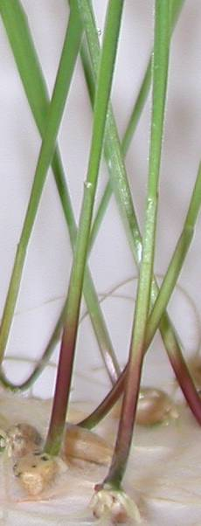 | 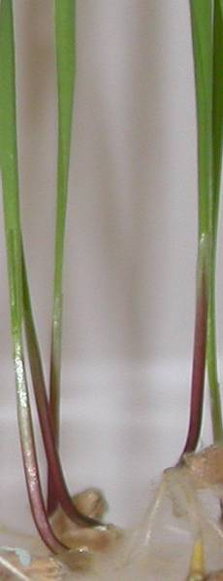
1 | 3 | 5 | 7 | 9
absent or very weak | weak | medium | strong | very strong

Ad.4: Plant: growth habit

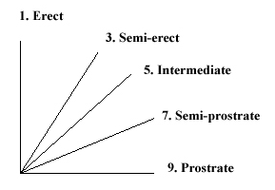

The growth habit should be assessed visually from the attitude of the leaves and tillers. The angle formed by the outer leaves and the tillers with an imaginary vertical axis should be used.

 | 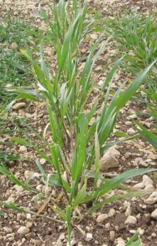 | 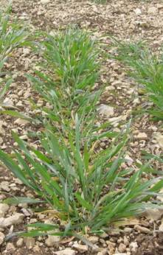 | 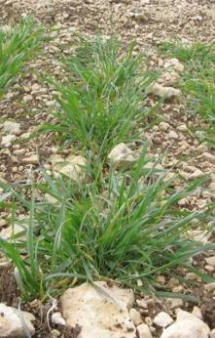 | 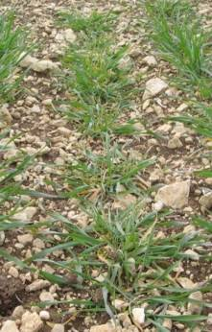
1 | 3 | 5 | 7 | 9
erect | semi erect | intermediate | semi prostrate | prostrate

Ad. 5: Plant: frequency of plants with recurved flag leaves

1 all flag leaves are rectilinear

3 about 1/4 of the plants with recurved flag leaves

5 about 1/2 of the plants with recurved flag leaves

7 about 3/4 of the plants with recurved flag leaves

9 all flag leaves are recurved

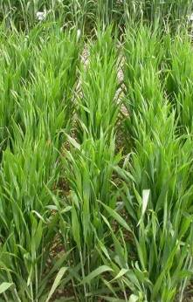 | 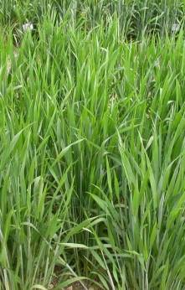 | 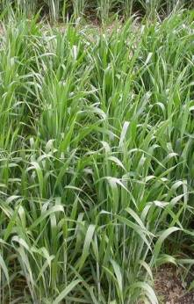 | 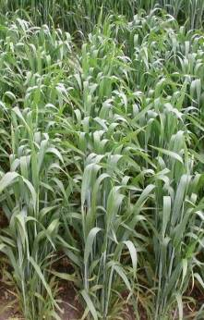 | 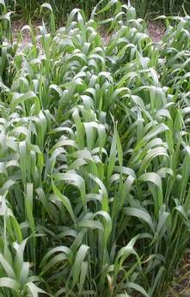
1 | 3 | 5 | 7 | 9
absent or very low | low | medium | high | very high

Ad. 7: Time of ear emergence

Time of ear emergence should be scored when the first spikelet is visible on 50% of ears.

Ad. 13: Plant: length

The length of plant includes stem, ear, awns and scurs.

Ad. 14: Straw: pith in cross section (half way between base of ear and stem node below)

All stems of the plant should be checked and the strongest expression per plant recorded.

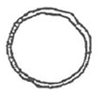 | 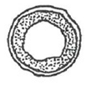 | 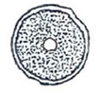
1 | 2 | 3
absent or very thin | medium | very thick or filled

Ad. 15: Ear: shape in profile

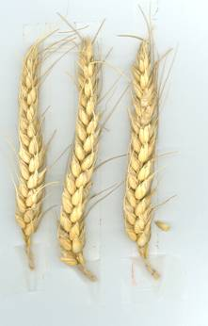 | 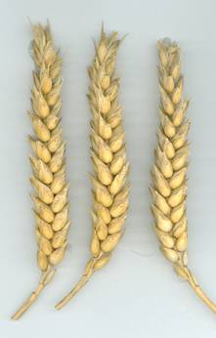 | 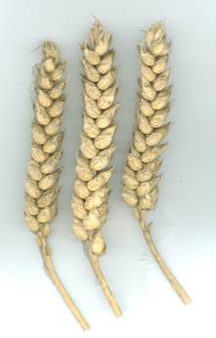 | 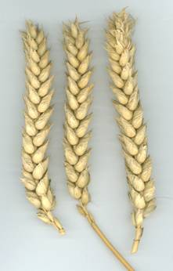 | 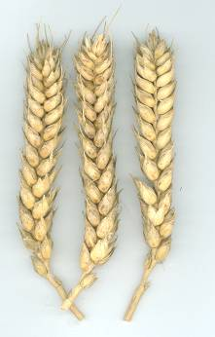
1 | 2 | 3 | 4 | 5
tapering | fusiform | parallel sided | slightly clavate | strongly clavate

Ad. 16: Ear: density

The density can be assessed either visually or as measurement of the ratio of the number of spikelets/ear length.

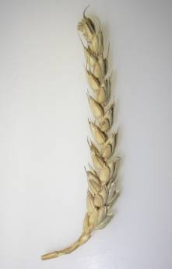 | 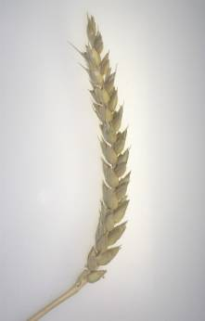 | 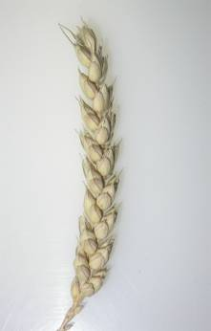 | 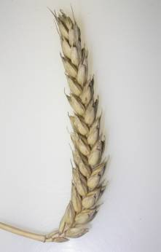 | 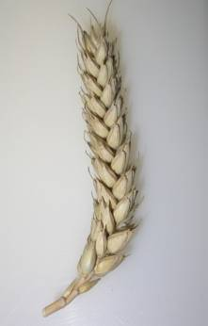
1 | 3 | 5 | 7 | 9
very lax | lax | medium | dense | very dense

Ad. 17: Ear: length

Length of ear should be observed excluding awns and scurs.

Ad. 18: Awns or scurs: presence

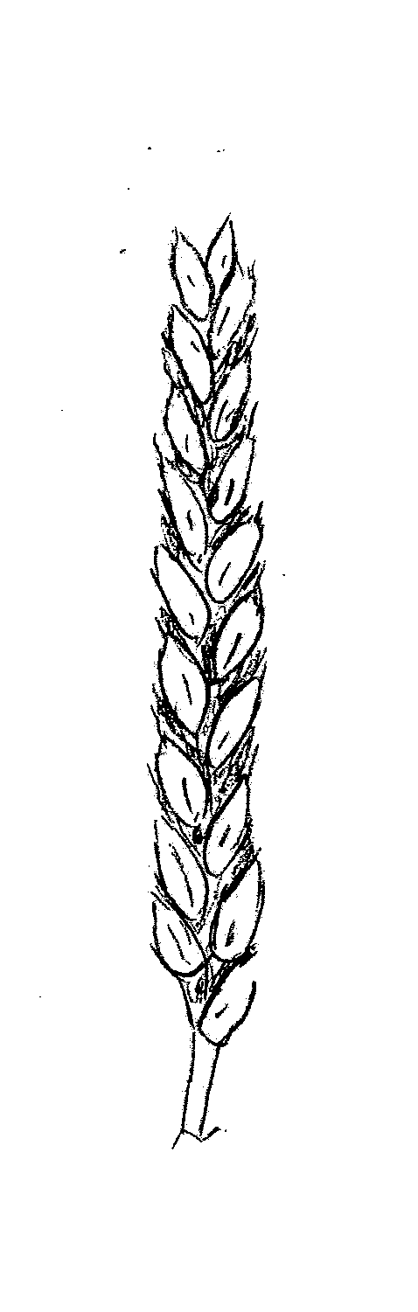 | 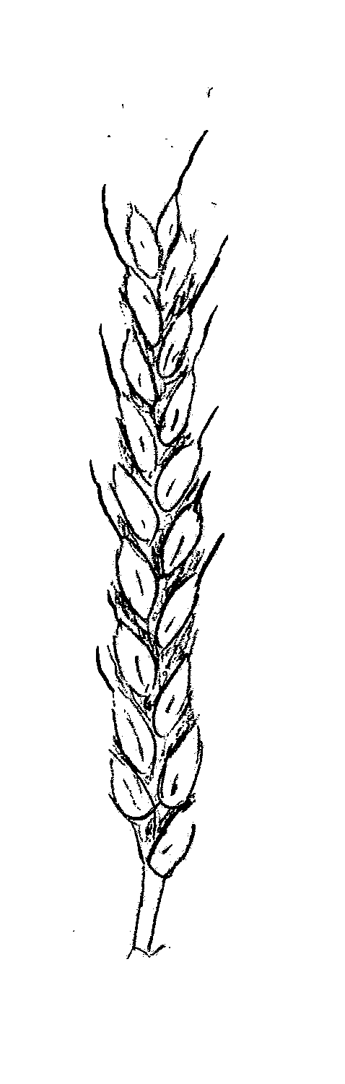 | 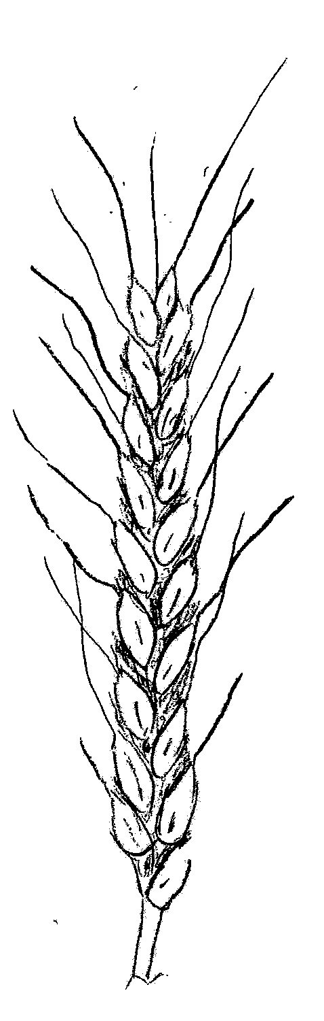
1 | 2 | 3
both absent | scurs present | awns present

Ad. 19: Awns or scurs at tip of ear: length

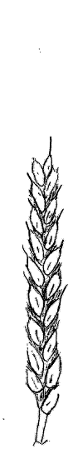 | 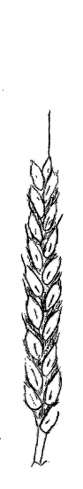 | 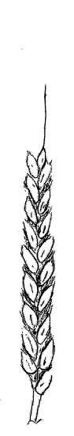 | 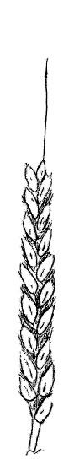 | 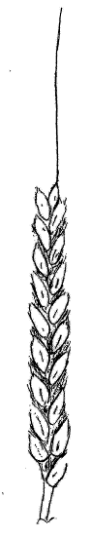
1 | 3 | 5 | 7 | 9
very short | short | medium | long | very long

Ad. 20: Ear: color

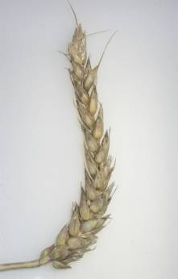 | 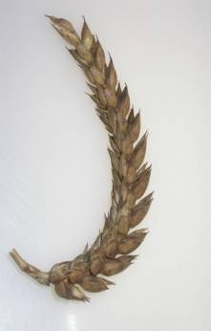
1 | 2
white | colored

Ad. 21: Apical rachis segment: extent of hairiness of convex surface

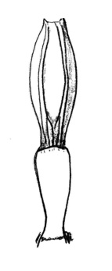 | 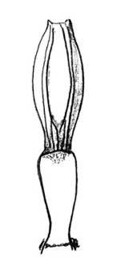 | 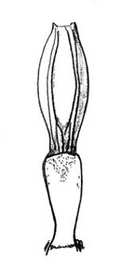 | 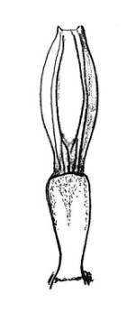 | 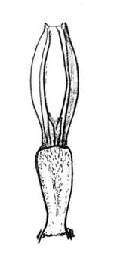
1 | 3 | 5 | 7 | 9
absent or very small | small | medium | large | very very large

These drawings must be improved on the basis of the Spanish proposal with more grey to indicate the hairs

Ad. 22: Lower glume: shoulder width

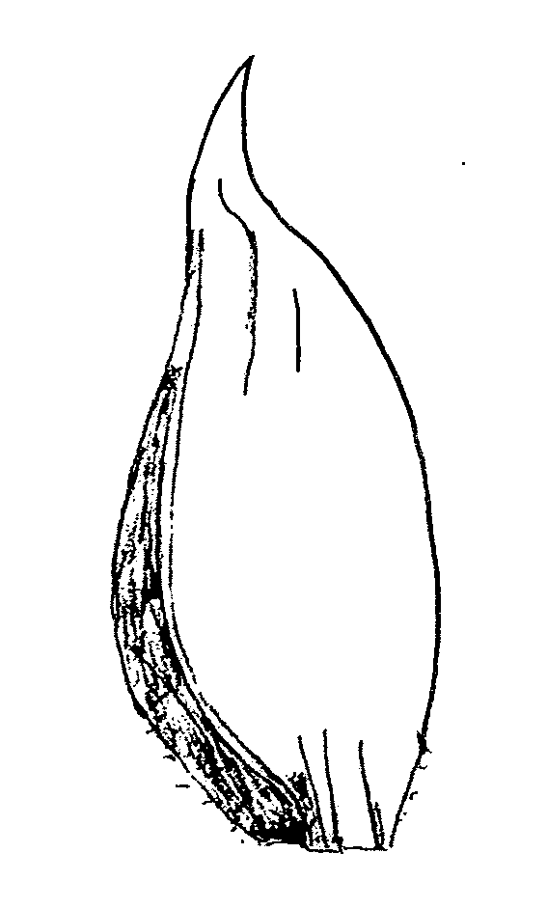 | 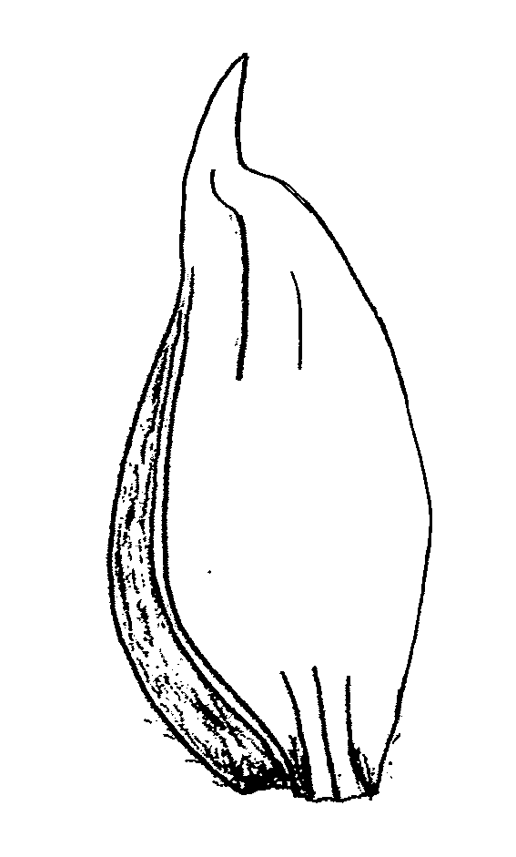 | 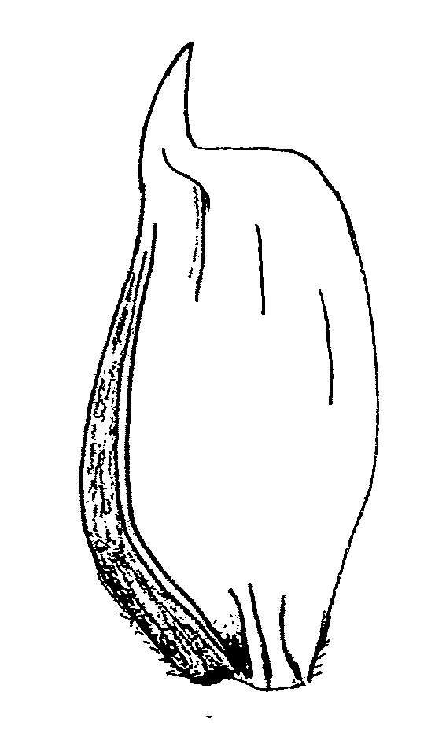 | 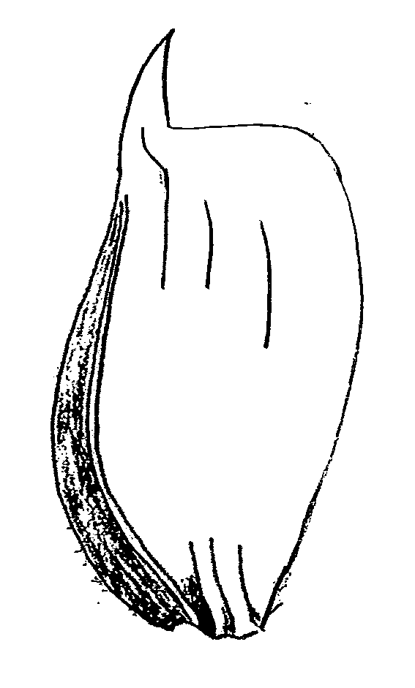 | 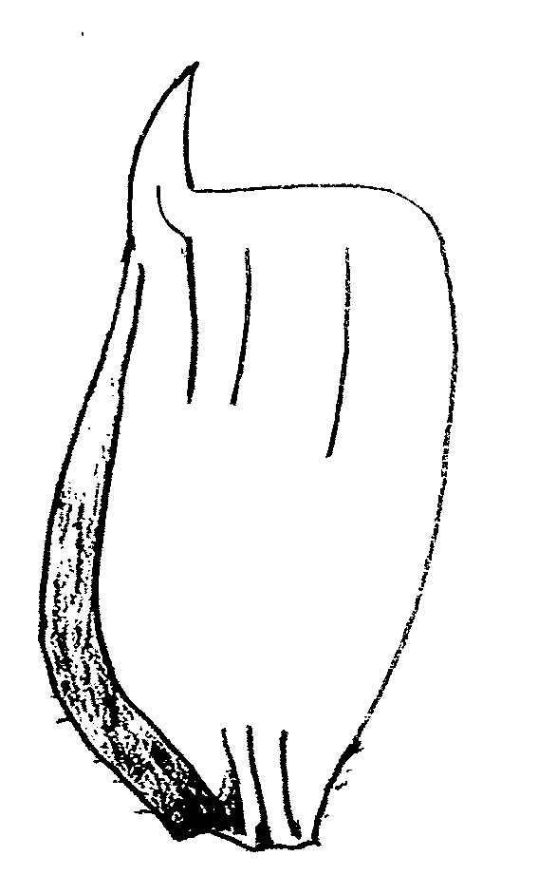
1 | 3 | 5 | 7 | 9
absent or very narrow | narrow | medium | broad | very broad

Ad. 23: Lower glume: shoulder shape

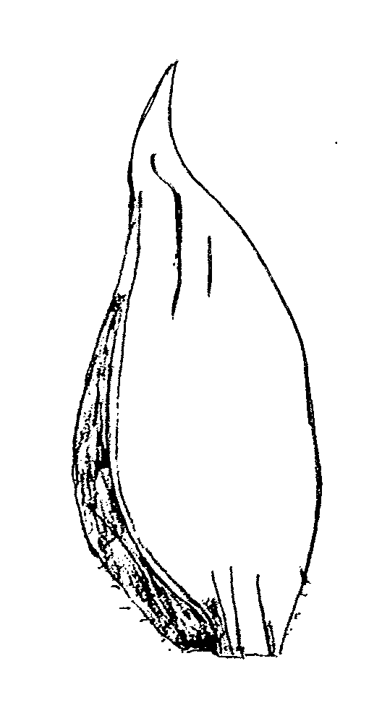 | 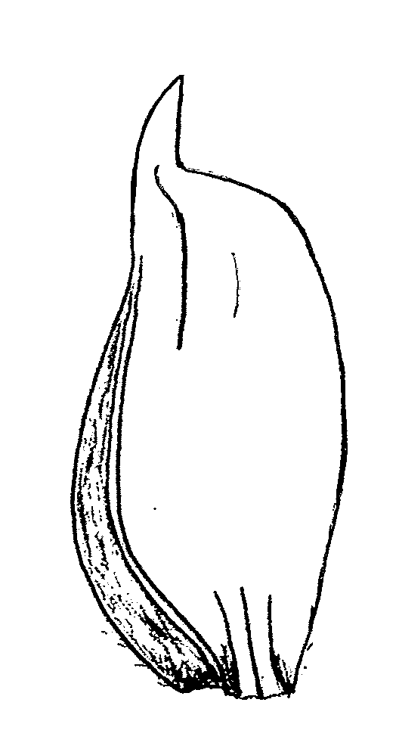 | 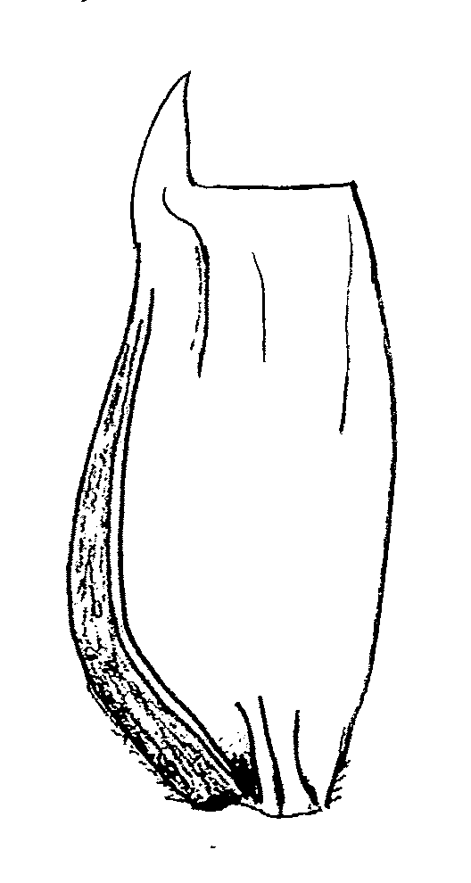 | 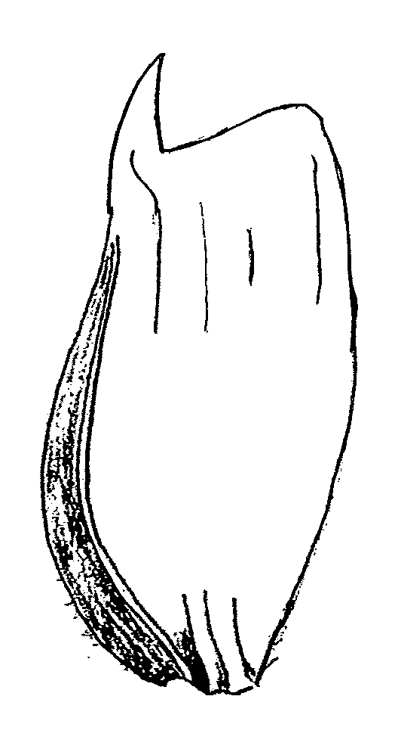 | 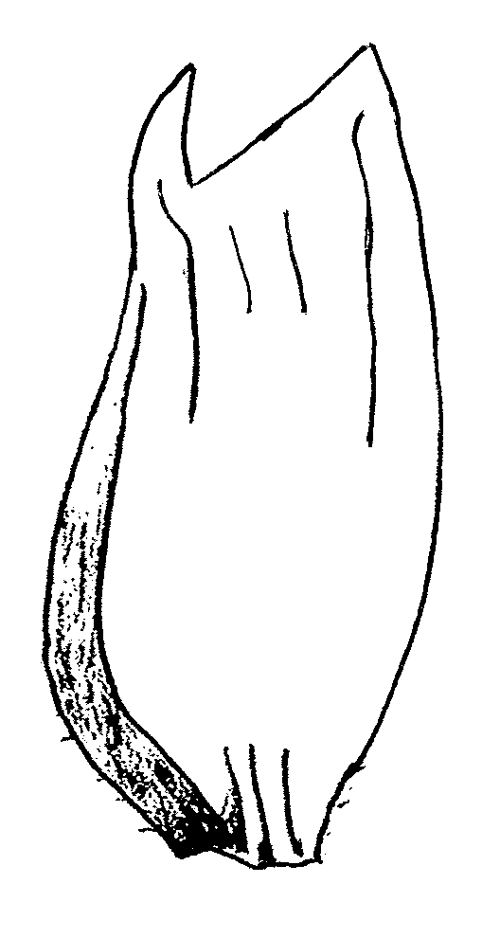
1 | 3 | 5 | 7 | 9
strongly sloping | slightly sloping | straight | elevated | strongly elevated with 2nd point present

Ad. 24: Lower glume: beak length

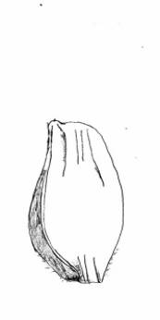 | 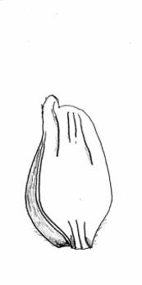 | 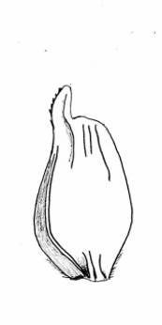 | 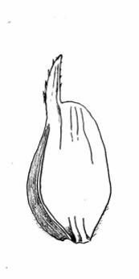 | 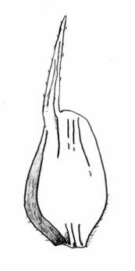
1 | 3 | 5 | 7 | 9
very short | short | medium | long | very long

Ad. 25: Lower glume: beak shape

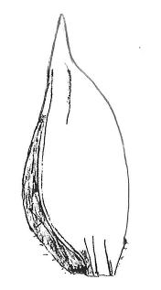 | 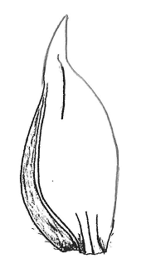 | 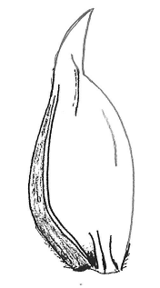 | 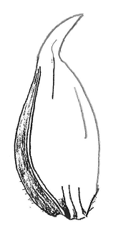 | 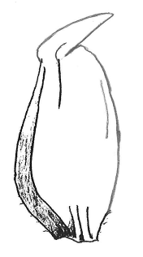
1 | 3 | 5 | 7 | 9
straight | slightly curved | moderately curved | strongly curved | geniculate

Ad. 26: Lower glume: extent of hairiness of internal surface

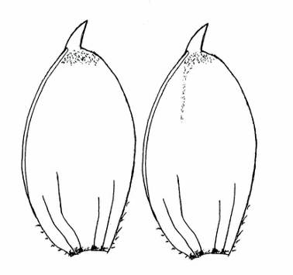 | 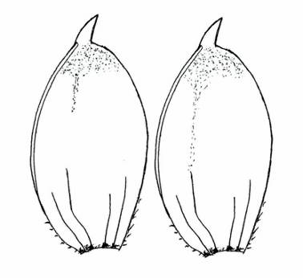 | 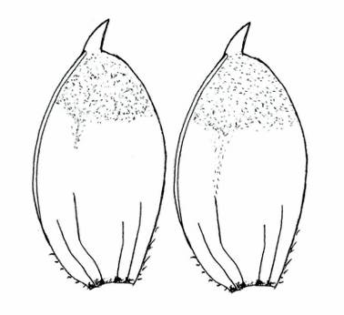
1 | 3 | 5
small | medium | large

Ad. 28: Seasonal type

The seasonal type (need of vernalization) should be assessed on plots sown in springtime. Example varieties should always be included in thetrial. When the example varieties behave according to its description, the varieties under study can be described. At the time when the latest spring type variety is fully mature (stage 91/92 of the Zadoks decimal code), the growth stage reached by the respective variety should be assessed. The states of expression are defined as follows:

Winter type: Winter type (high need of vernalization): the plants have reached stage 45 of the Zadoks decimal code (boots swollen) at maximum

Alternative type: Alternative type (partial need of vernalization): the plants have exceeded stage 45 of the Zadoks decimal code---as a rule they have exceeded stage 75---and have reached stage 90 at maximum

Spring type: Spring type (no need or very weak need of vernalization): the plants have exceeded stage 90 of the Zadoks decimal code.

8.3 The descriptions of the growth stages of the Zadoks decimal code for cereals

Zadoks Decimal code | Description
00 | Dry seed
01 | Start of imbibition
03 | Imbibition complete
05 | Radicle emerged from seed
07 | Coleoptile emerged from seed
09 | Leaf just at coleoptile tip
10 | First leaf through coleoptile
11 | First leaf unfolded
12 | 2 leaves unfolded
13 | 3 leaves unfolded
14 | 4 leaves unfolded
15 | 5 leaves unfolded
16 | 6 leaves unfolded
17 | 7 leaves unfolded
18 | 8 leaves unfolded
19 | 9 or more leaves unfolded
20 | Main shoot only
21 | Main shoot and 1 tiller
22 | Main shoot and 2 tillers
23 | Main shoot and 3 tillers
24 | Main shoot and 4 tillers
25 | Main shoot and 5 tillers
26 | Main shoot and 6 tillers
27 | Main shoot and 7 tillers
28 | Main shoot and 8 tillers
29 | Main shoot and 9 or more tillers
30 | Pseudo stem erection
31 | 1st node detectable
32 | 2nd node detectable
33 | 3rd node detectable
34 | 4th node detectable
35 | 5th node detectable
36 | 6th node detectable
37 | Flag leaf just visible
39 | Flag leaf ligule/collar just visible
40 | -
41 | Flag leaf sheath extending
45 | Boots just swollen
47 | Flag leaf sheath opening
49 | First awns visible
50 | First spikelet of inflorescence visible
53 | 1/4 of inflorescence emerged
55 | 1/2 of inflorescence emerged
57 | 3/4 of inflorescence emerged
59 | Emergence of inflorescence completed
60 | Beginning on anthesis
65 | Anthesis half-way
69 | Anthesis completed
70 | -
71 | Kernel watery ripe
73 | Early milk
75 | Medium milk
77 | Late milk
80 | -
83 | Early dough
85 | Soft dough
87 | Hard dough
90 | -
91 | Kernel hard (difficult to divide with thumbnail)
92 | Kernel hard (no longer dented with thumbnail)
93 | Kernel loosening in daytime
94 | Overripe, straw dead and collapsing
95 | Seed dormant
96 | Viable seed giving 50% germination
97 | Seed not dormant
98 | Secondary dormancy induced
99 | Secondary dormancy lost

Literature

Bezar, H.J., Hadfield, P.D., 1982: Identification of New Zealand Wheat Cultivars. Crop Research Division, D.S.I.R., Christchurch, NZ

Briggle, L.W., Reitz, L.P., 1963: Classification of Triticum Species and of Wheat Varieties Grown in the United States. United States Department of Agriculture, Technical Bulletin No. 1278, US

Bustarret, J.,1944: Variétés et variations. Annales agronomiques, 14ème année, FR, pp. 336, pp. 365

De Backer, A., 1983: L'homogénéité des variétés de Blé. Mémoire de fin d'études, 122e promotion Beauvais, FR

Dhorne, D., 1985: Les cultivars de blé (Triticum spp) et leur identification. Mémoire pour l'obtention du titre d'Ingénieur D.P.E., Ecole Nationale Supérieure Agronomique de Toulouse, FR

Feins, G.K. et al, 1975: Australian Wheat Varieties. CSIR Wheat Research Unit, North Rye, New South Wales, AU

Friedberg, L. 1958

Hervey-Murray, C.G., 1980: The Identification of Cereal Varieties. Cambridge University Press, GB

Jonard, P., 1951: Les blés tendres (Triticum vulgare vill) cultivés en France. Institut National de la Recherche Agronomique, Paris, FR

Milatz, R., 1970: Kriterien der Getreidearten einschliesslich Mais und ihre Bewertung zur Sortenidentifizierung. Verband Deutscher Pflanzenzüchter, Bonn, DE

Percival, J., 1921: The Wheat Plant. monograph, Duckworth and Co., London, GB

Technical Questionnaire

TECHNICAL QUESTIONNAIRE |  |  |  | Page {x} of {y} |  | Reference Number:
 |  |  |  |  |  | Application date:
 |  |  |  |  |  | (not to be filled in by the applicant)
TECHNICAL QUESTIONNAIRE
to be completed in connection with an application for plant breeders’ rights

In the case of hybrid varieties which are the subject of an application for plant breeders’ rights, and where the parent lines are to be submitted as a part of the examination of the hybrid variety, this Technical Questionnaire should be completed for each of the parent lines, in addition to being completed for the hybrid variety.
1. Subject of the Technical Questionnaire
1.1 Botanical name |  |  | Triticum aestivum L. emend. Fiori et Paol.
1.2 Common name |  |  | Wheat
2. Applicant
Name
Address
Telephone No.
Fax No.
E-mail address
Breeder (if different from applicant)
3. Proposed denomination and breeder’s reference
Proposed denomination
(if available)

Breeder’s reference
#4. Information on the breeding scheme and propagation of the variety

4.1 Breeding scheme

Variety resulting from:

4.1.1 Crossing

(a) controlled cross [ ]
(please state parent varieties)

(…………………..……………..…) x (……………..…………………..…)
female parent male parent

(b) partially known cross [ ]
(please state known parent variety(ies))

(…………………..……………..…) x (……………..…………………..…)
female parent male parent

(c) unknown cross [ ]

4.1.2 Mutation [ ]
(please state parent variety)

4.1.3 Discovery and development [ ]
(please state where and when discovered and how developed)

4.1.4 Other [ ]”
(please provide details)

4.2 Method of propagating the variety

4.2.1 Seed-propagated varieties

(a) Self-pollination [ ]
(b) Hybrid [ ]
(c) Other [ ]
(please provide details)

4.2.2 Other [ ]”
(please provide details)

In the case of hybrid varieties the production scheme for the hybrid should be provided on a separate sheet. This should provide details of all the parent lines required for propagating the hybrid e.g.

Single Hybrid

(…………………..……………..) x (……………..…………………..)
female parent male parent

Three-Way Hybrid

(…………………..……………..) x (……………..…………………..)
female line male line

(……………..…………………..) x (……………..…………………..)
single hybrid used as female parent male parent

and should identify in particular:

(a) any male sterile lines
(b) maintenance system of male sterile lines.
5. Characteristics of the variety to be indicated (the number in brackets refers to the corresponding characteristic in Test Guidelines; please mark the note which best corresponds).

 | Characteristics |  |  |  |  |  | Example Varieties |  |  | Note
5.1  (28) | Seasonal type
 | winter type |  |  |  |  |  | Aubusson |  |  | 1[ ]
 | alternative type |  |  |  |  |  | Cezanne |  |  | 2[ ]
 | spring type |  |  |  |  |  | Josselin |  |  | 3[ ]
5.2  (7) | Time of ear emergence
 | very early |  |  |  |  |  | Accor |  |  | 1[ ]
 | very early to early |  |  |  |  |  |  |  |  | 2[ ]
 | early |  |  |  |  |  | Caphorn |  |  | 3[ ]
 | early to medium |  |  |  |  |  |  |  |  | 4[ ]
 | medium |  |  |  |  |  | Richepain |  |  | 5[ ]
 | medium to late |  |  |  |  |  |  |  |  | 6[ ]
 | late |  |  |  |  |  | Boncap |  |  | 7[ ]
 | late to very late |  |  |  |  |  |  |  |  | 8[ ]
 | very late |  |  |  |  |  |  |  |  | 9[ ]
5.3  (13) | Plant: length
 | very short |  |  |  |  |  | Cordiale |  |  | 1[ ]
 | very short to short |  |  |  |  |  |  |  |  | 2[ ]
 | short |  |  |  |  |  | Renan |  |  | 3[ ]
 | short to medium |  |  |  |  |  |  |  |  | 4[ ]
 | medium |  |  |  |  |  | Intérêt |  |  | 5[ ]
 | medium to long |  |  |  |  |  |  |  |  | 6[ ]
 | long |  |  |  |  |  | Bagatelle 007 |  |  | 7[ ]
 | long to very long |  |  |  |  |  |  |  |  | 8[ ]
 | very long |  |  |  |  |  |  |  |  | 9[ ]
 | Characteristics |  |  |  |  |  | Example Varieties |  |  | Note
5.4  (14) | Straw: pith in cross section
 | absent or thin |  |  |  |  |  | Pakito |  |  | 1[ ]
 | medium |  |  |  |  |  | Saturnus |  |  | 2[ ]
 | thick or filled |  |  |  |  |  | Aerobic |  |  | 3[ ]
5.5  (18) | Awns or scurs: presence
 | both absent |  |  |  |  |  | Genoveva |  |  | 1[ ]
 | scurs present |  |  |  |  |  | Aubusson |  |  | 2[ ]
 | awns present |  |  |  |  |  | Arezzo |  |  | 3[ ]
5.6  (20) | Ear: color
 | white |  |  |  |  |  | Arezzo |  |  | 1[ ]
 | colored |  |  |  |  |  | Segor |  |  | 2[ ]
6. Similar varieties and differences from these varieties

Please use the following table and box for comments to provide information on how your candidate variety differs from the variety (or varieties) which, to the best of your knowledge, is (or are) most similar. This information may help the examination authority to conduct its examination of distinctness in a more efficient way.

Denomination(s) of variety(ies) similar to your candidate variety |  | Characteristic(s) in which your candidate variety differs from the similar variety(ies) |  |  | Describe the expression of the characteristic(s) for the similar variety(ies) |  |  | Describe the expression of the characteristic(s) for your candidate variety
Example |  | Coleoptile: anthocyanin  coloration |  |  | 9 |  |  | 6
Comments:

#7. Additional information which may help in the examination of the variety

7.1 In addition to the information provided in sections 5 and 6, are there any additional characteristics which may help to distinguish the variety?

Yes [ ] No [ ]

(If yes, please provide details)

7.2 Are there any special conditions for growing the variety or conducting the examination?

Yes [ ] No [ ]

(If yes, please provide details)

7.3 Other information

A representative color image of the variety should accompany the Technical Questionnaire.

8. Authorization for release

(a) Does the variety require prior authorization for release under legislation concerning the protection of the environment, human and animal health?

Yes [ ] No [ ]

(b) Has such authorization been obtained?

Yes [ ] No [ ]

If the answer to (b) is yes, please attach a copy of the authorization.

9. Information on plant material to be examined or submitted for examination.

9.1 The expression of a characteristic or several characteristics of a variety may be affected by factors, such as pests and disease, chemical treatment (e.g. growth retardants or pesticides), effects of tissue culture, different rootstocks, scions taken from different growth phases of a tree, etc.

9.2 The plant material should not have undergone any treatment which would affect the expression of the characteristics of the variety, unless the competent authorities allow or request such treatment. If the plant material has undergone such treatment, full details of the treatment must be given. In this respect, please indicate below, to the best of your knowledge, if the plant material to be examined has been subjected to:

(a) Microorganisms (e.g. virus, bacteria, phytoplasma) Yes [ ] No [ ]

(b) Chemical treatment (e.g. growth retardant, pesticide) Yes [ ] No [ ]

(c) Tissue culture Yes [ ] No [ ]

(d) Other factors Yes [ ] No [ ]

Please provide details for where you have indicated “yes”.

……………………………………………………………

10. I hereby declare that, to the best of my knowledge, the information provided in this form is correct:

Applicant’s name

Signature Date

[End of document]

* These names were correct at the time of the introduction of these Test Guidelines but may be revised or updated. [Readers are advised to consult the UPOV Code, which can be found on the UPOV Website (www.upov.int), for the latest information.]
# Authorities may allow certain of this information to be provided in a confidential section of the Technical Questionnaire.
# Authorities may allow certain of this information to be provided in a confidential section of the Technical Questionnaire.

