 |  |  |  |  |  |  | E  TG/33/7(proj.1)  ORIGINAL: English  DATE: 2012-04-16
INTERNATIONAL UNION FOR THE PROTECTION OF NEW VARIETIES OF PLANTS
Geneva
 |  |  | DRAFT
 |  | KENTUCKY BLUEGRASS  UPOV Code: POAAA_PRA  Poa pratensis L. |  |  | *

GUIDELINES

FOR THE CONDUCT OF TESTS

FOR DISTINCTNESS, UNIFORMITY AND STABILITY

prepared by an expert from Germany

to be considered by the
Technical Working Party for Agricultural Crops
at its forty-first session, to be held in Angers, France, from May 21 to 25, 2012

Alternative Names:*

Botanical name | English | French | German | Spanish
Poa pratensis L. | Kentucky Bluegrass, Smooth-stalked Meadowgrass | Pâturin des prés | Wiesenrispe | Pasto azul de Kentucky

The purpose of these guidelines (“Test Guidelines”) is to elaborate the principles contained in the General Introduction (document TG/1/3), and its associated TGP documents, into detailed practical guidance for the harmonized examination of distinctness, uniformity and stability (DUS) and, in particular, to identify appropriate characteristics for the examination of DUS and production of harmonized variety descriptions.

ASSOCIATED DOCUMENTS
These Test Guidelines should be read in conjunction with the General Introduction and its associated TGP documents.
TABLE OF CONTENTS PAGE

1. Subject of these Test Guidelines 3
2. Material Required 3
3. Method of Examination 3
3.1 Number of Growing Cycles 3
3.2 Testing Place 3
3.3 Conditions for Conducting the Examination 3
3.4 Test Design 3
3.5 Additional Tests 4
4. Assessment of Distinctness, Uniformity and Stability 4
4.1 Distinctness 4
4.2 Uniformity 5
4.3 Stability 5
5. Grouping of Varieties and Organization of the Growing Trial 5
6. Introduction to the Table of Characteristics 6
6.1 Categories of Characteristics 6
6.2 States of Expression and Corresponding Notes 6
6.3 Types of Expression 6
6.4 Example Varieties 7
6.5 Legend 7
7. Table of Characteristics/Tableau des caractères/Merkmalstabelle/Tabla de caracteres 8
8. Explanations on the Table of Characteristics 13
8.1 Explanations for individual characteristics 13
8.2 Growth stages for grasses 15
9. Literature 17
10. Technical Questionnaire 18

Subject of these Test Guidelines

These Test Guidelines apply to all varieties of Poa pratensis L..

Material Required

2.1 The competent authorities decide on the quantity and quality of the plant material required for testing the variety and when and where it is to be delivered. Applicants submitting material from a State other than that in which the testing takes place must ensure that all customs formalities and phytosanitary requirements are complied with.

2.2 The material is to be supplied in the form of seed.

2.3 The minimum quantity of plant material, to be supplied by the applicant, should be:

1.0 kg

The seed should meet the minimum requirements for germination, species and analytical purity, health and moisture content, specified by the competent authority. In cases where the seed is to be stored, the germination capacity should be as high as possible and should, be stated by the applicant.

2.4 The plant material supplied should be visibly healthy, not lacking in vigor, nor affected by any important pest or disease.

2.5 The plant material should not have undergone any treatment which would affect the expression of the characteristics of the variety, unless the competent authorities allow or request such treatment. If it has been treated, full details of the treatment must be given.

Method of Examination

3.1 Number of Growing Cycles

The minimum duration of tests should normally be two independent growing cycles. The two independent growing cycles should be in the form of two separate plantings.

3.2 Testing Place

Tests are normally conducted at one place. In the case of tests conducted at more than one place, guidance is provided in TGP/9 “Examining Distinctness”.

3.3 Conditions for Conducting the Examination

3.3.1 The tests should be carried out under conditions ensuring satisfactory growth for the expression of the relevant characteristics of the variety and for the conduct of the examination.

3.3.2 The optimum stage of development for the assessment of each characteristic is indicated by a number in the second column of the Table of Characteristics. The stages of development denoted by each number are described in Chapter 8.3.

3.3.3 The recommended type of plot in which to observe the characteristic is indicated by the following key in the second column of the Table of Characteristics:

A: spaced plants
B: row plot
C: greenhouse test

3.4 Test Design

3.4.1 Each test should be designed to result in a total of at least 30 spaced plants, in case of apomictic varieties, and at least 60 plants, in case of non-apomictic varieties, which should be divided between at least 2 replicates. In addition, the test may include 8 meters of row plot which should be divided between at least 2 replicates. The sowing density should be such that around 200 plants per meter can be expected.

3.4.2 The design of the tests should be such that plants or parts of plants may be removed for measurement or counting without prejudice to the observations which must be made up to the end of the growing cycle.

3.5 Additional Tests

Additional tests, for examining relevant characteristics, may be established.

Assessment of Distinctness, Uniformity and Stability

4.1 Distinctness

4.1.1 General Recommendations

It is of particular importance for users of these Test Guidelines to consult the General Introduction prior to making decisions regarding distinctness. However, the following points are provided for elaboration or emphasis in these Test Guidelines.

4.1.2 Consistent Differences

The differences observed between varieties may be so clear that more than one growing cycle is not necessary. In addition, in some circumstances, the influence of the environment is not such that more than a single growing cycle is required to provide assurance that the differences observed between varieties are sufficiently consistent. One means of ensuring that a difference in a characteristic, observed in a growing trial, is sufficiently consistent is to examine the characteristic in at least two independent growing cycles.

4.1.3 Clear Differences

Determining whether a difference between two varieties is clear depends on many factors, and should consider, in particular, the type of expression of the characteristic being examined, i.e. whether it is expressed in a qualitative, quantitative, or pseudo-qualitative manner. Therefore, it is important that users of these Test Guidelines are familiar with the recommendations contained in the General Introduction prior to making decisions regarding distinctness.

4.1.4 Number of Plants / Parts of Plants to be Examined

Self-pollinated (apomictic) varieties: Unless otherwise indicated, for the purposes of distinctness, all observations on single plants should be made on 20 plants or parts taken from each of 20 plants and any other observations made on all plants in the test, disregarding any off-type plants.
Cross-pollinated (non-apomictic) varieties: Unless otherwise indicated, for the purposes of distinctness, all observations on single plants should be made on 60 plants or parts taken from each of 60 plants and any other observations made on all plants in the test.

In the case of observations of parts taken from single plants, the number of parts to be taken from each of the plants should be 1.

4.1.5 Method of Observation

The recommended method of observing the characteristic for the purposes of distinctness is indicated by the following key in the second column of the Table of Characteristics (see document TGP/9 “Examining Distinctness”, Section 4 “Observation of characteristics”):

MG: single measurement of a group of plants or parts of plants
MS: measurement of a number of individual plants or parts of plants
VG: visual assessment by a single observation of a group of plants or parts of plants
VS: visual assessment by observation of individual plants or parts of plants

Type of observation: visual (V) or measurement (M)

“Visual” observation (V) is an observation made on the basis of the expert’s judgment. For the purposes of this document, “visual” observation refers to the sensory observations of the experts and, therefore, also includes smell, taste and touch. Visual observation includes observations where the expert uses reference points (e.g. diagrams, example varieties, side-by-side comparison) or non-linear charts (e.g. color charts). Measurement (M) is an objective observation against a calibrated, linear scale e.g. using a ruler, weighing scales, colorimeter, dates, counts, etc.

Type of record: for a group of plants (G) or for single, individual plants (S)

For the purposes of distinctness, observations may be recorded as a single record for a group of plants or parts of plants (G), or may be recorded as records for a number of single, individual plants or parts of plants (S). In most cases, “G” provides a single record per variety and it is not possible or necessary to apply statistical methods in a plant-by-plant analysis for the assessment of distinctness.”

In cases where more than one method of observing the characteristic is indicated in the Table of Characteristics (e.g. VG/MG), guidance on selecting an appropriate method is provided in document TGP/9, Section 4.2.

4.2 Uniformity

4.2.1 It is of particular importance for users of these Test Guidelines to consult the General Introduction prior to making decisions regarding uniformity. However, the following points are provided for elaboration or emphasis in these Test Guidelines:

4.2.2 Self-pollinated (apomictic) varieties: For the assessment of uniformity a population standard of 2 % and an acceptance probability of at least 95 % should be applied. In the case of a sample size of 30 plants, 2 off-types are allowed.

4.2.3 Cross-pollinated (non-apomictic) varieties: The assessment of uniformity should be according to the recommendations for cross-pollinated varieties in the General Introduction.

4.3 Stability

4.3.1 In practice, it is not usual to perform tests of stability that produce results as certain as those of the testing of distinctness and uniformity. However, experience has demonstrated that, for many types of variety, when a variety has been shown to be uniform, it can also be considered to be stable.

4.3.2 Where appropriate, or in cases of doubt, stability may be further examined by testing a new seed stock to ensure that it exhibits the same characteristics as those shown by the initial material supplied.

Grouping of Varieties and Organization of the Growing Trial

5.1 The selection of varieties of common knowledge to be grown in the trial with the candidate varieties and the way in which these varieties are divided into groups to facilitate the assessment of distinctness are aided by the use of grouping characteristics.

5.2 Grouping characteristics are those in which the documented states of expression, even where produced at different locations, can be used, either individually or in combination with other such characteristics: (a) to select varieties of common knowledge that can be excluded from the growing trial used for examination of distinctness; and (b) to organize the growing trial so that similar varieties are grouped together.

5.3 The following have been agreed as useful grouping characteristics:

(a) Plant: time of inflorescence emergence (characteristic 10)
(b) Plant: natural height when fully expanded (characteristic 13)

5.4 Guidance for the use of grouping characteristics, in the process of examining distinctness, is provided through the General Introduction and document TGP/9 “Examining Distinctness”.

Introduction to the Table of Characteristics

6.1 Categories of Characteristics

6.1.1 Standard Test Guidelines Characteristics

Standard Test Guidelines characteristics are those which are approved by UPOV for examination of DUS and from which members of the Union can select those suitable for their particular circumstances.

6.1.2 Asterisked Characteristics

Asterisked characteristics (denoted by *) are those included in the Test Guidelines which are important for the international harmonization of variety descriptions and should always be examined for DUS and included in the variety description by all members of the Union, except when the state of expression of a preceding characteristic or regional environmental conditions render this inappropriate.

6.2 States of Expression and Corresponding Notes

6.2.1 States of expression are given for each characteristic to define the characteristic and to harmonize descriptions. Each state of expression is allocated a corresponding numerical note for ease of recording of data and for the production and exchange of the description.

6.2.2 In the case of qualitative and pseudo-qualitative characteristics (see Chapter 6.3), all relevant states of expression are presented in the characteristic. However, in the case of quantitative characteristics with 5 or more states, an abbreviated scale may be used to minimize the size of the Table of Characteristics. For example, in the case of a quantitative characteristic with 9 states, the presentation of states of expression in the Test Guidelines may be abbreviated as follows:

State | Note
small | 3
medium | 5
large | 7

However, it should be noted that all of the following 9 states of expression exist to describe varieties and should be used as appropriate:

State | Note
very small | 1
very small to small | 2
small | 3
small to medium | 4
medium | 5
medium to large | 6
large | 7
large to very large | 8
very large | 9

6.2.3 Further explanation of the presentation of states of expression and notes is provided in document TGP/7 “Development of Test Guidelines”.

6.3 Types of Expression

An explanation of the types of expression of characteristics (qualitative, quantitative and pseudo-qualitative) is provided in the General Introduction.

6.4 Example Varieties

Where appropriate, example varieties are provided to clarify the states of expression of each characteristic.

6.5 Legend

(*) Asterisked characteristic – see Chapter 6.1.2

QL Qualitative characteristic – see Chapter 6.3
QN Quantitative characteristic – see Chapter 6.3
PQ Pseudo-qualitative characteristic – see Chapter 6.3

MG, MS, VG, VS – see Chapter 4.1.5

A, B, C See Chapter 3.3.3

(+) See Explanations on the Table of Characteristics in Chapter 8.1.
23 – 68 See Explanations on the Table of Characteristics in Chapter 8.2.

Table of Characteristics/Tableau des caractères/Merkmalstabelle/Tabla de caracteres

 |  | English | français | deutsch | español | Example Varieties  Exemples  Beispielssorten  Variedades ejemplo | Note/  Nota
1 | 23-25  VS C | Leaf sheath: anthocyanin coloration
QN |  | absent or very weak |  |  |  | Baron | 1
 |  | weak |  |  |  | Compact | 3
 |  | medium |  |  |  | Conni | 5
 |  | strong |  |  |  |  | 7
 |  | very strong |  |  |  |  | 9
2  (+) | 23-25  VS C | Leaf sheath: length of hairs of ligule
QN |  | absent or very short |  |  |  | Balin | 1
 |  | short |  |  |  | Evora, Lato | 3
 |  | medium |  |  |  | Compact | 5
 |  | long |  |  |  |  | 7
 |  | very long |  |  |  |  | 9
3  (+) | 23-25  VS C | Leaf blade: density of fringe of hairs on margin of base
QN |  | absent or very sparse |  |  |  |  | 1
 |  | sparse |  |  |  | Broadway | 3
 |  | medium |  |  |  | Geronimo | 5
 |  | dense |  |  |  | Compact | 7
 |  | very dense |  |  |  |  | 9
4 | 25-29  MS A/ MG B | Plant: natural height without vernalization
QN |  | very short |  |  |  |  | 1
 |  | short |  |  |  | Limousine | 3
 |  | medium |  |  |  | Limerick | 5
 |  | tall |  |  |  | Monopoly | 7
 |  | very tall |  |  |  |  | 9
5  (+) | 25-29 MS A/ VG B | Leaf: width
QN |  | very narrow |  |  |  |  | 1
 |  | narrow |  |  |  | Limousine | 3
 |  | medium |  |  |  | Conni | 5
 |  | broad |  |  |  | Lato, Monopoly | 7
 |  | very broad |  |  |  |  | 9
6  (+) | 29  VS A/  VG B | Plant: growth habit without vernalization
QN |  | erect |  |  |  |  | 1
 |  | semi-erect |  |  |  | Julia | 3
 |  | intermediate |  |  |  | Limerick | 5
 |  | semi-prostrate |  |  |  | Yvette | 7
 |  | prostrate |  |  |  |  | 9
7 | 29  VS A/  VG B | Leaf: intensity of green color without vernalization
QN |  | very light |  |  |  |  | 1
 |  | light |  |  |  | Monopoly | 3
 |  | medium |  |  |  | Conni | 5
 |  | dark |  |  |  | Limousine | 7
 |  | very dark |  |  |  |  | 9
8  (*)  (+) | 30-39 VS A/ VG B | Plant: growth habit after vernalization
QN |  | erect |  |  |  |  | 1
 |  | semi-erect |  |  |  | Danube | 3
 |  | intremediate |  |  |  | Compact | 5
 |  | semi-prostrate |  |  |  | Baron | 7
 |  | prostrate |  |  |  |  | 9
9  (*) | 30-39 VS A/ VG B | Leaf: intensity of green color after vernalization
QN |  | very light |  |  |  |  | 1
 |  | light |  |  |  |  | 3
 |  | medium |  |  |  | Compact | 5
 |  | dark |  |  |  | Bariris | 7
 |  | very dark |  |  |  | Rhythm | 9
10  (*)  (+) | 50  MS A/  MG B | Plant: time of inflorescence emergence
QN |  | very early |  |  |  | Adam 1 | 1
 |  | early |  |  |  | Balin | 3
 |  | medium |  |  |  | Compact | 5
 |  | late |  |  |  | Baron | 7
 |  | very late |  |  |  | Hifi | 9
11  (*) (+) | 50  MS A | Flag leaf: length
 |  | very short |  |  |  |  | 1
QN |  | short |  |  |  |  | 3
 |  | medium |  |  |  | Compact | 5
 |  | long |  |  |  | Balin | 7
 |  | very long |  |  |  |  | 9
12  (*) (+) | 50  MS A | Flag leaf: width
QN |  | narrow to medium |  |  |  | Limousine | 1
 |  | medium |  |  |  | Compact | 2
 |  | medium to broad |  |  |  | Lato | 3
13(*) | 58  MS A/ MG B | Plant: natural height when fully expanded
QN |  | very short |  |  |  |  | 1
 |  | short |  |  |  | Limousine | 3
 |  | medium |  |  |  | Compact | 5
 |  | tall |  |  |  | Likollo | 7
 |  | very tall |  |  |  | Lato | 9
14  (+) | 60-64  VG A | Inflorescence: shape of rachis of opposite lower side branches
QL |  | straight |  |  |  | Compact | 1
 |  | bent |  |  |  | Baron | 2
15  (+) | 60-64  VG A | Inflorescence: form of collar of rachis opposite lower side branches
QL |  | closed |  |  |  | Limousine | 1
 |  | open |  |  |  | Baron | 2
16 (*)  (+) | 64-68  MS A | Stem: length of upper internode
QN |  | very short |  |  |  |  | 1
 |  | short |  |  |  | Limousine | 3
 |  | medium |  |  |  | Compact | 5
 |  | long |  |  |  | Adam 1 | 7
 |  | very long |  |  |  |  | 9
17  (*) | 64-68  MS A | Inflorescence: length
(+) |  | very short |  |  |  |  | 1
QN |  | short |  |  |  | Conni | 3
 |  | medium |  |  |  | Limerick | 5
 |  | long |  |  |  | Balin | 7
 |  | very long |  |  |  |  | 9
18 | 64-68 VG A/  VG B | Inflorescence: anthocyanin coloration
QN |  | absent or very weak |  |  |  |  | 1
 |  | weak |  |  |  | Compact | 3
 |  | medium |  |  |  | Conni | 5
 |  | strong |  |  |  | Baron | 7
 |  | very strong |  |  |  |  | 9

Explanations on the Table of Characteristics

8.1 Explanations for individual characteristics

Ad 2: Leaf sheath: length of hairs of ligule

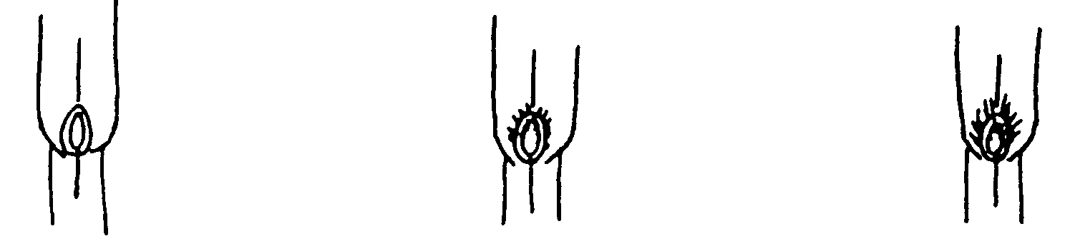
1 | 5 | 9
absent or very short | medium | very long

Ad 3: Leaf blade: density of fringe of hairs on margin of base

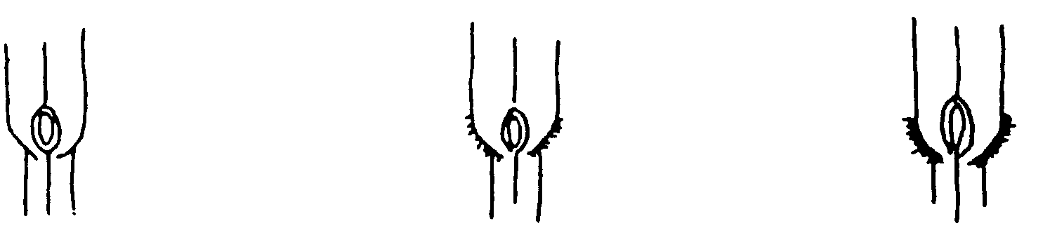
1 | 5 | 9
absent or very sparse | medium | very dense

Ad 6: Plant: growth habit without vernalization
Ad 8: Plant: growth habit after vernalization

1 - erect
3 – semi-erect
5 - intermediate
7 - semi-prostate
9 - prostate

Ad 10: Plant: time of inflorescence emergence

The trial should be observed at least twice a week.

Plots with spaced plants:
The date of inflorescence emergence of each single plant should be assessed. A single plant is considered to have reached inflorescence emergence when the tip of three inflorescences can be seen protruding from the flag leaf sheath (just after DC 50). From the single plant data a mean date per plot and a mean date per variety are obtained.

Row plots:
The time of inflorescence emergence is the date at which the average plot stage DC 54 has been reached. This date should – if necessary – be obtained by interpolation. At each observation date, the average plot stage should be expressed in one of the following growth stages:
DC 50 First spikelet of inflorescence just visible
DC 52 25% of the inflorescence emerged (across all stems)
DC 54 50% of the inflorescence emerged (across all stems)
DC 56 75% of the inflorescence emerged (across all stems)

Ad. 11: Flag leaf: length
Ad. 12: Flag leaf: width

The Flag leaf is the first leaf below the inflorescence. Measurements should be made on the same leaf.
Length should be measured, from the tip of the leaf blade to the leaf sheath.
Width should be measured, at the widest point of the leaf blade.

Ad 14: Inflorescence: shape of rachis of opposite lower side branches

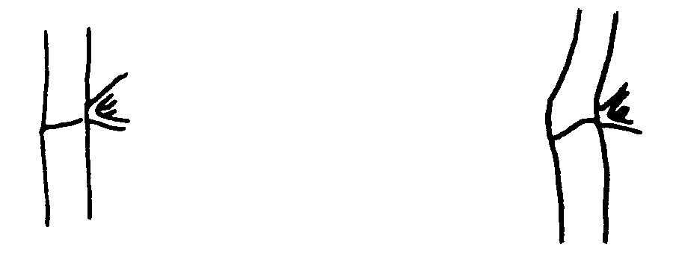
1 | 2
straight | bent

Ad 15: Inflorescence: form of collar of rachis opposite lower side branches

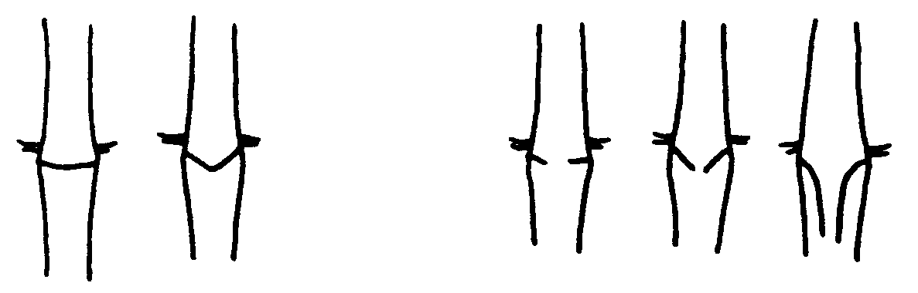
1 | 2
closed | open

Ad 16: Stem: length of upper internode
Ad 17: Inflorescence: length

Observations should be made on the longest stem. The upper internode (b) is the part of the stem above the upper node up to the beginning of the inflorescence (a).

8.2 Growth stages for grasses

All characteristics should be recorded at the appropriate time for the plant concerned. Growth stages of grasses are indicated by decimal codes which are derived from the decimal code for the growth stages of cereals (Zadoks, et al., 1974). This decimal code is in close conformity with the BBCH-code (Meier, 1997).

Seedling growth (seedling: one shoot)

DC 10 First leaf through coleoptile
DC 15 Five leaves unfolded
DC 19 Nine or more leaves unfolded

Tillering

DC 20 Main shoot only (beginning of tillering)
DC 23 Main shoot and 3 tillers
DC 25 Main shoot and 5 tillers
DC 29 Main shoot and 9 or more tillers

Stem elongation

DC 30 Pseudo-stem erection (formed by sheaths of leaves).
DC 31 First node detectable (early stem extension across all stems)
DC 35 Fifth node detectable (50 % extension across all stems)
DC 39 Flag leaf ligula/collar just visible (pre-boot stage)

Booting

DC 41 Flag leaf sheath extending (little enlargement of the inflorescence, early
boot-stage)
DC 45 Boots swollen (late-boot stage)
DC 47 First leaf sheath opening
DC 49 first awns visible (in awned forms only)

Inflorescence emergence (mostly non-synchronous)

DC 50 First spikelet of inflorescence just visible
DC 52 25 % of the inflorescence emerged (across all stems)
DC 54 50 % of the inflorescence emerged (across all stems)
DC 56 75 % of the inflorescence emerged (across all stems)
DC 58 Emergence of inflorescence completed

Anthesis (mostly non-synchronous)

DC 60 Beginning of anthesis
DC 64 Anthesis half-way
DC 68 Anthesis complete

Literature

Meier, U., 1997: Growth stages of mono- and dicotyledonous plants. BBCH-Monograph Blackwell Science. Berlin, Vienna, a.o., 622 pp.

Zadoks, J.C., Chang, T.T., Konzak, C.F., 1974: A decimal code for the growth stages of cereals. Weed Research 14: pp. 415 – 421.

Technical Questionnaire

TECHNICAL QUESTIONNAIRE |  |  |  | Page {x} of {y} |  | Reference Number:
 |  |  |  |  |  | Application date:
 |  |  |  |  |  | (not to be filled in by the applicant)
TECHNICAL QUESTIONNAIRE
to be completed in connection with an application for plant breeders’ rights

1. Subject of the Technical Questionnaire
1.1 Botanical name |  |  | Poa pratensis L.
1.2 Common name |  |  | Kentucky Bluegrass
2. Applicant
Name
Address
Telephone No.
Fax No.
E-mail address
Breeder (if different from applicant)
3. Proposed denomination and breeder’s reference
Proposed denomination
(if available)

Breeder’s reference
#4. Information on the breeding scheme and propagation of the variety

4.1 Breeding scheme

Variety resulting from:

4.1.1 Crossing

(a) controlled cross [ ]
(please state parent varieties)

(…………………..……………..…) x (……………..…………………..…)
female parent male parent

(b) partially known cross [ ]
(please state known parent variety(ies))

(…………………..……………..…) x (……………..…………………..…)
female parent male parent

(c) unknown cross [ ]

4.1.2 Mutation [ ]
(please state parent variety)

4.1.3 Discovery and development [ ]
(please state where and when discovered and how developed)

4.1.4 Other [ ]”
(please provide details)”

4.2 Method of propagating the variety

4.2.1 Seed-propagated varieties

(a) Self-pollination [ ]
(b) Cross-pollination
(i) population [ ]
(ii) synthetic variety [ ]
(c) Other [ ]
(please provide details)

4.2.3 Other [ ]
(please provide details)”

5. Characteristics of the variety to be indicated (the number in brackets refers to the corresponding characteristic in Test Guidelines; please mark the note which best corresponds).

 | Characteristics |  |  |  |  |  | Example Varieties |  |  | Note
5.1  (5) | Leaf: width
 | very narrow |  |  |  |  |  |  |  |  | 1[ ]
 | very narrow to narrow |  |  |  |  |  |  |  |  | 2[ ]
 | narrow |  |  |  |  |  | Limousine |  |  | 3[ ]
 | narrow to medium |  |  |  |  |  | Compact |  |  | 4[ ]
 | medium |  |  |  |  |  | Conni |  |  | 5[ ]
 | medium to broad |  |  |  |  |  | Baron |  |  | 6[ ]
 | broad |  |  |  |  |  | Lato, Monopoly |  |  | 7[ ]
 | broad to very broad |  |  |  |  |  |  |  |  | 8[ ]
 | very broad |  |  |  |  |  |  |  |  | 9[ ]
5.2  (10) | Plant: time of inflorescence emergence
 | very early |  |  |  |  |  | Adam 1 |  |  | 1[ ]
 | very early to early |  |  |  |  |  | Danube |  |  | 2[ ]
 | early |  |  |  |  |  | Balin |  |  | 3[ ]
 | early to medium |  |  |  |  |  | Limagie |  |  | 4[ ]
 | medium |  |  |  |  |  | Compact |  |  | 5[ ]
 | medium to late |  |  |  |  |  | Lato, |  |  | 6[ ]
 | late |  |  |  |  |  | Baron |  |  | 7[ ]
 | late to very late |  |  |  |  |  | Ambon |  |  | 8[ ]
 | very late |  |  |  |  |  | Hifi |  |  | 9[ ]
 | Characteristics |  |  |  |  |  | Example Varieties |  |  | Note
5.3  (13) | Plant: natural height when fully expanded
 | very short |  |  |  |  |  |  |  |  | 1[ ]
 | very short to short |  |  |  |  |  | Miracle |  |  | 2[ ]
 | short |  |  |  |  |  | Limousine |  |  | 3[ ]
 | short to medium |  |  |  |  |  | Bartender |  |  | 4[ ]
 | medium |  |  |  |  |  | Compact |  |  | 5[ ]
 | medium to long |  |  |  |  |  | Limerick |  |  | 6[ ]
 | long |  |  |  |  |  | Likollo |  |  | 7[ ]
 | long to very long |  |  |  |  |  | Danube |  |  | 8[ ]
 | very long |  |  |  |  |  | Lato |  |  | 9[ ]
6. Similar varieties and differences from these varieties

Please use the following table and box for comments to provide information on how your candidate variety differs from the variety (or varieties) which, to the best of your knowledge, is (or are) most similar. This information may help the examination authority to conduct its examination of distinctness in a more efficient way.

Denomination(s) of variety(ies) similar to your candidate variety |  | Characteristic(s) in which your candidate variety differs from the similar variety(ies) |  |  | Describe the expression of the characteristic(s) for the similar variety(ies) |  |  | Describe the expression of the characteristic(s) for your candidate variety
Example |  | Plant: time of inflorescence emergence |  |  | early |  |  | medium
Comments:

#7. Additional information which may help in the examination of the variety

7.1 In addition to the information provided in sections 5 and 6, are there any additional characteristics which may help to distinguish the variety?

Yes [ ] No [ ]

(If yes, please provide details)

7.2 Are there any special conditions for growing the variety or conducting the examination?

Yes [ ] No [ ]

(If yes, please provide details)

7.3 Other information

8. Authorization for release

(a) Does the variety require prior authorization for release under legislation concerning the protection of the environment, human and animal health?

Yes [ ] No [ ]

(b) Has such authorization been obtained?

Yes [ ] No [ ]

If the answer to (b) is yes, please attach a copy of the authorization.

9. Information on plant material to be examined or submitted for examination.

9.1 The expression of a characteristic or several characteristics of a variety may be affected by factors, such as pests and disease, chemical treatment (e.g. growth retardants or pesticides), effects of tissue culture, different rootstocks, scions taken from different growth phases of a tree, etc.

9.2 The plant material should not have undergone any treatment which would affect the expression of the characteristics of the variety, unless the competent authorities allow or request such treatment. If the plant material has undergone such treatment, full details of the treatment must be given. In this respect, please indicate below, to the best of your knowledge, if the plant material to be examined has been subjected to:

(a) Microorganisms (e.g. virus, bacteria, endophytes) Yes [ ] No [ ]

(b) Chemical treatment (e.g. growth retardant, pesticide) Yes [ ] No [ ]

(c) Tissue culture Yes [ ] No [ ]

(d) Other factors Yes [ ] No [ ]

Please provide details for where you have indicated “yes”.

……………………………………………………………

9.3 In case the variety is infected with endophytes please indicate for information purpose the level of infection

< 10% [ ]
10–85% [ ]
>85% [ ]

10. I hereby declare that, to the best of my knowledge, the information provided in this form is correct:

Applicant’s name

Signature Date

[Annex follows]

NL proposed to keep from TG/33/6:

- Leaf sheath: density of hairs on margin (+, 23-25, VS C)
- Leaf blade: density of hairs on upper side (+, 23-25, VS C)

IT proposed to add new characteristic:

- Plant: natural height after vernalisation (stage?, MS A, MG B)

CZ and IT proposed to keep from TG/33/6:

- Plant: length of longest stem, inflorescence included (when fully expanded) (60-68, MS A)

Remark: The characteristic was replaced by "Plant: natural height when fully expanded)". Natural height gives a higher contribution to distinctness because "Plant: length of longest stem, inflorescence included (when fully expanded)" is strongly correlated with "Inflorescence: length " and "Stem: length of upper internode".

[End of Annex and of document]

* These names were correct at the time of the introduction of these Test Guidelines but may be revised or updated. [Readers are advised to consult the UPOV Code, which can be found on the UPOV Website (www.upov.int), for the latest information.]
# Authorities may allow certain of this information to be provided in a confidential section of the Technical Questionnaire.
# Authorities may allow certain of this information to be provided in a confidential section of the Technical Questionnaire.

