E
International Union for the Protection of New Varieties of Plants

Enlarged Editorial Committee  Geneva, October 28 and 29, 2018 | TC-EDC/Oct18/5  Original: English  Date: October 13, 2018
Matters to be resolved concerning Test Guidelines considered by the Enlarged Editorial Committee in March: Pea (Pisum sativum L.) (Partial revision)
Document prepared by the Office of the Union
Disclaimer: this document does not represent UPOV policies or guidance
The Enlarged Editorial Committee (TC-EDC), at its meeting held in Geneva, on March 26 and 27, 2018, considered document TC-EDC/MAR18/5 “Partial revision of the Test Guidelines for Pea” and agreed that the technical issues raised should be addressed by the Technical Working Party for Vegetables (TWV) (see document TC-ECD/MAR18/11 “Report”, paragraph 57).

The TWV, at its fifty-second session, held in Beijing, China, from September 17 to 21, 2018, considered document TWV/52/10 “Matters to be resolved concerning Test Guidelines adopted by the Technical Committee: Pea” containing the comments made by the TC-EDC and the proposed responses by the Leading Expert, Mr. Pascal Coquin (France). The TWV agreed the following (see document TWV/52/20 “Report”, paragraph 61):

Ad. 60 | to magnify photos (Are the images large enough to see the detail required? If you zoom on the computer, they have very good resolution but are the details clear enough on the printed page?)  TWV: to read as follows (see also changes for Char. 60, Ad. 60, 11., below)  (see document TWV/52/10 for pictures in original size)

Class 0:  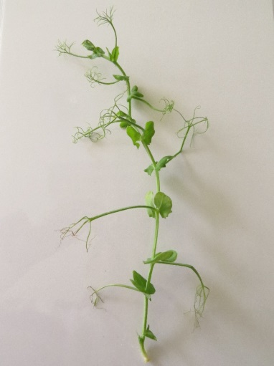 | Class 1:  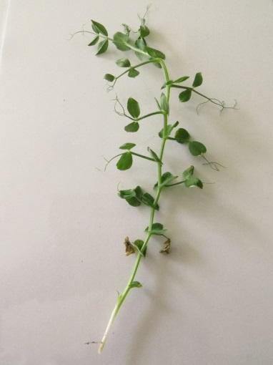
Class 2:  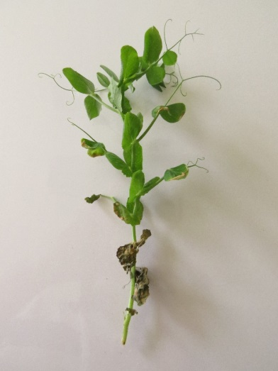 | Details on Class 2:  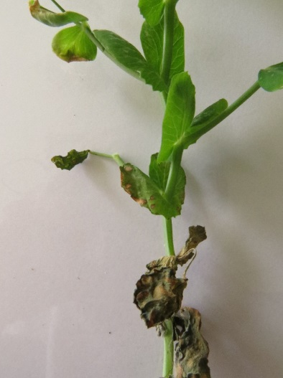
Class 3 :  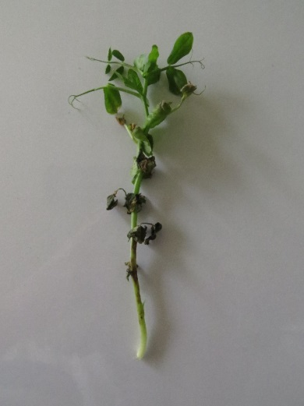 | Details on Class 3  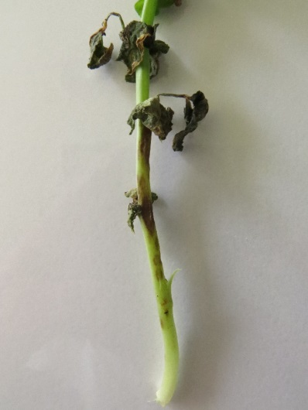

Ad. 60, 4.  Footnotes 1, 2 | to indicate e-mail and web address of the institutions instead of personal e-mail addresses  Leading Expert: matref@geves.fr / www.geves.fr  TWV: agreed
Ad. 60, 5. | to read “Ascochyta pisi race C strain 21A.13. (the test protocol has been validated in a European CPVO co-funded project3 with this isolate)³”  TWV: agreed
Ad. 60, Footnote 3 | to be moved to 9. Literature with standardized format of literature quotes.  TWV: agreed
Ad. 60, 6. | to add “Gallais et Bannerot, 1992” to chapter 9. Literature  TWV: agreed
Ad. 60 | to delete 8.2, 8.3 and 8.5  TWV: agreed
Ad. 60, 8.8 | to clarify meaning of “4/8h” (does it mean “half hour”?)  Leading Expert: it means “between 4 and 8 hours”  TWV: agreed
Char. 60,  Ad. 60, 11. | - to provide clarification on type of expression: see explanation, doesn’t correspond to QL  - the 4-notes scale in Ad. 60, 11.2 “observation scale” indicates QN)  clarification by TWV needed  - in order to avoid confusion, avoid the term notes  TWV: to replace “notes” with “classes”, to keep QL but delete illustration on Interpretation depending on controls  - to check whether to have separate characteristics for each strain  (With this explanation it is very unlikely that notes absent/present are appropriate. In particular the photos and the drawing are confusing. Where is the clear gap between 1 and 9?)  TWV: to delete all other strains except the strain C as precised below:  Physiological race (Dr. Hubbeling) Strains C Tézier 21A.13  Gullivert S  Rondo R  Finale R  Kelvedon Wonder S  Dark Skin Perfection S  Arabal, Cobri, Starcovert, Sucovert, Vitalis S  R = resistant; S = susceptible  - What means “necrosis at each level of the plant”? Clarification needed.  TWV: to read “necrosis on all parts of the plant”

[End of document]

