E
International Union for the Protection of New Varieties of Plants

Enlarged Editorial Committee  Geneva, March 20 and 21, 2023 | TC-EDC/Mar23/4  Original: English  Date: January 18, 2023
Matters to be resolved concerning Test Guidelines put forward for adoption by the Technical Committee: Sunflower
Document prepared by the Office of the Union
Disclaimer: this document does not represent UPOV policies or guidance
The Enlarged Editorial Committee (TC-EDC) at its meeting on October 18, 19 and 24, 2022, considered the draft Test Guidelines for Sunflower (document TG/81/7(PROJ.5)) and agreed that it required editorial clarifications to be provided by the Leading Expert. The TC-EDC agreed to reconsider the draft Test Guidelines at its meeting to be held in March 2023.

Recommendations from the TC-EDC on the draft Test Guidelines for Sunflower are presented in the table below, including the required editorial clarifications (indicated with “#”) and responses from the Leading Expert, Mr. Zoltán Csűrös (Hungary):

General | - to replace “grains” by “seeds” throughout the TG  - to correct spelling of “disc floret” (instead of “disk” throughout the TG)
2.3 | to read “… 1 kg of seed for hybrid and open-pollinated varieties…”
3.1.2 | to be deleted as it is an annual crop
Char. 5 | to read “Leaf: profile in cross-section”
#Char. 6 | to be reviewed (states of expression do not relate to the title of the char.)  Leading Expert: the characteristic title should read “Leaf: shape”. Ad.6 clarifies what should be observed.
Char. 7 | to read “Leaf: lobes”
Char. 8 | - to read “Leaf: parenchyma at base of lateral veins”  - to have states (1) none or very weak, (2) weak, (3) strong
Char. 12 | - state 1 to read “erect”  - state 2 to read “semi-erect”
Char. 13 | - to read “Ray floret: profile”  - to have states (1) flat, (2) rolled, (3) twisted, (4) strongly recurved
Char. 16 | to delete “moderately” from states 2 and 3
#Char. 20 | to check whether to have same explanation as characteristic 21  Leading Expert: agreed
Char. 26 | to replace “embracing” with “adpressed” in all states
Char. 30 | to read “… position of branching”
#Char. 34 | - to read “Head: diameter”  - to add in the explanation that for branching varieties the central head should be observed  Leading Expert: agreed
Char. 42 | to check whether to have order of colors according to document TGP/14 (brown before grey)
Char. 40 | - to read “Seed: stripes on margins”  - to have states (1) none or very weak, (2) weak, (3) strong
Char. 41 | to have states (1) none or very weak, (2) weak, (3) strong

#Ad. 6 | - to read “Observations should be made on the upper two-thirds of the leaf.”  Leading Expert: to delete sentence or to read “Observation should be made on the distal part of the leaf”  - to add drawings illustrating the shapes  Leading Expert: provided illustrations

 | 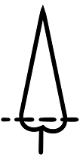 | 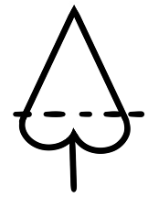 | 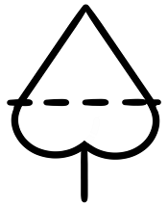
1 | 2 | 3 | 4
lanceolate | lanceolate to  narrow triangular | narrow triangular | medium triangular

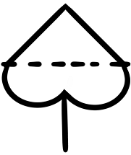 | 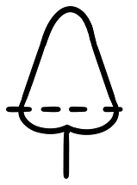 | 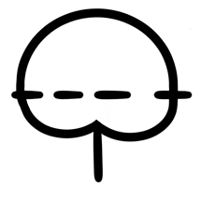
5 | 6 | 7
broad triangular | broad triangular to rounded | rounded

Ad. 17 | to check whether to read “The ray floret color is the color with the largest surface area. In cases where the areas of the color are too similar to reliably decide which color has the largest area, the darker color is to be observed.”
Ad. 18 | to read “…inner third of the disc.”
Ad. 23 | to read “To be observed excluding the differentiated tip.”
Ad. 24 | to delete arrow
Ad. 30 | state 3 to read “throughout”
9. | to adjust format of literature references (see TGP/7, GN 30)
TQ 5.6, 5.7 | to delete “the variety is not …”
TQ 7.3 (2) | to replace “precise” with “specify” in (a) and (b)
ANNEX, Part III, Procedure, 5.4 | - to remove additional space between “de-ionised water”  - to remove additional space before “fixed in 40% ethanol solution”

The TC-EDC will consider the above information on the draft Test Guidelines for Sunflower at its meeting to be held in March 2023 and the Test Guidelines be submitted to the TC for adoption by correspondence.

[End of document]

