E
International Union for the Protection of New Varieties of Plants

Enlarged Editorial Committee  Geneva, March 20 and 21, 2023 | TC-EDC/Mar23/3  Original: English  Date: January 12, 2023
Matters to be resolved concerning Test Guidelines put forward for adoption by the Technical Committee: Strawberry
Document prepared by the Office of the Union
Disclaimer: this document does not represent UPOV policies or guidance
The Enlarged Editorial Committee (TC-EDC) at its meeting on October 18, 19 and 24, 2022, considered the draft Test Guidelines for Strawberry (document TG/22/11(PROJ.5)) and agreed that it required an editorial clarification to be provided by the Leading Expert. The TC-EDC agreed to reconsider the draft Test Guidelines at its meeting to be held in March 2023.

Recommendations from the TC-EDC on the draft Test Guidelines for Strawberry are presented in the table below, including the required editorial clarification (indicated with “#”) and the response from the Leading Expert, Mr. Erik Schulte (Germany):

Table of Chars. | to correct names of example varieties as follows:  Aramella Aromella  Rinia Rina  CF 4402 CIR 104
Char. 2 | to reduce scale to 5 notes (see illustration for state 3 in Ad. 2 looks very sparse)
Char. 5 | state 2 to read “very few to few”
Char. 11 | state 3 to read “slightly longer than broad”
Char. 14 | to read “…incisions of margin”
Char. 15 | to read “Leaf: profile in cross-section”
Char. 18 | to be indicated as (a) (delete (b))
Chars. 19 to 25 | to be indicated as (b) (delete (c))
Char. 26 | to read “Fruit: length in relation to width”
Char. 28 | state 2 to read “conic” (see TGP/14)
Char. 29 | - to read “Fruit: position of maximum width”  - to add (d)
Char. 30 | to reverse order so that acute is the first state (see TGP/14)
Char. 35 | to add (d)
8.1 (a) | to read “Observations should be made shortly before …”
8.1 (b) | to read “Observations should be made at full flower. Observations on the flower …”
8.1 (c) | to read “Observations should be made after the end of bearing of the non-remontant varieties.”
#8.1 (d) | to check whether to read “Observations should be made at picking ripeness, excluding the terminal fruits of the infructescences.” (“one-year-old plants” are inconsistent with 3.1.2; to clarify how to observe fruits in the second year from a single planting)  Leading Expert: agreed with proposed new wording
Ad. 7 | to replace current illustration with the following on:  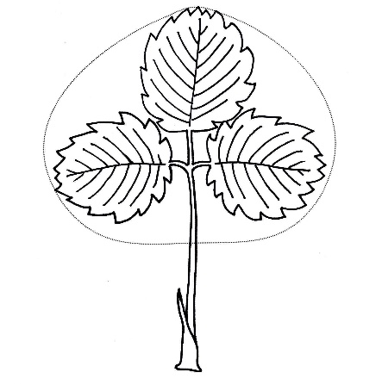
Ad.14 | to replace current illustration with improved one below:  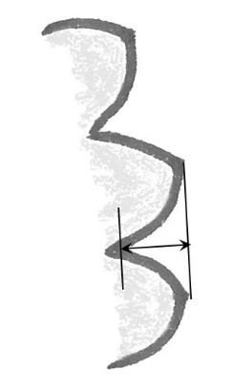
Ad. 16 | to move illustration in same direction as in Ad. 7
Ad. 17 | to replace current illustrations with improved ones below:
Ad. 23 | to replace current illustrations with improved ones below:
Ad. 35 | to read “Observations should be made on the side of the fruit which is exposed to the sun.”
Ad. 36 | to read “Observations should be made on the central part of the fruit by counting in a defined area [e.g. a 1 cm square] or by visual assessment.”
TQ 4.2.2 | to read “Seeds” (see GN 31, example 2)
Ad. 42 | to read “… plants have at least one open flower”
Ad. 43 | to read “… plants have at least one fully colored fruit.”

The TC-EDC is invited to note that the Test Guidelines for Strawberry will be submitted to the TC for adoption by correspondence.

[End of document]

