E
International Union for the Protection of New Varieties of Plants

Enlarged Editorial Committee  Geneva, March 26 and 27, 2019 | TC-EDC/Mar19/6  Original: English  Date: February 5, 2019
Partial revision of the Test Guidelines for Pea
Document prepared by an expert from France
Disclaimer: this document does not represent UPOV policies or guidance
The purpose of this document is to present a proposal for a partial revision of the Test Guidelines for Pea (document TG/7/10 Rev.).

The Technical Working Party for Vegetables (TWV), at its fifty-second session, held in Beijing, China, from September 17 to 21, 2018, considered a proposal for a partial revision of the Test Guidelines for Pea (Pisum sativum L.) on the basis of documents TG/55/7 Rev. 5 and TWV/52/5 “Partial Revision of the Test Guidelines for Pea” and proposed the following revisions to the Test Guidelines for Pea (see document TWV/52/20 “Report”, paragraph 70):

- To change the example varieties for Characteristic 58 “Resistance to Fusarium oxysporum f. sp. pisi Race 1”
- To change the methodology for Characteristic 58 under Ad. 58

The proposed changes are presented below in highlight and underline (insertion) and strikethrough (deletion).

Proposed change to the example varieties for Characteristic 58 “Resistance to Fusarium oxysporum f. sp. pisi Race 1”

Current wording

 |  | English | français | deutsch | español | Example Varieties  Exemples  Beispielssorten  Variedades ejemplo | Note/  Nota
58.  (+) | VG | Resistance to Fusarium oxysporum f. sp. pisi | Résistance à Fusarium oxysporum f. sp. pisi | Resistenz gegen Fusarium oxysporum f. sp. pisi | Resistencia a Fusarium oxysporum f. sp. pisi
58.1 |  | Race 1 | Race 1 | Pathotyp 1 | Raza 1
QL |  | absent | absente | fehlend | ausente | Eden,  Mammoth Melting Sugar | 1
 |  | present | présente | vorhanden | presente | Solara, Twinkle | 9
58.2 |  | Race 5 | Race 5 | Pathotyp 5 | Raza 5
QL |  | absent | absente | fehlend | ausente | Legacy, Little Marvel | 1
 |  | present | présente | vorhanden | presente | Serge, Sundance | 9
58.3 |  | Race 6 | Race 6 | Pathotyp 6 | Raza 6
QL |  | absent | absente | fehlend | ausente | Little Marvel, Serge | 1
 |  | present | présente | vorhanden | presente | Sundance | 9

Proposed new wording

 |  | English | français | deutsch | español | Example Varieties  Exemples  Beispielssorten  Variedades ejemplo | Note/  Nota
58.  (+) | VG | Resistance to Fusarium oxysporum f. sp. pisi  Race 1 | Résistance à Fusarium oxysporum f. sp. pisi  Race 1 | Resistenz gegen Fusarium oxysporum f. sp. pisi  Pathotyp 1 | Resistencia a Fusarium oxysporum f. sp. pisi  Raza 1
58.1 |  | Race 1 | Race 1 | Pathotyp 1 | Raza 1
QL |  | absent | absente | fehlend | ausente | Eden, Mammoth Melting Sugar  Bartavelle | 1
 |  | present | présente | vorhanden | presente | Solara, Twinkle  New Era, Nina | 9
58.2 |  | Race 5 | Race 5 | Pathotyp 5 | Raza 5
QL |  | absent | absente | fehlend | ausente | Legacy, Little Marvel, Mini | 1
 |  | present | présente | vorhanden | presente | Serge, Sundance II | 9
58.3 |  | Race 6 | Race 6 | Pathotyp 6 | Raza 6
QL |  | absent | absente | fehlend | ausente | Little Marvel, Serge, Mini | 1
 |  | present | présente | vorhanden | presente | Sundance Grant | 9

Proposed change to the methodology for Characteristics 58 under Ad. 58

Current wording

Ad. 58.1, 58.2, 58.3: Resistance to Fusarium oxysporum f. sp. pisi

Resistant and Susceptible varieties
Race 1: Eden, Mammoth Melting Sugar (susceptible = resistance absent (1))
Solara, Twinkle (resistant = resistance present (9))

Race 5: Little Marvel, Legacy (susceptible = resistance absent (1))
Serge, Sundance (resistant = resistance present (9))

Race 6: Little Marvel, Serge (susceptible = resistance absent (1))
Sundance (resistant = resistance present (9))

Isolates and isolate identity
Isolate identity is determined by testing against the host differential set described by Haglund and Kraft (1979). All isolates are derived from single spore cultures.

Isolates used in the test: Race 1: IPO culture collection no. 20379
Race 5: IPO culture collection no. 10279
Race 6: WSU culture type 6

Maintenance of isolates
Maintain in a refrigerator at 4ºC as a soil culture (loam) and pass through a susceptible variety every 2-3 years. Isolate identity is determined by testing against a host differential set.

Source for isolates
Races 1 and 5 Research Institute for Plant Protection (IPO)
PO Box 9060
NL-6700 GW Wageningen
The Netherlands

Race 6 Washington State University (WSU),
Research and Extension Unit,
Mount Vernon, Washington 98273,
United States of America

Preparation of inoculum and assessment of disease
Cultures of the fungus are grown in liquid Czapek-Dox medium at 2ºC in daylight conditions for 7 days. The liquid is continuously aerated by sterile air. The cultures are strained through muslin followed by centrifugation at 3,500 rpm for 10 minutes; the solution is diluted with distilled water to a concentration of 10⁶ spores/ml.

Inoculation and assessment of disease Test plants and controls are raised in 8 liters of 1:1 peat and sand mixture and adjusted to pH 5.0. 1 liter of spore suspension is used. Two replicates of 10 plants are grown for assessment; a third replicate is grown if any problems arise.

After 3 weeks, or 4 - 5 node stage, the basal third of the seedling roots can be cut and dipped into the inoculum for 3-5 seconds before being transplanted. Four weeks after inoculation, surviving seedlings are recorded as resistant.

Composition of the Czapek-Dox liquid medium

2.0 g Sodium Nitrate
0.5 g Potassium Chloride
1.0 g Dipotassium Phosphate
0.5 g Magnesium Sulphate
0.01 g Ferrous Sulphate
30.0 g Saccharose

The above mixture is added to 1 liter of distilled water and poured into a flask; the solution is sterilized in an autoclave at 115ºC for 20 minutes.

Genetic background
A single dominant gene Fw confers resistance to Race 1.
Proposed new wording

Ad. 58.1, 58.2 and 58.3: Resistance to Fusarium oxysporum f. sp. pisi race 1 (Near wilt) race 5 and race 6

1. | Pathogen | Fusarium oxysporum f. sp. pisi (race 1)
2. | Quarantine status | no
3. | Host species | Pea – Pisum sativum L.
4. | Source of inoculum | GEVES (FR), INIA (ES) or SASA (GB)
5. | Isolate | Fusarium oxysporum f. sp. pisi race 1 strain MATREF 04-02-01-01 (the test protocol has been validated with this isolate/race)
6. | Establishment isolate identity | genetically defined pea controls (See ISF website: http://www.worldseed.org)

Differentials host
susceptible: | M410, Bartavelle, Little Marvel
resistant: | New Era, Mini 93, Dark Skin Perfection, Vantage, WSU 23, New Season, WSU 31, 74SN5, Sundance II, Grant

7. | Establishment pathogenicity | Test on susceptible plants
8. | Multiplication inoculum
8.1 | Multiplication medium | Multiplication on agar medium: malt Agar or PDA for example
8.4 | Inoculation medium | Multiplication on agar medium: water for scraping agar plates.  Multiplication on liquid medium: Potato Dextrose Broth, Kerrs broth or Czapek-Dox (3 to 7 days old aerated culture) for example.
8.6 | Harvest of inoculum | see 10.1
8.7 | Check of harvested inoculum | see 10.2
8.8 | Shelflife/viability inoculum | between 4 and 8 hours, keep cool to prevent germination of spores. Viability of spores should be more than 3 years if stored at -20°C.
9. | Format of the test
9.1 | Number of plants per genotype | At least 20 plants and 5 non inoculated plants per variety.
9.2 | Number of replicates | -
9.3 | Control varieties | Susceptible controls: Bartavelle  Resistant controls: New Era and Nina
9.5 | Test facility | Climate room or greenhouse.
9.6 | Temperature | 20-25°C
9.7 | Light | 12 hours or longer
9.9 | Special measures | It is important to compare the inoculated plants with the negative non inoculated control plants of the same sample. This allows interpretation of symptoms of root rot, senescence or 'wilting' caused by the stress of having roots cutted and not caused by F. oxysporum infection.
10. | Inoculation
10.1 | Preparation inoculum | For agar plates, remove hyphen fragments by filtering solution through muslin.  For liquid medium, filter through muslin.
10.2 | Quantification inoculum | 10⁶ spores/ml
10.3 | Plant stage at inoculation | seeds or 2 weeks old seedlings (2-3 node stage).
10.4 | Inoculation method | For seeds:  sowing in contaminated substrate (soil based substrate), 750 ml of suspension of spores at 10⁶ sp/ml for 5 l of substrate.  For 2 weeks seedlings:  Sowing in a mix of vermiculite + soil or soil based substrate  Cut the apical 2/3 of the roots with scissors, dip the root of the seedling in the spores suspension for 1 to 5 minutes and transplant in clean soil based substrate in a new tray.
10.7 | Final observations | 28 days post-inoculation.
11. | Observations
11.1 | Method | Visual
11.2 | Observation scale | susceptible:  Class 2: Range from most of the plant wilted/dried but still alive, to plants brown and dead with stem collapsed.  resistant:  Class 0: No symptoms or equivalent to negative control, 1 or 2 wilted/dried lower leaves and slight reduction in growth compared to negative control of same variety are acceptable.  Class 1: Range from a few chlorotic or wilted/dried leaves not present on, or more than on the negative control, up to many leaves with symptoms of senescence or wilting, some leaf drop, upper part of the plant still green and growing.

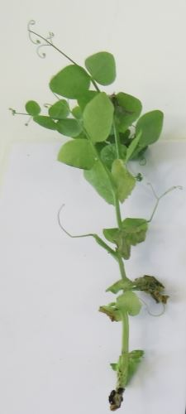 | 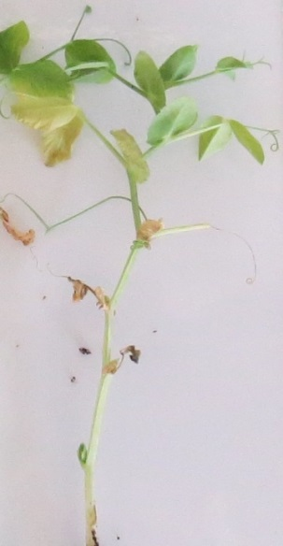 | 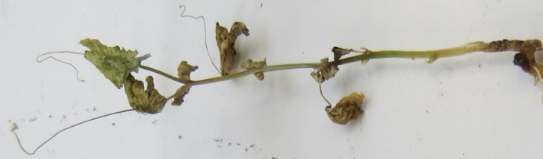 | 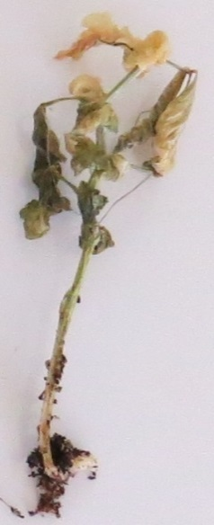
Class 0  resistant | Class 1  resistant | Class 2  susceptible

 |  | Varieties with the same or higher level of resistance as New Era will be interpreted as resistant. Varieties with a lower level of resistance than New Era will be interpreted as susceptible. Nina will be highly resistant, Bartavelle will be highly susceptible. New Era expresses weak symptoms and variation can occur in these weak symptoms depending on the agressivity of the test conditions.
11.3 | Validation of test | evaluation of variety resistance should be calibrated with results of resistant and susceptible controls.
12. | Interpretation of data in terms of UPOV characteristic states
 | absent [1] | susceptible
 | present [9] | resistant
13. | Critical control points | Each lab has to define the best method of inoculation in its lab depending on controls results.  Inoculation by sowing in contaminated soil can in some cases lead to germination problems. No conclusion can be done in this case, and the test should be repeated.

[End of document]

matref@geves.fr / www.geves.fr
resistencias@inia.es
restest@sasa.gov.scot

