E
International Union for the Protection of New Varieties of Plants

Enlarged Editorial Committee  Geneva, March 26 and 27, 2018 | TC-EDC/Mar18/5  Original: English  Date: January 25, 2018
Partial revision of the Test Guidelines for PEA
Document prepared by an expert from the European Union
Disclaimer: this document does not represent UPOV policies or guidance
The purpose of this document is to present a proposal for a partial revision of the Test Guidelines for Pea (Pisum sativum L.) (document TG/7/10 Rev.).

The Technical Working Party for Vegetables (TWV), at its fifty-first session, held in Roelofarendsveen, Netherlands, from July 3 to 7, 2017, considered a proposal for a partial revision of the Test Guidelines for Pea (Pisum sativum L.) on the basis of documents TG/7/10 Rev. and TWV/51/6 “Partial Revision of the Test Guidelines for Pea” and proposed the following revisions to the Test Guidelines for Pea (see document TWV/51/16 “Report”, paragraphs 104 and 105):

- To add new example varieties for Characteristic 60 “Resistance to Ascochyta pisi Race”
- To change the methodology for Characteristic 60 under Ad. 60
The proposed changes are presented below in highlight and underline (insertion).

Proposed change to add new example varieties for Characteristic 60 “Resistance to Ascochyta pisi Race”

Current wording

60.  (+) | VG | Resistance to Ascochyta pisi,  Race C | Résistance à Ascochyta pisi,  race C | Resistenz gegen Ascochyta pisi, Pathotyp C | Resistencia a Ascochyta pisi,  Raza C
QL |  | absent | absente | fehlend | ausente | Kelvedon Wonder | 1
 |  | present | présente | vorhanden | presente | Rondo | 9

Proposed new wording

60.  (+) | VG | Resistance to Ascochyta pisi,  Race C | Résistance à Ascochyta pisi,  race C | Resistenz gegen Ascochyta pisi, Pathotyp C | Resistencia a Ascochyta pisi,  Raza C
QL |  | absent | absente | fehlend | ausente | Crecerelle,  Kelvedon Wonder | 1
 |  | present | présente | vorhanden | presente | Madonna, Nina, Rondo | 9

Proposed change to the methodology for Characteristic 60 under Ad. 60

Current wording

Ad. 60: Resistance to Ascochyta pisi, Race C (Ascochyta Leaf and Pod Spot)

Resistant and Susceptible varieties
Kelvedon Wonder (susceptible = resistance absent (1))
Rondo (resistant = resistance present (9))
Isolates and isolate identity
Isolate used in the test: Tezier Strain
Isolate identity is determined by testing against a host differential set.

Maintenance of isolates
Maintain on Mathur medium at ambient temperature. Isolate identity is determined by testing against a host differential set.

Source for isolates: GEVES SNES
Station Nationale d’Essais de Semences
Rue George Morel, B.P.24
49071 Beaucouzé Cedex France

Preparation of inoculum
Add 0.4% Tween 80 wetting agent to aid dispersal of spores. Remove hyphal fragments by straining solution through muslin. Concentration of 10⁶ spores/ml

Inoculation and assessment of disease
Grow seedlings in glasshouse under natural daylength at 20ºC and high humidity. Spray inoculum on young seedlings 10-15 days after emergence; mist spray 2 or 3 times per day for 15 minutes. Alternatively, inoculation can be made at the apex of enclosed leaves. This method does not require conditions of high humidity.

Plants are assessed about 5 days after inoculation. Infection is very clear when present: necrotic lesions are slightly sunken, brown and sharply delineated. Lesions are circular on pods and elongated on stems. Two replicates of 10 plants are grown; a third replicate is grown if any problems arise.

Genetic background
The expression of resistance to Race C (also known as BP2) is controlled by a single dominant gene Rap2. At least five pathotypes and four resistance alleles are known.

Proposed new wording

Ad. 60: Resistance to Ascochyta pisi, Race C

1. | Pathogen | Ascochyta pisi
2. | Quarantine status | no
3. | Host species | Pea – Pisum sativum L.
4. | Source of inoculum | GEVES (FR) or SASA (GB)
5. | Isolate | Ascochyta pisi race C strain 21A.13. (the test protocol has been validated in a European CPVO co-funded project with this isolate).
6. | Establishment isolate identity | genetically defined pea controls (Physiological races of A. pisi and differentials, adapted from Gallais et Bannerot, 1992)

Physiological races (Dr Hubbeling)  Strains | D  N°1 | _  Several isolates | _  N°4 | _  N°14 | C  Tézier  21A.13 | B  _ | E  _
Gullivert | R | R | R | R | S | R | R
Rondo | R | R | S | VLS | R | R | S
Finale | R | R | S | LS | R | - | -
Kelvedon Wonder | R | S | S | S | S | R | R
Dark Skin Perfection | S | S | S | S | S | R | S
Arabal, Cobri, Starcovert, Sucovert, Vitalis | S | S | S | S | S | S | S
R = resistant; S = susceptible, VLS = very lightly susceptible, LS = lightly susceptible

7. | Establishment pathogenicity | test on susceptible plants
8. | Multiplication inoculum
8.1 | Multiplication medium | V8 agar or Mathur medium or Potato Dextrose Agar or a synthetic medium.
8.2 | Multiplication variety | -
8.3 | Plant stage at inoculation | -
8.4 | Inoculation medium | water, option: add Tween 80 (wetting agent to aid dispersal of spores, e.g. 0.4%)
8.5 | Inoculation method | -
8.6 | Harvest of inoculum | see 10.1
8.7 | Check of harvested inoculum | see 10.2
8.8 | Shelflife/viability inoculum | 4/8h, keep cool to prevent spores’ germination
9. | Format of the test
9.1 | Number of plants per genotype | at least 20 plants and 5 non inoculated plants per variety
9.2 | Number of replicates | -
9.3 | Control varieties
 | Susceptible | Crecerelle, Kelvedon Wonder
 | Resistant | Nina and Madonna or Rondo
9.4 | Test design | -
9.5 | Test facility | climate room or greenhouse
9.6 | Temperature | 20°C
9.7 | Light | 12 hours or longer
9.8 | Season | -
9.9 | Special measures | high humidity or watering by spraying 2 or 3 times per day
10. | Inoculation
10.1 | Preparation inoculum | remove hyphen fragments by straining solution through muslin
10.2 | Quantification inoculum | 10⁶ spores/mL (to adapt depending conditions of tests)
10.3 | Plant stage at inoculation | 2 weeks old seedlings (i.e. 2-3 node stage)
10.4 | Inoculation method | spraying on green leaves without surface moisture
10.5 | First observation | -
10.6 | Second observation | -
10.7 | Final observations | 10-18 days post-inoculation
11. | Observations
11.1 | Method | visual
11.2 | Observation scale | 0: no symptoms  1: few small superficial necrosis  2: bigger darker and deep necrosis  3: necrosis at each level of the plant or serious symptoms surrounding the stem  Madonna, Nina and Rondo will be resistant controls; varieties with same level of resistance as Madonna/Rondo and/or Nina will be interpreted as resistant. Crecerelle and Kelvedon Wonder will be susceptible controls, varieties with a lower level of resistance than Nina as well as Madonna/Rondo will be interpreted as susceptible.

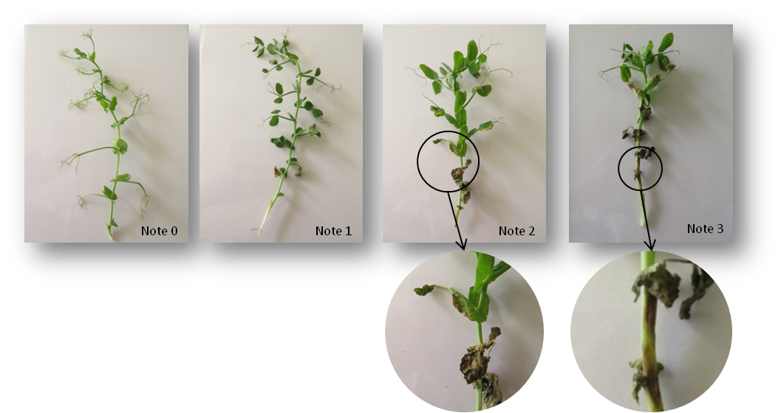

Resistant
Crecerelle
Madonna
Nina
Susceptible
Kelvedon Wonder
Rondo

11.3 | Validation of test | evaluation of variety resistance should be calibrated with results of resistant and susceptible controls
11.4 | Off-types | -
12. | Interpretation of data in terms of  UPOV characteristic states
 | absent [1]  present [9] | susceptible  resistant
13. | Critical control points | -

[End of document]

matref@geves.fr
Marian.McEwan@sasa.gsi.gov.uk
Harmores 2 CPVO project (http://www.cpvo.europa.eu/main/en/home/documents-and-publications/technical-projects-reports)

