 | E
International Union for the Protection of New Varieties of Plants

Enlarged Editorial Committee  Virtual meeting, January 13 and 15, 2025 | TC-EDC/Jan25/2  Original: English  Date: November 1, 2024
Partial revision of the Test Guidelines for Asparagus
Document prepared by an expert from Japan
Disclaimer: this document does not represent UPOV policies or guidance
The purpose of this document is to present a proposal for a partial revision of the Test Guidelines for Asparagus (document TG/130/4).

The Technical Working Party for Vegetables (TWV), at its fifty-eighth session, considered a proposal for a partial revision of the Test Guidelines for Asparagus (Asparagus officinalis L.) on the basis of documents TG/130/4 and TWV/58/5 “Partial revision of the Test Guidelines for Asparagus” and proposed the following changes (see document TWV/58/11 “Report”, paragraph 65):

- Revision of Characteristic 16 “Type of flowering”
- Revision of Ad.16 “Type of flowering”

The proposed new wording is presented below. The proposed changes are presented in highlight and underline (insertion) and strikethrough (deletion) in the Annex to this document (in English only).

Revision of Characteristic 16 “Type of flowering”

 |  | English | français | deutsch | español | Example Varieties/  Exemples/  Beispielssorten/  Variedades ejemplo | Note/  Nota
16.  (+)  (*) | VG | Type of flowering | Type de floraison | Blühtyp | Tipo de floración
QL |  | only plants with male flowers without style rudiments | seulement plantes avec des fleurs mâles sans rudiments de style | nur Pflanzen mit männlichen Blüten ohne Griffelrudimente | solo plantas con flores masculinas sin estilo | Cumulus | 1
 |  | plants with male flowers and plants with female flowers | plantes avec des fleurs mâles et plantes avec des fleurs femelles | Pflanzen mit männlichen Blüten und Pflanzen mit weiblichen Blüten | plantas con flores masculinas y plantas con flores femeninas | Argenteuil, Desto | 2
 |  | plants with male flowers with style rudiments | plantes avec des fleurs mâles avec rudiments de style | Pflanzen mit männlichen Blüten mit Griffelrudimenten | plantas con flores masculinas con estilo | Backlim, Gijnlim | 3
 |  | only plants with female flowers | seulement des plantes avec des fleurs femelles | nur Pflanzen mit weiblichen Blüten | solo plantas con flores femeninas | L324 | 4

Changes agreed to characteristics in the table of characteristics would also be reflected in Chapter 10 “Technical Questionnaire”, Section 5 “Characteristics of the variety to be indicated”.

Revision of Ad. 16 “Type of flowering”

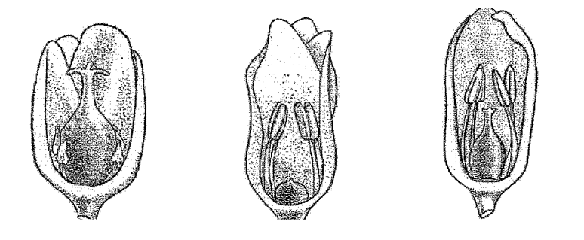
Female flower | Male flower  (without style rudiment) | Male flower  (with style rudiment including androhermaphrodite)

Type of male flowers

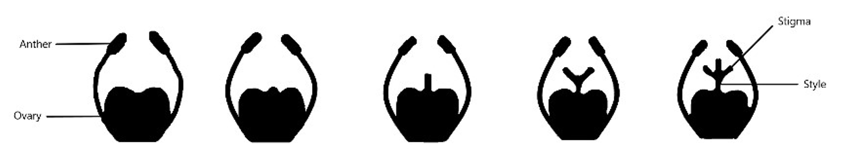
Stigma
Anther

Style
Ovary

Type I
Type IV
Type III
Type II
Note 3: plants with male flower with style rudiments (including androhermaphrodite flowers)
Note 1: plants with male flowers without style rudiment

Type of male flowers: the flowers always have fully developed anthers; the style can be from absent to fully developed (Type I to IV), but the stigmas are always rudimentary or absent. Even when two of the three stigmas are present, the flower is considered to be male. The male flower will not produce seeds.

The androhermaphrodite flower (Type IV) has three stigmas and anthers which produce pollen. The flower has the possibility, when self-pollinated, to produce a berry with some seeds. These berries are always smaller and with less seeds than on female plants and in much smaller quantities.

Varieties with note 3 (plants with male flower with style rudiments) can also have plants with androhermaphrodite flowers. Within these varieties the ratio between male flowers with style rudiments (type II and III) and androhermaphrodite flowers (type IV) can vary, leading to a smaller or larger percentage of male plants with small berries.

[Annex follows]

PROPOSED CHANGES PRESENTED IN HIGHLIGHT
(in English only)

Revision of Characteristic 16 “Type of flowering”

 |  | English | français | deutsch | español | Example Varieties/  Exemples/  Beispielssorten/  Variedades ejemplo | Note/  Nota
16.  (+)  (*) | VG | Type of flowering | Type de floraison | Blühtyp | Tipo de floración
QL |  | only plants with male flowers without style rudiments and plants with female flowers | seulement plantes avec des fleurs mâles sans rudiments de style et plantes avec des fleurs femelles | nur Pflanzen mit männlichen Blüten ohne Griffelrudimente und Pflanzen mit weiblichen Blüten | solo plantas con flores masculinas sin estilo y plantas con flores femeninas | Andreas, Cumulus | 1
 |  | plants with male flowers and plants with female flowers | plantes avec des fleurs mâles et plantes avec des fleurs femelles | Pflanzen mit männlichen Blüten und Pflanzen mit weiblichen Blüten | plantas con flores masculinas y plantas con flores femeninas | Argenteuil, Desto | 2
 |  | plants with androhermaphrodite flowers and plants with male flowers with style rudiments | plantes avec des fleurs androhermaphrodites et plantes avec des fleurs mâles avec rudiments de style | Pflanzen mit männlich-zwittrigen Blüten und Pflanzen mit männlichen Blüten mit Griffelrudimenten | plantas con flores hermafroditas masculinas y plantas con flores masculinas con estilo | Backlim, Gijnlim | 3
 |  | only plants with female flowers | seulement des plantes avec des fleurs femelles | nur Pflanzen mit weiblichen Blüten | solo plantas con flores femeninas | L324 | 4

Changes agreed to characteristics in the table of characteristics would also be reflected in Chapter 10 “Technical Questionnaire”, Section 5 “Characteristics of the variety to be indicated”.

Revision of Ad.16: Type of flowering

Female
androhermaphrodite
male
male flower
(with style rudiment including androhermaphrodite)
male flower
(without style rudiment)
Female flower

Type of male flowers
Stigma
Anther

Style
Ovary

Type I
Type IV
Type III
Type II
Note 3: plants with male flower with style rudiments (including androhermaphrodite flowers)
Note 1: plants with male flowers without style rudiment)

Type of male flowers: the flowers always have fully developed anthers; the style can be from absent to fully developed (Type I to IV), but the stigmas are always rudimentary or absent. Even when two of the three stigmas are present, the flower is considered to be male. The male flower will not produce seeds.

The androhermaphrodite flower (Type IV) has three stigmas and anthers which produce pollen. The flower has the possibility, when self-pollinated, to produce a berry with some seeds. These berries are always smaller and with less seeds than on female plants and in much smaller quantities.

Varieties with note 3 (plants with male flower with style rudiments) can also have plants with androhermaphrodite flowers. Within these varieties the ratio between male flowers with style rudiments (type II and III) and androhermaphrodite flowers (type IV) can vary, leading to a smaller or larger percentage of male plants with small berries.

[End of Annex and of document]

held by electronic means, from April 22 to 25, 2024.

