E
TC-EDC/Jan17/7
ORIGINAL: English
DATE: January 12, 2017
INTERNATIONAL UNION FOR THE PROTECTION OF NEW VARIETIES OF PLANTS
Geneva
enlarged editorial Committee
Geneva, January 11 and 12, 2017
Developments in relation to the web-based TG TemplatE
Document prepared by the Office of the Union
Disclaimer: this document does not represent UPOV policies or guidance
The purpose of this document is to present developments in relation to the web-based TG Template and the current guidance in document TGP/7 “Development of Test Guidelines”.

- Order of UPOV codes and botanical names
- Order of methods of observation
- Presentation of different types of example varieties
- Explanations covering all characteristics
- Subsequent explanations covering several characteristics
- Addition of Characteristics not contained in the Table of Characteristics to Chapter TQ 5 “Characteristics of the variety to be indicated”
- Presentation of RHS Colour Chart Characteristics in Chapter TQ 5 “Characteristics of the variety to be indicated”

Order of UPOV codes and botanical names

Currently, document TGP/7 does not provide guidance with regard to order of UPOV codes and botanical names within the relevant Chapters of the Test Guidelines: cover page, Chapter 1 “Subject of these Test Guidelines” and Chapter TQ 1 “Subject of the Technical Questionnaire”.

Within the web-based TG Template, UPOV codes and botanical names are presented in alphabetical order in the relevant Chapters.

However, in the Test Guidelines for Petunia for example, the TWO requested to reverse the order of the UPOV Codes and botanical names to have “Petunia Juss.” first:

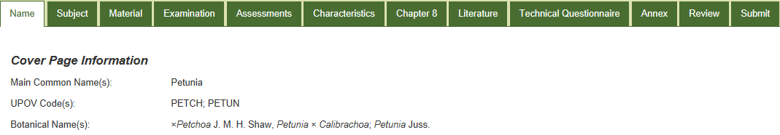

Proposal

It is proposed that the next version of the web-based TG Template allow the order of UPOV code names to be amended. In the meantime, amendments will be made in the Test Guidelines prior to publication of adopted Test Guidelines.

Order of methods of observation

Currently, document TGP7 “Development of Test Guidelines” does not provide guidance on the order of methods of observation where one characteristic has more than one method of observation. Currently, it is not possible to select methods of observation in any specific order in the web-based TG Template.

The TWO considered document TWO/48/12 “Revision of document TGP/7: Drafter’s Kit for Test Guidelines” and noted that there was no guidance on the order of the methods of observation for a characteristic in the Table of Characteristics (e.g. VG/MS) and agreed to propose to provide guidance in document TGP/7 and the Test Guidelines, e.g. to state that the most commonly used method was displayed first (see document TC/52/29 Rev., paragraph 60).

Proposal

The next version of the web-based TG Template should allow to order the methods of observation to be adjusted, subject to amendment of document TGP/7 “Development of Test Guidelines”.

Presentation of different types of example varieties

With regard to different types of example varieties, document TGP/7 “Development of Test Guidelines”, Annex 3 “Guidance Notes (GN) for the TG Template”, GN 28 “(TG Template: Chapter 6.4) – Example varieties”, Chapter 3 “Multiple sets of example varieties” states the following:

“[…]

“3.2 Different types of variety

“3.2.1 If it is not possible, with a single set of example varieties, to describe all the types of varieties (e.g. winter-types and spring-types) covered by the same Test Guidelines, they may be subdivided to create different sets of example varieties.

“3.2.2 Where different sets of example varieties are provided for different types of varieties covered by the same Test Guidelines, they are placed in the Table of Characteristics in the same column as normal. The sets of example varieties (e.g. winter and spring) are separated by a semicolon, and/or indicated by a key which is provided for each set and an explanation for the option chosen should be included in the legend of Chapter 6 of the Test Guidelines.

“Example: For certain characteristics, different example varieties are indicated for winter type and spring type varieties. These types are separated by a semicolon, with the winter types placed before the semicolon and prefixed by “(w)” and the spring types placed after the semicolon and prefixed by “(s)”.

 | Stage/  Stade/  Stadium/  Estado | English | français | deutsch | español | Example Varieties/  Exemples/  Beispielssorten/  Variedades ejemplo | Note/  Nota
7.  (*)  (+) | 75-92  MG/MS | Plant: length | Plante: port | Pflanze: Wuchsform | Planta: porte
 |  | short | courte | kurz | corta | (w) Variety A, Variety C; (s) Alpha | 3
 |  | medium | moyenne | mittel | media | (w) Variety B; (s) Beta | 5
 |  | long | longue | lang | larga | (s) Gamma | 7
[…]”

In the web-based TG Template it is currently not possible to present types of example varieties separated by a semicolon. However, it is possible to present different types of example varieties, for example summer (s) and winter (w) type, as follows:

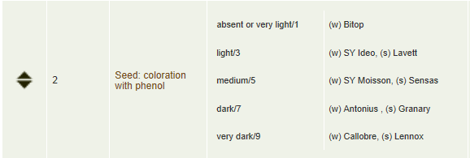

Proposal

To consider whether document TGP/7 “Development of Test Guidelines” should be amended to indicate that a comma is sufficient.

Explanations covering all characteristics

Some Test Guidelines contain explanations covering all characteristics in Chapter 8.1 “Explanations covering several characteristics”, as for example the Test Guidelines for Osteospermum (see document TG/176/5):

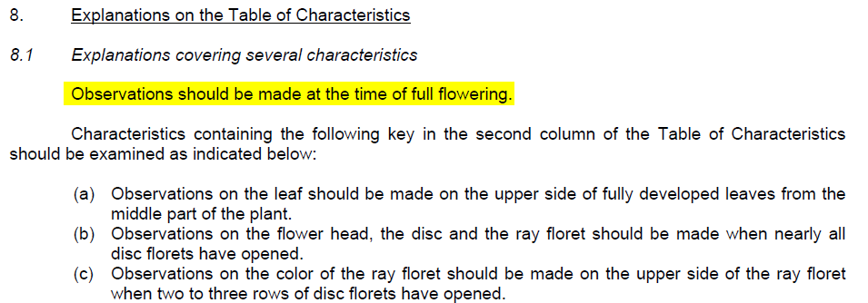

Currently, in the web-based TG Template, it is not possible to enter explanations covering all characteristics without a label. Explanations covering all characteristics can be entered with the option “Apply to all”. The relevant explanation will have a label (e.g. (a)) displayed for all characteristics and the explanation will appear together with other explanations covering several characteristics.

Proposal

For matters of transparency within the Test Guidelines, it is proposed to keep this item unchanged so that all notes relating to a characteristic are apparent.

Subsequent explanations covering several characteristics

Currently, in the web-based TG Template, there are two clearly defined types of explanations in Chapter 8 “Explanations on the Table of Characteristics”.

- Explanations covering several characteristics, which apply to more than one characteristic; and
- Explanations for individual characteristics, which apply to one single characteristic.

Some experts have requested that the explanations for individual characteristics should be made available as well to explanations for uninterrupted consecutively numbered characteristics (e.g. Characteristics 39, 40, 41).

See example in TG/212/2(proj.4):

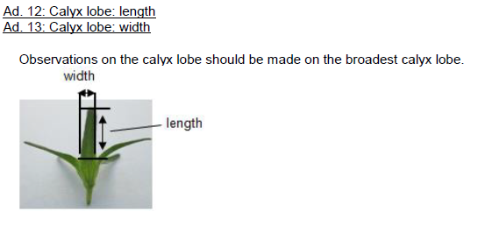

Proposal

It is proposed that in the case of an explanation covering more than one characteristic within the explanations for individual characteristics, it should be possible that any explanation can have a cross reference to an explanation(s) of other characteristics.

Addition of Characteristics Differing From The Table of Characteristics to Chapter TQ 5 “Characteristics of the variety to be indicated”

In the web-based TG Template it is currently not possible to add characteristics which differ in presentation from the Table of Characteristics to Chapter TQ 5 “Characteristics of the variety to be indicated”.

An example can be found in the draft Test Guidelines for Aglaonema (see document TG/AGLAO(proj.8)) where the characteristics “Leaf blade: color covering the largest surface area on upper side” and “Leaf blade: color covering the second largest surface area on upper side” differ from the Table of Characteristics due to the use of the “Lisbon” approach to describe colors and color patterns (see document TGP/14/3 “Glossary of Terms Used in UPOV Documents”, Section 2 “Botanical Terms”, Subsection 3 “Color”, Chapter 3 “Approaches to describe colors and color patterns”, 3.4 “Approach according to the RHS Colour Chart number ("Lisbon" approach)”

To overcome this proposal, the two characteristics “Leaf blade: color covering the largest surface area on upper side” and “Leaf blade: color covering the second largest surface area on upper side” have been placed in Chapter TQ 7.3 “Other information” instead of Chapter TQ 5 “Characteristics of the variety to be indicated”:

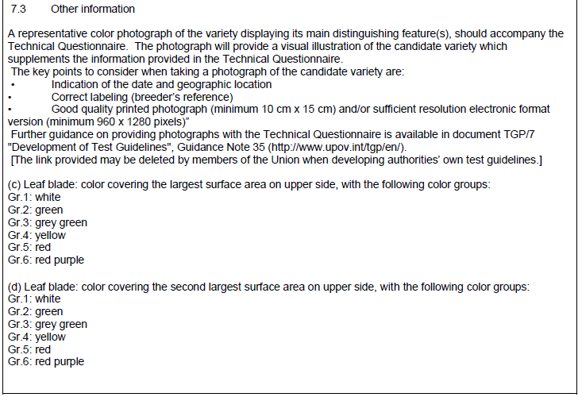

Document TGP/7 “Development of Test Guidelines”, Annex 3 “Guidance Notes (GN) for the TG Template”, GN 13 “Characteristics with specific functions”, Chapter 3 “Technical Questionnaire (TQ) characteristics (TG Template: Chapter 10: TQ 5)” states the following:

“3. Technical Questionnaire (TQ) characteristics (TG Template: Chapter 10: TQ 5)

“3.1 The model Technical Questionnaire included in the Test Guidelines seeks information on specific characteristics of importance for distinguishing varieties.

“3.2 Characteristics to be included in the Technical Questionnaire should comprise:

(a) the grouping characteristics and

(b) the most discriminating characteristics,

“unless it is considered unrealistic to expect breeders to describe these characteristics.

“3.3 In addition to the characteristics identified in Section 3.2, the Technical Questionnaire may also include characteristics that are agreed to be important for the management of the trial and the planning of observations.

“3.4 Where necessary, characteristics in the Test Guidelines can be simplified (e.g. color groups can be created rather than requesting an RHS Colour Chart reference) for inclusion in the Technical Questionnaire (TQ), if this would be of assistance for the breeder completing the TQ. Furthermore, the characteristics contained in the Test Guidelines can be formulated in a different way, if breeders would then be able to describe them more precisely and the information would be useful for performing the test. For example, the TQ for peach may request information on whether the variety is a “melting” or “non-melting” type, which although not a characteristic in the Table of Characteristics would provide information on the states of expression of certain characteristics included in the Table of Characteristics.

[…]”

Proposal

It is proposed to modify Chapter TQ 5 in the web-based TG Template to allow the possibility to enter Characteristics that differ in presentation from the Table of Characteristics. Until the implementation of this change it is proposed that Leading Experts be advised to enter these characteristics in Chapter TQ 7.3 “Other Information”. Prior to publication of adopted Test Guidelines, the characteristics concerned will be moved manually from Chapter TQ 7.3 “Other Information” to Chapter TQ 5 “Characteristics of the variety to be indicated”.

Presentation of RHS Colour Chart Characteristics in Chapter TQ 5 “Characteristics of the variety to be indicated”

Previous presentation of RHS Colour Chart Characteristics in Chapter TQ 5 “Characteristics of the variety to be indicated”

Previously, RHS Colour Chart Characteristics where split in two sub-characteristics:

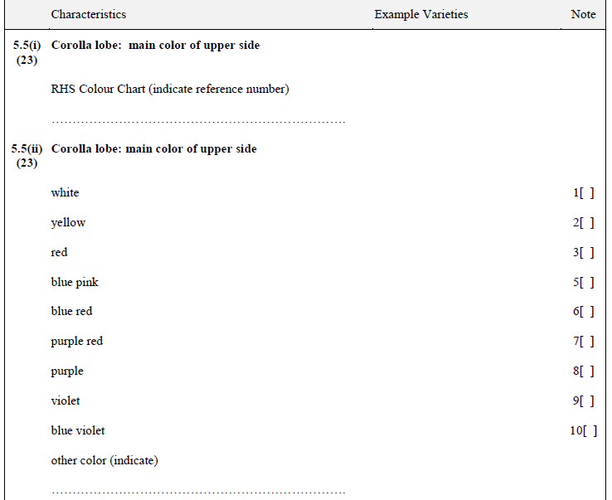

Current presentation of RHS Colour Chart Characteristics in Chapter TQ 5 “Characteristics of the variety to be indicated”

Currently RHS Colour Chart Characteristics are split in two sub-characteristics as follows:

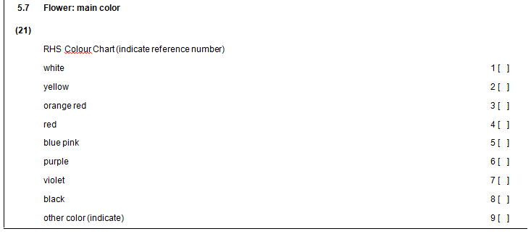

Proposal

It is proposed to check whether a change is needed to the presentation of RHS Colour Chart references in the web-based TG Template.

[End of document]

