E
TC-EDC/Jan15/19
ORIGINAL: English
DATE: September 01, 2014
INTERNATIONAL UNION FOR THE PROTECTION OF NEW VARIETIES OF PLANTS
Geneva
enlarged editorial Committee
Geneva, January 7 and 8, 2015
partial revision of the test guidelines for buddleja (document tg/263/1)
Document prepared by the Office of the Union
Disclaimer: this document does not represent UPOV policies or guidance
At its forty-seventh session held in Naivasha, Kenya, from May 19 to 23, 2014, the Technical Working Party for Ornamental Plants and Forest Trees (TWO) considered a partial revision of the Test Guidelines for Buddleja on the basis of documents TG/263/1 and TWO/47/25 “Partial Revision of the Test Guidelines for Buddleja (Document TG/263/1)” and proposed to revise the Test Guidelines for Buddleja as follows (see document TWO/47/28 “Report”, paragraphs 66 to 68):

- Characteristic 21: “Calyx: length” to be reworded as “Corolla tube: length”;

- To move the reworded Characteristic 21: “Corolla tube: length” after current Characteristic 22: “Calyx: pubescence”;

- To amend Chapter 8.1: “General illustration of flower”.

The proposed revisions are presented in the Annex to this document.

[Annex follows]
Characteristic 21: “Calyx: length”

Current wording:

21. |  | Calyx: length | Calice : longueur | Kelch: Länge | Cáliz: longitud
QN | (c) | short | court | kurz | corta | Huimoon, Morning Mist | 1
 |  | medium | moyen | mittel | media | Masquerade | 2
 |  | long | long | lang | larga | White Ball | 3

Proposed new wording:

21. |  | Corolla tube: length | Tube de la corolle : longueur | Kronröhre: Länge | Tubo de la corolla: longitud
QN | (c) | short | court | kurz | corta | Huimoon, Morning Mist | 1
 |  | medium | moyen | mittel | media | Masquerade | 2
 |  | long | long | lang | larga | White Ball | 3

It is proposed that the amended Characteristic 21 “Corolla tube: length” be placed after the current Characteristic 22: “Calyx: pubescence”.

It is proposed that Chapter 8.1: “General illustration of flower” be amended as follows:

Current illustration:
Corolla lobes
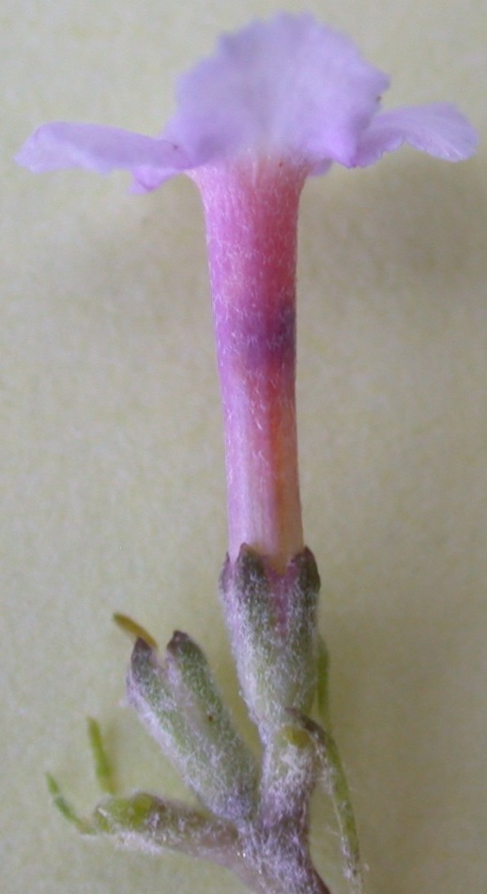

Corolla throat
Calyx

Proposed new illustration:

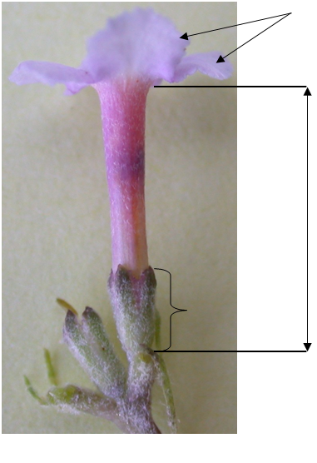
Calyx
Corolla tube
Corolla lobes
[End of Annex and of document]

