E
TG/93/4(proj.4)
ORIGINAL: English
DATE: 2013-07-31
INTERNATIONAL UNION FOR THE PROTECTION OF NEW VARIETIES OF PLANTS
Geneva
DRAFT

 | GROUNDNUT  UPOV Code: ARACH_HYP  Arachis hypogaea L. | *

GUIDELINES

FOR THE CONDUCT OF TESTS

FOR DISTINCTNESS, UNIFORMITY AND STABILITY

prepared by an expert from South Africa

to be considered by the
Enlarged Editorial Committee at its meeting
to be held in Geneva, on January 8 and 9, 2014

Alternative Names:*

Botanical name | English | French | German | Spanish
Arachis hypogaea L. | Groundnut, Peanut | Arachide | Erdnuß | Cacahuete, Maní

The purpose of these guidelines (“Test Guidelines”) is to elaborate the principles contained in the General Introduction (document TG/1/3), and its associated TGP documents, into detailed practical guidance for the harmonized examination of distinctness, uniformity and stability (DUS) and, in particular, to identify appropriate characteristics for the examination of DUS and production of harmonized variety descriptions.

ASSOCIATED DOCUMENTS
These Test Guidelines should be read in conjunction with the General Introduction and its associated TGP documents.
TABLE OF CONTENTS PAGE

1. Subject of these Test Guidelines 3
2. Material Required 3
3. Method of Examination 3
3.1 Number of Growing Cycles 3
3.2 Testing Place 3
3.3 Conditions for Conducting the Examination 3
3.4 Test Design 3
3.5 Additional Tests 4
4. Assessment of Distinctness, Uniformity and Stability 4
4.1 Distinctness 4
4.2 Uniformity 5
4.3 Stability 5
5. Grouping of Varieties and Organization of the Growing Trial 5
6. Introduction to the Table of Characteristics 6
6.1 Categories of Characteristics 6
6.2 States of Expression and Corresponding Notes 6
6.3 Types of Expression 6
6.4 Example Varieties 7
6.5 Legend 7
7. Table of Characteristics/Tableau des caractères/Merkmalstabelle/Tabla de caracteres 8
8. Explanations on the Table of Characteristics 11
8.1 Explanations covering several characteristics 11
8.2 Explanations for individual characteristics 11
8.3 Growth Stages 15
9. Literature 17
10. Technical Questionnaire 18

Subject of these Test Guidelines

These Test Guidelines apply to all varieties of Arachis hypogaea L..

Material Required

2.1 The competent authorities decide on the quantity and quality of the plant material required for testing the variety and when and where it is to be delivered. Applicants submitting material from a State other than that in which the testing takes place must ensure that all customs formalities and phytosanitary requirements are complied with.

2.2 The material is to be supplied in the form of seed.

2.3 The minimum quantity of plant material, to be supplied by the applicant, should be:

1,000 seeds.

The seed should meet the minimum requirements for germination, species and analytical purity, health and moisture content, specified by the competent authority.

2.4 The plant material supplied should be visibly healthy, not lacking in vigor, nor affected by any important pest or disease.

2.5 The plant material should not have undergone any treatment which would affect the expression of the characteristics of the variety, unless the competent authorities allow or request such treatment. If it has been treated, full details of the treatment must be given.

Method of Examination

3.1 Number of Growing Cycles

The minimum duration of tests should normally be a single growing cycle.

3.2 Testing Place

Tests are normally conducted at one place. In the case of tests conducted at more than one place, guidance is provided in TGP/9 “Examining Distinctness”.

3.3 Conditions for Conducting the Examination

3.3.1 The tests should be carried out under conditions ensuring satisfactory growth for the expression of the relevant characteristics of the variety and for the conduct of the examination.

3.3.2 The optimum stage of development for the assessment of each characteristic is indicated by a number in the second column of the Table of Characteristics. The stages of development denoted by each number are described in Chapter 8.2.

3.3.3 Because daylight varies, color determinations made against a color chart should be made either in a suitable cabinet providing artificial daylight or in the middle of the day in a room without direct sunlight. The spectral distribution of the illuminant for artificial daylight should conform with the CIE Standard of Preferred Daylight D 6500 and should fall within the tolerances set out in the British Standard 950, Part I. These determinations should be made with the plant part placed against a white background. The color chart and version used should be specified in the variety description.

3.4 Test Design

3.4.1 Each test should be designed to result in a total of at least 60 plants, which should be divided between at least 2 replicates.

3.4.2 The design of the tests should be such that plants or parts of plants may be removed for measurement or counting without prejudice to the observations which must be made up to the end of the growing cycle.

3.5 Additional Tests

Additional tests, for examining relevant characteristics, may be established.

Assessment of Distinctness, Uniformity and Stability

4.1 Distinctness

4.1.1 General Recommendations

It is of particular importance for users of these Test Guidelines to consult the General Introduction prior to making decisions regarding distinctness. However, the following points are provided for elaboration or emphasis in these Test Guidelines.

Further guidance is provided in documents TGP/9 “Examining Distinctness” and TGP/8 “Trial Design and Techniques Used in the Examination of Distinctness, Uniformity and Stability”.

4.1.2 Consistent Differences

The differences observed between varieties may be so clear that more than one growing cycle is not necessary. In addition, in some circumstances, the influence of the environment is not such that more than a single growing cycle is required to provide assurance that the differences observed between varieties are sufficiently consistent. One means of ensuring that a difference in a characteristic, observed in a growing trial, is sufficiently consistent is to examine the characteristic in at least two independent growing cycles.

4.1.3 Clear Differences

Determining whether a difference between two varieties is clear depends on many factors, and should consider, in particular, the type of expression of the characteristic being examined, i.e. whether it is expressed in a qualitative, quantitative, or pseudo-qualitative manner. Therefore, it is important that users of these Test Guidelines are familiar with the recommendations contained in the General Introduction prior to making decisions regarding distinctness.

4.1.4 Number of Plants / Parts of Plants to be Examined

Unless otherwise indicated, for the purposes of distinctness, all observations on single plants should be made on 20 plants or parts taken from each of 20 plants and any other observations made on all plants in the test, disregarding any off-type plants. In the case of observations of parts taken from single plants, the number of parts to be taken from each of the plants should be 1.

4.1.5 Method of Observation

The recommended method of observing the characteristic for the purposes of distinctness is indicated by the following key in the second column of the Table of Characteristics (see document TGP/9 “Examining Distinctness”, Section 4 “Observation of characteristics”):

MG: single measurement of a group of plants or parts of plants
MS: measurement of a number of individual plants or parts of plants
VG: visual assessment by a single observation of a group of plants or parts of plants
VS: visual assessment by observation of individual plants or parts of plants

Type of observation: visual (V) or measurement (M)

“Visual” observation (V) is an observation made on the basis of the expert’s judgment. For the purposes of this document, “visual” observation refers to the sensory observations of the experts and, therefore, also includes smell, taste and touch. Visual observation includes observations where the expert uses reference points (e.g. diagrams, example varieties, side-by-side comparison) or non-linear charts (e.g. color charts). Measurement (M) is an objective observation against a calibrated, linear scale e.g. using a ruler, weighing scales, colorimeter, dates, counts, etc.

Type of record: for a group of plants (G) or for single, individual plants (S)

For the purposes of distinctness, observations may be recorded as a single record for a group of plants or parts of plants (G), or may be recorded as records for a number of single, individual plants or parts of plants (S). In most cases, “G” provides a single record per variety and it is not possible or necessary to apply statistical methods in a plant-by-plant analysis for the assessment of distinctness.

In cases where more than one method of observing the characteristic is indicated in the Table of Characteristics (e.g. VG/MG), guidance on selecting an appropriate method is provided in document TGP/9, Section 4.2.

4.2 Uniformity

4.2.1 It is of particular importance for users of these Test Guidelines to consult the General Introduction prior to making decisions regarding uniformity. However, the following points are provided for elaboration or emphasis in these Test Guidelines:

4.2.2 Uniformity assessment by off-types (characteristics observed on different sample sizes)

In cases where samples of different sizes are used for the assessment of uniformity of different characteristics, guidance should be given for all sample sizes. In such cases, the relevant sample size for each characteristic should be indicated in the Table of Characteristics.

4.2.2.1 Uniformity assessment on all plants in the test

For the assessment of uniformity in a sample of 60 plants, a population standard of 1% and an acceptance probability of at least 95 % should be applied. In the case of a sample size of 60 plants, 2 off-types are allowed.

4.3 Stability

4.3.1 In practice, it is not usual to perform tests of stability that produce results as certain as those of the testing of distinctness and uniformity. However, experience has demonstrated that, for many types of variety, when a variety has been shown to be uniform, it can also be considered to be stable.

4.3.2 Where appropriate, or in cases of doubt, stability may be further examined by testing a new seed stock to ensure that it exhibits the same characteristics as those shown by the initial material supplied.

Grouping of Varieties and Organization of the Growing Trial

5.1 The selection of varieties of common knowledge to be grown in the trial with the candidate varieties and the way in which these varieties are divided into groups to facilitate the assessment of distinctness are aided by the use of grouping characteristics.

5.2 Grouping characteristics are those in which the documented states of expression, even where produced at different locations, can be used, either individually or in combination with other such characteristics: (a) to select varieties of common knowledge that can be excluded from the growing trial used for examination of distinctness; and (b) to organize the growing trial so that similar varieties are grouped together.

5.3 The following have been agreed as useful grouping characteristics:

(a) Plant: growth habit (characteristic 1)
(b) Primary branch: flowering pattern (characteristic 9)
(c) Pod: number of kernels (characteristic 12)
(d) Kernel: main color of testa (characteristic 13)
(e) Kernel: presence of secondary color of mature testa (characteristic 14)

5.4 Guidance for the use of grouping characteristics, in the process of examining distinctness, is provided through the General Introduction and document TGP/9 “Examining Distinctness”.

Introduction to the Table of Characteristics

6.1 Categories of Characteristics

6.1.1 Standard Test Guidelines Characteristics

Standard Test Guidelines characteristics are those which are approved by UPOV for examination of DUS and from which members of the Union can select those suitable for their particular circumstances.

6.1.2 Asterisked Characteristics

Asterisked characteristics (denoted by *) are those included in the Test Guidelines which are important for the international harmonization of variety descriptions and should always be examined for DUS and included in the variety description by all members of the Union, except when the state of expression of a preceding characteristic or regional environmental conditions render this inappropriate.

6.2 States of Expression and Corresponding Notes

6.2.1 States of expression are given for each characteristic to define the characteristic and to harmonize descriptions. Each state of expression is allocated a corresponding numerical note for ease of recording of data and for the production and exchange of the description.

6.2.2 In the case of qualitative and pseudo-qualitative characteristics (see Chapter 6.3), all relevant states of expression are presented in the characteristic. However, in the case of quantitative characteristics with 5 or more states, an abbreviated scale may be used to minimize the size of the Table of Characteristics. For example, in the case of a quantitative characteristic with 9 states, the presentation of states of expression in the Test Guidelines may be abbreviated as follows:

State | Note
small | 3
medium | 5
large | 7

However, it should be noted that all of the following 9 states of expression exist to describe varieties and should be used as appropriate:

State | Note
very small | 1
very small to small | 2
small | 3
small to medium | 4
medium | 5
medium to large | 6
large | 7
large to very large | 8
very large | 9

6.2.3 Further explanation of the presentation of states of expression and notes is provided in document TGP/7 “Development of Test Guidelines”.

6.3 Types of Expression

An explanation of the types of expression of characteristics (qualitative, quantitative and pseudo-qualitative) is provided in the General Introduction.

6.4 Example Varieties

Where appropriate, example varieties are provided to clarify the states of expression of each characteristic.

6.5 Legend

(*) Asterisked characteristic – see Chapter 6.1.2

QL Qualitative characteristic – see Chapter 6.3
QN Quantitative characteristic – see Chapter 6.3
PQ Pseudo-qualitative characteristic – see Chapter 6.3

MG, MS, VG, VS – see Chapter 4.1.5

(a) See Explanations on the Table of Characteristics in Chapter 8.1.

(+) See Explanations on the Table of Characteristics in Chapter 8.2.

Table of Characteristics/Tableau des caractères/Merkmalstabelle/Tabla de caracteres

 |  | English | français | deutsch | español | Example Varieties  Exemples  Beispielssorten  Variedades ejemplo | Note/  Nota
(*) | 61-69  VG | Plant: growth habit | Plante : port | Pflanze: Wuchsform | Planta: hábito de crecimiento
QN |  | erect | dressé | aufrecht | erguido | Tufa | 1
 |  | semi-erect | demi-dressé | halbaufrecht | semierguido | Sellie | 2
 |  | prostrate | étalé | liegend | postrado | Inkanyezi | 3
(+) | 61-69  VG | Plant: density | Plante : densité | Pflanze: Dichte | Planta: densidad
QN |  | sparse | clairsemée | locker | laxa | Mwenje | 1
 |  | medium | moyenne | mittel | media | Nyanda | 2
 |  | dense | dense | dicht | densa | ARC- Oleic2 | 3
(*) | 61-69  VG | Stem: anthocyanin coloration | Tige : pigmentation anthocyanique | Trieb: Anthocyanfärbung | Tallo: pigmentación antociánica
QN |  | absent or weak | absente ou faible | fehlend oder schwach | ausente o débil | Harts, Kwarts | 1
 |  | medium | moyenne | mittel | media | Sellie | 2
 |  | strong | forte | stark | fuerte | Kanosel | 3
(*)  (+) | 61-69  VG | Main stem: presence of flowers | Tige principale : présence de fleurs | Hauptsproß: Vorhandensein von Blüten | Tallo principal: presencia de flores
QL |  | absent | absentes | fehlend | ausentes |  | 1
 |  | present | présentes | vorhanden | presentes | Akwa | 9
 | 65-69  VG | Leaf: intensity of green color | Feuille : intensité de la couleur verte | Blatt: Intensität der Grünfärbung | Hoja: intensidad del color verde
QN | (a) | light | claire | hell | claro | ARC-Opal1 | 1
 |  | medium | moyenne | mittel | medio | ARC-Oleic2 | 2
 |  | dark | foncée | dunkel | oscuro |  | 3
(*)  (+) | 65-69  VG/  MG | Basal leaflet: length | Foliole de base : longueur | Basales Fiederblatt: Länge | Foliolo basal: longitud
QN | (a) | short | courte | kurz | corto | Sellie | 1
 |  | medium | moyenne | mittel | medio | Tufa | 2
 |  | long | longue | lang | largo | ARC-Opal1 | 3
(*)  (+) | 65-69  VG | Basal leaflet: position of broadest part | Foliole de base : position de la partie la plus large | Basales Fiederblatt: Position des breitesten Teils | Foliolo basal: posición de la parte más ancha
QN | (a) | strongly towards apex | fortement vers le sommet | stark zur Spitze hin | fuertemente hacia el ápice | ARC-Oleic2 | 1
 |  | moderately towards apex | modérément vers le sommet | mäßig zur Spitze hin | moderadamente hacia el ápice |  | 2
 |  | at middle | au milieu | in der Mitte | en la mitad | ARC-Opal1 | 3
(*)  (+) | 65-69  VG | Basal leaflet: shape of apex | Foliole de base : forme du sommet | Basales Fiederblatt: Form der Spitze | Foliolo basal: forma del ápice
PQ | (a) | narrow pointed | en pointe étroite | schmal zugespitzt | de punta estrecha | ARC-Opal1, Kwarts | 1
 |  | broad pointed | en pointe large | breit zugespitzt | de punta ancha | Akwa | 2
 |  | rounded | arrondie | abgerundet | redondeado | ARC-Oleic2 | 3
 |  | retuse | échancrée | eingedrückt | retuso | Tamrun 96 | 4
(*)  (+) | 61-69  VG | Primary branch: flowering pattern | Branche principale : type de floraison | Primärast: Anordnung der Blüten | Rama primaria: pauta de floración
QL |  | alternate | alternée | abwechselnd | alterna | ARC-Opal1 | 1
 |  | sequential | séquentielle | sequentiell | secuencial | Akwa, ARC-Oleic2 | 2
(*)  (+) | 88-89  VG | Pod: constrictions | Coque : étranglement | Hülse: Einschnürung | Vaina: estrangulamientos
QN |  | absent or very weak | absent ou très faible | fehlend oder sehr gering | ausentes o muy débiles |  | 1
 |  | weak | faible | gering | débiles | ARC-Oleic2 | 2
 |  | medium | moyen | mittel | medios | ARC-Opal1 | 3
 |  | strong | fort | stark | fuertes | Inkanyezi | 4
 |  | very strong | très fort | sehr stark | muy fuertes |  | 5
(*)  (+) | 99  VG | Pod: reticulation of surface | Coque : réticulation de la surface | Hülse: Netzmuster auf Oberfläche | Vaina: reticulado de la superficie
QN |  | weak | faible | schwach | débil |  | 1
 |  | medium | moyenne | mittel | medio | ARC-Oleic2 | 2
 |  | strong | forte | stark | fuerte |  | 3
(*)  (+) | 99  VG | Pod: number of kernels | Coque : nombre de graines | Hülse: Anzahl Samen | Vaina: número de semillas
QL |  | two | deux | zwei | dos | Akwa | 1
 |  | three or more | trois ou plus | drei oder mehr | tres o más | Kanosel | 2
(*)  (+) | VG | Kernel: main color of testa | Graine : couleur principale du tégument | Samen: Hauptfarbe der Samenschale | Semilla: color principal de la testa
PQ |  | white | blanc | weiss | blanco | White Kayabi | 1
 |  | brownish pink | rose brunâtre | bräunlichrosa | rosa amarronado | Akwa, Kwarts | 2
 |  | red | rouge | rot | rojo | Harts, Kanosel | 3
 |  | purple | pourpre | purpurn | púrpura | Kurorakkasel | 4
(*)  (+) | VG | Kernel: presence of secondary color of mature testa | Graine : présence d’une couleur secondaire sur le tégument mûr | Samen: Vorhandensein von Sekundärfarbe der reifen Samenschale | Semilla: presencia de color secundario en la testa madura
QL |  | absent | absente | fehlend | ausente | Akwa, Kwarts | 1
 |  | present | présente | vorhanden | presente | Shimahikari | 9
(*) | 99  MG | Kernel: weight | Graine : poids | Samen: Gewicht | Semilla: peso
QN |  | small | faible | gering | pequeño | Tufa | 1
 |  | medium | moyen | mittel | medio | Kanosel | 2
 |  | large | élevé | hoch | grande | Rambo | 3
 | 99  VG | Shell: thickness | Coque : épaisseur | Schale: Dicke | Cáscara: espesor
QN |  | thin | fine | dünn | delgada |  | 1
 |  | medium | moyenne | mittel | media | Kanosel | 2
 |  | thick | épaisse | dick | gruesa | Rambo | 3
(+) | MG | Time of maturity | Époque de maturité | Zeitpunkt der Reife | Época de madurez
QN |  | early | précoce | früh | temprana |  | 3
 |  | medium | moyenne | mittel | media |  | 5
 |  | late | tardive | spät | tardía |  | 7

Explanations on the Table of Characteristics

8.1 Explanations covering several characteristics

Characteristics containing the following key in the second column of the Table of Characteristics should be examined as indicated below:

(a) Observations on the basal leaflet should be made on a fully developed basal leaflet.

8.2 Explanations for individual characteristics

Ad. 2: Plant: density

Plant density is a combination of the amount of branching and the number of leaves.

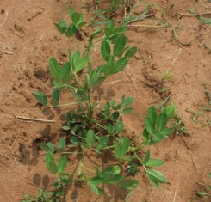 | 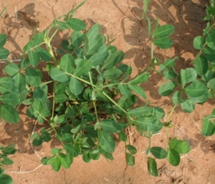 | 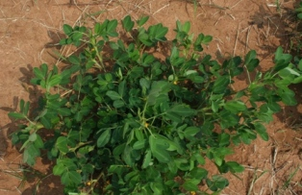
1 | 2 | 3
sparse | medium | dense

Ad. 4: Main stem: presence of flowers
Ad. 9: Primary branch: flowering pattern
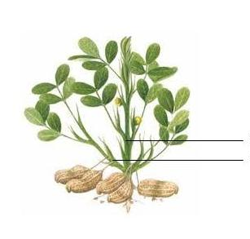
Primary branch
Main stem
alternate (1): nodes with flowers alternating with nodes without flowers
sequential (2): flowers on every node

Ad 6: Basal leaflet: length

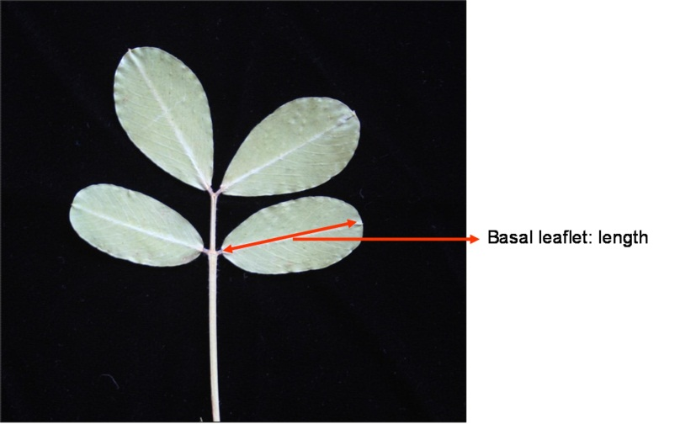
Basal leaflet: length

Ad 7: Basal leaflet: position of broadest part

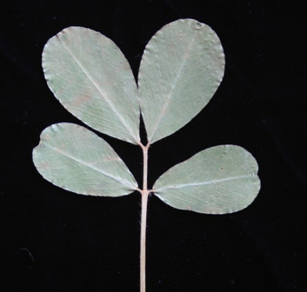 | 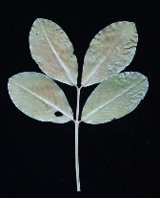 | 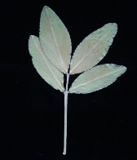
1 | 2 | 3
strongly towards apex | moderately towards apex | at middle

Ad. 8: Basal leaflet: shape of apex

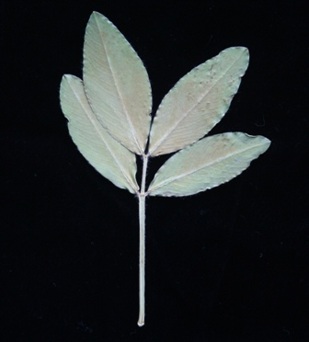 | 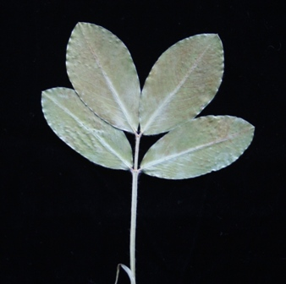
1 | 2
narrow pointed | broad pointed

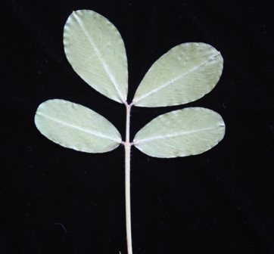
3 | 4
rounded | retuse

Ad. 10: Pod: constrictions

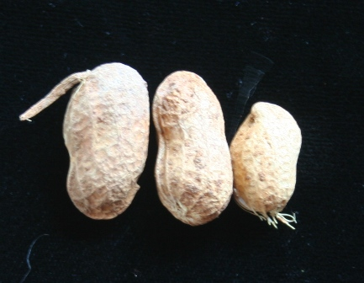 | 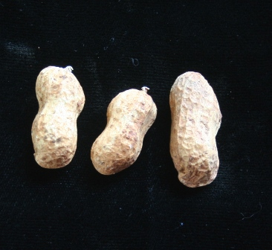 | 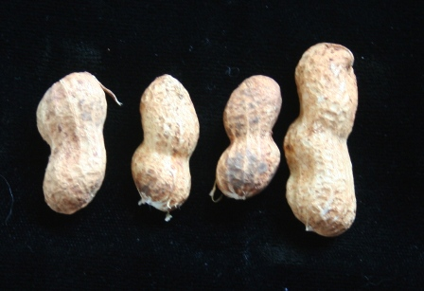
1 | 2 | 3
absent or very weak | weak | medium

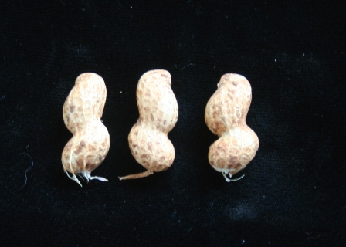 | 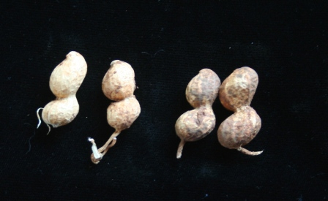
4 | 5
strong | very strong

Ad. 11: Pod: reticulation of surface

A pattern or arrangement of interlacing lines resembling a net on the surface of the pod. The degree of reticulation correlates with the depth of the pattern.

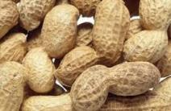 | 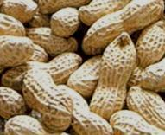 | 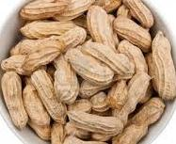
1 | 2 | 3
weak | medium | strong

Ad. 12: Pod: number of kernels

Varieties with two kernels may occasionally present one or three kernels.

Ad. 13: Kernel: main color of testa

The main color is the color with the largest surface area. In cases where the areas of the main and secondary color are too similar to reliably decide which color has the largest area, the darkest color is considered to be the main color.

Observations should be made on the mature testa.

Ad. 14: Kernel: presence of secondary color of mature testa

Observations should be made on the mature testa, two weeks after harvesting.

Ad. 15: Kernel: weight

Observations should be made on 100 seeds with moisture content at 7%.

Ad. 17: Time of maturity

The time of maturity is when 50% of plants have reached growth stage 85.

Ad. 18: Shell: thickness

Observations should be made 2 weeks after harvesting.

8.3 Growth Stages

Characteristics containing the 2-digit code in the second column of the Table of Characteristics should be examined as indicated below:

Growth stage | Code | Description
0: Germination | 00 | Dry seed
 | 01 | Beginning of seed imbibition
 | 03 | Seed imbibition complete
 | 05 | Radicle emerged from seed
 | 07 | Hypocotyl with cotyledons breaking through seed coat
 | 08 | Hypocotyl reaches the soil surface: hypocotyl arch visible
 | 09 | Emergence: hypocotyl with cotyledons arising above soil surface (cracking stage)
1: Leaf development (main shoot) | 10 | Cotyledons completely unfolded¹
 | 11 | First true leaf (pinnate) unfolded¹
 | 12 | 2nd true leaf (pinnate) unfolded¹
 | 13 | 3rd true leaf (pinnate) unfolded¹
 | 1 . | Stages continuous till
 | 19 | 9 or more true leaves unfolded¹. No side shoots visible²
2: formation of side shoots | 21 | 1st side shoot visible
 | 22 | 2nd side shoot visible
 | 23 | 3rd side shoot visible
 | 2 . | Stages continuous till ….
 | 29 | 9 or more side shoots visible
3: Main stem elongation (crop cover) | 31 | Beginning of crop cover: 10% of plants meets between rows
 | 32 | 20% of plants meets between rows
 | 33 | 30% of plants meets between rows
 | 34 | 40% of plants meets between rows
 | 35 | 50% of plants meets between rows
 | 36 | 60% of plants meets between rows
 | 37 | 70% of plants meets between rows
 | 38 | 80% of plants meets between rows
 | 39 | Crop cover complete. 90% of plants meets between rows
5: Inflorescence emergence | 51 | First inflorescence buds visible
 | 55 | First individual flower buds visible
 | 59 | First flower petals visible. Flower buds still closed
6: Flowering | 61 | Beginning of flowering
 | 62 | First carpophore pegs visible
 | 63 | Continuation of flowering
 | 64 | First carpophore pegs visibly elongated
 | 65 | Full flowering
 | 66 | First carpophore pegs penetrating the soil
 | 67 | Flowering declining³
 | 68 | Tip of first carpophore pegs growing horizontally in the soil
 | 69 | End of flowering
7: Development of fruits and seeds | 71 | Beginning of pod development: tip of first carpophore pegs swollen (at least twice the original diameter)
 | 73 | Continuation of pod development: beginning of pod filling: first pods have attained final size and are ripening
 | 75 | Main phase of pod development: continuation of pod filling
 | 77 | Advance pod filling
 | 79 | Fresh seeds fill the cavity of the pods which have attained their final size
8: Ripening of fruits and seeds⁴ | 81 | Beginning of ripening: about 10% of pods developed to final size are ripe
 | 82 | About 20% of pods developed to final size are ripe
 | 83 | Continuation of ripening: about 30% of pods developed to final size are ripe
 | 84 | About 40% of pods developed to final size are ripe
 | 85 | Main phase of ripening: about 50% of pods developed to final size are ripe
 | 86 | About 60% of pods developed to final size are ripe
 | 87 | Advanced ripening: about 70% of pods developed to final size are ripe
 | 88 | About 80% of pods developed to final size are ripe
 | 89 | Full maturity: nearly all pods developed to final size are ripe
9: Senescence | 91 | About 10% of above ground parts of plant dry
 | 92 | About 20% of above ground parts of plant dry
 | 93 | About 30% of above ground parts of plant dry
 | 94 | About 40% of above ground parts of plant dry
 | 95 | About 50% of above ground parts of plant dry
 | 96 | About 60% of above ground parts of plant dry
 | 97 | Above ground parts of plant dead
 | 99 | Harvested product
¹ Leaves are counted from the cotyledon node (= node 0)
² Side shoot development may occur earlier; in this case continue with principal growth stage 2
³ Only for varieties with a determinate flowering period
⁴ Criteria of maturity: Pericarp hard, with distinct texture, can be split open easily

Literature

Munger, P., Bleiholder, H., Hack, H., Heß, M., Stauss, R., van den Boom T., Weber, E., 1998: Phenological Growth Stages of the Peanut plant (Arachis hypogaea L.): Codification and Description according to the BBCH Scale – with figures. Journal of Agronomy and Crop Science 180 (2): 101–107.

Pittman, Roy N., editor 1995. United States Peanut Descriptors. U.S. Department of Agriculture, Agricultural Research Services, ARS-132.

Technical Questionnaire

TECHNICAL QUESTIONNAIRE |  |  |  | Page {x} of {y} |  | Reference Number:
 |  |  |  |  |  | Application date:
 |  |  |  |  |  | (not to be filled in by the applicant)
TECHNICAL QUESTIONNAIRE
to be completed in connection with an application for plant breeders’ rights

1. Subject of the Technical Questionnaire
1.1 Botanical name |  |  | Arachis hypogaea L.
1.2 Common name |  |  | Groundnut
2. Applicant
Name
Address
3.Telephone No.
Fax No.
E-mail address
Breeder (if different from applicant)
3. Proposed denomination and breeder’s reference
Proposed denomination
(if available)

Breeder’s reference
#4. Information on the breeding scheme and propagation of the variety

4.1 Breeding scheme

Variety resulting from:

4.1.1 Crossing

- controlled cross [ ]
(please state parent varieties)

(…………………..……………..…) x (……………..…………………..…)
female parent male parent

(b) partially known cross [ ]
(please state known parent variety(ies))

(…………………..……………..…) x (……………..…………………..…)
female parent male parent

(c) unknown cross [ ]

4.1.2 Mutation [ ]
(please state parent variety)

4.1.3 Discovery and development [ ]
(please state where and when discovered and how developed)

4.1.4 Other [ ]
(please provide details)

4.2 Method of propagating the variety

4.2.1 Seed-propagated varieties

(a) Self-pollination [ ]
(b) Cross-pollination
(i) population [ ]
(ii) synthetic variety [ ]
(c) Hybrid [ ]
(d) Other [ ]
(please provide details)

4.2.2 Vegetatively propagated varieties [ ]

4.2.3 Other [ ]
(please provide details)

5. Characteristics of the variety to be indicated (the number in brackets refers to the corresponding characteristic in Test Guidelines; please mark the note which best corresponds).

 | Characteristics |  |  |  |  |  | Example Varieties |  |  | Note
5.1  (1) | Plant: growth habit
 | erect |  |  |  |  |  | Tufa |  |  | 1[ ]
 | semi-erect |  |  |  |  |  | Sellie |  |  | 2[ ]
 | prostrate |  |  |  |  |  | Inkanyezi |  |  | 3[ ]
5.2  (9) | Primary branch: flowering pattern
 | alternate |  |  |  |  |  | ARC-Opal1 |  |  | 1[ ]
 | sequential |  |  |  |  |  | Akwa, ARC-Oleic2 |  |  | 2[ ]
5.3  (12) | Pod: number of kernels
 | two |  |  |  |  |  | Akwa |  |  | 1[ ]
 | three or more |  |  |  |  |  | Kanosel |  |  | 2[ ]
5.4  (13) | Kernel: main color of testa
 | white |  |  |  |  |  | White Kayabi |  |  | 1[ ]
 | brownish pink |  |  |  |  |  | Akwa, Kwarts |  |  | 2[ ]
 | red |  |  |  |  |  | Harts, Kanosel |  |  | 3[ ]
 | purple |  |  |  |  |  | Kurorakkasel |  |  | 4[ ]
5.5  (14) | Kernel: presence of secondary color of mature testa
 | absent |  |  |  |  |  | Akwa, Kwarts |  |  | 1[ ]
 | present |  |  |  |  |  | Shimahikari |  |  | 9[ ]
6. Similar varieties and differences from these varieties

Please use the following table and box for comments to provide information on how your candidate variety differs from the variety (or varieties) which, to the best of your knowledge, is (or are) most similar. This information may help the examination authority to conduct its examination of distinctness in a more efficient way.

Denomination(s) of variety(ies) similar to your candidate variety |  | Characteristic(s) in which your candidate variety differs from the similar variety(ies) |  |  | Describe the expression of the characteristic(s) for the similar variety(ies) |  |  | Describe the expression of the characteristic(s) for your candidate variety
Example |  | Kernel: size |  |  | small |  |  | large
Comments:

#7. Additional information which may help in the examination of the variety

7.1 In addition to the information provided in sections 5 and 6, please provide information concerning commercial grouping:

Commercial grouping | Example varieties
Spanish | Sellie | [ ]
Valencia | Kangwane Red | [ ]
Virginia | Inkanyezi | [ ]
Runner |  | [ ]

7.2 Are there any special conditions for growing the variety or conducting the examination?

Yes [ ] No [ ]

(If yes, please provide details)

7.3 Other information

A representative color image of the variety should accompany the Technical Questionnaire.

8. Authorization for release

(a) Does the variety require prior authorization for release under legislation concerning the protection of the environment, human and animal health?

Yes [ ] No [ ]

(b) Has such authorization been obtained?

Yes [ ] No [ ]

If the answer to (b) is yes, please attach a copy of the authorization.

9. Information on plant material to be examined or submitted for examination.

9.1 The expression of a characteristic or several characteristics of a variety may be affected by factors, such as pests and disease, chemical treatment (e.g. growth retardants or pesticides), effects of tissue culture, different rootstocks, scions taken from different growth phases of a tree, etc.

9.2 The plant material should not have undergone any treatment which would affect the expression of the characteristics of the variety, unless the competent authorities allow or request such treatment. If the plant material has undergone such treatment, full details of the treatment must be given. In this respect, please indicate below, to the best of your knowledge, if the plant material to be examined has been subjected to:

(a) Microorganisms (e.g. virus, bacteria, phytoplasma) Yes [ ] No [ ]

(b) Chemical treatment (e.g. growth retardant, pesticide) Yes [ ] No [ ]

(c) Tissue culture Yes [ ] No [ ]

(d) Other factors Yes [ ] No [ ]

Please provide details for where you have indicated “yes”.

……………………………………………………………

9.3 Has the plant material to be examined been tested for the presence of virus or other pathogens?

Yes [ ]
(please provide details as specified by the Authority)

No [ ]

10. I hereby declare that, to the best of my knowledge, the information provided in this form is correct:

Applicant’s name

Signature Date

[End of document]

* These names were correct at the time of the introduction of these Test Guidelines but may be revised or updated. [Readers are advised to consult the UPOV Code, which can be found on the UPOV Website (www.upov.int), for the latest information.]
# Authorities may allow certain of this information to be provided in a confidential section of the Technical Questionnaire.
# Authorities may allow certain of this information to be provided in a confidential section of the Technical Questionnaire.

