 |  |  |  |  |  |  | E  TG/SESAME(proj.9)  ORIGINAL: English  DATE: 2012-08-20
INTERNATIONAL UNION FOR THE PROTECTION OF NEW VARIETIES OF PLANTS
Geneva
 |  |  | DRAFT
 |  | SESAME  UPOV Code: SESAM_IND  Sesamum indicum L. |  |  | *

GUIDELINES

FOR THE CONDUCT OF TESTS

FOR DISTINCTNESS, UNIFORMITY AND STABILITY

prepared by experts from Israel and Republic of Korea

to be considered by the

Enlarged Editorial Committee at its meeting
to be held in Geneva, on January 9 and 10, 2013

Alternative Names:*

Botanical name | English | French | German | Spanish
Sesamum indicum L. | Sesame | Sésame | Sesam | Sésamo, Ajonjolí

The purpose of these guidelines (“Test Guidelines”) is to elaborate the principles contained in the General Introduction (document TG/1/3), and its associated TGP documents, into detailed practical guidance for the harmonized examination of distinctness, uniformity and stability (DUS) and, in particular, to identify appropriate characteristics for the examination of DUS and production of harmonized variety descriptions.

ASSOCIATED DOCUMENTS
These Test Guidelines should be read in conjunction with the General Introduction and its associated TGP documents.
TABLE OF CONTENTS PAGE

1. Subject of these Test Guidelines 3
2. Material Required 3
3. Method of Examination 3
3.1 Number of Growing Cycles 3
3.2 Testing Place 3
3.3 Conditions for Conducting the Examination 3
3.4 Test Design 3
3.5 Additional Tests 3
4. Assessment of Distinctness, Uniformity and Stability 4
4.1 Distinctness 4
4.2 Uniformity 5
4.3 Stability 5
5. Grouping of Varieties and Organization of the Growing Trial 5
6. Introduction to the Table of Characteristics 5
6.1 Categories of Characteristics 5
6.2 States of Expression and Corresponding Notes 6
6.3 Types of Expression 6
6.4 Example Varieties 6
6.5 Legend 7
7. Table of Characteristics/Tableau des caractères/Merkmalstabelle/Tabla de caracteres 8
8. Explanations on the Table of Characteristics 12
8.1 Explanations covering several characteristics 12
8.2 Explanations for individual characteristics 12
9. Literature 19
10. Technical Questionnaire 20

Subject of these Test Guidelines

These Test Guidelines apply to all varieties of Sesamum indicum L..

Material Required

2.1 The competent authorities decide on the quantity and quality of the plant material required for testing the variety and when and where it is to be delivered. Applicants submitting material from a State other than that in which the testing takes place must ensure that all customs formalities and phytosanitary requirements are complied with.

2.2 The material is to be supplied in the form of seed.

2.3 The minimum quantity of plant material to be supplied by the applicant should be:

30 g of seed.

The seed should meet the minimum requirements for germination, species and analytical purity, health and moisture content, specified by the competent authority. In cases where the seed is to be stored, the germination capacity should be as high as possible and should, be stated by the applicant.

2.4 The plant material supplied should be visibly healthy, not lacking in vigor, nor affected by any important pest or disease.

2.5 The plant material should not have undergone any treatment which would affect the expression of the characteristics of the variety, unless the competent authorities allow or request such treatment. If it has been treated, full details of the treatment must be given.

Method of Examination

3.1 Number of Growing Cycles

The minimum duration of tests should normally be two independent growing cycles.

3.2 Testing Place

Tests are normally conducted at one place. In the case of tests conducted at more than one place, guidance is provided in TGP/9 “Examining Distinctness”.

3.3 Conditions for Conducting the Examination

The tests should be carried out under conditions ensuring satisfactory growth for the expression of the relevant characteristics of the variety and for the conduct of the examination.

3.4 Test Design

Each test should be designed to result in a total of at least 50 plants, which should be divided between at least 2 replicates.

3.5 Additional Tests

Additional tests, for examining relevant characteristics, may be established.

Assessment of Distinctness, Uniformity and Stability

4.1 Distinctness

4.1.1 General Recommendations

It is of particular importance for users of these Test Guidelines to consult the General Introduction prior to making decisions regarding distinctness. However, the following points are provided for elaboration or emphasis in these Test Guidelines.

4.1.2 Consistent Differences

The differences observed between varieties may be so clear that more than one growing cycle is not necessary. In addition, in some circumstances, the influence of the environment is not such that more than a single growing cycle is required to provide assurance that the differences observed between varieties are sufficiently consistent. One means of ensuring that a difference in a characteristic, observed in a growing trial, is sufficiently consistent is to examine the characteristic in at least two independent growing cycles.

4.1.3 Clear Differences

Determining whether a difference between two varieties is clear depends on many factors, and should consider, in particular, the type of expression of the characteristic being examined, i.e. whether it is expressed in a qualitative, quantitative, or pseudo-qualitative manner. Therefore, it is important that users of these Test Guidelines are familiar with the recommendations contained in the General Introduction prior to making decisions regarding distinctness.

4.1.4 Number of Plants / Parts of Plants to be Examined

Unless otherwise indicated, for the purposes of distinctness, all observations on single plants should be made on 20 plants or parts taken from each of 20 plants and any other observations made on all plants in the test, disregarding any off-type plants.

4.1.5 Method of Observation

The recommended method of observing the characteristic for the purposes of distinctness is indicated by the following key in the second column of the Table of Characteristics (see document TGP/9 “Examining Distinctness”, Section 4 “Observation of characteristics”):

MG: single measurement of a group of plants or parts of plants
MS: measurement of a number of individual plants or parts of plants
VG: visual assessment by a single observation of a group of plants or parts of plants
VS: visual assessment by observation of individual plants or parts of plants

Type of observation: visual (V) or measurement (M)

“Visual” observation (V) is an observation made on the basis of the expert’s judgment. For the purposes of this document, “visual” observation refers to the sensory observations of the experts and, therefore, also includes smell, taste and touch. Visual observation includes observations where the expert uses reference points (e.g. diagrams, example varieties, side-by-side comparison) or non-linear charts (e.g. color charts). Measurement (M) is an objective observation against a calibrated, linear scale e.g. using a ruler, weighing scales, colorimeter, dates, counts, etc.

Type of record: for a group of plants (G) or for single, individual plants (S)

For the purposes of distinctness, observations may be recorded as a single record for a group of plants or parts of plants (G), or may be recorded as records for a number of single, individual plants or parts of plants (S). In most cases, “G” provides a single record per variety and it is not possible or necessary to apply statistical methods in a plant-by-plant analysis for the assessment of distinctness.”

In cases where more than one method of observing the characteristic is indicated in the Table of Characteristics (e.g. VG/MG), guidance on selecting an appropriate method is provided in document TGP/9, Section 4.2.

4.2 Uniformity

4.2.1 It is of particular importance for users of these Test Guidelines to consult the General Introduction prior to making decisions regarding uniformity. However, the following points are provided for elaboration or emphasis in these Test Guidelines:

4.2.2 For the assessment of uniformity, a population standard of 1% and an acceptance probability of at least 95% should be applied. In the case of a sample size of 50 plants, 2 off-types are allowed.

4.3 Stability

4.3.1 In practice, it is not usual to perform tests of stability that produce results as certain as those of the testing of distinctness and uniformity. However, experience has demonstrated that, for many types of variety, when a variety has been shown to be uniform, it can also be considered to be stable.

4.3.2 Where appropriate, or in cases of doubt, stability may be further examined by testing a new seed stock to ensure that it exhibits the same characteristics as those shown by the initial material supplied.

Grouping of Varieties and Organization of the Growing Trial

5.1 The selection of varieties of common knowledge to be grown in the trial with the candidate varieties and the way in which these varieties are divided into groups to facilitate the assessment of distinctness are aided by the use of grouping characteristics.

5.2 Grouping characteristics are those in which the documented states of expression, even where produced at different locations, can be used, either individually or in combination with other such characteristics: (a) to select varieties of common knowledge that can be excluded from the growing trial used for examination of distinctness; and (b) to organize the growing trial so that similar varieties are grouped together.

5.3 The following have been agreed as useful grouping characteristics:

(a) Plant: growth type (characteristic 1)
(b) Peduncle: number of flowers per leaf axil (characteristic 16)
(c) Capsule: number of carpels (characteristic 21)
(d) Seed coat: color (characteristic 26)

5.4 Guidance for the use of grouping characteristics, in the process of examining distinctness, is provided through the General Introduction and document TGP/9 “Examining Distinctness”.

Introduction to the Table of Characteristics

6.1 Categories of Characteristics

6.1.1 Standard Test Guidelines Characteristics

Standard Test Guidelines characteristics are those which are approved by UPOV for examination of DUS and from which members of the Union can select those suitable for their particular circumstances.

6.1.2 Asterisked Characteristics

Asterisked characteristics (denoted by *) are those included in the Test Guidelines which are important for the international harmonization of variety descriptions and should always be examined for DUS and included in the variety description by all members of the Union, except when the state of expression of a preceding characteristic or regional environmental conditions render this inappropriate.

6.2 States of Expression and Corresponding Notes

6.2.1 States of expression are given for each characteristic to define the characteristic and to harmonize descriptions. Each state of expression is allocated a corresponding numerical note for ease of recording of data and for the production and exchange of the description.

6.2.2 In the case of qualitative and pseudo-qualitative characteristics (see Chapter 6.3), all relevant states of expression are presented in the characteristic. However, in the case of quantitative characteristics with 5 or more states, an abbreviated scale may be used to minimize the size of the Table of Characteristics. For example, in the case of a quantitative characteristic with 9 states, the presentation of states of expression in the Test Guidelines may be abbreviated as follows:

State | Note
small | 3
medium | 5
large | 7

However, it should be noted that all of the following 9 states of expression exist to describe varieties and should be used as appropriate:

State | Note
very small | 1
very small to small | 2
small | 3
small to medium | 4
medium | 5
medium to large | 6
large | 7
large to very large | 8
very large | 9

6.2.3 Further explanation of the presentation of states of expression and notes is provided in document TGP/7 “Development of Test Guidelines”.

6.3 Types of Expression

An explanation of the types of expression of characteristics (qualitative, quantitative and pseudo-qualitative) is provided in the General Introduction.

6.4 Example Varieties

Where appropriate, example varieties are provided to clarify the states of expression of each characteristic.

6.5 Legend

(*) Asterisked characteristic – see Chapter 6.1.2

QL Qualitative characteristic – see Chapter 6.3
QN Quantitative characteristic – see Chapter 6.3
PQ Pseudo-qualitative characteristic – see Chapter 6.3

MG, MS, VG, VS – see Chapter 4.1.5

(a)-(c) See Explanations on the Table of Characteristics in Chapter 8.1.
(+) See Explanations on the Table of Characteristics in Chapter 8.2.

Table of Characteristics/Tableau des caractères/Merkmalstabelle/Tabla de caracteres

 |  | English | français | deutsch | español | Example Varieties  Exemples  Beispielssorten  Variedades ejemplo | Note/  Nota
1  (*)  (+) | VG | Plant: growth type | Plante : type de croissance | Pflanze: Wuchstyp | Planta: tipo de crecimiento
QL | (a) | indeterminate | indéterminé | unbegrenzt wachsend | indeterminado | Yangbaek | 1
 |  | determinate | déterminé | begrenzt wachsend | determinado |  | 2
2  (*)  (+) | VG | Plant: number of branches | Plante : nombre de branches | Pflanze: Anzahl der Zweige | Planta: número de ramas
QN | (a) | absent or very few | nul ou très petit | fehlend oder sehr gering | ninguna o muy pocas | Jinju | 1
 |  | medium | moyen | mittel | medio | Pyungan | 3
 |  | very many | très grand | sehr groß | muy alto | Ansan | 5
3.  (+) | VG | Plant: position of branches | Plante : position des branches | Pflanze: Stellung der Zweige | Planta: posición de las ramas
PQ | (a) | basal | basale | basal | basal | Kanto 1 go | 1
 |  | along stem | le long de la tige | entlang dem Stengel | a lo largo del tallo | Ansan | 2
 |  | apical | apicale | apikal | apical | H 65 | 3
4.  (*)  (+) | MS | Stem: number of nodes to first flower | Tige : nombre de nœuds jusqu’à la première fleur | Stengel: Anzahl Knoten bis zur ersten Blüte | Tallo: número de nudos hasta la primera flor
QN | (a) | few | petit | gering | bajo | Yunhuck | 3
 |  | medium | moyen | mittel | medio | Jinju | 5
 |  | many | grand | groß | alto | Whangbaek | 7
5. | VG | Stem: pubescence | Tige : pubescence | Stengel: Behaarung | Tallo: pubescencia
QN | (a) | absent or weak | nulle ou faible | fehlend oder gering | ausente o débil | Jinki | 1
 |  | medium | moyenne | mittel | media | Poongnam | 2
 |  | strong | forte | stark | fuerte | Sunbaek | 3
6.  (*)  (+) | MS | Stem: length | Tige : longueur | Stengel: Länge | Tallo: longitud
QN | (c) | short | courte | kurz | corto | Adam | 3
 |  | medium | moyenne | mittel | medio |  | 5
 |  | long | longue | lang | largo | Ansan | 7
7.  (+) | MS | Leaf blade: length | Limbe : longueur | Blattspreite: Länge | Limbo: longitud
QN | (b) | short | court | kurz | corto | Soonhuck | 3
 |  | medium | moyen | mittel | medio | Danbaek | 5
 |  | long | long | lang | largo | Osan | 7
8.  (+) | MS | Leaf blade: width | Limbe : largeur | Blattspreite: Breite | Limbo: anchura
QN | (b) | narrow | étroit | schmal | estrecho | Soonhuck | 3
 |  | medium | moyen | mittel | medio | Danbaek | 5
 |  | broad | large | breit | ancho | Osan | 7
9.  (*)  (+) | MS | Leaf blade: shape | Limbe : forme | Blattspreite: Form | Limbo: forma
QN | (b) | weakly elongated | faiblement allongé | leicht länglich | débilmente alargado | Soonhuck | 3
 |  | moderately elongated | moyennement allongé | mäßig länglich | moderadamente alargado | Danbaek | 5
 |  | strongly elongated | fortement allongé | stark länglich | fuertemente alargado | Osan | 7
10.  (+) | VG | Leaf blade: degree of lobing | Limbe : degré de découpure du bord | Blattspreite: Stärke der Lappung | Limbo: grado de lobulado
QN | (b) | absent or very weak | absente ou très faible | fehlend oder sehr gering | ausente o muy débil | Soonhuck | 1
 |  | weak | faible | gering | débil | Hucksun | 3
 |  | medium | moyenne | mittel | medio | Nambaek | 5
 |  | strong | forte | stark | fuerte | Osan | 7
 |  | very strong | très forte | sehr stark | muy fuerte | Milsung | 9
11. | VG | Leaf blade: intensity of green color | Limbe : intensité de la couleur verte | Blattspreite: Intensität der Grünfärbung | Limbo: intensidad del color verde
QN | (b) | light | claire | hell | claro | Osan | 3
 |  | medium | moyenne | mittel | medio | Yanghuck | 5
 |  | dark | foncée | dunkel | oscuro | Milsung | 7
12.  (+) | VG | Leaf blade: venation on lower side | Limbe : nervation sur la face inférieure | Blattspreite: Aderung an der Unterseite | Limbo: nervadura en el envés
QL | (b) | absent | absentes | fehlend | ausente |  | 1
 |  | present | présentes | vorhanden | presente | Yangbaek | 9
13. | MS | Petiole: length | Pétiole : longueur | Blattstiel: Länge | Pecíolo: longitud
QN | (b) | short | court | kurz | corto | Kanghuck | 3
 |  | medium | moyen | mittel | medio | Namsan | 5
 |  | long | long | lang | largo | Poongsan | 7
14. | VG | Petiole: anthocyanin coloration | Pétiole : pigmentation anthocyanique | Blattstiel: Anthocyanfärbung | Pecíolo: pigmentación antociánica
QN | (b) | absent or weak | nulle ou faible | fehlend oder gering | ausente o débil | Hucksun | 1
 |  | moderate | moyenne | mittel | moderada |  | 2
 |  | strong | forte | stark | fuerte | Mihuck | 3
15. | VG | Flower: color of corolla | Fleur : couleur de la corolle | Blüte: Farbe der Krone | Flor: color de la corola
PQ | (a) | white | blanche | weiß | blanco | BRS Seda | 1
 |  | yellowish | jaunâtre | gelblich | amarillento | Yangbaek | 2
 |  | pink | rose | rosa | rosa | Hucksun | 3
16.  (*)  (+) | VG | Peduncle: number of flowers per leaf axil | Pédoncule : nombre de fleurs à aisselle de la feuille | Blütenstiel: Anzahl der Blüten pro Blattachse | Pedúnculo: número de flores por axila foliar
QL | (a) | one | une | eine | una | Ansan | 1
 |  | more than one | plus d’une | mehr als eine | más de una | Yangbaek | 2
17.  (+) | VG | Peduncle: nectaries | Pédoncule : nectaires | Blütenstiel: Nektarien | Pedúnculo: nectarios
QL | (a) | absent | absents | fehlend | ausentes | Masekin | 1
 |  | present | présents | vorhanden | presentes | Yangbaek | 9
18.  (*)  (+) | VG | Flower: intensity of pink color on outer side of corolla | Fleur : intensité de la couleur rose sur la face externe de la corolle | Blüte: Intensität der Rosafärbung auf der Außenseite der Krone | Flor: intensidad del color rosa en la cara exterior de la corola
QN | (a) | light | claire | hell | claro | Naman | 1
 |  | medium | moyenne | mittel | medio | Dasak | 2
 |  | dark | foncée | dunkel | oscuro | Mihuck | 3
19.  (+) | VG | Flower: intensity of pink color at inner side of lower lip | Fleur : intensité de la couleur rose sur la face interne de la lèvre inférieure | Blüte: Intensität der Rosafärbung an der Innenseite der Unterlippe | Flor: intensidad del color rosa en la cara interior del labio inferior
QN | (a) | light | claire | hell | claro | Naman | 1
 |  | medium | moyenne | mittel | medio | Dasak | 2
 |  | dark | foncée | dunkel | oscuro | Mihuck | 3
20. | VG | Flower: pubescence of corolla | Fleur : pubescence de la corolle | Blüte: Behaarung der Krone | Flor: pubescencia de la corola
QN | (a) | weak | faible | gering | débil | Mihuck | 1
 |  | medium | moyenne | mittel | media | Kanghuck | 2
 |  | strong | forte | stark | fuerte | Kyeonghuck | 3
21.  (*)  (+) | VG | Capsule: number of carpels | Capsule : nombre de carpelles | Kapsel: Anzahl der Karpelle | Cápsula: número de carpelos
QL | (c) | two | deux | zwei | dos | Ansan | 1
 |  | more than two | plus de deux | mehr als zwei | más de dos |  | 2
22.  (+) | MS | Capsule: length | Capsule : longueur | Kapsel: Länge | Cápsula: longitud
QN | (c) | short | courte | kurz | corta | Adam | 3
 |  | medium | moyenne | mittel | media | Ansan | 5
 |  | long | longue | lang | larga |  | 7
23.  (+) | MS | Capsule: width | Capsule : largeur | Kapsel: Breite | Cápsula: anchura
QN | (c) | narrow | étroite | schmal | estrecha | Adam | 3
 |  | medium | moyenne | mittel | media | Miheuk | 5
 |  | broad | large | breit | ancha |  | 7
24. | VG | Capsule: pubescence | Capsule : pubescence | Kapsel: Behaarung | Cápsula: pubescencia
QN | (c) | weak | faible | gering | débil | Mihuck | 1
 |  | medium | moyenne | mittel | media | Poongan | 2
 |  | strong | forte | stark | fuerte | Whangbaek | 3
25. | VG | Capsule: color | Capsule : couleur | Kapsel: Farbe | Cápsula: color
PQ | (c) | green | verte | grün | verde | Yangbaek | 1
 |  | yellow | jaune | gelb | amarillo | Whangbaek | 2
 |  | purple | pourpre | purpurn | púrpura |  | 3
26.  (*) | VG | Seed coat: color | Tégument : couleur | Samenschale: Farbe | Cubierta de semilla: color
PQ | (c) | white | blanc | weiß | blanco | Yangbaek | 1
 |  | grey | gris | grau | gris | Mankum | 2
 |  | yellowish brown | brun jaunâtre | gelblich braun | marrón amarillento | Masekin | 3
 |  | medium brown | brun moyen | mittelbraun | marrón medio | Yuyoung | 4
 |  | black | noir | schwarz | negro | Jingi | 5
27.  (+) | VG | Seed coat: texture | Tégument : texture | Samenschale: Textur | Cubierta de semilla: textura
QL | (c) | smooth | lisse | glatt | suave | Yangbaek | 1
 |  | rough | rugueuse | rauh | áspero | NonggiS1 | 2
28.  (+) | VG/  MG | Time of beginning of flowering | Époque de début de floraison | Zeitpunkt des Blühbeginns | Época de comienzo de la floración
QN | (a) | early | précoce | früh | temprana | Jingi | 3
 |  | medium | moyenne | mittel | media | Yangbaek | 5
 |  | late | tardive | spät | tardía | Namda | 7
29.  (+) | MG | Time of maturity | Époque de maturité | Zeitpunkt der Reife | Época de madurez
QN | (c) | early | précoce | früh | temprana | Manhuck | 3
 |  | medium | moyenne | mittel | media | Kangbaek | 5
 |  | late | tardive | spät | tardía | Namda | 7

Explanations on the Table of Characteristics

8.1 Explanations covering several characteristics

Characteristics containing the following key in the second column of the Table of Characteristics should be examined as indicated below:

(a) characteristics should be measured at full flowering stage. (Full flowering stage: 50% of plants with flowers open.)
(b) characteristics related to leaf should be observed at full flowering stage on the middle part of plant.
(c) characteristics related to capsule and seed should be observed at fully matured stage on the middle part of plant. (Fully matured stage: 50% plant dehiscence of capsule on the main stem.)

8.2 Explanations for individual characteristics

Ad. 1: Plant: growth type

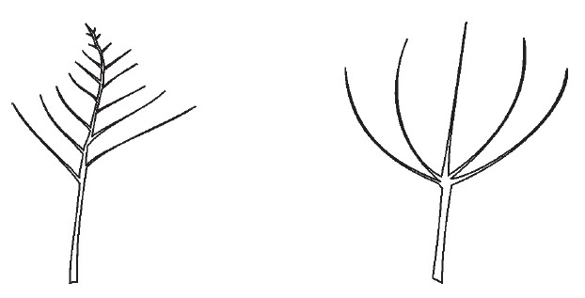

1 | 2
indeterminate | determinate

Ad. 2: Plant: number of branches

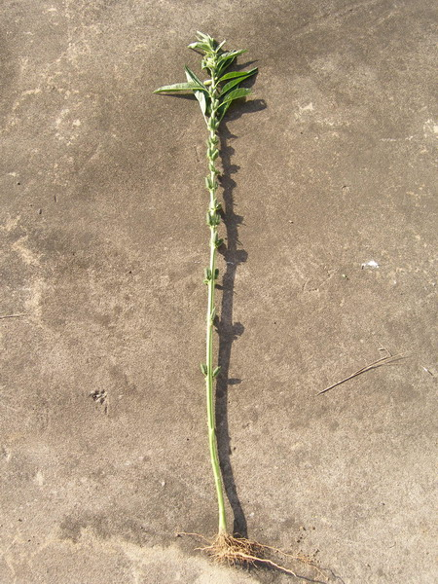 | 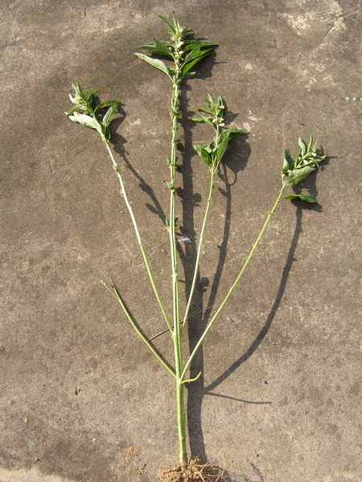 | 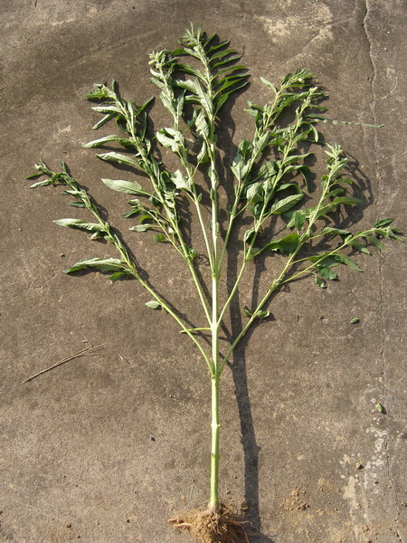
1 | 3 | 5
absent or very few | medium | very many

Ad. 3: Plant: position of branches

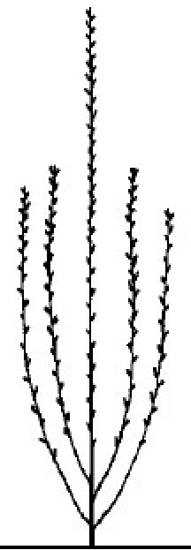 | 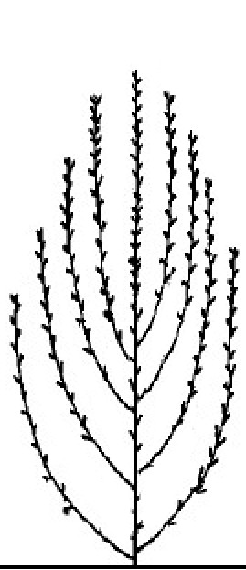 | 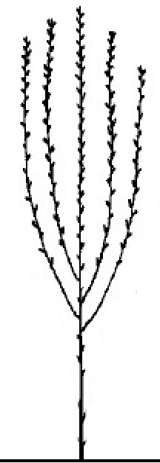
1 | 2 | 3
basal | along stem | apical

Ad. 4: Stem: number of nodes to first flower

The observation should be made on main stem (the number of nodes on the main stem varies between 4 and 65) and count from first node to node where first flower presented.
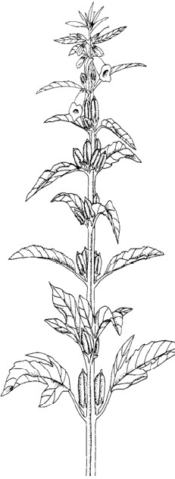
first node
node where first flower presented
first flower
2
3
4
5
6

Ad. 6: Stem: length

To be observed at fully matured stage.

Ad. 7: Leaf blade: length
Ad. 8: Leaf blade: width

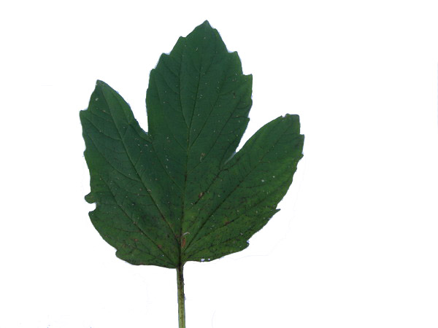
width
length

Ad. 9: Leaf blade: shape
To be observed on the ratio of length to width. For example, if an approximately one to one ratio was observed, it is possible to be visually scored on a scale with values 5.

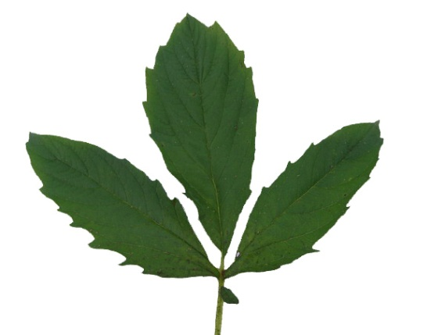 | 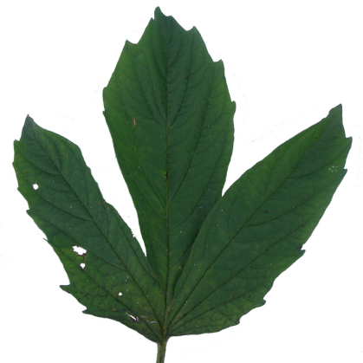 | 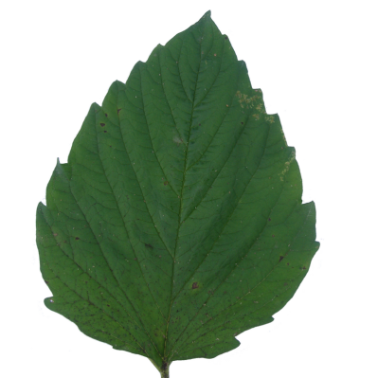
3 | 5 | 7
weakly elongated | moderatly elongated | strongly elongated

Ad. 10: Leaf blade: degree of lobing

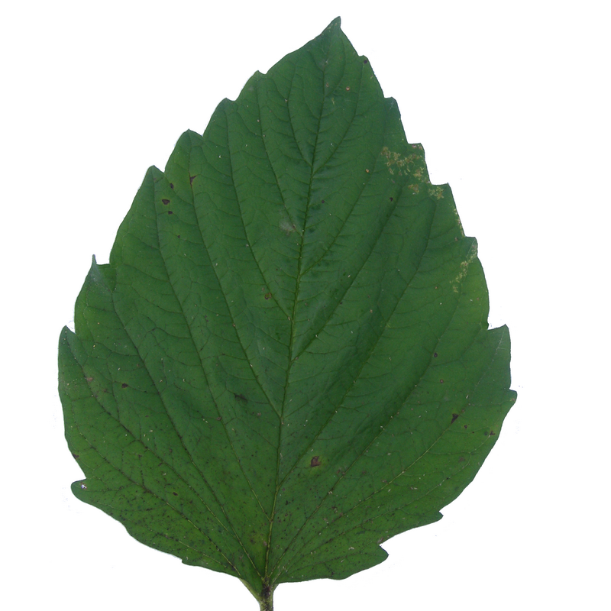 | 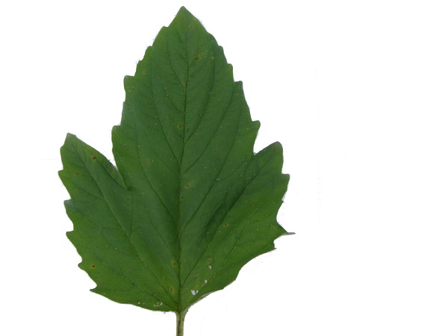
1 | 3 | 5
absent or very weak | weak | medium
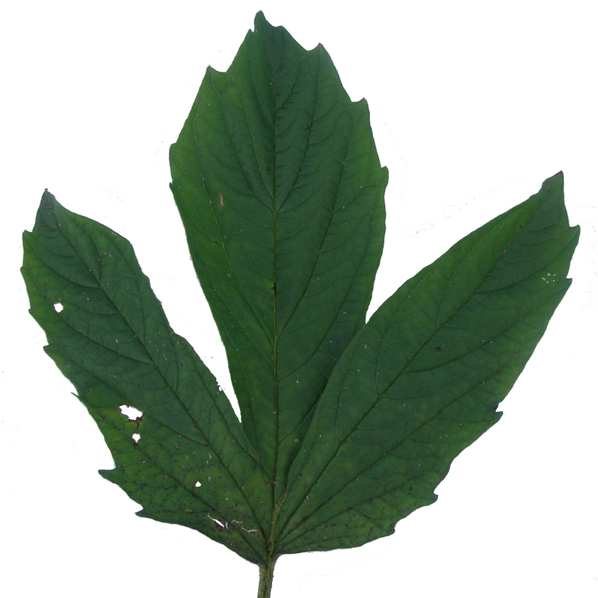 | 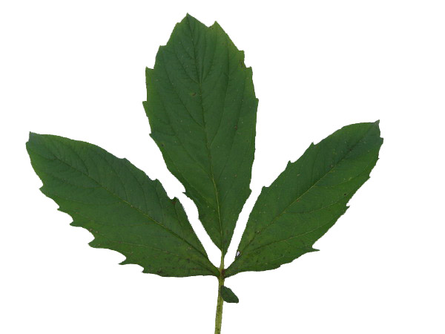
7 | 9
strong | very strong

Ad. 12: Leaf blade: venation on lower side
Observation should be made on the middle part of the plant.

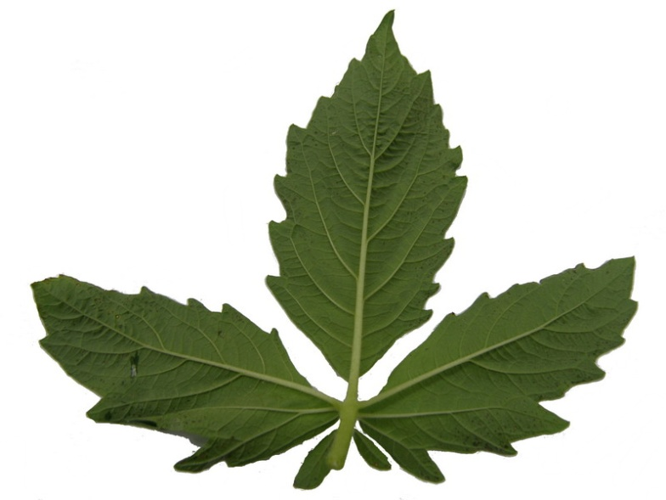
9
present

Ad. 16: Peduncle: number of flowers per leaf axil

Observations should be made on the middle part of the plant.

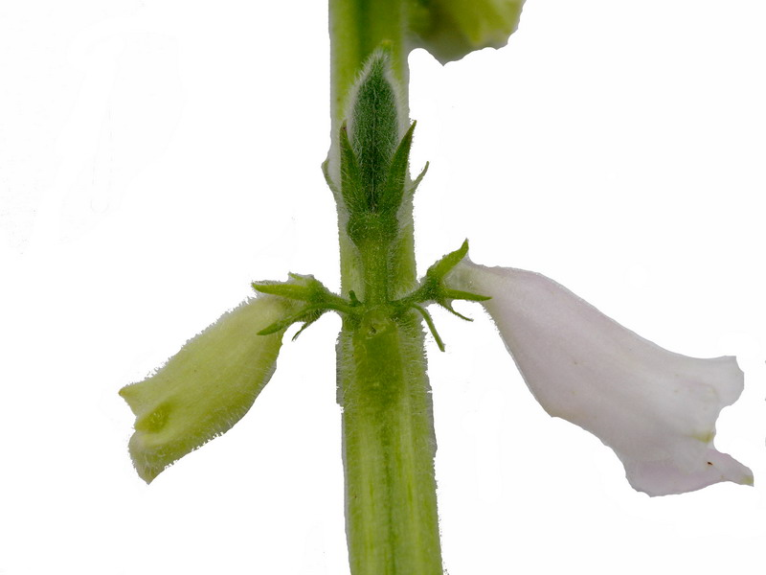
2
more than one

Ad. 17: Peduncle: nectaries

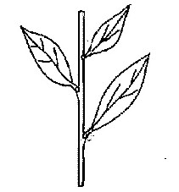 | 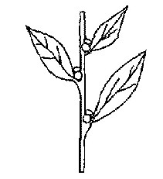
1 | 9
absent | present

Ad. 18: Flower: intensity of pink color on outer side of corolla
Ad. 19: Flower: intensity of pink color on inner side of lower lip

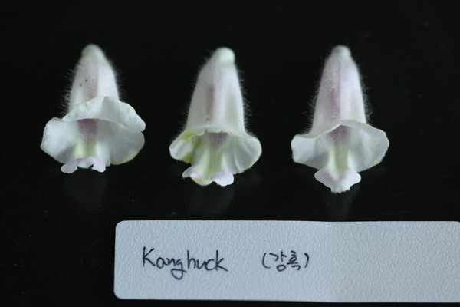 | 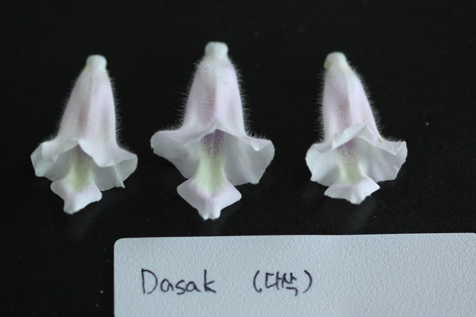
1 | 2
light | medium

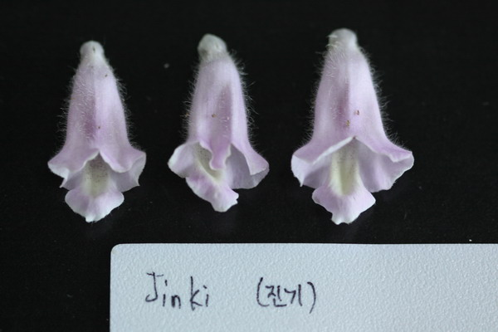
3
dark

Ad. 21: Capsule: number of carpels

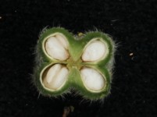 | 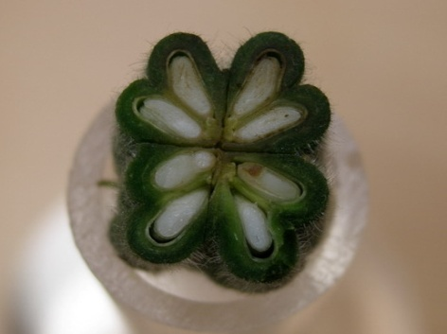
1 | 2
two | more than two

Ad. 22: Capsule: length
Ad. 23: Capsule: width

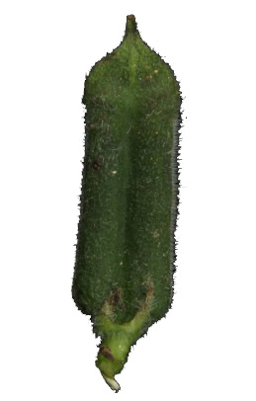
width
length

Ad. 27: Seed coat: texture

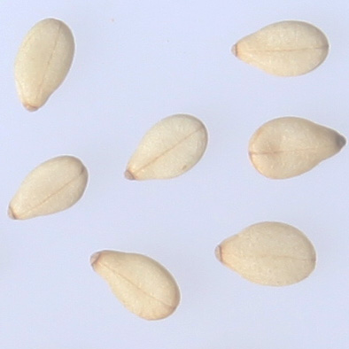 | 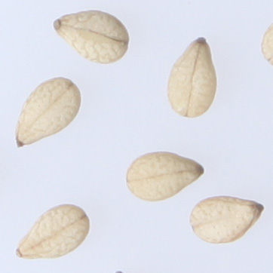
1 | 2
smooth | rough

Ad. 28: Time of beginning of flowering

The time of at least one open flower on 10% of plants.

Ad. 29: Time of maturity

The time of 50% plant dehiscence of capsule on the main stem in one plot.

Literature

IPGRI. Descriptors for Sesame: 2004

KSVS. Test guideline for Sesame: 2002, KR

RDA. Descriptors and guideline for management of Sesame: 2006, KR

Technical Questionnaire

TECHNICAL QUESTIONNAIRE |  |  |  | Page {x} of {y} |  | Reference Number:
 |  |  |  |  |  | Application date:
 |  |  |  |  |  | (not to be filled in by the applicant)
TECHNICAL QUESTIONNAIRE
to be completed in connection with an application for plant breeders’ rights

1. Subject of the Technical Questionnaire
1.1 Botanical name |  |  | Sesamum indicum L.
1.2 Common name |  |  | Sesame
2. Applicant
Name
Address
Telephone No.
Fax No.
E-mail address
Breeder (if different from applicant)
3. Proposed denomination and breeder’s reference
Proposed denomination
(if available)

Breeder’s reference
#4. Information on the breeding scheme and propagation of the variety

4.1 Breeding scheme

Variety resulting from:

4.1.1 Crossing

(a) controlled cross [ ]
(please state parent varieties)

(…………………..……………..…) x (……………..…………………..…)
female parent male parent

(b) partially known cross [ ]
(please state known parent variety(ies))

(…………………..……………..…) x (……………..…………………..…)
female parent male parent

(c) unknown cross [ ]

4.1.2 Mutation [ ]
(please state parent variety)

4.1.3 Discovery and development [ ]
(please state where and when discovered and how developed)

4.1.4 Other [ ]
(please provide details)”

4.2 Method of propagating the variety

4.2.1 Seed-propagated varieties

(a) Self-pollination [ ]
(b) Cross-pollination
(i) population [ ]
(ii) synthetic variety [ ]
(c) Hybrid [ ]
(d) Other [ ]
(please provide details)”

4.2.2 Vegetatively propagated varieties

(a) cuttings [ ]
(b) in vitro propagation [ ]
(c) other (state method) [ ]

4.2.3 Other [ ]
(please provide details)

5. Characteristics of the variety to be indicated (the number in brackets refers to the corresponding characteristic in Test Guidelines; please mark the note which best corresponds).

 | Characteristics |  |  |  |  |  | Example Varieties |  |  | Note
5.1  (1) | Plant: growth type
 | indeterminate |  |  |  |  |  | Yangbeak |  |  | 1 [ ]
 | determinate |  |  |  |  |  |  |  |  | 2 [ ]
5.2  (16) | Peduncle: number of flowers per leaf axil
 | one |  |  |  |  |  | Ansan |  |  | 1 [ ]
 | more than one |  |  |  |  |  | Yangbeak |  |  | 2 [ ]
5.3  (21) | Capsule: number of carpels
 | two |  |  |  |  |  | Ansan |  |  | 1 [ ]
 | more than two |  |  |  |  |  |  |  |  | 2 [ ]
5.4  (26) | Seed coat: color
 | white |  |  |  |  |  | Yangbeak |  |  | 1 [ ]
 | grey |  |  |  |  |  | Mankum |  |  | 2[ ]
 | yellowish brown |  |  |  |  |  | Masekin |  |  | 3 [ ]
 | medium brown |  |  |  |  |  | Yuyoung |  |  | 4 [ ]
 | black |  |  |  |  |  | Jingi |  |  | 5 [ ]
6. Similar varieties and differences from these varieties

Please use the following table and box for comments to provide information on how your candidate variety differs from the variety (or varieties) which, to the best of your knowledge, is (or are) most similar. This information may help the examination authority to conduct its examination of distinctness in a more efficient way.

Denomination(s) of variety(ies) similar to your candidate variety |  | Characteristic(s) in which your candidate variety differs from the similar variety(ies) |  |  | Describe the expression of the characteristic(s) for the similar variety(ies) |  |  | Describe the expression of the characteristic(s) for your candidate variety
Example |  | Plant: growth type |  |  | indeterminate |  |  | determinate
Comments:

#7. Additional information which may help in the examination of the variety

7.1 In addition to the information provided in sections 5 and 6, are there any additional characteristics which may help to distinguish the variety?

Yes [ ] No [ ]

(If yes, please provide details)

7.2 Are there any special conditions for growing the variety or conducting the examination?

Yes [ ] No [ ]

(If yes, please provide details)

7.3 Other information

8. Authorization for release

(a) Does the variety require prior authorization for release under legislation concerning the protection of the environment, human and animal health?

Yes [ ] No [ ]

(b) Has such authorization been obtained?

Yes [ ] No [ ]

If the answer to (b) is yes, please attach a copy of the authorization.

9. Information on plant material to be examined or submitted for examination.

9.1 The expression of a characteristic or several characteristics of a variety may be affected by factors, such as pests and disease, chemical treatment (e.g. growth retardants or pesticides), effects of tissue culture, different rootstocks, scions taken from different growth phases of a tree, etc.

9.2 The plant material should not have undergone any treatment which would affect the expression of the characteristics of the variety, unless the competent authorities allow or request such treatment. If the plant material has undergone such treatment, full details of the treatment must be given. In this respect, please indicate below, to the best of your knowledge, if the plant material to be examined has been subjected to:

(a) Chemical treatment (e.g. growth retardant, pesticide) Yes [ ] No [ ]

(b) Tissue culture Yes [ ] No [ ]

(c) Other factors Yes [ ] No [ ]

Please provide details for where you have indicated “yes”.

……………………………………………………………

10. I hereby declare that, to the best of my knowledge, the information provided in this form is correct:

Applicant’s name

Signature Date

[End of document]

* These names were correct at the time of the introduction of these Test Guidelines but may be revised or updated. [Readers are advised to consult the UPOV Code, which can be found on the UPOV Website (www.upov.int), for the latest information.]
# Authorities may allow certain of this information to be provided in a confidential section of the Technical Questionnaire.
# Authorities may allow certain of this information to be provided in a confidential section of the Technical Questionnaire.

