 |  |  |  |  |  |  | E  TG/PLEUR(proj.4)  ORIGINAL: English  DATE: 2012-08-28
INTERNATIONAL UNION FOR THE PROTECTION OF NEW VARIETIES OF PLANTS
Geneva
 |  |  | DRAFT
 |  | OYSTER MUSHROOM;  KING OYSTER MUSHROOM;  LUNG OYSTER MUSHROOM  UPOV Code: PLEUR_OST; PLEUR_ERY; PLEUR_PUL  Pleurotus ostreatus (Jacq.) P. Kumm.;  Pleurotus eryngii (DC.) Quél.;  Pleurotus pulmonarius (Fr.) Quél. |  |  | *

GUIDELINES

FOR THE CONDUCT OF TESTS

FOR DISTINCTNESS, UNIFORMITY AND STABILITY

prepared by an expert from the Republic of Korea

to be considered by the
Enlarged Editorial Committee at its meeting,
to be held in Geneva, on January 9 and 10, 2013

Alternative Names:

Botanical name | English | French | German | Spanish
Pleurotus ostreatus (Jacq.) P. Kumm. | Hiratake;  Oyster Mushroom | Pleurote en coquille | Drehling | Girgola  Seta de ostra  Champiñon ostra
Pleurotus eryngii (DC.) Quél. | Enringi ;  King Oyster Mushroom |  |  | Seta de cardo
Pleurotus pulmonarius  (Fr.) Quél. | Lung Oyster Mushroom; Usuhiratake |  |  | Pleuroto pulmonado  Pleuroto de verano

The purpose of these guidelines (“Test Guidelines”) is to elaborate the principles contained in the General Introduction (document TG/1/3), and its associated TGP documents, into detailed practical guidance for the harmonized examination of distinctness, uniformity and stability (DUS) and, in particular, to identify appropriate characteristics for the examination of DUS and production of harmonized variety descriptions.

ASSOCIATED DOCUMENTS
These Test Guidelines should be read in conjunction with the General Introduction and its associated TGP documents.
TABLE OF CONTENTS PAGE

1. Subject of these Test Guidelines 3
2. Material Required 3
3. Method of Examination 3
3.1 Number of Growing Cycles 3
3.2 Testing Place 3
3.3 Conditions for Conducting the Examination 3
3.4 Test Design 3
3.5 Additional Tests 3
4. Assessment of Distinctness, Uniformity and Stability 4
4.1 Distinctness 4
4.2 Uniformity 5
4.3 Stability 5
5. Grouping of Varieties and Organization of the Growing Trial 5
6. Introduction to the Table of Characteristics 5
6.1 Categories of Characteristics 5
6.2 States of Expression and Corresponding Notes 6
6.3 Types of Expression 6
6.4 Example Varieties 6
6.5 Legend 7
7. Table of Characteristics/Tableau des caractères/Merkmalstabelle/Tabla de caracteres 8
8. Explanations on the Table of Characteristics 11
8.1 Key for species of Pleurotus 11
8.2 Explanations covering several characteristics 11
8.3 Explanations for individual characteristics 12
9. Literature 16
10. Technical Questionnaire 17

Subject of these Test Guidelines

These Test Guidelines apply to all varieties of Pleurotus ostreatus (Jacq.) P. Kumm., Pleurotus eryngii (DC.) Quél., Pleurotus pulmonarius (Fr.) Quél..

Material Required

2.1 The competent authorities decide on the quantity and quality of the plant material required for testing the variety and when and where it is to be delivered. Applicants submitting material from a State other than that in which the testing takes place must ensure that all customs formalities and phytosanitary requirements are complied with.

2.2 The material is to be supplied in the form of spawn or as a pure culture on a suitable medium.

Pure cultures must be on slant agar tubes with an appropriate medium such as PDA (potato dextrose agar) or Malt extract agar. Tubes should be covered by cotton plugs or plastic caps allowing sterile air diffusion. Cultures should be fresh, i.e. not stored for longer than 2 weeks at low temperature.

2.3 The minimum quantity of material, to be supplied by the applicant, should be:

2 liters of spawn or 5 slant tubes containing a pure culture.

2.4 The material should not have undergone any treatment which would affect the expression of the characteristics of the variety, unless the competent authorities allow or request such treatment. If it has been treated, full details of the treatment must be given.

Method of Examination

3.1 Number of Growing Cycles

The minimum duration of tests should normally be two independent growing cycles. The growing cycle is considered to be from spawning until the end of the first flush.

3.2 Testing Place

Tests are normally conducted at one place. In the case of tests conducted at more than one place, guidance is provided in TGP/9 “Examining Distinctness”.

3.3 Conditions for Conducting the Examination

The tests should be carried out under conditions ensuring satisfactory growth for the expression of the relevant characteristics of the variety and for the conduct of the examination.

3.4 Test Design

3.4.1 Each test should be designed to result in a total of at least 90 fruit bodies, which should be divided between at least 3 replicates. Only the first flush has to be observed.

3.4.2 The design of the tests should be such that fruit bodies or parts of fruit bodies may be removed for measurement or counting without prejudice to the observations which must be made up to the end of the growing cycle.

3.5 Additional Tests

Additional tests, for examining relevant characteristics, may be established.

Assessment of Distinctness, Uniformity and Stability

4.1 Distinctness

4.1.1 General Recommendations

It is of particular importance for users of these Test Guidelines to consult the General Introduction prior to making decisions regarding distinctness. However, the following points are provided for elaboration or emphasis in these Test Guidelines.

4.1.2 Consistent Differences

The differences observed between varieties may be so clear that more than one growing cycle is not necessary. In addition, in some circumstances, the influence of the environment is not such that more than a single growing cycle is required to provide assurance that the differences observed between varieties are sufficiently consistent. One means of ensuring that a difference in a characteristic, observed in a growing trial, is sufficiently consistent is to examine the characteristic in at least two independent growing cycles.

4.1.3 Clear Differences

Determining whether a difference between two varieties is clear depends on many factors, and should consider, in particular, the type of expression of the characteristic being examined, i.e. whether it is expressed in a qualitative, quantitative, or pseudo-qualitative manner. Therefore, it is important that users of these Test Guidelines are familiar with the recommendations contained in the General Introduction prior to making decisions regarding distinctness.

4.1.4 Number of Fruit Bodies / Parts of Fruit Bodies to be Examined

Unless otherwise indicated, for the purposes of distinctness, all observations on single fruit bodies should be made on 90 fruit bodies or parts taken from each of 90 fruit bodies and any other observations made on all fruit bodies in the test, disregarding any off-type fruit bodies.

4.1.5 Method of Observation

The recommended method of observing the characteristic for the purposes of distinctness is indicated by the following key in the second column of the Table of Characteristics (see document TGP/9 “Examining Distinctness”, Section 4 “Observation of characteristics”):

MG: single measurement of a group of fruit bodies or parts of fruit bodies
MS: measurement of a number of individual fruit bodies or parts of fruit bodies
VG: visual assessment by a single observation of a group of fruit bodies or parts of fruit bodies
VS: visual assessment by observation of individual fruit bodies or parts of fruit bodies

Type of observation: visual (V) or measurement (M)

“Visual” observation (V) is an observation made on the basis of the expert’s judgment. For the purposes of this document, “visual” observation refers to the sensory observations of the experts and, therefore, also includes smell, taste and touch. Visual observation includes observations where the expert uses reference points (e.g. diagrams, example varieties, side-by-side comparison) or non-linear charts (e.g. color charts). Measurement (M) is an objective observation against a calibrated, linear scale e.g. using a ruler, weighing scales, colorimeter, dates, counts, etc.

Type of record: for a group of plants (G) or for single, individual plants (S)

For the purposes of distinctness, observations may be recorded as a single record for a group of plants or parts of plants (G), or may be recorded as records for a number of single, individual plants or parts of plants (S). In most cases, “G” provides a single record per variety and it is not possible or necessary to apply statistical methods in a plant-by-plant analysis for the assessment of distinctness.”

In cases where more than one method of observing the characteristic is indicated in the Table of Characteristics (e.g. VG/MG), guidance on selecting an appropriate method is provided in document TGP/9, Section 4.2.

4.2 Uniformity

4.2.1 It is of particular importance for users of these Test Guidelines to consult the General Introduction prior to making decisions regarding uniformity. However, the following points are provided for elaboration or emphasis in these Test Guidelines:

4.2.2 For the assessment of uniformity, a population standard of 1% and an acceptance probability of at least 95% should be applied. In the case of a sample size of 90 fruit bodies, 3 off-types are allowed.

4.3 Stability

4.3.1 In practice, it is not usual to perform tests of stability that produce results as certain as those of the testing of distinctness and uniformity. However, experience has demonstrated that, for many types of variety, when a variety has been shown to be uniform, it can also be considered to be stable.

4.3.2 Where appropriate, or in cases of doubt, stability may be further examined by testing a new stock to ensure that it exhibits the same characteristics as those shown by the initial material supplied.

Grouping of Varieties and Organization of the Growing Trial

5.1 The selection of varieties of common knowledge to be grown in the trial with the candidate varieties and the way in which these varieties are divided into groups to facilitate the assessment of distinctness are aided by the use of grouping characteristics.

5.2 Grouping characteristics are those in which the documented states of expression, even where produced at different locations, can be used, either individually or in combination with other such characteristics: (a) to select varieties of common knowledge that can be excluded from the growing trial used for examination of distinctness; and (b) to organize the growing trial so that similar varieties are grouped together.

5.3 The following have been agreed as useful grouping characteristics:

(a) Stipe: shape in longitudinal section (characteristic 3)
(b) Cap: curvature of upper surface in longitudinal section (characteristic 7)
(c) Cap: color (characteristic 8)
(d) Fruit body: cluster (characteristic 12)

5.4 Guidance for the use of grouping characteristics, in the process of examining distinctness, is provided through the General Introduction and document TGP/9 “Examining Distinctness”.

Introduction to the Table of Characteristics

6.1 Categories of Characteristics

6.1.1 Standard Test Guidelines Characteristics

Standard Test Guidelines characteristics are those which are approved by UPOV for examination of DUS and from which members of the Union can select those suitable for their particular circumstances.

6.1.2 Asterisked Characteristics

Asterisked characteristics (denoted by *) are those included in the Test Guidelines which are important for the international harmonization of variety descriptions and should always be examined for DUS and included in the variety description by all members of the Union, except when the state of expression of a preceding characteristic or regional environmental conditions render this inappropriate.

6.2 States of Expression and Corresponding Notes

6.2.1 States of expression are given for each characteristic to define the characteristic and to harmonize descriptions. Each state of expression is allocated a corresponding numerical note for ease of recording of data and for the production and exchange of the description.

6.2.2 In the case of qualitative and pseudo-qualitative characteristics (see Chapter 6.3), all relevant states of expression are presented in the characteristic. However, in the case of quantitative characteristics with 5 or more states, an abbreviated scale may be used to minimize the size of the Table of Characteristics. For example, in the case of a quantitative characteristic with 9 states, the presentation of states of expression in the Test Guidelines may be abbreviated as follows:

State | Note
small | 3
medium | 5
large | 7

However, it should be noted that all of the following 9 states of expression exist to describe varieties and should be used as appropriate:

State | Note
very small | 1
very small to small | 2
small | 3
small to medium | 4
medium | 5
medium to large | 6
large | 7
large to very large | 8
very large | 9

6.2.3 Further explanation of the presentation of states of expression and notes is provided in document TGP/7 “Development of Test Guidelines”.

6.3 Types of Expression

An explanation of the types of expression of characteristics (qualitative, quantitative and pseudo-qualitative) is provided in the General Introduction.

6.4 Example Varieties

Where appropriate, example varieties are provided to clarify the states of expression of each characteristic.

6.5 Legend

(1) Type of example variety – see Chapter 8.1
(*) Asterisked characteristic – see Chapter 6.1.2

QL Qualitative characteristic – see Chapter 6.3
QN Quantitative characteristic – see Chapter 6.3
PQ Pseudo-qualitative characteristic – see Chapter 6.3

MG, MS, VG, VS – see Chapter 4.1.5

(+) See Explanations on the Table of Characteristics in Chapter 8.2.

Table of Characteristics/Tableau des caractères/Merkmalstabelle/Tabla de caracteres

 |  | English | français | deutsch | español | Example Varieties(1)/  Exemples(1)/  Beispielssorten(1)/  Variedades ejemplo(1) | Note/  Nota
1.  (+) | VG/  MS | Stipe: length | Stipe : longueur | Stiel: Länge | Pie: longitud
QN |  | short | court | kurz | corto | Nonggi 2-1ho(o) | 3
 |  | medium | moyen | mittel | medio | Chunchu2ho(o), Helios(o),  HOKUTO PLE-2go(e) | 5
 |  | long | long | lang | largo | Hwasung 2ho(o),  KX-EG070(e) | 7
2.  (+) | VG/  MS | Stipe: diameter | Stipe : diamètre | Stiel: Durchmesser | Pie: diámetro
QN |  | small | petit | klein | pequeño | Chunchu2ho(o) | 3
 |  | medium | moyen | mittel | medio | Fotios(o), HK 35(o),  HOKUTO PLE-2go(e), Suhan(o) | 5
 |  | large | grand | groß | grande | Aeryni(e), KX-EG070(e) | 7
3.  (*)  (+) | VG | Stipe: shape in longitudinal section | Stipe : forme en section longitudinale | Stiel: Form im Längsschnitt | Pie: forma en sección longitudinal
PQ |  | club-shaped | en forme de massue | keulenförmig | mazudo | Aeryni(e),  HOKUTO PLE-2go(e),  KX-EG070(e) | 1
 |  | cylindrical | cylindrique | zylinderförmig | cilíndrico | Chunchu2ho(o), Helios(o) | 2
 |  | pot-shaped | en forme de pot | topfförmig | en forma de puchero | Maehyang(e) | 3
 |  | tapered at base | fuselé à la base | konisch an der Basis | claviforme | Mongblang(e) | 4
4.  (+) | VG/MS | Cap: height | Chapeau : hauteur | Hut: Höhe | Sombrero: altura
QN |  | short | court | niedrig | corto | Helios(o), HK 35(o) | 3
 |  | medium | moyen | mittel | medio | HOKUTO PLE-2go(e) | 5
 |  | tall | haut | hoch | alto | Chunchu 2ho(o),  KX-EG079(e), Suhan (o) | 7
5.  (+) | VG/MS | Cap: diameter | Chapeau : diamètre | Hut: Durchmesser | Sombrero: diámetro
QN |  | small | petit | klein | pequeño | Goni(o), Helios(o) | 3
 |  | medium | moyen | mittel | medio | HOKUTO PLE-2go(e),  HK 35(o), Suhan(o) | 5
 |  | large | grand | groß | grande | Fotios(o), KX-EG079(e), Nonggi 2-1ho(o) | 7
6. | VG/MS | Cap: ratio: height/diameter | Chapeau : rapport hauteur/diamètre | Hut: Verhältnis: Höhe/Durchmesser | Sombrero: relación: altura/diámetro
QN |  | low | bas | klein | pequeño | Goni(o) | 3
 |  | medium | moyen | mittel | medio | Suhan(o) | 5
 |  | high | élevé | groß | alto | Chunchu 2ho(o), Ikaros(o) | 7
7.  (*)  (+) | VG | Cap: curvature of upper surface in longitudinal section | Chapeau : courbure de la surface supérieure en section longitudinale | Hut: Wölbung der Oberfläche im Längsschnitt | Sombrero: curvatura de la superficie superior en sección longitudinal
QN |  | convex | convexe | konvex | convexo | Nonggi 1ho(o) | 1
 |  | flat | plate | flach | plano | Aeryni(e), KX-EG079(e) | 3
 |  | concave | concave | konkav | cóncavo | Chunchu 2ho(o), Suhan(o) | 5
8.  (*) | VG | Cap: color | Chapeau : couleur | Hut: Farbe | Sombrero: color
PQ |  | white | blanc | weiß | blanco | Goni(o) | 1
 |  | medium brown | brun moyen | mittelbraun | marrón medio | HOKUTO PLE-2go(e),  Yeoreumneutari 1ho(p),  3014(p) | 2
 |  | dark brown | brun foncé | dunkelbraun | marrón oscuro | Hosan(p) | 3
 |  | medium grey | gris moyen | mittelgrau | gris medio | Chunchu 2ho(o), Fotios(o), Helios(o),  HK 35(o), Ikaros(o),  KX-EG070(e) | 4
 |  | dark grey | gris foncé | dunkelgrau | gris oscuro | Manchuri(o),  Nonggi 2-1ho(o) | 5
9.  (+) | VG | Cap: attachment | Chapeau : attache | Hut: Ansatz | Sombrero: unión
QN |  | central | centrale | zentral | centrado | HK 35(o),  HOKUTO PLE-2go(e) | 1
 |  | moderately offset | modérément excentrée | mäßig versetzt | moderadamente descentrado | Suhan(o), KX-EG070(e) | 2
 |  | strongly offset | fortement excentrée | stark versetzt | fuertemente descentrado | Yeoreumneutari 1ho(p) | 3
10.  (+) | VG/MS | Cap: thickness | Chapeau : épaisseur | Hut: Dicke | Sombrero: grosor
QN |  | thin | mince | dünn | fino | Chunchu 2ho(o),  Helios(o), KX-EG1001(e) | 3
 |  | medium | moyen | mittel | medio |  | 5
 |  | thick | épais | dick | grueso | Aeryni(e),  HOKUTO PLE-2go(e) | 7
11.  (+) | VG | Number of basidiospores | Nombre de basidiospores | Anzahl von Basidiosporen | Número de basidioesporas
QN |  | absent or very few | nul ou très petit | fehlend or sehr wenige | ausente o muy bajo | Spoppo(o) | 1
 |  | medium | moyen | mittel | medio | KX-EG070(e), Suhan(o) | 2
 |  | many | grand | viele | alto | HK 35(o),  Yeoreumneutri 1ho(p), 3014(p) | 3
12.  (*) | VG | Fruit body: cluster | Organe de fructification : grappe | Fruchtkörper: Büschel | Cuerpo frutal: agrupación
QL |  | absent | absente | fehlend | ausente | KX-EG070(e),  Yeoreumneutari1ho(p) | 1
 |  | present | présente | vorhanden | presente | HK 35(o), KX-EG1001(e), Suhan(o) | 9
13. | MG | Fruit body: period from spawning to first harvest | Organe de fructification : période allant de la durée du champignon jusqu’à la première récolte | Fruchtkörper: Periode von der Pilzbrut bis zur ersten Ernte | Cuerpo frutal: período desde la aparición de micelios hasta la primera cosecha
QN |  | short | courte | kurz | corto | Helios(o), Sambok(p) | 3
 |  | medium | moyenne | mittel | medio | Chunchu2ho(o), Ikaros(o),  KX-EG079(e) | 5
 |  | long | longue | lang | largo | KX-EG070(e),  Wonhyeong-neutari #3(o) | 7

Explanations on the Table of Characteristics

8.1 Key for species of Pleurotus

Species | Key in the Table of Characteristics
P. ostreatus | o
P. eryngii | e
P. pulmonarius | p

8.2 Explanations covering several characteristics

All characteristics of the stipe and the cap should be recorded at fully developed stage before discoloration or aging.

8.3 Explanations for individual characteristics

Ad. 1: Stipe: length
Ad. 2: Stipe: diameter
Ad. 4: Cap: height
Ad. 5: Cap: diameter
Ad. 10: Cap: thickness

The fruit bodies observed at harvest stage for the above characteristics should be cut longitudinally and observed as follows:
Type Ⅰ  longitudinal section  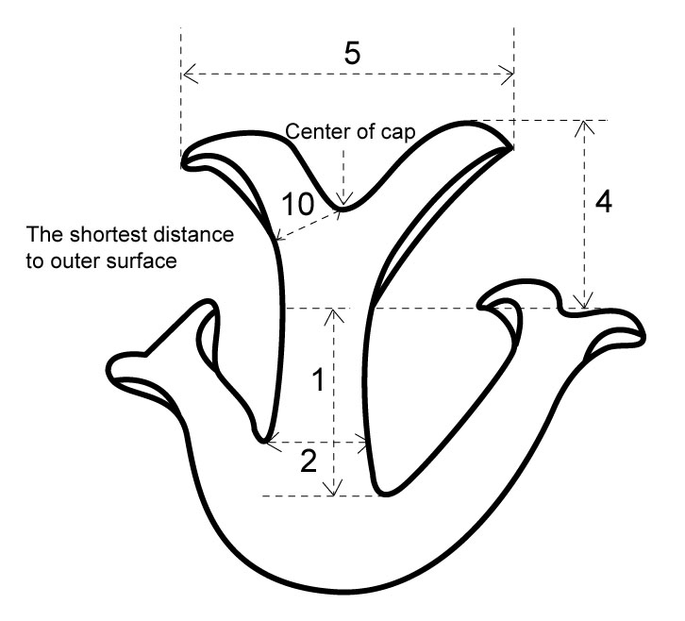 | 1: Stipe: length  2: Stipe: diameter  4: Cap: height  5: Cap: diameter  10: Cap: thickness

Type II  longitudinal section  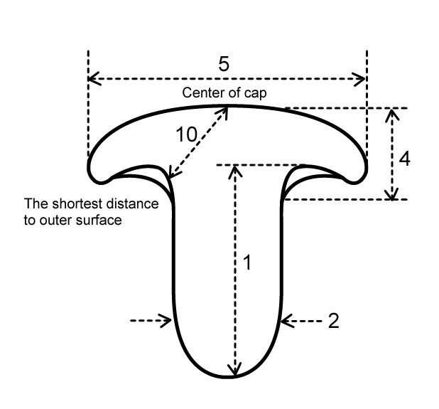 |  | 1: Stipe: length  2: Stipe: diameter  4: Cap: height  5: Cap: diameter  10: Cap: thickness
Type III  longitudinal section  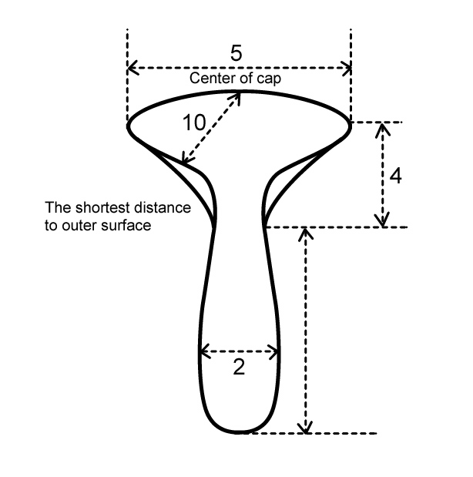 | 1: Stipe: length  2: Stipe: diameter  4: Cap: height  5: Cap: diameter  10: Cap: thickness

Type IV  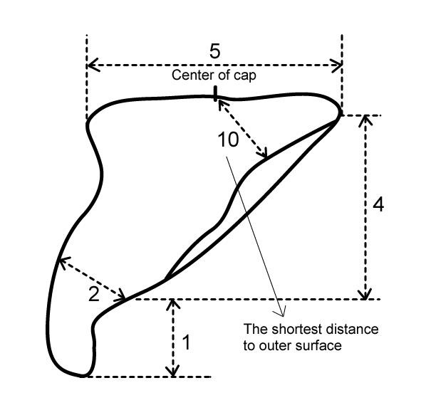 | 1: Stipe: length  2: Stipe: diameter  4: Cap: height  5: Cap: diameter  10: Cap: thickness

Ad. 3: Stipe: shape in longitudinal section

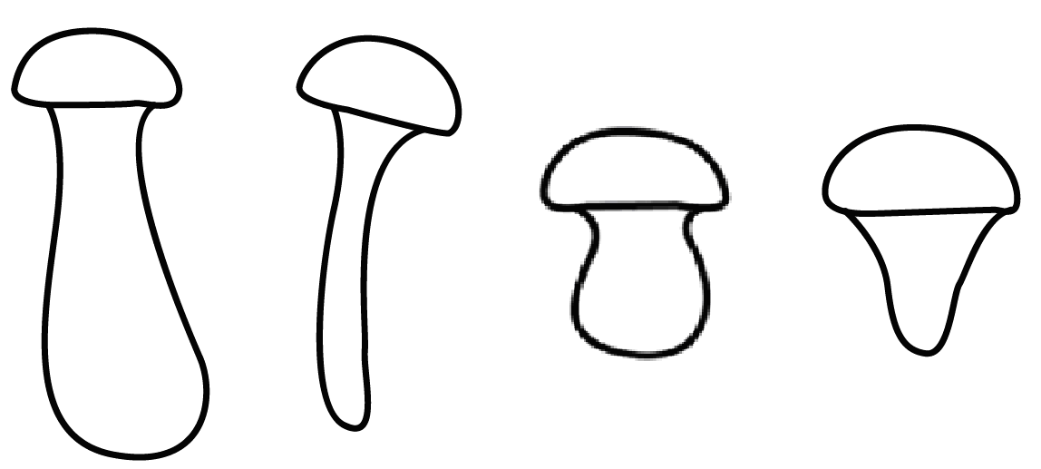
1 | 2 | 3 | 4
club-shaped | cylindrical | pot-shaped | tapered at base

Ad. 7: Cap: curvature of upper surface in longitudinal section

 | 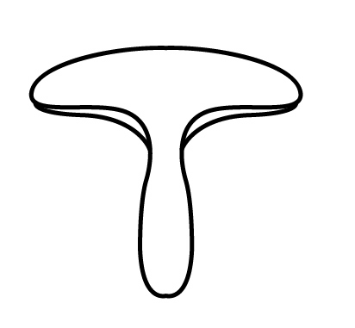 | 
1 | 3 | 5
convex | flat | concave

Ad. 9: Cap: attachment

To observe major type of middle part of cluster.

 |  | 
1 | 2 | 3
central | moderately offset | strongly offset

The usual pattern is for the stipe to attach in the center of the pileus, called central. If the attachment is at the margin of the pileus, it is called strongly offset. Any attachment intermediate between central and lateral is termed moderately offset.

Ad. 11: Number of basidiospores

Select vigorous fruit body before it releases basidiospore. Cut a part of the cap from the fruit body (one cap per replication) and place in the Petri-dish at room temperature. After one day, collect and determine the number of basidiospore.

Additional information: Life cycle of Pleurotus spp.

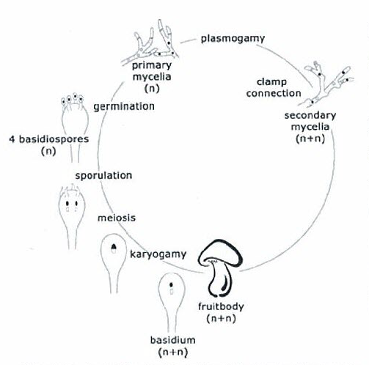

Literature

Deacon, J.W., 1997: Modern Mycology. Blackwell Science, 143pp.

Kang, S.W., 2004: Oyster Mushroom Cultivation. MushWorld, 48pp.

Largent, D. L. 1986: How to Identify Mushrooms to Genus Ⅰ: Macroscopic Features, 36-38pp.

Technical Questionnaire

TECHNICAL QUESTIONNAIRE |  |  |  | Page {x} of {y} |  | Reference Number:
 |  |  |  |  |  | Application date:
 |  |  |  |  |  | (not to be filled in by the applicant)
TECHNICAL QUESTIONNAIRE
to be completed in connection with an application for plant breeders’ rights

1. Subject of the Technical Questionnaire (please indicate the relevant genus or hybrid)
1.1.1 Genus name |  |  | Pleurotus ostreatus (Jacq.) P. Kumm.
1.1.2 Botanical name |  |  |  |  |  |  |  |  | [ ]
1.1.3 Common name |  |  | Hiratake; Oyster Mushroom
1.2.1 Genus name |  |  | Pleurotus eryngii (DC.) Quél.
1.2.2 Botanical name |  |  |  |  |  |  |  |  | [ ]
1.2.3 Common name |  |  | Enringi ; King Oyster Mushroom
1.3.1 Genus name |  |  | Pleurotus pulmonarius (Fr.) Quél.
1.3.2 Botanical name |  |  |  |  |  |  |  |  | [ ]
1.3.3 Common name |  |  | Lung Oyster Mushroom; Usuhiratake
2. Applicant
Name
Address
Telephone No.
Fax No.
E-mail address
Breeder (if different from applicant)
3. Proposed denomination and breeder’s reference
Proposed denomination
(if available)

Breeder’s reference
#4. Information on the breeding scheme and propagation of the variety

4.1 Breeding scheme

Variety resulting from:

4.1.1 Crossing

(a) controlled cross [ ]
(please state parent varieties)

(b) partially known cross [ ]
(please state known parent variety(ies))

(c) unknown cross [ ]

4.1.2 Mutation [ ]
(please state parent variety)

4.1.3 Discovery and development [ ]
(please state where and when discovered and how developed)

4.1.4 Other [ ]
(please provide details)

4.2 Method of propagating the variety

5. Characteristics of the variety to be indicated (the number in brackets refers to the corresponding characteristic in Test Guidelines; please mark the note which best corresponds).

 | Characteristics |  |  |  |  |  | Example Varieties |  |  | Note
5.1  (3) | Stipe: shape in longitudinal section
 | club-shaped |  |  |  |  |  | Aeryni(e),  HOKUTO PLE-2go(e),  KX-EG070(e) |  |  | 1[ ]
 | cylindrical |  |  |  |  |  | Chunchu2ho(o), Helios(o) |  |  | 2[ ]
 | pot-shaped |  |  |  |  |  | Maehyang(e) |  |  | 3[ ]
 | tapered at base |  |  |  |  |  | Mongblang(e) |  |  | 4[ ]
5.2  (7) | Cap: curvature of upper surface in longitudinal section
 | convex |  |  |  |  |  | Nonggi 1ho(o) |  |  | 1[ ]
 | convex to flat |  |  |  |  |  |  |  |  | 2[ ]
 | flat |  |  |  |  |  | Aeryni(e), KX-EG079(e) |  |  | 3[ ]
 | flat to concave |  |  |  |  |  |  |  |  | 4[ ]
 | concave |  |  |  |  |  | Chunchu 2ho(o), Suhan(o) |  |  | 5[ ]
5.3  (8) | Cap: color
 | white |  |  |  |  |  | Goni(o) |  |  | 1[ ]
 | medium brown |  |  |  |  |  | HOKUTO PLE-2go(e),  Yeoreumneutari 1ho(p),  3014(p) |  |  | 2[ ]
 | dark brown |  |  |  |  |  | Hosan(p) |  |  | 3[ ]
 | medium grey |  |  |  |  |  | Chunchu 2ho(o), Fotios(o), Helios(o), HK 35(o), Ikaros(o),  KX-EG070(e) |  |  | 4[ ]
 | dark grey |  |  |  |  |  | Manchuri(o), Nonggi 2-1ho(o) |  |  | 5[ ]
5.4  (12) | Fruit body: cluster
 | absent |  |  |  |  |  | KX-EG070(e),  Yeoreumneutari1ho(p) |  |  | 1[ ]
 | present |  |  |  |  |  | HK 35(o), KX-EG1001(e), Suhan(o) |  |  | 9[ ]
6. Similar varieties and differences from these varieties

Please use the following table and box for comments to provide information on how your candidate variety differs from the variety (or varieties) which, to the best of your knowledge, is (or are) most similar. This information may help the examination authority to conduct its examination of distinctness in a more efficient way.

Denomination(s) of variety(ies) similar to your candidate variety |  | Characteristic(s) in which your candidate variety differs from the similar variety(ies) |  |  | Describe the expression of the characteristic(s) for the similar variety(ies) |  |  | Describe the expression of the characteristic(s) for your candidate variety
Example |  | Cap: color |  |  | dark grey |  |  | medium grey
Comments:

#7. Additional information which may help in the examination of the variety

7.1 In addition to the information provided in sections 5 and 6, are there any additional characteristics which may help to distinguish the variety?

Yes [ ] No [ ]

(If yes, please provide details)

7.2 Are there any special conditions for growing the variety or conducting the examination?

Yes [ ] No [ ]

(If yes, please provide details)

7.3 Aversion line

Yes [ ] No [ ]

7.4 Optimum temperature for primodia formation

7.5 Optimum temperature for fruit body formation

7.6 Stipe: color

7.7 Other information

8. Authorization for release

(a) Does the variety require prior authorization for release under legislation concerning the protection of the environment, human and animal health?

Yes [ ] No [ ]

(b) Has such authorization been obtained?

Yes [ ] No [ ]

If the answer to (b) is yes, please attach a copy of the authorization.

9. Information on material to be examined or submitted for examination.

9.1 The expression of a characteristic or several characteristics of a variety may be affected by factors, such as pests and disease, chemical treatment (e.g. growth retardants or pesticides), effects of tissue culture, different rootstocks, scions taken from different growth phases of a tree, etc.

9.2 The material should not have undergone any treatment which would affect the expression of the characteristics of the variety, unless the competent authorities allow or request such treatment. If the material has undergone such treatment, full details of the treatment must be given. In this respect, please indicate below, to the best of your knowledge, if the material to be examined has been subjected to:

(a) Microorganisms (e.g. virus, bacteria, phytoplasma) Yes [ ] No [ ]

(b) Chemical treatment (e.g. growth retardant, pesticide) Yes [ ] No [ ]

(c) Tissue culture Yes [ ] No [ ]

(d) Other factors Yes [ ] No [ ]

Please provide details for where you have indicated “yes”.

……………………………………………………………

10. I hereby declare that, to the best of my knowledge, the information provided in this form is correct:

Applicant’s name

Signature Date

[End of document]

* These names were correct at the time of the introduction of these Test Guidelines but may be revised or updated. [Readers are advised to consult the UPOV Code, which can be found on the UPOV Website (www.upov.int), for the latest information.]
# Authorities may allow certain of this information to be provided in a confidential section of the Technical Questionnaire.
# Authorities may allow certain of this information to be provided in a confidential section of the Technical Questionnaire.

