 |  |  |  |  |  |  | E  TG/HEBE(proj.4)  ORIGINAL: English  DATE: 2012-09-11
INTERNATIONAL UNION FOR THE PROTECTION OF NEW VARIETIES OF PLANTS
Geneva
 |  |  | DRAFT
 |  | HEBE  UPOV Code: HEBEE  Hebe Comm. ex Juss. |  |  | *

GUIDELINES

FOR THE CONDUCT OF TESTS

FOR DISTINCTNESS, UNIFORMITY AND STABILITY

prepared by experts from New Zealand

to be considered by the
Enlarged Editorial Committee at its meeting
to be held in Geneva, on January 9 and 10, 2013

Alternative Names:*

Botanical name | English | French | German | Spanish
Hebe Comm. ex Juss. | Hebe | Veronique | Strauchveronika | Verónica

The purpose of these guidelines (“Test Guidelines”) is to elaborate the principles contained in the General Introduction (document TG/1/3), and its associated TGP documents, into detailed practical guidance for the harmonized examination of distinctness, uniformity and stability (DUS) and, in particular, to identify appropriate characteristics for the examination of DUS and production of harmonized variety descriptions.

ASSOCIATED DOCUMENTS
These Test Guidelines should be read in conjunction with the General Introduction and its associated TGP documents.
TABLE OF CONTENTS PAGE

1. Subject of these Test Guidelines 3
2. Material Required 3
3. Method of Examination 3
3.1 Number of Growing Cycles 3
3.2 Testing Place 3
3.3 Conditions for Conducting the Examination 3
3.4 Test Design 3
3.5 Additional Tests 3
4. Assessment of Distinctness, Uniformity and Stability 4
4.1 Distinctness 4
4.2 Uniformity 5
4.3 Stability 5
5. Grouping of Varieties and Organization of the Growing Trial 5
6. Introduction to the Table of Characteristics 6
6.1 Categories of Characteristics 6
6.2 States of Expression and Corresponding Notes 6
6.3 Types of Expression 7
6.4 Example Varieties 7
6.5 Legend 7
7. Table of Characteristics/Tableau des caractères/Merkmalstabelle/Tabla de caracteres 8
8. Explanations on the Table of Characteristics 15
8.1 Explanations covering several characteristics 15
8.2 Explanations for individual characteristics 15
9. Literature 23
10. Technical Questionnaire 24

Subject of these Test Guidelines

These Test Guidelines apply to all varieties of Hebe Comm. ex Juss..

Material Required

2.1 The competent authorities decide on the quantity and quality of the plant material required for testing the variety and when and where it is to be delivered. Applicants submitting material from a State other than that in which the testing takes place must ensure that all customs formalities and phytosanitary requirements are complied with.

2.2 The material is to be supplied in the form of young plants capable of flowering and expressing relevant characteristics of the variety in the first growing cycle.

2.3 The minimum quantity of plant material, to be supplied by the applicant, should be:

8 plants.

2.4 The plant material supplied should be visibly healthy, not lacking in vigor, nor affected by any important pest or disease.

2.5 The plant material should not have undergone any treatment which would affect the expression of the characteristics of the variety, unless the competent authorities allow or request such treatment. If it has been treated, full details of the treatment must be given.

Method of Examination

3.1 Number of Growing Cycles

The minimum duration of tests should normally be a single growing cycle.

3.2 Testing Place

Tests are normally conducted at one place. In the case of tests conducted at more than one place, guidance is provided in TGP/9 “Examining Distinctness”.

3.3 Conditions for Conducting the Examination

3.3.1 The tests should be carried out under conditions ensuring satisfactory growth for the expression of the relevant characteristics of the variety and for the conduct of the examination.

3.3.2 Because daylight varies, color determinations made against a color chart should be made either in a suitable cabinet providing artificial daylight or in the middle of the day in a room without direct sunlight. The spectral distribution of the illuminant for artificial daylight should conform with the CIE Standard of Preferred Daylight D 6500 and should fall within the tolerances set out in the British Standard 950, Part I. These determinations should be made with the plant part placed against a white background. The color chart and version used should be specified in the variety description.

3.4 Test Design

3.4.1 Each test should be designed to result in a total of at least 8 plants.

3.4.2 The design of the tests should be such that plants or parts of plants may be removed for measurement or counting without prejudice to the observations which must be made up to the end of the growing cycle.

3.5 Additional Tests

Additional tests, for examining relevant characteristics, may be established.

Assessment of Distinctness, Uniformity and Stability

4.1 Distinctness

4.1.1 General Recommendations

It is of particular importance for users of these Test Guidelines to consult the General Introduction prior to making decisions regarding distinctness. However, the following points are provided for elaboration or emphasis in these Test Guidelines.

4.1.2 Consistent Differences

The differences observed between varieties may be so clear that more than one growing cycle is not necessary. In addition, in some circumstances, the influence of the environment is not such that more than a single growing cycle is required to provide assurance that the differences observed between varieties are sufficiently consistent. One means of ensuring that a difference in a characteristic, observed in a growing trial, is sufficiently consistent is to examine the characteristic in at least two independent growing cycles.

4.1.3 Clear Differences

Determining whether a difference between two varieties is clear depends on many factors, and should consider, in particular, the type of expression of the characteristic being examined, i.e. whether it is expressed in a qualitative, quantitative, or pseudo-qualitative manner. Therefore, it is important that users of these Test Guidelines are familiar with the recommendations contained in the General Introduction prior to making decisions regarding distinctness.

4.1.4 Number of Plants / Parts of Plants to be Examined

Unless otherwise indicated, for the purposes of distinctness, all observations on single plants should be made on 7 plants or parts taken from each of 7 plants and any other observations made on all plants in the test, disregarding any off-type plants. In the case of observations of parts taken from single plants, the number of parts to be taken from each of the plants should be 2.

4.1.5 Method of Observation

The recommended method of observing the characteristic for the purposes of distinctness is indicated by the following key in the second column of the Table of Characteristics (see document TGP/9 “Examining Distinctness”, Section 4 “Observation of characteristics”):

MG: single measurement of a group of plants or parts of plants
MS: measurement of a number of individual plants or parts of plants
VG: visual assessment by a single observation of a group of plants or parts of plants
VS: visual assessment by observation of individual plants or parts of plants

Type of observation: visual (V) or measurement (M)

“Visual” observation (V) is an observation made on the basis of the expert’s judgment. For the purposes of this document, “visual” observation refers to the sensory observations of the experts and, therefore, also includes smell, taste and touch. Visual observation includes observations where the expert uses reference points (e.g. diagrams, example varieties, side-by-side comparison) or non-linear charts (e.g. color charts). Measurement (M) is an objective observation against a calibrated, linear scale e.g. using a ruler, weighing scales, colorimeter, dates, counts, etc.

Type of record: for a group of plants (G) or for single, individual plants (S)

For the purposes of distinctness, observations may be recorded as a single record for a group of plants or parts of plants (G), or may be recorded as records for a number of single, individual plants or parts of plants (S). In most cases, “G” provides a single record per variety and it is not possible or necessary to apply statistical methods in a plant-by-plant analysis for the assessment of distinctness.

In cases where more than one method of observing the characteristic is indicated in the Table of Characteristics (e.g. VG/MG), guidance on selecting an appropriate method is provided in document TGP/9, Section 4.2.

4.2 Uniformity

4.2.1 It is of particular importance for users of these Test Guidelines to consult the General Introduction prior to making decisions regarding uniformity. However, the following points are provided for elaboration or emphasis in these Test Guidelines:

4.2.2 For the assessment of uniformity of vegetatively propagated varieties, a population standard of 1% and an acceptance probability of at least 95% should be applied. In the case of a sample size of 8 plants, 1 off-type is allowed.

4.3 Stability

4.3.1 In practice, it is not usual to perform tests of stability that produce results as certain as those of the testing of distinctness and uniformity. However, experience has demonstrated that, for many types of variety, when a variety has been shown to be uniform, it can also be considered to be stable.

4.3.2 Where appropriate, or in cases of doubt, stability may be further examined by testing a new plant stock to ensure that it exhibits the same characteristics as those shown by the initial material supplied.

Grouping of Varieties and Organization of the Growing Trial

5.1 The selection of varieties of common knowledge to be grown in the trial with the candidate varieties and the way in which these varieties are divided into groups to facilitate the assessment of distinctness are aided by the use of grouping characteristics.

5.2 Grouping characteristics are those in which the documented states of expression, even where produced at different locations, can be used, either individually or in combination with other such characteristics: (a) to select varieties of common knowledge that can be excluded from the growing trial used for examination of distinctness; and (b) to organize the growing trial so that similar varieties are grouped together.

5.3 The following have been agreed as useful grouping characteristics:

(a) Plant: habit (characteristic 1)
(b) Leaf blade: width (characteristic 15)
(c) Leaf blade: main color (characteristic 22) with the following groups:
white
yellowish white
yellow
yellow green
green
yellow brown
reddish brown
reddish purple
purple
purplish black
(d) Leaf blade: secondary color (characteristic 24) with the following color groups:
none
white
yellowish white
yellow
yellow green
green
yellow brown
reddish brown
reddish purple
purple
purplish black
(e) Inflorescence: shape in profile (characteristic 31)
(f) Corolla lobe: color of inner side (characteristic 37) with the following groups:
white
pink
pink red
purple
violet
blue

5.4 Guidance for the use of grouping characteristics, in the process of examining distinctness, is provided through the General Introduction and document TGP/9 “Examining Distinctness”.

Introduction to the Table of Characteristics

6.1 Categories of Characteristics

6.1.1 Standard Test Guidelines Characteristics

Standard Test Guidelines characteristics are those which are approved by UPOV for examination of DUS and from which members of the Union can select those suitable for their particular circumstances.

6.1.2 Asterisked Characteristics

Asterisked characteristics (denoted by *) are those included in the Test Guidelines which are important for the international harmonization of variety descriptions and should always be examined for DUS and included in the variety description by all members of the Union, except when the state of expression of a preceding characteristic or regional environmental conditions render this inappropriate.

6.2 States of Expression and Corresponding Notes

6.2.1 States of expression are given for each characteristic to define the characteristic and to harmonize descriptions. Each state of expression is allocated a corresponding numerical note for ease of recording of data and for the production and exchange of the description.

6.2.2 In the case of qualitative and pseudo-qualitative characteristics (see Chapter 6.3), all relevant states of expression are presented in the characteristic. However, in the case of quantitative characteristics with 5 or more states, an abbreviated scale may be used to minimize the size of the Table of Characteristics. For example, in the case of a quantitative characteristic with 9 states, the presentation of states of expression in the Test Guidelines may be abbreviated as follows:

State | Note
small | 3
medium | 5
large | 7

However, it should be noted that all of the following 9 states of expression exist to describe varieties and should be used as appropriate:

State | Note
very small | 1
very small to small | 2
small | 3
small to medium | 4
medium | 5
medium to large | 6
large | 7
large to very large | 8
very large | 9

6.2.3 Further explanation of the presentation of states of expression and notes is provided in document TGP/7 “Development of Test Guidelines”.

6.3 Types of Expression

An explanation of the types of expression of characteristics (qualitative, quantitative and pseudo-qualitative) is provided in the General Introduction.

6.4 Example Varieties

Where appropriate, example varieties are provided to clarify the states of expression of each characteristic.

6.5 Legend

(*) Asterisked characteristic – see Chapter 6.1.2

QL Qualitative characteristic – see Chapter 6.3
QN Quantitative characteristic – see Chapter 6.3
PQ Pseudo-qualitative characteristic – see Chapter 6.3

MG, MS, VG, VS – see Chapter 4.1.5

(a)-(f) See Explanations on the Table of Characteristics in Chapter 8.1

(+) See Explanations on the Table of Characteristics in Chapter 8.2.

Table of Characteristics/Tableau des caractères/Merkmalstabelle/Tabla de caracteres

 |  | English | français | deutsch | español | Example Varieties  Exemples  Beispielssorten  Variedades ejemplo | Note/  Nota
1  (*)  (+) | VG | Plant: habit | Plante : port | Pflanze: Wuchsform | Planta: hábito
PQ | (a) | upright | dressé | aufrecht | erecto | Sandra Joy,  Turkish Delight | 1
 |  | semi upright | demi-dressé | halbaufrecht | semierecto | Beverley Hills | 2
 |  | spreading | étalé | breitwüchsig | abierto | Orphan Annie,  Pretty N Pink | 3
 |  | horizontal | horizontal | waagerecht | horizontal | First Light, Hartii | 4
2  (*) | VG/  MG | Plant: height | Plante : hauteur | Pflanze: Höhe | Planta: altura
QN | (a) | very short | très courte | sehr niedrig | muy corta | Hartii | 1
 |  | short | courte | niedrig | corta | Orphan Annie, Rosie | 3
 |  | medium | moyenne | mittel | media | Beverley Hills,  Nicola’s Blush | 5
 |  | tall | haute | hoch | alta | Eveline, Wiri Desire | 7
 |  | very tall | très haute | sehr hoch | muy alta | Andersonii | 9
3 | VG | Plant: density of foliage | Plante : densité du feuillage | Pflanze: Dichte des Laubes | Planta: densidad del follaje
QN | (a) | sparse | lâche | locker | laxa | Sandra Joy,  Wiri Prince | 3
 |  | medium | moyenne | mittel | media | Champseiont,  First Light | 5
 |  | dense | dense | dicht | densa | Wiri Mist | 7
4  (*) | VG | Young shoot : anthocyanin coloration | Jeune rameau : pigmentation anthocyanique | Junger Trieb: Anthocyanfärbung | Tallo joven: pigmentación antociánica
 |  | absent or very weak | absente ou très faible | fehlend oder sehr gering | ausente o muy débil | Champseiont | 1
QN | (b) | weak | faible | gering | débil | Rosie | 2
 |  | medium | moyenne | mittel | media | Wiri Desire | 3
 |  | strong | forte | stark | fuerte | Turkish Delight | 4
 |  | very strong | très forte | sehr stark | muy fuerte | Orphan Annie | 5
5  (*) | VG | Young shoot: pubescence | Jeune rameau : pubescence | Junger Trieb: Behaarung | Tallo joven: pubescencia
QL | (b) | absent | absente | fehlend | ausente | Champseiont | 1
 |  | present | présente | vorhanden | presente | Orphan Annie | 9
6 | VG | Young shoot: density of pubescence | Jeune rameau : densité de la pubescence | Junger Trieb: Dichte der Behaarung | Tallo joven: densidad de la pubescencia
QN | (b) | very sparse | très lâche | sehr locker | muy laxa | First Light | 1
 |  | sparse | lâche | locker | laxa | Rosie | 2
 |  | medium | moyenne | mittel | media | Orphan Annie | 3
 |  | dense | dense | dicht | densa |  | 4
7  (*) | VG | Young stem: color | Jeune tige : couleur | Junger Trieb: Farbe | Tallo joven: color
PQ | (b) | yellow green | vert jaune | gelbgrün | verde amarillento | Lavender Lace,  Oratia Beauty | 1
 |  | green | verte | grün | verde | Wiri Mist | 2
 |  | yellow brown | brun jaune | gelbbraun | marrón amarillento | Diosmifolia Minor | 3
 |  | greenish brown | brun verdâtre | grünlich braun | marrón verdoso | Pagei | 4
 |  | brown | brune | braun | marrón | Gina Maree | 5
 |  | reddish brown | brun rougeâtre | rötlich braun | marrón rojizo | Mary Antoinette,  Wiri Prince | 6
 |  | reddish purple | pourpre rougeâtre | rötlich purpurn | púrpura rojizo | Pretty N Pink | 7
 |  | purple | pourpre | purpurn | púrpura | Santa Monica | 8
 |  | purplish black | noir violacé | purpurschwarz | negro purpúreo | Pascal | 9
8  (*) | VG/  MG | Stem: length of internodes | Tige : longueur des entre-nœuds | Stengel: Länge der Internoden | Tallo: longitud de los entrenudos
QN | (c) | very short | très courte | sehr kurz | muy corta | Karo Golden Esk | 1
 |  | short | courte | kurz | corta | Beverley Hills | 3
 |  | medium | moyenne | mittel | media | Wiri Desire | 5
 |  | long | longue | lang | larga | Moonlight | 7
9 | VG | Stem: anthocyanin coloration of internodes | Tige : pigmentation anthocyanique des entre-nœuds | Stengel: Anthocyanfärbung der Internoden | Tallo: pigmentación antociánica de los entrenudos
QN | (c) | absent or very weak | absente ou très faible | fehlend oder sehr gering | ausente o muy débil | Champseiont | 1
 |  | weak | faible | gering | débil | Beverley Hills | 3
 |  | medium | moyenne | mittel | media | Wiri Vogue | 5
 |  | strong | forte | stark | fuerte | Rosie | 7
10  (*)  (+) | VG | Leaf bud: presence of sinus | Bourgeon à feuilles : présence du sinus | Vegetative Knospe: Vorhandensein einer Einbuchtung | Yema foliar: presencia de seno
QL |  | absent | absent | fehlend | ausente | Orphan Annie | 1
 |  | present | présent | vorhanden | presente | Beverley Hills | 9
11  (*) | VG | Leaf: presence of petiole | Feuille : présence du pétiole | Blatt: Vorhandensein eines Blattstiels | Hoja: presencia de peciolo
QL | (d) | absent | absent | fehlend | ausente | Oratia Beauty, Red Edge | 1
 |  | present | présent | vorhanden | presente | Ohakea, Wiri Desire | 9
12  (*) | VG/  MG | Leaf: length of petiole | Feuille : longueur du pétiole | Blatt: Länge des Blattstiels | Hoja: longitud del peciolo
QN | (d) | short | court | kurz | corta | Champseiont,  Wiri Desire | 1
 |  | medium | moyen | mittel | media | Lavender Lace,  Sandra Joy | 2
 |  | long | long | lang | larga | Otari Delight,  Silver Queen | 3
13  (+) | VG | Leaf: attitude | Feuille : port | Blatt: Haltung | Hoja: porte
QN | (d) | adpressed | appliqué | anliegend | adpreso | Karo Golden Esk | 1
 |  | erect | dressé | aufrecht | erecto | Silver Queen | 2
 |  | semi erect | demi-dressé | halbaufrecht | semierecto | Wiri Mist | 3
 |  | horizontal | horizontal | waagerecht | horizontal | Pagei | 4
 |  | downwards | retombant | abwärts gerichtet | hacia abajo |  | 5
14  (*) | VG/  MS | Leaf blade: length | Limbe : longueur | Blattspreite: Länge | Limbo: longitud
QN | (d) | very short | très court | sehr kurz | muy corto | Greensleeves, Hartii | 1
 |  | short | court | kurz | corto | Headfortii, Orphan Annie | 3
 |  | medium | moyen | mittel | medio | La Seduisante,  Wiri Vogue | 5
 |  | long | long | lang | largo | Sandra Joy, Wiri Prince | 7
 |  | very long | très long | sehr lang | muy largo | Eveline | 9
15  (*) | VG/  MS | Leaf blade: width | Limbe : largeur | Blattspreite: Breite | Limbo: anchura
QN | (d) | very narrow | très étroit | sehr schmal | muy estrecho | Karo Golden Esk | 1
 |  | narrow | étroit | schmal | estrecho | Mary Antoinette, Silver Queen | 3
 |  | medium | moyen | mittel | medio | Eveline, Wiri Desire | 5
 |  | broad | large | breit | ancho | Andersonii,  La Seduisante | 7
16  (*) | VG/  MS | Leaf blade: ratio length/width | Limbe : rapport longueur/largeur | Blattspreite: Verhältnis Länge/Breite | Limbo: relación longitud/anchura
QN | (d) | rounded | arrondi | abgerundet | redondeado | Silver Queen | 1
 |  | slightly elongated | légèrement allongé | leicht langgezogen | ligeramente alargado | Turkish Delight | 3
 |  | moderately elongated | modérément allongé | mäßig langgezogen | moderadamente alargado | Sunstreak | 5
 |  | strongly elongated | fortement allongé | stark langgezogen | fuertemente alargado |  | 7
 |  | very strongly elongated | très fortement allongé | sehr stark langgezogen | muy fuertemente alargado | Lavender Lace | 9
17  (*)  (+) | VG | Leaf blade: shape | Limbe : forme | Blattspreite: Form | Limbo: forma
PQ | (d) | lanceolate | lancéolé | lanzettlich | lanceolado | Orphan Annie | 1
 |  | ovate | ovale | eiförmig | oval |  | 2
 |  | oblong | oblong | rechteckig | oblongo | Beverley Hills | 3
 |  | elliptic | elliptique | elliptisch | elíptico | First Light | 4
 |  | oblanceolate | oblancéolé | verkehrt lanzettlich | oblanceolado | Moonlight | 5
 |  | obovate | obovale | verkehrt eiförmig | oboval |  | 6
18  (*) | VG | Leaf blade: position of broadest part | Limbe : position de la partie la plus large | Blattspreite: Stellung des breitesten Teils | Limbo: posición de la parte más ancha
QN | (d) | towards base | vers la base | zur Basis hin | hacia la base | Orphan Annie | 1
 |  | in middle | au milieu | in der Mitte | en la mitad | Beverley Hills | 2
 |  | towards apex | vers le sommet | zur Spitze hin | hacia el ápice | Moonlight | 3
19  (+) | VG | Leaf blade: shape of apex | Limbe : forme du sommet | Blattspreite: Form der Spitze | Limbo: forma del ápice
PQ | (d) | acuminate | acuminé | zugespitzt | acuminado |  | 1
 |  | acute | pointu | spitz | agudo | Rosie | 2
 |  | rounded | arrondi | abgerundet | redondeado | Turkish Delight | 3
20 | VG | Leaf blade: profile in cross section | Limbe : profil en section transversale | Blattspreite: Profil im Querschnitt | Limbo: perfil en sección transversal
QN | (d) | concave | concave | konkav | cóncavo |  | 1
 |  | flat | plat | flach | plano |  | 2
 |  | convex | convexe | konvex | convexo |  | 3
21  (*) | VG | Leaf blade: incisions on margin | Limbe : incisions du bord | Blattspreite: Randeinschnitte | Limbo: incisiones en el margen
QL | (d) | absent | absentes | fehlend | ausente | Silver Queen | 1
 |  | present | présentes | vorhanden | presente | Diosmifolia Minor | 9
22  (*)  (+) | VG | Leaf blade: main color | Limbe : couleur principale | Blattspreite: Hauptfarbe | Limbo: color principal
PQ | (d) | RHS Colour Chart (indicate reference number) | Code RHS des couleurs (indiquer le numéro de référence) | RHS-Farbkarte (Nummer angeben) | Carta de colores RHS (indíquese el número de referencia)
23  (+) | VG | Leaf blade : distribution of secondary color | Limbe : répartition de la couleur secondaire | Blattspreite: Verteilung der Sekundärfarbe | Limbo: distribución del color secundario
PQ | (d) | none | aucune | keine | ninguna |  | 1
 |  | on margin only | en bordure seulement | nur am Rand | sólo en el margen | Frozen Flame,  Red Edge | 2
 |  | broad margin | bordure large | breiter Rand | en margen amplio | Heartbreaker | 3
 |  | intermediate zone | zone intermédiaire | intermediäre Zone | zona intermedia | Wild Romance | 4
 |  | central zone | zone centrale | Mittelzone | zona central | Neprock | 5
 |  | on mid rib only | sur la nervure médiane seulement | nur auf der Mittelrippe | sólo en el nervio central | Pacific Paradise | 6
 |  | on margin and on midrib | en bordure et sur la nervure médiane | am Rand und auf der Mittelrippe | en el margen y en el nervio central | Flame, Tullylrr | 7
 |  | irregular | irrégulière | unregelmäßig | irregular |  | 8
24  (+) | VG | Leaf blade: secondary color | Limbe : couleur secondaire | Blattspreite: Sekundärfarbe | Limbo: color secundario
PQ | (d) | RHS Colour Chart (indicate reference number) | Code RHS des couleurs (indiquer le numéro de référence) | RHS-Farbkarte (Nummer angeben) | Carta de colores RHS (indíquese el número de referencia)
25 | VG | Leaf blade : area covered by secondary color | Limbe : surface couverte par la couleur secondaire | Blattspreite: Zone der Sekundärfarbe | Limbo: superficie que ocupa el color secundario
QN | (d) | very small | très petite | sehr klein | muy pequeña | Marilyn Monroe | 1
 |  | small | petite | klein | pequeña | Wild Romance | 3
 |  | medium | moyenne | mittel | media | Baby Boo | 5
 |  | large | grande | groß | grande | Vero 1 | 7
 |  | very large | très grande | sehr groß | muy grande | Sweet Kim | 9
26  (+) | VG | Leaf blade : distribution of tertiary color | Limbe : répartition de la couleur tertiaire | Blattspreite: Verteilung der Tertiärfarbe | Limbo: distribución del color terciario
PQ | (d) | none | aucune | keine | ninguno |  | 1
 |  | on margin only | en bordure seulement | nur am Rand | sólo en el margen | Frozen Flame | 2
 |  | on mid rib only | sur la nervure médiane seulement | nur auf der Mittelrippe | sólo en el nervio central | Wild Romance | 3
 |  | on margin and on midrib | en bordure et sur la nervure médiane | am Rand und auf der Mittelrippe | en el margen y en el nervio central | Baby Boo | 4
27  (+) | VG | Leaf blade: tertiary color | Limbe : couleur tertiaire | Blattspreite: Tertiärfarbe | Limbo: color terciario
PQ | (d) | RHS Colour Chart (indicate reference number | Code RHS des couleurs (indiquer le numéro de référence) | RHS-Farbkarte (Nummer angeben) | Carta de colores RHS (indíquese el número de referencia)
28 | VG | Leaf blade: glossiness | Limbe : brillance | Blattspreite: Glanz | Limbo: brillo
QN | (d) | absent or very weak | absente ou très faible | fehlend oder sehr gering | ausente o muy débil | Wiri Desire | 1
 |  | weak | faible | gering | débil |  | 2
 |  | medium | moyenne | mittel | medio | Sunset Boulevard | 3
 |  | strong | forte | stark | fuerte | Champseiont | 4
29  (+) | VG | Leaf blade: glaucosity | Limbe : glaucescence | Blattspreite: Bereifung | Limbo: glauescencia
QN | (d) | absent or very weak | absente ou très faible | fehlend oder sehr gering | ausente o muy débil |  | 1
 |  | weak | faible | gering | débil | Turkish Delight | 2
 |  | medium | moyenne | mittel | media |  | 3
 |  | strong | forte | stark | fuerte | First Light | 4
30  (*)  (+) | VG | Inflorescence: arrangement | Inflorescence : disposition | Blütenstand: Anordnung | Inflorescencia: disposición
PQ |  | terminal only | terminale seulement | nur terminal | solamente terminal | Champseiont, Greensleeves | 1
 |  | terminal and lateral | terminale et latérale | terminal und lateral | terminal y lateral |  | 2
 |  | lateral only | latérale seulement | nur lateral | solamente lateral | Beverley Hills | 3
31  (*)  (+) | VG | Inflorescence: shape in profile | Inflorescence : forme de profil | Blütenstand: Form im Profil | Inflorescencia: forma de perfil
PQ | (e) | triangular | triangulaire | dreieckig | triangular | Moonlight | 1
 |  | oblong | oblongue | rechteckig | oblongo | Eveline, Wiri Vogue | 2
 |  | elliptic | elliptique | elliptisch | elíptico | Icing Sugar, Wiri Joy | 3
32  (*)  (+) | VG/  MS | Inflorescence: length of flowering part | Inflorescence : longueur de la partie florifère | Blütenstand: Länge des blühenden Teils | Inflorescencia: longitud de la parte en floración
QN | (e) | very short | très courte | sehr kurz | muy corta | County Park | 1
 |  | short | courte | kurz | corta | Beverley Hills | 3
 |  | medium | moyenne | mittel | media | Moonlight | 5
 |  | long | longue | lang | larga | Sandra Joy,  Sunset Boulevard | 7
33  (*)  (+) | VG/  MS | Inflorescence: width of flowering part | Inflorescence : largeur de la partie florifère | Blütenstand: Breite des blühenden Teils | Inflorescencia: anchura de la parte en floración
QN | (e) | narrow | étroite | schmal | estrecha | Tullylrr | 3
 |  | medium | moyenne | mittel | media | Zerina | 5
 |  | broad | large | breit | ancha | Grethe | 7
34 | VG | Inflorescence: density of flowers | Inflorescence : densité des fleurs | Blütenstand: Dichte der Blüten | Inflorescencia: densidad de flores
QN | (e) | sparse | faible | locker | laxa |  | 3
 |  | medium | moyenne | mittel | media | Ohakea | 5
 |  | dense | forte | dicht | densa | Beverley Hills | 7
35  (*)  (+) | VG | Inflorescence: corolla color change with age | Inflorescence : changement de couleur de la corolle avec l’âge | Blütenstand: Farbveränderung der Krone mit dem Alter | Inflorescencia: cambio de color con el paso del tiempo
QN |  | absent or weak | absent ou faible | fehlend oder sehr gering | ausente o débil | Purple Queen | 1
 |  | medium | moyen | mittel | medio | Nicola’s Blush | 2
 |  | strong | fort | stark | fuerte | Great Orme | 3
36  (*)  (+) | VG/  MS | Corolla: width | Corolle : largeur | Krone: Breite | Corola: anchura
QN | (e) | narrow | étroite | schmal | estrecha | Wiri Vogue | 3
 | (f) | medium | moyenne | mittel | media | Orphan Annie | 5
 |  | broad | large | breit | ancha | Silver Queen | 7
37  (*) | VG | Corolla lobe: color of inner side | Lobe de la corolle : couleur de la face interne | Kronlappen: Farbe der Innenseite | Lóbulo de la corola: color de la cara interior
PQ | (e)  (f) | RHS Colour Chart (indicate reference number) | Code RHS des couleurs (indiquer le numéro de référence) | RHS-Farbkarte (Nummer angeben) | Carta de colores RHS (indíquese el número de referencia)
38  (*)  (+) | VG | Corolla tube: length in relation to calyx | Tube de la corolle : longueur par rapport au calice | Kronröhre: Länge im Verhältnis zum Kelch | Tubo de la corola: longitud en relación con cáliz
QN | (e) | shorter | plus court | kürzer | más corto | Beverley Hills | 1
 | (f) | equal | égal | gleich lang | igual | Rosie | 2
 |  | longer | plus long | länger | más largo | Wiri Vogue | 3
39  (*) | VG | Corolla tube: color of outer side | Tube de la corolle : couleur de la face externe | Kronröhre: Farbe der Außenseite | Tubo de la corola: color de la cara externa
PQ | (e)  (f) | RHS Colour Chart (indicate reference number) | Code RHS des couleurs (indiquer le numéro de référence) | RHS-Farbkarte (Nummer angeben) | Carta de colores RHS (indíquese el número de referencia)
40  (+) | VG | Plant: number of inflorescences | Plante : nombre d’inflorescences | Pflanze: Anzahl Blütenstände | Planta: número de inflorescencias
QN |  | few | petit | gering | bajo |  | 3
 |  | medium | moyen | mittel | medio |  | 5
 |  | many | grand | groß | alto |  | 7

Explanations on the Table of Characteristics

8.1 Explanations covering several characteristics

Unless otherwise indicated, all characteristics should be examined at the time of full flowering.

Characteristics containing the following key in the second column of the Table of Characteristics should be examined as indicated below:

(a) The assessment of plant characteristics should be carried out later in the growing season, towards the end of active growth.

(b) All observations on young shoot and young stem characteristics should be made in the first flush of growth in the season. The young stem is on the upper third on a current seasons shoot.

(c) All observations on stem internodes should be made on the middle third of a well developed shoot in active growth.

(d) All observations on the leaf and petiole should be made on a leaf from the middle third of a flowering shoot. All color observations are made on the inner side of the leaf. The inner side is the same as the upper side.

(e) Unless otherwise stated, all observations on the inflorescence and flower should be made when the flowers which have opened first, at the base of an inflorescence, are beginning to dehisce.

(f) All observations on the corolla should be made from flowers in the middle third of the inflorescence.

8.2 Explanations for individual characteristics

Ad. 1: Plant: habit

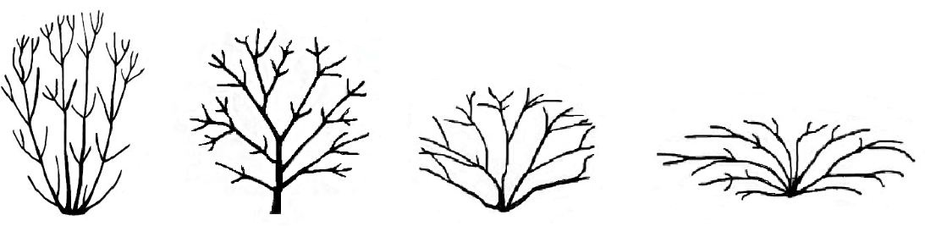
1 | 2 | 3 | 4
upright | semi upright | spreading | horizontal

Ad.10: Leaf bud: presence of sinus

The sinus is located in the leaf bud, a gap between the bases of two leaves of a pair when in bud. It can be seen with an unaided eye for some varieties and is recommended to be observed with a magnifying glass. The presence or absence of a petiole or the shape of the leaf blade can indicate the presence of the sinus. Narrower leaves and those with petioles are more likely to have a sinus.

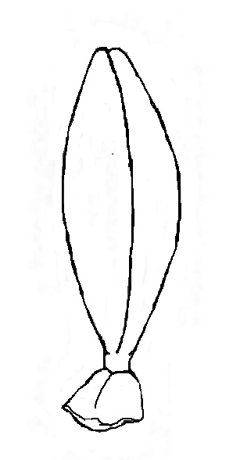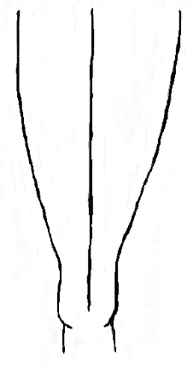 | 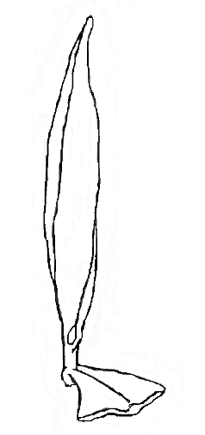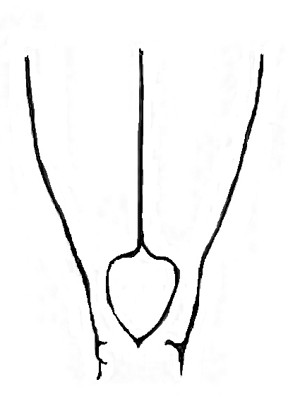  sinus
1 | 9
absent | present

Ad. 13: Leaf: attitude

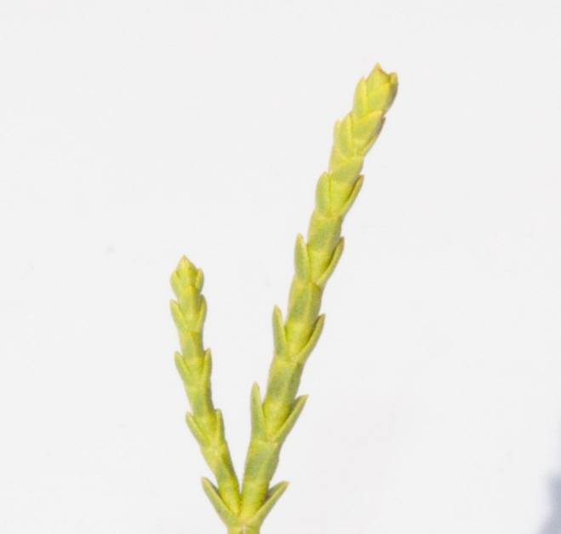 | 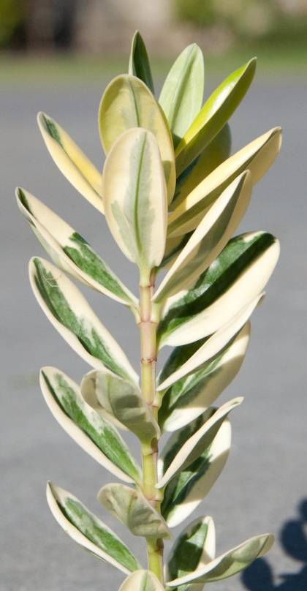
1 | 2
adpressed | erect

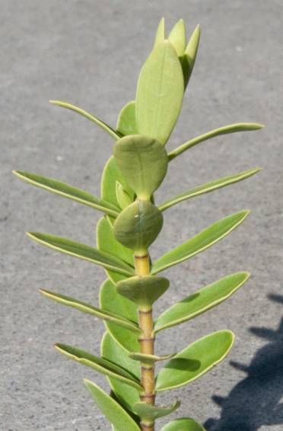 | 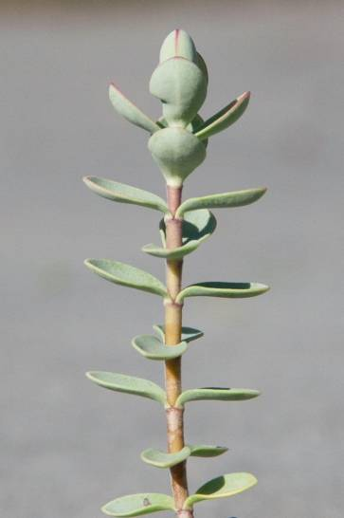 | 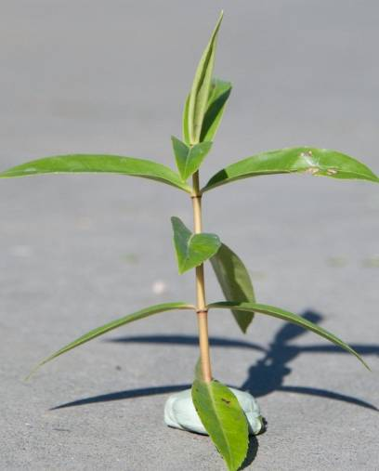
3 | 4 | 5
semi erect | horizontal | downwards

Ad. 17: Leaf blade: shape

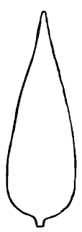
1 | 2 | 3 | 4 | 5 | 6
lanceolate | ovate | oblong | elliptic | oblanceolate | obovate

Ad. 19: Leaf blade: shape of apex

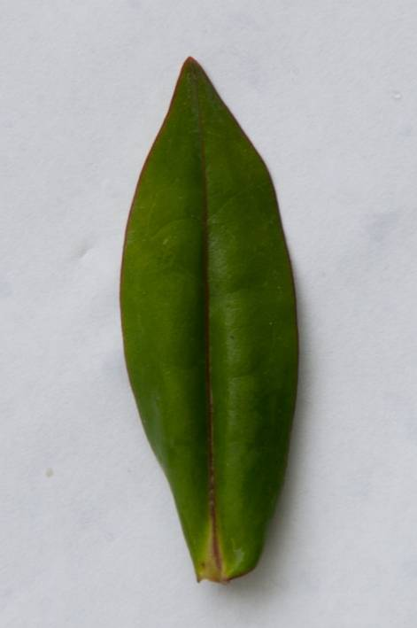 | 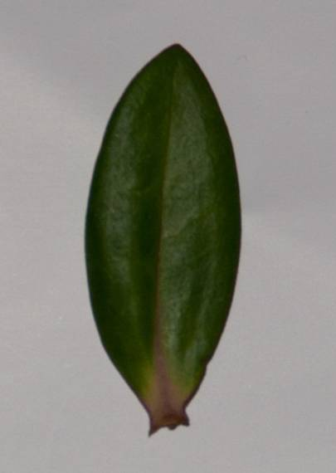 | 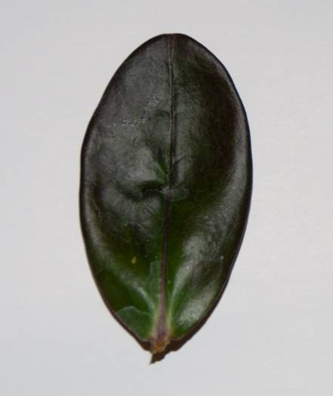
1 | 2 | 3
acuminate | acute | rounded

Ad. 22: Leaf blade: main color
3
narrow
5
medium
3
narrow
5
medium
3
narrow
5
medium

The main color is determined as the color with the largest surface area present on the inner side of a leaf. Observations should be made on plants not subjected to chilling. For varieties with glaucosity, the waxy layer is removed. The inner side is the same as the upper side.

Ad. 23: Leaf blade: distribution of secondary color

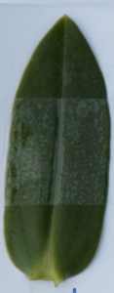 | 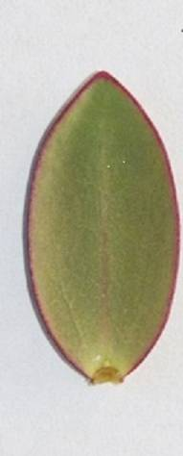 | 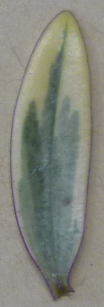 | 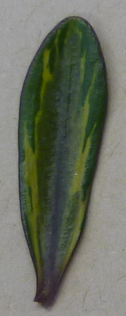
1 | 2 | 3 | 4
none | on margin only | broad margin  (whitish) | intermediate zone  (light green)

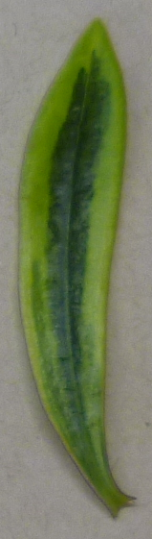 |  | 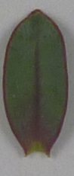 | 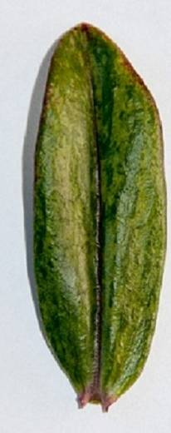
5 | 6 | 7 | 8
central zone  (dark green) | on mid rib only | on margin and  on mid rib  (red purple) | irregular  (light yellow)

Ad. 24: Leaf blade: secondary color

The secondary color is determined as the color with the second largest surface area, usually observed as a defined pattern on the inner side of a leaf.

Ad. 26: Leaf blade: distribution of tertiary color

 | 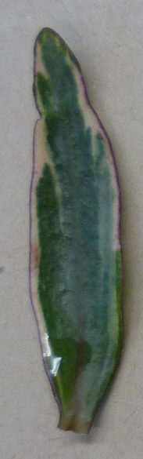 |  | 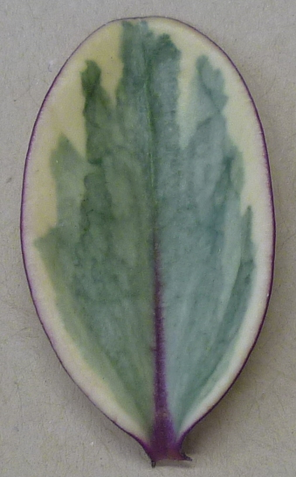
1 | 2 | 3 | 4
none | on margin only  (purple) | on mid rib only  (blackish) | on margin and on mid rib (purple)

Ad. 27: Leaf blade: tertiary color

The tertiary color is determined as the color with the third largest surface area, usually observed as a defined pattern on the inner side of a leaf. For varieties with glaucosity, the waxy layer is removed. The inner side is the same as the upper side.

Ad. 29: Leaf blade: glaucosity

The glaucosity is the bloom or waxy layer covering the leaf surface and generally gives a leaf a bluish or milky coloration. The layer can be removed.

Ad. 30: Inflorescence: arrangement

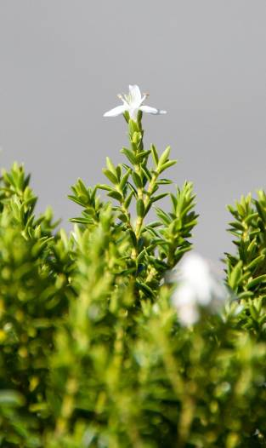 | 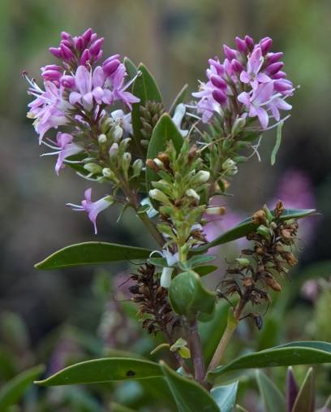 | 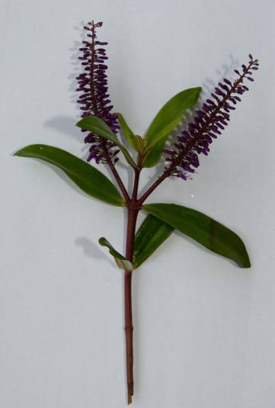
1 | 2 | 3
terminal only | terminal and lateral | lateral only

Ad. 31: Inflorescence: shape in profile

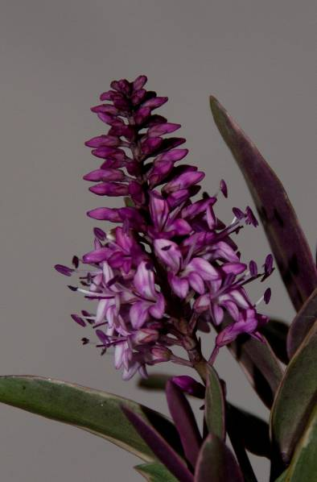 | 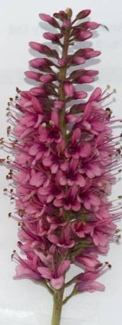 | 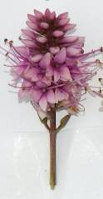
1 | 2 | 3
triangular | oblong | elliptic

Ad. 32: Inflorescence: length of flowering part
Ad 33: Inflorescence: width of flowering part

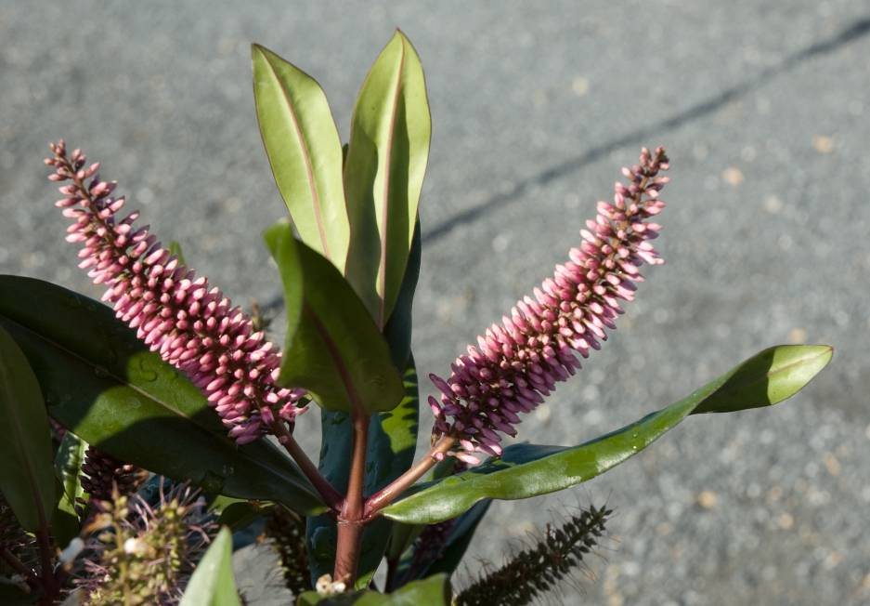
Length
Width
Length
Width

The width of the inflorescence is taken at the broadest point.

Ad. 35: Inflorescence: corolla color change with age

Observations are made when half to two thirds of all flowers on a single inflorescence are open.

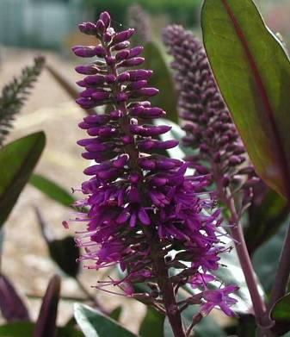 | 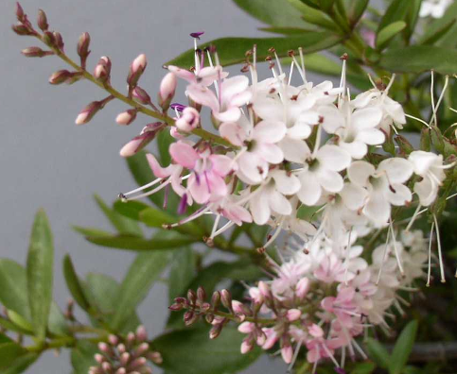 | 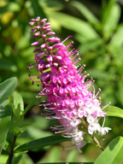
1 | 2 | 3
absent or weak | medium | strong

Ad. 36: Corolla: width
Ad. 38: Corolla tube: length in relation to calyx

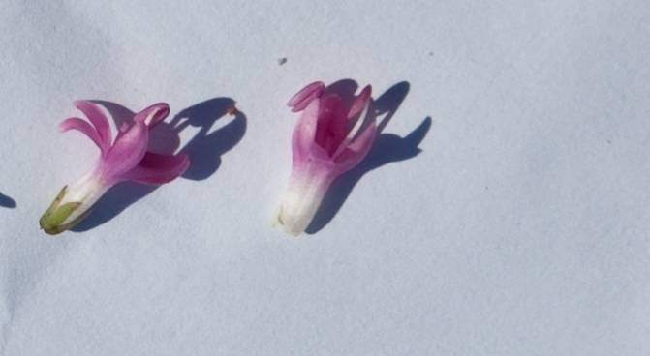
Corolla
width
Corolla
lobe
Calyx

Corolla
tube

Ad. 40: Plant: number of inflorescences

The observation should be made when approximately 50% of inflorescences present have open flowers.

Literature

Hutchins, G., 1997: Hebes Here and There, Hutchins and Davies, Reading, GB

Metcalf, L.J., 1975: The Cultivation of New Zealand Trees and Shrubs, AH & AW Reed Ltd. Auckland, NZ

Metcalf, L.J., 2001: International Register of Hebe Cultivars, Royal New Zealand Institute of Horticulture

Metcalf, L.J., 2006: Hebe: a guide to species, hybrids and allied genera, Timber Press, Oregon, US

Poole, A.L., Adams, N.M. 1986: Trees and Shrubs of New Zealand, Government Printing, Wellington, NZ, pp. 218 to 237

Technical Questionnaire

TECHNICAL QUESTIONNAIRE |  |  |  | Page {x} of {y} |  | Reference Number:
 |  |  |  |  |  | Application date:
 |  |  |  |  |  | (not to be filled in by the applicant)
TECHNICAL QUESTIONNAIRE
to be completed in connection with an application for plant breeders’ rights

1. Subject of the Technical Questionnaire
1.1 Botanical name |  |  | Hebe Comm. ex Juss.
1.2 Common name |  |  | Hebe
1.3 Species
2. Applicant
Name
Address
Telephone No.
Fax No.
E-mail address
Breeder (if different from applicant)
3. Proposed denomination and breeder’s reference
Proposed denomination
(if available)

Breeder’s reference
#4. Information on the breeding scheme and propagation of the variety

4.1 Breeding scheme

Variety resulting from:

4.1.1 Crossing

(a) controlled cross [ ]
(please state parent varieties)

(…………………..……………..…) x (……………..…………………..…)
female parent male parent

(b) partially known cross [ ]
(please state known parent variety(ies))

(…………………..……………..…) x (……………..…………………..…)
female parent male parent

(c) unknown cross [ ]

4.1.2 Mutation [ ]
(please state parent variety)

4.1.3 Discovery and development [ ]
(please state where and when discovered and how developed)

4.1.4 Other [ ]
(please provide details)

  - Method of propagating the variety

4.2.1 Vegetative propagation

(a) cuttings [ ]

(b) in vitro propagation [ ]

(c) other (state method) [ ]

4.2.2 Other [ ]
(please provide details)

5. Characteristics of the variety to be indicated (the number in brackets refers to the corresponding characteristic in Test Guidelines; please mark the note which best corresponds).

 | Characteristics |  |  |  |  |  | Example Varieties |  |  | Note
5.1  (1) | Plant: habit
 | upright |  |  |  |  |  | Sandra Joy, Turkish Delight |  |  | 1[ ]
 | semi upright |  |  |  |  |  | Beverley Hills |  |  | 2[ ]
 | spreading |  |  |  |  |  | Orphan Annie, Pretty N Pink |  |  | 3[ ]
 | horizontal |  |  |  |  |  | First Light, Hartii |  |  | 4[ ]
5.2  (15) | Leaf blade: width
 | very narrow |  |  |  |  |  | Karo Golden Esk |  |  | 1[ ]
 | very narrow to narrow |  |  |  |  |  |  |  |  | 2[ ]
 | narrow |  |  |  |  |  | Mary Antoinette, Silver Queen |  |  | 3[ ]
 | narrow to medium |  |  |  |  |  |  |  |  | 4[ ]
 | medium |  |  |  |  |  | Eveline, Wiri Desire |  |  | 5[ ]
 | medium to broad |  |  |  |  |  |  |  |  | 6[ ]
 | broad |  |  |  |  |  | Andersonii, La Seduisante |  |  | 7[ ]
 | broad to very broad |  |  |  |  |  |  |  |  | 8[ ]
 | very broad |  |  |  |  |  |  |  |  | 9[ ]
5.3 i  (22) | Leaf blade: main color
 | RHS Colour Chart (indicate reference number)
5.3 ii  (22) | Leaf blade: main color color
 | white |  |  |  |  |  |  |  |  | 1[ ]
 | yellowish white |  |  |  |  |  |  |  |  | 2[ ]
 | yellow |  |  |  |  |  |  |  |  | 3[ ]
 | yellow green |  |  |  |  |  |  |  |  | 4[ ]
 | green |  |  |  |  |  |  |  |  | 5[ ]
 | yellow brown |  |  |  |  |  |  |  |  | 6[ ]
 | reddish brown |  |  |  |  |  |  |  |  | 7[ ]
 | reddish purple |  |  |  |  |  |  |  |  | 8[ ]
 | purple |  |  |  |  |  |  |  |  | 9[ ]
 | purplish black |  |  |  |  |  |  |  |  | 10[ ]
 | Characteristics |  |  |  |  |  | Example Varieties |  |  | Note
5.4 i  (24) | Leaf blade: secondary color
 | RHS Colour Chart (indicate reference number)
5.4 ii  (24) | Leaf blade: secondary color
 | none |  |  |  |  |  |  |  |  | 1[ ]
 | white |  |  |  |  |  |  |  |  | 2[ ]
 | yellowish white |  |  |  |  |  | Sunstreak |  |  | 3[ ]
 | yellow |  |  |  |  |  | Orphan Annie |  |  | 4[ ]
 | yellow green |  |  |  |  |  | Moonlight |  |  | 5[ ]
 | green |  |  |  |  |  |  |  |  | 6[ ]
 | yellow brown |  |  |  |  |  |  |  |  | 7[ ]
 | reddish brown |  |  |  |  |  |  |  |  | 8[ ]
 | reddish purple |  |  |  |  |  |  |  |  | 9[ ]
 | purple |  |  |  |  |  |  |  |  | 10[ ]
 | purplish black |  |  |  |  |  |  |  |  | 11[ ]
5.5  (31) | Inflorescence: shape in profile
 | triangular |  |  |  |  |  | Moonlight |  |  | 1[ ]
 | oblong |  |  |  |  |  | Eveline, Wiri Vogue |  |  | 2[ ]
 | elliptic |  |  |  |  |  | Icing Sugar, Wiri Joy |  |  | 3[ ]
5.6 i  (37) | Corolla lobe: color of inner side
 | RHS Colour Chart (indicate reference number)
5.6 ii  (37) | Corolla lobe: color of inner side
 | white |  |  |  |  |  |  |  |  | 1[ ]
 | pink |  |  |  |  |  |  |  |  | 2[ ]
 | pink red |  |  |  |  |  |  |  |  | 3[ ]
 | purple |  |  |  |  |  |  |  |  | 4 [ ]
 | violet |  |  |  |  |  |  |  |  | 5[ ]
 | blue |  |  |  |  |  |  |  |  | 6[ ]
6. Similar varieties and differences from these varieties

Please use the following table and box for comments to provide information on how your candidate variety differs from the variety (or varieties) which, to the best of your knowledge, is (or are) most similar. This information may help the examination authority to conduct its examination of distinctness in a more efficient way.

Denomination(s) of variety(ies) similar to your candidate variety |  | Characteristic(s) in which your candidate variety differs from the similar variety(ies) |  |  | Describe the expression of the characteristic(s) for the similar variety(ies) |  |  | Describe the expression of the characteristic(s) for your candidate variety
Example |  | Plant: habit |  |  | semi-upright |  |  | spreading
Comments:

#7. Additional information which may help in the examination of the variety

7.1 In addition to the information provided in sections 5 and 6, are there any additional characteristics which may help to distinguish the variety?

Yes [ ] No [ ]

(If yes, please provide details)

7.2 Are there any special conditions for growing the variety or conducting the examination?

Yes [ ] No [ ]

(If yes, please provide details)

7.3 Main use of the variety

(a) pot plant [ ]
(b) garden plant [ ]
(c) other [ ]
(please provide details)

..............................................................

A representative color image of the variety should accompany the Technical Questionnaire.

8. Authorization for release

(a) Does the variety require prior authorization for release under legislation concerning the protection of the environment, human and animal health?

Yes [ ] No [ ]

(b) Has such authorization been obtained?

Yes [ ] No [ ]

If the answer to (b) is yes, please attach a copy of the authorization.

9. Information on plant material to be examined or submitted for examination.

9.1 The expression of a characteristic or several characteristics of a variety may be affected by factors, such as pests and disease, chemical treatment (e.g. growth retardants or pesticides), effects of tissue culture, different rootstocks, scions taken from different growth phases of a tree, etc.

9.2 The plant material should not have undergone any treatment which would affect the expression of the characteristics of the variety, unless the competent authorities allow or request such treatment. If the plant material has undergone such treatment, full details of the treatment must be given. In this respect, please indicate below, to the best of your knowledge, if the plant material to be examined has been subjected to:

(a) Microorganisms (e.g. virus, bacteria, phytoplasma) Yes [ ] No [ ]

(b) Chemical treatment (e.g. growth retardant, pesticide) Yes [ ] No [ ]

(c) Tissue culture Yes [ ] No [ ]

(d) Other factors Yes [ ] No [ ]

Please provide details for where you have indicated “yes”.

……………………………………………………………

10. I hereby declare that, to the best of my knowledge, the information provided in this form is correct:

Applicant’s name

Signature Date

[End of document]

* These names were correct at the time of the introduction of these Test Guidelines but may be revised or updated. [Readers are advised to consult the UPOV Code, which can be found on the UPOV Website (www.upov.int), for the latest information.]
# Authorities may allow certain of this information to be provided in a confidential section of the Technical Questionnaire.
# Authorities may allow certain of this information to be provided in a confidential section of the Technical Questionnaire.

