 |  |  |  |  |  |  | E  TG/166/4(proj.3)  ORIGINAL: English  DATE: 2012-08-21
INTERNATIONAL UNION FOR THE PROTECTION OF NEW VARIETIES OF PLANTS
Geneva
 |  |  | DRAFT
 |  | OPIUM/SEED POPPY  UPOV Code: PAPAV_SOM  Papaver somniferum L. |  |  | *

GUIDELINES

FOR THE CONDUCT OF TESTS

FOR DISTINCTNESS, UNIFORMITY AND STABILITY

prepared by an expert from Hungary

to be considered by the
Enlarged Editorial Committee at its meeting
to be held in Geneva, on January 9 and 10, 2013

Alternative Names:*

Botanical name | English | French | German | Spanish
Papaver somniferum L. | Opium/Seed Poppy | Œillette, Pavot | Mohn, Schlafmohn | Adormidera, Amapola

The purpose of these guidelines (“Test Guidelines”) is to elaborate the principles contained in the General Introduction (document TG/1/3), and its associated TGP documents, into detailed practical guidance for the harmonized examination of distinctness, uniformity and stability (DUS) and, in particular, to identify appropriate characteristics for the examination of DUS and production of harmonized variety descriptions.

ASSOCIATED DOCUMENTS
These Test Guidelines should be read in conjunction with the General Introduction and its associated TGP documents.
TABLE OF CONTENTS PAGE

1. Subject of these Test Guidelines 3
2. Material Required 3
3. Method of Examination 3
3.1 Number of Growing Cycles 3
3.2 Testing Place 3
3.3 Conditions for Conducting the Examination 3
3.4 Test Design 3
3.5 Additional Tests 3
4. Assessment of Distinctness, Uniformity and Stability 4
4.1 Distinctness 4
4.2 Uniformity 5
4.3 Stability 5
5. Grouping of Varieties and Organization of the Growing Trial 5
6. Introduction to the Table of Characteristics 6
6.1 Categories of Characteristics 6
6.2 States of Expression and Corresponding Notes 6
6.3 Types of Expression 6
6.4 Example Varieties 6
6.5 Legend 7
7. Table of Characteristics/Tableau des caractères/Merkmalstabelle/Tabla de caracteres 8
8. Explanations on the Table of Characteristics 14
8.1 Explanations covering several characteristics 14
8.2 Explanations for individual characteristics 14
9. Literature 23
10. Technical Questionnaire 24

Subject of these Test Guidelines

These Test Guidelines apply to all varieties of Papaver somniferum L. In the case of ornamental varieties, in particular, it may be necessary to use additional characteristics or additional states of expression to those included in the Table of Characteristics in order to examine Distinctness, Uniformity and Stability.

Material Required

2.1 The competent authorities decide on the quantity and quality of the plant material required for testing the variety and when and where it is to be delivered. Applicants submitting material from a State other than that in which the testing takes place must ensure that all customs formalities and phytosanitary requirements are complied with.

2.2 The material is to be supplied in the form of seed.

2.3 The minimum quantity of plant material, to be supplied by the applicant, should be:

100 g of seed.

The seed should meet the minimum requirements for germination, species and analytical purity, health and moisture content, specified by the competent authority. In cases where the seed is to be stored, the germination capacity should be as high as possible and should be stated by the applicant.

2.4 The plant material supplied should be visibly healthy, not lacking in vigor, nor affected by any important pest or disease.

2.5 The plant material should not have undergone any treatment which would affect the expression of the characteristics of the variety, unless the competent authorities allow or request such treatment. If it has been treated, full details of the treatment must be given.

Method of Examination

Number of Growing Cycles

The minimum duration of tests should normally be two independent growing cycles.

3.2 Testing Place

Tests are normally conducted at one place. In the case of tests conducted at more than one place, guidance is provided in TGP/9 “Examining Distinctness”.

3.3 Conditions for Conducting the Examination

    - The tests should be carried out under conditions ensuring satisfactory growth for the expression of the relevant characteristics of the variety and for the conduct of the examination.

3.3.2 The optimum stage of development for the assessment of each characteristic is indicated by a number in the second column of the Table of Characteristics. The stages of development denoted by each number are described in Chapter 8.1.

3.4 Test Design

Each test should be designed to result in a total of at least 200 plants, which should be divided between at least 2 replicates.

3.5 Additional Tests

Additional tests, for examining relevant characteristics, may be established.

Assessment of Distinctness, Uniformity and Stability

4.1 Distinctness

4.1.1 General Recommendations

It is of particular importance for users of these Test Guidelines to consult the General Introduction prior to making decisions regarding distinctness. However, the following points are provided for elaboration or emphasis in these Test Guidelines.

4.1.2 Consistent Differences

The differences observed between varieties may be so clear that more than one growing cycle is not necessary. In addition, in some circumstances, the influence of the environment is not such that more than a single growing cycle is required to provide assurance that the differences observed between varieties are sufficiently consistent. One means of ensuring that a difference in a characteristic, observed in a growing trial, is sufficiently consistent is to examine the characteristic in at least two independent growing cycles.

4.1.3 Clear Differences

Determining whether a difference between two varieties is clear depends on many factors, and should consider, in particular, the type of expression of the characteristic being examined, i.e. whether it is expressed in a qualitative, quantitative, or pseudo-qualitative manner. Therefore, it is important that users of these Test Guidelines are familiar with the recommendations contained in the General Introduction prior to making decisions regarding distinctness.

4.1.4 Number of Plants / Parts of Plants to be Examined

Unless otherwise indicated, for the purposes of distinctness, all observations on single plants should be made on 20 plants or parts taken from each of 20 plants and any other observations made on all plants in the test, disregarding any off-type plants.

4.1.5 Method of Observation

The recommended method of observing the characteristic for the purposes of distinctness is indicated by the following key in the second column of the Table of Characteristics (see document TGP/9 “Examining Distinctness”, Section 4 “Observation of characteristics”):

MG: single measurement of a group of plants or parts of plants
MS: measurement of a number of individual plants or parts of plants
VG: visual assessment by a single observation of a group of plants or parts of plants
VS: visual assessment by observation of individual plants or parts of plants

Type of observation: visual (V) or measurement (M)

“Visual” observation (V) is an observation made on the basis of the expert’s judgment. For the purposes of this document, “visual” observation refers to the sensory observations of the experts and, therefore, also includes smell, taste and touch. Visual observation includes observations where the expert uses reference points (e.g. diagrams, example varieties, side-by-side comparison) or non-linear charts (e.g. color charts). Measurement (M) is an objective observation against a calibrated, linear scale e.g. using a ruler, weighing scales, colorimeter, dates, counts, etc.

Type of record: for a group of plants (G) or for single, individual plants (S)

For the purposes of distinctness, observations may be recorded as a single record for a group of plants or parts of plants (G), or may be recorded as records for a number of single, individual plants or parts of plants (S). In most cases, “G” provides a single record per variety and it is not possible or necessary to apply statistical methods in a plant-by-plant analysis for the assessment of distinctness.

In cases where more than one method of observing the characteristic is indicated in the Table of Characteristics (e.g. VG/MG), guidance on selecting an appropriate method is provided in document TGP/9, Section 4.2.

4.2 Uniformity

4.2.1 It is of particular importance for users of these Test Guidelines to consult the General Introduction prior to making decisions regarding uniformity. However, the following points are provided for elaboration or emphasis in these Test Guidelines:

4.2.2 For the assessment of uniformity of self-pollinated varieties, a population standard of 2% and an acceptance probability of at least 95% should be applied. In the case of a sample size of 200 plants, 7 off-types are allowed.

4.3 Stability

4.3.1 In practice, it is not usual to perform tests of stability that produce results as certain as those of the testing of distinctness and uniformity. However, experience has demonstrated that, for many types of variety, when a variety has been shown to be uniform, it can also be considered to be stable.

4.3.2 Where appropriate, or in cases of doubt, stability may be further examined by testing a new seed or plant stock to ensure that it exhibits the same characteristics as those shown by the initial material supplied.

Grouping of Varieties and Organization of the Growing Trial

5.1 The selection of varieties of common knowledge to be grown in the trial with the candidate varieties and the way in which these varieties are divided into groups to facilitate the assessment of distinctness are aided by the use of grouping characteristics.

5.2 Grouping characteristics are those in which the documented states of expression, even where produced at different locations, can be used, either individually or in combination with other such characteristics: (a) to select varieties of common knowledge that can be excluded from the growing trial used for examination of distinctness; and (b) to organize the growing trial so that similar varieties are grouped together.

5.3 The following have been agreed as useful grouping characteristics:

(a) Rosette leaf: white spots (characteristic 2)
(b) Petal: color (characteristic 10)
(c) Petal: blotch (characteristic 11)
(d) Capsule: shape of longitudinal section (characteristic 18)
(e) Capsule: dehiscence (characteristic 23)
(f) Seed: color (characteristic 27)
(g) Capsule: morphine content (characteristic 29)

5.4 Guidance for the use of grouping characteristics, in the process of examining distinctness, is provided through the General Introduction and document TGP/9 “Examining Distinctness”.

Introduction to the Table of Characteristics

6.1 Categories of Characteristics

6.1.1 Standard Test Guidelines Characteristics

Standard Test Guidelines characteristics are those which are approved by UPOV for examination of DUS and from which members of the Union can select those suitable for their particular circumstances.

6.1.2 Asterisked Characteristics

Asterisked characteristics (denoted by *) are those included in the Test Guidelines which are important for the international harmonization of variety descriptions and should always be examined for DUS and included in the variety description by all members of the Union, except when the state of expression of a preceding characteristic or regional environmental conditions render this inappropriate.

6.2 States of Expression and Corresponding Notes

6.2.1 States of expression are given for each characteristic to define the characteristic and to harmonize descriptions. Each state of expression is allocated a corresponding numerical note for ease of recording of data and for the production and exchange of the description.

6.2.2 In the case of qualitative and pseudo-qualitative characteristics (see Chapter 6.3), all relevant states of expression are presented in the characteristic. However, in the case of quantitative characteristics with 5 or more states, an abbreviated scale may be used to minimize the size of the Table of Characteristics. For example, in the case of a quantitative characteristic with 9 states, the presentation of states of expression in the Test Guidelines may be abbreviated as follows:

State | Note
small | 3
medium | 5
large | 7

However, it should be noted that all of the following 9 states of expression exist to describe varieties and should be used as appropriate:

State | Note
very small | 1
very small to small | 2
small | 3
small to medium | 4
medium | 5
medium to large | 6
large | 7
large to very large | 8
very large | 9

6.2.3 Further explanation of the presentation of states of expression and notes is provided in document TGP/7 “Development of Test Guidelines”.

6.3 Types of Expression

An explanation of the types of expression of characteristics (qualitative, quantitative and pseudo-qualitative) is provided in the General Introduction.

6.4 Example Varieties

Where appropriate, example varieties are provided to clarify the states of expression of each characteristic.

6.5 Legend

(*) Asterisked characteristic – see Chapter 6.1.2

QL Qualitative characteristic – see Chapter 6.3
QN Quantitative characteristic – see Chapter 6.3
PQ Pseudo-qualitative characteristic – see Chapter 6.3

MG, MS, VG, VS – see Chapter 4.1.5

(a)-(f) See Explanations on the Table of Characteristics in Chapter 8.1.

(+) See Explanations on the Table of Characteristics in Chapter 8.2.

Table of Characteristics/Tableau des caractères/Merkmalstabelle/Tabla de caracteres

 |  | English | français | deutsch | español | Example Varieties  Exemples  Beispielssorten  Variedades ejemplo | Note/  Nota
1  (*) | VG | Rosette leaf: hairiness | Feuille de la rosette : pilosité | Rosettenblatt:  Behaarung | Hoja de la roseta:  vellosidad
QL | (a) | absent | absente | fehlend | ausente | Korona, Morwin, Rubin, Zeno 2002 | 1
 |  | present | présente | vorhanden | presente | Major, Opal, Sokol | 9
2  (*)  (+) | VG | Rosette leaf:  white spots | Feuille de la rosette : taches blanches | Rosettenblatt: weiße Flecken | Hoja de la roseta:  manchas blancas
QL | (a) | absent | absentes | fehlend | ausentes | Botond, Buddha, Major | 1
 |  | present | présentes | vorhanden | presentes | Kozmosz, Orel, Racek, Sokol | 9
3  (+) | VG | Rosette leaf: color | Feuille de la rosette : couleur | Rosettenblatt: Farbe | Hoja de la roseta: color
PQ | (a) | yellowish green | vert jaunâtre | gelblich grün | verde amarillento |  | 1
 |  | green | verte | grün | verde | Buddha, Zeno Morphex | 2
 |  | bluish green | vert bleuâtre | bläulich grün | verde azulado | Leila, Morwin, Zeno 2002 | 3
4  (+) | VG | Rosette leaf:  waxiness | Feuille de la rosette : glaucescence | Rosettenblatt:  Bereifung | Hoja de la roseta: cerosidad
QN | (a) | weak | faible | gering | débil | Zeno Morphex | 1
 |  | medium | moyenne | mittel | media | Morwin | 2
 |  | strong | forte | stark | fuerte | Kozmosz | 3
5  (+) | VG | Rosette leaf: depth of lobes | Feuille de la rosette : profondeur des lobes | Rosettenblatt: Tiefe der Lappen | Hoja de la roseta: profundidad de los lóbulos
QN | (a) | absent or shallow | absents ou peu profonds | fehlend oder flach | ausente o superficial | Korona, Mieszko,  Morwin | 1
 |  | medium | moyens | mittel | medio | Aristo, Major, Opal,  Zeno Morphex | 2
 |  | deep | profonds | tief | profundo | Agat, Kozmosz, Malsar | 3
6  (+) | VG/  MS | Main stem: length | Tige principale : longueur | Hauptstengel: Länge | Tallo principal: longitud
QN | (f) | very short | très courte | sehr kurz | muy corto |  | 1
 |  | short | courte | kurz | corto | Minoán, Tebona | 3
 |  | medium | moyenne | mittel | medio | Postomi | 5
 |  | long | longue | lang | largo | Botond, Lazur, Major, Redy | 7
 |  | very long | très longue | sehr lang | muy largo |  | 9
7  (*)  (+) | VG | Stem: anthocyanin coloration | Tige : pigmentation anthocyanique | Stengel: Anthocyanfärbung | Tallo: pigmentación antociánica
QL | (e) | absent | absente | fehlend | ausente | Kozmosz, Major, Orel, Sokol | 1
 |  | present | présente | vorhanden | presente | Botond, Korona, Lazur, Malsar, Redy | 9
8  (+) | VG | Stem: hairiness | Tige : pilosité | Stengel: Behaarung | Tallo: vellosidad
QN | (d) | absent or weak | nulle ou très faible | fehlend oder sehr gering | ausente o débil | Botond, Lazur, Morwin, Zeno 2002 | 1
 |  | medium | moyenne | mittel | media | Buddha, Postomi, Sokol | 2
 |  | strong | forte | stark | fuerte | Agat, Edel-Weiss,  Edel-Rot, Orel, Racek | 3
9  (*)  (+) | VG | Flower bud: anthocyanin coloration | Bourgeon floral : pigmentation anthocyanique | Blütenknospen: Anthocyanfärbung | Botón floral: pigmentación antociánica
PQ | (b) | absent | absente | fehlend | ausente | Buddha | 1
 |  | ring around stem | anneau autour de la tige | Ring um den Stengel | anillo alrededor del tallo | Botond | 2
 |  | bottom part towards stem end | partie inférieure vers l’extrémité de la tige | unterer Teil gegen Ende des Stengels | parte inferior hacia el extremo del tallo | Minoán | 3
10  (*) | VG | Petal: color | Pétale : couleur | Blütenblatt: Farbe | Pétalo: color
PQ | (d) | white | blanc | weiß | blanco | Botond, Korona, Major, Sokol | 1
 |  | light pink | rose clair | hellrosa | rosa claro | Agat | 2
 |  | medium pink | rose moyen | mittelrosa | rosa medio | Albín, Rosemarie, Rubin | 3
 |  | dark pink | rose foncé | dunkelrosa | rosa oscuro | Edel-Rot | 4
 |  | red | rouge | rot | rojo | Danish Flag | 5
 |  | light violet | violet clair | hellviolett | violeta claro | Kozmosz | 6
 |  | medium violet | violet moyen | mittelviolett | violeta medio | Leila | 7
 |  | dark violet | violet foncé | dunkelviolett | violeta oscuro | Zeno 2002 | 8
11  (*)  (+) | VG | Petal: blotch | Pétale : tache | Blütenblatt: Fleck | Pétalo: mancha
PQ | (d) | none | aucune | fehlend | ninguna | TMO1, Afyon 95, Ofis 96 | 1
 |  | entire blotch | tache entière | massiver Fleck | en bloque | Botond, Malsar, Rosemarie, Sokol | 2
 |  | band | en bande | Streifen | en banda |  | 3
 |  | radial stripes | stries rayonnantes | radiale Streifen | franjas radiales |  | 4
12  (*) | VG | Petal: color of blotch | Pétale : couleur de la tache | Blütenblatt: Farbe des Flecks | Pétalo: color de la mancha
PQ | (d) | white | blanche | weiß | blanco | Danish Flag | 1
 |  | red | rouge | rot | rojo |  | 2
 |  | light violet | violet clair | hellviolett | violeta claro | KP Albakomp, Mieszkoi, Rubin | 3
 |  | medium violet | violet moyen | mittelviolett | violeta medio | Lazur, Morwin | 4
 |  | dark violet | violet foncé | dunkelviolett | violeta oscuro | Gerlach, Major, Leila, Zeno 2002 | 5
13  (+) | VG | Petal: extension of blotch | Pétale : extension de la tache | Blütenblatt: Ausdehnung des Flecks | Pétalo: extensión de la mancha
QN | (d) | below the widest point | en dessous du point le plus large | unter dem breitesten Punkt | por debajo del punto más ancho | Rubin | 1
 |  | at the widest point | au point le plus large | am breitesten Punkt | en el punto más ancho | Florian, Zeno | 2
 |  | above the widest point | au-dessus du point le plus large | über dem breitesten Punkt | por encima del punto más ancho | Leila | 3
14  (*)  (+) | VG | Petal: incisions | Pétale : incisions | Blütenblatt: Einschnitte | Pétalo: incisiones
QL | (d) | absent | absentes | fehlend | ausentes | Agat, Botond, Korona, Major | 1
 |  | present | présentes | vorhanden | presentes | Danish Flag | 9
15  (*) | VG | Filament: color | Filament : couleur | Staubfaden: Farbe | Filamento: color
PQ | (d) | white | blanc | weiß | blanco | Botond, Korona | 1
 |  | light violet | violet clair | hellviolett | violeta claro |  | 2
 |  | dark violet | violet foncé | dunkelviolett | violeta oscuro | Zeno 2002 | 3
16 | VG | Capsule: waxiness | Capsule : glaucescence | Kapsel: Bereifung | Cápsula: cerosidad
QN | (e) | absent or  weak | absente ou très faible | fehlend oder sehr gering | ausente o débil | Gerlach, Opal | 1
 |  | medium | moyenne | mittel | media | Edel-Rot, Edel-Weiss | 2
 |  | strong | forte | stark | fuerte | Botond, Morwin, Kozmosz,  Zeno 2002 | 3
17 | VG | Capsule: anthocyanin coloration | Capsule : pigmentation anthocyanique | Kapsel: Anthocyanfärbung | Cápsula: pigmentación antociánica
QL | (e) | absent | absente | fehlend | ausente | Botond | 1
 |  | present | présente | vorhanden | presente | Minoán | 9
18  (*)  (+) | VG | Capsule: shape of longitudinal section | Capsule : forme de la section longitudinale | Kapsel: Form des Längsschnitts | Cápsula: forma de la sección longitudinal
PQ | (f) | oblate | aplatie | breitrund | oblata | Botond | 1
 |  | truncate | tronquée | flach | truncada | Kék Gemona, Korona | 2
 |  | round | circulaire | kreisförmig | circular | Postomi | 3
 |  | elliptic | elliptique | elliptisch | elíptica | Minoán | 4
 |  | conical | conique | leicht kegelförmig | cónica | Major, Opal | 5
19  (*)  (+) | VG | Capsule: shape of base | Capsule : forme de la base | Kapsel: Form der Basis | Cápsula: forma de la base
PQ | (f) | pointed | pointue | spitz | puntiaguda | Agat, Minoán | 1
 |  | truncate | tronquée | flach | truncada | Albín, Morwin, Opal, Sokol | 2
 |  | depressed | déprimée | eingesenkt | deprimida | Botond, Edel-Rot, Korona, Lazur, Redy | 3
20  (+) | VG/  MS | Capsule: length | Capsule : longueur | Kapsel: Länge | Cápsula: longitud
QN | (f) | short | courte | kurz | corta | Botond | 3
 |  | medium | moyenne | mittel | media | Bergam, Edel-Rot,  Kék Duna, Lazur, Tebona | 5
 |  | long | longue | lang | larga |  | 7
21 | VG/  MS | Capsule: diameter | Capsule : diamètre | Kapsel: Durchmesser | Cápsula: diámetro
QN | (f) | small | petit | klein | pequeño | Minoán, Orfeus, Tebona | 3
 |  | medium | moyen | mittel | medio | Leila, Zeno Plus | 5
 |  | large | large | groß | grande |  | 7
22  (+) | VS | Capsule: ribbing | Capsule : côtes | Kapsel: Rippung | Cápsula: acostillado
QN | (f) | absent or  shallow | nulles ou très faibles | fehlend oder sehr gering | ausente o débil | KP Albakomp | 1
 |  | medium | moyennes | mittel | medio | Bergam, Korona, Lazur, Morwin | 2
 |  | deep | fortes | stark | profundo | Gerlach, Zeno Plus | 3
23  (*)  (+) | VG | Capsule: dehiscence | Capsule : déhiscence | Kapsel: Dehiszenz | Cápsula: dehiscencia
QL | (f) | indehiscent | indéhiscente | indehiszent | indehiscente | Botond, Kék Gemona, Major | 1
 |  | dehiscent | déhiscente | dehiszent | dehiscente | Edel-Rot, Edel-Weiss | 2
24  (*)  (+) | VG | Stigmatic disc: shape | Disque stigmatique : forme | Stigmatische Scheibe: Form | Disco estigmático: forma
QL | (f) | erect | dressé | aufrecht | erecto | Edel-Rot, Redy | 1
 |  | semi-erect | demi-dressé | halbaufrecht | semierecto | Albín, Botond, Mieszko, Orel, Racek | 2
 |  | horizontal | horizontal | waagrecht | horizontal | Lazur, Morwin, Tebona, Zeno Morphex | 3
 |  | declined | décliné | geneigt | en declive |  | 4
 |  | decumbent | décombant | kriechend | decumbente | Rubin, Zeta | 5
25 | VG/  MS | Stigmatic disc: number of lobes | Disque stigmatique : nombre de lobes | Stigmatische Scheibe: Anzahl Lappen | Disco estigmático: número de lóbulos
QN | (f) | few | faible | gering | bajo | Alfa, Postomi, Tebona | 3
 |  | medium | moyen | mittel | medio | Buddha, Rosemarie,  Kék Duna, Zeno 2002 | 5
 |  | many | grand | groß | alto | Sokol | 7
26  (*)  (+) | VG | Stigmatic disc: apex of lobe | Disque stigmatique : sommet du lobe | Stigmatische Scheibe: Spitze des Lappens | Disco estigmático: ápice del lóbulo
PQ | (f) | pointed | pointu | spitz | puntiagudo | Madrigal | 1
 |  | rounded | arrondi | abgerundet | redondeado | Korona, Leila, Morwin | 2
 |  | truncate | tronqué | abgestumpft | truncado | Agat, Albín, Bergam, Major, Mieszko, Orfeus | 3
27  (*) | VG | Seed: color | Semence : couleur | Samen: Farbe | Semilla: color
PQ | (f) | white | blanche | weiß | blanco | Albín, KP Albakomp, Orel, Racek, Sokol | 1
 |  | yellowish brown | brun jaunâtre | gelblich braun | marrón amarillento |  | 2
 |  | brown | brune | braun | marrón | Redy | 3
 |  | pink | rose | rosa | rosa |  | 4
 |  | grey | grise | grau | gris | Edel-Rot, Edel-Weiss, Florian | 5
 |  | light bluish | bleuâtre clair | hell bläulich | azulado claro | Minoán | 6
 |  | medium bluish | bleuâtre moyen | mittel bläulich | azulado medio | Agat, Morwin, Opal | 7
 |  | dark bluish | bleuâtre foncé | dunkel bläulich | azulado oscuro | Botond, Buddha, Madrigal | 8
28  (+) | MG | Time of flowering | Époque de floraison | Zeitpunkt der Blüte | Época de la floración
QN | (c) | very early | très précoce | sehr früh | muy temprana | Leila, Morwin | 1
 |  | early | précoce | früh | temprana | Zeno 2002 | 3
 |  | medium | moyenne | mittel | media | Edel-Weiss, Korona | 5
 |  | late | tardive | spät | tardía | Botond, Lazur | 7
 |  | very late | très tardive | sehr spät | muy tardía |  | 9
29  (+) | MG | Capsule: morphine content | Capsule : teneur en morphine | Kapsel: Morphingehalt | Cápsula: contenido en morfina
QN | (f) | very low | très faible | sehr gering | muy bajo | Mieszko, Zeno Morphex | 1
 |  | low | faible | gering | bajo | Albín, Kék Duna, Redy | 3
 |  | medium | moyenne | mittel | medio | Bergam, Major, Opal | 5
 |  | high | forte | hoch | alto | Postomi | 7
 |  | very high | très forte | sehr hoch | muy alto | Botond, Buddha | 9
30  (+) | MG | Capsule: codeine content | Capsule : teneur en codéine | Kapsel: Kodeingehalt | Cápsula: contenido en codeína
QN | (f) | very low | très faible | sehr gering | muy bajo | Rubin, Zeno | 1
 |  | low | faible | gering | bajo | Bergam, Botond, Maratón | 3
 |  | medium | moyenne | mittel | medio | Tebona | 5
 |  | high | forte | hoch | alto |  | 7
 |  | very high | très forte | sehr hoch | muy alto |  | 9
31  (+) | MG | Capsule: thebaine content | Capsule : teneur en thébaïne | Kapsel: Thebaingehalt | Cápsula: contenido en tebaína
QN | (f) | none or very low | nulle ou très faible | fehlend oder sehr gering | ninguno o muy bajo | Leila, Zeno Morphex | 1
 |  | low | faible | gering | bajo | Kozmosz, Maratón | 3
 |  | medium | moyenne | mittel | medio | Kék Gemona, Lazur, Tebona | 5
 |  | high | forte | hoch | alto |  | 7
 |  | very high | très forte | sehr hoch | muy alto |  | 9
32  (+) | MG | Capsule: narcotine content | Capsule : teneur en narcotine | Kapsel: Narkotingehalt | Cápsula: contenido en narcotina
QN | (f) | none or very low | nulle ou très faible | fehlend oder sehr gering | ninguno o muy bajo | Maratón, Opal | 1
 |  | low | faible | gering | bajo | Kozmosz, Tebona | 3
 |  | medium | moyenne | mittel | medio |  | 5
 |  | high | forte | hoch | alto | Kék Gemona | 7
 |  | very high | très forte | sehr hoch | muy alto | Korona | 9

Explanations on the Table of Characteristics

8.1 Explanations covering several characteristics

Characteristics containing the following key in the second column of the Table of Characteristics should be examined as indicated below:

(a) 10-12 true leaves stage (prior to internode elongation);
(b) The pedicel is in hook stage;
(c) Time of flowering (when the first flower opens on the main stem at 10 % of the plants);
(d) Full blossom;
(e) 10-14 days after the petals drop down on main stem;
(f) Mature, dry capsule of main stem.

8.2 Explanations for individual characteristics

Ad. 2: Rosette leaf: white spots
Ad. 3: Rosette leaf: color
Ad. 4: Rosette leaf: waxiness

The observations of white spots, color and waxiness should be made on the upper side of the rosette leaf.

Ad. 5: Rosette leaf: depth of lobes

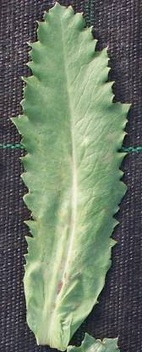 | 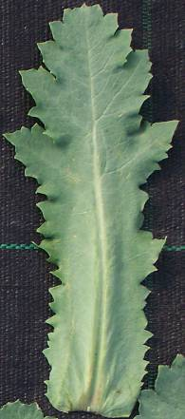 | 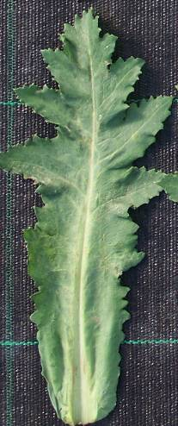
1 | 2 | 3
absent or shallow | medium | deep

Ad. 6: Main stem: length
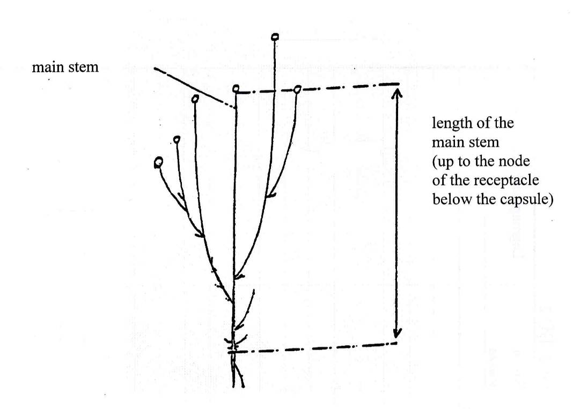

Ad. 7: Stem: anthocyanin coloration
Ad. 8: Stem: hairiness

The observation of anthocyanin coloration and hairiness should be made between the capsule and the upper stem leaf.

Ad. 9: Flower bud: anthocyanin coloration

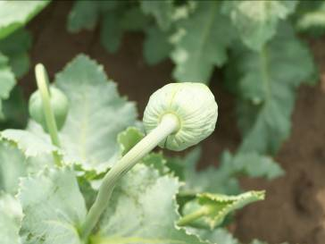 | 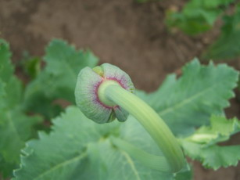 | 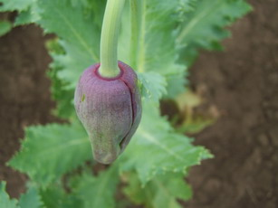
1 | 2 | 3
absent | ring around stem | bottom part towards stem end

Ad. 11: Petal: blotch

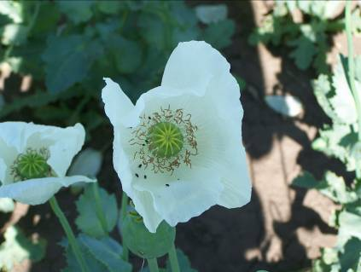
1
none

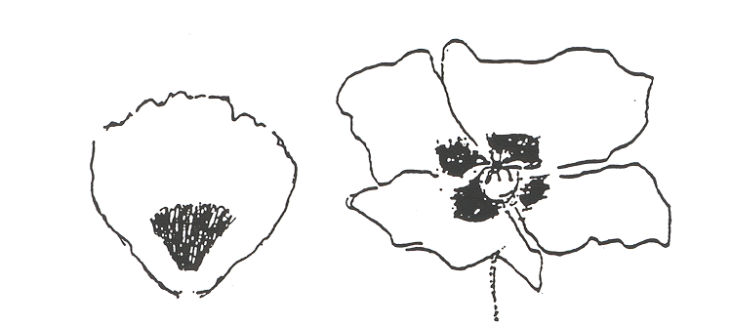
2
entire blotch
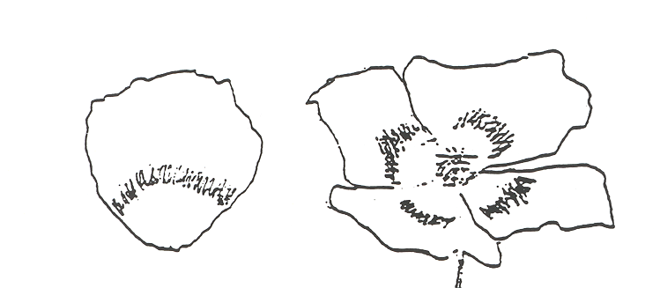
3
band

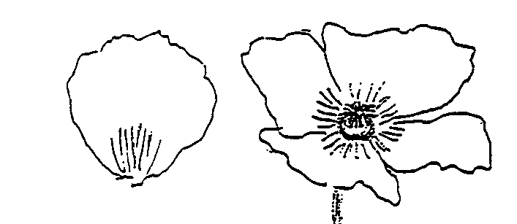
4
radial stripes

Ad. 13: Petal: extension of blotch

The measurement should be made at the widest point of petal.

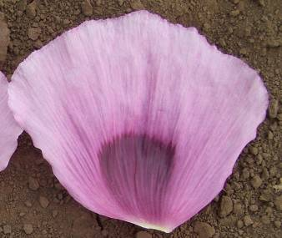 | 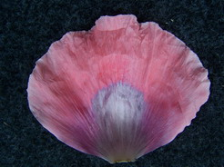 | 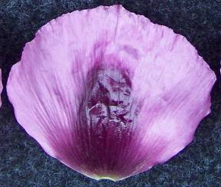
1 | 2 | 3
below the widest point | at the widest point | above the widest point

Ad. 14: Petal: incisions

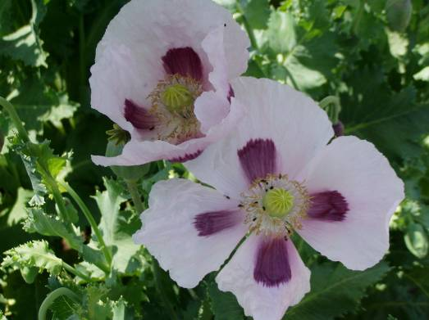 | 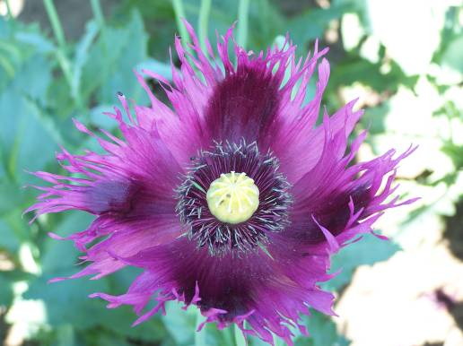
1 | 9
absent | present

Ad. 18: Capsule: shape of longitudinal section

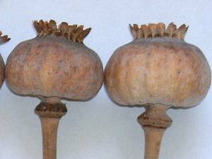 | 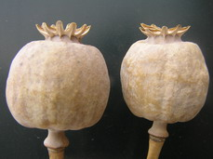 | 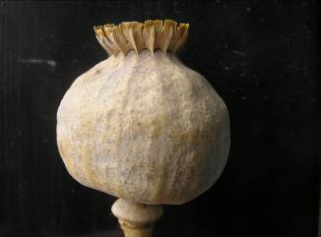
1 | 2 | 3
oblate | truncate | circular

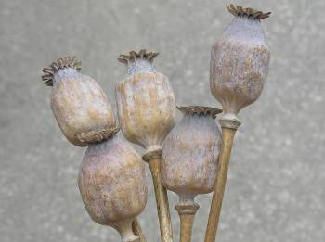 | 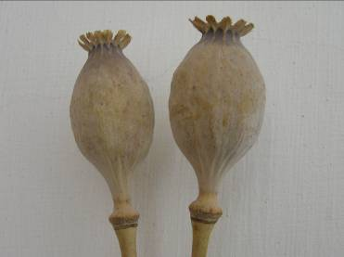
4
elliptic

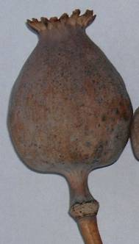 | 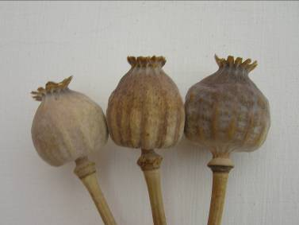
5
conical

Ad. 19: Capsule: shape of base
Ad. 20: Capsule: length

length | 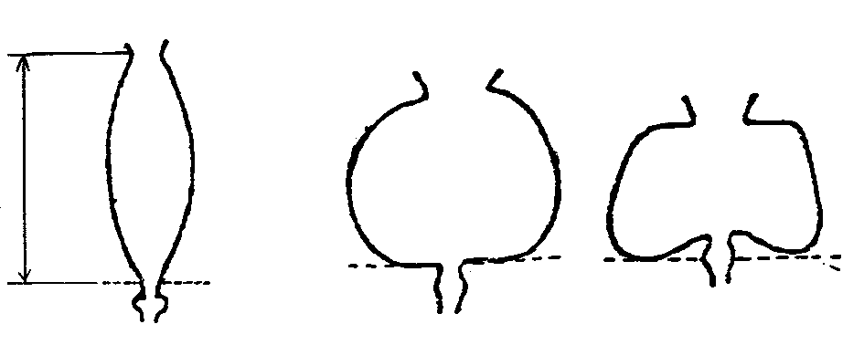

1 | 2 | 3
pointed | truncate | depressed

Ad. 22: Capsule: ribbing

For the observation of ribbing, the capsule should be touched.

Ad. 23: Capsule: dehiscence

For the observation of dehiscence the capsule should be held upside-down and shaken. If seeds do not fall out, the capsule is indehiscent (1). If seeds fall out, the capsule is dehiscent (2).

Ad. 24: Stigmatic disc: shape

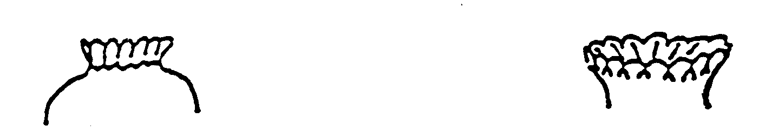

1 | 2
erect | semi-erect


3
horizontal

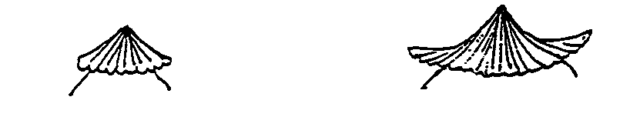
4 | 5
declined | decumbent

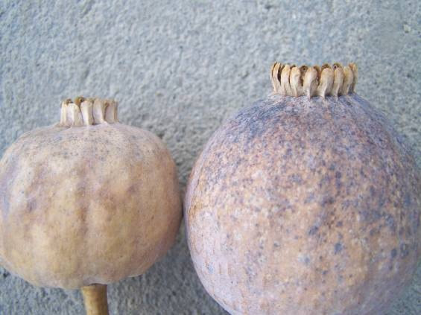 | 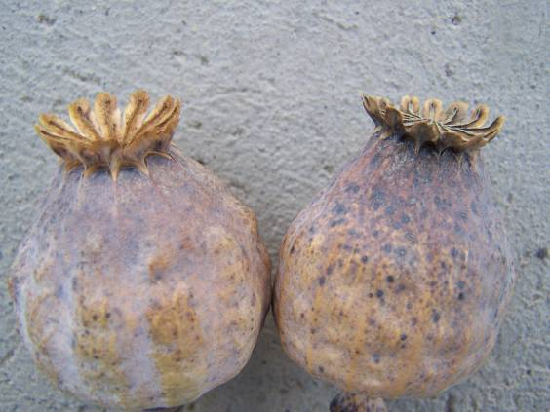
1 | 2
erect | semi-erect

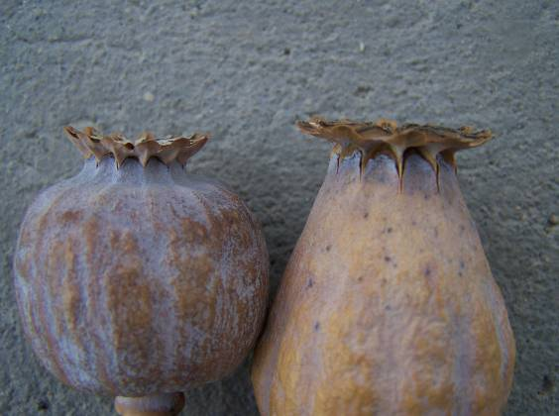 | 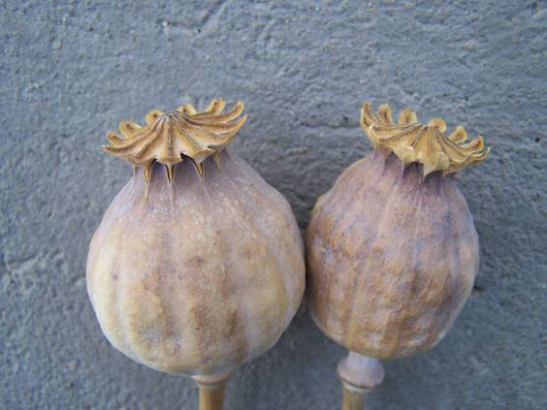
3 | 5
horizontal | decumbent
Ad. 26: Stigmatic disc: apex of lobe

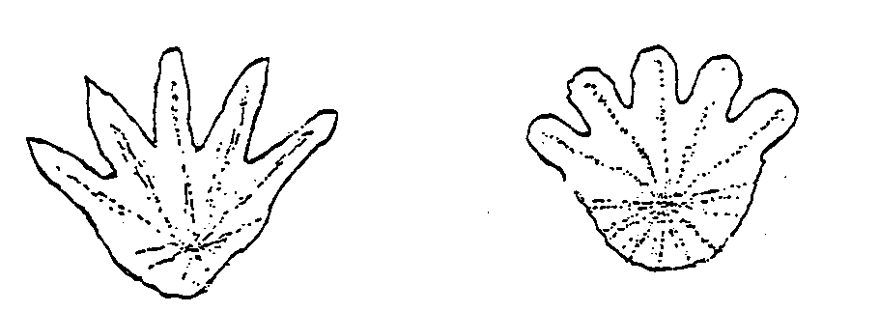

1 | 2
pointed | rounded
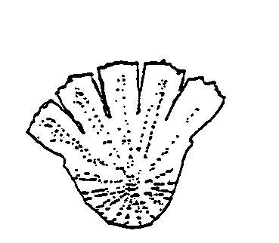

3
truncate

Ads. 29-32: Capsule: determination of alkaloid contents: morphine, codeine, thebaine and narcotine

Determination of Morphine, Codeine, Thebaine, Papaverine
and Narcotine content in poppy capsule
HPLC method, MS detection
1. Scope

Determination of Morphine, Codeine, Thebaine, Papaverine and Noscapine content in poppy
capsule for qualification purposes.
Limit Of Detection (LOD): 10 mg/kg/component
Limit Of Quantitation (LOQ): 50 mg/kg/component

2. Principle

The sample is extracted with methanol containing 1 ml of cc. hydrochloric acid/litre. The alkaloid content of the extract is determined by HPLC-MS system using RP C18 column. External standards are used for qualitative and quantitative determination.

3. Procedure

3.1. Sample preparation
The receipt sample is weighted and dried to air-dry condition. The stalk, the crop and the seeds are separated. The stalk is ground using 0,5 mm sieve.
3.2. Extraction and clean-up
Weigh 0,2 g of grinded sample and add 100 ml methanol-HCl solution (1 ml cc. HCl/litre methanol. Keep in ultrasonic bath 30 minutes. Filter and this solution inject to the HPLC column.
3.3. HPLC measurement
The determination of the alkaloid content is performed by MS detection (SIM mode) after separation using reversed phase C18 column.

HPLC conditions
The HPLC conditions are advised listed below, but any other conditions can be used if those give suitable results.

Chromatographic column: NUCLEODUR C-18 Gravity 150*4.6mm*5μm or equivalents.

Mobile phase
A eluent: HPLC grade methanol
B eluent: 2 g Ammonium-acetate/litre HPLC grade water
Gradient: 0-4 min. 70% B
4-14 min. 10% B-ig linear gradient
14-20 min. 10% B
Post time: 5 min.

Flow rate
0.9 cm3/min.

Detector
MS SIM APCI: 2-20 perc: 286.0 AMU Positive
300.0 AMU Positive
312.0 AMU Positive
340.0 AMU Positive
414.0 AMU Positive
Injected volume: 2  μl

For qualitative and quantitative determination used analytical grade standard solutions in HCL-methanol (1 ml cc. HCl/litre methanol) solvent. Calibrate according to ESTD method.

4. Expression of the results

The results are expressed in mg/kg referred to air-dry material.

Literature
Bernáth, J., Dános, B., Veres, T., Tétényi, P., 1988: “Variation and alkaloid production in poppy ecotypes: Responses to different environments”. Biochemical Systematics and Ecology 16 (2): pp. 171-178

Bernáth, J., 1998: “Poppy, The Genus Papaver”, Harwood Academic Publishers

Biomed. Chromatogr., 2001,15,45.
Biomed. Chromatogr., 2002,16,390.

Günther, K.F., 1975: “Beiträge zur Morphologie der Papaveraceae”. Flora 164: pp. 415-418.

Kodaira, H., and Spector, S., 1988: “Transformation of thebaine to orpavine, codeine and morphine by rat liver, kidney and brain microsomes”. Proc. Natl. Acad. Sci. USA 85: pp.1267-1271

Hammer, K., 1981: “Probleme der Klassifikation von Papaver somniferum”, Kulturpflanze 29: pp. 287-296.

Schijfsma, L., Hoesbergen, M. and Nijdam, F.E., 1960: “A Study of the Colour and Other Characters of the Seed in Some Varieties of Oil Seed Poppy”. Euphytica 9: pp. 127-140.

ST/SOA/SER. Y./33 UN Method No. 33, Dec. 16, 1977: “Determination of Phenanthreene Alkaloids in Papaver Somniferum Capsules and Papaver Bracteatum Plant Tissue By High Performance Liquid Chromatography”.

Tétényi, P., 1997: “Opium Poppy (Papaver somniferum) Botany and Horticulture”. Horticultural Reviews, 19: pp. 373-408

Technical Questionnaire

TECHNICAL QUESTIONNAIRE |  |  |  |  | Page {x} of {y} |  | Reference Number:
 |  |  |  |  |  |  | Application date:
 |  |  |  |  |  |  | (not to be filled in by the applicant)
TECHNICAL QUESTIONNAIRE
to be completed in connection with an application for plant breeders’ rights

1. Subject of the Technical Questionnaire
1.1 Botanical name |  |  |  | Papaver somniferum L.
1.2 Common name |  |  |  | Opium/Seed Poppy
2. Applicant
Name
Address
Telephone No.
Fax No.
E-mail address
Breeder (if different from applicant)
3. Proposed denomination and breeder’s reference
Proposed denomination
(if available)

Breeder’s reference
#4. Information on the breeding scheme and propagation of the variety

4.1 Method of propagating the variety

4.1.1 Seed-propagated varieties

(a) Self-pollination [ ]
(b) Cross-pollination
(i) population [ ]
(ii) synthetic variety [ ]
(c) Hybrid [ ]
(d) Other [ ]
(please provide details)

5. Characteristics of the variety to be indicated (the number in brackets refers to the corresponding characteristic in Test Guidelines; please mark the note which best corresponds).

 |  | Characteristics |  |  |  |  |  | Example Varieties |  |  |  | Note
5.1  (2) | Rosette leaf: white spots
 | absent |  |  |  |  |  |  |  | Botond, Buddha, Major |  |  |  | 1[ ]
 | present |  |  |  |  |  |  |  | Kozmosz, Orel, Racek, Sokol |  |  |  | 9[ ]
5.2  (10) | Petal: color
 | white |  |  |  |  |  |  |  | Botond, Korona, Major, Sokol |  |  |  | 1[ ]
 | light pink |  |  |  |  |  |  |  | Agat |  |  |  | 2[ ]
 | medium pink |  |  |  |  |  |  |  | Albín, Rosemarie, Rubin |  |  |  | 3[ ]
 | dark pink |  |  |  |  |  |  |  | Edel-Rot |  |  |  | 4[ ]
 | red |  |  |  |  |  |  |  | Danish Flag |  |  |  | 5[ ]
 | light violet |  |  |  |  |  |  |  | Kozmosz |  |  |  | 6[ ]
 | medium violet |  |  |  |  |  |  |  | Leila |  |  |  | 7[ ]
 | dark violet |  |  |  |  |  |  |  | Zeno 2002 |  |  |  | 8[ ]
5.3  (11) | Petal: blotch
 | none |  |  |  |  |  |  |  | TMO1, Afyon 95, Ofis 96 |  |  |  | 1[ ]
 | entire blotch |  |  |  |  |  |  |  | Botond, Malsar, Rosemarie, Sokol |  |  |  | 2[ ]
 | band |  |  |  |  |  |  |  |  |  |  |  | 3[ ]
 | radial stripes |  |  |  |  |  |  |  |  |  |  |  | 4[ ]
5.4  (18) | Capsule: shape of longitudinal section
 | oblate |  |  |  |  |  |  |  | Botond |  |  |  | 1[ ]
 | truncate |  |  |  |  |  |  |  | Kék Gemona, Korona |  |  |  | 2[ ]
 | round |  |  |  |  |  |  |  | Postomi |  |  |  | 3[ ]
 | elliptic |  |  |  |  |  |  |  | Minoán |  |  |  | 4[ ]
 | conical |  |  |  |  |  |  |  | Major, Opal |  |  |  | 5[ ]
5.5  (23) | Capsule: dehiscence
 | indehiscent |  |  |  |  |  |  |  | Botond, Kék Gemona, Major |  |  |  | 1[ ]
 | dehiscent |  |  |  |  |  |  |  | Edel-Rot, Edel-Weiss |  |  |  | 2[ ]
 |  | Characteristics |  |  |  |  |  | Example Varieties |  |  |  | Note
5.6  (27) | Seed: color
 | white |  |  |  |  |  |  |  | Albín, KP Albakomp, Orel, Racek, Sokol |  |  |  | 1[ ]
 | yellowish brown |  |  |  |  |  |  |  |  |  |  |  | 2[ ]
 | brown |  |  |  |  |  |  |  | Redy |  |  |  | 3[ ]
 | pink |  |  |  |  |  |  |  |  |  |  |  | 4[ ]
 | grey |  |  |  |  |  |  |  | Edel-Rot, Edel-Weiss, Florian |  |  |  | 5[ ]
 | light bluish |  |  |  |  |  |  |  | Minoán |  |  |  | 6[ ]
 | medium bluish |  |  |  |  |  |  |  | Agat, Morwin, Opal |  |  |  | 7[ ]
 | dark bluish |  |  |  |  |  |  |  | Botond, Buddha, Madrigal |  |  |  | 8[ ]
5.7  (29) | Capsule: morphine content
 | very low |  |  |  |  |  |  |  | Mieszko, Zeno Morphex |  |  |  | 1[ ]
 | very low to low |  |  |  |  |  |  |  |  |  |  |  | 2[ ]
 | low |  |  |  |  |  |  |  | Albín, Kék Duna, Redy |  |  |  | 3[ ]
 | low to medium |  |  |  |  |  |  |  |  |  |  |  | 4[ ]
 | medium |  |  |  |  |  |  |  | Bergam, Major, Opal |  |  |  | 5[ ]
 | medium to high |  |  |  |  |  |  |  |  |  |  |  | 6[ ]
 | high |  |  |  |  |  |  |  | Postomi |  |  |  | 7[ ]
 | high to very high |  |  |  |  |  |  |  |  |  |  |  | 8[ ]
 | very high |  |  |  |  |  |  |  | Botond, Buddha |  |  |  | 9[ ]
6. Similar varieties and differences from these varieties

Please use the following table and box for comments to provide information on how your candidate variety differs from the variety (or varieties) which, to the best of your knowledge, is (or are) most similar. This information may help the examination authority to conduct its examination of distinctness in a more efficient way.

Denomination(s) of variety(ies) similar to your candidate variety |  |  | Characteristic(s) in which your candidate variety differs from the similar variety(ies) |  |  | Describe the expression of the characteristic(s) for the similar variety(ies) |  |  |  | Describe the expression of the characteristic(s) for your candidate variety
Example |  |  | Petal: color of blotch |  |  | medium violet |  |  |  | dark violet
Comments:

#7. Additional information which may help in the examination of the variety

7.1 In addition to the information provided in sections 5 and 6, are there any additional characteristics which may help to distinguish the variety?

Yes [ ] No [ ]

(If yes, please provide details)

7.2 Are there any special conditions for growing the variety or conducting the examination?

Yes [ ] No [ ]

(If yes, please provide details)

7.3 Other information

7.3.1 Resistance to pests and diseases

7.3.2 Special conditions for the examination of the variety

(a) Growing season:
- spring [ ]
- autumn [ ]
(b) Other conditions

8. Authorization for release

(a) Does the variety require prior authorization for release under legislation concerning the protection of the environment, human and animal health?

Yes [ ] No [ ]

(b) Has such authorization been obtained?

Yes [ ] No [ ]

If the answer to (b) is yes, please attach a copy of the authorization.

9. Information on plant material to be examined or submitted for examination.

9.1 The expression of a characteristic or several characteristics of a variety may be affected by factors, such as pests and disease, chemical treatment (e.g. growth retardants or pesticides), effects of tissue culture, different rootstocks, scions taken from different growth phases of a tree, etc.

9.2 The plant material should not have undergone any treatment which would affect the expression of the characteristics of the variety, unless the competent authorities allow or request such treatment. If the plant material has undergone such treatment, full details of the treatment must be given. In this respect, please indicate below, to the best of your knowledge, if the plant material to be examined has been subjected to:

(a) Microorganisms (e.g. virus, bacteria, phytoplasma) Yes [ ] No [ ]

(b) Chemical treatment (e.g. growth retardant, pesticide) Yes [ ] No [ ]

(c) Tissue culture Yes [ ] No [ ]

(d) Other factors Yes [ ] No [ ]

Please provide details for where you have indicated “yes”.

……………………………………………………………

10. I hereby declare that, to the best of my knowledge, the information provided in this form is correct:

Applicant’s name

Signature Date

[End of document]

* These names were correct at the time of the introduction of these Test Guidelines but may be revised or updated. [Readers are advised to consult the UPOV Code, which can be found on the UPOV Website (www.upov.int), for the latest information.]
# Authorities may allow certain of this information to be provided in a confidential section of the Technical Questionnaire.
# Authorities may allow certain of this information to be provided in a confidential section of the Technical Questionnaire.

