 |  |  |  |  |  |  | E  TG/142/5(proj.4)  ORIGINAL: English  DATE: 2012-08-01
INTERNATIONAL UNION FOR THE PROTECTION OF NEW VARIETIES OF PLANTS
Geneva
 |  |  | DRAFT
 |  | WATERMELON  UPOV Code: CTRLS_LAN  (Citrullus lanatus (Thunb.) Matsum. et Nakai) |  |  | *

GUIDELINES

FOR THE CONDUCT OF TESTS

FOR DISTINCTNESS, UNIFORMITY AND STABILITY

prepared by an expert from the Netherlands

to be considered by the
Enlarged Editorial Committee at its meeting
to be held in Geneva, on January 9 and 10, 2013

Alternative Names:*

Botanical name | English | French | German | Spanish
Citrullus lanatus (Thunb.) Matsum. et Nakai,  Citrullus vulgaris Schrad. | Watermelon | Pastèque | Wassermelone | Sandía

The purpose of these guidelines (“Test Guidelines”) is to elaborate the principles contained in the General Introduction (document TG/1/3), and its associated TGP documents, into detailed practical guidance for the harmonized examination of distinctness, uniformity and stability (DUS) and, in particular, to identify appropriate characteristics for the examination of DUS and production of harmonized variety descriptions.

ASSOCIATED DOCUMENTS
These Test Guidelines should be read in conjunction with the General Introduction and its associated TGP documents.
TABLE OF CONTENTS PAGE

1. Subject of these Test Guidelines 3
2. Material Required 3
3. Method of Examination 3
3.1 Number of Growing Cycles 3
3.2 Testing Place 3
3.3 Conditions for Conducting the Examination 3
3.4 Test Design 3
3.5 Additional Tests 3
4. Assessment of Distinctness, Uniformity and Stability 4
4.1 Distinctness 4
4.2 Uniformity 5
4.3 Stability 5
5. Grouping of Varieties and Organization of the Growing Trial 5
6. Introduction to the Table of Characteristics 6
6.1 Categories of Characteristics 6
6.2 States of Expression and Corresponding Notes 6
6.3 Types of Expression 6
6.4 Example Varieties 6
6.5 Legend 7
7. Table of Characteristics/Tableau des caractères/Merkmalstabelle/Tabla de caracteres 8
8. Explanations on the Table of Characteristics 16
8.1 Explanations covering several characteristics 16
8.2 Explanations for individual characteristics 16
9. Literature 31
10. Technical Questionnaire 33

Subject of these Test Guidelines

These Test Guidelines apply to all varieties of Citrullus lanatus (Thunb.) Matsum. et Nakai.

Material Required

2.1 The competent authorities decide on the quantity and quality of the plant material required for testing the variety and when and where it is to be delivered. Applicants submitting material from a State other than that in which the testing takes place must ensure that all customs formalities and phytosanitary requirements are complied with.

2.2 The material is to be supplied in the form of seed.

2.3 The minimum quantity of plant material, to be supplied by the applicant, should be:

1,200 seeds.

The seed should meet the minimum requirements for germination, species and analytical purity, health and moisture content, specified by the competent authority.

2.4 The plant material supplied should be visibly healthy, not lacking in vigor, nor affected by any important pest or disease.

2.5 The plant material should not have undergone any treatment which would affect the expression of the characteristics of the variety, unless the competent authorities allow or request such treatment. If it has been treated, full details of the treatment must be given.

Method of Examination

3.1 Number of Growing Cycles

The minimum duration of tests should normally be two independent growing cycles.

3.2 Testing Place

Tests are normally conducted at one place. In the case of tests conducted at more than one place, guidance is provided in TGP/9 “Examining Distinctness”.

3.3 Conditions for Conducting the Examination

The tests should be carried out under conditions ensuring satisfactory growth for the expression of the relevant characteristics of the variety and for the conduct of the examination.

3.4 Test Design

3.4.1 Each test should be designed to result in a total of at least 20 plants which should be divided between at least two replicates.

3.4.2 The design of the tests should be such that plants or parts of plants may be removed for measurement or counting without prejudice to the observations which must be made up to the end of the growing cycle.

3.4.3 For pollination and fruit set of triploid varieties it is needed to interplant with diploid varieties in a trial lay out so that the diploid pollenizers will be close to the triploid plants. The minimum percentage of diploid plants should not be less than 30%. When pollinators (e.g. bees, bumblebees) are used a slightly lower percentage of pollenizer may be required.

3.5 Additional Tests

Additional tests, for examining relevant characteristics, may be established.

Assessment of Distinctness, Uniformity and Stability

4.1 Distinctness

4.1.1 General Recommendations

It is of particular importance for users of these Test Guidelines to consult the General Introduction prior to making decisions regarding distinctness. However, the following points are provided for elaboration or emphasis in these Test Guidelines.

4.1.2 Consistent Differences

The differences observed between varieties may be so clear that more than one growing cycle is not necessary. In addition, in some circumstances, the influence of the environment is not such that more than a single growing cycle is required to provide assurance that the differences observed between varieties are sufficiently consistent. One means of ensuring that a difference in a characteristic, observed in a growing trial, is sufficiently consistent is to examine the characteristic in at least two independent growing cycles.

4.1.3 Clear Differences

Determining whether a difference between two varieties is clear depends on many factors, and should consider, in particular, the type of expression of the characteristic being examined, i.e. whether it is expressed in a qualitative, quantitative, or pseudo-qualitative manner. Therefore, it is important that users of these Test Guidelines are familiar with the recommendations contained in the General Introduction prior to making decisions regarding distinctness.

4.1.4 Number of Plants / Parts of Plants to be Examined

Unless otherwise indicated, for the purposes of distinctness, all observations on single plants should be made on 10 plants or parts taken from each of 10 plants and any other observations made on all plants in the test, disregarding any off-type plants.

4.1.5 Method of Observation

The recommended method of observing the characteristic for the purposes of distinctness is indicated by the following key in the second column of the Table of Characteristics (see document TGP/9 “Examining Distinctness”, Section 4 “Observation of characteristics”):

MG: single measurement of a group of plants or parts of plants
MS: measurement of a number of individual plants or parts of plants
VG: visual assessment by a single observation of a group of plants or parts of plants
VS: visual assessment by observation of individual plants or parts of plants

Type of observation: visual (V) or measurement (M)

“Visual” observation (V) is an observation made on the basis of the expert’s judgment. For the purposes of this document, “visual” observation refers to the sensory observations of the experts and, therefore, also includes smell, taste and touch. Visual observation includes observations where the expert uses reference points (e.g. diagrams, example varieties, side-by-side comparison) or non-linear charts (e.g. color charts). Measurement (M) is an objective observation against a calibrated, linear scale e.g. using a ruler, weighing scales, colorimeter, dates, counts, etc.

Type of record: for a group of plants (G) or for single, individual plants (S)

For the purposes of distinctness, observations may be recorded as a single record for a group of plants or parts of plants (G), or may be recorded as records for a number of single, individual plants or parts of plants (S). In most cases, “G” provides a single record per variety and it is not possible or necessary to apply statistical methods in a plant-by-plant analysis for the assessment of distinctness.”

In cases where more than one method of observing the characteristic is indicated in the Table of Characteristics (e.g. VG/MG), guidance on selecting an appropriate method is provided in document TGP/9, Section 4.2.

4.2 Uniformity

4.2.1 It is of particular importance for users of these Test Guidelines to consult the General Introduction prior to making decisions regarding uniformity. However, the following points are provided for elaboration or emphasis in these Test Guidelines:

(a) Cross-pollinated varieties

4.2.2 The assessment of uniformity for cross-pollinated varieties should be according to the recommendations for cross-pollinated varieties in the General Introduction.

(b) Hybrid varieties and inbred lines

4.2.3 For the assessment of uniformity of hybrids and inbred lines, a population standard of 2% and an acceptance probability of at least 95% should be applied. In the case of a sample size of 20 plants, 2 off-types are allowed.

4.3 Stability

4.3.1 In practice, it is not usual to perform tests of stability that produce results as certain as those of the testing of distinctness and uniformity. However, experience has demonstrated that, for many types of variety, when a variety has been shown to be uniform, it can also be considered to be stable.

4.3.2 Where appropriate, or in cases of doubt, stability may be further examined by testing a new seed stock to ensure that it exhibits the same characteristics as those shown by the initial material supplied.

Grouping of Varieties and Organization of the Growing Trial

5.1 The selection of varieties of common knowledge to be grown in the trial with the candidate varieties and the way in which these varieties are divided into groups to facilitate the assessment of distinctness are aided by the use of grouping characteristics.

5.2 Grouping characteristics are those in which the documented states of expression, even where produced at different locations, can be used, either individually or in combination with other such characteristics: (a) to select varieties of common knowledge that can be excluded from the growing trial used for examination of distinctness; and (b) to organize the growing trial so that similar varieties are grouped together.

5.3 The following have been agreed as useful grouping characteristics:

(a) Ploidy (characteristic 1)
(b) Fruit: weight (characteristic 11)
(c) Fruit: shape in longitudinal section (characteristic 12)
(d) Fruit: ground color of skin (characteristic 16)
(e) Fruit: width of stripes (characteristic 19)
(f) Fruit: margin of stripes (characteristic 22)
(g) Fruit: main color of flesh (characteristic 28)
(h) Only diploid and tetraploid varieties: Seed: length (characteristic 31)
(i) Only diploid and tetraploid varieties: Seed: ground color of testa (characteristic 33)

5.4 Guidance for the use of grouping characteristics, in the process of examining distinctness, is provided through the General Introduction and document TGP/9 “Examining Distinctness”.

Introduction to the Table of Characteristics

6.1 Categories of Characteristics

6.1.1 Standard Test Guidelines Characteristics

Standard Test Guidelines characteristics are those which are approved by UPOV for examination of DUS and from which members of the Union can select those suitable for their particular circumstances.

6.1.2 Asterisked Characteristics

Asterisked characteristics (denoted by *) are those included in the Test Guidelines which are important for the international harmonization of variety descriptions and should always be examined for DUS and included in the variety description by all members of the Union, except when the state of expression of a preceding characteristic or regional environmental conditions render this inappropriate.

6.2 States of Expression and Corresponding Notes

6.2.1 States of expression are given for each characteristic to define the characteristic and to harmonize descriptions. Each state of expression is allocated a corresponding numerical note for ease of recording of data and for the production and exchange of the description.

6.2.2 In the case of qualitative and pseudo-qualitative characteristics (see Chapter 6.3), all relevant states of expression are presented in the characteristic. However, in the case of quantitative characteristics with 5 or more states, an abbreviated scale may be used to minimize the size of the Table of Characteristics. For example, in the case of a quantitative characteristic with 9 states, the presentation of states of expression in the Test Guidelines may be abbreviated as follows:

State | Note
small | 3
medium | 5
large | 7

However, it should be noted that all of the following 9 states of expression exist to describe varieties and should be used as appropriate:

State | Note
very small | 1
very small to small | 2
small | 3
small to medium | 4
medium | 5
medium to large | 6
large | 7
large to very large | 8
very large | 9

6.2.3 Further explanation of the presentation of states of expression and notes is provided in document TGP/7 “Development of Test Guidelines”.

6.3 Types of Expression

An explanation of the types of expression of characteristics (qualitative, quantitative and pseudo-qualitative) is provided in the General Introduction.

6.4 Example Varieties

Where appropriate, example varieties are provided to clarify the states of expression of each characteristic.

6.5 Legend

(*) Asterisked characteristic – see Chapter 6.1.2

QL Qualitative characteristic – see Chapter 6.3
QN Quantitative characteristic – see Chapter 6.3
PQ Pseudo-qualitative characteristic – see Chapter 6.3

MG, MS, VG, VS – see Chapter 4.1.5

(a) – (d) See Explanations on the Table of Characteristics in Chapter 8.1.

(+) See Explanations on the Table of Characteristics in Chapter 8.2.

Table of Characteristics/Tableau des caractères/Merkmalstabelle/Tabla de caracteres

 |  | English | français | deutsch | español | Example Varieties  Exemples  Beispielssorten  Variedades ejemplo | Note/  Nota
1  (*)  (+) | VG | Ploidy | Ploïdie | Ploidie | Ploidía
QL |  | diploid | diploïde | diploid | diploide | SP 4, Sugar Baby, Yamato 3 | 2
 |  | triploid | triploïde | triploid | triploide | Boston, TRIX 313 | 3
 |  | tetraploid | tétraploïde | tetraploid | tetraploide |  | 4
2 | MS/  VG | Cotyledon: size | Cotylédon : taille | Keimblatt: Größe | Cotiledón: tamaño
QN | (a) | small | petit | klein | pequeño | Crimson Glory, Kanro, Rapid | 3
 |  | medium | moyen | mittel | medio | Crisby, Granit, Panni, Yamato 3 | 5
 |  | large | grand | groß | grande | Farao, Kurobe,  Royal flesh hybrid | 7
3  (+) | VG | Cotyledon: shape | Cotylédon : forme | Keimblatt: Form | Cotiledón: forma
QN | (a) | narrow elliptic | elliptique étroit | schmal elliptisch | elíptica estrecha | Kahô | 1
 |  | medium elliptic | elliptique moyen | mittel elliptisch | elíptica media | Crimson Sweet, Farao, Napsugár, Yamato 3, | 2
 |  | broad elliptic | elliptique large | breit elliptisch | elíptica ancha | Kanro | 3
4 | VG | Cotyledon: intensity of green color | Cotylédon : intensité de la couleur verte | Keimblatt: Intensität der grünen Farbe | Cotiledón: intensidad del color verde
QN | (a) | light | faible | hell | claro | À graine rouge à confire à chair verte, Shin Kurobe 7 | 1
 |  | medium | moyenne | mittel | medio | Jenny, Yamato 3 | 3
 |  | dark | forte | dunkel | oscuro | Boston, Kahô, SP 4 | 5
5 | VG | Leaf blade: size | Limbe : taille | Blattspreite: Größe | Limbo: tamaño
QN | (b) | small | petite | klein | pequeño | SP 1, SP 4 | 1
 |  | medium | moyenne | mittel | medio | Sugar Baby | 3
 |  | large | grande | groß | grande | Topgun | 5
6  (+) | VG/ MS | Leaf blade: ratio length/width | Limbe : rapport longueur/largeur | Blattspreite: Verhältnis Länge/Breite | Limbo: relación longitud/anchura
QN | (b) | slightly elongated | légèrement allongé | leicht länglich | ligeramente alargado | Kanro | 1
 |  | moderately elongated | moyennement allongé | mäßig länglich | moderadamente alargado | Sugar Baby, Yamato 3 | 2
 |  | strongly elongated | très allongé | sehr länglich | muy alargado | Kurobe | 3
7 | VG | Leaf blade: color | Limbe : couleur | Blattspreite: Farbe | Limbo: color
PQ | (b) | yellowish green | vert jaune | gelblichgrün | verde amarillento | Baby Fun, Okan | 1
 |  | green | vert | grün | verde | Crimson Sweet, Yamato 3 | 2
 |  | greyish green | vert grisâtre | gräulichgrün | verde grisáceo | Sugar Baby | 3
 |  | bluish green | vert bleuâtre | bläulichgrün | verde azulado | SP 4 | 4
8  (*)  (+) | VG | Leaf blade: degree of lobing | Limbe : degré de la découpure du bord | Blattspreite: Stärke der Lappung | Limbo: grado de lobulado
QN | (b) | absent or very weak | absente ou très faible | fehlend oder sehr gering | ausente o muy débil | Sunshade | 1
 |  | weak | faible | gering | débil | Estrella, Karistan | 3
 |  | medium | moyenne | mittel | medio | Crimson Sweet, Crisby | 5
 |  | strong | forte | stark | fuerte | Cadans | 7
 |  | very strong | très forte | sehr stark | muy fuerte | SP 1 | 9
9 | VG | Leaf blade: blistering | Limbe : clôqure | Blattspreite: Blasigkeit | Limbo: abullonado
QN | (b) | weak | faible | gering | débil | Tabata, Estel | 1
 |  | medium | moyenne | mittel | medio | Yamato 3 | 2
 |  | strong | forte | stark | fuerte | Klondike Striped II, Sakura | 3
10  (+) | VG | Leaf blade: color of veins | Limbe : couleur des nervures | Blattspreite: Farbe der Adern | Limbo: color de los nervios
QL | (b) | green | vert | grün | verde | Asahiyamato | 1
 |  | yellow | jaune | gelb | amarillo | Taiyô | 2
11  (*) | MG/ MS | Fruit: weight | Fruit : poids | Frucht: Gewicht | Fruto: peso
QN | (c) | very low | très petit | sehr gering | muy pequeño | Monaco,  New Hampshire Midget | 1
 |  | very low to low | très petit à petit | sehr gering bis gering | muy pequeño a pequeño | Mini, Petite Perfection | 2
 |  | low | petit | gering | pequeño | Angela | 3
 |  | low to medium | petit à moyen | gering bis mittel | pequeño a medio | Pasion, Sugar Baby | 4
 |  | medium | moyen | mittel | medio | Boston | 5
 |  | medium to high | moyen à grand | mittel bis hoch | medio a grande | Crimson Sweet, Panonia | 6
 |  | high | grand | hoch | grande | Fabiola | 7
 |  | high to very high | grand à très grand | hoch bis sehr hoch | grande a muy grande | Jubilee | 8
 |  | very high | très grand | sehr hoch | muy grande | Carolina Cross,  Cobb’s Gem,  Florida Giant | 9
12  (*)  (+) | VG | Fruit: shape in longitudinal section | Fruit : forme en section longitudinale | Frucht: Form im Längsschnitt | Fruto: forma en sección longitudinal
QN | (c) | circular | circulaire | kreisförmig | circular | Camilla, Kanro | 1
 |  | broad elliptic | elliptique large | breit elliptisch | elíptica ancha | Fumin, Gray Belle,  Yellow Baby, Zorba | 2
 |  | medium elliptic | elliptique moyen | mittel elliptisch | elíptica media | Congo, Kurobe, Picnic | 3
 |  | narrow elliptic | elliptique étroit | schmal elliptisch | elíptica estrecha | Allsweet,  Charleston Gray | 4
13  (+) | VG | Fruit: depression at base | Fruit : dépression à la base | Frucht: Vertiefung an der Basis | Fruto: depresión de la base
QN | (c) | absent or very shallow | absente ou très peu profonde | fehlend oder sehr flach | ausente o muy poco profunda |  | 1
 |  | shallow | peu profonde | flach | poco profunda | Kahô, Yellow Baby | 2
 |  | medium | moyenne | mittel | media | Triple Sweet, Yamato 3 | 3
 |  | deep | profonde | tief | profunda | À graine rouge à confire à chair verte, Kanro | 4
 |  | very deep | très profonde | sehr tief | muy profunda |  | 5
14  (+) | VG | Fruit: shape of apical part | Fruit : forme de la partie apicale | Frucht: Form des apikalen Teils | Fruto: forma de la zona apical
PQ | (c) | truncate | tronquée | abgestumpft | truncada | Cream Sinka, Kanro | 1
 |  | truncate to rounded | tronquée à arrondie | abgestumpft bis abgerundet | truncada a redondeada |  | 2
 |  | rounded | arrondie | abgerundet | redondeada | Glory, Sugar Baby, Toro, Yamato 3 | 3
 |  | rounded to conical | arrondie à conique | abgerundet bis kegelförmig | redondeada a cónica |  | 4
 |  | conical | conique | kegelförmig | cónica | Kahô | 5
15  (+) | VG | Fruit: depression at apex | Fruit : cuvette pistillaire | Frucht: Vertiefung an der Spitze | Fruto: depresión del ápice
QN | (c) | absent or very shallow | absente ou très peu profonde | fehlend oder sehr flach | ausente o muy poco profunda |  | 1
 |  | shallow | peu profonde | flach | poco profunda | Burpee Hybrid, Kahô, Valdoria | 2
 |  | medium | moyenne | mittel | media | Asahi Miyako, Fumin | 3
 |  | deep | profonde | tief | profunda | Cobb’s Gem | 4
 |  | very deep | très profonde | sehr tief | muy profunda |  | 5
16  (*) | VG | Fruit: ground color of skin | Fruit : couleur de fond de l’épiderme | Frucht: Grundfarbe der Schale | Fruto: color de fondo de la epidermis
PQ | (c) | yellow | jaune | gelb | amarillo | Taiyô | 1
 |  | very light green | vert très clair | sehr hellgrün | verde muy claro | Ipanema | 2
 |  | very light green to light green | vert très clair à vert clair | sehr hellgrün bis hellgrün | verde muy claro a verde claro | Napsugar | 3
 |  | light green | vert clair | hellgrün | verde claro | Tigre | 4
 |  | light green to medium green | vert clair à vert moyen | hellgrün bis mittelgrün | verde claro a verde medio | Pepsin | 5
 |  | medium green | vert moyen | mittelgrün | verde medio | Ovation, Talete | 6
 |  | medium green to dark green | vert moyen à vert foncé | mittelgrün bis dunkelgrün | verde medio a verde oscuro | Odem, Resistant,  Sweet Marvel | 7
 |  | dark green | vert foncé | dunkelgrün | verde oscuro | Sugar Baby | 8
 |  | dark green to very dark green | vert foncé à vert très foncé | dunkelgrün bis sehr dunkelgrün | verde oscuro a verde muy oscuro | Augusta, Rocio | 9
 |  | very dark green | vert très foncé | sehr dunkelgrün | verde muy oscuro |  | 10
17  (+) | VG | Fruit: conspicuousness of veining | Fruit : netteté de la veinure | Frucht: Ausprägung der Aderung | Fruto: visibilidad de la nervadura
QN | (c) | inconspicuous or very weakly conspicuous | absente ou très peu nette | undeutlich oder etwas deutlich | no visible o muy poco visible | Napsugar | 1
 |  | weak | faible | gering | débil |  | 2
 |  | medium | moyenne | mittel | media | Crimson Sweet | 3
 |  | strong | forte | stark | fuerte | Trix Palomar | 4
 |  | very strong | très forte | sehr stark | muy fuerte |  | 5
18  (*)  (+) | VG | Fruit: pattern of stripes | Fruit : répartition des stries | Frucht: Muster der Streifen | Fruto: distribución de las rayas
PQ | (c) | only one colored | monocolore seulement | nur einfarbig | de un solo color | Congo | 1
 |  | one colored and veins | monocolore et nervures | einfarbig und Adern | de un color y con nervios | Trix Palomar | 2
 |  | one colored, veins and marbled | monocolore, nervures et marbré | einfarbig, Adern und marmoriert | de un color, con nervios y jaspeadas | Boston | 3
 |  | one colored and marbled | monocolore et marbré | einfarbig und marmoriert | de un color y jaspeadas | Jenny | 4
 |  | two colored, veins and marbled | bicolore, nervures et marbré | zweifarbig, Adern und marmoriert | de dos colores, con nervios y jaspeadas | Crisby | 5
 |  | only veins | nervures seulement | nur Adern | sólo con nervios |  | 6
19  (*)  (+) | VG | Fruit: width of stripes | Fruit : largeur des stries | Frucht: Breite der Streifen | Fruto: anchura de las rayas
QN | (c) | very narrow | très étroites | sehr schmal | muy estrechas | SP 4, Tiny Orchid | 1
 |  | narrow | étroites | schmal | estrechas | Boston | 3
 |  | medium | moyennes | mittel | medias | Crimson Sweet | 5
 |  | broad | larges | breit | anchas | Sangria | 7
 |  | very broad | très larges | sehr breit | muy anchas | All Sweet | 9
20  (+) | VG | Fruit: main color of stripes | Fruit : couleur principale des stries | Frucht: Hauptfarbe der Streifen | Fruto: color principal de las rayas
PQ | (c) | yellow | jaune | gelb | amarillo |  | 1
 |  | very light green | vert très clair | sehr hellgrün | verde muy claro |  | 2
 |  | light green | vert clair | hellgrün | verde claro |  | 3
 |  | medium green | vert moyen | mittelgrün | verde medio |  | 4
 |  | dark green | vert foncé | dunkelgrün | verde oscuro |  | 5
 |  | very dark green | vert très foncé | sehr dunkelgrün | verde muy oscuro |  | 6
21  (*)  (+) | VG | Fruit: conspicuousness of stripes | Fruit : netteté des stries | Frucht: Ausprägung der Streifen | Fruto: visibilidad de las rayas
QN | (c) | inconspicuous or very weakly conspicuous | absente ou très peu nette | undeutlich oder etwas deutlich | no visibles o muy poco visibles | Augusta | 1
 |  | weak | faible | schwach | débil | Odem | 2
 |  | medium | moyenne | mittel | media | Trix Palomar | 3
 |  | strong | forte | stark | fuerte | Jenny | 4
 |  | very strong | très forte | sehr stark | muy fuerte | A graine rouge à confire à chaire verte | 5
22  (*)  (+) | VG | Fruit: margin of stripes | Fruit : bord des stries | Frucht: Rand der Streifen | Fruto: borde de las rayas
QN | (c) | diffuse | diffus | diffus | difuso | Crimson Glory, Crisby | 1
 |  | medium | moyen | mittel | medio | Crimson Sweet | 2
 |  | sharp | net | klar abgegrenzt | definido | Jenny, Jubilee | 3
23  (+) | VG | Fruit: size of insertion of peduncle | Fruit : taille de l’insertion du pédoncule | Frucht: Größe des Stielansatzes | Fruto: tamaño de la inserción del pedúnculo
QN | (c) | small | petite | klein | pequeño | Charleston Gray,  Sugar Bush | 3
 |  | medium | moyenne | mittel | medio | Fumin, Picnic | 5
 |  | large | grande | groß | grande | Dixie Queen, Kanro | 7
24  (+) | VG | Fruit: size of pistil scar | Fruit : taille de l’attache pistillaire | Frucht: Größe der Griffelnarbe | Fruto: tamaño de la cicatriz del pistilo
QN | (c) | small | petite | klein | pequeña | Charleston Gray, Daisen | 3
 |  | medium | moyenne | mittel | media | Yamato 3 | 5
 |  | large | grande | groß | grande | Kanro, Trix Palomar | 7
25  (+) | VG | Fruit: degree of grooving | Fruit : degré de la cannelure | Frucht: Grad der Riefung | Fruto: grado de acanalado
QN | (c) | absent or very weak | absente ou très faible | fehlend oder sehr gering | ausente o muy débil | Sugar Baby | 1
 |  | weak | faible | gering | débil | Augusta, Kanro, Rapid | 2
 |  | medium | moyenne | mittel | medio | Asahi, Bego, Miyako | 3
 |  | strong | forte | stark | fuerte | Marsowszky, Napsugár, Panni | 4
26  (+) | VG | Fruit: waxy layer | Fruit : film brillant | Frucht: Wachsschicht | Fruto: capa cerosa
QN | (c) | absent or very weak | absent ou très faible | fehlend oder sehr schwach | ausente o muy débil | Betica | 1
 |  | medium | moyen | mittel | media | Sugar Baby | 3
 |  | very strong | très fort | sehr stark | muy fuerte | Red Star, Romanza | 5
27  (*)  (+) | VG/ MS | Fruit: thickness of pericarp | Fruit : épaisseur du péricarpe | Frucht: Dicke des Perikarps | Fruto: espesor del pericarpio
QN | (c) | very thin | très mince | sehr dünn | muy delgado | Bibo, Tiny Orchid, Luciano | 1
 |  | thin | mince | dünn | delgado | À graine rouge à confire à chair verte, Beni-kodama, Jenny, Kahô, Kassai | 3
 |  | medium | moyen | mittel | medio | Panonia, Sugar Baby, Sugar Belle, Yamato 3 | 5
 |  | thick | épais | dick | grueso | Charleston Gray, Crimson Sweet, Kurobe, Triple Sweet, Sunrise | 7
 |  | very thick | très épais | sehr dick | muy grueso | Coles Early, Kholodok | 9
28  (*) | VS | Fruit: main color of flesh | Fruit : couleur principale de la chair | Frucht: Hauptfarbe des Fleisches | Fruto: color principal de la pulpa
PQ | (c) | white | blanche | weiß | blanco | SP 4, SP1,  Yamato Cream 3 | 1
 |  | yellow | jaune | gelb | amarillo | Napsugár,  Yamato Cream 1 | 2
 |  | orange | orange | orange | naranja | Kahô, Tendersweet | 3
 |  | pink | rose | pink | rosa | Sadul | 4
 |  | pinkish red | rouge rosâtre | rosarot | rojo rosado | Bingo, Crimson Sweet | 5
 |  | red | rouge | rot | rojo | Asahiy, Sugar Baby, Topgun | 6
 |  | dark red | rouge foncé | dunkelrot | rojo oscuro | Dixie Lee | 7
29  (+) | VG | Only triploid varieties: Seed coat: size | Variétés triploïdes seulement :  Tégument : taille | Nur triploide Sorten: Samenschale: Größe | Sólo variedades triploides: Tegumento de la semilla: tamaño
QN | (d) | small | petit | klein | pequeño | Petite Perfection | 2
 |  | medium | moyenn | mittel | medio | Boston, Valdoria,  Sweet Sun | 3
 |  | large | grand | groß | grande | Ortal, Tigre, Pasion | 4
30 | VG | Only diploid and tetraploid varieties: Fruit: number of seeds | Variétés diploïdes et tétraploïdes seulement : Fruit : nombre de graines | Nur diploide und tetraploide Sorten: Frucht: Anzahl der Samen | Sólo variedades diploides y tetraploides: Fruto: número de semillas
QN | (d) | none or few | nul ou petit | fehlend oder gering | ausente o bajo | Tanenashi Kôyô | 1
 |  | medium | moyen | mittel | medio | Miyako 3 | 2
 |  | many | grand | groß | alto | Fumin | 3
31  (*)  (+) | VG/ MS | Only diploid and tetraploid varieties: Seed: length | Variétés diploïdes et tétraploïdes seulement : Graine : longueur | Nur diploide und tetraploide Sorten: Samen: Länge | Sólo variedades diploides y tetraploides: Semilla: longitud
QN | (d) | very short | très courte | sehr kurz | muy corta | Kudam | 1
 |  | short | courte | kurz | corta | Panonia, Tabata | 3
 |  | medium | moyenne | mittel | media | Sugar Baby | 5
 |  | long | longue | lang | larga | Charleston Gray, Kurobe | 7
 |  | very long | très longue | sehr lang | muy larga | Malali, Wanli | 9
32 |  | Only diploid and tetraploid varieties: Seed: ratio length/width | Variétés diploïdes et tétraploïdes seulement : Graine : rapport longueur/largeur | Nur diploide und tetraploide Sorten: Samen: Verhältnis Länge/Breite | Sólo variedades diploides y tetraploides: Semilla: relación longitud/anchura
 |  | very small | très petit | sehr klein | muy pequeña | Wanli | 1
 |  | small | petit | klein | pequeña | Klondike | 2
 |  | medium | moyen | mittel | media | Early Star | 3
 |  | large | grand | groß | grande | Nubia | 4
 |  | very large | très grand | sehr groß | muy grande | Green Citron | 5
33  (*)  (+) | VG | Only diploid and tetraploid varieties: Seed: ground color of testa | Variétés diploïdes et tétraploïdes seulement : Graine : couleur de fond du tégument | Nur diploide und tetraploide Sorten: Samen: Grundfarbe der Samenschale | Sólo variedades diploides y tetraploides: Semilla: color de fondo de la testa
PQ | (d) | white | blanc | weiß | blanco | Sanpaku | 1
 |  | cream | crème | cremefarben | crema | Kurobe | 2
 |  | green | vert | grün | verde | A confire allongée à graine verte,  Green Citron | 3
 |  | red | rouge | rot | rojo | A graine rouge à confire à chair verte, Red Citron | 4
 |  | red brown | brun rouge | rotbraun | marrón rojizo | Kahô | 5
 |  | brown | brun | braun | marrón | Otome, Sugar Baby | 6
 |  | black | noir | schwarz | negro | Yamato Cream | 7
34  (+) | VG | Only diploid and tetraploid varieties: Seed: over color of testa | Variétés diploïdes et tétraploïdes seulement : Graine : lavis du tégument | Nur diploide und tetraploide Sorten: Samen: Deckfarbe der Samenschale | Sólo variedades diploides y tetraploides: Semilla: color superior de la testa
QL | (d) | absent | absent | fehlend | ausente | Kahô | 1
 |  | present | présent | vorhanden | presente | Charleston Gray | 9
35  (+) | VG | Only diploid and tetraploid varieties: Seed: area of over color in relation to that of ground color | Variétés diploïdes et tétraploïdes seulement : Graine : surface du lavis par rapport à celle de la couleur de fond | Nur diploide und tetraploide Sorten: Samen: Anteil der Deckfarbe im Vergleich zur Grundfarbe | Sólo variedades diploides y tetraploides: Semilla: área del color superior en relación con el del color de fondo
QN | (d) | very small | très petite | sehr klein | muy pequeña | Estela roja | 1
 |  | small | petite | klein | pequeña | Sugar Baby | 3
 |  | medium | moyenne | mittel | media | Crimson Sweet | 5
 |  | large | grande | groß | grande | Furia | 7
 |  | very large | très grande | sehr groß | muy grande | Starlich | 9
36  (+) | VG | Only diploid and tetraploid varieties: Seed: patches at hilum | Variétés diploïdes et tétraploïdes seulement : Graine : taches sur le hile | Nur diploide und tetraploide Sorten: Samen: Flecken am Nabel | Sólo variedades diploides y tetraploides: Semilla: manchas en el hilo
QN | (d) | absent or very weak | absentes ou très faibles | fehlend oder sehr schwach | ausentes o débil | Daisen, Kahô | 1
 |  | medium | moyennes | mittel | media | Kurobe, Rattle Snake, Yamato 3 | 2
 |  | strong | fortes | stark | fuerte |  | 3
37  (+) | VG | Time of female flowering | Époque de floraison femelle | Zeitpunkt der Blüte der weiblichen Blüte | Época de la floración femenina
QN |  | early | précoce | früh | temprana | Tiny Orchid | 3
 |  | medium | moyenne | mittel | media | Sugar Baby, Yamato 3 | 5
 |  | late | tardive | spät | tardía | Kurobe | 7
38  (+)  QL | VG | Resistance to Fusarium oxysporum f.sp. niveum | Résistance au Fusarium oxysporum f.sp. niveum | Resistenz gegen Fusarium oxysporum f.sp. niveum | Resistencia a Fusarium oxysporum f. sp. niveum
39.1 |  | Race 0 | Pathotype 0 | Pathotyp 0 | Raza 0
 |  | absent | absente | fehlend | ausente | Kahô, Sugar Baby | 1
 |  | present | présente | vorhanden | presente | Calhoun Gray, Charleston Gray | 9
38.2 |  | Race 1 | Pathotype 1 | Pathotyp 1 | Raza 1
 |  | absent | absente | fehlend | ausente | Charleston Gray, Kahô, Sugar Baby | 1
 |  | present | présente | vorhanden | presente | Calhoun Gray | 9
38.3 |  | Race 2 | Pathotype 2 | Pathotyp 2 | Raza 2
 |  | absent | absente | fehlend | ausente | Calhoun Gray, Kahô | 1
 |  | present | présente | vorhanden | presente | PI 296341-FR | 9
39  (+)  QL | VG | Resistance to Colletotrichum orbiculare | Résistance au Colletotrichum orbiculare | Resistenz gegen Colletotrichum orbiculare | Resistencia a Colletotrichum orbiculare
39.1 |  | Race 1 | Pathotype 1 | Pathotyp 1 | Raza 1
 |  | absent | absente | fehlend | ausente | Black Diamond,  Calhoun Gray, Kahô | 1
 |  | present | presente | vorhanden | presente | Charleston Gray, Congo, Jubilee | 9

Explanations on the Table of Characteristics

8.1 Explanations covering several characteristics

Characteristics containing the following key in the second column of the Table of Characteristics should be examined as indicated below:

(a) Cotyledon: All observations on the cotyledon should be observed when the cotyledons are fully developed and before the development of the first leaf: the surface is flat and the attitude is horizontal.

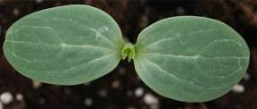

Right stage for observation

(b) Leaf blade: All observations on the leaf blade should be made on fully developed leaves on the main vine, from the 10th to the 15th leaf, during fruit set, before the fruits are developed.

(c) Fruit: Unless otherwise indicated, all observations on the fruit should be made on first well developed, mature fruits. In the case of striped fruits, the stripes are defined by the darkest color.

(d) Seed: All observations on the seed should be recorded on fully developed, mature seeds harvested from the fruit.

8.2 Explanations for individual characteristics

Ad. 1: Ploidy

Ploidy level may be detected by several methods:

- by counting chromosomes of cells under the microscope;
- by counting the number chloroplasts of stomatal guard cells using a leaf peel under the microscope;
- by flow cytometry.
- Triploid varieties show a whitish seed coat without embryo.

Ad. 3: Cotyledon: shape

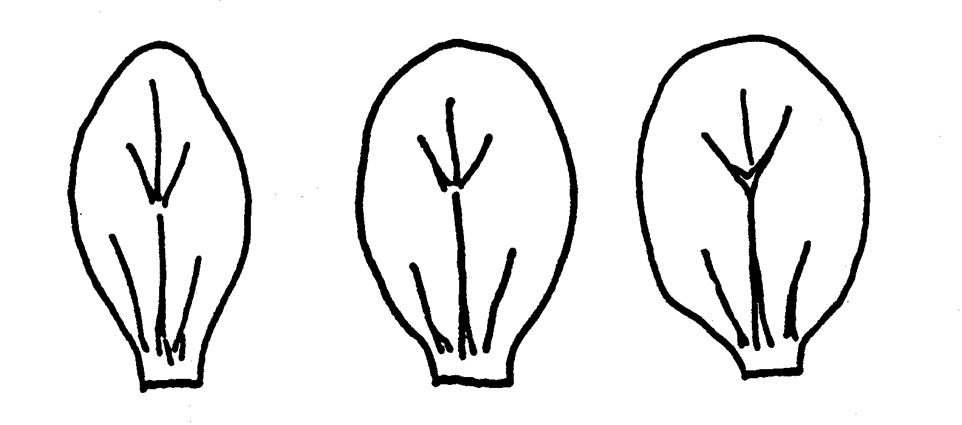

1 | 2 | 3
narrow elliptic | medium elliptic | broad elliptic

Ad. 6: Leaf blade: ratio length/width

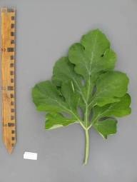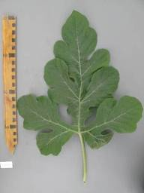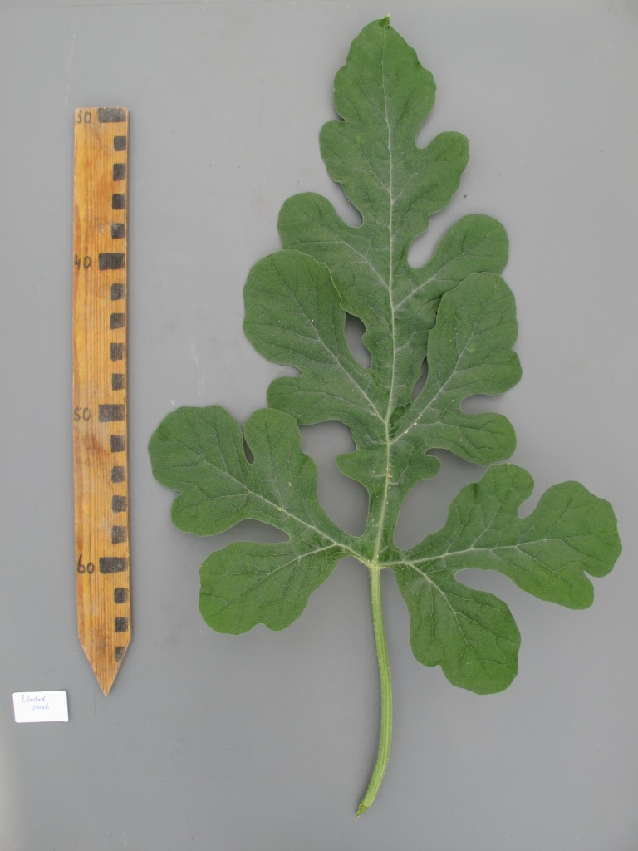
1 | 2 | 3
slightly elongated | moderately elongated | strongly elongated

Ad. 8: Leaf blade: degree of lobing

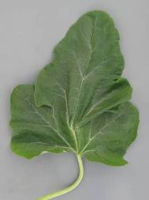 | 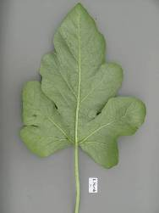 | 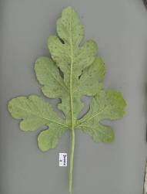
1 | 3 | 5
absent or very weak | weak | medium

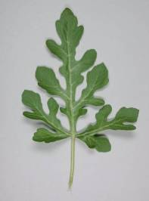 | 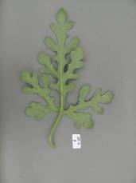
7 | 9
strong | very strong

Ad. 9: Leaf blade: blistering

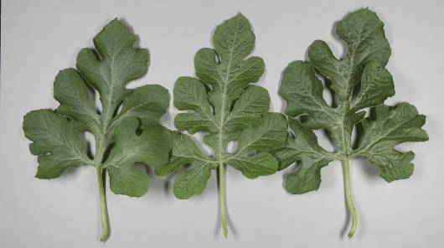

1 | 2 | 3
weak | medium | strong

Ad. 10: Leaf blade: color of veins

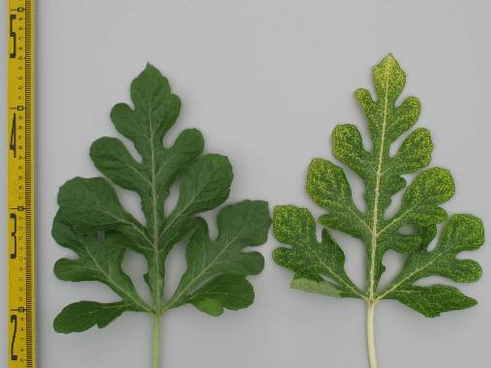
1 | 2
green | yellow

Ad. 12: Fruit: shape in longitudinal section

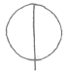 | 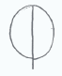 | 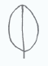 | 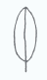
1 | 2 | 3 | 4
circular | broad elliptic | medium elliptic | narrow elliptic

Ad. 13: Fruit: depression at base
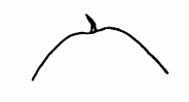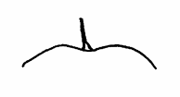
2 | 3 | 4
shallow | medium | deep

Ad. 14: Fruit: shape of apical part

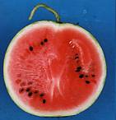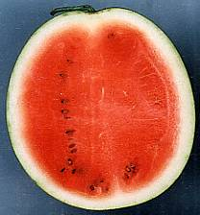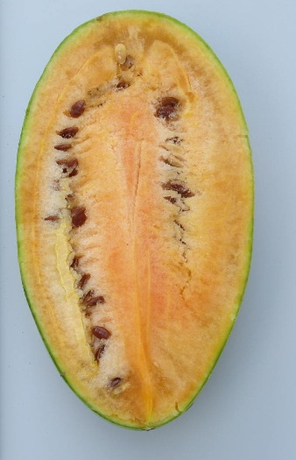
1 | 3 | 5
truncate | rounded | conical

Ad. 15: Fruit: depression at apex
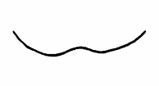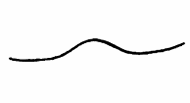
2 | 3 | 4
shallow | medium | deep

Ad. 16: Fruit: ground color of skin

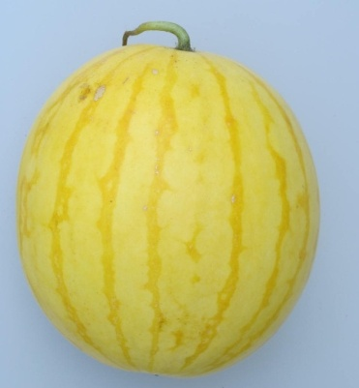
1
yellow

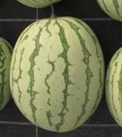 | 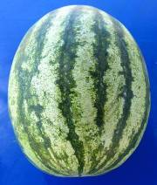 | 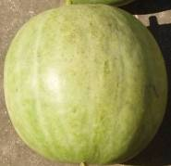
2 | 3 | 4
very light green | very light green to light green | light green

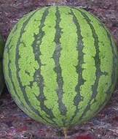 | 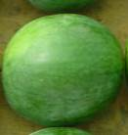 | 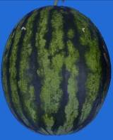
5 | 6 | 7
light green to medium green | medium green | medium green to dark green

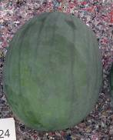 | 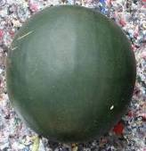 | 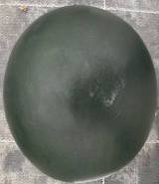
8 | 9 | 10
dark green | dark green to very dark green | very dark green
Ad. 17: Fruit: conspicuousness of veining

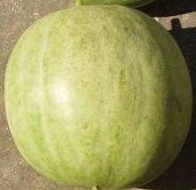 | 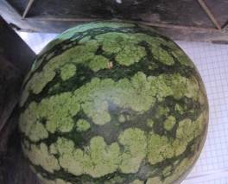
1 | 2
inconspicuous or very weakly conspicuous | weak

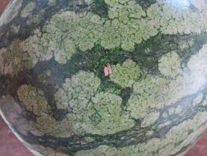 | 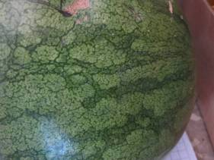
3 | 4
medium | strong

Ad. 18: Fruit: pattern of stripes

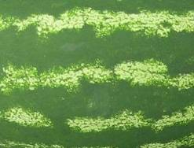 | 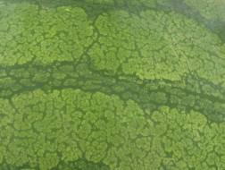
1 | 2
only one colored | one colored and veins

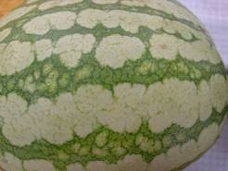 | 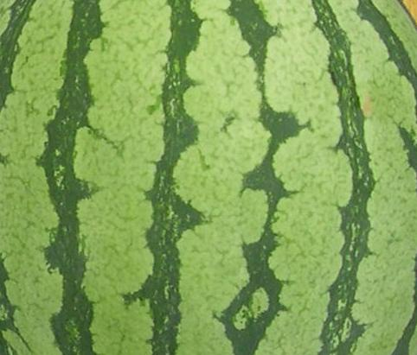
3 | 4
one colored, veins and marbled | one colored and marbled

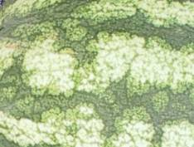 | 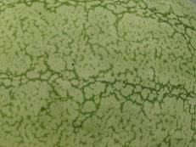
5 | 6
two colored, veins and marbled | only veins

Ad. 19: Fruit: width of stripes

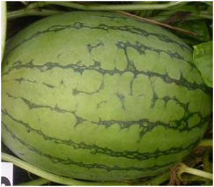 | 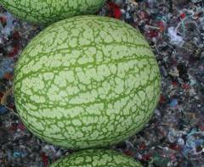 | 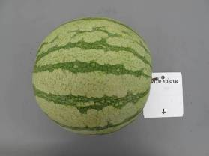
1 |  | 3
very narrow |  | narrow

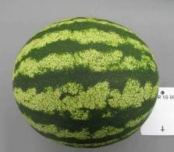 | 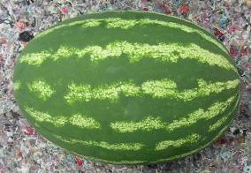
5 | 7
medium | broad

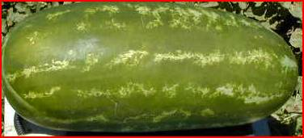
9
very broad

Ad. 20: Fruit: main color of stripes

Use the same scale as ground color.

Ad. 21: Fruit: conspicuousness of stripes

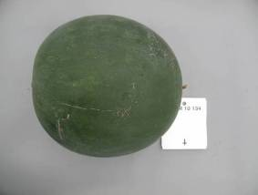 | 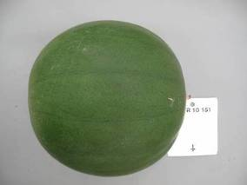
1 | 2
inconspicuous or very weakly conspicuous | weak

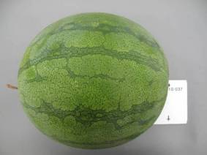 | 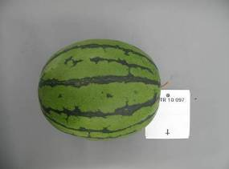
3 | 4
medium | strong

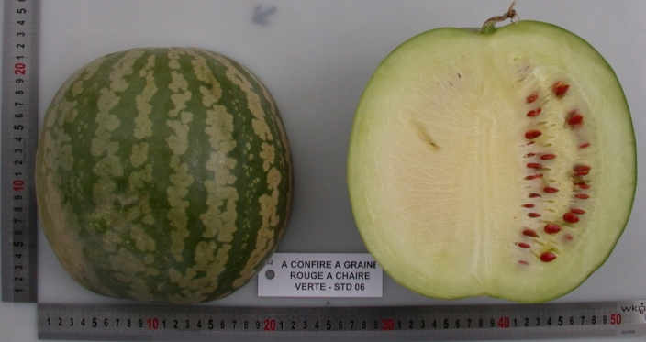
5
very strong

Ad. 22: Fruit: margin of stripes

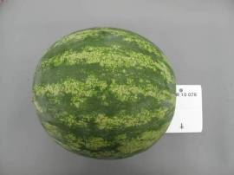 | 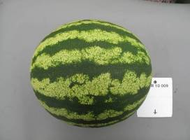
1 | 2
diffuse | medium

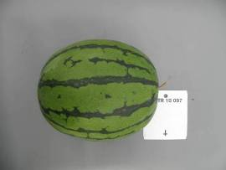
3
sharp

Ad. 23: Fruit: size of insertion of peduncle

The size of the insertion of the peduncle is absolute and not relative to fruit size.

Ad. 24: Fruit: size of pistil scar

The size of the pistil scar is absolute and not relative to fruit size.

Ad. 25: Fruit: degree of grooving

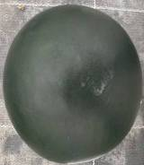 | 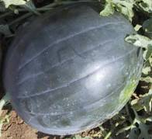
1 | 3
absent or very weak | medium

Ad. 26: Fruit: waxy layer

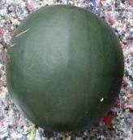 | 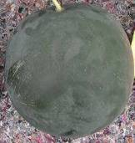 | 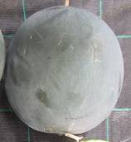
1 | 3 | 5
absent or very weak | medium | very strong

Ad. 27: Fruit: thickness of pericarp

The thickness of pericarp is absolute and not relative to fruit size.

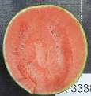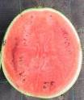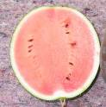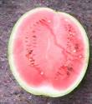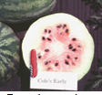
1 | 3 | 5 | 7 | 9
very thin | thin | medium | thick | very thick

Ad. 29: Only triploid varieties: Seed coat: size

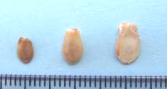
2 | 3 | 4
small | medium | large

Ad. 31: Only diploid and tetraploid varieties: Seed: length

1 | 2 | 3 | 4 | 5 | 6 | 7 | 8 | 9
very short | very short to short | short | short to medium | medium | medium to long | long | long to very long | very long
Ad. 33: Only diploid and tetraploid varieties: Seed: ground color of testa

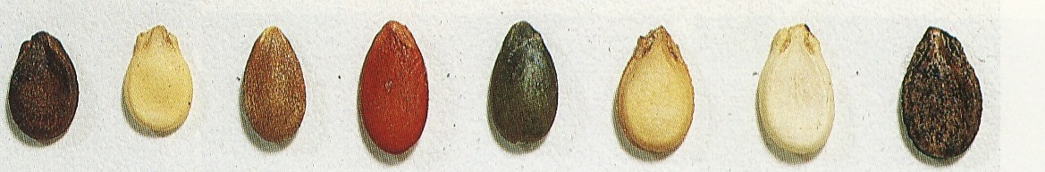 | 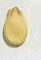 | 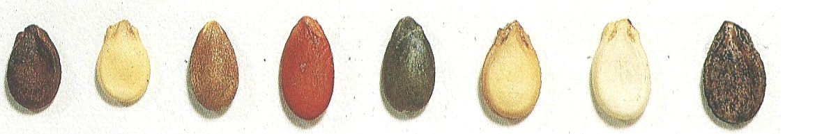 |  | 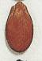 |  | 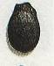
1 | 2 | 3 | 4 | 5 | 6 | 7
white | cream | green | red | red brown | brown | black

Ad. 34: Only diploid and tetraploid varieties: Seed: over color of testa

1 | 9
absent | present

Ad. 35: Only diploid and tetraploid varieties: Seed: area of over color in relation to that of ground color

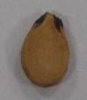 | 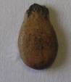 | 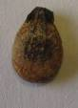 | 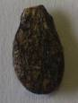 | 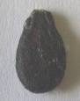
1 | 3 | 5 | 7 | 9
very small | small | medium | large | very large

Ad. 36: Only diploid and tetraploid varieties: Seed: patches at hilum

 | 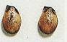 | 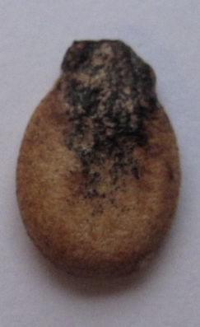
1 | 2 | 3
absent or very weak | medium | strong

Ad. 37: Time of female flowering

50% of plants with at least one female flower.

Ad. 38: Resistance to Fusarium oxysporum f. sp. niveum

1. Pathogen Fusarium oxysporum f. sp. niveum
2. Quarantine status no
3. Host species watermelon (Citrullus lanatus)
4. Source of inoculum Naktuinbouw
5. Isolate Fon: 0, 1, 2
6. Establishment isolate identity differentials
7. Establishment pathogenicity susceptible varieties
8. Multiplication inoculums…… PDA or PSA; renew from frozen stock annually
9. Format of the test
9.1 Number of plants per genotype 20
9.2 Number of replicates 2
9.3 Control varieties differentials
 | Fon: 0 | Fon: 1 | Fon: 2
Black Diamond, Kahô | S | S | S
Charleston Gray | R | S | S
Calhoun Gray | R | R | S
P.I. 296341-FR | R | R | R

9.4 Test design include at least the two most informative differential varieties
9.5 Test facility glasshouse or climate room
9.6 Temperature day 25°C, night 15°C
9.7 Light > 12 hours
9.9 Special measures apply liquid fertilizer once a week
10. Inoculation
10.1 Preparation inoculum Czapek Dox or PS (potato and sugar); aerated liquid culture at 28ºC; filter through double muslin
10.2 Quantification inoculum count 1.3 x 10⁷ spores per ml, dilute if necessary
10.3 Plant stage at inoculation 2nd to 3rd leaf just expandingv
10.4 Inoculation method soaking of roots and of hypocotyl axis for one minute in inoculum solution. After inoculation, transplantation of plantlets in steam- sterilized soil or perlite.
10.5 First observation 7 days after inoculation
10.6 Second observation 14 days after inoculation
10.7 End of test 21 days after inoculation
11. Observations
11.1 Method visual, external
11.2 Observation scale lesions equal to or more than 2 mm in size
11.3 Validation of test standard varieties
12. Interpretation of data in terms of UPOV characteristic states
[1] lesions equal to or more than 2 mm in size
[9] without external symptoms
13. Critical control points
Resistant plants show no or little delayed growth but no internal or external symptoms.
Vascular browning is the most reliable diagnostic symptom. Plants with external symptoms should have vascular browning, otherwise the symptom may be caused by Pythium.

Ad. 39: Resistance to Colletotrichum orbiculare

1. Pathogen Colletotrichum orbiculare (anthracnose)
2. Quarantine status no
3. Host species Citrullus lanatus (watermelon)
4. Source of inoculum Academic research
5. Isolate Co: 1
6. Establishment isolate identity on differentials
7. Establishment pathogenicity on susceptible varieties
8. Multiplication inoculum
8.1 Multiplication medium ………… PSA, renew from frozen stock annually
9.1 Number of plants per genotype 20
9.2 Number of replicates 2
9.3 Control varieties differentials: Calhoun Gray susceptible,
Charleston Gray resistant
9.4 Test design including at least the most informative differentials
9.5 Test facility glasshouse or climate room
9.6 Temperature day 25°C, night 16°C
9.7 Light >12 hours
9.9 Special measures inoculated plants should be placed in a dark and humid chamber
at 25°C with 100% relative humidity for 48 hours before being moved to the greenhouse.
10. Inoculation
10.1 Preparation inoculum shaking culture in P.D. (Potato and Dextrose) liquid medium for 7 to 10 days at 28°C. Filter the medium through double muslin cloth.
10.2 Quantification inoculum 1.5*10⁴ spores per ml
10.3 Plant stage at inoculation 2nd or 3rd leaf just expanding
10.4 Inoculation method spraying of inoculum on leaf and stem
10.5 First observation 7 days
10.7 End of test 10 days
11. Observations
11.1 Method Visual
11.2 Observation scale lesions equal to or more than 2 mm in size
lesions may coalesce and kill the leaf back to the petiole.
11.3 Validation of test on standard varieties

12. Interpretation of data in terms of UPOV characteristic states
[1] lesions equal to or more than 2 mm in size
[9] lesions absent or less than 2 mm in size
13. Critical control points
Lesions that stay small and tend towards necrosis indicate resistance. Complete absence of symptoms indicates a low disease pressure or high resistance.

Literature

Corell, J.C., Morelock, T. E. and McNew, R.E., 1993: Reexamination of races of the cucurbit anthracnose pathogen Colletotrichum orbiculare. Phytopathology 83: pp. 1190-1198

Crall, J.M., 1959: Effect of Seed Source on Watermelon Maturity, Proc. Amer. Soc. Hort. Sci. 74, pp. 555-557

Crall, J.M., Montelaro, J., 1972: Fusarium Wilt Resistance in Jubilee Watermelon, Proc. Fra. State Hoet. Soc. 85, pp 102-105

Cucurbit Genetics Cooperative, Cucurbit Gene List Committee, 1987: Gene List for Watermelon, Cucurbit Gent.Coop. Rpt. 10, pp. 106-110

Cucurbit Genetics Cooperative, 2007: Gene List for Watermelon

Elmstrom, G.W., Hopkins, D.L., 1981: Resistance of Watermelon Cultivars to Fusarium Wilt, Plant Disease 65(10), pp. 825-827

Grubben, G.J.H., Denton, O.A. (Editors), 2004: Plant Resources of Tropical Africa 2: Vegetables, Prota Foundation, Wageningen pp. 185-191

Gusmini, G., Wehner, T.C., 2005: Genes determining rind pattern inheritance in watermelon: a review, HortScience 40: pp. 1928-1930

Gusmini, G., and Wehner, T. C., 2006: Qualitative inheritance of rind pattern and flesh color in watermelon, J. Hered. 97: pp. 177-185

Kanda, T., 1951: Triploid Watermelons, Proc. Am. Soc. Hortic. Sci. 58, pp. 217-230

Kensler, T.R., Barham, W.S., 1958: The Inheritance of Seed Size in Watermelon, Proc. Amer. Soc. Hort. Sci. 71, pp. 480-484

Martyn, R.D., McLaughin, R.J., 1983: Susceptibility of Summer Squash to the Watermelon Wilt Pathogen (Fusarium oxysporum f. sp. niveum), Plant Disease 67(3), pp. 263-266

Martyn, R.D., Netzer, D., 1991: Resistance to Race 0, 1 and 2 of Fusarium Wilt of Watermelon in Citrullus sp., PI-296341-FR

Maynard, D.N., Xingping Zhang, Jannick, J., 2007: Watermelons: New Choices, New Trends, Chronica Horticulturae 47(4), pp. 26-29

McCuiston, F. and Wehner, Todd C., 2010: Seedless Watermelon Breeding: Tetraploid Production, Unpublished, NC State University

Mizyno, S., Pratt, H.K., 1973: Relations of Respiration and Ethylene Production to Maturity in the Watermelon, J. Amer. Soc. Hort. Sci. 98(6), pp. 614-617

Mohr, H.C., 1963: Utilization of the Genetic Character for Short-internode in Improvement of the Watermelon, J. Amer. Soc. Hort. Sci. 82, pp. 454-459

Ochatt, S.J.: Flow Cytometry, (ploidy determination, cell cycle analysis, DNA content per nucleus), Medicago truncatula handbook version November 2006; INRA France

Pool, C.F., Porter, D.R., 1933: Pollen Germination and Development in Watermelon, Proc. Amer. Soc. Hort. Sci. 30, pp. 526-530

Pool, C.F., Grimball, P.C., Porter, D.R., 1941: Inheritance of Seed Characters in Watermelon, Jour. Agr. Res. 66, pp. 433-456

Prusky, D., Freeman, S., Dickman M.B., eds., 2000. Colletotrichum: Host specificity, Pathology and Host-pathogen interactions. APS, St. Paul, Chapter 21 Host-pathogen interaction and variability of Colletotrichum lindemuthianum.Wasilwa L.A.

Siemonsma, J.S., Piluek, K. (ed.), 1993: Plant resources of South East Asia No.8: Vegetables, Wageningen Pudoc, pp. 144-148

Shinohara, S., 1984: Vegetable Seed Production Technology of Japan Elucidated with Respective Variety Development Histories, Particulars, Volume 1. Shinohara’s Authorized Agricultural Consulting Engineer Office, Tokyo, Japan, pp. 318-339

Shomotsuma, M., Jines, C.M., 1972: Effect of Ethephon and Daylight on Sex Expression of Muskmelon and Watermelon, Hort. Sci. 7, pp. 73-75

Wasilwa, L.A., Correll J.C., Morelock T.E., and McNew R.E. 1993: Reexamination of races of the cucurbit anthracnose pathogen Colletotrichum orbiculare. Phytopathology 83: pp. 1190-1198.

Wehner, T.C., 2008: Overview of the Genes of Watermelon, Proc. Cucurbitaceae 2008, EUCARPIA meeting, (ed. M. Pitrat) pp. 79-89

Wehner, T.C., 2008: Watermelon In: J. Prohens and F. Nuez (eds.) Handbook of Plant Breeding; Vegetables I: Asteraceae, Brassicaceae, Chenopodiaceae, and Cucurbitaceae. Springer Science+Business LLC, New York, NY, 426 p.17, pp. 381-418

Technical Questionnaire

TECHNICAL QUESTIONNAIRE |  |  |  | Page {x} of {y} |  | Reference Number:
 |  |  |  |  |  | Application date:
 |  |  |  |  |  | (not to be filled in by the applicant)
TECHNICAL QUESTIONNAIRE
to be completed in connection with an application for plant breeders’ rights

1. Subject of the Technical Questionnaire
1.1 Botanical name |  |  | Citrullus lanatus (Thunb.) Matsum. et Nakai
1.2 Common name |  |  | Watermelon
2. Applicant
Name
Address
Telephone No.
Fax No.
E-mail address
Breeder (if different from applicant)
3. Proposed denomination and breeder’s reference
Proposed denomination
(if available)

Breeder’s reference
#4. Information on the breeding scheme and propagation of the variety

4.1 Method of propagating the variety

4.1.1 Seed-propagated varieties

(a) Self-pollination [ ]
(b) Cross-pollination
(i) population [ ]
(ii) synthetic variety [ ]
(c) Hybrid [ ]
(d) Other [ ]
(please provide details)

5. Characteristics of the variety to be indicated (the number in brackets refers to the corresponding characteristic in Test Guidelines; please mark the note which best corresponds).

 | Characteristics |  |  |  |  |  | Example Varieties |  |  | Note
5.1  (1) | Ploidy
 | diploid |  |  |  |  |  | SP 4, Sugar Baby, Yamato 3 |  |  | 2[ ]
 | triploid |  |  |  |  |  | Boston, TRIX 313 |  |  | 3[ ]
 | tetraploid |  |  |  |  |  |  |  |  | 4[ ]
5.2  (11) | Fruit: weight
 | very low |  |  |  |  |  | Monaco, New Hampshire Midget |  |  | 1[ ]
 | very low to low |  |  |  |  |  | Mini, Petite Perfection |  |  | 2[ ]
 | low |  |  |  |  |  | Angela |  |  | 3[ ]
 | low to medium |  |  |  |  |  | Pasion, Sugar Baby |  |  | 4[ ]
 | medium |  |  |  |  |  | Boston |  |  | 5[ ]
 | medium to high |  |  |  |  |  | Crimson Sweet, Panonia |  |  | 6[ ]
 | high |  |  |  |  |  | Fabiola |  |  | 7[ ]
 | high to very high |  |  |  |  |  | Jubilee |  |  | 8[ ]
 | very high |  |  |  |  |  | Carolina Cross, Cobb’s Gem,  Florida Giant |  |  | 9[ ]
5.3  (12) | Fruit: shape in longitudinal section
 | circular |  |  |  |  |  | Camilla, Kanro |  |  | 1[ ]
 | broad elliptic |  |  |  |  |  | Fumin, Gray Belle, Yellow Baby, Zorba |  |  | 2[ ]
 | medium elliptic |  |  |  |  |  | Congo, Kurobe, Picnic |  |  | 3[ ]
 | narrow elliptic |  |  |  |  |  | Allsweet, Charleston Gray |  |  | 4[ ]
 | Characteristics |  |  |  |  |  | Example Varieties |  |  | Note
5.4  (16) | Fruit: ground color of skin
 | yellow |  |  |  |  |  | Taiyô |  |  | 1[ ]
 | very light green |  |  |  |  |  | Ipanema |  |  | 2[ ]
 | very light green to light green |  |  |  |  |  | Napsugar |  |  | 3[ ]
 | light green |  |  |  |  |  | Tigre |  |  | 4[ ]
 | light green to medium green |  |  |  |  |  | Pepsin |  |  | 5[ ]
 | medium green |  |  |  |  |  | Ovation, Talete |  |  | 6[ ]
 | medium green to dark green |  |  |  |  |  | Odem, Resistant, Sweet Marvel |  |  | 7[ ]
 | dark green |  |  |  |  |  | Sugar Baby |  |  | 8[ ]
 | dark green to very dark green |  |  |  |  |  | Augusta, Rocio |  |  | 9[ ]
 | very dark green |  |  |  |  |  |  |  |  | 10[ ]
5.5  (19) | Fruit: width of stripes
 | very narrow |  |  |  |  |  | SP 4, Tiny Orchid |  |  | 1[ ]
 | very narrow to narrow |  |  |  |  |  |  |  |  | 2[ ]
 | narrow |  |  |  |  |  | Boston |  |  | 3[ ]
 | narrow to medium |  |  |  |  |  |  |  |  | 4[ ]
 | medium |  |  |  |  |  | Crimson Sweet |  |  | 5[ ]
 | medium to broad |  |  |  |  |  |  |  |  | 6[ ]
 | broad |  |  |  |  |  | Sangria |  |  | 7[ ]
 | broad to very broad |  |  |  |  |  |  |  |  | 8[ ]
 | very broad |  |  |  |  |  | All Sweet |  |  | 9[ ]
5.6  (22) | Fruit: margin of stripes
 | diffuse |  |  |  |  |  | Crimson Glory, Crisby |  |  | 1[ ]
 | medium |  |  |  |  |  | Crimson Sweet |  |  | 2[ ]
 | sharp |  |  |  |  |  | Jenny, Jubilee |  |  | 3[ ]
 | Characteristics |  |  |  |  |  | Example Varieties |  |  | Note
5.7  (28) | Fruit: main color of flesh
 | white |  |  |  |  |  | SP 4, SP1,Yamato Cream 3 |  |  | 1[ ]
 | yellow |  |  |  |  |  | Napsugár, Yamato Cream 1 |  |  | 2[ ]
 | orange |  |  |  |  |  | Kahô, Tendersweet |  |  | 3[ ]
 | pink |  |  |  |  |  | Sadul |  |  | 4[ ]
 | pinkish red |  |  |  |  |  | Bingo, Crimson Sweet |  |  | 5[ ]
 | red |  |  |  |  |  | Asahiy, Sugar Baby, Topgun |  |  | 6[ ]
 | dark red |  |  |  |  |  | Dixie Lee |  |  | 7[ ]
5.8  (31) | Only diploid and tetraploid varieties: Seed: length
 | very short |  |  |  |  |  | Kudam |  |  | 1[ ]
 | very short to short |  |  |  |  |  |  |  |  | 2[ ]
 | short |  |  |  |  |  | Panonia, Tabata |  |  | 3[ ]
 | short to medium |  |  |  |  |  |  |  |  | 4[ ]
 | medium |  |  |  |  |  | Sugar Baby |  |  | 5[ ]
 | medium to long |  |  |  |  |  |  |  |  | 6[ ]
 | long |  |  |  |  |  | Charleston Gray, Kurobe |  |  | 7[ ]
 | long to very long |  |  |  |  |  |  |  |  | 8[ ]
 | very long |  |  |  |  |  | Malali, Wanli |  |  | 9[ ]
5.9  (33) | Only diploid and tetraploid varieties: Seed: ground color of testa
 | white |  |  |  |  |  | Sanpaku |  |  | 1[ ]
 | cream |  |  |  |  |  | Kurobe |  |  | 2[ ]
 | green |  |  |  |  |  | A confire allongée à graine verte, Green Citron |  |  | 3[ ]
 | red |  |  |  |  |  | A graine rouge à confire à chair verte, Red Citron |  |  | 4[ ]
 | red brown |  |  |  |  |  | Kahô |  |  | 5[ ]
 | brown |  |  |  |  |  | Otome, Sugar Baby |  |  | 6[ ]
 | black |  |  |  |  |  | Yamato Cream |  |  | 7[ ]
6. Similar varieties and differences from these varieties

Please use the following table and box for comments to provide information on how your candidate variety differs from the variety (or varieties) which, to the best of your knowledge, is (or are) most similar. This information may help the examination authority to conduct its examination of distinctness in a more efficient way.

Denomination(s) of variety(ies) similar to your candidate variety |  | Characteristic(s) in which your candidate variety differs from the similar variety(ies) |  |  | Describe the expression of the characteristic(s) for the similar variety(ies) |  |  | Describe the expression of the characteristic(s) for your candidate variety
Example |  | Fruit: width of stripes |  |  | narrow |  |  | medium
Comments:

#7. Additional information which may help in the examination of the variety

7.1 In addition to the information provided in sections 5 and 6, are there any additional characteristics which may help to distinguish the variety?

Yes [ ] No [ ]

(If yes, please provide details)

7.2 Are there any special conditions for growing the variety or conducting the examination?

Yes [ ] No [ ]

(If yes, please provide details)

7.3 Other information

A representative color image of the variety should accompany the Technical Questionnaire.

8. Authorization for release

(a) Does the variety require prior authorization for release under legislation concerning the protection of the environment, human and animal health?

Yes [ ] No [ ]

(b) Has such authorization been obtained?

Yes [ ] No [ ]

If the answer to (b) is yes, please attach a copy of the authorization.

9. Information on plant material to be examined or submitted for examination.

9.1 The expression of a characteristic or several characteristics of a variety may be affected by factors, such as pests and disease, chemical treatment (e.g. growth retardants or pesticides), effects of tissue culture, different rootstocks, scions taken from different growth phases of a tree, etc.

9.2 The plant material should not have undergone any treatment which would affect the expression of the characteristics of the variety, unless the competent authorities allow or request such treatment. If the plant material has undergone such treatment, full details of the treatment must be given. In this respect, please indicate below, to the best of your knowledge, if the plant material to be examined has been subjected to:

(a) Microorganisms (e.g. virus, bacteria, phytoplasma) Yes [ ] No [ ]

(b) Chemical treatment (e.g. growth retardant, pesticide) Yes [ ] No [ ]

(c) Tissue culture Yes [ ] No [ ]

(d) Other factors Yes [ ] No [ ]

Please provide details for where you have indicated “yes”.

……………………………………………………………

10. I hereby declare that, to the best of my knowledge, the information provided in this form is correct:

Applicant’s name

Signature Date

[End of document]

* These names were correct at the time of the introduction of these Test Guidelines but may be revised or updated. [Readers are advised to consult the UPOV Code, which can be found on the UPOV Website (www.upov.int), for the latest information.]
# Authorities may allow certain of this information to be provided in a confidential section of the Technical Questionnaire.
# Authorities may allow certain of this information to be provided in a confidential section of the Technical Questionnaire.

