 |  | E  TC-EDC/Jan13/6  ORIGINAL: English  DATE: November 29, 2012
INTERNATIONAL UNION FOR THE PROTECTION OF NEW VARIETIES OF PLANTS
Geneva
enlarged editorial Committee
Geneva, January 9 and 10, 2013
Revision of document TGP/7: Example Varieties
Document prepared by the Office of the Union
(containing proposals prepared by experts from France)
1 The purpose of this document is to present a proposal prepared by experts from France to amend document TGP/7 Guidance Note 28 (GN 28), for inclusion in a future revision of document TGP/7, on the basis of the comments made by the Technical Working Parties (TWPs) at their sessions in 2012.

2 The following abbreviations are used in this document:

TC: Technical Committee
TC-EDC: Enlarged Editorial Committee
TWA: Technical Working Party for Agricultural Crops
TWC: Technical Working Party on Automation and Computer Programs
TWF: Technical Working Party for Fruit Crops
TWO: Technical Working Party for Ornamental Plants and Forest Trees
TWPs: Technical Working Parties
TWV: Technical Working Party for Vegetables

Background

3 Document TGP/7/2 Draft 2, considered by the Technical Committee (TC) at its fortyfifth session, held in Geneva from March 30 to April 1, 2009, indicated that experts from France would develop a document, based on GN 28 “Example varieties”, for discussion at the TWP sessions in 2009. However, the Technical Working Party for Vegetables (TWV), held from April 20 to 24, 2009, was less than three weeks after the fortyfifth session of the TC, which meant that it was not feasible to prepare a document for consideration by the TWV in 2009. The TWV noted that it would not be able to review any proposed amendments to GN 28 before the TC considered the approval of document TGP/7/2 in 2010. The TWV noted the importance of example varieties in Test Guidelines for vegetable crops and generally supported the text in GN 28. Therefore, to avoid a delay in the adoption of document TGP/7/2, it proposed that document TGP/7/2 should be adopted in 2010 without amendments to GN 28 and that any proposed amendments should be considered in a future revision of document TGP/7, if appropriate. The Technical Working Party for Agricultural Crops (TWA), at its thirty-eighth session, held in Seoul, Republic of Korea, from August 31 to September 4, 2009, agreed with that proposal and also agreed to add an agenda item to discuss example varieties at its thirty-ninth session (see document TWA/38/17 “Report”, paragraph 36).

4 The Technical Working Party for Ornamental Plants and Forest Trees (TWO) and Technical Working Party for Fruit Crops (TWF), at their sessions in 2009, agreed that experts with suggestions concerning the document to be developed on example varieties should send those to Mr. Joël Guiard (France), or to the Office of the Union, which would forward the suggestions to Mr. Guiard. The expert from New Zealand explained that he would raise the matter of example varieties that were a matter of common knowledge, but did not have a denomination.

5 At its forty-sixth session, held in Geneva from March 22 to 24, 2010, the TC agreed that consideration be given to example varieties in a future revision of TGP/7 (document TGP/7/3) (see document TC/46/15 “Report on the Conclusions”, paragraph 31).

6 The TC at its forty-seventh session, held in Geneva from April 4 to 6, 2011, considered the proposal, prepared by an expert from France, as presented in the Annex to this document and the comments of the TWPs in relation to that proposal. The TC agreed that the subject of example varieties would be considered as a possible matter for discussion on the Monday session of the TC, in 2012, “which will be dedicated to a discussion on experiences of members if the Union in measures to improve the efficiency and effectiveness of DUS testing. (see document TC/47/26 “Report on the Conclusions”, paragraphs 62 and 111).

COMMENTS BY THE TECHNICAL WORKING PARTIES AT THEIR SESSIONS IN 2011

Technical Working Party for Agricultural Crops (TWA)

7 At its fortieth session, held in Brasilia, Brazil, from May 16 to 20, 2011, the TWA considered document TWA/40/18 and noted the comments from the TWPs in 2010. The TWA agreed that, for the time being, it was not necessary to redraft the proposal prepared by an expert from France concerning example varieties (see Annex to document TWA/40/18) and that it would be discussed on the Monday session of the TC in 2012. The TWA recommended that the TC should consider the possibility for national authorities to exchange example varieties. The expert from the Republic of Korea noted that it might be useful to have contact details of the relevant experts (see document TWA/40/23 “Report”, paragraph 18).

Technical Working Party on Automation and Computer Programs (TWC)

8 The TWC considered document TWC/29/18 and noted the comments from the TWPs in 2010 and the TWA, at its fortieth session, held in Brasilia, Brazil, from May 16 to 20, 2011. The TWC agreed with the comments made at that session of the TWA (see document TWC/29/31 “Report”, paragraph 17).

Technical Working Party for Vegetables (TWV)

9 At its forty-fifth session, held in Monterey, United States of America, from July 25 to 29, 2011, the TWV considered document TWV/45/18.

10 The TWV noted that TGP/7 “Development of Test Guidelines”, Guidance Note GN 28 states as follows:

“1. Purpose of example varieties

“The General Introduction (Chapter 4.3) states that “example varieties are provided in the Test Guidelines to clarify the states of expression of a characteristic.” This clarification of the states of expression is required with respect to two aspects:

(a) to illustrate the characteristic and/or

- to provide the basis for ascribing the appropriate state of expression to each variety and, thereby, to develop internationally harmonized variety descriptions.”

11 The TWV agreed that example varieties in the UPOV Test Guidelines could not be expected to provide internationally harmonized variety descriptions. It proposed that GN 28 be revised to explain that example varieties would be useful for: (a) members of the Union to be able to establish a range of expression for characteristics for crops and species in which they did not have experience; and (b) inclusion in the Technical Questionnaire as a basis for guidance for applicants. The TWV further agreed that it would discuss the role of example varieties in the Monday morning session of the Technical Committee in 2012 (see document TWV/45/26 “Report”, paragraph 19 to 21).

Technical Working Party for Ornamental Plants and Forest Trees (TWO)

12 The TWO at its forty-fourth session held in Fukuyama City, Hiroshima Prefecture, Japan, from November 7 to 11, 2011, did not agree with the general view expressed by the TWV at its forty-fifth session, that example varieties in the UPOV Test Guidelines could not be expected to provide internationally harmonized variety descriptions. The TWO noted that example varieties could provide the basis for useful international harmonization of variety descriptions for ornamental varieties, as indicated in the model study for Petunia (document TWO/37/8) where it had been seen that there was a high level of consistency for the states of expression across varieties (see document TWO/44/25 “Report”, paragraph 18).

The Technical Working Party for Fruit Crops (TWF)

13 The TWF at its forty-second session in Hiroshima, Japan, from November 14 to 18, 2011, considered the document TWF/42/18 and agreed to add a new paragraph after paragraph 13:

“Test Guideline drafters should take steps to ensure that example varieties proposed by other members of the subgroup are compatible with those provided by the leading expert for that characteristic. This is of particular importance for quantitative characteristics (QN). The best approach would be for a subgroup member to propose a full set of varieties for that characteristic.”

14 The TWF expressed the need to develop guidelines for leading experts on how to accept the example varieties proposed by the other experts, following the principles of regional sets of example varieties, as set out in document TWF/42/18.

15 The TWF supported the revision and review of example varieties and agreed to only include varieties which are readily available.

16 The TWF also agreed with the proposal that this issue be discussed on the Monday session of the TC meeting in 2012 (see document TWF/42/26 “Report”, paragraphs 18 to 21).

Comments by the Technical Committee in 2012

17 The TC, at its forty-eighth session held in Geneva, Switzerland, from March 26 to 28, 2012, discussed example varieties on the basis of a presentation “Example varieties” by Mr. Richard Brand (France) (see http://www.upov.int/edocs/mdocs/upov/en/tc_48/example_varieties.pdf ).

18 The Chairman of the TC recalled that the discussion concerned the inclusion of example varieties in the (UPOV) Test Guidelines and noted that a complete set of example varieties would be important for each member of the Union. With regard to example varieties in the Test Guidelines, he concluded that, in many cases, it would be difficult to identify a “universal” set of example varieties that would be suitable for all members of the Union. However, where it was not possible to develop a universal set of example varieties, he noted that it might still be beneficial to try to preserve similar ranges for the states of expression for all members of the Union. With regard to solutions where a universal set of example varieties could not be agreed for all members of the Union, he recalled that regional sets of example varieties could be an effective measure. He also observed that the making available of variety descriptions by members of the Union could be an important source of information, whilst noting that the development of such databases would involve substantial cost.

19 With regard to Test Guidelines, the Chairman noted a suggestion that the Leading Expert might provide a full list of varieties that might be available as example varieties, rather than suggesting a limited list. He also recalled that, where appropriate, example varieties might be replaced by illustrations and references to calibration books of members of the Union, in the Test Guidelines’ Chapter on Literature (see document TC/48/22 “Report on the Conclusions”, paragraphs 10 to 12).

20 The TC, at its forty-eighth session agreed that the experts from France should be requested to make a presentation to the TWPs at their sessions in 2012 on the basis of the presentation made under agenda item “Discussion on experiences of members of the Union on measures to improve the efficiency and effectiveness of DUS testing” and reflecting the comments and suggestions made during the discussion (see document TC/48/22 “Report on the Conclusions”, paragraph 45).

Comments by the Technical working parties in 2012

21 The TWA, TWV, TWC, TWF and TWO considered documents TWA/41/14 and TWA/41/14 Add., TWV/46/14 and TWV/46/14 Add., TWC/30/14 and TWC/30/14 Add., TWF/43/14 and TWF/43/14 Add., and TWO/45/14 and TWO/45/14 Add. respectively and commented as follows:

General | The TWA supported the proposal made by the expert from New Zealand and presented by an expert from France as follows (see documents TWA/41/14 Add. and TWA/41/34 “Report”, paragraph 19):  - Leading Expert collects the example varieties proposed by the interested UPOV members with a description for each of these varieties.  - Leading Expert compiles the proposals taking into account the number of countries in common. Request for additional information on descriptions if necessary.  - Based on the descriptions received, Leading Expert analyses the robustness of the levels of expression and establishes a proposal based on the most common varieties as a first priority for QN characteristics. This proposal included in the 2nd draft will be studied by the experts before the following session and discussed during the session.  - Finally the subgroup decides for which characteristic the example varieties will be proposed. | TWA
 | The TWV considered documents TWV/46/14 and TWV/46/14 Add.. The TWV supported the comments made by the expert from New Zealand as follows and presented by an expert from France (see documents TWV/46/14 Add. and TWV/46/41 “Report”, paragraph 17):  - Leading Expert collects the example varieties proposed by the interested UPOV members with a description for each of these varieties.  - Leading Expert compiles the proposals taking into account the number of countries in common. Request for additional information on descriptions if necessary.  - Based on the descriptions received, Leading Expert analyses the robustness of the levels of expression and establishes a proposal based on the most common varieties as a first priority for QN characteristics. This proposal included in the 2nd draft will be studied by the experts before the following session and discussed during the session.  - Finally the subgroup decides for which characteristic the example varieties will be proposed.  The TWV proposed to provide the minimum number of example varieties required for QN characteristics according to document TGP/7/3, Annex 3: GN 28: 2.3 “Illustration of the range of expression within the variety collection“ and that it would be useful to organize ring tests for calibration where appropriate (see document TWV/46/41 “Report”, paragraph 17). | TWV
 | The TWC understood the importance of the document and suggested to continue the work on example varieties. It underlined the relevance of example varieties for the preparation of the Technical Questionnaire by the applicant (see document TWC/30/41 “Report”, paragraph 17). | TWC
 | The TWC highlighted that example varieties should be well known and available on the market. For species cultivated under controlled conditions, such as ornamentals, example varieties might have worldwide importance (see document TWC/30/41 “Report”, paragraph 18). | TWC
 | The TWF proposed that a three step approach be taken into consideration by the Leading Expert:  - Step 1: to ascertain whether example varieties were necessary for a specific characteristic;  - Step 2: if considered necessary, those example varieties that could be used as common or universal references should be identified;  - Step 3: to establish whether a regional set of example varieties were necessary for the specific Test Guidelines.  The TWF proposed that consideration be given to allow applicants to suggest their choice of example varieties in the Technical Questionnaire, to assist in the clarification of the expression of their varieties. (see document TWF/43/38 “Report”, paragraphs 15 and 16) | TWF
 | The TWO agreed that the use of illustrations should be further encouraged for QL and PQ characteristics and supported the three step approach developed by the TWF whereby the Leading Expert takes into consideration (see document TWO/45/37 “Report”, paragraph 16):  - Step 1: to ascertain whether example varieties were necessary for a specific characteristic;  - Step 2: if considered necessary, those example varieties that could be used as common or universal references should be identified;  - Step 3: to establish whether a regional set of example varieties were necessary for the specific Test Guidelines.  The TWO noted the proposal of the TWF that consideration be given to allowing applicants to suggest their choice of example varieties in the Technical Questionnaire, in order to assist in the clarification of the expression of their varieties (see document TWO/45/37 “Report”, paragraph 17). | TWO
TGP/7/3, Annex 3: GN 28: 2.3 | The TWV proposed to provide the minimum number of example varieties required for QN characteristics according to document TGP/7/3, Annex 3: GN 28: 2.3 “Illustration of the range of expression within the variety collection“ and agreed that it would be useful to organize ring tests for calibration where appropriate (see document TWV/46/41 “Report”, paragraph 18). | TWV

21 The Annex to this document presents the text proposed by the drafter (Mr. Joël Guiard, France) for revision of GN 28 of TGP/7 on Example Varieties, on the basis of comments by the TWPs at their sessions in 2012. The amendments to the current text of GN 28 in TGP/7 are indicated by highlighting and strikethrough for deletions and highlighting and underlining for additions.

[Annex follows]

PROPOSED TEXT FOR TGP/7 GN 28 EXAMPLE VARIETIES

GN 28 (TG Template: Chapter 6.4) – Example varieties

3. 1. Deciding where example varieties are needed for a characteristic

3.1.1 The General Introduction (Chapter 4.3) states that “example varieties are provided in the Test Guidelines to clarify the states of expression of a characteristic.” As explained in Section 1, This clarification of the states of expression is required with respect to two aspects:

(a) to illustrate the characteristic and/or

(b) to provide the basis for ascribing the appropriate state of expression to each variety and, thereby, to develop internationally harmonized variety descriptions. (Further information on these two aspects is provided in Section 4 “Purpose of Example Varieties”)

3.1.2 UPOV has, in particular, identified “Asterisked Characteristics” as those which are important for the international harmonization of variety descriptions.

3.1.3 The decision on whether example varieties are required for a characteristic can be summarized as follows:

(i) If a characteristic is not important for the international harmonization of variety descriptions (non-asterisked characteristic) and example varieties are not necessary for illustration of the characteristic (see Section 1.3.1), there is no requirement for example varieties to be provided.

(ii) If a characteristic which is important for the international harmonization of variety descriptions (asterisked characteristic) is not influenced by the year or environment (e.g. qualitative characteristics) and example varieties are not necessary for illustration of the characteristic (see Section 1.1), it may not be necessary to provide example varieties.

(iii) If a characteristic is important for the international harmonization of variety descriptions (asterisked characteristics) and is influenced by the environment (most quantitative and pseudo-qualitative characteristics) or example varieties are necessary for illustration of the characteristic (see Section 1.3.1) it is necessary to provide example varieties.

(iv) If example varieties are considered necessary according to (i) to (iii) above, but it is not appropriate to seek to develop a universal set of example varieties that is applicable for all UPOV members, the development of regional sets of example varieties should be considered.

3.1.4 The process for deciding if example varieties need to be provided for a characteristic is illustrated in the following Flow Diagram 1. Flow Diagram 2 indicates where example varieties should be provided in the case of regional sets of example varieties (see Section 4).

2. Criteria for Example Varieties

2.1 Availability

Authorities responsible for DUS testing and breeders need to be able to obtain plant material of example varieties and therefore, in general, example varieties should be widely and readily available for the coverage of the Test Guidelines or, in case of regional sets of example varieties, for the region concerned (see also Section 4 “Multiple sets of example varieties”). For this reason, at the point of starting to draft Test Guidelines, drafters are encouraged to seek lists of varieties from interested parties in order to identify example varieties with the widest availability. If an example variety it is not widely available, it should only be recommended if there are specific reasons for this, for example, if it is the only variety with a particular state of expression for a given characteristic

2.2 Fluctuation of expression

The example variety should provide a clear example of the state of expression. Any fluctuation in the expression of the example variety for the given state for which it has been selected, in relation to other varieties in the collection, would lead to problems for harmonization of variety descriptions. If varieties are prone to such fluctuations, it is an indication of a specific variety genotype / location interaction which would make it difficult to harmonize variety descriptions on an international basis. In such cases, a single set of example varieties should not be provided in the Test Guidelines because it would be misleading and may even lead to an incorrect interpretation of the characteristic (see also Section 1.2.7)

2.3.2 Minimizing the number

For practical reasons it is recommended to choose the overall set of example varieties for the Test Guidelines in a way that all the desired characteristics and states of expression are covered by the minimum total number of example varieties. This means that, if possible, each example variety should be used for as many characteristics as possible and example varieties should not be used only for one or very few characteristics.

2.43 Agreement of interested experts

2.43.1 The set of example varieties proposed by the Leading Expert in the preparation of the Test Guidelines should be prepared in cooperation with all the interested experts. If one or more expert(s) consider(s) that certain example varieties are not suitable for their conditions, a new example variety should, if possible, be found (see also Section 4 3 “Multiple sets of example varieties”).

2.43.2 It is important that the set of example varieties for a particular characteristic is developed by one expert in order to ensure that the set of example varieties for that characteristic represents the same scale. Example varieties proposed by other experts, for the same characteristic, should be known to represent the same scale before they are accepted in Test Guidelines. In cases where it is necessary to develop a separate scale for different types of variety, or different regions, multiple sets of example varieties may need to be developed (see Section 4 3 “Multiple sets of example varieties”).

2.3.4 Illustration of the range of expression within the variety collection

The set of example varieties for a given characteristic should provide information on the range of expression of the characteristic in the collection of varieties covered by the Test Guidelines. Thus, in general, it is necessary to provide example varieties for more than one state of expression and in the case of:

Quantitative characteristics:

(i) “1-9” scale: to provide example varieties for at least three states of expression (e.g. (3), (5) and (7)), although, in exceptional cases, example varieties for only two states of expression may be accepted;

(ii) “1-5” / “1-4” / “1-3” scales: to provide example varieties for at least two states of expression.

Pseudo-qualitative characteristics: to provide a set of example varieties to cover the different types of variation within the range of expression of the characteristics.

4.2 2.5 Regional sets of example varieties

4.2.2.5.1 Basis for regional sets of example varieties

UPOV Test Guidelines need to cover all the different countries, regions and environments where the DUS examinations are conducted and, as far as possible, they provide universal sets of example varieties in order maximize harmonization of variety descriptions. However, the regional adaptation of varieties in some genera and species may mean that it is inappropriate to seek to harmonize variety descriptions on a global basis and, therefore, inappropriate to seek to develop a universal set of example varieties. Nevertheless, in such cases, regional harmonization is important and is facilitated by providing regional sets of example varieties as summarized in Flow Diagram 2 in section 3.4. The rationale for identifying regional types will be explained in the Test Guidelines and, where appropriate, correlation between the different regional sets of example varieties may be established.

4.2.2.5.2 Procedure for developing regional sets

4.2.2.5.2.1 In cases where the relevant TWP agrees to the development of regional sets of example varieties, the TWP concerned will determine the regions and the contributors of regional lists of varieties.

4.2.2.5.2.2 In cases where it is known by the relevant TWP that regional sets of example varieties are to be developed, this will be stated in the Test Guidelines.

Flow Diagram 1
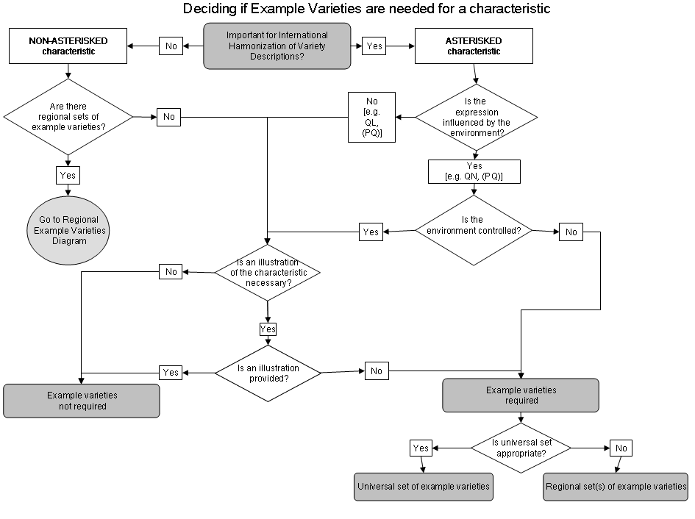
Flow Diagram 2
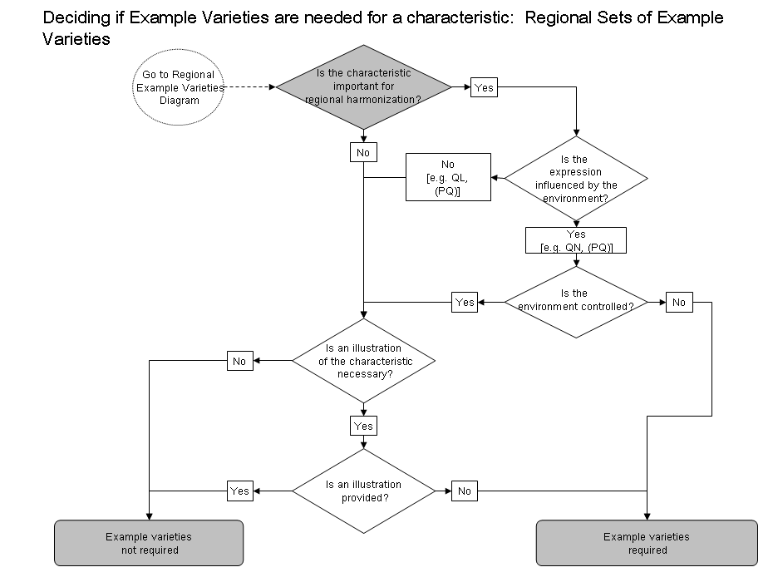

4.3. Multiple sets of example varieties

4.1 Introduction

4.1.1 The General Introduction states that “Different groups of varieties within a species can be dealt with in separate or subdivided Test Guidelines if the categories can be reliably separated on the basis of characteristics suitable for distinctness, or where an appropriate procedure has been developed to ensure that all varieties of common knowledge will be adequately considered for distinctness.”

4.1.2 This explanation is provided to ensure that groups or types of varieties are only created where it is possible to ensure that a variety will be clearly placed into the appropriate group or, if not, that other measures are taken to ensure that all varieties of common knowledge are considered for distinctness. Thus, if the example varieties in the Test Guidelines cover only a group, or type, within a species, the Test Guidelines should explain which characteristics, or what other basis, ensure distinctness of all the varieties of one type of variety from all the varieties of the other types.

4.2.3.1 Presentation of Regional Sets of Example Varieties

4.2.3.1.1 The existence of multiple sets of example varieties means that, for some or all characteristics, no example varieties are presented in the Table of Characteristics and the multiple sets of example varieties are presented in an annex available on the UPOV Website which is presented as follows:

 | Region A
Example varieties | Ch. 1 | Ch. 2 | Ch. 3 | Ch. 4 | Ch. 5 | etc.
Variety A | 3 | 1 | 3 |  | 3
Variety B | 5 | 2 | 7 | 1 | 1
Variety C | 7 | 3 | 5 | 9 | 2
Variety D |  | 4 |  |  | 4
etc.

 | Region B
Example varieties | Ch. 1 | Ch. 2 | Ch. 3 | Ch. 4 | Ch. 5 | etc.
Variety I | 3 | 4 | 5 |  | 1
Variety II | 5 | 2 | 3 | 1 | 2
Variety III | 7 | 1 | 7 | 9 | 3
Variety IV |  | 3 |  |  | 4
etc.

4.2.3.1.2 Even where the “example variety” column is empty (i.e. there are no universal example varieties for any characteristic), the column is retained in the Table of Characteristics to allow users to complete this with the appropriate example varieties.

4.3.2 Different types of variety

4.3.2.1 If it is not possible, with a single set of example varieties, to describe all the types of varieties (e.g. winter-types and spring-types) covered by the same Test Guidelines, they may be subdivided to create different sets of example varieties.

4.3.2.2 Where different sets of example varieties are provided for different types of varieties covered by the same Test Guidelines, they are placed in the Table of Characteristics in the same column as normal. The two sets of example varieties (e.g. winter and spring) are separated by a semicolon, with a key provided for each set and an explanation included in the legend of chapter 6 of the Test Guidelines.

Example: For certain characteristics, different example varieties are indicated for winter type and spring type varieties. These types are separated by a semicolon, with the winter types placed before the semicolon and prefixed by “(w)” and the spring types placed after the semicolon and prefixed by “(s)”.

 | Stage/  Stade/  Stadium/  Estado | English | français | deutsch | español | Example Varieties/  Exemples/  Beispielssorten/  Variedades ejemplo | Note/  Nota
7.  (*)  (+) | 75-92  MG/MS | Plant: length | Plante: port | Pflanze: Wuchsform | Planta: porte
 |  | short | courte | kurz | corta | (w) Variety A, Variety C; (s) Alpha | 3
 |  | medium | moyenne | mittel | media | (w) Variety B; (s) Beta | 5
 |  | long | longue | lang | larga | (s) Gamma | 7

1.4. Purpose of example varieties

The General Introduction (Chapter 4.3) states that “example varieties are provided in the Test Guidelines to clarify the states of expression of a characteristic.” This clarification of the states of expression is required with respect to two aspects:

(a) to illustrate the characteristic and/or

(b) to provide the basis for ascribing the appropriate state of expression to each variety and, thereby, to develop internationally harmonized variety descriptions.

1.4.1 Illustration of a characteristic

Although example varieties have the benefit of enabling examiners to see a characteristic in “real life”, in many cases, the illustration of a characteristic by photographs or drawings (to be provided in chapter 8 of the Test Guidelines) may provide a clearer illustration of the characteristic. Furthermore, the difficulty in selecting suitable example varieties, which satisfy all the requirements in Section 2 below, means that photographs or drawings are an important alternative or addition to example varieties as a means of illustrating characteristics.

1.4.2 International Harmonization of Variety Descriptions

1.4.2.1 The main reason why example varieties are used in place of, for example, actual measurements is that measurements can be influenced by the environment. The following hypothetical and simplistic example has been created to demonstrate why example varieties are superior to absolute measurements in this respect.

Example: Characteristic to be examined: Leaf length

1.4.2.2 Figure 1 compares the results for a candidate variety “X” from DUS growing trials in country A and country B:

Figure 1

(a) Example varieties in the Test Guidelines

1.4.2.3 Example varieties are important to adjust the description of the characteristics for the year and location effects, as far as possible. Thus, using the relative scale provided by the example varieties, it can be seen that the example variety Beta measured 10 cm in Country A and 15 cm in Country B, but in both locations demonstrates the state of expression “medium”. On this basis, candidate variety X would be considered to have a medium length leaf in both Countries A and B.

 | Example Varieties | Note
Leaf: length of blade
short | Alpha | 3
medium | Beta | 5
long | Gamma | 7

(b) Fixed measurements in the Test Guidelines

1.4.2.4 If absolute measurements were to be indicated in the Test Guidelines and the Test Guidelines were drafted in Country A on the basis of the data from Figure 1, the Table of Characteristics would show the following:

 | Length | Note
Leaf: length of blade
short | 5 cm | 3
medium | 10 cm | 5
long | 15 cm | 7

1.4.2.5 Because there is no “relative scale” provided by the example varieties, the same data as for Figure 1 would lead to the following descriptions:

 | Country A | Country B
Variety X | 10 cm  (medium: note 5) | 15 cm  (long: note 7)

1.4.2.6 Thus, if absolute measurements were used in the Test Guidelines, variety X, when grown in Country A, would be described as “medium (note 5)”, but if grown in Country B, would be described as “long (note 7)”. This demonstrates that it could be very misleading to compare descriptions from different locations on the basis of absolute measurements, without the adjustment for year or location effects provided by example varieties.

1.4.2.7 Nevertheless, because of the possibility of particular interactions between the variety genotype and location (e.g. influence of photoperiod), it should not be assumed that descriptions developed in different countries or locations using the same set of example varieties will be the same (see also section 2.2). Guidance on the scope for comparison of varieties on the basis of descriptions produced in different locations is provided in document TGP/9, Examining Distinctness.

[End of Annex and of document]

