 |  | E  TC-EDC/Jan13/20  ORIGINAL: English  DATE: December 19, 2012
INTERNATIONAL UNION FOR THE PROTECTION OF NEW VARIETIES OF PLANTS
Geneva
enlarged editorial Committee
Geneva, January 9 and 10, 2013
Revisions of existing Sections of document TGP/14:
Section 2: Botanical Terms, Subsection 2: Shapes and Structures
Document prepared by the Office of the Union
1 The purpose of this document is a report on developments concerning the items approved by the Technical Committee for consideration in the future revision of document TGP/14 Section 2: Botanical Terms, Subsection 2: Shapes and Structures (document TGP/14/2) (see document TC/48/22 “Report on the conclusions”, paragraphs 70 to 75).

2 The structure of this document is as follows:
SECTION 2: BOTANICAL TERMS: SUBSECTION 2: SHAPES AND STRUCTURES: I. SHAPE 2
1. Components of Shape: states of expression for ratios 2
Conclusions of the Technical Committee in 2012 2
Comments of the Technical Working Parties in 2012 2
Proposal 3
2. Developing Shape-Related Characteristics: avoidance of duplication of characteristics 3
Conclusions of the Technical Committee in 2012 3
Comments of the Technical Working Parties in 2012 3
Proposal 4
3. Developing Shape-Related Characteristics: perspective from which to observe plant shapes 4
Conclusions of the Technical Committee in 2012 4
Comments of the Technical Working Parties in 2012 4
Proposal 5
SECTION 2: BOTANICAL TERMS: SUBSECTION 2: SHAPES AND STRUCTURES: III. definitions for shapes and structure terms 5
1. Definition for Botanical Terms 5
Conclusions of the Technical Committee in 2012 5
Comments of the Technical Working Parties in 2012 5
Proposal 6
ANNEX I: PROPOSED TEXT for REVISION OF TGP 14 – Section 2: Botanical Terms: Subsection 2: Shapes and Structures: I. SHAPE: Section 1
ANNEX II: PROPOSED TEXT for INCLUSION IN TGP 14- Section 2: Botanical Terms: Subsection 2: Shapes and Structures: I. SHAPE: Section 2
ANNEX III: PROPOSED TEXT for REVISION OF TGP/14: Section 2: Botanical Terms: Subsection 2: Shapes and Structures: I Shape: 2. DEVELOPING SHAPE –RELATED CHARACTERISTICS, New Section
ANNEX IV: PROPOSED TEXT for REVISION OF TGP/14: Section 2: Botanical Terms: Subsection 2: Shapes and Structures: III. Definitions for Shape and Structure Terms

3 The following abbreviations are used in this document:
CAJ: Administrative and Legal Committee
TC: Technical Committee
TC-EDC: Enlarged Editorial Committee
TWA: Technical Working Party for Agricultural Crops
TWC: Technical Working Party on Automation and Computer Programs
TWF: Technical Working Party for Fruit Crops
TWO: Technical Working Party for Ornamental Plants and Forest Trees
TWV: Technical Working Party for Vegetables
TWPs: Technical Working Parties

SECTION 2: BOTANICAL TERMS: SUBSECTION 2: SHAPES AND STRUCTURES: I. SHAPE

1. Components of Shape: states of expression for ratios

Conclusions of the Technical Committee in 2012

4 With regard to the use of characteristics for ratios, the TC, at its forty-eighth session, agreed that it should be possible to use states such as “high” or “low”, provided that explanations and illustrations were provided to avoid any risk of confusion. It also agreed that it should be possible to use states such as “elongated” and “compressed” for characteristics that were worded as shapes, rather than ratios (see document TC/48/22 “Report on the Conclusions”, paragraph 74).

Comments of the Technical Working Parties in 2012

5 At their sessions in 2012, the Technical Working Parties received a draft for a proposed text for revision of TGP/14 – “Section 2: Botanical Terms: Subsection 2: Shapes and Structures: I. SHAPE: Section 1”, prepared by experts from Denmark, Germany and the United Kingdom, as presented in documents TWO/45/27, TWA/41/27, TWC/30/27, TWF/43/27 and TWV/46/27.

6 The Technical Working Parties in 2012, made the following comments:

 | With regard to revision of “components of shape: states of expression for ratios” the TWA recommended that it would be more appropriate to use the states small to large in place of low to high when considering ratio: length/width. If the characteristic ratio: length/ width was presented as shape, then the states would be compressed to elongated (see document TWA/41/34 “Report”, paragraph 56). | TWA
 | The TWV highlighted that the use of length, width and ratio could be useful in certain cases, if appropriate (see document TWV/46/41 “Report”, paragraph 48). | TWV
 | With regard to revision of “components of shape: states of expression for ratios”, the TWV recommended that it would be more appropriate to use the states “very low to very high” in place of “very high to very low” when considering ratio: length/width. If the characteristic ratio: length/width was presented as shape, then the states would be “very compressed to very elongated” in place of “very elongated to very compressed” (see document TWV/46/41 “Report”, paragraph 49). | TWV
 | With regard to revision of “components of shape: states of expression for ratios”, the TWF:  - appreciated that their earlier proposal to have all states from “compressed to elongated” had been agreed upon by other TWPs;  - requested that the changes proposed be consistently updated throughout document TGP/14;  - proposed that the ratio diameter/height be changed to ratio length/width to be consistent throughout document TGP/14.  (see document TWF/43/38 “Report”, paragraph 42). | TWF
 | With regard to revision of “Components of shape: states of expression for ratios”, the TWO agreed with the recommendations of the TWF and TWV that it would be more appropriate to use the states “very low to very high” in place of “very high to very low” when considering ratio: length/width. If the characteristic ratio: length/width was presented as shape, then the states would be “very compressed to very elongated” in place of “very elongated to very compressed”, with the appropriate explanation (see document TWO/45/37 “Report”, paragraph 42). | TWO
para. 1.3 | With regard to Section 2: paragraph 1.3, the TWF requested further elaboration on the definition for “base”, providing an example, indicating the precise orientation of base (see document TWF/43/38 “Report”, paragraph 43). | TWF
para 1.5 | With regard to revision of “Components of shape: states of expression for ratios”, the TWO proposed to amend the spelling of the word “length” in paragraph 1.5 in Annex III to document TWO/45/27 (see document TWO/45/37 “Report”, paragraph 43). | TWO

Proposal

7 Proposals for the revision of document TGP/14 in “Section 2: Botanical Terms: Subsection 2: Shapes and Structures: I. SHAPE”, with regard to clarification of the use of characteristics for ratio are presented in Annex I. The amendments to the text considered by the TWPs at their sessions in 2012 are indicated by highlighting and strikethrough for deletions and highlighting and underlining for additions.

2. Developing Shape-Related Characteristics: avoidance of duplication of characteristics

Conclusions of the Technical Committee in 2012

8 The TC at its forty eighth session held in Geneva from March 26 to 28, 2012, welcomed the study concerning “Examination of the use component and composite characters for determining distinctness”, prepared by experts from Denmark, Germany and the United Kingdom, as presented in the Annex I. The TC agreed that guidance, based on that study, should be prepared for the TWPs sessions in 2012, by the experts from Germany, Denmark and the United Kingdom (see document TC/48/22 “Report on the Conclusions”, paragraph 75).

Comments of the Technical Working Parties in 2012

9 At their sessions in 2012, the Technical Working Parties received a draft for a proposed text prepared by experts from Denmark, Germany and the United Kingdom to be included in TGP/14: Section 2: Botanical Terms: Subsection 2: Shapes and Structures: I. Shape: Section 2 new paragraph 2.9 – “Use of composite characteristics for determining distinctness and uniformity”, as presented in documents TWO/45/27, TWA/41/27, TWC/30/27, TWF/43/27 and TWV/46/27.

10 The Technical Working Parties in 2012, made the following comments:

The TWA considered the guidance on use of composite characteristics for determining distinctness and uniformity contained in Annex V to document TWA/41/27. The TWA agreed that the presented method was useful and recommended its inclusion in document TGP/14 (see document TWA/41/34 “Report”, paragraph 57). | TWA
The TWV agreed with the proposal of the TWA that the guidance on use of composite characteristics for determining distinctness and uniformity contained in Annex V to document TWA/41/27 was useful and recommended its inclusion in document TGP/14 (see document TWV/46/41 “Report”, paragraph 50). | TWV
With regard to the guidance on use of composite characteristics for determining distinctness and uniformity contained in the Annex V to document TWC/30/27, the TWC suggested that the heading of the second bullet point should read “provide additional information over that of its components” (see document TWC/30/41 “Report”, paragraph 60). | TWC
The TWO agreed on the usefulness of the guidance on use of composite characteristics for determining distinctness and uniformity contained in the Annex V to document TWO/43/27 and noted that length/width and ratios were frequently used in the field of ornamentals and fruit trees (see document TWO/45/37 “Report”, paragraph 44). | TWO

Proposal

11 On the basis of the comments made by the TWPs, the proposed text to be included in TGP 14: “Use of Composite Characteristics for Determining Distinctness and Uniformity”, is presented in Annex II. The amendments to the text considered by the TWPs at their sessions in 2012 are indicated by highlighting and strikethrough for deletions and highlighting and underlining for additions.

3. Developing Shape-Related Characteristics: perspective from which to observe plant shapes

Conclusions of the Technical Committee in 2012

12 The TC at its forty eighth session held in Geneva from March 26 to 28, 2012, recalled that it had agreed to recommend that, where appropriate, an explanation for shape characteristics should provide guidance on the perspective from which to observe the shape (see document TC/48/22 “Report on the Conclusions”, paragraph 71).

Comments of the Technical Working Parties in 2012

13 At their sessions in 2012, the Technical Working Parties received a draft for a proposed text prepared by experts from Denmark, Germany and the United Kingdom, for revision of TGP/14: “Section 2: Botanical Terms: Subsection 2: Shapes and Structures: I Shape: 2. Developing Shape –Related Characteristics, New Section”, as presented in documents TWO/45/27, TWA/41/27, TWC/30/27, TWF/43/27 and TWV/46/27.

14 The Technical Working Parties in 2012, made the following comments:

The TWA agreed with the proposed text in Annex I to document TWA/41/27 concerning the perspective from which to observe plant shapes (see document TWA/41/34 “Report”, paragraph 54). | TWA
With regard to Section 2: paragraph 2.8 perspective from which to observe plant shapes, the TWF agreed with the text in Annex I and proposed to add examples and explanations in TGP/14. Experts from Mexico and New Zealand would provide information. (see document TWF/43/38 “Report”, paragraph 39). | TWF
With regard to Section 2: paragraph 2.8 “Perspective from which to observe plant shapes”, the TWO agreed with the text as set out in Annex I of document TWO/45/27, paragraph 2.8, as follows: “Where appropriate, an explanation of the perspective from which to observe the shape should be included in the Test Guidelines.” (See document TWO/45/37 “Report” paragraph 40). | TWO

Proposal

15 On the basis of the comments made by the TWPs, the proposed text for revision of TGP/14: Section 2: Botanical Terms: Subsection 2: Shapes and Structures: I SHAPE: 2. developing shape –related characteristics, New Section, is presented in Annex III. The amendments to the text considered by the TWPs at their sessions in 2012 are indicated by highlighting and strikethrough for deletions and highlighting and underlining for additions.

SECTION 2: BOTANICAL TERMS: SUBSECTION 2: SHAPES AND STRUCTURES: III. definitions for shapes and structure terms

1. Definition for Botanical Terms

Conclusions of the Technical Committee in 2012

16 With regard to a future revision of TGP/14 “Glossary of Terms Used in UPOV Documents”, Section 2: Botanical Terms: Subsection 2: Shapes and Structures: I. Shape: II. Structure: Section 2.4, the TC, at its forty eighth session held in Geneva from March 26 to 28, 2012, agreed that additional definitions for botanical terms, such as for peduncle and petiole, should be added to document TGP/14 where the provision of such definitions would help to avoid confusion. However, it confirmed that this should not result in a change to the explanation in document TGP/14/1 that “In general, the meaning of botanical terms which are used in the Test Guidelines to indicate the relevant part of the plant to be examined, but which are not themselves used as states of expression (e.g. bract, petal, berry, etc.), do not require a UPOV specific definition and are not included in this document” (see document TC/48/22 “Report on the Conclusions”, paragraph 72).

17 The TC, at it session in 2012, agreed the following definition of “spike” for inclusion in a future revision of document TGP/14/1: Section 2: Botanical Terms: Subsection 2: Shapes and Structures: III. Definitions for Shape and Structure Terms (see document TC/47/26 “Report on the Conclusions”, paragraphs 81 to 83):

Spike | an indeterminate inflorescence with sessile flowers on an unbranched axis.

Comments of the Technical Working Parties in 2012

18 At their sessions in 2012, the Technical Working Parties received a draft for a proposed text prepared by experts from Denmark, Germany and the United Kingdom to be included in Tgp/14: Section 2: Botanical Terms: Subsection 2: Shapes and Structures: III. Definitions for shape and structure terms”, as presented in documents TWO/45/27, TWA/41/27, TWC/30/27, TWF/43/27 and TWV/46/27.

19 The Technical Working Parties in 2012, made the following comments:

 | The TWA agreed with the proposed definitions for peduncle, pedicel, petiole and petiolule and recommended to check translation of these terms (see document TWA/41/34 “Report”, paragraph 55). | TWA
 | The TWV proposed to amend the definitions of peduncle, pedicel, main stem, as set out in Annex II to document TWV/46/27, as follows (see document TWV/46/41 “Report”, paragraph 46): | TWV
Terms
Peduncle | A stem supporting a solitary flower or fruit, or an inflorescence, or supporting an infructescence after fecundation. | TWV
 | The TWF proposed to read “Pedúnculo” in the Spanish translation for “Peduncle”. (see document TWF/43/38 “Report”, paragraph 40). | TWF
 | With regard to Section 2: “Definition for Botanical Terms”, the TWO proposed to maintain the original definition for “Peduncle” as set out in Annex II of document TWO/45/27 with the following amendment: “A stem supporting an inflorescence or supporting an infructescence after fecundation.” (See document TWO/45/37 “Report”, paragraph 41). | TWO
Pedicel | A stem which attaches single flowers or fruits to the main stem peduncle of the inflorescence or infructescence. | TWV
 | The TWF requested clarification on the term “single flowers”. (see document TWF/43/38 “Report”, paragraph 41). | TWF
Petiole | A stalk attaching the leaf blade to the stem. | TWV
Petiolule | A stalk of any of the leaflets making up a compound leaf. | TWV
 | The TWF proposed to read “Peciolulo” in the Spanish translation and “Blattfiederstiel” in the German translation for “Petiolule”. (see document TWF/43/38 “Report”, paragraph 40). | TWF

Proposal

20 On the basis of the comments made by the TWPs, the proposed text for revision of “TGP/14 Section 2: Botanical Terms: Subsection 2: Shapes and Structures: III. Definitions for Shape and Structure Terms”, is presented in Annex IV. The amendments to the text considered by the TWPs at their sessions in 2012 are indicated by highlighting and strikethrough for deletions and highlighting and underlining for additions.

[Annexes follow]

PROPOSED TEXT for REVISION OF TGP 14 – Section 2: Botanical Terms: Subsection 2: Shapes and Structures: I. SHAPE: Section 1

I. Shape

1. Components of Shape

1.1 Document TG/1/3 “General Introduction to the Examination of Distinctness, Uniformity and Stability and the Development of Harmonized Descriptions of New Varieties of Plants” (General Introduction) explains that shape can be considered in terms of a pseudo-qualitative characteristic:

“4.4.3 Pseudo-Qualitative Characteristics

“In the case of ‘pseudo-qualitative characteristics’, the range of expression is at least partly continuous, but varies in more than one dimension (e.g. shape: ovate (1), elliptic (2), circular (3), obovate (4)) and cannot be adequately described by just defining two ends of a linear range. In a similar way to qualitative (discontinuous) characteristics – hence the term ‘pseudo-qualitative’ – each individual state of expression needs to be identified to adequately describe the range of the characteristic.”

However, document TGP/9 “Examining Distinctness” explains that the use of pseudo-qualitative characteristics for the assessment of distinctness on the basis of notes has particular limitations (see document TGP/9/1, Section 5.2.3):

“Pseudo-qualitative (PQ) characteristics

“[…]

“5.2.3.2.2.1 […] However, an important additional factor with pseudo-qualitative characteristics is that, whilst a part of the range is continuous, there is not an even distribution across the scale and the range varies in more than one dimension (e.g. shape: ovate (1), elliptic (2), circular (3), obovate (4): there is a variation in the length/width ratio and in the position of the widest point). This means that it is difficult to define a general rule on the difference in Notes to establish distinctness within a characteristic.”

1.2 Therefore, for the purposes of DUS examination, it can be useful to develop quantitative or qualitative characteristics related to shape, rather than considering shape as a single pseudo-qualitative characteristic. In that respect, it is possible to define a plane shape using the following components:

(a) Ratio length/width (or ratio width/length)
(used as a generic term in this document to cover also ratio: thickness/length; diameter/length; thickness/width, for cross-sections of 3 dimensional shapes)
(b) Position of broadest part
The broadest part may be a point (e.g. for a circle) or, in cases where the sides are parallel (e.g. for an oblong), the broadest part is situated along a length. In cases where the broadest part is not a precise point, the position of the broadest part is considered to be the mid-point along the broadest part. For example:
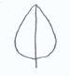
position of broadest part
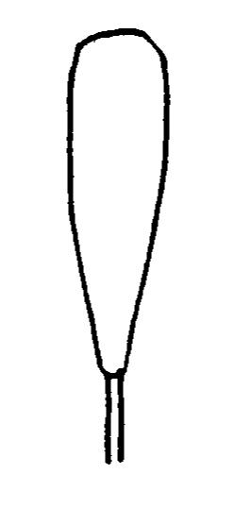
x

x

x

position of broadest part (mid-point of length of broadest part)
(c) Shape of base (see Section 2.3 Base Shape Characteristics);
(d) Shape of apex (see Section 2.4 Apex/Tip Shape Characteristics);
(e) Lateral outline.

[1.3 The apex (apical or distal part) of an organ or plant part is the end furthest from the point of attachment. The base (proximal part) of a plant part is the end nearest to the point of attachment. However, it should be noted that the illustrations of shapes in the Test Guidelines might not always be orientated with the point of attachment (base) at the bottom if that is not the natural orientation of the organ on the plant.
Base
Apex
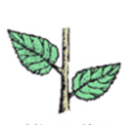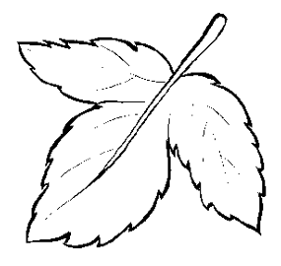

1.4 The shape of base and shape of apex are considered in Sections 2.3 and 2.4 respectively. The chart below (Chart for Simple Symmetric Plane Shapes) illustrates the other three components for simple symmetric plane shapes (those for which the angle at the base and at the apex does not exceed 180°) as follows:

(a) Ratio length/width (or ratio width/length): the ratio length/width varies from left to right within a row, but is approximately the same within a column;
(b) Position of broadest part: the position of the broadest part varies from row to row, but is approximately the same in each row;
(c) Lateral outline: the shape of the lateral sides varies from set to set, but is approximately the same within a set.

1.5 To ensure that the ratio length/width is clearly understood, it is recommended to use meaningful present the characteristic as a shape with states such as “very elongated“ to “very compressed”, or to present the characteristic as “ratio legth length/width” with states such as “very high low” to “very low high” and to provide an illustration rather than states such as “very high”. To avoid confusion concerning the absolute dimensions, it is recommended to avoid the use of terms such as “narrow“ and “broad“ for ratio length/width, particularly where characteristics for the absolute dimensions are also included for the same plant part. The terms associated with certain length/width ratios used in the Chart for Simple Symmetric Plane Shapes are only intended to illustrate the use of ratio length/width. In the Test Guidelines, the use of terms such as “[very/moderately/slightly] low (elongated)” and “[very/moderately/slightly] high (compressed)“ will need to be determined according to the range of expression for the characteristic concerned.

Chart for Simple Symmetric Plane Shapes

shape |  |  | very elongated | moderately elongated | slightly elongated | medium | slightly compressed | moderately compressed | very compressed
ratio length/width |  |  | very low | low | Low to medium | medium | medium to high | high | very high
Parallel set
oblong | 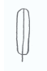 |  | 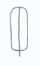 | 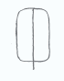 | 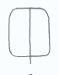 | 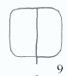 | 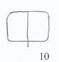 | 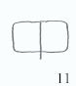 | 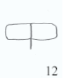
Rounded set
ovate | 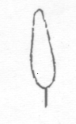 |  | 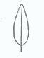 | 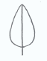 |  | 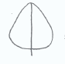 | 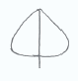 | 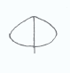 | 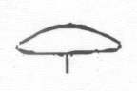
elliptic | 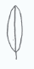 |  | 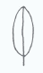 | 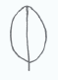 | 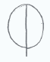 | 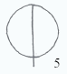 | 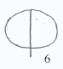 | 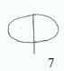 | 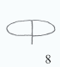
obovate | 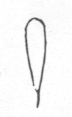 |  | 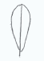 | 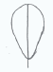 | 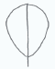 | 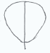 | 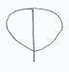 | 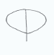 | 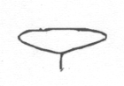
Angular set
triangular | 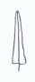 | 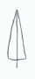 |  | 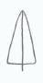 | 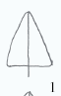 | 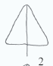 | 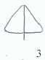 | 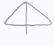 | 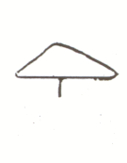
trullate | 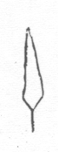 | 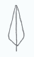 |  | 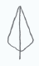 | 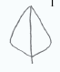 | 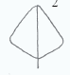 | 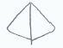 | 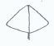 | 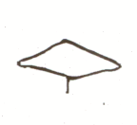
rhombic | 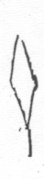 | 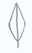 |  | 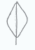 | 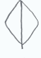 | 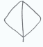 | 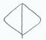 | 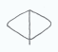 | 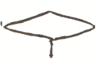
obtrullate | 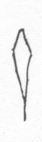 | 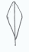 |  | 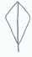 | 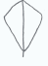 | 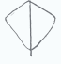 | 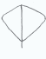 | 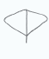 | 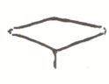
obtriangular | 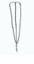 | 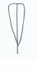 |  | 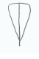 | 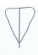 | 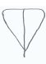 | 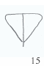 | 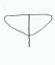 | 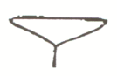

1 (narrow deltate) 9 square
2 (medium deltate) 10 transverse broad oblong
3 (broad deltate) 11 transverse medium oblong
4 (quadrate rhombic) 12 transverse narrow oblong
5 circular 13 (narrow obdeltate)
6 narrow oblate 14 (medium obdeltate)
7 medium oblate 15 (broad obdeltate)
8 broad oblate

Notes

Parallel set: the lateral sides are more or less straight over most of their length and more or less parallel to the main axis (The leaves of most of the monocotyledons belong in this group.)

Rounded set: the lateral sides are rounded in a single, sweeping curve, without sudden changes of direction (The leaves of most of the dicotyledons belong in this group.)

Angular set: the lateral sides are somewhat bent at a certain point, resulting in a change of direction, combined with a somewhat straightening towards the base and apex from that point and more or less forming two triangles joined at the longitudinal axis.

1.6 The following chart (Chart for Other Plane Shapes) illustrates some other common plane shapes:

Chart for Other Plane Shapes

For each of the shapes below, ranges for ratio length/width (or ratio width/length) and position of broadest part can be developed, in a similar way to that shown in the Chart for Simple Symmetric Plane Shapes (Section 1.5).

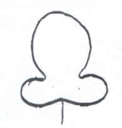 | 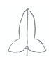 | 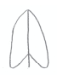 | 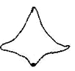
auriculiform | hastiform | sagittate | alate | trapezoidal

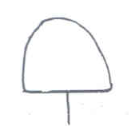 | 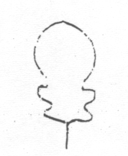 | 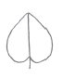 | 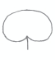 | 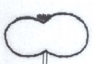
flabellate  (fan shape) | lyrate | cordiform | reniform | lemniscate

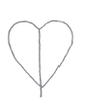 | 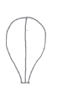 | 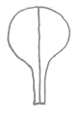 | 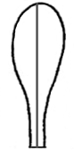 | 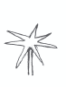
obcordiform | spatulate | clawed | clavate | stellate

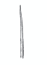 | 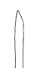 | 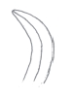 | 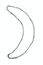
acicular | subulate | falcate | lunate

2. Developing Shape-Related Characteristics

2.1 Introduction

2.1.1 In general, it can be most useful to consider the variation in shape between varieties in the variety collection using the following steps:

Step 1: Ratio length/width (or ratio width/length) (see Section 1 Components of Shape);
Step 2: Position of broadest part (see Section 1 Components of Shape);
Step 3: Shape of base (see Section 2.3 Base Shape Characteristics);
Step 4: Shape of apex (see Section 2.4 Apex/Tip Shape Characteristics);
Step 5: Lateral outline (see Section 1 Components of Shape).

Thus, if all the variation in shape between varieties in the variety collection is accounted for by the ratio length/width (e.g. narrow elliptic, medium elliptic or broad elliptic), it is only necessary to have a characteristic “ratio length/width” (or ratio width/length). Similarly, if all the variation in shape between varieties in the variety collection is accounted for by ratio length/width and position of broadest part (e.g. all varieties fall within the rounded set in the Chart for Simple Symmetric Plane Shapes) it is only necessary to have the characteristics “ratio length/width” (or ratio width/length) and “position of broadest part”. It is only necessary to go to subsequent steps when the variation in shape between varieties in the variety collection has not been accounted for by the preceding steps/components. Duplication of the same difference in two separate characteristics should be avoided: for example, the use of characteristics for both ratio length/width and for shape should be avoided where states of expression of the characteristic for shape relate to different length/width ratios.

2.1.2 In general, where shape characteristics are developed on the basis of the individual components above, it is appropriate to present the characteristics in the order of the steps 1 to 5. However, a particular exception to this approach should be made where a qualitative characteristic is identified. Qualitative characteristics should be presented as the first of the series of shape-related characteristics because of the value of such characteristics for assessing distinctness and because the examination of subsequent shape-related characteristics may not be relevant for varieties with certain states of expression for the qualitative characteristic. For example, “Only varieties with Leaf lateral outline: ovate: Leaf: ratio length/width (or ratio width/length)” might be appropriate if the preceding characteristic for “Leaf: lateral outline” was qualitative, e.g. ovate (1); hastiform (2) and there was no useful variation in ratio length/width for hastiform varieties.

2.1.3 Notwithstanding the difficulty in using a difference in Notes to establish distinctness for a pseudo-qualitative characteristic (see Section 1), it may be appropriate to develop a single pseudo-qualitative characteristic for shape. In such cases, it is important that the difference between the states of expression is indicated in an illustration. The illustration should, as far as possible, place the states with the least difference closest together, regardless of their notes, e.g. the illustrations for notes 1 and 5 might be positioned side-by-side and notes 2 and 4 might be further apart. Where the overall shape is presented as a single pseudo-qualitative characteristic, the order of states should be: primary order, broadest part below middle to broadest part above middle; secondary order, narrow to broad (high to low ratio length/width) (see Section 2.2, Example 5, Alternative 2).

2.2 Full plane shape characteristics

The following illustrations provide examples of variation in full plane shape components (ratio length/width, position of broadest part and lateral outline) for the development of characteristics, either as characteristics for the individual components or as a single overall shape characteristic:
Example 1 (a circle indicates the shape of one or more varieties in the variety collection)

The only variation between varieties is found in the ratio length/width.

Parallel set
oblong
Rounded set
ovate
elliptic
obovate

Possible characteristic(s) (Example 1)

Alternative 1

Plant [part]: ratio length/width (elongated to compressed) (QN)

Alternative 2

Plant [part]: shape (narrow obovate (1); medium obovate (2); broad obovate (3)) (QN)
with the following illustration
Alternative 1: | ratio length/width: elongated low | ratio length/width: medium | ratio length/width: compressed high
Alternative 2: | 1  Shape: narrow obovate | 2  Shape: medium obovate | 3  Shape: broad obovate
Example 2 (a circle indicates the shape of one or more varieties in the variety collection)

The only variation between varieties is found in the position of the broadest part.

Parallel set
oblong
Rounded set
ovate
elliptic
obovate

Possible characteristic(s) (Example 2)

Alternative 1

Plant [part]: position of broadest part (towards base to towards apex) (QN)

Alternative 2

Plant [part]: shape (ovate (1); elliptic (2); obovate (3)) (QN)
with the following illustration
broadest part towards base | broadest part at middle | broadest part towards apex
1  ovate | 2  elliptic | 3  obovate
Example 3 (a circle indicates the shape of one or more varieties in the variety collection)

There is variation between varieties in the ratio length/width (or ratio width/length), the shape of the base and the lateral outline. The lateral outline varies between ovate and trullate.

Rounded set
ovate
elliptic
obovate
Angular set
triangular
trullate
rhombic |  |  |  |  |  | 4

Possible characteristic(s) (Example 3)

Alternative 1

Plant [part]: ratio length/width (elongated to compressed) (QN)
Plant [part]: shape of base (acute, obtuse, rounded) (PQ)
Plant [part]: lateral outline (clearly rounded to clearly triangular) (QN)

Alternative 2

Plant [part]: shape (narrow trullate (1); narrow ovate (2); medium trullate (3); medium ovate (4); broad ovate (5)) (PQ)

with the following illustration

 |  | narrow | ←→ | broad
triangular outline
←→ |  | 1  narrow trullate | 3  medium trullate
rounded outline
 |  | 2  narrow ovate | 4  medium ovate | 5  broad ovate

Example 4

There is variation between varieties in the ratio diameter/height height/diameter, position of broadest part and the lateral outline in the apical half. The lateral outline varies between ovate and trullate.

 |  | ratio diameter/height height/diameter
 | lateral outline in apical half  (Notes) | elongated low  (3) | medium  (5) | compressed high  (7) | position of broadest part  (Notes)
cylindrical waisted | concave (4) | 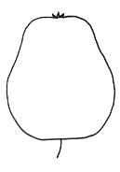 | 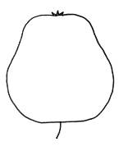 | 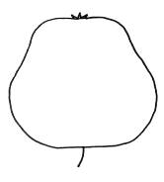 | at middle (1); moderately towards base (2); or strongly towards base (3)
conic | flat taper (3) | 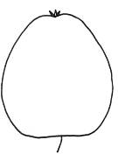 | 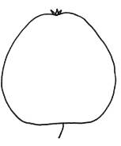 | 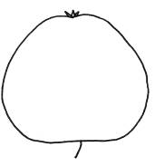 | at middle (1); moderately towards base (2); or strongly towards base (3)
ovoid | rounded (1) | 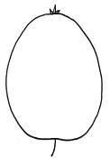 | 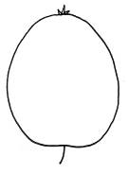 | 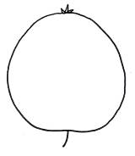 | moderately towards base (2); or strongly towards base (3)
cylindrical | parallel (2) | 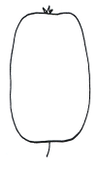 | 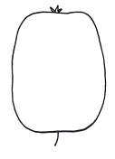 | 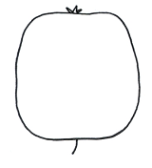 | at middle (1)
ellipsoid | rounded (1) | 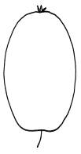  (elliptic) | 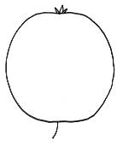  (round) | 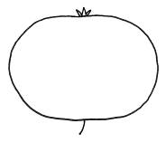  (oblate) | at middle (1)

Possible characteristic(s) (Example 4)

Alternative 1

(a) ratio diameter/height height/diameter (QN):
e.g. very elongated low (1); moderately elongated low (3); medium (5); moderately compressed high(7); very compressed high (9);
(b) position of broadest part (QN):
e.g. at middle (1); moderately towards base (2); strongly towards base (3);
(c) lateral outline in apical half (PQ):
e.g. rounded (1); parallel (2); flat taper (3); concave (4)

Alternative 2

(a) ratio diameter/height height/diameter (QN):
e.g. very elongated low (1); moderately elongated low (3); medium (5); moderately compressed high (7); very compressed high (9)

(b) general shape (PQ):
e.g. cylindrical waisted (1); conic (2); ovate (3); cylindric (4); elliptic (5)

with the following illustration:

 |  | ← lateral outline in apical half →
 |  | concave | flat tapering | rounded | flat parallel sides
at base ← position of broadest part → at middle |  |  |  | 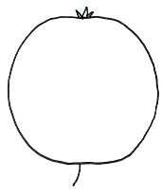  3  ovate
at base ← position of broadest part → at middle |  | 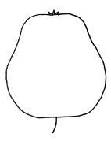 | 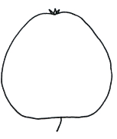
at base ← position of broadest part → at middle |  | 1  cylindrical waisted | 2  conic | 5  elliptic  (includes round and oblate) | 4  cylindric

Example 5

the variation between the range of shapes indicated by the illustrations below:

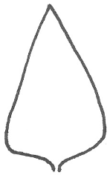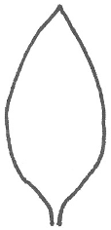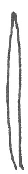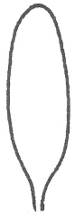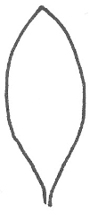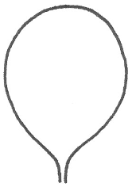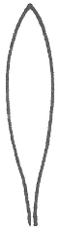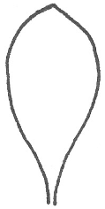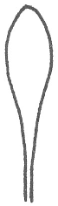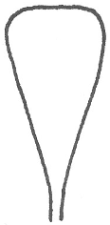

Possible characteristic(s) (Example 5)

Alternative 1

(a) ratio length/width (QN):
e.g. very elongated low (1); moderately elongated low (3); medium (5); moderately compressed high (7); very compressed high (9)

(b) position of broadest part (QN):
e.g. strongly towards base (1); moderately towards base (3); at middle (5); moderately towards apex (7); strongly towards apex (9)

Alternative 2

General shape (PQ): triangular (1); ovate (2); linear (3); oblong (4); elliptic (5); circular (6); oblanceolate (7); obovate (8); spatulate (9); obtriangular (10)
(Note: Where the overall shape is presented as a single pseudo-qualitative characteristic, the order of states should be: primary order, broadest part below middle to broadest part above middle; secondary order, narrow to broad (high to low ratio length/width)).

with the following illustration:

 |  | ← broadest part →
 |  | (below middle) | at middle | (above middle)

broad (compressed high)← width (ratio length/width) → narrow (elongated low) |  |  |  | 3  linear
 |  |  |  | 4  oblong | 7  oblanceolate | 9  spatulate
 |  | 1  triangular | 2  ovate | 5  elliptic | 8  obovate |  | 10 obtriangular
6
circular

Example 6

The variation between the range of shapes indicated by the illustrations below:
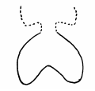 | 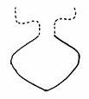 | 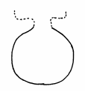 |  | 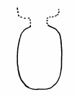

Possible characteristic(s) (Example 6)

Alternative 1

(a) lateral outline (QL)
e.g. reniform (1); rhombic (2); elliptic (3)
(b) ratio length/width (QN):
e.g. elongated low (1); medium (2); compressed high (3)

Alternative 2

General shape (PQ): reniform (1); rhombic (2); elliptic (3); circular (4); transverse elliptic (5)
with the following illustration:

compressed high ← ratio length/width → elongated low |  |  |  | 3  elliptic
compressed high ← ratio length/width → elongated low |  | 1  reniform | 2  rhombic | 4  circular
compressed high ← ratio length/width → elongated low |  |  |  | 5  transverse elliptic oblate

2.3 Base Shape Characteristics

2.3.1 As explained in Section 2.1, it is only necessary to develop a characteristic for the shape of base when the variation in shape between varieties in the variety collection has not been accounted for by the ratio length/width or the position of the broadest part concerning the full plant part.

2.3.2 In the same way as for plane shapes, whilst a base shape can be considered in terms of a pseudo-qualitative characteristic, it can be useful to develop quantitative or qualitative characteristics related to base shape, rather than considering shape as a single pseudo-qualitative characteristic. A particular example of this is the consideration of the angle of the base (e.g. as a quantitative characteristic) and the curvature at the base, an example of which is provided below for illustrations purposes.

Example

the variation between the range of base shapes indicated by the illustrations below

Possible characteristic(s)

Alternative 1

(a) angle of base (QN):
e.g. acute (1); obtuse (2); straight (180°) (3); weakly reflex (4); strongly reflex (5)
(b) curvature at base (QN):
e.g. concave (1); flat (2); convex (3)

Alternative 2

Shape of base (PQ): wedge-shaped, convex (1); wedge-shaped, straight (2); wedge-shaped concave (3); broad wedge-shaped, convex (4); broad wedge-shaped, straight (5); broad wedge-shaped, concave (6); rounded (7); flat (8); weakly cordate (9); medium cordate (10); strongly cordate (11).

with the following illustration:

 |  |  | ← angle at base →
 |  |  | acute | obtuse | straight | weakly reflexed | medium reflexed | strongly reflexed
→ | convex
 |  |  | 1  wedge-shaped, convex | 4  broad wedge-shaped, convex | 7  rounded | 9  weakly cordate | 10  medium cordate | 11  strongly cordate
curvature | flat
 |  |  | 2  wedge-shaped, straight | 5  broad wedge-shaped, straight | 8  flat
← | concave
 |  |  | 3  wedge-shaped concave | 6  broad wedge-shaped, concave

2.4 Apex/Tip Shape Characteristics

2.4.1 The APEX (apical or distal part) of an organ or plant part is the end furthest from the point of attachment.

2.4.2 In some cases, the distal extremity of the apex may be differentiated into a “TIP“. In such cases, the shape of the apex is taken as the general shape, excluding any differentiated tip (if present). For example:

Differentiated tip | 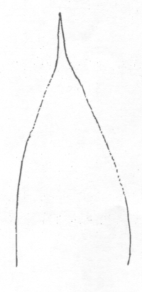
Apex
Differentiated tip: | acuminate | acuminate | acuminate
Apex: | acute | rounded | truncate

2.4.3 As explained in Section 2.1, it is only necessary to develop a characteristic for the shape of apex when the variation in shape between varieties in the variety collection has not been accounted for by the ratio length/width or the position of the broadest part concerning the full plant part.

2.4.4 In the same way as for plane shapes, whilst an apex shape can be considered in terms of a pseudo-qualitative characteristic, it can be useful to develop quantitative or qualitative characteristics related to apex shape, rather than considering shape as a single pseudo-qualitative characteristic. A particular example of this is the consideration of the angle of the apex (e.g. as a quantitative characteristic).

2.4.5 In cases where the tip is differentiated within the general shape of the apex, characteristics concerning the shape of the tip may be developed independently from those concerning the general shape of the apex. Different combinations between these two categories are possible, for example: a first characteristic for the general shape of the apex (e.g. acute, obtuse, rounded), together with a second characteristic for emargination at apex (absent, present), or apiculate tip (absent, present).

2.4.6 In the case of tip shapes, it may be more appropriate to have a simple characteristic such as length of tip, rather than using botanical terms. The only difference between mucronate and aristate is the length of the ‘tip’, the only difference between cuspidate and pungent is the length of the ‘tip’, and the only difference between emarginate and retuse is the angle and depth of the notch. These pairs can therefore also be quantified where applicable, by stating, for example, ‘length of tip’ or ‘depth of notch’, instead of using the specific botanical terms.
Example

the variation between the range of apex shapes indicated by the illustrations below

Possible characteristic(s)

Alternative 1

(a) angle of apex (excluding tip, if present) (QN):
e.g. strongly acute (1); moderately acute (2); right-angle (3); moderately obtuse (4); strongly obtuse (5)
(b) length of acuminate tip (QN):
e.g. absent or short (1); medium (2); long (3)

Alternative 2

(a) angle of apex (excluding tip, if present) (QN):
e.g. strongly acute (1); moderately acute (2); right-angle (3); moderately obtuse (4); strongly obtuse (5)

(b) tip (PQ): absent or very weak (1); mucronate (2); narrow short acuminate (3); broad short acuminate (4); narrow long acuminate (5); broad long acuminate (6)

with the following illustration:

 |  |  | ← length of tip →
 |  |  | absent or very weak | short | medium | long
← width of tip → | narrow |  | [see below]
← width of tip → |  |  | [see below] | 2  mucronate | 3  narrow short acuminate | 5  narrow long acuminate
← width of tip → | broad |  | [see below]
← width of tip → |  |  | [see below] |  | 4  broad short acuminate | 6  broad long acuminate

examples of tip: absent or very weak (1) with different angles of apex (characteristic (a)):

strongly acute apex | right-angle apex | obtuse apex

2.5 Combination of Full Plane-, Base- and Apex Shape Characteristics

The following example illustrates how the overall shape of an organ or plant part can be observed in relation to the components of shape explained in Sections 2.2 to 2.4.

Example

the range of shapes covered by the illustrations below

can be observed in relation to:

(a) ratio length/width (QN):
e.g. very elongated low (1); moderately elongated low (3); medium (5); moderately compressed high (7); very compressed high (9)
(b) position of broadest part (QN):
e.g. at middle (1); moderately towards base (2); strongly towards base (3);
(c) shape of base (QN/PQ):
e.g. pointed (1); rounded (2); depressed (3)
(d) shape of apex (QN/PQ):
e.g. pointed (1); rounded (2); truncate (3); notched (4)

The chart below illustrates how the different components cover the range of overall shapes. Such a chart is not appropriate in the Test Guidelines, although illustrations may be useful for the individual characteristics to clarify the parts to be observed.:

 | shape of base
shape of apex | pointed (1) |  | rounded (2) |  | depressed (3)
pointed (1)
rounded (2) |  |  | (ovate) | position of broadest part
rounded (2) |  | ratio length/width | (round) | position of broadest part
rounded (2) |  | ratio length/width | (oblate)
truncate (3)
notched (4)

2.6 Three-dimensional shape characteristics

Wherever possible, three-dimensional plant parts should be described in cross-section as plane or two-dimensional shapes (see Section 2.1: ratio length/width, position of broadest part, base, shape and lateral outline), e.g. using characteristics in cross-section, lateral view, longitudinal section, etc. To describe the three-dimensional shape fully it may also be necessary to use, for example, a characteristic for hollow or solid interior in addition to the characteristics describing the plane shape. The use of characteristics for three-dimensional shapes should only be used where it is not practical to describe the characteristic in a two-dimensional way.

2.7 Symmetry

2.7.1 Lateral symmetry around the main axis may be handled in different ways. For example:

(a) lateral symmetry of plant part shapes may be considered within a particular shape, e.g. falcate and lunate are laterally asymmetric (see Section 1.6); or

(b) it may be appropriate to introduce symmetry as a separate characteristic. In such cases, whether the characteristic for symmetry is a qualitative (symmetric / asymmetric), a quantitative (e.g. symmetric or weakly asymmetric (1), moderately asymmetric (2), strongly asymmetric (3)) or a pseudo-qualitative characteristic needs to be considered on a case-by-case basis.

Example:

quantitative characteristic for symmetry

symmetric or weakly asymmetric (1) | moderately asymmetric  (2) | strongly asymmetric  (3)

2.8 Shape: types of expression and states / notes

The type of expression (i.e. qualitative, quantitative or pseudo-qualitative) of the characteristics describing components of shape needs to be considered separately for each situation. In particular, as explained in document TGP/7 “Development of Test Guidelines”, Annex 4, paragraph 1 “it should be remembered that what may appear to be very similar characteristics in different types of plant, or different organs of the same plant, may in fact be under different types of genetic control.” Thus, for example, in one type of plant, or one organ, the characteristic “position of broadest part” might be a qualitative characteristic but in another type of plant, or organ, it might be a quantitative characteristic. Therefore, the following notes are only intended to indicate the most normal situations:

(a) Ratio length/width: normally a quantitative characteristic
(b) Position of broadest part: within the same lateral outline set (e.g. rounded), this is normally a quantitative characteristic. However, where varieties cover more than one lateral outline set (e.g. angular and hastiform), the position of the broadest part is less likely to be a quantitative characteristic and is more likely to be pseudo-qualitative or qualitative;
(c) Shape of base (see Section 2.3 Base Shape Characteristics);
(d) Shape of apex (see Section 2.4 Apex/Tip Shape Characteristics);
(e) Lateral outline: there is no “normal” situation for the lateral outline, which can be a qualitative, quantitative or pseudo-qualitative characteristic

2.9 Shape: defining the characteristic

In the same way as for any characteristic, each characteristic should be precisely defined. With respect to shape-related characteristics it is particularly important to clarify which part of the plant is to be observed. Some illustrative examples are as follows:

Leaf: ratio length/width

- to specify if any tip (e.g. aristate tip) should be included or excluded from the observation of leaf length
- to specify if the reference point for the “base” should be the point of attachment or the lowest part of the plant part (e.g. for a cordiform leaf);
- to specify how to observe width/length length/width in the case of laterally asymmetric shapes

Leaf: position of broadest part

- to specify if any tip (e.g. aristate tip) should be included or excluded from the observation of the position of the broadest part
- to specify if the reference point for the “base” should be the point of attachment or the lowest part of the plant part (e.g. for a cordiform leaf);
- to specify how to observe position of the broadest part in the case of laterally asymmetric shapes

2.10 Shape: Technical Questionnaire Characteristics

Where the normal requirements for a Technical Questionnaire characteristic are met (see document TGP/7 Annex 3 GN 13.3), characteristics developed according to the guidance set out in this document are suitable for inclusion in the Technical Questionnaire. However, document TGP/7: Annex 3 GN 13.3.4 clarifies that “[w]here necessary, characteristics in the Test Guidelines can be simplified (e.g. color groups can be created rather than requesting an RHS Colour Chart reference) for inclusion in the Technical Questionnaire (TQ), if this would be of assistance for the breeder completing the TQ. Furthermore, the characteristics contained in the Test Guidelines can be formulated in a different way, if breeders would then be able to describe them more precisely and the information would be useful for performing the test.”. Thus, in some cases, it may be appropriate to provide breeders with an opportunity to describe shape in a way which is more widely recognized. In such cases, the Technical Questionnaire may invite breeders to indicate shape on the following basis:

(a) Simple Symmetric Plane Shapes: to indicate the shape according to the Chart for Simple Symmetric Plane Shapes (see Section 1.5), e.g. narrow oblong

(b) Other Plane Shapes: to indicate the shape according to the other plane shapes identified in Section 1.6, with an indication of relative width where useful, e.g. narrow cordiform

[Annex II follows]

PROPOSED TEXT for INCLUSION IN TGP 14- Section 2: Botanical Terms: Subsection 2: Shapes and Structures: I. SHAPE: Section 2

NEW PARAGRAPH 2.9 – USE OF COMPOSITE CHARACTERISTICS FOR DETERMINING DISTINCTNESS AND UNIFORMITY

It is possible to derive additional characteristics for comparing between varieties by calculating ‘composite’ characteristics that are mathematical combinations of existing independently examined characteristics. While this can facilitate assessment of important differences between varieties, certain safeguards are necessary to ensure appropriate use. Therefore, composite characteristics should:

- describe a definable plant characteristic. While it is possible to calculate a mathematical value for any combination of two characteristics (e.g a flowering date divided by a leaf length), only those calculations that describe an actual biological characteristic should be considered for inclusion in procedures. Permissible examples would be the calculation of a bidimensional characteristic such as area, using linear length and width measurements. Relationship characteristics in morphology can also be derived, such as differences in awn length relative to the length of ear, calculated from the independently measured awn and ear lengths. Similarly, for physiological characteristics a composite can be derived to describe a plant development period for example, by subtracting the timing of flower bud emergence and anthesis. Any other type of composite characteristics that describes a plant feature should be equally suitable.

- be independent of their components provide additional information over that of its components. It is important to understand the relationship between a composite characteristic and its components. In compliance with TGP/14 guidelines, it is necessary to ascertain whether or not the same difference is being duplicated. Evidence for this would include comparing how each component distinguishes between a range of variety-pairs and specifically whether a high similarity exists in the variety separations achieved by a composite characteristics and any of its components.

Assessment of uniformity should be conducted in the same manner as for any other characteristics, according to the requirements of TGP/10 (Examining Uniformity) for the characteristics and crop types being examined.

Adoption of any new composite characteristics should, therefore, be considered on an individual species basis and compliance with the above criteria established from evidence of independence from its components and by defining the plant characteristic being examined.

[Annex III follows]

Background note

Document TG/1/3: “General Introduction to the Examination of Distinctness, Uniformity and Stability and the Development of Harmonized Descriptions of New Varieties of Plants” states as follows:

“4.6.3 Combined Characteristics

“4.6.3.1 A combined characteristic is a simple combination of a small number of characteristics. Provided the combination is biologically meaningful, characteristics that are assessed separately may subsequently be combined, for example the ratio of length to width, to produce such a combined characteristic. Combined characteristics must be examined for distinctness, uniformity and stability to the same extent as other characteristics. In some cases, these combined characteristics are examined by means of techniques, such as Image Analysis. In these cases, the methods for appropriate examination of DUS are specified in document TGP/12, “Special Characteristics.”

“4.6.3.2 Combined characteristics are not to be confused with the application of methods, such as “multivariate analysis.” The potential for use of multivariate analysis is considered in document TGP/9, “Examining Distinctness.”

PROPOSED TEXT for REVISION OF TGP/14: Section 2: Botanical Terms: Subsection 2: Shapes and Structures: I Shape: 2. DEVELOPING SHAPE –RELATED CHARACTERISTICS, New Section

2.8 Perspective from which to observe plant shapes

Where appropriate, an explanation of the perspective from which to observe the shape should be included in the Test Guidelines.]

Example from TG/53/7 for Peach:
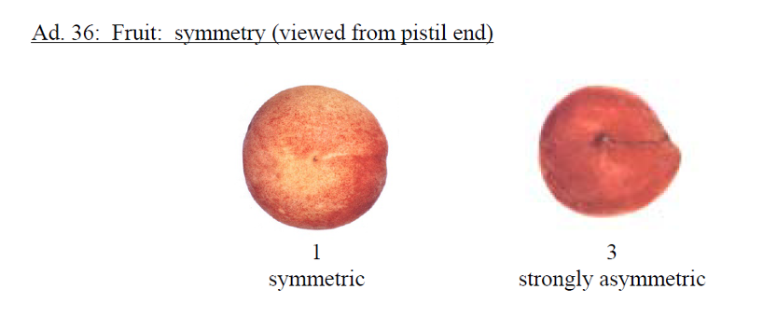
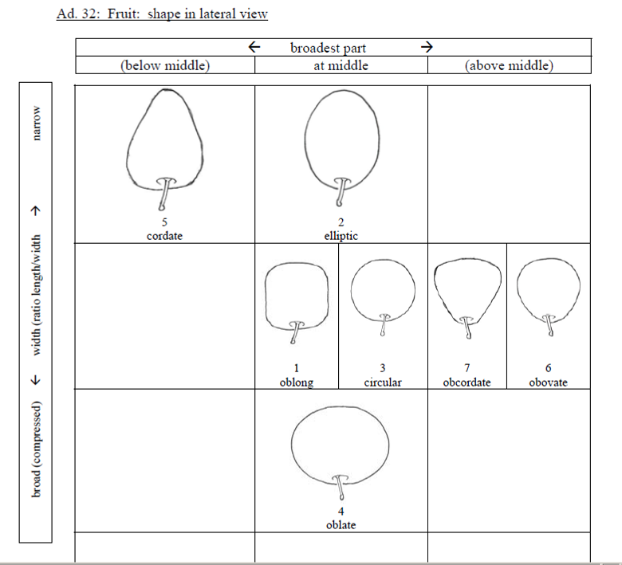

Example from TG/266/1 for African Lily:

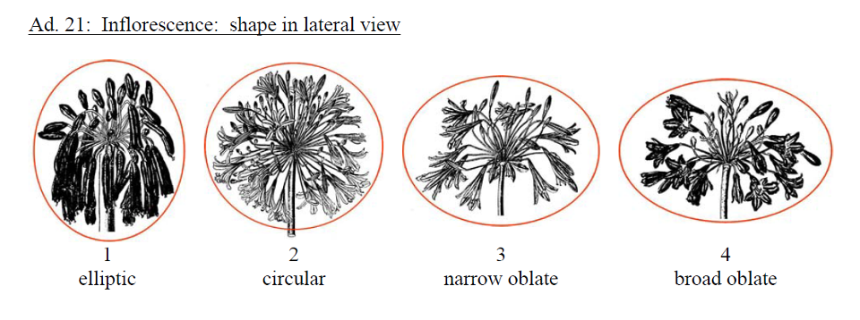
[Annex IV follows]

PROPOSED TEXT for REVISION OF TGP/14: Section 2: Botanical Terms: Subsection 2: Shapes and Structures: III. Definitions for Shape and Structure Terms

Terms | Definition / comment
Peduncle | A stem supporting a solitary flower or fruit, or an inflorescence or supporting an infructescence after fecundation
Pedicel | A stem which attaches single flowers or fruits to the main stem peduncle of the inflorescence or infructescence.
Petiole | A stalk attaching the leaf blade to the stem
Petiolule | A stalk of any of the leaflets making up a compound leaf.
Single flower | A single flower is the reproductive structure found in flowering plants. A single flower could be a solitary flower or part of an inflorescence
Spike | An indeterminate inflorescence with sessile flowers on an unbranched axis.

Translation:
English | Français | Deutsch | Español
Peduncle | Pédoncule | Blütenstandstiel | Pédonculo Pedúnculo
Pedicel | Pédicelle | Blütenstiel | Pedicelo
Petiole | Pétiole | Blattstiel | Peciolo
Petiolule | Pétiolule | Kleiner Blattstiel Blattfiederstiel | Peciólulo Peciolulo

[End of Annex IV and of document]

The term “broadest part” is used in preference to “widest point” in this document, because the broadest part may be a point (e.g. for a circle) or, in cases where the sides are parallel (e.g. for an oblong), the broadest part is situated along a length (see Section 1.2(b)).

