 |  | E
 | 
  TG/24/7(proj.6)
  ORIGINAL: English
  DATE: 2026-01-20
INTERNATIONAL UNION FOR THE PROTECTION OF NEW VARIETIES OF PLANTS
 | Geneva
  DRAFT
  POINSETTIA
  UPOV Code(s): EUPHO_PUL; EUPHO_PCO
  Euphorbia pulcherrima Willd. ex Klotzsch;
  Euphorbia pulcherrima Willd. ex Klotzsch × Euphorbia cornastra (Dressler) Radcl.-Sm.
  *
GUIDELINES
FOR THE CONDUCT OF TESTS
FOR DISTINCTNESS, UNIFORMITY AND STABILITY

prepared by an expert from the European Union

to be considered by the

Technical Committee for adoption by correspondence

Disclaimer: this document does not represent UPOV policies or guidance
Alternative names:*

Botanical name | English | French | German | Spanish
  Euphorbia pulcherrima Willd. ex Klotzsch
  Poinsettia
  Poinsettia
  Poinsettie, Weihnachtsstern
  Flor de Pascua, Cuetlaxochitl, Nochebuena
  Euphorbia pulcherrima Willd. ex Klotzsch × Euphorbia cornastra (Dressler) Radcl.-Sm.
  Poinsettia
  Poinsettia
  Poinsettie, Weihnachtsstern
  Flor de Pascua, Cuetlaxochitl, Nochebuena

The purpose of these guidelines (“Test Guidelines”) is to elaborate the principles contained in the General Introduction (document TG/1/3), and its associated TGP documents, into detailed practical guidance for the harmonized examination of distinctness, uniformity and stability (DUS) and, in particular, to identify appropriate characteristics for the examination of DUS and production of harmonized variety descriptions.
ASSOCIATED DOCUMENTS
These Test Guidelines should be read in conjunction with the General Introduction and its associated TGP documents.

TABLE OF CONTENTS | PAGE
1. | SUBJECT OF THESE TEST GUIDELINES.......................................................................................................... | 3
2. | MATERIAL REQUIRED......................................................................................................................................... | 3
3. | METHOD OF EXAMINATION................................................................................................................................ | 3
3.1 | Number of Growing Cycles........................................................................................................................ | 3
3.2 | Testing Place............................................................................................................................................. | 3
3.3 | Conditions for Conducting the Examination............................................................................................... | 3
3.4 | Test Design................................................................................................................................................ | 3
3.5 | Additional Tests......................................................................................................................................... | 4

4. | ASSESSMENT OF DISTINCTNESS, UNIFORMITY AND STABILITY................................................................. | 4
4.1 | Distinctness............................................................................................................................................... | 4
4.2 | Uniformity.................................................................................................................................................. | 5
4.3 | Stability...................................................................................................................................................... | 5

5. | GROUPING OF VARIETIES AND ORGANIZATION OF THE GROWING TRIAL................................................ | 5
6. | INTRODUCTION TO THE TABLE OF CHARACTERISTICS................................................................................ | 6
6.1 | Categories of Characteristics..................................................................................................................... | 6
6.2 | States of Expression and Corresponding Notes........................................................................................ | 6
6.3 | Types of Expression.................................................................................................................................. | 6
6.4 | Example Varieties...................................................................................................................................... | 6
6.5 | Legend....................................................................................................................................................... | 7

7. | TABLE OF CHARACTERISTICS/TABLEAU DES CARACTÈRES/MERKMALSTABELLE/TABLA DE CARACTERES...................................................................................................................................................... | 8
8. | EXPLANATIONS ON THE TABLE OF CHARACTERISTICS............................................................................... | 23
8.1 | Explanations covering several characteristics........................................................................................... | 23
 | Explanations for individual characteristics................................................................................................. | 23
  8.2

9. | LITERATURE......................................................................................................................................................... | 30
10. | TECHNICAL QUESTIONNAIRE............................................................................................................................ | 31

1. | Subject of these Test Guidelines
1.1
  These Test Guidelines apply to all varieties of Euphorbia pulcherrima Willd. ex Klotzsch and Euphorbia pulcherrima Willd. ex Klotzsch × Euphorbia cornastra (Dressler) Radcl.-Sm.

1.2 | Guidance on the use of Test Guidelines for other hybrids involving Euphorbia pulcherrima Willd. ex Klotzsch that are not explicitly covered by Test Guidelines is provided in document TGP/13 "Guidance for New Types and Species".
2. | Material Required
2.1
  The competent authorities decide on the quantity and quality of the plant material required for testing the variety and when and where it is to be delivered. Applicants submitting material from a State other than that in which the testing takes place must ensure that all customs formalities and phytosanitary requirements are complied with.
2.2
  The material is to be supplied in the form of rooted cuttings. The plants should not be pinched.
2.3
  The minimum quantity of plant material, to be supplied by the applicant, should be:
  10 rooted cuttings
2.4
  The plant material supplied should be visibly healthy, not lacking in vigor, nor affected by any important pest or disease.
2.5
  The plant material should not have undergone any treatment which would affect the expression of the characteristics of the variety, unless the competent authorities allow or request such treatment. If it has been treated, full details of the treatment must be given.

3. | Method of Examination
3.1 | Number of Growing Cycles
 | The minimum duration of tests should normally be a single growing cycle.
  3.1.1
 | The testing of a variety may be concluded when the competent authority can determine with certainty the outcome of the test.
  3.1.2
3.2 | Testing Place
 | Tests are normally conducted at one place. In the case of tests conducted at more than one place, guidance is provided in TGP/9 “Examining Distinctness”.
3.3 | Conditions for Conducting the Examination
 | The tests should be carried out under conditions ensuring satisfactory growth for the expression of the relevant characteristics of the variety and for the conduct of the examination.
  3.3.1
 | Because daylight varies, color determinations made against a color chart should be made either in a suitable cabinet providing artificial daylight or in the middle of the day in a room without direct sunlight. The spectral distribution of the illuminant for artificial daylight should conform with the CIE Standard of Preferred Daylight D 6500 and should fall within the tolerances set out in the British Standard 950, Part I. These determinations should be made with the plant part placed against a white background. The color chart and version used should be specified in the variety description.
  3.3.2

3.4 | Test Design
3.4.1
  Each test should be designed to result in a total of at least 10 plants.
  3.4.2
  The design of the tests should be such that plants or parts of plants may be removed for measurement or counting without prejudice to the observations which must be made up to the end of the growing cycle.

3.5 | Additional Tests
 | Additional tests, for examining relevant characteristics, may be established.

4. | Assessment of Distinctness, Uniformity and Stability
4.1 | Distinctness
4.1.1 | General Recommendations
 | It is of particular importance for users of these Test Guidelines to consult the General Introduction prior to making decisions regarding distinctness. However, the following points are provided for elaboration or emphasis in these Test Guidelines.
4.1.2 | Consistent Differences
 | The differences observed between varieties may be so clear that more than one growing cycle is not necessary. In addition, in some circumstances, the influence of the environment is not such that more than a single growing cycle is required to provide assurance that the differences observed between varieties are sufficiently consistent. One means of ensuring that a difference in a characteristic, observed in a growing trial, is sufficiently consistent is to examine the characteristic in at least two independent growing cycles.
4.1.3 | Clear Differences
 | Determining whether a difference between two varieties is clear depends on many factors, and should consider, in particular, the type of expression of the characteristic being examined, i.e. whether it is expressed in a qualitative, quantitative, or pseudo-qualitative manner. Therefore, it is important that users of these Test Guidelines are familiar with the recommendations contained in the General Introduction prior to making decisions regarding distinctness.
4.1.4
  Number of Plants or Parts of Plants to be Examined
  Unless otherwise indicated, for the purposes of distinctness, all observations on single plants should be made on 9 plants or parts of plants taken from each of 9 plants and any other observations made on all plants in the test, disregarding any off-type plants.
  In the case of observations of parts taken from single plants, the number of parts to be taken from each of the plants should be 1.
4.1.5 | Method of Observation
 | The recommended method of observing the characteristic for the purposes of distinctness is indicated by the following key in the Table of Characteristics (see document TGP/9 “Examining Distinctness”, Section 4 “Observation of characteristics”):
MG: single measurement of a group of plants or parts of plants
MS: measurement of a number of individual plants or parts of plants
VG: visual assessment by a single observation of a group of plants or parts of plants
VS: visual assessment by observation of individual plants or parts of plants

 | Type of observation: visual (V) or measurement (M)
 | “Visual” observation (V) is an observation made on the basis of the expert’s judgment. For the purposes of this document, “visual” observation refers to the sensory observations of the experts and, therefore, also includes smell, taste and touch. Visual observation includes observations where the expert uses reference points (e.g. diagrams, example varieties, side-by-side comparison) or non-linear charts (e.g. color charts). Measurement (M) is an objective observation against a calibrated, linear scale e.g. using a ruler, weighing scales, colorimeter, dates, counts, etc.
  Type of record: for a group of plants (G) or for single, individual plants (S)
  For the purposes of distinctness, observations may be recorded as a single record for a group of plants or parts of plants (G), or may be recorded as records for a number of single, individual plants or parts of plants (S). In most cases, “G” provides a single record per variety and it is not possible or necessary to apply statistical methods in a plant-by-plant analysis for the assessment of distinctness.
 | In cases where more than one method of observing the characteristic is indicated in the Table of Characteristics (e.g. VG/MG), guidance on selecting an appropriate method is provided in document TGP/9, Section 4.2.
4.2 | Uniformity
4.2.1 | It is of particular importance for users of these Test Guidelines to consult the General Introduction prior to making decisions regarding uniformity. However, the following points are provided for elaboration or emphasis in these Test Guidelines:
  4.2.2
  These Test Guidelines have been developed for the examination of vegetatively propagated varieties. For varieties with other types of propagation, the recommendations in the General Introduction and document TGP/13 "Guidance for new types and species" Section 4.5 "Testing Uniformity" should be followed.
4.2.3
  For the assessment of uniformity of vegetatively propagated varieties, a population standard of 1% and an acceptance probability of at least 95% should be applied. In the case of a sample size of 10 plants, 1 off-type is allowed.
4.3 | Stability
4.3.1 | In practice, it is not usual to perform tests of stability that produce results as certain as those of the testing of distinctness and uniformity. However, experience has demonstrated that, for many types of variety, when a variety has been shown to be uniform, it can also be considered to be stable.
4.3.2 | Where appropriate, or in cases of doubt, stability may be further examined by testing a new plant stock to ensure that it exhibits the same characteristics as those shown by the initial material supplied.

5. | Grouping of Varieties and Organization of the Growing Trial
5.1 | The selection of varieties of common knowledge to be grown in the trial with the candidate varieties and the way in which these varieties are divided into groups to facilitate the assessment of distinctness are aided by the use of grouping characteristics.
5.2 | Grouping characteristics are those in which the documented states of expression, even where produced at different locations, can be used, either individually or in combination with other such characteristics: (a) to select varieties of common knowledge that can be excluded from the growing trial used for examination of distinctness; and (b) to organize the growing trial so that similar varieties are grouped together.
5.3 | The following have been agreed as useful grouping characteristics:
  (a)
  Leaf blade: number of colors of upper side (characteristic 12)
  (b)
  Bract: main color of upper side (characteristic 33) with the following groups:
  -Gr. 1: white
  -Gr. 2: yellow
  -Gr. 3: pink
  -Gr. 4: orange red
  -Gr. 5: red
  -Gr. 6: purple
  (c)
  Bract: secondary color of upper side (characteristic 34) with the following groups:
  -Gr. 1: white
  -Gr. 2: yellow
  -Gr. 3: pink
  -Gr. 4: orange red
  -Gr. 5: red
  -Gr. 6: purple
  (d)
  Bract: distribution of secondary color of upper side (characteristic 35)
  (e)
  Bract: pattern of secondary color of upper side (characteristic 36)

5.4 | Guidance for the use of grouping characteristics, in the process of examining distinctness, is provided through the General Introduction and document TGP/9 “Examining Distinctness”.

6. | Introduction to the Table of Characteristics
6.1 | Categories of Characteristics
6.1.1 | Standard Test Guidelines Characteristics
 | Standard Test Guidelines characteristics are those which are approved by UPOV for examination of DUS and from which members of the Union can select those suitable for their particular circumstances.
6.1.2 | Asterisked Characteristics

 | Asterisked characteristics (denoted by *) are those included in the Test Guidelines which are important for the international harmonization of variety descriptions and should always be examined for DUS and included in the variety description by all members of the Union, except when the state of expression of a preceding characteristic or regional environmental conditions render this inappropriate.
6.2 | States of Expression and Corresponding Notes
6.2.1 | States of expression are given for each characteristic to define the characteristic and to harmonize descriptions. Each state of expression is allocated a corresponding numerical note for ease of recording of data and for the production and exchange of the description.
6.2.2 | All relevant states of expression are presented in the characteristic.
6.2.3 | Further explanation of the presentation of states of expression and notes is provided in document TGP/7 “Development of Test Guidelines”.
6.3 | Types of Expression
 | An explanation of the types of expression of characteristics (qualitative, quantitative and pseudo-qualitative) is provided in the General Introduction.
6.4 | Example Varieties
 | Where appropriate, example varieties are provided to clarify the states of expression of each characteristic.

6.5 | Legend
 |  | English |  | français |  | deutsch | español | Example Varieties/  Exemples/  Beispielssorten/  Variedades ejemplo | Note/  Nota
  1
  2
  3
  4
  5
  6
  7
  Name of characteristics in English
  Nom du caractère en français
  Name des Merkmals auf Deutsch
  Nombre del carácter en español
  states of expression
  types d’expression
  Ausprägungsstufen
  tipos de expresión

1 | Characteristic number
2 | (*) | Asterisked characteristic | – see Chapter 6.1.2
3 | Type of expression
 | QL | Qualitative characteristic | – see Chapter 6.3
 | QN | Quantitative characteristic | – see Chapter 6.3
 | PQ | Pseudo-qualitative characteristic | – see Chapter 6.3
4 | Method of observation (and type of plot, if applicable)
 | MG, MS, VG, VS |  | – see Chapter 4.1.5
5
  (+)
  See Explanations on the Table of Characteristics in Chapter 8.2
6
  (a)-(d)
  See Explanations on the Table of Characteristics in Chapter 8.1
7
  Not applicable

7. | Table of Characteristics/Tableau des caractères/Merkmalstabelle/Tabla de caracteres

 |  | English |  | français |  | deutsch | español | Example Varieties/  Exemples/  Beispielssorten/  Variedades ejemplo | Note/  Nota
1. | (*) | QL | VG
  Plant: branching
  Plante : ramifications
  Pflanze: Verzweigung
  Planta: ramificación
 |  | absent |  | absentes |  | fehlend | ausente | QS47 | 1
 |  | present |  | présentes |  | vorhanden | presente | QS44 | 9
2. | (*) | QN | MG/VG
  Plant: number of branches
  Plante : nombre de ramifications
  Pflanze: Anzahl Verzweigungen
  Planta: número de ramificaciones
 |  | very few |  | très petit |  | sehr gering | muy bajo |  | 1
 |  | very few to few |  | très petit à petit |  | sehr gering bis gering | muy bajo a bajo |  | 2
 |  | few |  | petit |  | gering | bajo | EURZ0025, Lilo | 3
 |  | few to medium |  | petit à moyen |  | gering bis mittel | bajo a medio |  | 4
 |  | medium |  | moyen |  | mittel | medio | Dueinfinity, Freedom | 5
 |  | medium to many |  | moyen à élevé |  | mittel bis hoch | medio a alto |  | 6
 |  | many |  | élevé |  | hoch | alto | Regina | 7
 |  | many to very many |  | élevé à très élevé |  | hoch bis sehr hoch | alto a muy alto | BONPRI 9276 | 8
 |  | very many |  | très élevé |  | sehr hoch | muy alto |  | 9
3. | (*) | QN | MG/MS/VG
  Plant: height
  Plante : hauteur
  Pflanze: Höhe
  Planta: altura
 |  | very short |  | basse |  | sehr niedrig | muy baja | BONPRIPAPCOM | 1
 |  | very short to short |  | très basse à basse |  | sehr niedrig bis niedrig | muy baja a baja |  | 2
 |  | short |  | basse |  | niedrig | baja | Duepremimapri | 3
 |  | short to medium |  | basse à moyenne |  | niedrig bis mittel | baja a media |  | 4
 |  | medium |  | moyenne |  | mittel | media | Fiscor | 5
 |  | medium to tall |  | moyenne à haute |  | mittel bis hoch | media a alta |  | 6
 |  | tall |  | haute |  | hoch | alta | Fismille, NPCW16260 | 7
 |  | tall to very tall |  | haute à très haute |  | hoch bis sehr hoch | alta a muy alta |  | 8
 |  | very tall |  | très haute |  | sehr hoch | muy alta | WEL20390 | 9
4. |  | QN | MG/MS/VG
  Plant: width
  Plante : largeur
  Pflanze: Breite
  Planta: anchura
 |  | very narrow |  | très étroite |  | sehr schmal | muy estrecha |  | 1
 |  | very narrow to narrow |  | très étroite à étroite |  | sehr schmal bis schmal | muy estrecha a estrecha |  | 2
 |  | narrow |  | étroite |  | schmal | estrecha | Duepremimpol, Eckalon | 3
 |  | narrow to medium |  | étroite à moyenne |  | schmal bis mittel | estrecha a media |  | 4
 |  | medium |  | moyenne |  | mittel | media | Allegra White, Red Angel | 5
 |  | medium to broad |  | moyenne à large |  | mittel bis breit | media a ancha |  | 6
 |  | broad |  | large |  | breit | ancha | EURZ0025, Fismille | 7
 |  | broad to very broad |  | large à très large |  | breit bis sehr breit | ancha a muy ancha |  | 8
 |  | very broad |  | très large |  | sehr breit | muy ancha |  | 9
5. | (*) | QN | VG
  Stem: intensity of green color on middle third
  Tige : intensité de la couleur verte au tiers médian
  Stängel: Intensität der Grünfärbung im mittleren Drittel
  Tallo: intensidad del color verde en el tercio medio
 |  | light |  | claire |  | hell | clara | BKPONRR | 1
 |  | light to medium |  | claire à moyenne |  | hell bis mittel | clara a media | LAZZPO1531 | 2
 |  | medium |  | moyenne |  | mittel | media | Winpeach | 3
 |  | medium to dark |  | moyenne à foncée |  | mittel bis dunkel | media a oscura |  | 4
 |  | dark |  | foncée |  | dunkel | oscura | Duepremimapri | 5
6. | (*) | QN | VG
  Stem: intensity of anthocyanin coloration on middle third
  Tige : intensité de la pigmentation anthocyanique au tiers médian
  Stängel: Intensität der Anthocyanfärbung im mittleren Drittel
  Tallo: intensidad de la pigmentación antociánica en el tercio medio
 |  | absent or weak |  | absente ou faible |  | fehlend oder gering | ausente o débil | White Freedom | 1
 |  | weak to medium |  | faible à moyenne |  | gering bis mittel | débil a media | NPCW19280 | 2
 |  | medium |  | moyenne |  | mittel | media | Fisson Orange, NPCW18087 | 3
 |  | medium to strong |  | moyenne à forte |  | mittel bis stark | media a fuerte | EURZ0019 | 4
 |  | strong |  | forte |  | stark | fuerte | Fisson | 5
7. | (*) | QN | VG
  Stem: intensity of anthocyanin coloration on upper third
  Tige : intensité de la pigmentation anthocyanique au tiers supérieur
  Stängel: Intensität der Anthocyanfärbung im oberen Drittel
  Tallo: intensidad de la pigmentación antociánica en el tercio superior
 |  | absent or weak |  | absente ou faible |  | fehlend oder gering | ausente o débil | Ice Punch,  Red Fox Premiummarble | 1
 |  | medium |  | moyenne |  | mittel | media | Freedom Marble, NPCW19282 | 2
 |  | strong |  | forte |  | stark | fuerte | LAZZPO1531 | 3
8. | (*) | QN | MG/MS/VG |  | (a)
  Leaf blade: length
  Limbe : longueur
  Blattspreite: Länge
  Limbo: longitud
 |  | very short |  | très courte |  | sehr kurz | muy corta |  | 1
 |  | very short to short |  | très courte à courte |  | sehr kurz bis kurz | muy corta a corta |  | 2
 |  | short |  | courte |  | kurz | corta | Dueavant | 3
 |  | short to medium |  | courte à moyenne |  | kurz bis mittel | corta a media |  | 4
 |  | medium |  | moyenne |  | mittel | media | Fiscor | 5
 |  | medium to long |  | moyenne à longue |  | mittel bis lang | media a larga |  | 6
 |  | long |  | longue |  | lang | larga | LAZZPO1078,  Winterfest Red | 7
 |  | long to very long |  | longue à très longue |  | lang bis sehr lang | larga a muy larga |  | 8
 |  | very long |  | très longue |  | sehr lang | muy larga |  | 9
9. | (*) | QN | MG/MS/VG |  | (a)
  Leaf blade: width
  Limbe : largeur
  Blattspreite: Breite
  Limbo: anchura
 |  | very narrow |  | très étroite |  | sehr schmal | muy estrecha |  | 1
 |  | very narrow to narrow |  | très étroite à étroite |  | sehr schmal bis schmal | muy estrecha a estrecha |  | 2
 |  | narrow |  | étroite |  | schmal | estrecha | Fiscor | 3
 |  | narrow to medium |  | étroite à moyenne |  | schmal bis mittel | estrecha a media |  | 4
 |  | medium |  | moyenne |  | mittel | media | Duecowhite, Duepre | 5
 |  | medium to broad |  | moyenne à large |  | mittel bis breit | media a ancha |  | 6
 |  | broad |  | large |  | breit | ancha | LAZZPO1078,  White Freedom | 7
 |  | broad to very broad |  | large à très large |  | breit bis sehr breit | ancha a muy ancha |  | 8
 |  | very broad |  | très large |  | sehr breit | muy ancha |  | 9
10. |  | PQ | VG | (+) | (a)
  Leaf blade: shape
  Limbe : forme
  Blattspreite: Form
  Limbo: forma
 |  | deltate |  | deltate |  | deltaförmig | deltada | Q102 | 1
 |  | ovate |  | ovale |  | eiförmig | oval | Duepre, NPCW13218 | 2
 |  | lanceolate |  | lancéolée |  | lanzettlich | lanceolada | Bonpri 974 | 3
 |  | elliptic |  | elliptique |  | elliptisch | elíptica | BONPRI 9172 | 4
 |  | circular |  | circulaire |  | kreisförmig | circular | NPCW18087, NPCW19280 | 5
11. |  | PQ | VG | (+) | (a)
  Leaf blade: shape of base
  Limbe : forme de la base
  Blattspreite: Form der Basis
  Limbo: forma de la base
 |  | wedge-shaped |  | cunéiforme |  | keilförmig | cuneiforme | Dueavant | 1
 |  | rounded |  | arrondie |  | abgerundet | redondeada | Dopoinsayerf, Marblestar | 2
 |  | truncate |  | tronquée |  | gerade | truncada | Dueinfinity | 3
 |  | cordate |  | cordiforme |  | herzförmig | cordiforme | Bright Red, Early Joy, Roccostar Bright Red | 4
12. | (*) | PQ | VG | (+) | (a)
  Leaf blade: number of colors of upper side
  Limbe : nombre de couleurs de la face supérieure
  Blattspreite: Anzahl Farben der Oberseite
  Limbo: número de colores del haz
 |  | one |  | une |  | eine | uno | DUEPRIMDON, Fiscor | 1
 |  | two |  | deux |  | zwei | dos | Dueavant | 2
 |  | more than two |  | plus de deux |  | mehr als zwei | más de dos | Fismarble Silver | 3
13. | (*) | QN | VG |  | (a)
  Only varieties with Leaf blade: number of colors of upper side: one: Leaf blade: intensity of green color on upper side
  Seulement les variétés avec Limbe : nombre de couleurs de la face supérieure : une : Limbe : intensité de la couleur verte sur la face supérieure
  Nur Sorten mit Blattspreite: Anzahl Farben der Oberseite: eine: Blattspreite: Intensität der Grünfärbung der Oberseite
  Sólo variedades con Limbo: número de colores del haz: uno: Limbo: intensidad del color verde en el haz
 |  | very light |  | très claire |  | sehr hell | muy clara | Fiscor | 1
 |  | light |  | claire |  | hell | clara |  | 2
 |  | medium |  | moyenne |  | mittel | media |  | 3
 |  | dark |  | foncée |  | dunkel | oscura | NPCW12200 | 4
 |  | very dark |  | très foncée |  | sehr dunkel | muy oscura | Peterstar | 5
14. |  | PQ | VG |  | (a), (b)
  Only varieties with Leaf blade: number of colors on upper side: two or more than two: Leaf blade: main color of upper side
  Seulement les variétés avec Limbe : nombre de couleurs sur la face supérieure : deux ou plus de deux : Limbe : couleur principale de la face supérieure
  Nur Sorten mit Blattspreite: Anzahl Farben der Oberseite: zwei oder mehr als zwei: Blattspreite: Hauptfarbe der Oberseite
  Sólo variedades con Limbo: número de colores del haz: dos o más de dos: Limbo: color principal del haz
 |  | yellowish |  | jaunâtre |  | gelblich | amarillento |  | 1
 |  | yellowish green |  | vert jaunâtre |  | gelblichgrün | verde amarillento |  | 2
 |  | greyish green |  | vert grisâtre |  | gräulichgrün | verde grisáceo | Fismarble Silver | 3
 |  | light green |  | vert clair |  | hellgrün | verde claro | Bright Red Queen | 4
 |  | medium green |  | vert moyen |  | mittelgrün | verde medio | Dueavant | 5
 |  | dark green |  | vert foncé |  | dunkelgrün | verde oscuro | Carousel Dark Red | 6
 |  | very dark green |  | vert très foncé |  | sehr dunkelgrün | verde muy oscuro |  | 7
15. |  | PQ | VG |  | (a), (b)
  Only varieties with Leaf blade: number of colors on upper side: two or more than two: Leaf blade: secondary color of upper side
  Seulement les variétés avec Limbe : nombre de couleurs sur la face supérieure : deux ou plus de deux : Limbe : couleur secondaire de la face supérieure
  Nur Sorten mit Blattspreite: Anzahl Farben der Oberseite: zwei oder mehr als zwei: Blattspreite: Sekundärfarbe der Oberseite
  Sólo variedades con Limbo: número de colores del haz: dos o más de dos: Limbo: color secundario del haz
 |  | white |  | blanc |  | weiß | blanco | Fismarble Silver | 1
 |  | yellowish |  | jaunâtre |  | gelblich | amarillento | Bright Red Queen | 2
 |  | yellowish green |  | vert jaunâtre |  | gelblichgrün | verde amarillento |  | 3
 |  | greyish green |  | vert grisâtre |  | gräulichgrün | verde grisáceo | Allegra Art Deco | 4
 |  | light green |  | vert clair |  | hellgrün | verde claro |  | 5
 |  | medium green |  | vert moyen |  | mittelgrün | verde medio |  | 6
 |  | dark green |  | vert foncé |  | dunkelgrün | verde oscuro | Dueavant | 7
 |  | very dark green |  | vert très foncé |  | sehr dunkelgrün | verde muy oscuro | Carousel Dark Red | 8
16. |  | PQ | VG |  | (a), (b)
  Only varieties with Leaf blade: number of colors on upper side: more than two: Leaf blade: tertiary color of upper side
  Seulement les variétés avec Limbe : nombre de couleurs sur la face supérieure : plus de deux : Limbe : couleur tertiaire de la face supérieure
  Nur Sorten mit Blattspreite: Anzahl Farben der Oberseite: mehr als zwei: Blattspreite: Tertiärfarbe der Oberseite
  Sólo variedades con Limbo: número de colores del haz: más de dos: Limbo: color terciario del haz
 |  | white |  | blanc |  | weiß | blanco | Silverleaf | 1
 |  | yellowish |  | jaunâtre |  | gelblich | amarillento |  | 2
 |  | yellowish green |  | vert jaunâtre |  | gelblichgrün | verde amarillento | Bright Red Queen | 3
 |  | greyish green |  | vert grisâtre |  | gräulichgrün | verde grisáceo | Fiswhite Silver | 4
 |  | light green |  | vert clair |  | hellgrün | verde claro | Fissilver | 5
 |  | medium green |  | vert moyen |  | mittelgrün | verde medio |  | 6
 |  | dark green |  | vert foncé |  | dunkelgrün | verde oscuro |  | 7
 |  | very dark green |  | vert très foncé |  | sehr dunkelgrün | verde muy oscuro |  | 8
17. |  | PQ | VG |  | (a)
  Leaf blade: color of upper side of main vein
  Limbe: couleur de la face supérieure de la nervure principale
  Blattspreite: Farbe der Oberseite der Hauptader
  Limbo: color del haz del nervio principal
 |  | only green |  | uniquement vert |  | nur grün | sólo verde | Freedom Marble | 1
 |  | green and red |  | vert et rouge |  | grün und rot | verde y rojo | Petoy | 2
 |  | only red |  | uniquement rouge |  | nur rot | sólo rojo | KLEW01063, WEL20390 | 3
18. |  | QN | MG/VG | (+) | (a)
  Leaf blade: number of lobes
  Limbe : nombre de lobes
  Blattspreite: Anzahl Lappen
  Limbo: número de lóbulos
 |  | none or few |  | aucun ou petit |  | fehlend oder gering | ausente o bajo | DUEPRIMDON, Regina | 1
 |  | medium |  | moyen |  | mittel | medio | Allegra White, Fisdra | 2
 |  | many |  | élevé |  | hoch | alto | Dueavant | 3
19. |  | QN | MG/VG | (+) | (a)
  Leaf blade: depth of deepest sinus
  Limbe : profondeur du sinus le plus profond
  Blattspreite: Tiefe der tiefsten Einbuchtung
  Limbo: profundidad del seno más profundo
 |  | absent or very shallow |  | absente ou très peu profonde |  | fehlend oder sehr flach | ausente o muy poco profunda | Duepremimpol | 1
 |  | very shallow to shallow |  | très peu profonde à peu profonde |  | sehr flach bis flach | muy poco profunda a poco profunda |  | 2
 |  | shallow |  | peu profonde |  | flach | poco profunda | KLEW01063 | 3
 |  | shallow to medium |  | peu profonde à moyenne |  | flach bis mittel | profunda a media |  | 4
 |  | medium |  | moyenne |  | mittel | media | Dueavant | 5
 |  | medium to deep |  | moyenne à profonde |  | mittel bis tief | media a profunda |  | 6
 |  | deep |  | profonde |  | tief | profunda | Duemerlot | 7
 |  | deep to very deep |  | profonde à très profonde |  | tief bis sehr tief | profunda a muy profunda |  | 8
 |  | very deep |  | très profonde |  | sehr tief | muy profunda |  | 9
20. |  | QN | VG | (+) | (a)
  Leaf blade: curvature along main vein
  Limbe : courbure le long de la nervure principale
  Blattspreite: Biegung entlang der Hauptader
  Limbo: curvatura a lo largo del nervio principal
 |  | absent or weak |  | absente ou faible |  | fehlend oder gering | ausente o débil | Fiscor, LAZZPO1047 | 1
 |  | medium |  | moyenne |  | mittel | media | Eckalverta, LAZZPO1078 | 2
 |  | strong |  | forte |  | stark | fuerte | Eckaddis | 3
21. | (*) | QN | MG/MS/VG |  | (a)
  Petiole: length
  Pétiole : longueur
  Blattstiel: Länge
  Peciolo: longitud
 |  | very short |  | très courte |  | sehr kurz | muy corta |  | 1
 |  | very short to short |  | très courte à courte |  | sehr kurz bis kurz | muy corta a corta |  | 2
 |  | short |  | courte |  | kurz | corta | Duepremimhopi | 3
 |  | short to medium |  | courte à moyenne |  | kurz bis mittel | corta a media |  | 4
 |  | medium |  | moyenne |  | mittel | media | Fiscor, LAZZPO1615 | 5
 |  | medium to long |  | moyenne à longue |  | mittel bis lang | media a larga |  | 6
 |  | long |  | longue |  | lang | larga | QS44, Purple Heart | 7
 |  | long to very long |  | longue à très longue |  | lang bis sehr lang | larga a muy larga |  | 8
 |  | very long |  | très longue |  | sehr lang | muy larga | NPCW21350 | 9
22. |  | QN | VG |  | (a)
  Petiole: intensity of green color on upper side
  Pétiole : intensité de la couleur verte sur la face supérieure
  Blattstiel: Intensität der Grünfärbung der Oberseite
  Peciolo: intensidad del color verde en el haz
 |  | very light |  | très claire |  | sehr hell | muy clara | White Freedom | 1
 |  | light |  | claire |  | hell | clara |  | 2
 |  | medium |  | moyenne |  | mittel | media | Allegra White | 3
 |  | dark |  | foncée |  | dunkel | oscura |  | 4
 |  | very dark |  | très foncée |  | sehr dunkel | muy oscura | Duepremwi | 5
23. |  | QN | VG |  | (a)
  Petiole: intensity of anthocyanin coloration on upper side
  Pétiole : intensité de la pigmentation anthocyanique sur la face supérieure
  Blattstiel: Intensität der Anthocyanfärbung der Oberseite
  Peciolo: intensidad de la pigmentación antociánica en el haz
 |  | absent or very weak |  | absente ou très faible |  | fehlend oder sehr gering | ausente o muy débil | SRPO140540 | 1
 |  | very weak to weak |  | très faible à faible |  | sehr gering bis gering | muy débil a débil |  | 2
 |  | weak |  | faible |  | gering | débil | BONPRIDEPCOM,  Ice Punch | 3
 |  | weak to medium |  | faible à moyenne |  | gering bis mittel | débil a media |  | 4
 |  | medium |  | moyenne |  | mittel | media | Fisdra | 5
 |  | medium to strong |  | moyenne à forte |  | mittel bis stark | media a fuerte |  | 6
 |  | strong |  | forte |  | stark | fuerte | Freedom, Valsu, WEL20390 | 7
 |  | strong to very strong |  | forte à très forte |  | stark bis sehr stark | fuerte a muy fuerte |  | 8
 |  | very strong |  | très forte |  | sehr stark | muy fuerte |  | 9
24. | (*) | QN | VG |  | (a)
  Petiole: intensity of anthocyanin coloration on lower side
  Pétiole : intensité de la pigmentation anthocyanique sur la face inférieure
  Blattstiel: Intensität der Anthocyanfärbung der Unterseite
  Peciolo: intensidad de la pigmentación antociánica en el envés
 |  | absent or weak |  | absente ou faible |  | fehlend oder gering | ausente o débil | Allegra White, Ice Punch | 1
 |  | medium |  | moyenne |  | mittel | media | Early Red | 2
 |  | strong |  | forte |  | stark | fuerte | Freedom, WEL20390 | 3
25. | (*) | QN | MG/MS/VG | (+) | (c)
  Transitional leaves: number of partly bract‑colored leaf blades
  Feuilles transitoires : nombre de limbes partiellement colorés comme la bractée
  Zwischenblätter: Anzahl teilweise wie Hochblatt gefärbter Blattspreiten
  Hojas de transición: número de limbos parcialmente coloreados como las brácteas
 |  | very few |  | très petit |  | sehr gering | muy bajo | NPCW02044 | 1
 |  | very few to few |  | très petit à petit |  | sehr gering bis gering | muy bajo a bajo |  | 2
 |  | few |  | petit |  | gering | bajo | Fismille | 3
 |  | few to medium |  | petit à moyen |  | gering bis mittel | bajo a medio |  | 4
 |  | medium |  | moyen |  | mittel | medio | Duearcwi | 5
 |  | medium to many |  | moyen à élevé |  | mittel bis hoch | medio a alto |  | 6
 |  | many |  | élevé |  | hoch | alto | Fuego, Renate | 7
 |  | many to very many |  | élevé à très élevé |  | hoch bis sehr hoch | alto a muy alto |  | 8
 |  | very many |  | très élevé |  | sehr hoch | muy alto |  | 9
26. | (*) | QN | MG/MS/VG | (+) | (c)
  Transitional leaves: number of fully bract‑colored leaf blades
  Feuilles transitoires : nombre de limbes ayant entièrement la couleur de la bractée
  Zwischenblätter: Anzahl vollständig wie Hochblatt gefärbter Blattspreiten
  Hojas de transición: número de limbos totalmente coloreados como las brácteas
 |  | very few |  | très petit |  | sehr gering | muy bajo | QS47 | 1
 |  | very few to few |  | très petit à petit |  | sehr gering bis gering | muy bajo a bajo |  | 2
 |  | few |  | petit |  | gering | bajo | NPCW02044, Renate | 3
 |  | few to medium |  | petit à moyen |  | gering bis mittel | bajo a medio |  | 4
 |  | medium |  | moyenne |  | mittel | medio | Duecitric, NPCW21350 | 5
 |  | medium to many |  | moyen à élevé |  | mittel bis hoch | medio a alto | Valenciana | 6
 |  | many |  | élevé |  | hoch | alto | Fismille, LAZZPO1531 | 7
 |  | many to very many |  | élevé à très élevé |  | hoch bis sehr hoch | alto a muy alto |  | 8
 |  | very many |  | très élevé |  | sehr hoch | muy alto | NPCW10164 | 9
27. |  | QN | VG | (+) | (c)
  Transitional leaf: number of lobes
  Feuille transitoire : nombre de lobes
  Zwischenblatt: Anzahl Lappen
  Hoja de transición: número de lóbulos
 |  | none or one |  | aucun ou un |  | fehlend oder einen | ausente o uno | Duepre, Duepremimpol | 1
 |  | two |  | deux |  | zwei | dos | NPCW06115 | 2
 |  | more than two |  | plus de deux |  | mehr als zwei | más de dos | Lazzporega | 3
28. |  | QN | VG | (+) | (c)
  Transitional leaf: curvature along main vein
  Feuille transitoire : courbure le long de la nervure principale
  Zwischenblatt: Biegung entlang der Hauptader
  Hoja de transición: curvatura a lo largo del nervio principal
 |  | absent or weak |  | absente ou faible |  | fehlend oder gering | ausente o débil | Fiscor | 1
 |  | medium |  | moyenne |  | mittel | media | Eckalverta, LAZZPO1078 | 2
 |  | strong |  | forte |  | stark | fuerte | Winred | 3
29. | (*) | QN | MG/VG | (+)
  Bracts: number
  Bractées : nombre
  Hochblätter: Anzahl
  Brácteas: número
 |  | very few |  | très petit |  | sehr gering | muy bajo | Bonpri 974 | 1
 |  | very few to few |  | très petit à petit |  | sehr gering bis gering | muy bajo a bajo |  | 2
 |  | few |  | petit |  | gering | bajo | BKPONVW, Duecitric | 3
 |  | few to medium |  | petit à moyen |  | gering bis mittel | bajo a medio |  | 4
 |  | medium |  | moyen |  | mittel | medio | DUEPRIMDON, Renate | 5
 |  | medium to many |  | moyen à élevé |  | mittel bis hoch | medio a alto |  | 6
 |  | many |  | élevé |  | hoch | alto | Fismille | 7
 |  | many to very many |  | élevé à très élevé |  | hoch bis sehr hoch | alto a muy alto |  | 8
 |  | very many |  | très élevé |  | sehr hoch | muy alto |  | 9
30. | (*) | QN | MG/MS/VG | (+) | (d)
  Bract: length
  Bractée : longueur
  Hochblatt: Länge
  Bráctea: longitud
 |  | very short |  | très courte |  | sehr kurz | muy corta | BONPRI 9172 | 1
 |  | very short to short |  | très courte à courte |  | sehr kurz bis kurz | muy corta a corta |  | 2
 |  | short |  | courte |  | kurz | corta |  | 3
 |  | short to medium |  | courte à moyenne |  | kurz bis mittel | corta a media |  | 4
 |  | medium |  | moyenne |  | mittel | media | LAZZPO1615, Stargazer | 5
 |  | medium to long |  | moyenne à longue |  | mittel bis lang | media a larga |  | 6
 |  | long |  | longue |  | lang | larga | Ice Punch | 7
 |  | long to very long |  | longue à très longue |  | lang bis sehr lang | larga a muy larga |  | 8
 |  | very long |  | très longue |  | sehr lang | muy larga |  | 9
31. | (*) | QN | MG/MS/VG |  | (d)
  Bract: width
  Bractée : largeur
  Hochblatt: Breite
  Bráctea: anchura
 |  | very narrow |  | très étroite |  | sehr schmal | muy estrecha | BONPRI 9172 | 1
 |  | very narrow to narrow |  | très étroite à étroite |  | sehr schmal bis schmal | muy estrecha a estrecha |  | 2
 |  | narrow |  | étroite |  | schmal | estrecha | Bonpri 974, Stargazer | 3
 |  | narrow to medium |  | étroite à moyenne |  | schmal bis mittel | estrecha a media |  | 4
 |  | medium |  | moyenne |  | mittel | media | Ice Punch, LAZZPO1201 | 5
 |  | medium to broad |  | moyenne à large |  | mittel bis breit | media a ancha |  | 6
 |  | broad |  | large |  | breit | ancha | Duepremimhopi | 7
 |  | broad to very broad |  | large à très large |  | breit bis sehr breit | ancha a muy ancha |  | 8
 |  | very broad |  | très large |  | sehr breit | muy ancha | Duepremice | 9
32. | (*) | PQ | VG | (+) | (d)
  Bract: shape
  Bractée : forme
  Hochblatt: Form
  Bráctea: forma
 |  | ovate |  | ovale |  | eiförmig | oval | Eckalon, NPCW19254 | 1
 |  | elliptic |  | elliptique |  | elliptisch | elíptica | Allegra White, Fiscor | 2
 |  | oblanceolate |  | oblancéolée |  | verkehrt lanzettlich | oblanceolada | Dueavant | 3
 |  | obovate |  | obovale |  | verkehrt eiförmig | oboval |  | 4
33. | (*) | PQ | VG |  | (b), (d)
  Bract: main color of upper side
  Bractée : couleur principale de la face supérieure
  Hochblatt: Hauptfarbe der Oberseite
  Bráctea: color principal del haz
 |  | RHS Colour Chart (indicate reference number) |  | Code RHS des couleurs (indiquer le numéro de référence) |  | RHS-Farbkarte (Nummer angeben) | Carta de colores RHS (indíquese el número de referencia)
34. | (*) | PQ | VG |  | (b), (d)
  Bract: secondary color of upper side
  Bractée : couleur secondaire de la face supérieure
  Hochblatt: Sekundärfarbe der Oberseite
  Bráctea: color secundario del haz
 |  | RHS Colour Chart (indicate reference number) |  | Code RHS des couleurs (indiquer le numéro de référence) |  | RHS-Farbkarte (Nummer angeben) | Carta de colores RHS (indíquese el número de referencia)
35. | (*) | PQ | VG | (+) | (b), (d)
  Bract: distribution of secondary color of upper side
  Bractée : distribution de la couleur secondaire de la face supérieure
  Hochblatt: Verteilung der Sekundärfarbe der Oberseite
  Bráctea: distribución del color secundario en el haz
 |  | at center |  | au centre |  | in der Mitte | en el centro | NPCW18289 | 1
 |  | at veins |  | aux nervures |  | an den Adern | en los nervios |  | 2
 |  | at margin |  | au bord |  | am Rand | en el borde | Allegra Marble Improved | 3
 |  | throughout |  | partout |  | überall | en la totalidad | WEL20390 | 4
36. | (*) | PQ | VG | (+) | (b), (d)
  Bract: pattern of secondary color of upper side
  Bractée : répartition de la couleur secondaire de la face supérieure
  Hochblatt: Muster der Sekundärfarbe der Oberseite
  Bráctea: forma de disposición del color secundario en el haz
 |  | solid |  | uniforme |  | ganzflächig | lisa | Valenciana, Valsu | 1
 |  | irregular |  | irrégulière |  | unregelmäßig | irregular |  | 2
 |  | small blotches |  | petites taches |  | kleine Flecken | manchas pequeñas |  | 3
 |  | large speckles |  | grandes taches |  | große Sprenkel | granos grandes |  | 4
37. |  | QN | VG |  | (b), (d)
  Bract: area of secondary color of upper side
  Bractée : surface de la couleur secondaire de la face supérieure
  Hochblatt: Fläche der Sekundärfarbe der Oberseite
  Bráctea: superficie del color secundario del haz
 |  | small |  | petite |  | klein | pequeña |  | 1
 |  | medium |  | moyenne |  | mittel | media |  | 2
 |  | large |  | grande |  | groß | grande |  | 3
38. | (*) | PQ | VG |  | (b), (d)
  Bract: tertiary color of upper side
  Bractée : couleur tertiaire de la face supérieure
  Hochblatt: Tertiärfarbe der Oberseite
  Bráctea: color terciario del haz
 |  | RHS Colour Chart (indicate reference number) |  | Code RHS des couleurs (indiquer le numéro de référence) |  | RHS-Farbkarte (Nummer angeben) | Carta de colores RHS (indíquese el número de referencia)
39. |  | PQ | VG | (+) | (b), (d)
  Bract: distribution of tertiary color of upper side
  Bractée : distribution de la couleur tertiaire de la face supérieure
  Hochblatt: Verteilung der Tertiärfarbe der Oberseite
  Bráctea: distribución del color terciario en el haz
 |  | at center |  | au centre |  | in der Mitte | en el centro | FREEDOM MARBLE | 1
 |  | at veins |  | aux nervures |  | an den Adern | en los nervios |  | 2
 |  | at margin |  | au bord |  | am Rand | en el borde | MARBLE PETERSTAR | 3
 |  | throughout |  | partout |  | überall | en la totalidad | LAZZPOSUGI | 4
40. |  | PQ | VG |  | (b), (d)
  Bract: pattern of tertiary color of upper side
  Bractée : répartition de la couleur tertiaire de la face supérieure
  Hochblatt: Muster der Tertiärfarbe der Oberseite
  Bráctea: forma de disposición del color terciario en el haz
 |  | solid |  | uniforme |  | ganzflächig | lisa |  | 1
 |  | irregular |  | irrégulière |  | unregelmäßig | irregular |  | 2
 |  | small blotches |  | petites taches |  | kleine Flecken | manchas pequeñas |  | 3
 |  | large speckles |  | grandes taches |  | große Sprenkel | granos grandes |  | 4
41. |  | PQ | VG |  | (b), (d)
  Bract: main color of lower side
  Bractée : couleur principale de la face inférieure
  Hochblatt: Hauptfarbe der Unterseite
  Bráctea: color principal del envés
 |  | RHS Colour Chart (indicate reference number) |  | Code RHS des couleurs (indiquer le numéro de référence) |  | RHS-Farbkarte (Nummer angeben) | Carta de colores RHS (indíquese el número de referencia)
42. |  | PQ | VG |  | (b), (d)
  Bract: secondary color of lower side
  Bractée : couleur secondaire de la face inférieure
  Hochblatt: Sekundärfarbe der Unterseite
  Bráctea: color secundario del envés
 |  | RHS Colour Chart (indicate reference number) |  | Code RHS des couleurs (indiquer le numéro de référence) |  | RHS-Farbkarte (Nummer angeben) | Carta de colores RHS (indíquese el número de referencia)
43. |  | PQ | VG | (+) | (b), (d)
  Bract: distribution of secondary color of lower side
  Bractée : distribution de la couleur secondaire de la face inférieure
  Hochblatt: Verteilung der Sekundärfarbe der Unterseite
  Bráctea: distribución del color secundario en el envés
 |  | at center |  | au centre |  | in der Mitte | en el centro |  | 1
 |  | at veins |  | aux nervures |  | an den Adern | en los nervios |  | 2
 |  | at margin |  | au bord |  | am Rand | en el borde |  | 3
 |  | throughout |  | partout |  | überall | en la totalidad |  | 4
44. |  | PQ | VG |  | (b), (d)
  Bract: pattern of secondary color of lower side
  Bractée : répartition de la couleur secondaire de la face inférieure
  Hochblatt: Muster der Sekundärfarbe der Unterseite
  Bráctea: forma de disposición del color secundario en el envés
 |  | solid |  | uniforme |  | ganzflächig | lisa |  | 1
 |  | irregular |  | irrégulière |  | unregelmäßig | irregular |  | 2
 |  | small blotches |  | petites taches |  | kleine Flecken | manchas pequeñas |  | 3
 |  | large speckles |  | grandes taches |  | große Sprenkel | granos grandes |  | 4
45. |  | PQ | VG |  | (b), (d)
  Bract: tertiary color of lower side
  Bractée : couleur tertiaire de la face inférieure
  Deckblatt: Tertiärfarbe der Unterseite
  Bráctea: color terciario del envés
 |  | RHS Colour Chart (indicate reference number) |  | Code RHS des couleurs (indiquer le numéro de référence) |  | RHS-Farbkarte (Nummer angeben) | Carta de colores RHS (indíquese el número de referencia)
46. |  | PQ | VG | (+) | (b), (d)
  Bract: distribution of tertiary color of lower side
  Bractée : distribution de la couleur tertiaire de la face inférieure
  Hochblatt: Verteilung der Tertiärfarbe der Unterseite
  Bráctea: distribución del color terciario en el envés
 |  | at center |  | au centre |  | in der Mitte | en el centro |  | 1
 |  | at veins |  | aux nervures |  | an den Adern | en los nervios |  | 2
 |  | at margin |  | au bord |  | am Rand | en el borde |  | 3
 |  | throughout |  | partout |  | überall | en la totalidad |  | 4
47. |  | PQ | VG |  | (b), (d)
  Bract: pattern of tertiary color of lower side
  Bractée : répartition de la couleur tertiaire de la face inférieure
  Hochblatt: Muster der Tertiärfarbe der Unterseite
  Bráctea: forma de disposición del color terciario en el envés
 |  | solid |  | uniforme |  | ganzflächig | lisa |  | 1
 |  | irregular |  | irrégulière |  | unregelmäßig | irregular |  | 2
 |  | small blotches |  | petites taches |  | kleine Flecken | manchas pequeñas |  | 3
 |  | large speckles |  | grandes taches |  | große Sprenkel | granos grandes |  | 4
48. |  | QN | VG | (+) | (d)
  Bract: folding across main vein
  Bractée : pliure de la nervure principale
  Hochblatt: Faltung über die Hauptader
  Bráctea: pliegue a lo largo del nervio principal
 |  | absent or very weak |  | absente ou très faible |  | fehlend oder sehr gering | ausente o muy débil | Fiscor | 1
 |  | weak |  | faible |  | gering | débil |  | 2
 |  | medium |  | moyenne |  | mittel | medio |  | 3
 |  | strong |  | forte |  | stark | fuerte |  | 4
 |  | very strong |  | très forte |  | sehr stark | muy fuerte | Duetwister | 5
49. |  | QN | VG | (+) | (d)
  Bract: twisting
  Bractée : torsion
  Hochblatt: Verdrehung
  Bráctea: torsión
 |  | absent or very weak |  | absente ou très faible |  | fehlend oder sehr gering | ausente o muy débil | Fiscor, LAZZPO1623 | 1
 |  | weak |  | faible |  | gering | débil |  | 2
 |  | medium |  | moyenne |  | mittel | media |  | 3
 |  | strong |  | forte |  | stark | fuerte | Rehilete | 4
 |  | very strong |  | très forte |  | sehr stark | muy fuerte | Future, QS47 | 5
50. |  | QN | VG |  | (d)
  Bract: rugosity
  Bractée : rugosité
  Hochblatt: Blasigkeit
  Bráctea: rugosidad
 |  | absent or very weak |  | absente ou très faible |  | fehlend oder sehr gering | ausente o muy débil | Dopoinsayerf, Ice Punch, Valenciana | 1
 |  | weak |  | faible |  | gering | débil | Duearcwi, NPCW18087 | 2
 |  | medium |  | moyenne |  | mittel | media | Eckalverta, Purple Heart | 3
 |  | strong |  | forte |  | stark | fuerte | Winwhite | 4
 |  | very strong |  | très forte |  | sehr stark | muy fuerte | Winred | 5
51. | (*) | QN | VG | (+)
  Cyme: width
  Cyme : largeur
  Trugdolde: Breite
  Cima: anchura
 |  | narrow |  | étroite |  | schmal | estrecha | Bonpri 974 | 1
 |  | narrow to medium |  | étroite à moyenne |  | schmal bis mittel | estrecha a media | BKPONVW | 2
 |  | medium |  | moyenne |  | mittel | media | Duecitric | 3
 |  | medium to broad |  | moyenne à large |  | mittel bis breit | media a ancha |  | 4
 |  | broad |  | large |  | breit | ancha | Eckabud | 5
52. | (*) | QN | VG
  Cyathium: size of glands
  Cyathe : taille des glandes
  Cyathium: Größe der Drüsen
  Ciatio: tamaño de las glándulas
 |  | small |  | petite |  | klein | pequeño | BONPRIPICOM | 1
 |  | small to medium |  | petite à moyenne |  | klein bis mittel | pequeño a medio |  | 2
 |  | medium |  | moyenne |  | mittel | medio | Purple Heart | 3
 |  | medium to large |  | moyenne à grande |  | mittel bis groß | medio a grande | Premiummarble,  Red Fox Premiummarble | 4
 |  | large |  | grande |  | groß | grande | Duepre, Fismars Marble | 5
53. | (*) | PQ | VG |  | (b)
  Cyathium: main color of glands
  Cyathe : couleur principale des glandes
  Cyathium: Hauptfarbe der Drüsen
  Ciatio: color principal de las glándulas
 |  | yellow |  | jaune |  | gelb | amarillo | Allegra White, Duepremimapri | 1
 |  | orange |  | orange |  | orange | naranja | BKPONVW, Peterstar | 2
 |  | red |  | rouge |  | rot | rojo | Temptation Red, WEL20390 | 3
54. |  | QL | VG | (+)
  Cyathium: deformation of glands
  Cyathe : déformation des glandes
  Cyathium: Verformung der Drüsen
  Ciatio: deformación de las glándulas
 |  | absent |  | absente |  | fehlend | ausente | LAZZPO1623, Valsu | 1
 |  | present |  | présente |  | vorhanden | presente | EURZ0025, Valenciana | 9
55. |  | QN | VG
  Cyathium: intensity of red coloration
  Cyathe : intensité de la coloration rouge
  Cyathium: Intensität der Rotfärbung
  Ciatio: intensidad de la coloración roja
 |  | absent or weak |  | absente ou faible |  | fehlend oder gering | ausente o débil | PER2711 | 1
 |  | weak to medium |  | faible à moyenne |  | gering bis mittel | débil a media |  | 2
 |  | medium |  | moyenne |  | mittel | media | LAZZPOFUBR | 3
 |  | medium to strong |  | moyenne à forte |  | mittel bis stark | media a fuerte | WEL20390 | 4
 |  | strong |  | forte |  | stark | fuerte | BONPRI 9276 | 5
56. |  | QN | MG/VG
  Time of opening of cyathia
  Époque d’ouverture des cyathes
  Zeitpunkt der Öffnung der Cyathien
  Época de apertura de los ciatios
 |  | very early |  | très précoce |  | sehr früh | muy temprana |  | 1
 |  | very early to early |  | très précoce à précoce |  | sehr früh bis früh | muy temprana a temprana | QS47 | 2
 |  | early |  | précoce |  | früh | temprana | Estrella Red, NPCW10164 | 3
 |  | early to medium |  | précoce à moyenne |  | früh bis mittel | temprana a media |  | 4
 |  | medium |  | moyenne |  | mittel | media | EURZ0025,  Fismars Crème | 5
 |  | medium to late |  | moyenne à tardive |  | mittel bis spät | media a tardía |  | 6
 |  | late |  | tardive |  | spät | tardía | Duearcwi | 7
 |  | late to very late |  | tardive à très tardive |  | spät bis sehr spät | tardía a muy tardía |  | 8
 |  | very late |  | très tardive |  | sehr spät | muy tardía |  | 9

8. | Explanations on the Table of Characteristics
8.1 | Explanations covering several characteristics
  Unless otherwise indicated, all observations should be made when the plants have three cyathia open.
 | Characteristics containing the following key in the Table of Characteristics should be examined as indicated below:
  (a)
  Observations should be made on the second fully developed leaf from the top.
  (b)
  The main color is the color with the largest surface area, the secondary color is the color with the second largest surface area, and the tertiary color is the color with the third largest surface area. In cases where the areas of the main and secondary are too similar to reliably decide which color has the largest area, the darker color is considered to be the main color. In cases where the area of the secondary and tertiary color are too similar to reliably decide which color has the second largest area, the darker color is considered to be the secondary color.
  (c)
  Transitional leaves are leaves with partly bract-colored or fully bract-colored leaf blades.
  (d)
  Observations should be made on the largest bract.

 | Explanations for individual characteristics
  8.2
Ad. 10: Leaf blade: shape

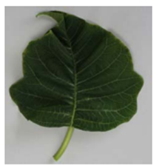 | 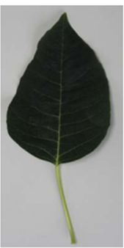 | 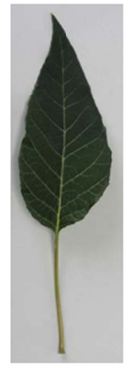 | 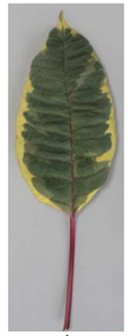 | 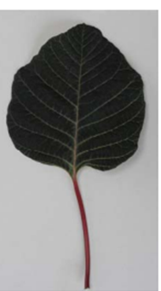
1  deltate | 2  ovate | 3  lanceolate | 4  elliptic | 5  circular

Ad. 11: Leaf blade: shape of base

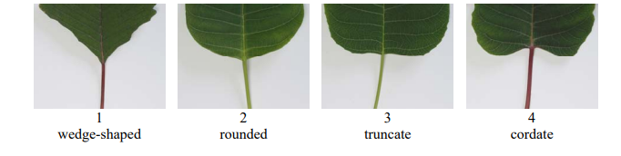
1  wedge-shaped | 2  rounded | 3  truncate | 4  cordate

Ad. 12: Leaf blade: number of colors of upper side

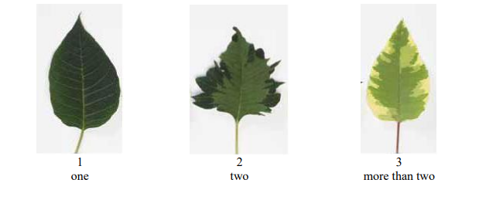
1  one | 2  two | 3  more than two

Ad. 18: Leaf blade: number of lobes

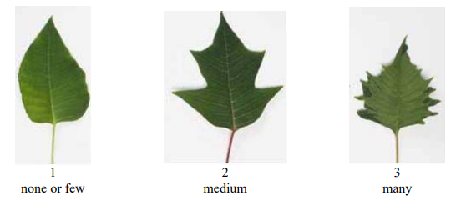
1  none or few | 2  medium | 3  many

Ad. 19: Leaf blade: depth of deepest sinus

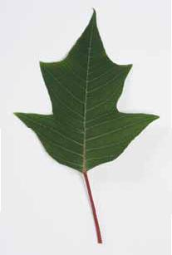
Depth of deepest sinus

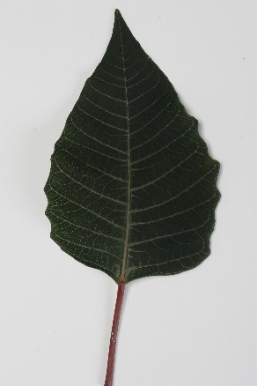 | 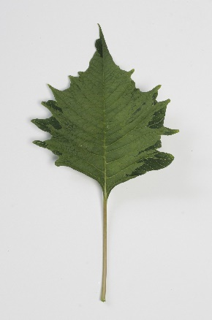 | 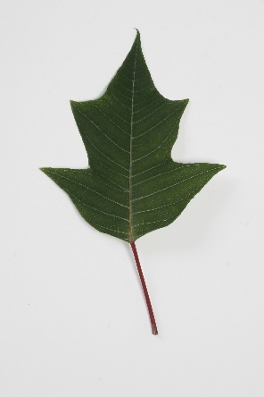
3 | 5 | 7
shallow | medium | deep

Ad. 20: Leaf blade: curvature along main vein

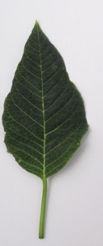 | 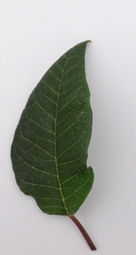 | 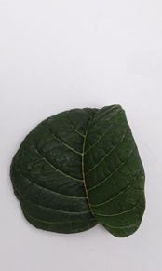
1 | 2 | 3
absent or weak | medium | strong

Ad. 25: Transitional leaves: number of partly bract‑colored leaf blades

partly bract-colored leaf blade
bract

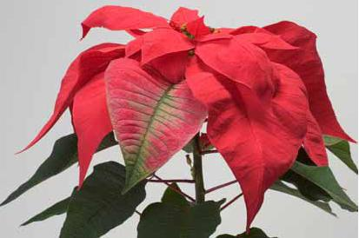
fully bract-colored leaf blade

Ad. 26: Transitional leaves: number of fully bract‑colored leaf blades

See Ad. 25

Ad. 27: Transitional leaf: number of lobes

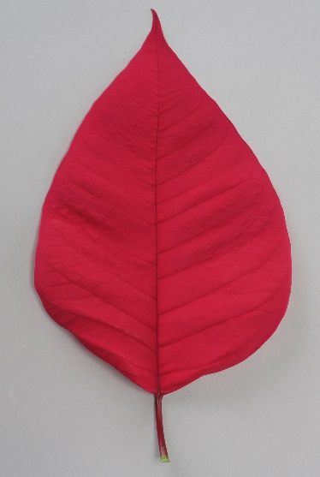 | 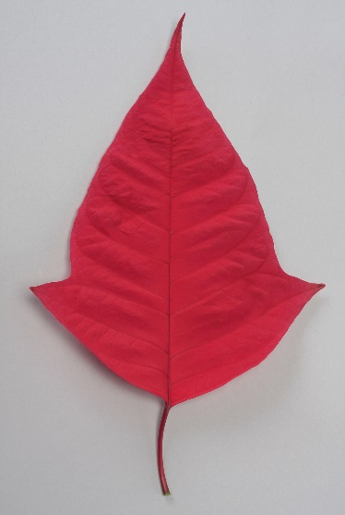 | 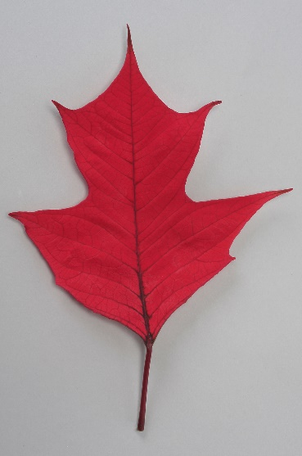
1 | 2 | 3
none or one | two | more than two

Ad. 28: Transitional leaf: curvature along main vein

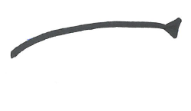 | 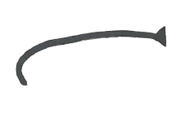 | 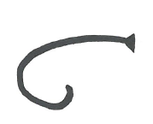
1 | 2 | 3
absent or weak | medium | strong

Ad. 29: Bracts: number

See Ad. 25

Ad. 30: Bract: length

Observations should be made including the petioles.

Ad. 32: Bract: shape

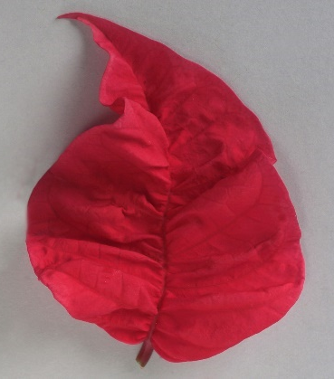 | 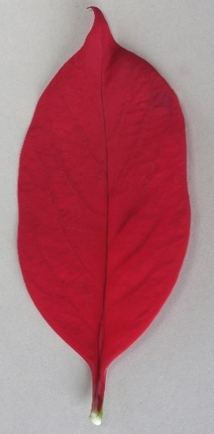 | 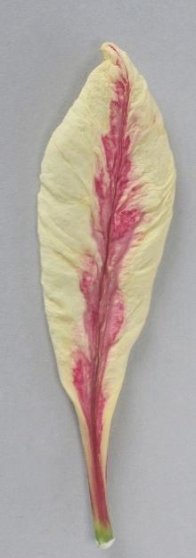 | 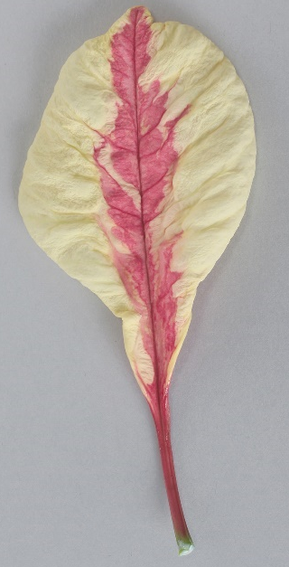
1 | 2 | 3 | 4
ovate | elliptic | oblanceolate | obovate

Ad. 35: Bract: distribution of secondary color of upper side

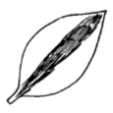 | 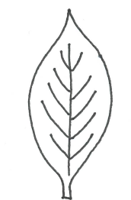 | 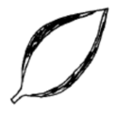 | 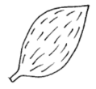
1 | 2 | 3 | 4
at center | at veins | at margin | throughout

Ad. 36: Bract: pattern of secondary color of upper side

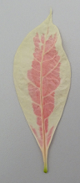 | 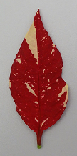 | 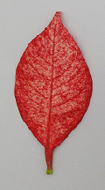 | 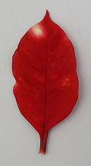
1 | 2 | 3 | 4
solid | irregular | small blotches | large speckles

Ad. 39: Bract: distribution of tertiary color of upper side

See Ad. 35

Ad. 43: Bract: distribution of secondary color of lower side

See Ad. 35

Ad. 46: Bract: distribution of tertiary color of lower side

See Ad. 35

Ad. 48: Bract: folding across main vein

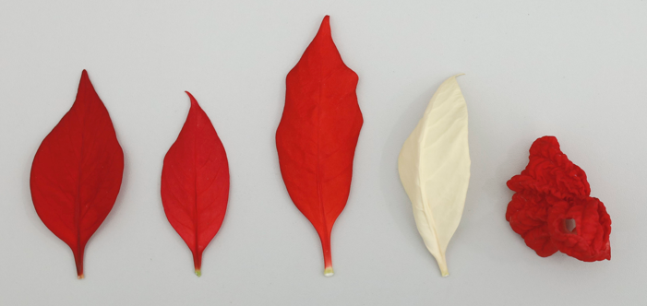
1 | 4
absent or very weak | strong

Ad. 49: Bract: twisting

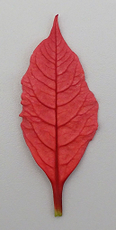 | 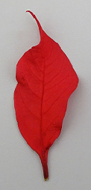 | 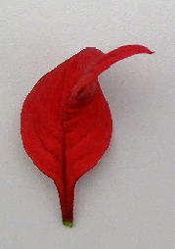
1 | 3 | 5
absent or very weak | medium | very strong

Ad. 51: Cyme: width
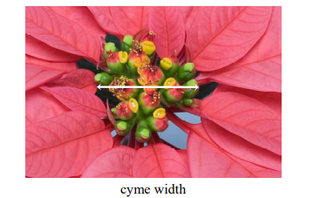
Cyme width

Ad. 54: Cyathium: deformation of glands

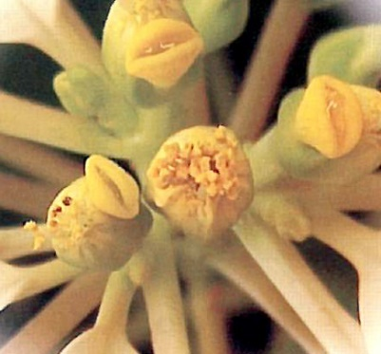 | 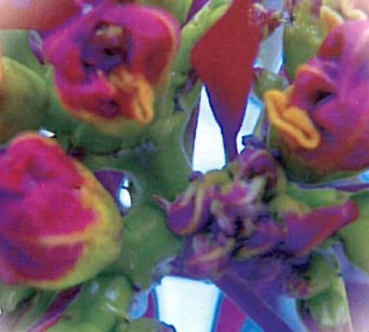
1 | 9
absent | present

9. | Literature

Ecke, P. et al., 2004: The Ecke Poinsettia Manual. Ball Publishing

10. | Technical Questionnaire

TECHNICAL QUESTIONNAIRE | Page {x} of {y} | Reference Number:

Application date:
(not to be filled in by the applicant)
TECHNICAL QUESTIONNAIRE
to be completed in connection with an application for plant breeders' rights

1. | Subject of the Technical Questionnaire
 |  | Botanical name
  1.1.1
  Euphorbia pulcherrima Willd. ex Klotzsch
  [ ]
 |  | Common name
  1.1.2
  Poinsettia
 |  | Botanical name
  1.2.1
  Euphorbia pulcherrima Willd. ex Klotzsch × Euphorbia cornastra (Dressler) Radcl.-Sm.
  [ ]
 |  | Common name | Poinsettia
  1.2.2
 | 1.3 | Species (please indicate:) |  | [ ]

2. | Applicant
 | Name
 | Address
 | Telephone No.
 | Fax No.
 | E-mail address
 | Breeder (if different from
 | applicant)

3. | Proposed denomination and breeder's reference
 | Proposed denomination
 | (if available)
 | Breeder's reference

TECHNICAL QUESTIONNAIRE |  |  | Page {x} of {y} | Reference Number:
 | Information on the breeding scheme and propagation of the variety
  #4.
 | 4.1 | Breeding scheme
 | Variety resulting from:
  4.1.1
  Crossing
 |  | [ ]
  (a)
  controlled cross
(please state parent variety)

(…………………..……………..…) x (……………..…………………..…)

female parent male parent

 |  | [ ]
  (b)
  partially known cross
(please state known parent variety(ies))

(…………………..……………..…) x (……………..…………………..…)

female parent male parent

 |  | [ ]
  (c)
  unknown cross
 |  | [ ]
  4.1.2
  Mutation
  (please state parent variety)
 |  | [ ]
  4.1.3
  Discovery and development
  (please state where and when discovered and how developed)
 | Other  (Please provide details) | [ ]
  4.1.4

TECHNICAL QUESTIONNAIRE | Page {x} of {y} | Reference Number:

 | 4.2 | Method of propagating the variety
 |  | [ ]
  4.2.1
  Seed-propagated varieties
  4.2.2
  Vegetative propagation
 |  | [ ]
  (a)
  Cuttings
 |  | [ ]
  (b)
  In vitro propagation
 |  | [ ]
  (c)
  Other (state method)
 | Other  (Please provide details) | [ ]
  4.2.3

TECHNICAL QUESTIONNAIRE | Page {x} of {y} | Reference Number:

5. | Characteristics of the variety to be indicated (the number in brackets refers to the corresponding characteristic in Test Guidelines; please mark the note which best corresponds).

 | Characteristics | Example Varieties | Note
  5.1
  (12)
  Leaf blade: number of colors of upper side
  one
  DUEPRIMDON, Fiscor
  1 [ ]
  two
  Dueavant
  2 [ ]
  more than two
  Fismarble Silver
  3 [ ]
  5.2(i)
  (33)
  Bract: main color of upper side
  RHS Colour Chart (indicate reference number)
  5.2(ii)
  (33)
  Bract: main color of upper side
  white
  1 [ ]
  yellow
  2 [ ]
  pink
  3 [ ]
  orange red
  4 [ ]
  red
  5 [ ]
  purple
  6 [ ]
  other (please specify)
  [ ]
  5.3(i)
  (34)
  Bract: secondary color of upper side
  RHS Colour Chart (indicate reference number)
  5.3(ii)
  (34)
  Bract: secondary color of upper side
  white
  1 [ ]
  yellow
  2 [ ]
  pink
  3 [ ]
  orange red
  4 [ ]
  red
  5 [ ]
  purple
  6 [ ]
  other (please specify)
  [ ]
  none
  [ ]
  5.4
  (35)
  Bract: distribution of secondary color of upper side
 |  | NPCW18289
  at center
  1 [ ]
  at veins
  2 [ ]
 |  | Allegra Marble Improved
  at margin
  3 [ ]
 |  | WEL20390
  throughout
  4 [ ]

TECHNICAL QUESTIONNAIRE | Page {x} of {y} | Reference Number:

 | Characteristics | Example Varieties | Note
  5.5
  (36)
  Bract: pattern of secondary color of upper side
  solid
  Valenciana, Valsu
  1 [ ]
  irregular
  2 [ ]
  small blotches
  3 [ ]
  large speckles
  4 [ ]

TECHNICAL QUESTIONNAIRE | Page {x} of {y} | Reference Number:

6. | Similar varieties and differences from these varieties
Please use the following table and box for comments to provide information on how your candidate variety differs from the variety (or varieties) which, to the best of your knowledge, is (or are) most similar. This information may help the examination authority to conduct its examination of distinctness in a more efficient way.

  Denomination(s) of variety(ies) similar to your candidate variety
  Characteristic(s) in which your candidate variety differs from the similar variety(ies)
  Describe the expression of the characteristic(s) for the similar variety(ies)
  Describe the expression of the characteristic(s) for your candidate variety

Example
  Leaf blade: shape
  deltate
  circular

 | Comments:

TECHNICAL QUESTIONNAIRE | Page {x} of {y} | Reference Number:

 | Additional information which may help in the examination of the variety
  #7.
7.1 | In addition to the information provided in sections 5 and 6, are there any additional characteristics which may help to distinguish the variety?
 | Yes | [ ] | No | [ ]
 | (If yes, please provide details)
7.2 | Are there any special conditions for growing the variety or conducting the examination?
 | Yes | [ ] | No | [ ]
 | (If yes, please provide details)
7.3 | Other information
A representative color photograph of the variety displaying its main distinguishing feature(s), should accompany the Technical Questionnaire. The photograph will provide a visual illustration of the candidate variety which supplements the information provided in the Technical Questionnaire.
The key points to consider when taking a photograph of the candidate variety are:
• Indication of the date and geographic location
• Correct labeling (breeder’s reference)
• Good quality printed photograph (minimum 10 cm x 15 cm) and/or sufficient resolution electronic format version (minimum 960 x 1280 pixels)”
Further guidance on providing photographs with the Technical Questionnaire is available in document TGP/7 "Development of Test Guidelines", Guidance Note 35 (http://www.upov.int/tgp/en/).
[The link provided may be deleted by members of the Union when developing authorities’ own test guidelines.]

TECHNICAL QUESTIONNAIRE | Page {x} of {y} | Reference Number:

8. | Authorization for release
 | (a) | Does the variety require prior authorization for release under legislation concerning the protection of the environment, human and animal health?
 |  | Yes | [ ] | No | [ ]
 | (b) | Has such authorization been obtained?
 |  | Yes | [ ] | No | [ ]
 | If the answer to (b) is yes, please attach a copy of the authorization.

9. Information on plant material to be examined or submitted for examination

9.1 The expression of a characteristic or several characteristics of a variety may be affected by factors, such as pests and disease, chemical treatment (e.g. growth retardants or pesticides), effects of tissue culture, different rootstocks, scions taken from different growth phases of a tree, etc.
9.2 The plant material should not have undergone any treatment which would affect the expression of the characteristics of the variety, unless the competent authorities allow or request such treatment. If the plant material has undergone such treatment, full details of the treatment must be given. In this respect, please indicate below, to the best of your knowledge, if the plant material to be examined has been subjected to:

 | (a) | Microorganisms (e.g. virus, bacteria, phytoplasma) | Yes [ ] | No [ ]
 | (b) | Chemical treatment (e.g. growth retardant, pesticide) | Yes [ ] | No [ ]
 | (c) | Tissue culture | Yes [ ] | No [ ]
 | (d) | Other factors | Yes [ ] | No [ ]
 | Please provide details for where you have indicated “yes”.

10. | I hereby declare that, to the best of my knowledge, the information provided in this form is correct:
 | Applicant’s name
 | Signature |  | Date

[End of document]

