 |  |  |  | E  TG/LYCIUM_BAR(proj.7)  ORIGINAL: English  DATE: 2026-03-10
INTERNATIONAL UNION FOR THE PROTECTION OF NEW VARIETIES OF PLANTS
Geneva
 |  | DRAFT

 | GOJI  UPOV Code(s): LYCIU_BAR; LYCIU_CHI; LYCIU_CYL; LYCIU_DAS; LYCIU_RUT; LYCIU_TRU; LYCIU_YUN  Lycium barbarum L.;  Lycium chinense Mill.;  Lycium cylindricum Kuang & A. M. Lu;  Lycium dasystemum Pojark.;  Lycium ruthenicum Murray;  Lycium truncatum Y. C. Wang;  Lycium yunnanense Kuang & A. M. Lu | *

GUIDELINES
FOR THE CONDUCT OF TESTS
FOR DISTINCTNESS, UNIFORMITY AND STABILITY

prepared by an expert from China

to be considered by the

Technical Committee for adoption by correspondence

Disclaimer: this document does not represent UPOV policies or guidance

Alternative Names:*

Nom botanique | anglais | français | allemand | espagnol
Lycium barbarum L., Lycium halimifolium Mill., Lycium vulgare Dunal | Barbary matrimony-vine,  Chinese boxthorn, Chinese wolfberry, Duke of Argyll's teaplant,  Duke of Argyll's teatree,  Himalayan goji, Tibetan goji, goji-berry, Matrimony-vine | Baie de Goji,  Lyciet commun,  Lyciet de Barbarie | Bocksdorn | Baya de goji
Lycium chinense Mill. | Chinese Boxthorn, Chinese Matrimony-vine,  Chinese Wolfberry, Duke of Argyle's Tea Tree, Wolfberry | Lyciet de Chine, Baie de Goji | Chinesischer Bocksdorn
Lycium cylindricum Kuang & A. M. Lu
Lycium dasystemum Pojark.
Lycium ruthenicum Murray
Lycium truncatum Y. C. Wang
Lycium yunnanense Kuang & A. M. Lu

The purpose of these guidelines (“Test Guidelines”) is to elaborate the principles contained in the General Introduction (document TG/1/3), and its associated TGP documents, into detailed practical guidance for the harmonized examination of distinctness, uniformity and stability (DUS) and, in particular, to identify appropriate characteristics for the examination of DUS and production of harmonized variety descriptions.

ASSOCIATED DOCUMENTS

These Test Guidelines should be read in conjunction with the General Introduction and its associated
TGP documents.

TABLE OF CONTENTS PAGE
1. Subject of these Test Guidelines 4
2. Material Required 4
3. Method of Examination 4
3.1 Number of Growing Cycles 4
3.2 Testing Place 4
3.3 Conditions for Conducting the Examination 4
3.4 Test Design 4
3.5 Additional Tests 5
4. Assessment of Distinctness, Uniformity and Stability 5
4.1 Distinctness 5
4.2 Uniformity 6
4.3 Stability 6
5. Grouping of Varieties and Organization of the Growing Trial 6
6. Introduction to the Table of Characteristics 7
6.1 Categories of Characteristics 7
6.2 States of Expression and Corresponding Notes 7
6.3 Types of Expression 7
6.4 Example Varieties 8
6.5 Legend 9
7. Table of Characteristics/Tableau des caracteres/Merkmalstabelle/Tabla de caracteres 10
8. Explanations on the Table of Characteristics 16
8.1 Explanations covering several characteristics 16
8.2 Explanations for individual characteristics 16
9. Literature 23
10. Technical Questionnaire 24

Subject of these Test Guidelines

1.1 These Test Guidelines apply to all varieties of Lycium barbarum L., Lycium chinense Mill., Lycium cylindricum Kuang & A. M. Lu, Lycium dasystemum Pojark., Lycium ruthenicum Murray, Lycium truncatum Y. C. Wang and Lycium yunnanense Kuang & A. M. Lu.

1.2 Guidance on the use of Test Guidelines for species in the same genus / interspecific hybrids that are not explicitly covered by Test Guidelines is provided in document TGP/13"Guidance for New Types and Species".

Material Required

2.1 The competent authorities decide on the quantity and quality of the plant material required for testing the variety and when and where it is to be delivered. Applicants submitting material from a State other than that in which the testing takes place must ensure that all customs formalities and phytosanitary requirements are complied with.

2.2 The material is to be supplied in the form of vegetatively propagated plants.

2.3 The minimum quantity of plant material, to be supplied by the applicant, should be:

5 plants.
2.4 The plant material supplied should be visibly healthy, not lacking in vigor, nor affected by any important pest or disease.

2.5 The plant material should not have undergone any treatment which would affect the expression of the characteristics of the variety, unless the competent authorities allow or request such treatment. If it has been treated, full details of the treatment must be given.

Method of Examination

3.1 Number of Growing Cycles

3.1.1 The minimum duration of tests should normally be two independent growing cycles.

3.1.2 The two independent growing cycles may be observed from a single planting, examined in two separate growing cycles.

3.1.3 In particular, it is essential that the plants produce a satisfactory crop of fruit in each of the two growing cycles.

3.1.4 The growing cycle is considered to be the duration of a single growing season, beginning with the dormancy period, followed by bud burst (flowering and/or vegetative), flowering and fruit harvest and concluding when the following dormant period starts.

3.1.5 The testing of a variety may be concluded when the competent authority can determine with certainty the outcome of the test.

3.2 Testing Place

Tests are normally conducted at one place. In the case of tests conducted at more than one place, guidance is provided in TGP/9 “Examining Distinctness”.

3.3 Conditions for Conducting the Examination

The tests should be carried out under conditions ensuring satisfactory growth for the expression of the relevant characteristics of the variety and for the conduct of the examination.

3.4 Test Design

3.4.1 Each test should be designed to result in a total of at least 5 plants.

3.4.2 The design of the tests should be such that plants or parts of plants may be removed for measurement or counting without prejudice to the observations which must be made up to the end of the growing cycle.

3.5 Additional Tests

Additional tests, for examining relevant characteristics, may be established.

Assessment of Distinctness, Uniformity and Stability

4.1 Distinctness

4.1.1 General Recommendations

It is of particular importance for users of these Test Guidelines to consult the General Introduction prior to making decisions regarding distinctness. However, the following points are provided for elaboration or emphasis in these Test Guidelines.

4.1.2 Consistent Differences

The differences observed between varieties may be so clear that more than one growing cycle is not necessary. In addition, in some circumstances, the influence of the environment is not such that more than a single growing cycle is required to provide assurance that the differences observed between varieties are sufficiently consistent. One means of ensuring that a difference in a characteristic, observed in a growing trial, is sufficiently consistent is to examine the characteristic in at least two independent growing cycles.

4.1.3 Clear Differences

Determining whether a difference between two varieties is clear depends on many factors, and should consider, in particular, the type of expression of the characteristic being examined, i.e. whether it is expressed in a qualitative, quantitative, or pseudo-qualitative manner. Therefore, it is important that users of these Test Guidelines are familiar with the recommendations contained in the General Introduction prior to making decisions regarding distinctness.

4.1.4 Number of Plants or Parts of Plants to be Examined

Unless otherwise indicated, for the purposes of distinctness, all observations on single plants should be made on 3 plants or parts of plants taken from each of 3 plants and any other observations made on all plants in the test, disregarding any off-type plants.

In the case of observations of parts taken from single plants, the number of parts to be taken from each of the plants should be 2.

4.1.5 Method of Observation

The recommended method of observing the characteristic for the purposes of distinctness is indicated by the following key in the Table of Characteristics (see document TGP/9 “Examining Distinctness”, Section 4 “Observation of characteristics”):

MG: single measurement of a group of plants or parts of plants
MS: measurement of a number of individual plants or parts of plants
VG: visual assessment by a single observation of a group of plants or parts of plants
VS: visual assessment by observation of individual plants or parts of plants”):

Type of observation: visual (V) or measurement (M)

“Visual” observation (V) is an observation made on the basis of the expert’s judgment. For the purposes of this document, “visual” observation refers to the sensory observations of the experts and, therefore, also includes smell, taste and touch. Visual observation includes observations where the expert uses reference points (e.g. diagrams, example varieties, side-by-side comparison) or non-linear charts (e.g. color charts). Measurement (M) is an objective observation against a calibrated, linear scale e.g. using a ruler, weighing scales, colorimeter, dates, counts, etc.

Type of record: for a group of plants (G) or for single, individual plants (S)

For the purposes of distinctness, observations may be recorded as a single record for a group of plants or parts of plants (G), or may be recorded as records for a number of single, individual plants or parts of plants (S). In most cases, “G” provides a single record per variety and it is not possible or necessary to apply statistical methods in a plant-by-plant analysis for the assessment of distinctness.

In cases where more than one method of observing the characteristic is indicated in the Table of Characteristics (e.g. VG/MG), guidance on selecting an appropriate method is provided in document TGP/9, Section 4.2.

4.2 Uniformity

4.2.1 It is of particular importance for users of these Test Guidelines to consult the General Introduction prior to making decisions regarding uniformity. However, the following points are provided for elaboration or emphasis in these Test Guidelines:

4.2.2 These Test Guidelines have been developed for the examination of vegetatively propagated varieties. For varieties with other types of propagation, the recommendations in the General Introduction and document TGP/13 "Guidance for new types and species" Section 4.5 "Testing Uniformity" should be followed.

4.2.3 For the assessment of uniformity of vegetatively propagated varieties a population standard of 1% and an acceptance probability of at least 95% should be applied. In the case of a sample size of 5 plants, no off-types are allowed.

4.3 Stability

4.3.1 In practice, it is not usual to perform tests of stability that produce results as certain as those of the testing of distinctness and uniformity. However, experience has demonstrated that, for many types of variety, when a variety has been shown to be uniform, it can also be considered to be stable.

4.3.2 Where appropriate, or in cases of doubt, stability may be further examined by testing a new plant stock to ensure that it exhibits the same characteristics as those shown by the initial material supplied.

Grouping of Varieties and Organization of the Growing Trial

5.1 The selection of varieties of common knowledge to be grown in the trial with the candidate varieties and the way in which these varieties are divided into groups to facilitate the assessment of distinctness are aided by the use of grouping characteristics.

5.2 Grouping characteristics are those in which the documented states of expression, even where produced at different locations, can be used, either individually or in combination with other such characteristics: (a) to select varieties of common knowledge that can be excluded from the growing trial used for examination of distinctness; and (b) to organize the growing trial so that similar varieties are grouped together.

5.3 The following have been agreed as useful grouping characteristics:

(a) One-year-old shoot: presence of thorns (characteristic 6)
(b) Leaf: shape (characteristic 12)
(c) Corolla: color of lobes (characteristic 16)
(d) Fruit: shape in lateral view (characteristic 22)
(e) Fruit: color (characteristic 23)
(f) Fruit: mucron (characteristic 24)

5.4 Guidance for the use of grouping characteristics, in the process of examining distinctness, is provided through the General Introduction and document TGP/9 “Examining Distinctness”.

Introduction to the Table of Characteristics

6.1 Categories of Characteristics

6.1.1 Standard Test Guidelines Characteristics

Standard Test Guidelines characteristics are those which are approved by UPOV for examination of DUS and from which members of the Union can select those suitable for their particular circumstances.

6.1.2 Asterisked Characteristics

Asterisked characteristics (denoted by *) are those included in the Test Guidelines which are important for the international harmonization of variety descriptions and should always be examined for DUS and included in the variety description by all members of the Union, except when the state of expression of a preceding characteristic or regional environmental conditions render this inappropriate.

6.2 States of Expression and Corresponding Notes

6.2.1 States of expression are given for each characteristic to define the characteristic and to harmonize descriptions. Each state of expression is allocated a corresponding numerical note for ease of recording of data and for the production and exchange of the description.

6.2.2 All relevant states of expression are presented in the characteristic.

6.2.3 Further explanation of the presentation of states of expression and notes is provided in document TGP/7 “Development of Test Guidelines”.

6.3 Types of Expression

An explanation of the types of expression of characteristics (qualitative, quantitative and pseudo-qualitative) is provided in the General Introduction.

6.4 Example Varieties

Where appropriate, example varieties are provided to clarify the states of expression of each characteristic.

(1) | Lycium barbarum L. | FPW07
(1) | Lycium barbarum L. | Instant Success
(1) | Lycium barbarum L. | Jingqi 4 Hao
(1) | Lycium barbarum L. | Keqi 6081
(1) | Lycium barbarum L. | Keqi 6082
(1) | Lycium barbarum L. | Ningqi 1 Hao
(1) | Lycium barbarum L. | Ningqi 2 Hao
(1) | Lycium barbarum L. | Ningqi 3 Hao
(1) | Lycium barbarum L. | Ningqi 4 Hao
(1) | Lycium barbarum L. | Ningqi 5 Hao
(1) | Lycium barbarum L. | Ningqi 7 Hao
(1) | Lycium barbarum L. | Ningqi 8 Hao
(1) | Lycium barbarum L. | Ningnongqi 9 Hao
(1) | Lycium barbarum L. | Ningnongqi 18 Hao
(1) | Lycium barbarum L. | NQ1
(1) | Lycium barbarum L. | Qixin 1 Hao
(1) | Lycium barbarum L. | Qixin 3 Hao
(1) | Lycium barbarum L. | Ningnongqi 4 Hao
(1) | Lycium barbarum L. | Ningnongqi 5 Hao
(1) | Lycium barbarum L. | Ningnongqi 16 Hao
(1) | Lycium barbarum L. | Ningnongqi 19 Hao
(1) | Lycium barbarum L. | Ningnongqi 20 Hao
(2) | Lycium chinense Mill. | Tianjing 3 Hao
(3) | Lycium ruthenicum Murray. | Jinmozhu
(3) | Lycium ruthenicum Murray. | Linqi 1 Hao

6.5 Legend

 |  | English |  | français |  | deutsch | español | Example Varieties  Exemples  Beispielssorten  Variedades ejemplo | Note/  Nota
1 | 2 | 3 | 4 | 5 | 6 | 7
 |  | Name of characteristics in English |  | Nom du caractère en français |  | Name des Merkmals auf Deutsch | Nombre del carácter en español
 |  | states of expression |  | types d’expression |  | Ausprägungsstufen | tipos de expresión

1 Characteristic number

2 (*) Asterisked characteristic – see Chapter 6.1.2

3 Type of expression
QL Qualitative characteristic – see Chapter 6.3
QN Quantitative characteristic – see Chapter 6.3
PQ Pseudo-qualitative characteristic – see Chapter 6.3

4 Method of observation (and type of plot, if applicable)
MG, MS, VG, VS – see Chapter 4.1.5

5 (+) See Explanations on the Table of Characteristics in Chapter 8.2

6 (a)-(e) See Explanations on the Table of Characteristics in Chapter 8.1

7 Not applicable See Explanations on the Table of Characteristics in Chapter 8.3

(1), (2), (3) See Chapter 6.4

Table of Characteristics/Tableau des caracteres/Merkmalstabelle/Tabla de caracteres

 |  | English |  | français |  | deutsch | español | Example Varieties  Exemples  Beispielssorten  Variedades ejemplo | Note/  Nota
1. | (*) | PQ | VG | (+) | (a)
 |  | Plant: growth habit |  | Plante : port |  | Pflanze: Wuchsform | Planta: hábito de crecimiento
 |  | upright |  | dressé |  | aufrecht | erguido | Keqi 6081 (1) | 1
 |  | upright to spreading |  | dressé à étalé |  | aufrecht bis breitwüchsig | erguido a extendido | Ningqicai 1 Hao (1) | 2
 |  | spreading |  | étalé |  | breitwüchsig | extendido |  | 3
 |  | drooping |  | retombant |  | überhängend | colgante |  | 4
2. |  | QN | VG | (+) | (a)
 |  | Plant: number of basal shoots |  | Plante : nombre de pousses basales |  | Pflanze: Anzahl Basistriebe | Planta: número de ramas basales
 |  | few |  | petit |  | gering | bajo | NQ1 (1) | 1
 |  | medium |  | moyen |  | mittel | medio | FPW07 (1) | 2
 |  | many |  | élevé |  | hoch | alto | Instant Success (1) | 3
3. | (*) | QN | MG/VG | (+)
 |  | One-year-old fruiting shoot: length |  | Rameau fructifère d'un an : longueur |  | Einjähriger Fruchttrieb: Länge | Rama fructífera de un año: longitud
 |  | short |  | courte |  | kurz | corta | Ningnongqi 5 Hao (1) | 1
 |  | short to medium |  | courte à moyenne |  | kurz bis mittel | corta a media |  | 2
 |  | medium |  | moyenne |  | mittel | media | Ningnongqi 20 Hao (1) | 3
 |  | medium to long |  | moyenne à longue |  | mittel bis lang | media a larga |  | 4
 |  | long |  | longue |  | lang | larga | Qixin 1 Hao (1) | 5
4. |  | QN | MG/VG | (+)
 |  | One-year-old fruiting shoot: thickness |  | Rameau fructifère d'un an : épaisseur |  | Einjähriger Fruchttrieb: Dicke | Rama fructífera de un año: grosor
 |  | thin |  | mince |  | dünn | delgado | Ningqi 1 Hao (1) | 1
 |  | medium |  | moyenne |  | mittel | medio | Ningqi 7 Hao (1) | 2
 |  | thick |  | épaisse |  | dick | grueso | Keqi 6082 (1) | 3
5. | (*) | QN | MG/VG |  | (b)
 |  | One-year-old fruiting shoot: length of internode |  | Rameau fructifère d'un an : longueur de l'entre-nœud |  | Einjähriger Fruchtrieb: Länge des Internodiums | Rama fructífera de un año: longitud del entrenudo
 |  | short |  | courte |  | kurz | corta | Jinmozhu (3) | 1
 |  | medium |  | moyenne |  | mittel | media | Ningnongqi 4 Hao (1) | 2
 |  | long |  | longue |  | lang | larga | Ningqi 2 Hao (1) | 3
6. | (*) | QL | VG |  | (b)
 |  | One-year-old shoot: presence of thorns |  | Rameau d'un an : présence d'épines |  | Einjähriger Trieb: Vorhandensein von Dornen | Rama de un año: presencia de espinas
 |  | absent |  | absente |  | fehlend | ausente |  | 1
 |  | present |  | présente |  | vorhanden | presente | Ningqi 3 Hao (1) | 9
7. |  | QN | MS/VG | (+) | (b)
 |  | One-year-old shoot: length of thorns |  | Rameau d'un an : longueur des épines |  | Einjähriger Trieb: Dornenlänge | Rama de un año: longitud de las espinas
 |  | short |  | courte |  | kurz | corta |  | 1
 |  | medium |  | moyenne |  | mittel | media | Ningnongqi 16 Hao (1) | 2
 |  | long |  | longue |  | lang | larga |  | 3
8. |  | PQ | VG | (+) | (a)
 |  | Bark: color |  | Écorce : couleur |  | Rinde: Farbe | Corteza: color
 |  | yellow brown |  | brun-jaune |  | gelbbraun | marrón amarillento | Ningqi 7 Hao (1) | 1
 |  | light brown |  | brun clair |  | hellbraun | marrón claro | Ningqi 5 Hao (1) | 2
 |  | dark brown |  | brun foncé |  | dunkelbraun | marrón oscuro | Ningqi 1 Hao (1) | 3
 |  | grey brown |  | brun-gris |  | graubraun | marrón grisáceo | Ningnongqi 9 Hao (1) | 4
9. | (*) | QN | MG/VG | (+) | (c)
 |  | Leaf: length |  | Feuille : longueur |  | Blatt: Länge | Hoja: longitud
 |  | short |  | courte |  | kurz | corta | Ningnongqi 5 Hao (1) | 1
 |  | short to medium |  | courte à moyenne |  | kurz bis mittel | corta a media | Ningqi 4 Hao (1) | 2
 |  | medium |  | moyenne |  | mittel | media | Ningqi 5 Hao (1) | 3
 |  | medium to long |  | moyenne à longue |  | mittel bis lang | media a larga | Ningqi 2 Hao (1) | 4
 |  | long |  | longue |  | lang | larga | Ningnongqi 20 Hao (1) | 5
10. | (*) | QN | MG/VG | (+) | (c)
 |  | Leaf: width |  | Feuille : largeur |  | Blatt: Breite | Hoja: anchura
 |  | narrow |  | étroite |  | schmal | estrecha | Jinmozhu (3), Ningnongqi 5 Hao (1) | 1
 |  | narrow to medium |  | étroite à moyenne |  | schmal bis mittel | estrecha a media | Ningqi 4 Hao (1) | 2
 |  | medium |  | moyenne |  | mittel | media | Ningqi 3 Hao (1) | 3
 |  | medium to broad |  | moyenne à large |  | mittel bis breit | media a ancha | Ningqi 7 Hao (1) | 4
 |  | broad |  | large |  | breit | ancha | Ningnongqi 4 Hao (1) | 5
11. | (*) | QN | MG/VG |  | (c)
 |  | Leaf: ratio length/width |  | Feuille : rapport longueur/largeur |  | Blatt: Verhältnis Länge/Breite | Hoja: relación longitud/anchura
 |  | low |  | bas |  | klein | baja | Ningnongqi 4 Hao (1) | 1
 |  | low to medium |  | bas à moyen |  | klein bis mittel | baja a media | Ningnongqi 18 Hao (1) | 2
 |  | medium |  | moyen |  | mittel | media | Ningqi 4 Hao (1) | 3
 |  | medium to high |  | moyen à élevé |  | mittel bis groß | media a alta | Ningqi 5 Hao (1) | 4
 |  | high |  | élevé |  | groß | alta | Ningqi 8 Hao (1) | 5
12. | (*) | PQ | VG | (+) | (c)
 |  | Leaf: shape |  | Feuille : forme |  | Blatt: Form | Hoja: forma
 |  | ovate |  | ovale |  | eiförmig | oval |  | 1
 |  | lanceolate |  | lancéolée |  | lanzettlich | lanceolada | Ningqi 7 Hao (1) | 2
 |  | linear |  | linéaire |  | linear | lineal |  | 3
 |  | oblanceolate |  | oblancéolée |  | verkehrt lanzettlich | oblanceolada |  | 4
13. | (*) | PQ | VG |  | (c)
 |  | Leaf: color on upper side |  | Feuille : couleur de la face supérieure |  | Blatt: Farbe der Oberseite | Hoja: color del haz
 |  | light green |  | vert clair |  | hellgrün | verde claro |  | 1
 |  | medium green |  | vert moyen |  | mittelgrün | verde medio | Ningqi 1 Hao (1) | 2
 |  | dark green |  | vert foncé |  | dunkelgrün | verde oscuro |  | 3
 |  | grey green |  | vert-gris |  | graugrün | verde grisáceo | Jinmozhu (3) | 4
 |  | yellow green |  | vert-jaune |  | gelbgrün | verde amarillento |  | 5
14. | (*) | PQ | VG | (+) | (c)
 |  | Leaf: shape of apex |  | Feuille : forme de l'apex |  | Blatt: Form des Apex | Hoja: forma del ápice
 |  | narrow acute |  | aiguë étroite |  | schmal spitz | aguda estrecha | Ningqi 5 Hao (1) | 1
 |  | medium acute |  | aiguë moyenne |  | mittel spitz | aguda media | Tianjing 3 Hao (2) | 2
 |  | obtuse |  | obtuse |  | stumpf | obtusa |  | 3
 |  | rounded |  | arrondie |  | abgerundet | redondeada |  | 4
15. |  | QN | MG/VG | (+) | (d)
 |  | Corolla: diameter |  | Corolle : diamètre |  | Blütenkrone: Durchmesser | Corola: diámetro
 |  | small |  | petit |  | klein | pequeño | Qixin 3 Hao (1) | 1
 |  | small to medium |  | petit à moyen |  | klein bis mittel | pequeño a medio | Ningqi 5 Hao (1) | 2
 |  | medium |  | moyen |  | mittel | medio | Jingqi 4 Hao (1) | 3
 |  | medium to large |  | moyen à grand |  | mittel bis groß | medio a grande | Keqi 6081 (1) | 4
 |  | large |  | grand |  | groß | grande | Ningnongqi 20 Hao (1) | 5
16. | (*) | QL | VG |  | (d)
 |  | Corolla: color of lobes |  | Corolle : couleur des lobes |  | Blütenkrone: Farbe der Lappen | Corola: color de los lóbulos
 |  | white |  | blanc |  | weiß | blanco |  | 1
 |  | purple |  | pourpre |  | purpurn | púrpura |  | 2
17. |  | QN | MG/VG | (+) | (d)
 |  | Corolla: length of tube |  | Corolle : longueur du tube |  | Blütenkrone: Länge der Röhre | Corola: longitud del tubo
 |  | short |  | courte |  | kurz | corta | Ningqi 7 Hao (1) | 1
 |  | medium |  | moyenne |  | mittel | media | Ningnongqi 5 Hao (1) | 2
 |  | long |  | longue |  | lang | larga | Keqi 6082 (1) | 3
18. | (*) | QN | VG | (+)
 |  | Shoot: density of fruits |  | Rameau : densité des fruits |  | Trieb: Fruchtdichte | Rama: densidad de frutos
 |  | sparse |  | lâche |  | locker | laxa |  | 1
 |  | sparse to medium |  | lâche à moyenne |  | locker bis mittel | laxa a media | Ningnongqi 20 Hao (1) | 2
 |  | medium |  | moyenne |  | mittel | media | Ningqi 5 Hao (1) | 3
 |  | medium to dense |  | moyenne à dense |  | mittel bis dicht | media a densa | Ningnongqi 16 Hao (1) | 4
 |  | dense |  | dense |  | dicht | densa | Ningqi 1 Hao (1) | 5
19. |  | QN | VG | (+) | (e)
 |  | Pedicel: attachment to calyx |  | Pédicelle : attache du calice |  | Blütenstiel: Kelchansatz | Pedicelo: unión con el cáliz
 |  | mostly symmetrical |  | principalement symétrique |  | überwiegend symmetrisch | mayormente simétrico | Ningnongqi 5 Hao (1) | 1
 |  | equally symmetrical and asymmetrical |  | également symétrique et asymétrique |  | gleichermaßen symmetrisch und asymmetrisch | igualmente simétrico y asimétrico | Ningnongqi 19 Hao (1) | 2
 |  | mostly asymmetrical |  | principalement asymétrique |  | überwiegend asymmetrisch | mayormente asimétrico | Ningnongqi 9 Hao (1) | 3
20. | (*) | QN | MG/VG | (+) | (e)
 |  | Fruit: length |  | Fruit : longueur |  | Frucht: Länge | Fruto: longitud
 |  | short |  | courte |  | kurz | corta | Ningnongqi 5 Hao (1) | 1
 |  | short to medium |  | courte à moyenne |  | kurz bis mittel | corta a media | Ningnongqi 4 Hao (1) | 2
 |  | medium |  | moyenne |  | mittel | media | Ningqi 1 Hao (1) | 3
 |  | medium to long |  | moyenne à longue |  | mittel bis lang | media a larga | Ningnongqi 9 Hao (1) | 4
 |  | long |  | longue |  | lang | larga | Ningqi 8 Hao (1) | 5
21. | (*) | QN | MG/VG | (+) | (e)
 |  | Fruit: width |  | Fruit : largeur |  | Frucht: Breite | Fruto: anchura
 |  | narrow |  | étroite |  | schmal | estrecha | Ningqi 2 Hao (1) | 1
 |  | medium |  | moyenne |  | mittel | media | Ningqi 7 Hao (1) | 2
 |  | broad |  | large |  | breit | ancha | Ningnongqi 18 Hao (1) | 3
22. | (*) | PQ | VG | (+) | (e)
 |  | Fruit: shape in lateral view |  | Fruit : forme en vue latérale |  | Frucht: Form in Seitenansicht | Fruto: forma en vista lateral
 |  | ovate |  | ovale |  | eiförmig | oval | Ningqi 2 Hao (1) | 1
 |  | oblate |  | arrondie-aplatie |  | breitrund | achatada | Linqi 1 Hao (3) | 2
 |  | circular |  | circulaire |  | kreisförmig | circular | Ningnongqi 5 Hao (1) | 3
 |  | rhombic |  | rhombique |  | rhombisch | rómbica |  | 4
 |  | elliptic |  | elliptique |  | elliptisch | elíptica | Ningqi 5 Hao (1) | 5
 |  | obovate |  | obovale |  | verkehrt eiförmig | oboval | Ningqi 7 Hao (1) | 6
23. | (*) | PQ | VG |  | (e)
 |  | Fruit: color |  | Fruit : couleur |  | Frucht: Farbe | Fruto: color
 |  | whitish |  | blanchâtre |  | weißlich | blanquecino |  | 1
 |  | yellow |  | jaune |  | gelb | amarillo | Ningnongqi 19 Hao (1) | 2
 |  | yellow orange |  | orange-jaune |  | gelborange | naranja amarillento | Ningnongqi 5 Hao (1) | 3
 |  | orange |  | orange |  | orange | naranja | Ningnongqi 20 Hao (1) | 4
 |  | orange red |  | rouge-orange |  | orangerot | rojo anaranjado | Ningnongqi 18 Hao (1) | 5
 |  | red |  | rouge |  | rot | rojo | Ningqi 1 Hao (1) | 6
 |  | purple red |  | rouge-pourpre |  | purpurrot | rojo púrpura | Qixin 3 Hao (1) | 7
 |  | dark purple |  | violet foncé |  | dunkelpurpurn | púrpura oscuro |  | 8
24. | (*) | QL | VG | (+) | (e)
 |  | Fruit: mucron |  | Fruit : mucron |  | Frucht: aufgesetzte Spitze | Fruto: mucrón
 |  | absent |  | absent |  | fehlend | ausente |  | 1
 |  | present |  | présent |  | vorhanden | presente |  | 9
25. | (*) | QN | VG | (+) | (e)
 |  | Fruit: length of stalk |  | Fruit : longueur du pédoncule |  | Frucht: Stiellänge | Fruto: longitud del pedúnculo
 |  | short |  | courte |  | kurz | corta | Linqi 1 Hao (3) | 1
 |  | short to medium |  | courte à moyenne |  | kurz bis mittel | corta a media | Ningnongqi 5 Hao (1) | 2
 |  | medium |  | moyenne |  | mittel | media | Ningqi 7 Hao (1) | 3
 |  | medium to long |  | moyenne à longue |  | mittel bis lang | media a larga | Qixin 1 Hao (1) | 4
 |  | long |  | longue |  | lang | larga | Keqi 6081 (1) | 5
26. | (*) | PQ | VG | (+) | (e)
 |  | Fruit: color of stalk |  | Fruit : couleur du pédoncule |  | Frucht: Farbe des Stiels | Fruto: color del pedúnculo
 |  | medium green |  | vert moyen |  | mittelgrün | verde medio | Ningqi 2 Hao (1) | 1
 |  | bluish green |  | vert bleuâtre |  | bläulichgrün | verde azulado | Ningqi 3 Hao (1) | 2
 |  | green and purple |  | vert et pourpre |  | grün und purpurn | verde y púrpura | Ningnongqi 4 Hao (1) | 3
27. | (*) | QN | MG/VG | (+)
 |  | Time of beginning of fruit maturity |  | Époque de début de maturité des fruits |  | Zeitpunkt des Beginns der Fruchtreife | Época de inicio de la madurez del fruto
 |  | early |  | précoce |  | früh | temprana | Ningqi 5 Hao (1) | 1
 |  | medium |  | moyenne |  | mittel | media | Ningqi 1 Hao (1) | 2
 |  | late |  | tardive |  | spät | tardía | Ningnongqi 4 Hao (1) | 3

Explanations on the Table of Characteristics

8.1 Explanations covering several characteristics

Characteristics containing the following key in the Table of Characteristics should be examined as indicated below:

(a) Observations should be made on dormant plants.

(b) Observations should be made on the middle third of a one-year-old shoot in the dormant period.
(c) Observations should be made on the fully developed leaves taken from the middle third of a current-year's fruiting shoot.

(d) Observations should be made on fully open flowers taken from the middle third of a fruiting shoot.

(e) Observations should be made on fully ripened fruits taken from the middle third of a fruiting shoot.

8.2 Explanations for individual characteristics

Ad. 1: Plant: growth habit

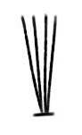 | 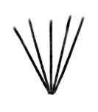 |  | 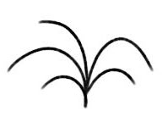
1 | 2 | 3 | 4
upright | upright to spreading | spreading | drooping

Ad. 2: Plant: number of basal shoots

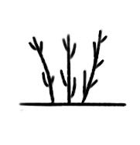 | 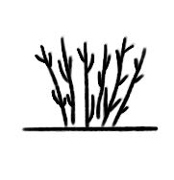 | 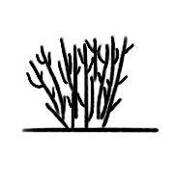
1 | 2 | 3
few | medium | many

Ad. 3: One-year-old fruiting shoot: length

Observations should be made on the whole length of one-year-old fruiting shoots in the dormant period.

Ad. 4: One-year-old fruiting shoot: thickness

Observations should be made on the middle third of one-year-old fruiting shoots in the dormant period.
Ad. 7: One-year-old shoot: length of thorns

Observations should be made on the longest thorn.

Ad. 8: Bark: color

Observations should be made on the middle third of two-year-old shoots.

Ad. 9: Leaf: length

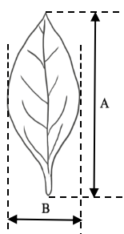

A = Leaf: length
B = Leaf: width

Ad. 10: Leaf: width

See Ad. 9.

Ad. 12: Leaf: shape

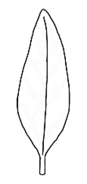 | 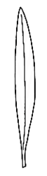 | 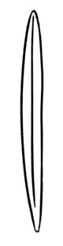 | 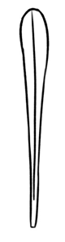
1 | 2 | 3 | 4
ovate | lanceolate | linear | oblanceolate

Ad. 14: Leaf: shape of apex

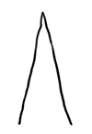 | 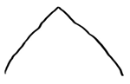 | 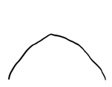 | 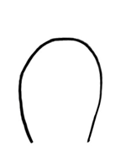
1 | 2 | 3 | 4
narrow acute | medium acute | obtuse | rounded

Ad. 15: Corolla: diameter

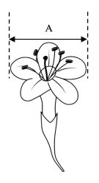
A = Corolla: diameter
Ad. 17: Corolla: length of tube

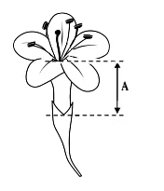
A = Corolla: length of tube

Ad. 18: Shoot: density of fruits

Observations should be made on the middle third of a fruiting shoot.

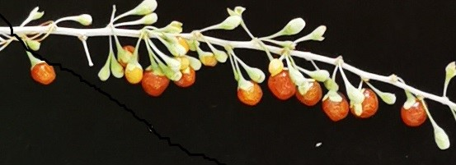 | 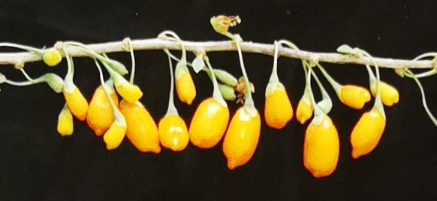 |  | 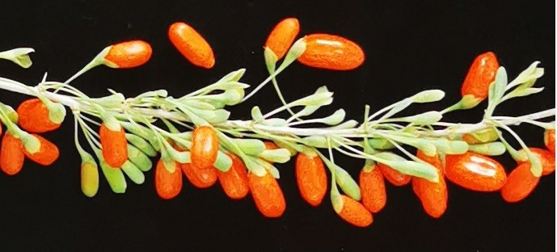
1 | 2 |  | 3
sparse | sparse to medium |  | medium
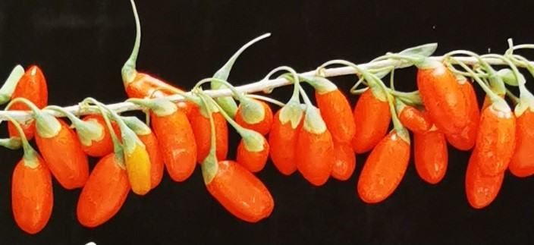 |  | 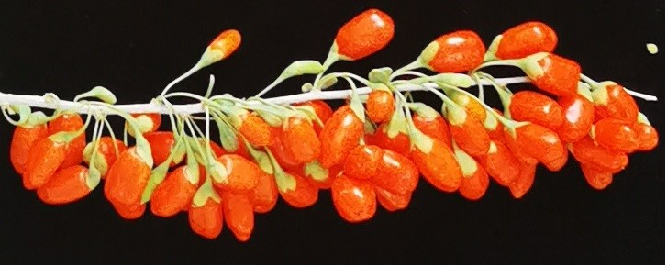
4 |  | 5
medium to dense |  | dense

Ad. 19: Pedicel: attachment to calyx

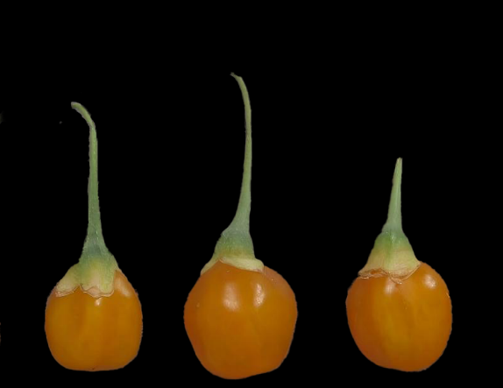 | 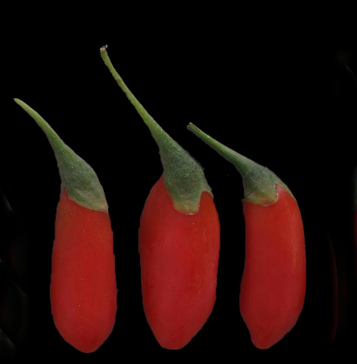
1 | 3
mostly symmetrical | mostly asymmetrical

Ad. 20: Fruit: length

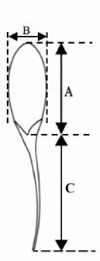
A = Fruit: length
B = Fruit: width
C = Fruit: length of stalk

Ad. 21: Fruit: width

See Ad. 20.

Ad. 22: Fruit: shape in lateral view

 |  | ← broadest part →
 |  | below middle | at middle |  |  | above middle
width (ratio length/width)
narrow  (high) |  | 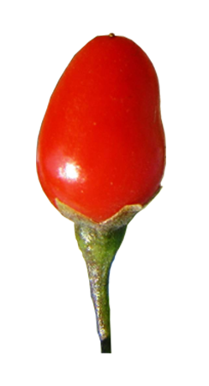  ovate  1 | 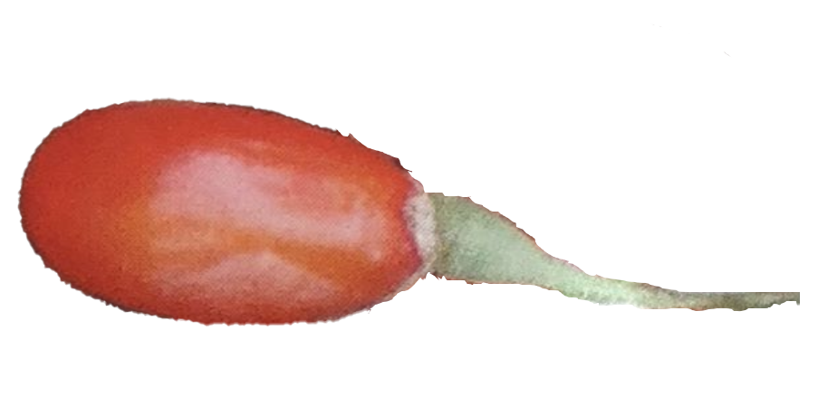  elliptic  5 |  |  | 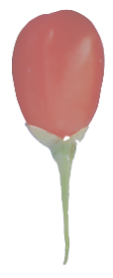  obovate  6
medium  (medium) |  |  | 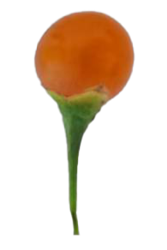  circular  3 | 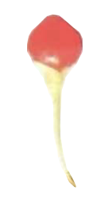  rhombic  4
broad  (low) |  |  | 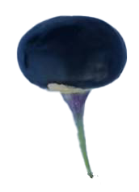  2  oblate

Ad. 24: Fruit: mucron
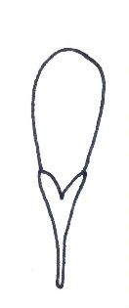 | 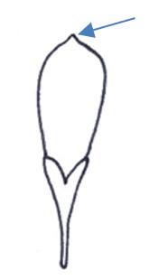
1 | 9
absent | present

Ad. 25: Fruit: length of stalk

See Ad. 20.

Ad. 26: Fruit: color of stalk

See Ad. 20.

Observations should be made including the calyx.

Ad. 27: Time of beginning of fruit maturity

Time of beginning of fruit maturity is reached when 10% of the fruiting shoots of the whole plant have mature fruits in the first fruit ripening period.

Literature

石志刚，杜慧莹，门慧芹，2012: 枸杞种质资源描述规范和数据标准. 中国林业出版社. 北京，中国, 66pp.
(Zhi-gang S., Hui-ying D., Huiqin M., 2012: Description specification and data standard of germplasm resources for Lycium L. China forestry publishing house. Beijing, CN, 66 pp.)

Technical Questionnaire

TECHNICAL QUESTIONNAIRE | Page {x} of {y} | Reference Number:
Application date:
(not to be filled in by the applicant)
TECHNICAL QUESTIONNAIRE
to be completed in connection with an application for plant breeders' rights
1. Subject of the Technical Questionnaire

1.1.1 Botanical name | Lycium barbarum L.
1.1.2 Common name
Barbary matrimony-vine, Chinese boxthorn, Chinese wolfberry, Duke of Argyll's teaplant, Duke of Argyll's teatree, Himalayan goji, Tibetan goji, goji-berry, Matrimony-vine
Lycium chinense Mill.
1.2.1 Botanical name
1.2.2 Common name
Chinese Boxthorn, Chinese Matrimony-vine, Chinese Wolfberry, Duke of Argyle's Tea Tree, Wolfberry
1.3.1 Botanical name | Lycium cylindricum Kuang & A. M. Lu
1.3.2 Common name
1.4.1 Botanical name | Lycium dasystemum Pojark.
1.4.2 Common name
1.5.1 Botanical name | Lycium ruthenicum Murray
1.5.2 Common name
1.6.1 Botanical name | Lycium truncatum Y. C. Wang
1.6.2 Common name
1.7.1 Botanical name | Lycium yunnanense Kuang & A. M. Lu
1.7.2 Common name
1.8.1 Botanical name | Other species, please specify
1.8.2 Common name

TECHNICAL QUESTIONNAIRE | Page {x} of {y} | Reference Number:
2. Applicant

Name
Address
Telephone No.
Fax No.
E-mail address
Breeder (if different from
applicant)
3. Proposed denomination and breeder's reference

Proposed denomination
(if available)
Breeder's reference

TECHNICAL QUESTIONNAIRE | Page {x} of {y} | Reference Number:

#4. Information on the breeding scheme and propagation of the variety

4.1 Breeding scheme

Variety resulting from:

4.1.1 Crossing

(a) controlled cross [ ]

(please state parent variety)

(…………………..……………..…) x (……………..…………………..…)

female parent male parent

(b) partially known cross [ ]

(please state parent variety(ies))

(…………………..……………..…) x (……………..…………………..…)

female parent male parent

(c) unknown cross [ ]

4.1.2 Mutation
(please state parent variety)

4.1.3 Discovery and development
(please state where and when discovered and how developed)

4.1.4 Other
(Please provide details)

TECHNICAL QUESTIONNAIRE | Page {x} of {y} | Reference Number:

4.2 Method of propagating the variety

4.2.1 Vegetative propagation

(a) Cuttings [ ]
(b) In vitro propagation [ ]
(c) Budding or grafting (please specify rootstock) [ ]
(d) Other (state method) [ ]

4.2.2 Other
(Please provide details) [ ]

TECHNICAL QUESTIONNAIRE |  | Page {x} of {y} |  | Reference Number:
5. Characteristics of the variety to be indicated (the number in brackets refers to the corresponding characteristic in Test Guidelines; please mark the note which best corresponds).

 | Characteristics |  | Example Varieties |  | Note
5.1  (1) | Plant: growth habit
 | upright |  | Keqi 6081 (1) |  | 1 [ ]
 | upright to spreading |  | Ningqicai 1 Hao (1) |  | 2 [ ]
 | spreading |  |  |  | 3 [ ]
 | drooping |  |  |  | 4 [ ]
5.2  (3) | One-year-old fruiting shoot: length
 | short |  | Ningnongqi 5 Hao (1) |  | 1 [ ]
 | short to medium |  |  |  | 2 [ ]
 | medium |  | Ningnongqi 20 Hao (1) |  | 3 [ ]
 | medium to long |  |  |  | 4 [ ]
 | long |  | Qixin 1 Hao (1) |  | 5 [ ]
5.3  (5) | One-year-old fruiting shoot: length of internode
 | short |  | Jinmozhu (3) |  | 1 [ ]
 | medium |  | Ningnongqi 4 Hao (1) |  | 2 [ ]
 | long |  | Ningqi 2 Hao (1) |  | 3 [ ]
5.4  (6) | One-year-old shoot: presence of thorns
 | absent |  |  |  | 1 [ ]
 | present |  | Ningqi 3 Hao (1) |  | 9 [ ]
5.5  (9) | Leaf: length
 | short |  | Ningnongqi 5 Hao (1) |  | 1 [ ]
 | short to medium |  | Ningqi 4 Hao (1) |  | 2 [ ]
 | medium |  | Ningqi 5 Hao (1) |  | 3 [ ]
 | medium to long |  | Ningqi 2 Hao (1) |  | 4 [ ]
 | long |  | Ningnongqi 20 Hao (1) |  | 5 [ ]
5.6  (10) | Leaf: width
 | narrow |  | Jinmozhu (3), Ningnongqi 5 Hao (1) |  | 1 [ ]
 | narrow to medium |  | Ningqi 4 Hao (1) |  | 2 [ ]
 | medium |  | Ningqi 3 Hao (1) |  | 3 [ ]
 | medium to broad |  | Ningqi 7 Hao (1) |  | 4 [ ]
 | broad |  | Ningnongqi 4 Hao (1) |  | 5 [ ]

TECHNICAL QUESTIONNAIRE |  | Page {x} of {y} |  | Reference Number:
 | Characteristics |  | Example Varieties |  | Note
5.7  (12) | Leaf: shape
 | ovate |  |  |  | 1 [ ]
 | lanceolate |  | Ningqi 7 Hao (1) |  | 2 [ ]
 | linear |  |  |  | 3 [ ]
 | oblanceolate |  |  |  | 4 [ ]
5.8  (16) | Corolla: color of lobes
 | white |  |  |  | 1 [ ]
 | purple |  |  |  | 2 [ ]
5.9  (20) | Fruit: length
 | short |  | Ningnongqi 5 Hao (1) |  | 1 [ ]
 | short to medium |  | Ningnongqi 4 Hao (1) |  | 2 [ ]
 | medium |  | Ningqi 1 Hao (1) |  | 3 [ ]
 | medium to long |  | Ningnongqi 9 Hao (1) |  | 4 [ ]
 | long |  | Ningqi 8 Hao (1) |  | 5 [ ]
5.10  (21) | Fruit: width
 | narrow |  | Ningqi 2 Hao (1) |  | 1 [ ]
 | medium |  | Ningqi 7 Hao (1) |  | 2 [ ]
 | broad |  | Ningnongqi 18 Hao (1) |  | 3 [ ]
5.11  (22) | Fruit: shape in lateral view
 | ovate |  | Ningqi 2 Hao (1) |  | 1 [ ]
 | oblate |  | Linqi 1 Hao (3) |  | 2 [ ]
 | circular |  | Ningnongqi 5 Hao (1) |  | 3 [ ]
 | rhombic |  |  |  | 4 [ ]
 | elliptic |  | Ningqi 5 Hao (1) |  | 5 [ ]
 | obovate |  | Ningqi 7 Hao (1) |  | 6 [ ]
5.12  (23) | Fruit: color
 | whitish |  |  |  | 1 [ ]
 | yellow |  | Ningnongqi 19 Hao (1) |  | 2 [ ]
 | yellow orange |  | Ningnongqi 5 Hao (1) |  | 3 [ ]
 | orange |  | Ningnongqi 20 Hao (1) |  | 4 [ ]
 | orange red |  | Ningnongqi 18 Hao (1) |  | 5 [ ]
 | red |  | Ningqi 1 Hao (1) |  | 6 [ ]
 | purple red |  | Qixin 3 Hao (1) |  | 7 [ ]
 | dark purple |  |  |  | 8 [ ]

TECHNICAL QUESTIONNAIRE |  | Page {x} of {y} |  | Reference Number:
 | Characteristics |  | Example Varieties |  | Note
5.13  (24) | Fruit: mucron
 | absent |  |  |  | 1 [ ]
 | present |  |  |  | 9 [ ]
5.14  (27) | Time of beginning of fruit maturity
 | early |  | Ningqi 5 Hao (1) |  | 1 [ ]
 | medium |  | Ningqi 1 Hao (1) |  | 2 [ ]
 | late |  | Ningnongqi 4 Hao (1) |  | 3 [ ]

TECHNICAL QUESTIONNAIRE |  | Page {x} of {y} |  | Reference Number:
6. Similar varieties and differences from these varieties

Please use the following table and box for comments to provide information on how your candidate variety differs from the variety (or varieties) which, to the best of your knowledge, is (or are) most similar. This information may help the examination authority to conduct its examination of distinctness in a more efficient way.

Denomination(s) of variety(ies) similar to your candidate variety | Characteristic(s) in which your candidate variety differs from the similar variety(ies) |  | Describe the expression of the characteristic(s) for the similar variety(ies) |  | Describe the expression of the characteristic(s) for your candidate variety
Example | Leaf: length |  | short |  | medium
Comments

TECHNICAL QUESTIONNAIRE | Page {x} of {y} | Reference Number:
#7. Additional information which may help in the examination of the variety

7.1 In addition to the information provided in sections 5 and 6, are there any additional characteristics which may help to distinguish the variety?

Yes [ ] No [ ]

(If yes, please provide details)

7.2 Are there any special conditions for growing the variety or conducting the examination?

Yes [ ] No [ ]

(If yes, please provide details)

7.3 Other information

A representative color photograph of the variety displaying its main distinguishing feature(s), should accompany the Technical Questionnaire. The photograph will provide a visual illustration of the candidate variety which supplements the information provided in the Technical Questionnaire.

The key points to consider when taking a photograph of the candidate variety are:

• Indication of the date and geographic location
• Correct labeling (breeder’s reference)
• Good quality printed photograph (minimum 10 cm x 15 cm) and/or sufficient resolution electronic format version (minimum 960 x 1280 pixels)”

Further guidance on providing photographs with the Technical Questionnaire is available in document TGP/7 "Development of Test Guidelines", Guidance Note 35 (http://www.upov.int/tgp/en/).

[The link provided may be deleted by members of the Union when developing authorities’ own test guidelines.]

TECHNICAL QUESTIONNAIRE | Page {x} of {y} | Reference Number:
8. Authorization for release

(a) Does the variety require prior authorization for release under legislation concerning the protection of the environment, human and animal health?

Yes [ ] No [ ]

(b) Has such authorization been obtained?

Yes [ ] No [ ]

If the answer to (b) is yes, please attach a copy of the authorization.

9. Information on plant material to be examined or submitted for examination

9.1 The expression of a characteristic or several characteristics of a variety may be affected by factors, such as pests and disease, chemical treatment (e.g. growth retardants or pesticides), effects of tissue culture, different rootstocks, scions taken from different growth phases of a tree, etc.

9.2 The plant material should not have undergone any treatment which would affect the expression of the characteristics of the variety, unless the competent authorities allow or request such treatment. If the plant material has undergone such treatment, full details of the treatment must be given. In this respect, please indicate below, to the best of your knowledge, if the plant material to be examined has been subjected to:

(a) Microorganisms (e.g. virus, bacteria, phytoplasma) Yes [ ] No [ ]

(b) Chemical treatment (e.g. growth retardant, pesticide) Yes [ ] No [ ]

(c) Tissue culture Yes [ ] No [ ]

(d) Other factors Yes [ ] No [ ]

Please provide details for where you have indicated “yes”.

____________________________________________________________

9.3 Has the plant material to be examined been tested for the presence of virus or other pathogens?

Yes [ ]

(please provide details as specified by the Authority)

No [ ]

10. I hereby declare that, to the best of my knowledge, the information provided in this form is correct:

Applicant’s name
Signature |  | Date
 | [End of document]

