 |  | E  TG/65/4 Rev. 4(proj.1)

INTERNATIONAL UNION FOR THE PROTECTION  OF NEW VARIETIES OF PLANTS | UNION INTERNATIONALE POUR LA PROTECTION  DES OBTENTIONS VÉGÉTALES | INTERNATIONALER VERBAND ZUM SCHUTZ VON PFLANZEN-ZÜCHTUNGEN | UNIÓN INTERNACIONAL PARA LA PROTECCIÓN  DE LAS OBTENCIONES VEGETALES

DRAFT

GUIDELINES

FOR THE CONDUCT OF TESTS

FOR DISTINCTNESS, UNIFORMITY AND STABILITY

prepared by an expert from the Netherlands (Kingdom of the)
to be considered by the
Technical Committee at its sixty-first session,
to be held Geneva from 2025-10-20 to 2025-10-21

Disclaimer: this document does not represent UPOV policies or guidance

This document contains the following changes proposed by the Technical Working Party for Vegetables (TWV), at its fifty-ninth session, presented in grey highlight:
- Addition of characteristics “Resistance to Plasmodiophora brassicae (Pb) – Races 0 to 3” at the end of the Table of Characteristics;
- Addition of explanation “Resistance to Plasmodiophora brassicae (Pb) – Races 0 to 3”;
- Addition of characteristics “Resistance to Plasmodiophora brassicae (Pb) – Races 0 to 3” to TQ 5. with option “not tested”.

KOHLRABI

(Brassica oleracea L. convar.
acephala (DC.) Alef. var. gongylodes L.;
Brassica oleracea L. Gongylodes Group)

GENEVA
2025

Copies of this document are available on request at the price of 10 Swiss francs each, including surface mail, from the Office of UPOV, 34, chemin des Colombettes, P.O. Box 18, 1211 Geneva 20, Switzerland

This document or parts of it may be reproduced, translated and published without obtaining the specific consent of UPOV, provided that the source is acknowledged.

* * * * * * *

E
TG/65/4 Rev. 4(proj.1)
ORIGINAL: English
DATE: 2025-09-18

INTERNATIONAL UNION FOR THE PROTECTION  OF NEW VARIETIES OF PLANTS | UNION INTERNATIONALE POUR LA PROTECTION  DES OBTENTIONS VÉGÉTALES | INTERNATIONALER VERBAND ZUM SCHUTZ VON PFLANZEN-ZÜCHTUNGEN | UNIÓN INTERNACIONAL PARA LA PROTECCIÓN  DE LAS OBTENCIONES VEGETALES

GUIDELINES

FOR THE CONDUCT OF TESTS

FOR DISTINCTNESS, UNIFORMITY AND STABILITY

KOHLRABI

(Brassica oleracea L. convar.
acephala (DC.) Alef. var. gongylodes L.;
Brassica oleracea L. Gongylodes Group)

These Guidelines should be read in conjunction with document TG/1/2, which contains explanatory notes on the general principles on which the Guidelines have been established.

TABLE OF CONTENTS PAGE

I. Subject of these Guidelines 3

II. Material Required 3

III. Conduct of Tests 3

IV. Methods and Observations 3

V. Grouping of Varieties 4

VI. Characteristics and Symbols 4

VII. Table of Characteristics 5

VIII. Explanations on Table of Characteristics 11

IX. Literature 18

X. Technical Questionnaire 19

I. Subject of these Guidelines

These Guidelines apply to all varieties of Brassica oleracea L. convar. acephala (DC.) Alef. var. gongylodes L. (Brassica oleracea L. Gongylodes Group).

II. Material Required

1. The competent authorities decide when, where and in what quantity and quality the seed required for testing the variety is to be delivered. Applicants submitting material from a State other than that in which the testing takes place must make sure that all customs formalities are complied with. As a minimum, for each year of the test the following quantity of seed is recommended:

20 g. or at least 4,000 seeds.

2. The seed should meet the minimum requirements for germination, species and analytical purity, health and moisture content, specified by the competent authority. In cases where the seed is to be stored, the germination capacity should be as high as possible and should be stated by the applicant.

3. The plant material must not have undergone any treatment unless the competent authorities allow or request such treatment. If it has been treated, full details of the treatment must be given.

III. Conduct of Tests

1. The minimum duration of tests should normally be two independent growing cycles.

2. The tests should normally be conducted at one place. If any important characteristics of the variety cannot be seen at that place, the variety may be tested at an additional place.

3. The tests should be carried out under conditions ensuring satisfactory growth for the expression of the relevant characteristics of the variety and for the conduct of the examination. The size of the plots should be such that plants or parts of plants may be removed for measurement and counting without prejudice to the observations which must be made up to the end of the growing period. Each test should be designed to result in a total of at least 40 plants, which should be divided between two or more replicates. Separate plots for observation and for measuring can only be used if they have been subject to similar environmental conditions.

4. Additional tests for special purposes may be established.

IV. Methods and Observations

1. Unless otherwise indicated, all observations determined by measurement, weighing or counting should be made on 40 plants or parts taken from each of 40 plants.

2. The assessment of uniformity for cross-pollinated varieties should be according to the recommendations in the General Introduction.

3. The assessment of uniformity for hybrid varieties depends on the type of hybrid and should be according to the recommendations in the General Introduction.

4. All observations on the plant and the leaf should be made before harvest maturity.

5. All observations on the kohlrabi should be made at harvest maturity.

V. Grouping of Varieties

1. The collection of varieties to be grown should be divided into groups to facilitate the assessment of distinctness. Characteristics which are suitable for grouping purposes are those which are known from experience not to vary, or to vary only slightly, within a variety. Their various states of expression should be fairly evenly distributed throughout the collection.

2. It is recommended that the competent authorities use the following characteristics for grouping varieties:

(a) Seedling: anthocyanin coloration of cotyledons (characteristic 1);
(b) Harvest maturity (characteristic 22).

VI. Characteristics and Symbols

1. To assess distinctness, uniformity and stability, the characteristics and their states as given in the Table of Characteristics should be used.

2. Notes (numbers), for the purposes of electronic data processing, are given opposite the states of expression for each characteristic.

3. Legend:

(*) Characteristics that should be used on all varieties in every growing period over which the examinations are made and always be included in the variety descriptions, except when the state of expression of a preceding characteristic or regional environmental conditions render this impossible.

(+) See Explanations on the Table of Characteristics in Chapter VIII.

VII. Table of Characteristics/Tableau des caractères/Merkmalstabelle/Tabla de caracteres

 |  | English |  | français | deutsch |  | español |  | Example Varieties  Exemples  Beispielssorten  Variedades ejemplo | Note/  Nota
1.  (*) |  | Seedling: anthocyanin coloration of cotyledons |  | Plantule: pigmentation anthocyanique des cotylédons | Keimpflanze: Anthocyanfärbung der Keimblätter |  | Plántula: pigmentación antociánica de los cotiledones
 |  | absent |  | absente | fehlend |  | ausente |  | Expreß Forcer | 1
 |  | present |  | présente | vorhanden |  | presente |  | Azur-Star | 9
2. |  | Seedling: intensity  of green coloration of cotyledons |  | Plantule: intensité de la couleur verte des cotylédons | Keimpflanze: Intensität der Grünfärbung der Keimblätter |  | Plántula: intensidad del color verde del cotiledón
 |  | light |  | faible | hell |  | clara |  | Erko | 3
 |  | medium |  | moyenne | mittel |  | media |  | Expreß Forcer | 5
 |  | dark |  | forte | dunkel |  | oscura |  | Eder | 7
3.  (+) |  | Petioles: crossing |  | Pétioles: recouvrement | Blattstiele: Überschlagen |  | Pecíolos: cruzamiento
 |  | absent |  | absent | fehlend |  | ausente |  | Expreß Forcer | 1
 |  | present |  | présent | vorhanden |  | presente |  | Delikateß blauer | 9
4.  (*) (+) |  | Petiole: length |  | Pétiole: longueur | Blattstiel: Länge |  | Pecíolo: longitud
 |  | very short |  | très court | sehr kurz |  | muy corto |  | Primavera weiß | 1
 |  | short |  | court | kurz |  | corto |  | Quickstar, Spree | 3
 |  | medium |  | moyen | mittel |  | medio |  | Patrick, Rolano | 5
 |  | long |  | long | lang |  | largo |  | Delikateß blauer | 7
 |  | very long |  | très long | sehr lang |  | muy largo |  |  | 9
5. |  | Petiole: thickness  (in the middle) |  | Pétiole: épaisseur (au centre) | Blattstiel: Dicke  (in der Mitte) |  | Pecíolo: grosor  (en el medio)
 |  | thin |  | mince | dünn |  | delgado |  | Avanti, Kohyro | 3
 |  | medium |  | moyenne | mittel |  | medio |  | Noriko, Rolano | 5
 |  | thick |  | forte | dick |  | grueso |  | Adriana | 7
6.  (*) |  | Petiole: attitude |  | Pétiole: port | Blattstiel: Haltung |  | Pecíolo: porte
 |  | erect |  | dressé | aufrecht |  | erecto |  | Eder, Pader | 1
 |  | semi-erect |  | demi-dressé | halbaufrecht |  | semierecto |  | Erko, Lanro | 3
 |  | horizontal |  | horizontal | waagerecht |  | horizontal |  |  | 5
7.  (*) |  | Leaf blade: attitude |  | Limbe: port | Blattspreite: Haltung |  | Limbo: porte
 |  | erect |  | dressé | aufrecht |  | erecto |  | Eder | 1
 |  | semi-erect |  | demi-dressé | halbaufrecht |  | semierecto |  | Erko, Lanro | 3
 |  | horizontal |  | horizontal | waagerecht |  | horizontal |  |  | 5
8.  (*)  (+) |  | Leaf blade: length |  | Limbe: longueur | Blattspreite: Länge |  | Limbo: longitud
 |  | very short |  | très court | sehr kurz |  | muy corto |  |  | 1
 |  | short |  | court | kurz |  | corto |  | Kohyro, Primavera weiß | 3
 |  | medium |  | moyen | mittel |  | medio |  | Domino, Logo | 5
 |  | long |  | long | lang |  | largo |  | Lanro, Noriko | 7
 |  | very long |  | très long | sehr lang |  | muy largo |  | Gigant, Superschmelz | 9
9.  (*)  (+) |  | Leaf blade: width |  | Limbe: largeur | Blattspreite: Breite |  | Limbo: anchura
 |  | very narrow |  | très étroit | sehr schmal |  | muy estrecho |  |  | 1
 |  | narrow |  | étroit | schmal |  | estrecho |  | Knaufs Ideal | 3
 |  | medium |  | moyen | mittel |  | medio |  | Expreß Forcer | 5
 |  | broad |  | large | breit |  | ancho |  | Noriko | 7
 |  | very broad |  | très large | sehr breit |  | muy ancho |  | Gigant, Superschmelz | 9
10.  (+) |  | Leaf blade: shape of apex |  | Limbe: forme de la partie apicale | Blattspreite: Form des oberen Teils |  | Limbo: forma del ápice
 |  | acute |  | aigüe | schmal spitz |  | aguda |  |  | 1
 |  | pointed |  | pointue | spitz |  | puntiaguda |  |  | 2
 |  | obtuse |  | obtuse | stumpf |  | obtusa |  | Avanti, Expreß Forcer | 3
 |  | rounded |  | arrondie | abgerundet |  | redondeada |  | Noriko, Spree | 4
 |  | broadly rounded |  | arrondie large | breit abgerundet |  | redondeada ancha |  | Gigant, Superschmelz | 5
11.  (+) |  | Leaf blade: number of margin incisions (on upper part of leaf) |  | Limbe: nombre d’incisions du bord (partie supérieure de la feuille) | Blattspreite: Anzahl Randeinschnitte  (am oberen Teil des Blattes) |  | Limbo: número de incisiones del borde (en la parte superior de la hoja)
 |  | absent or very few |  | nul ou très petit | fehlend oder  sehr gering |  | ausentes o  muy escasas |  |  | 1
 |  | few |  | petit | gering |  | escasas |  | Azur-Star | 3
 |  | medium |  | moyen | mittel |  | medias |  | Expreß Forcer | 5
 |  | many |  | grand | groß |  | numerosas |  |  | 7
 |  | very many |  | très grand | sehr groß |  | muy numerosas |  |  | 9
12.  (+) |  | Leaf blade: depth of margin incisions  (on upper part of leaf) |  | Limbe: profondeur des incisions du bord (partie supérieure de la feuille) | Blattspreite: Tiefe der Randeinschnitte (am oberen Teil des Blattes) |  | Limbo: profundidad de las incisiones del borde (en la parte superior de la hoja)
 |  | absent or  very shallow |  | nulle ou très faible | fehlend oder  sehr flach |  | ausentes o  muy poco profundas |  |  | 1
 |  | shallow |  | faible | flach |  | poco profundas |  | Oste | 3
 |  | medium |  | moyenne | mittel |  | medias |  | Expreß Forcer | 5
 |  | deep |  | profonde | tief |  | profundas |  | Soko | 7
 |  | very deep |  | très profonde | sehr tief |  | muy profundas |  |  | 9
13. |  | Leaf blade: shape in cross section |  | Limbe: forme en coupe transversale | Blattspreite: Form im Querschnitt |  | Limbo: forma en sección transversal
 |  | concave |  | concave | konkav |  | cóncava |  |  | 1
 |  | plane |  | droite | eben |  | plana |  | Expreß Forcer | 2
 |  | convex |  | convexe | konvex |  | convexa |  | Azur-Star, Erko | 3
14.  (*) |  | Leaf blade: blistering |  | Limbe: cloqûre | Blattspreite: Blasigkeit |  | Limbo: abullonado
 |  | weak |  | faible | gering |  | débil |  | Avanti | 3
 |  | medium |  | moyenne | mittel |  | media |  | Spree | 5
 |  | strong |  | forte | stark |  | fuerte |  | Lanro | 7
15. |  | Leaf blade: waxiness |  | Limbe: pruine | Blattspreite: Wachsschicht |  | Limbo: cerosidad
 |  | weak |  | faible | gering |  | débil |  |  | 3
 |  | medium |  | moyenne | mittel |  | media |  | Expreß Forcer | 5
 |  | strong |  | forte | stark |  | fuerte |  | Blaril | 7
16.  (*) |  | Leaf blade: hue of green color |  | Limbe: teinte de la couleur verte | Blattspreite: Ton der Grünfärbung |  | Limbo: tono del color verde
 |  | absent |  | absente | fehlend |  | ausente |  | Erko, Noriko | 1
 |  | greyish |  | grisâtre | gräulich |  | grisáceo |  | Expreß Forcer, Lanro | 2
 |  | bluish |  | bleuâtre | bläulich |  | azulado |  | Azur-Star | 3
17.  (*) |  | Leaf blade: intensity of green color |  | Limbe: intensité de la couleur verte | Blattspreite: Intensität der Grünfärbung |  | Limbo: intensidad del color verde
 |  | very light |  | très claire | sehr hell |  | muy claro |  |  | 1
 |  | light |  | claire | hell |  | claro |  |  | 3
 |  | medium |  | moyenne | mittel |  | medio |  | Noriko, Quickstar | 5
 |  | dark |  | foncée | dunkel |  | oscuro |  | Avanti, Lanro | 7
 |  | very dark |  | très foncée | sehr dunkel |  | muy oscuro |  | Pader | 9
18.  (+) |  | Kohlrabi: number of inner leaves |  | Rave: nombre de feuilles intérieures | Kohlrabi: Anzahl der inneren Blätter |  | Colinabo: número de hojas interiores
 |  | few |  | petit | gering |  | escasas |  | Erko | 3
 |  | medium |  | moyen | mittel |  | medias |  | Expreß Forcer | 5
 |  | many |  | grand | groß |  | numerosas |  | Lanro | 7
19.  (*) |  | Kohlrabi: color of skin |  | Rave: couleur de l’épiderme | Kohlrabi: Farbe der Haut |  | Colinabo: color de la epidermis
 |  | white |  | blanc | weiß |  | blanco |  | Beas | 1
 |  | white green |  | vert blanc | weißgrün |  | verde blanquecino |  | Bode, Expreß Forcer, Lanro, Timpano | 2
 |  | green |  | vert | grün |  | verde |  | Avaya, Erko, Gaston, Noriko | 3
 |  | violet |  | violet | violett |  | violeta |  | Azur-Star, Oder, Purpuran | 4
20.  (*)  (+) |  | Kohlrabi: shape  (in longitudinal section) |  | Rave: forme  (coupe longitudinale) | Kohlrabi: Form  (im Längsschnitt) |  | Colinabo: forma  (en sección longitudinal)
 |  | transverse narrow elliptic |  | elliptique transversal étroit | quer schmal elliptisch |  | elíptica transversal estrecha |  | Erko | 1
 |  | transverse elliptic |  | elliptique tranversal | quer elliptisch |  | elíptica transversal |  | Azur-Star, Quickstar | 2
 |  | transverse broad elliptic |  | elliptique transversal large | quer breit elliptisch |  | elíptica transversal ancha |  | Noriko | 3
 |  | circular |  | rond | rund |  | circular |  | Blaril | 4
 |  | broad elliptic |  | elliptique large | breit elliptisch |  | elíptica ancha |  |  | 5
21.  (+) |  | Kohlrabi: shape of apex |  | Rave: forme du sommet | Kohlrabi: Form des oberen Endes |  | Colinabo: forma del ápice
 |  | indented |  | concave | eingesunken |  | hundido |  | Expreß Forcer | 3
 |  | level |  | plane | eben |  | plano |  | Avanti, Spree | 5
 |  | raised |  | convexe | vorgewölbt |  | elevado |  | Gigant, Superschmelz | 7
22.  (*)  (+) |  | Harvest maturity |  | Maturité de récolte | Erntereife |  | Madurez para la cosecha
 |  | very early |  | très précoce | sehr früh |  | muy temprana |  | Expreß Forcer | 1
 |  | early |  | précoce | früh |  | temprana |  | Azur-Star, Quickstar | 3
 |  | medium |  | moyenne | mittel |  | media |  | Lanro | 5
 |  | late |  | tardive | spät |  | tardía |  | Delikateß blauer | 7
 |  | very late |  | très tardive | sehr spät |  | muy tardía |  | Blaril | 9
23.  (*)  (+) | VS/  MS |  | Male sterility | Stérilité mâle |  | Männliche Sterilität |  | Androesterilidad
QL |  |  | absent | absente |  | fehlend |  | ausente | Expreß Forcer, Lanro | 1
 |  |  | present | présente |  | vorhanden |  | presente | Erika, Morre, Oasis | 9
24.  (+) | VS² |  | Resistance to Plasmodiophora brassicae (Pb)  – Race Pb: 0 | Résistance à Plasmodiophora brassicae (Pb)  – Race Pb: 0 |  | Resistenz gegen Plasmodiophora brassicae (Pb)  – Pathotyp Pb: 0 |  | Resistencia a Plasmodiophora brassicae (Pb)  – Raza Pb: 0
QL³ |  |  | absent | absente |  | fehlend |  | ausente | Eder | 1
 |  |  | present | présente |  | vorhanden |  | presente | Fonda | 9
25.  (+) | VS² |  | Resistance to Plasmodiophora brassicae (Pb)  – Race Pb: 1 | Résistance à Plasmodiophora brassicae (Pb)  – Race Pb: 1 |  | Resistenz gegen Plasmodiophora brassicae (Pb)  – Pathotyp Pb: 1 |  | Resistencia a Plasmodiophora brassicae (Pb)  – Raza Pb: 1
QL³ |  |  | absent | absente |  | fehlend |  | ausente | Eder | 1
 |  |  | present | présente |  | vorhanden |  | presente | Fonda | 9
26.  (+) | VS² |  | Resistance to Plasmodiophora brassicae (Pb)  – Race Pb: 2 | Résistance à Plasmodiophora brassicae (Pb)  – Race Pb: 2 |  | Resistenz gegen Plasmodiophora brassicae (Pb)  – Pathotyp Pb: 2 |  | Resistencia a Plasmodiophora brassicae (Pb)  – Raza Pb: 2
QL³ |  |  | absent | absente |  | fehlend |  | ausente | Eder, Fonda | 1
 |  |  | present | présente |  | vorhanden |  | presente |  | 9
27.  (+) | VS² |  | Resistance to Plasmodiophora brassicae (Pb)  – Race Pb: 3 | Résistance à Plasmodiophora brassicae (Pb)  – Race Pb: 3 |  | Resistenz gegen Plasmodiophora brassicae (Pb)  – Pathotyp Pb: 3 |  | Resistencia a Plasmodiophora brassicae (Pb)  – Raza Pb: 3
QL³ |  |  | absent | absente |  | fehlend |  | ausente | Eder | 1
 |  |  | present | présente |  | vorhanden |  | presente | Fonda | 9

VIII. Explanations on the Table of Characteristics

Ad. 3: Petioles: crossing

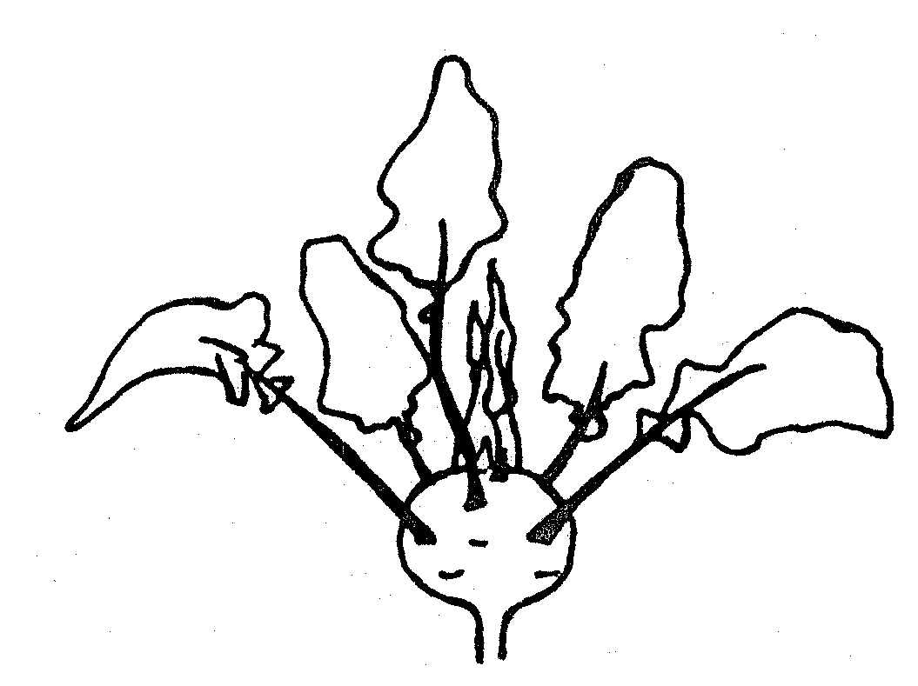 | 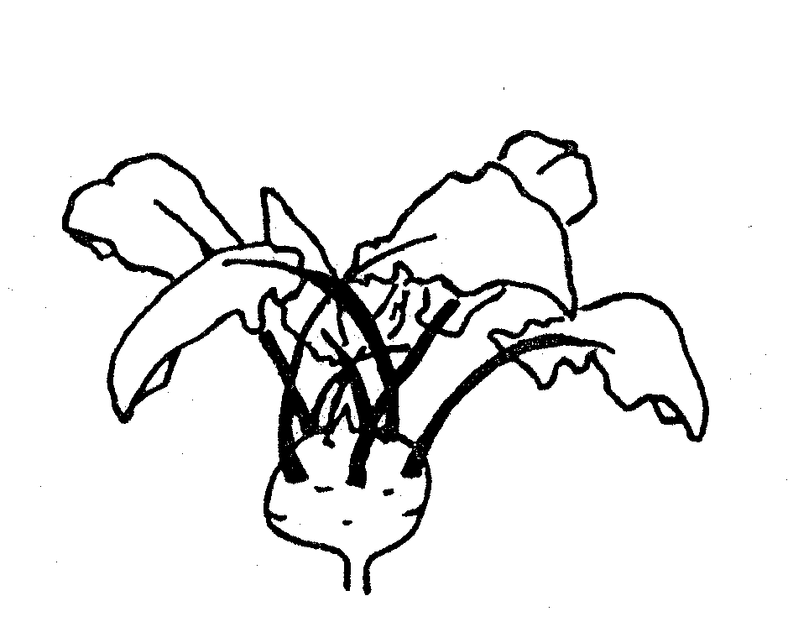
1 | 9
absent | present

Ad. 4: Petiole: length
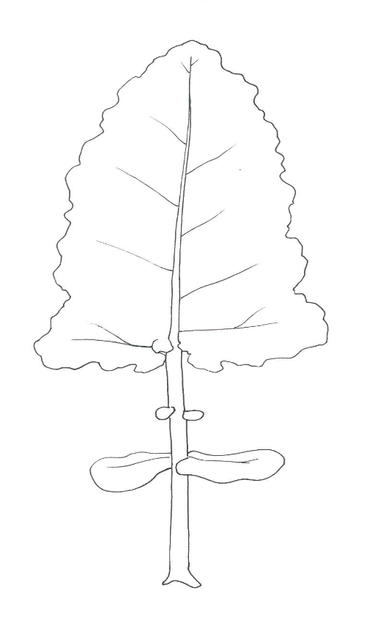
Ad. 8 and 9: Leaf blade: length and width

length of leaf blade

length of
petiole

width of leaf blade

Ad. 10: Leaf blade: shape of apex

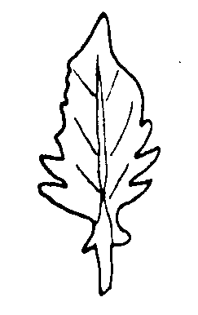 | 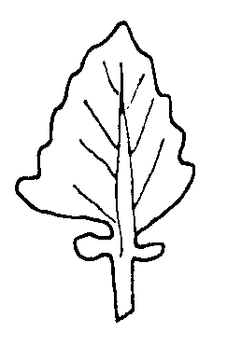 | 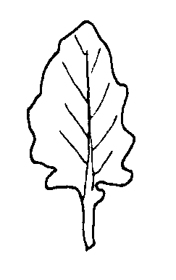 | 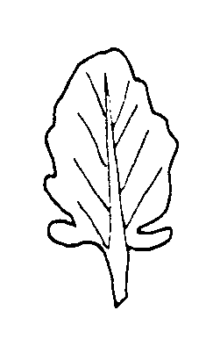 | 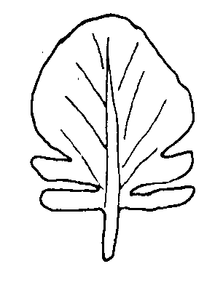
1 | 2 | 3 | 4 | 5
acute | pointed | obtuse | rounded | broadly rounded

Ad. 11-12: Leaf blade: margin incisions (11 and 12)

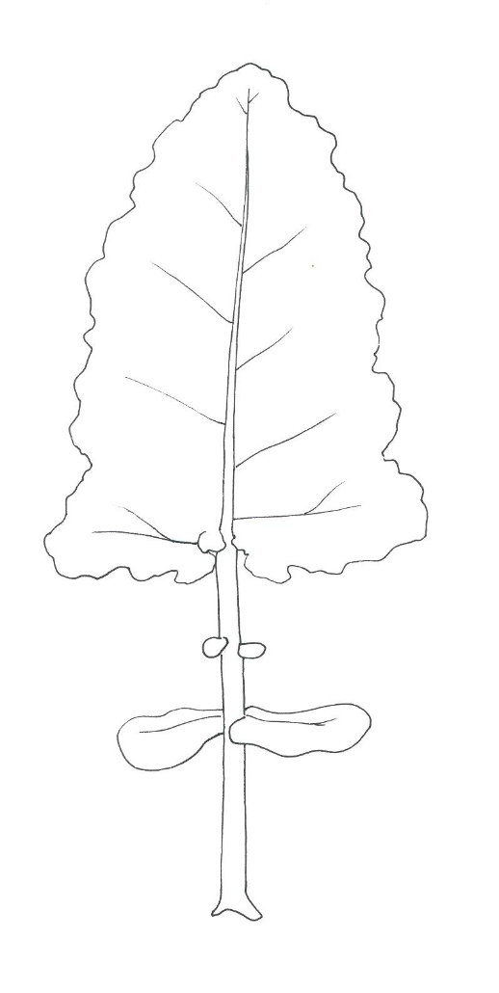

2

1

1

Upper part on which
margin incisions
should be recorded
(11 and 12)

lobes: parts of the leaf blade are considered as lobes if the upper notch has at least half the length of the lobe itself.
Lappen: Teile der Blattspreite werden als Lappen angesehen, wenn der obere Einschnitt mindestens die Hälfte der Länge des Lappens ausmacht.
.divisions to midrib

2 lobes

Ad. 18: Kohlrabi: number of inner leaves
1 = divisions to midrib

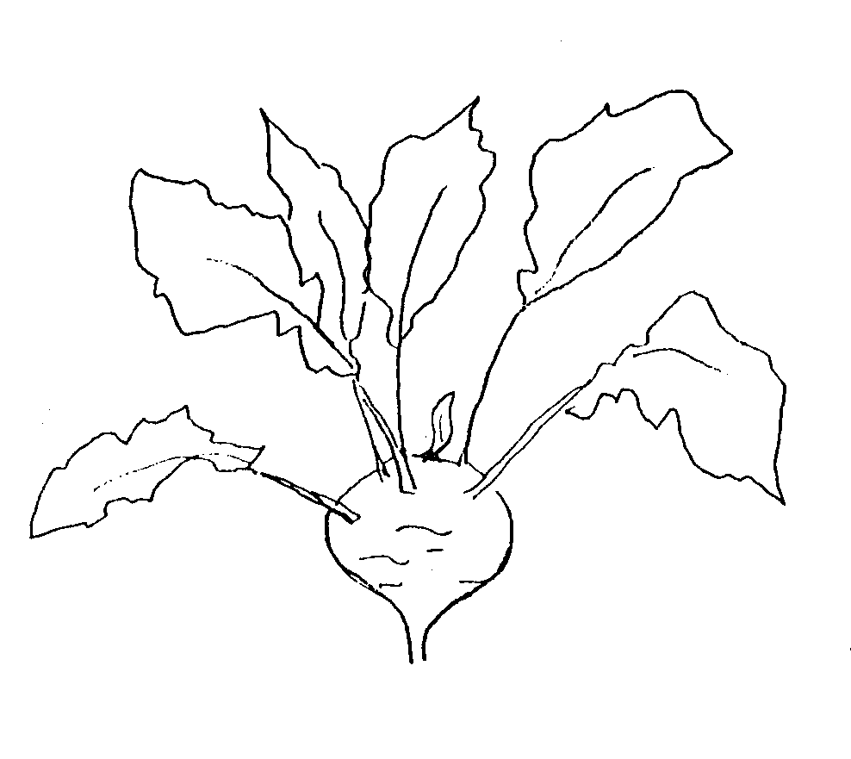 | 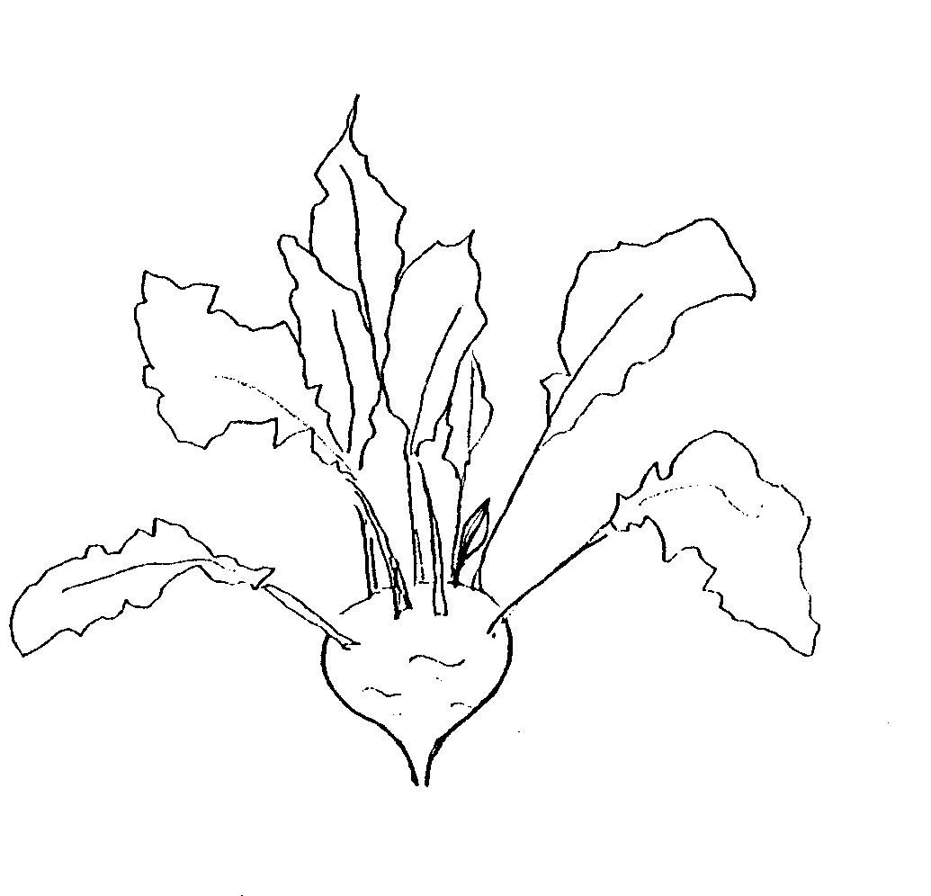 | 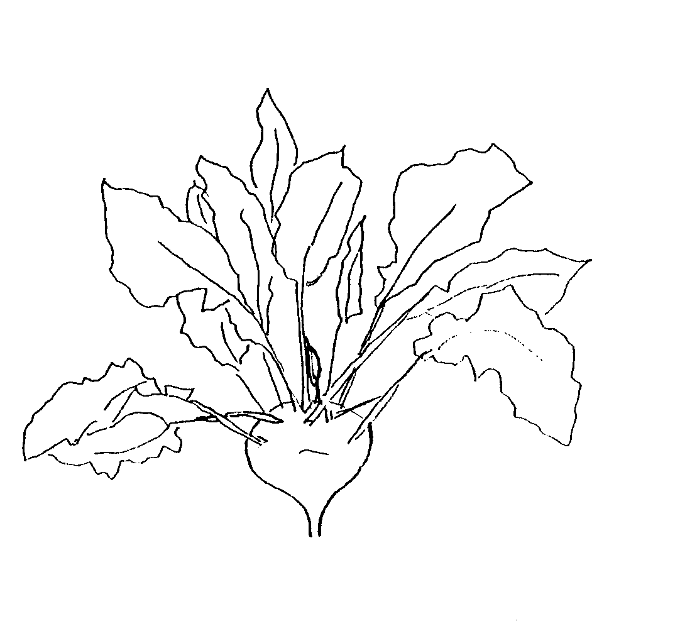
3 | 5 | 7
few | medium | many

Ad. 20: Kohlrabi: shape (in longitudinal section)

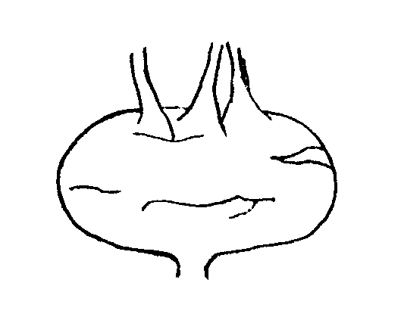 | 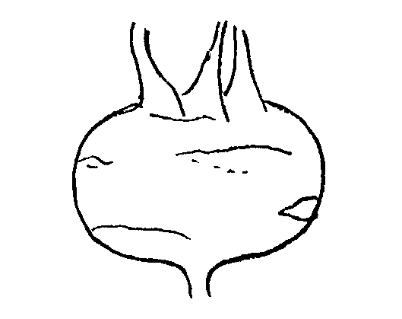 | 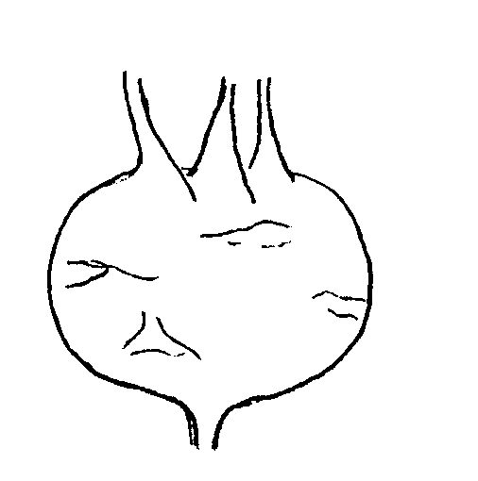
1 | 2 | 3
transverse narrow elliptic | transverse elliptic | transverse broad elliptic

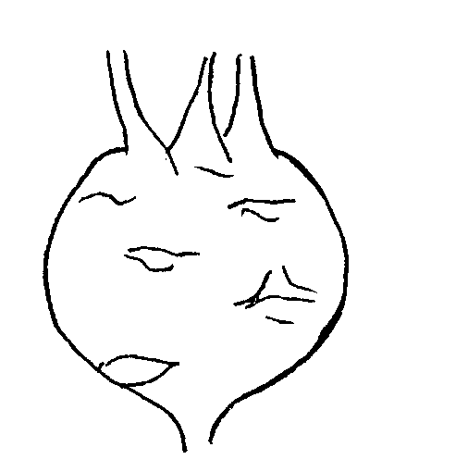 | 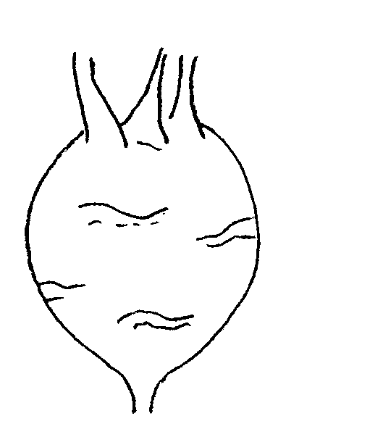
4 | 5
circular | broad elliptic

Ad. 21: Kohlrabi: shape of apex


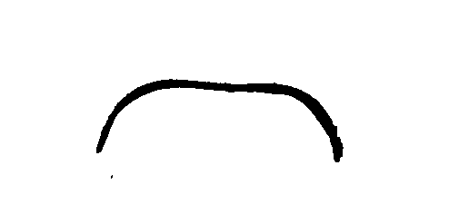
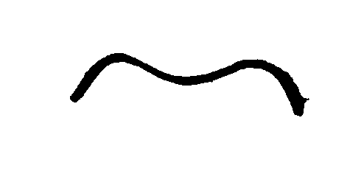

3 | 5 | 7
indented | level | raised

Ad. 22: Harvest maturity

Harvest maturity is considered as being reached if 50% of kohlrabis reach 7 cm diameter in the greenhouse or 8 cm diameter in the open field.

Ad. 23: Male sterility

To be tested in a field trial and/or in a DNA marker test.

In the case of a field trial, the type of observation is VS. In the case of a DNA marker test, the type of observation is MS.

Field trial:

Observations should be made on fully opened flowers. Tapping or shaking the flowering stem will release pollen, which, if present, can be observed on dark colored paper or card. The absence of pollen production is an indication of male sterility. The presence of pollen production is an indication of male fertility.

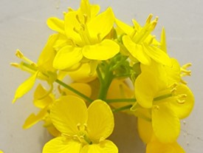 | 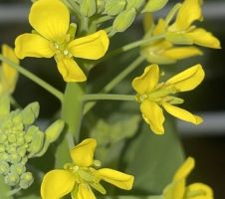
male fertile (pollen present) | male sterile (pollen absent)

DNA marker test:

If the cytoplasmic male sterility (CMS) marker is absent, the variety is expected to have male fertile flowers. If the CMS marker is present, the variety is expected to have male sterile flowers.

In cases where the DNA marker test result does not confirm the declaration in the TQ, a field trial should be performed to observe whether the variety has male fertile or male sterile flowers due to another mechanism.

Ad. 24 to 27: Resistance to Plasmodiophora brassicae (Pb) – Races 0 to 3

1. | Pathogen | Plasmodiophora brassicae
2. | Quarantine status | no
3. | Host species | Brassica oleracea
4. | Source of inoculum | Naktuinbouw (NL)
5. | Isolate | Race Pb: 0, Pb: 1, Pb: 2 and Pb: 3
6. | Establishment isolate identity | with genetically defined differentials from Naktuinbouw (NL)  The most recent table is available through ISF at  https://www.worldseed.org/our-work/plant-health/differential-hosts/
7. | Establishment pathogenicity | symptoms on susceptible Brassica oleracea spp.
8. | Multiplication inoculum
8.1 | Multiplication medium | Plant roots
8.2 | Multiplication variety | Susceptible variety Bartolo (WC), Granaat (CC)
8.3 | Plant stage at inoculation | Seedling, 1 week after sowing
8.4 | Inoculation medium | Water
8.5 | Inoculation method | 2 ml spore suspension (10⁷ sp/ml)  Pipette to the base of each seedling.
8.6 | Harvest of inoculum | Harvest roots 6-8 weeks after inoculation
8.7 | Check of harvested inoculum | Microscopic count
8.8 | Shelf life/viability inoculum | Frozen 3 years, room temperature 1-2 days
9. | Format of the test
9.1 | Number of plants per genotype | 20 plants
9.2 | Number of replicates | 2 replicates (2 x 10)
9.3 | Control varieties | Susceptible: Bartolo (WC)⁴  Resistant to race Pb: 0 051632 Bejo (WC), Clapton (CF),  Lodero (RC)  Resistant to race Pb: 1 Clapton (CF), Lodero (RC)  Resistant to race Pb: 2 Lodero (RC)  Resistant to race Pb: 3 051632 Bejo (WC)
9.5 | Test facility | Glasshouse or climatic room
9.6 | Temperature | 20-22°C
9.7 | Light | Natural, extended to 16 h if needed
9.9 | Special measures | A moderate amount of water is required to prevent rotting.  Keep the soil saturated in the first week. During plant growth the soil should not  be too dry to lower the soil temperature.
9.8 | Season | Not in winter, not in too warm conditions if test performed in greenhouse
10. | Inoculation
10.1 | Preparation inoculum | Symptomatic roots are homogenized ca. 1 min in a blender.  Dilute clubs 1:4 with demineralized water.  Blender the mix for less than 1 minute. (Beware: longer blendering may cause overheating of the suspension)
10.2 | Quantification inoculum | count spores; adjust to 10⁷ spores per ml
10.3 | Plant stage at inoculation | 1 week old seedlings
10.4 | Inoculation method | Pipette 1 ml on both sides at the base of each seedling, totalling 2 ml per plant.
10.7 | Observation, evaluation and end of test | 6 weeks after inoculation (destructive)
11. | Observations
11.1 | Method | Visual: observation of severe galling and growth retardation  Destructive: observation on a 0-3 scale for galling
11.2 | Observation scale | class 0 = no swellings or a few small spheroid galls  class 1 = very slight swelling, usually confined to the lateral roots  class 2 = moderate swelling on lateral and/or tap roots or  slight swelling of the main root and browning and ultimately death of all the lateral roots  class 3 = severe swelling on lateral and/or tap roots
11.3 | Validation of test | Validation on controls. Expected response of controls:  Susceptible control:  -most plants in classes 2 and 3  Resistant control:  -most plants in classes 0 and 1
12. | Interpretation of data in terms of UPOV characteristic states | [1] absent: distribution of plants in the classes comparable with susceptible control  [9] present: distribution of plants in the classes comparable with resistant control
13. | Critical control points | Clubroot is a zoosporic pathogen. Keep isolates spatially well-separated.

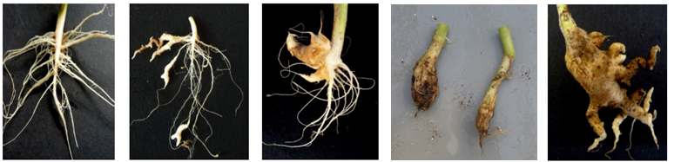
0 = no galling | 1 = a few small galls | 2 = moderate galling | 2 = slight swelling of the main root, no lateral roots | 3 = severe galling

IX. Literature

Becker, G. (1962): Kohlrabi in: Handbuch der Pflanzenzüchtung, Band VI, 2. Auflage, Paul Parey Verlag, Berlin –Hamburg, 201-203.

Becker-Dillingen, J. (1950): Kohlrabi in: Handbuch des gesamten Gemüsebaues, 5. Auflage, Parey Verlag, Berlin – Hamburg, 331-342.

Hahn, P. und Schmitt, U. (1951): Kohlrabi in: Kohl- und Wurzelgemüse, Arten- und Sortenkunde, Band 2, 1. Auflage, Deutscher Bauernverlag, Berlin, 108-138.

Kampe, K.; Basse, H.; Glaschke, B. und Schreiber, F. (1956): Kohlrabi in: Gemüsesorten, II. Teil (Kohl-, Blatt- und Wurzelgemüse), 1. Auflage, Parey Verlag, Berlin – Hamburg, 44-51.

Wiebe, H.-J. (1989): Vernalisation von wichtigen Gemüsearten – Ein Überblick. Gartenbauwissenschaft 54 (3), Ulmer Verlag, Stuttgart, 97-104.

Vogel, G. (1996): Kohlrabi in: Handbuch des speziellen Gemüsebaues. Ulmer Verlag, Stuttgart, 304 – 323.

X. Technical Questionnaire

Reference Number
(not to be filled in by the applicant)
TECHNICAL QUESTIONNAIRE
to be completed in connection with an application for plant breeders’ rights

1. Species Brassica oleracea L. convar. acephala (DC.) Alef. var. gongylodes L.
(Brassica oleracea L. Gongylodes Group)

KOHLRABI

2. Applicant (Name and address)

3. Proposed denomination or breeder’s reference

4. Information on origin, maintenance and reproduction of the variety

4.1 Method of maintenance and reproduction

(i) hybrid [ ]

(ii) open-pollinated variety [ ]

(iii) other [ ]

4.2 Other information

5. Characteristics of the variety to be given (the number in brackets refers to the corresponding characteristics in the Test Guidelines; please mark the state of expression which best corresponds)

 | Characteristics |  |  |  |  | Example Varieties |  | Note
5.1  (1) | Seedling: anthocyanin coloration of cotyledons
 | absent |  |  |  |  | Expreß Forcer |  | 1[ ]
 | present |  |  |  |  | Azur-Star |  | 9[ ]
5.2  (14) | Leaf blade: blistering
 | weak |  |  |  |  | Avanti |  | 3[ ]
 | medium |  |  |  |  | Spree |  | 5[ ]
 | strong |  |  |  |  | Lanro |  | 7[ ]
5.3  (17) | Leaf blade: intensity of green color
 | very light |  |  |  |  |  |  | 1[ ]
 | light |  |  |  |  |  |  | 3[ ]
 | medium |  |  |  |  | Noriko, Quickstar |  | 5[ ]
 | dark |  |  |  |  | Avanti, Lanro |  | 7[ ]
 | very dark |  |  |  |  | Pader |  | 9[ ]
 | Characteristics |  |  |  |  | Example Varieties |  | Note
5.4  (19) | Kohlrabi: color of skin
 | white |  |  |  |  | Beas |  | 1[ ]
 | white green |  |  |  |  | Bode, Expreß Forcer, Lanro, Timpano |  | 2[ ]
 | green |  |  |  |  | Avaya, Erko, Gaston, Noriko |  | 3[ ]
 | violet |  |  |  |  | Azur-Star, Oder, Purpuran |  | 4[ ]
5.5  (20) | Kohlrabi: shape (in longitudinal section)
 | transverse narrow elliptic |  |  |  |  | Erko |  | 1[ ]
 | transverse elliptic |  |  |  |  | Azur-Star, Quickstar |  | 2[ ]
 | transverse broad elliptic |  |  |  |  | Noriko |  | 3[ ]
 | circular |  |  |  |  | Blaril |  | 4[ ]
 | broad elliptic |  |  |  |  |  |  | 5[ ]
5.6  (22) | Harvest maturity
 | very early |  |  |  |  | Expreß Forcer |  | 1[ ]
 | early |  |  |  |  | Azur-Star, Quickstar |  | 3[ ]
 | medium |  |  |  |  | Lanro |  | 5[ ]
 | late |  |  |  |  | Delikateß blauer |  | 7[ ]
 | very late |  |  |  |  | Blaril |  | 9[ ]
5.7  (24) | Resistance to Plasmodiophora brassicae (Pb) – Race Pb: 0
 | absent |  |  |  |  | Eder
  1 [ ]
 | present |  |  |  |  | Fonda
  9 [ ]
 | not tested |  |  |  |  |  |  | [ ]
5.8  (25) | Resistance to Plasmodiophora brassicae (Pb) – Race Pb: 1
 | absent |  |  |  |  | Eder
  1 [ ]
 | present |  |  |  |  | Fonda
  9 [ ]
 | not tested |  |  |  |  |  |  | [ ]
 | Characteristics |  |  |  |  | Example Varieties |  | Note
5.9  (26) | Resistance to Plasmodiophora brassicae (Pb) – Race Pb: 2
 | absent |  |  |  |  | Eder, Fonda
  1 [ ]
 | present
  9 [ ]
 | not tested |  |  |  |  |  |  | [ ]
5.10  (27) | Resistance to Plasmodiophora brassicae (Pb) – Race Pb: 3
 | absent |  |  |  |  | Eder
  1 [ ]
 | present |  |  |  |  | Fonda
  9 [ ]
 | not tested |  |  |  |  |  |  | [ ]
6. Similar varieties and differences between these varieties

Denomination of similar variety |  |  | Characteristic in which the similar variety is different ^{o)} | State of expression of similar variety |  |  | State of expression of candidate variety
_______________
^{o)} In the case of identical states of expressions of both varieties, please indicate the size of the difference.

7. Additional information which may help to distinguish the variety

7.1 Resistance to pests and diseases

7.2 Special conditions for the examination of the variety

Variety for glasshouse culture 1 [ ]

Variety for field production at spring 2 [ ]
summer 3 [ ]
autumn 4 [ ]

7.3 Other information

A representative photograph of one or more leaf blades of the variety may be added to the Technical Questionnaire.

8. Authorization for release

(a) Does the variety require prior authorization for release under legislation concerning the protection of the environment, human and animal health?

Yes [ ] No [ ]

(b) Has such authorization been obtained?

Yes [ ] No [ ]

If the answer to that question is yes, please attach a copy of such an authorization.

[End of document]

held by electronic means, from May 5 to 8, 2025.
See document TGP/7 “Development of Test Guidelines”, Annex 3 “Guidance Notes (GN) for the TG Template”, GN 25 “Recommendations for conducting the examination” (http://www.upov.int/edocs/tgpdocs/en/tgp_7.pdf)
See document TGP/7 “Development of Test Guidelines”, Annex 3 “Guidance Notes (GN) for the TG Template”, GN 20 “Presentation of characteristics: States of expression according to type of expression of a characteristic”, 2. “Qualitative Characteristics” (http://www.upov.int/edocs/tgpdocs/en/tgp_7.pdf)
The description of the method to test male sterility for Brassica (CMS marker) is covered by a trade secret. The owner of the trade secret, Syngenta Seeds B.V., has given its consent for the use of the CMS marker solely for the purposes of examination of Distinctness, Uniformity and Stability (DUS) and for the development of variety descriptions by UPOV and authorities of UPOV members. Syngenta Seeds B.V. declares that neither UPOV, nor authorities of UPOV members that use the CMS marker for the above purposes will be held accountable for possible (mis)use of the CMS marker by third parties. Please contact Naktuinbouw, Netherlands, to obtain the method and information on the CMS marker for the purposes mentioned above.
Naktuinbouw: resistentie@naktuinbouw.nl
WC=White cabbage, CC=Chinese cabbage, RC=Red cabbage, CF=Cauliflower

