E
International Union for the Protection of New Varieties of Plants

Technical Committee  Sixty-First Session  Geneva, October 20 and 21, 2025 | TC/61/6  Original: English  Date: October 2, 2025
Measures to improve support provided for DUS examination
Document prepared by the Office of the Union
Disclaimer: this document does not represent UPOV policies or guidance

Executive SUMMARY

As of September 2025, the 339 adopted UPOV Test Guidelines cover 95% of all applications for plant variety protection filed in UPOV members. The remaining 5% applications fall under more than 4.000 genera and species for which there is limited international experience in variety examination and no harmonized Test Guidelines. Nonetheless, UPOV members increasingly seek guidance from Technical Working Parties (TWPs) to support developing test guidelines. This document presents a proposal to reorganize the work of the TWPs to create space for supporting UPOV members developing national test guidelines for genera and species that, for the time being, do not meet the requirements for the development of UPOV Test Guidelines.

To support the work of UPOV members in variety examination, UPOV developed an online drafting tool for Test Guidelines, the web-based TG template (TG template). Advances in digital technologies and the expansion of UPOV offer opportunities to further improve the TG template, as a working tool for plant variety protection authorities of UPOV members. Proposal for improving UPOV Test Guidelines were developed by the TWPs in 2025, regarding developments in plant breeding and the increasing use of Test Guidelines in digital format.

The structure of this document is as follows:
Executive SUMMARY 1
Support for drafting national test guidelines 2
Developments at the Technical Working Party for Fruit Crops 2
UPOV guidance and priorities to develop internationally harmonized Test Guidelines 2
Support for drafting national test guidelines at UPOV Technical Working Parties: 3
possible Measures on Test Guidelines (TGs) and online tool for drafting TGs 3
Developments at the TC subgroup on Test Guidelines 3
the Web-based Test Guidelines Template (tg template) 4
Background 4
Current developments 5
Test Guidelines translation 5
Facilitated access for Interested Experts 5
Future developments 6
Development of individual authorities’ test guidelines 6

Annex I TC Subgroup on Test Guidelines: 2025 TWPs consultation
Annex II Summary of discussions at the TWPs

The following abbreviations are used in this document:

TC: Technical Committee
TC-EDC: Enlarged Editorial Committee
TWA: Technical Working Party for Agricultural Crops
TWF: Technical Working Party for Fruit Crops
TWM: Technical Working Party on Testing Methods and Techniques
TWO: Technical Working Party for Ornamental Plants and Forest Trees
TWPs: Technical Working Parties
TWV: Technical Working Party for Vegetables

Support for drafting national test guidelines

Developments at the Technical Working Party for Fruit Crops

The TWF, at its fifty-sixth session, discussed possible measures to support UPOV members drafting national test guidelines. The TWF agreed there were species or crops which, for the time being, were only of interest at a national or local level while noting that certain aspects of those test guidelines could be of interest to the wider community of TWF experts.

The TWF agreed to include an agenda item for its fifty-seventh session inviting UPOV members to present characteristics, approaches or challenges for DUS examination relevant for drafting national test guidelines.

UPOV guidance and priorities to develop internationally harmonized Test Guidelines

UPOV currently has 339 adopted Test Guidelines covering over 95% of PBR-related varieties in the UPOV Plant Variety Database. The remaining 5% of protected varieties in the database fall under more than 4.000 genera and species where international harmonization might not yet apply due to insufficient experience among members in accordance with the criteria set out in document TGP/7 “Development of Test Guidelines”:

“2.2.2.2 In recognition of the importance of international harmonization, the Technical Committee will take into account the following factors when considering and prioritizing the commissioning of Test Guidelines:

“(a) Total number of applications for plant breeders’ rights within the territories of the members of the Union.

“The Technical Committee is unlikely to prioritize Test Guidelines where there are very few applications, unless certain other factors make this appropriate e.g. it is known that there is an intensive breeding effort in progress at the international level (see (e)).

“(b) Number of authorities receiving applications for the varieties which would be covered by the Test Guidelines.

“In general, Test Guidelines where only one or two authorities are receiving applications would not normally be given a high priority.

“(c) Number of foreign applications received by members of the Union.

“A high level of foreign applications indicates that international harmonization is important.

“(d) Economic importance of the crop/species.

“(e) The level of breeding activity.”

There is however a need to support UPOV members drafting national test guidelines for species or crops which, for the time being, are only of interest at a national level.

Support for matters relevant for drafting national test guidelines at UPOV Technical Working Parties:

The TC may wish to consider inviting the TWPs, at their sessions in 2026, to organize the agenda for discussions on Test Guidelines providing an opportunity for UPOV members to present characteristics, approaches or challenges for DUS examination relevant for drafting national test guidelines, based on the following assumptions:

- Discussions on matters relevant for national test guidelines would support UPOV members efforts to promote the development of new plant varieties of a wider range of crops
- Discussions on matters relevant for national test guidelines would have a specific space in the agenda different from the exercise of international harmonization through the development of UPOV Test Guidelines.
- UPOV members would provide expertise to support discussions on matters relevant for the development of national test guidelines according to UPOV guidance.
- Discussions on matters relevant for national test guidelines would be reported to the TC for guidance and adjustment of the approach to promote technical cooperation, subject to the resources of the UPOV Office.
- The use of the TG template for the development of national test guidelines would be provided to UPOV members, subject to the availability of additional resources for the development of the required functionalities.

The TC is invited to consider inviting the TWPs, at their sessions in 2026, to organize the agenda for discussions on Test Guidelines providing an opportunity for UPOV members to present characteristics, approaches or challenges for DUS examination relevant for drafting national test guidelines, as set out in paragraph 9 of this document.

possible Measures on Test Guidelines (TGs) and online tool for drafting TGs

Developments at the TC subgroup on Test Guidelines

The terms of reference of the TC subgroup on Test Guidelines is provided in document TC/59/28 “Report”, paragraph 61. The background to this matter is provided in document TC/60/6 “Measures to improve support provided for DUS examination.”

At their sessions in 2025, the TWO, TWV, TWA, and TWF considered document TWP/9/3 and proposed options for improving the Test Guidelines structure, the TG template and the creation of national test guidelines, as set out in Annex I to this document. The following report on discussions was provided by the leading expert of the TC subgroup on Test Guidelines, Ms. Margaret Wallace (United Kingdom):

- It is recommended that consideration is given to the need to review the standard wording of the Test Guidelines.

- It is recommended that the format of the Test Guidelines should be revised to take advantage of the opportunities for interactive viewing when accessed electronically:
  - Active links to UPOV Guidance
  - Pop-ups and hints
  - Zoom
  - Video explanations

- It is recommended that consideration be given to the layout of the Test Guidelines to bring the additional information and diagrams closer to (or within) the table of contents.

- It is recommended that additional information provided in a Test Guidelines (for example details of a molecular technique or a laboratory test) should have a harmonised template across all guidelines.

- It is recommended that the format and layout of the Test Guidelines is such that it can be translated using automated electronic methods.

- It is recommended that the removal of the four UPOV languages from the table of characteristics be considered.

- It is recommended that consideration be given to the process of revising Test Guidelines, in particular to partial updates that affect only one part of the document, for example the technical questionnaire or single characteristics.

- It is recommended that consideration be given to producing the technical questionnaires in a document separate to the Test Guidelines. It is important that the technical questionnaire be reviewed along with a revision of the Test Guidelines. However, it is not considered necessary for the Test Guidelines to be reviewed along with a revision of the Technical Questionnaire.

The individual reports of discussions at the TWO, TWV, TWA and TWF, at their sessions in 2025, are provided in Annex II to this document.

The TWV, at its fifty-ninth session, considered the procedure for updating and how explanations for disease resistance characteristics were presented in Test Guidelines. The TWV agreed that the explanations should be presented in the Test Guidelines or a webpage (e.g. UPOV website) accessible via link in the Test Guidelines.

The TWV agreed that explanations on disease resistance characteristics should seek to use as much as possible standard language suitable for machine translation. The TWV agreed the explanations should provide contact details of the organizations that could provide assistance or further information about the methods.

The TC is invited to consider the options for improving the Test Guidelines structure, the TG template and the creation of national test guidelines, as set out in paragraph 8 of this document.

the Web-based Test Guidelines Template (tg template)

Background

UPOV has developed the web-based TG Template (TG Template) to implement the guidance for drafting Test Guidelines provided in document TGP/7 “Development of Test Guidelines”. A collection of characteristics with their corresponding states of expression which have already been approved for inclusion in existing Test Guidelines after the adoption of document TGP/7 is provided in the web-based TG template (“approved characteristics”).

The TC, at its sixtieth session, considered possible options to improve the online tool for drafting Test Guidelines (TG Template) and noted the report from the Office of the Union on issues identified by the subgroup currently being addressed, including a new reporting tool and improved functionalities to upload tables and images. The TC noted the plan to test using the online drafting tool during TWPs to record the outcome of discussions on draft Test Guidelines during the sessions.

Release of a new version

A new version of the web-based TG Template (new link: https://tg-template.upov.int/upovtg) was released in June 2025, introducing the following new features providing an improved user experience:

- A new tool to generate draft Test Guidelines in word processor format and facilitate visualization of changes in real time.
- A new rich text editor to upload images, illustrations and diagrams, including format and size adjustments
- Use of WIPO accounts for user authentication (same as used for other UPOV systems and databases)
- Migration to cloud servers, including updated software code.

Recording outcome of discussions on draft Test Guidelines using the TG Template (live editing)

In 2025, the TG Template was used during the Technical Working Party for Fruit Crops (TWF) to record the outcomes of discussions on draft Test Guidelines. Instead of writing lists of changes to be implemented to the individual characteristics and other sections of the Test Guidelines, the agreed changes were implemented during the session. This procedure enabled participants to immediately see the result of discussions and how it would be featured in the Test Guidelines. The following paragraphs are an extract of the relevant section of the TWF report (see document TWF/56/7 “Report”, paragraphs 47 and 48):

“47. The TWF noted that the drafting tool was used during the discussions of Test Guidelines to record the changes agreed directly into the drafting tool. The TWF noted that the new procedure replaced the creation of lists of changes to be implemented in future, implementing them directly in the drafting tool during the meeting. The TWF noted that the drafters of Test Guidelines would use the document generated during the session as the starting point for further work.

“48. The TWF noted that the drafts generated directly into the drafting tool as a result of discussions during the session were made available on the TWF/56 webpage and presented all changes in “revision mode” (available at the TWF/56 webpage: https://www.upov.int/meetings/en/details.jsp?meeting_id=85860)”

In 2026, all TWPs will have the opportunity to record the changes agreed during discussions on Test Guidelines directly into the drafting tool (TG Template). Drafters of Test Guidelines will be able to use the draft edited during the TWP session as the starting point for further work. This process simplifies the work during TWPs and facilitate creating Test Guidelines for the TWPs and TC.

The new procedure addresses a request from interested experts to identify the changes in relation to previous versions of the Test Guidelines, which are indicated in revisions mode in a new draft published on the webpage of the meeting. Word versions showing all changes agreed during discussions of the draft Test Guidelines will be made available on the webpages of the relevant TWPs, such as can be seen on the webpage of the fifty-sixth session of the TWF (see section “Test Guidelines” available at: https://www.upov.int/meetings/en/details.jsp?meeting_id=85860).

Current developments

Test Guidelines translation

The new features of the TG template are being expanded to support French, German, and Spanish translations with improved formatting. A machine translation API (application programming interface) is being added to the TG Template, enabling faster draft Test Guidelines translations. These enhancements will make draft and adopted TGs available on the UPOV website more expeditiously.

Facilitated access for Interested Experts

The procedure to grant access to the TG Template for interested experts is being revised in response to the increasing number of participants in hybrid sessions and to ensure broad access to crop experts. A new automated procedure will let users choose their preferred TWPs when logging into the TG Template; once validated by the UPOV Office, experts will gain access to all relevant draft TGs.

Future developments

Following the recommendations from the TC subgroup on Test Guidelines, and to streamline and speed up TG drafting and publication, new functionalities are been identified for further development of the TG Template. The UPOV Office will continue improvements based on these recommendations, subject to availability of resources.

Development of individual authorities’ test guidelines

The current web-based TG Template was designed for the development of Test Guidelines for UPOV. However, it has also been designed that a future Version 2 would enable members of the Union to use:

(a) adopted UPOV Test Guidelines as a basis for the development of individual authorities’ test guidelines;

(b) the web-based TG Template and database of characteristics to develop individual authorities’ test guidelines for which there are no UPOV Test Guidelines; and

(c) use individual authorities’ test guidelines, developed using the web-based TG Template, as the basis for draft UPOV Test Guidelines.

Version 2 would have a feature for individual authorities to modify the template wording, within the same structure, to act as a template for their own test guidelines and a feature to allow individual authorities to convert UPOV Test Guidelines into individual authorities’ test guidelines, with necessary modifications.

The TC is invited to note development on the web-based TG template, as set out in paragraphs 17 to 27 of this document.

[Annex I follows]

TC SUB-GROUP ON TEST GUIDELINES

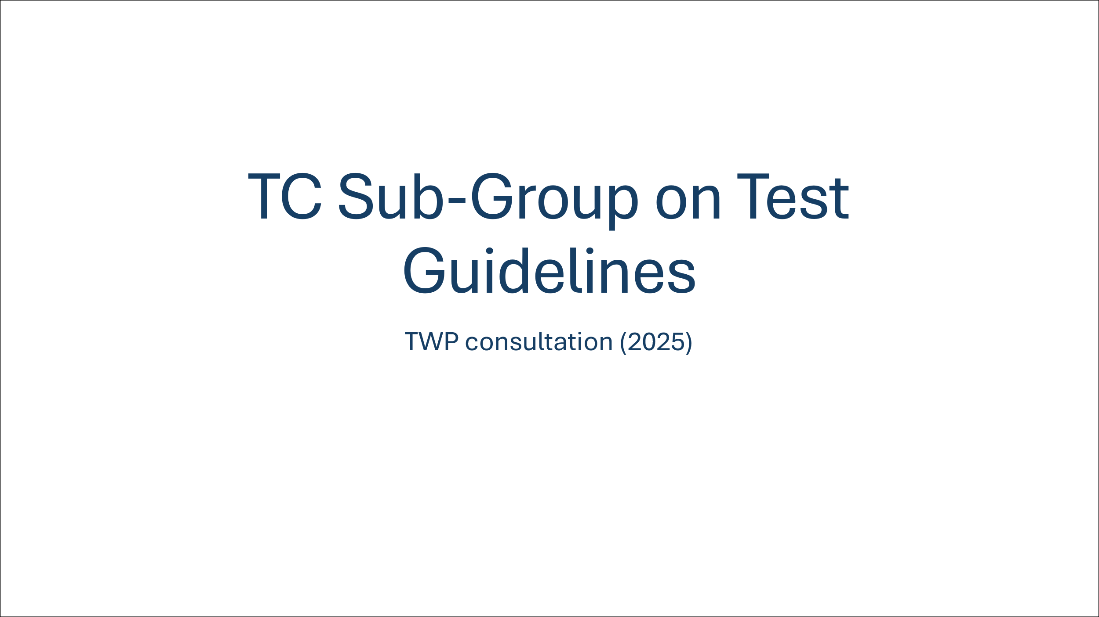

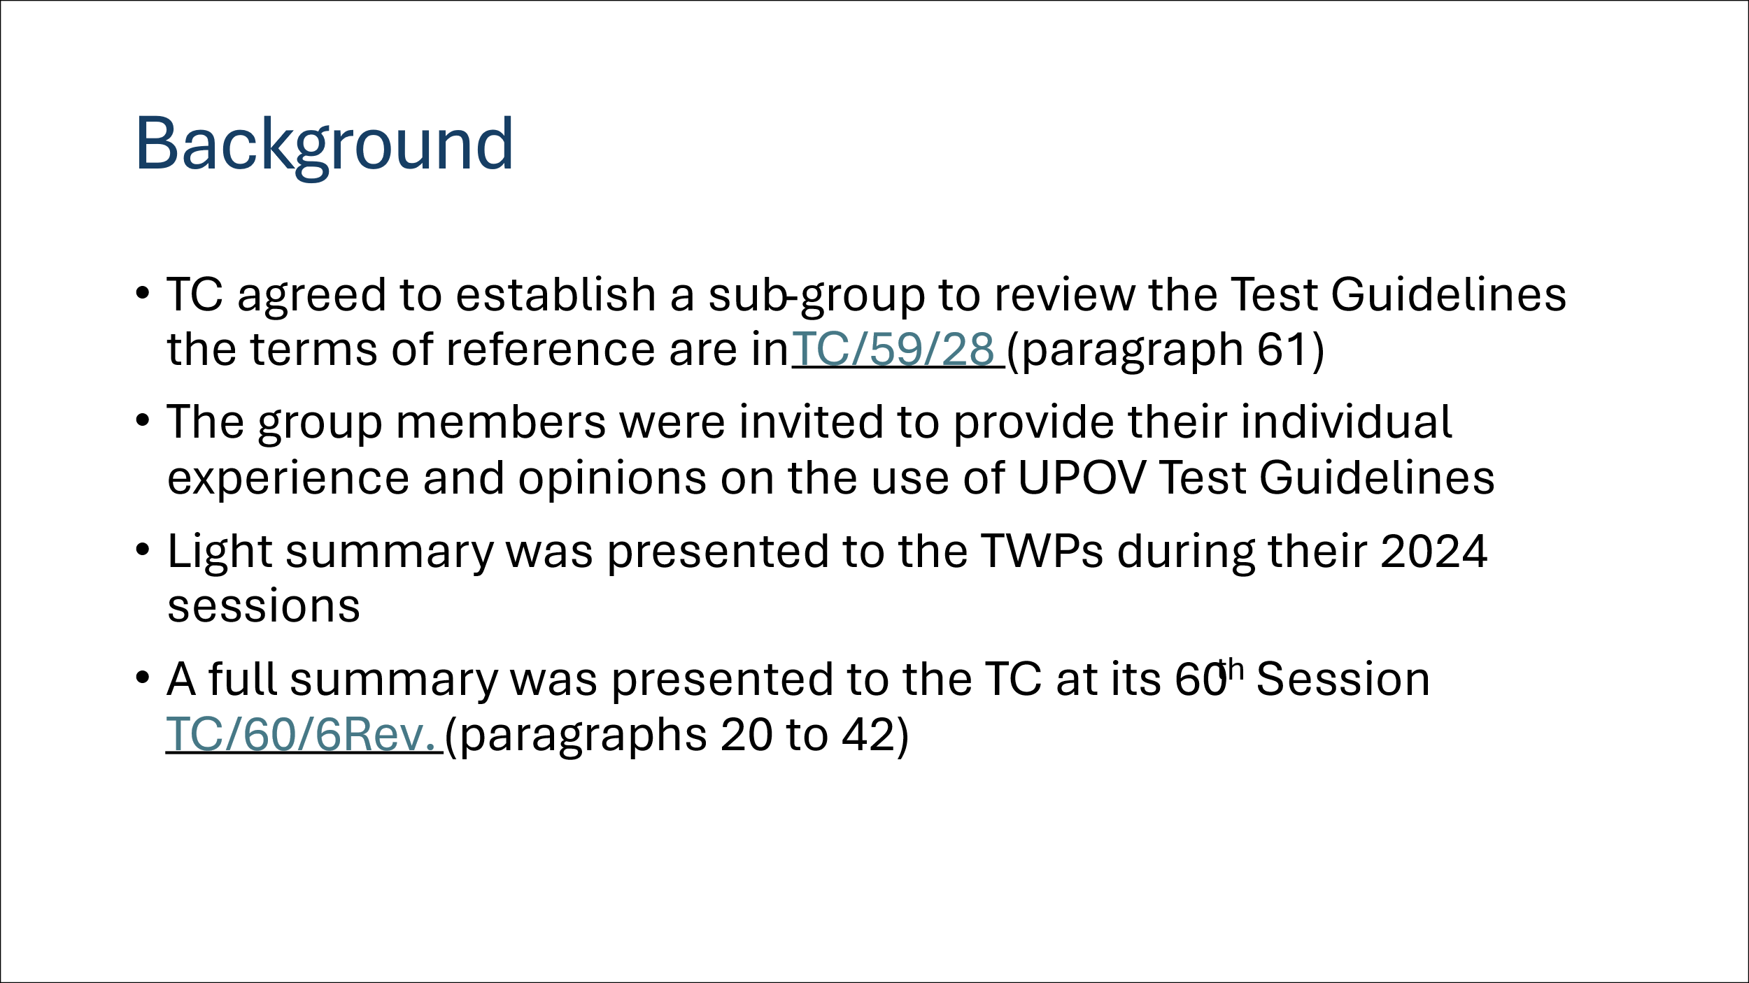

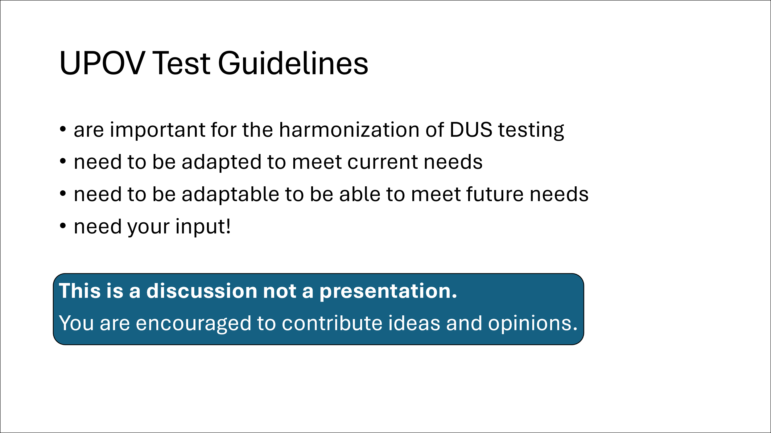

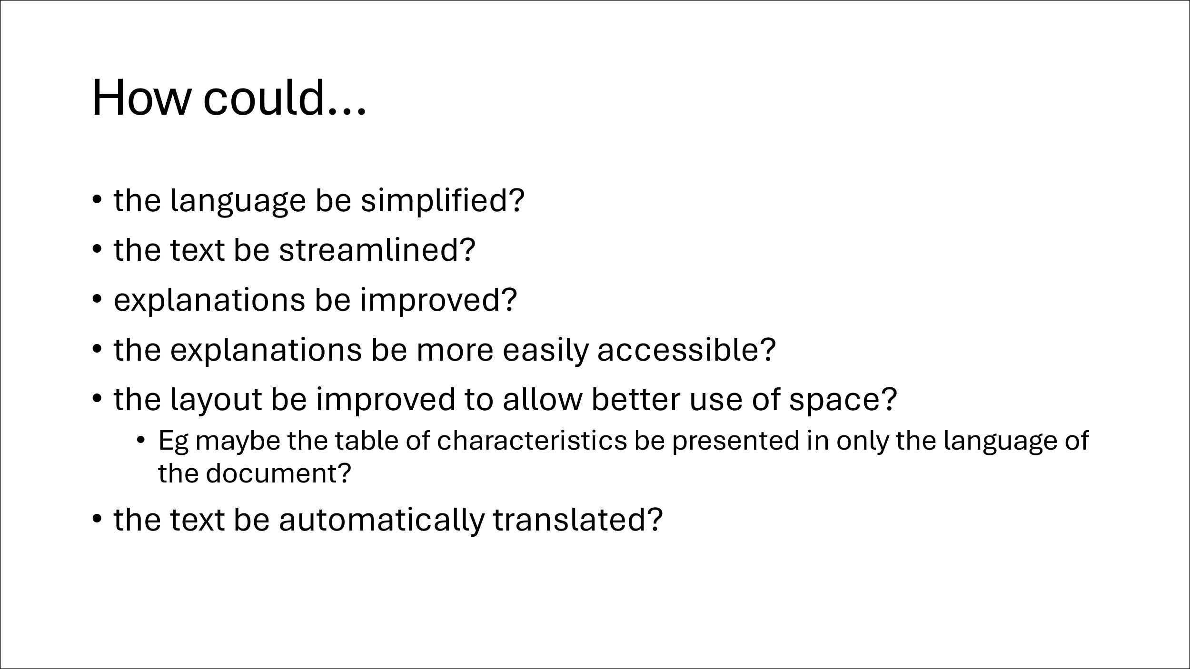

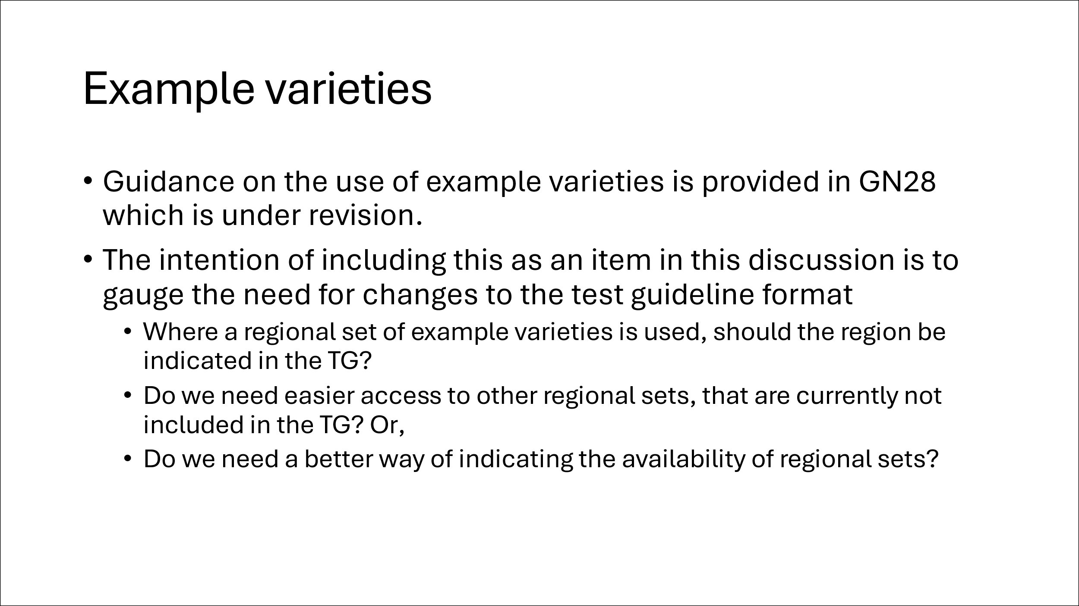

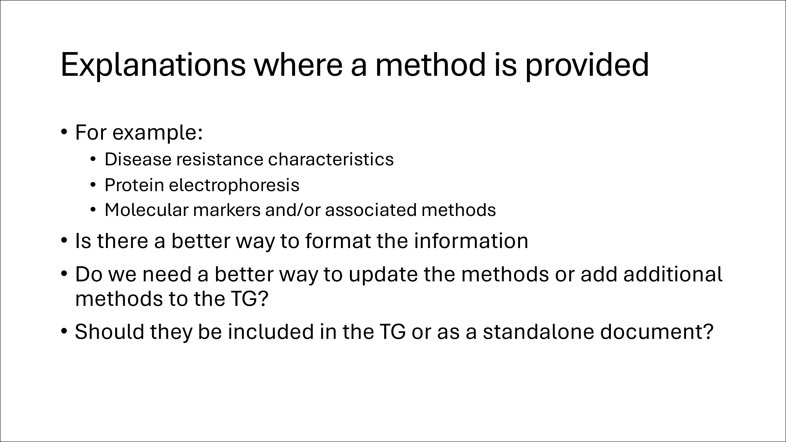

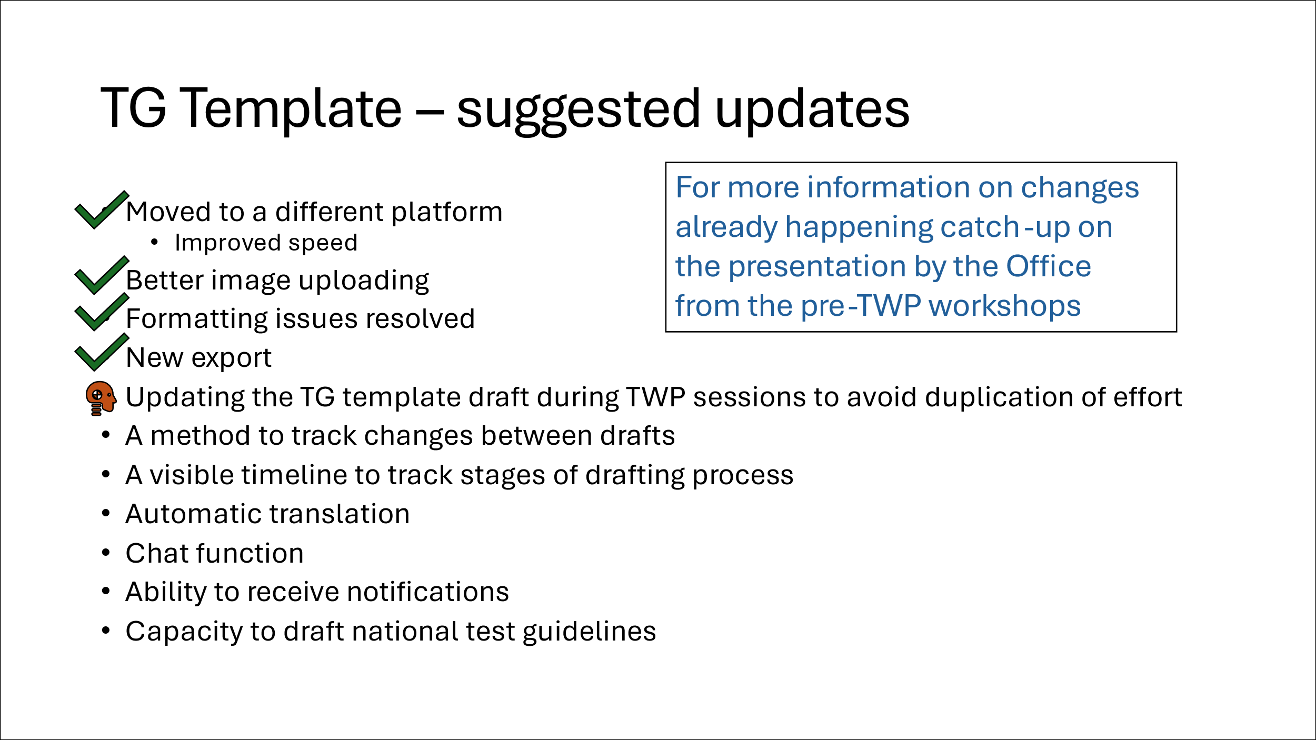

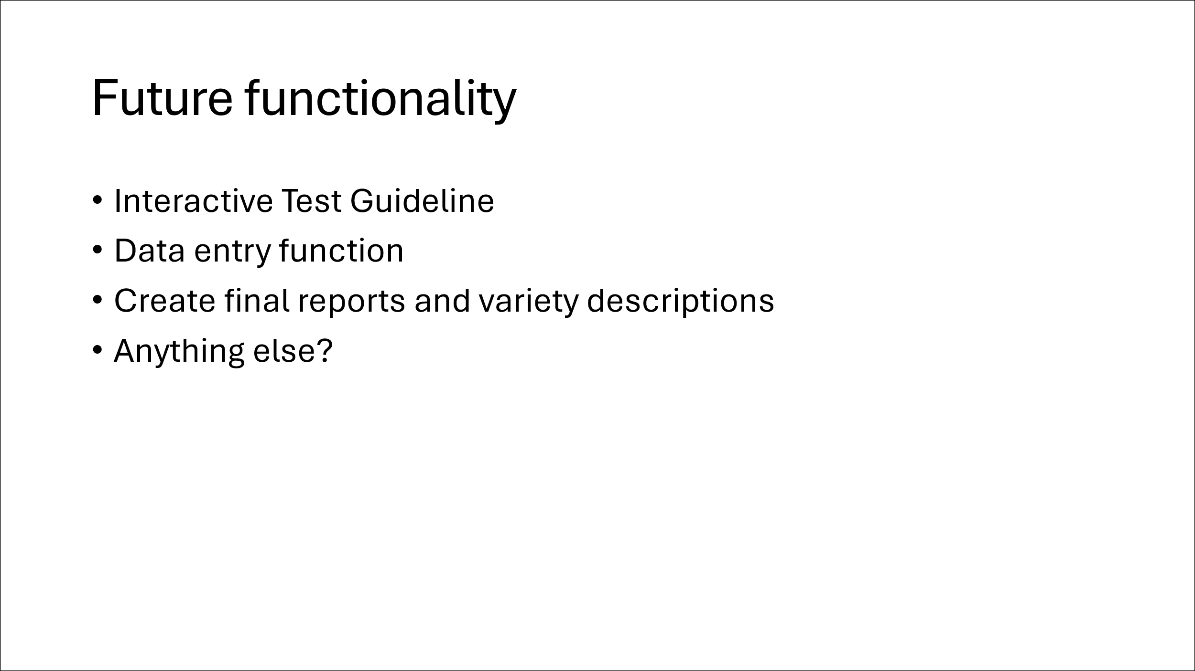

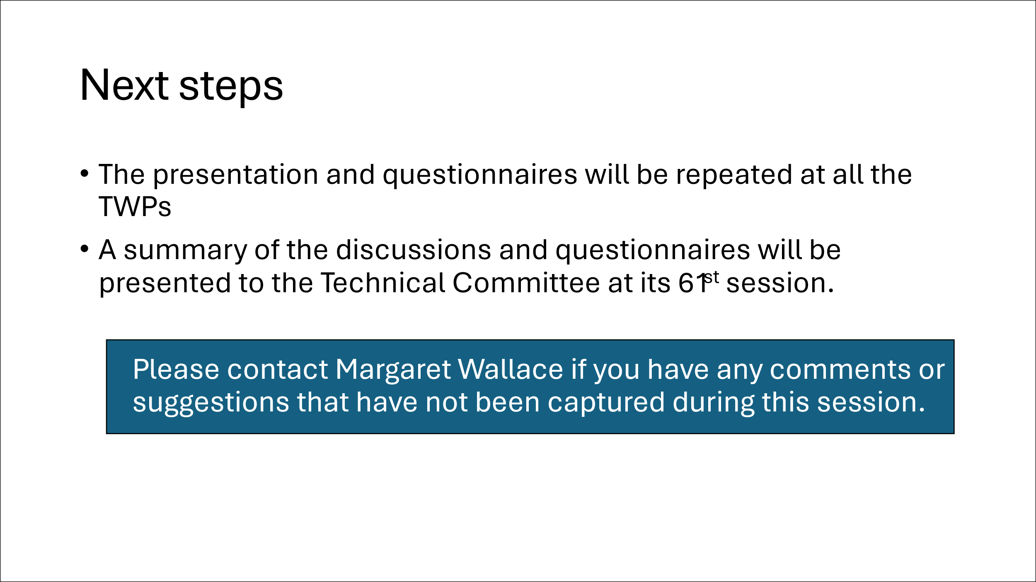

[Annex II follows]

TC SUB-GROUP ON TEST GUIDELINES:
SUMMARY OF DISCUSSION AT THE 57TH SESSION OF THE TWO
(Report by the leading expert, Ms. Margaret Wallace (United Kingdom))

The TWO discussed the presentation from the leading expert of the subgroup, Margaret Wallace (United Kingdom), a copy of which is provided in document TWP/9/3. The group also submitted responses to an online questionnaire.

A summary of the responses and discussion follows:

The group recognised the technical nature of the language used in the standard wording and agreed that it was important that any simplification of wording does not lose the important information.

The TWO agreed that there could be improvements made to the linking of UPOV Guidance documents.

Of the 36 responses to the questionnaire, 28 said that they do print the Test Guidelines. Of those who print, half said they only print part(s) of the document, with the table of characteristics (section 7) and associated explanations (section 8) being the most printed section of the Test Guidelines.

The TWO agreed that viewing the Test Guidelines on a screen (rather than on paper) caused some difficulty in viewing the table of characteristics and the explanations.

The summary of the group responses to the questionnaire indicated that illustrations, diagrams, or photographs was the preferred method of harmonising observations; followed by text explanations, then example varieties in the order of UPOV, National, and then Regional sets.

The questionnaire included questions related to the use of the UPOV Technical Questionnaires.

The group had mixed opinions on whether the TQ should remain part of the Test Guidelines (33%) or form a separate document (36%). The remaining responses were unsure and would have to check (31%).

The TWO had limited experience of the inclusion of descriptions of methods in a Test Guidelines but agreed that having a separate document may reduce ease of access, so careful consideration would be required.

Follow-up actions:

This summary will be collated with those from discussions at the 2025 sessions of the TWM, TWV, TWA, and TWF, along with other comments made during the discussions and presented to the Technical Committee for consideration at its sixty-first session.

TC SUB-GROUP ON TEST GUIDELINES
SUMMARY OF THE DISCUSSION AT THE 59th SESSION OF THE TWV
(Report by the leading expert, Ms. Margaret Wallace (United Kingdom))

The TWV discussed the presentation from the leading expert of the subgroup, Margaret Wallace (United Kingdom), a copy of which is provided in document TWP/9/3. The group also submitted responses to an online questionnaire.

Prior to the online survey, the group discussed the importance of example varieties. It was noted that regional sets of example varieties are important so that the characteristics are expressed appropriately in the growing conditions of that region. The TWV also recognized the significant role of illustrations in cases where example varieties were not readily available.

It was recognized that the TWV had the most experience with the development of disease resistance characteristics, therefore would be best placed to provide opinion on these including the associated explanations. The group agreed that it was essential that details of the methods are included in the Test Guidelines for the purposes of harmonization particularly in the exchange of reports. It was noted that the explanations for disease resistance characteristics included contact details of experts with experience in the assessment of the characteristics. It was agreed that there was scope to improve the presentation of the information to streamline the process, with three proposals made:

- Present the explanations in English only to avoid the cost of translation of technical material while developing further translation options.
- As far as possible use a standardized template to facilitate translation.
- Provide a link in the Test Guidelines to a document on the UPOV website that contains the explanation of the characteristic.

It was agreed that there is an opportunity to increase efficiency in the process for revision of Test Guidelines when including disease resistance characteristics. It is likely this process needs to be agreed first, so that the format of the Test Guidelines can be adapted appropriately.

Of the 29 responses to the questionnaire, 22 said that they do print the Test Guidelines. Of those who print, 10 said they only print part(s) of the document, with the table of characteristics (section 7) and associated explanations (section 8) being the most printed section of the Test Guidelines.

The summary of the group responses to the questionnaire indicated that illustrations, diagrams, or photographs was the preferred method of harmonizing observations; followed by text explanations, then example varieties in the order of regional sets, across the UPOV membership, and then national.

The questionnaire included questions related to the use of the UPOV Technical Questionnaires.

The group had mixed opinions on whether the TQ should remain part of the Test Guidelines (34%) or form a separate document (38%). The remaining responses were unsure and would have to check (28%).

The TWV did not agree on whether guidance on methods being contained in a separate document. They were in favor of having a structured template for guidance on techniques to ensure consistent presentation.

The group felt that links within the document could help usability, or to put the explanation of characteristics beside the characteristics.

Another suggestion was received to include the explanation from the TG in the technical questionnaire to help the applicant complete the form.

Follow-up actions

This summary of the discussion and the results of the online questionnaire will be collated with those from discussions at the 2025 sessions of the TWO, TWA, and TWF, along with other comments made during the discussions and presented to the Technical Committee for consideration at its sixty-first session.
TC SUB-GROUP ON TEST GUIDELINES
SUMMARY OF THE DISCUSSION AT THE 54TH SESSION OF THE TWA
(Report by the leading expert, Ms. Margaret Wallace (United Kingdom))

The TWA received a presentation from the leading expert of the subgroup, Margaret Wallace (United Kingdom), a copy of which is provided in document TWP/9/3. The group also submitted responses to an online questionnaire. There was limited time for a discussion so the opinions of the TWA are captured in the responses to the questionnaire only.

A summary of the responses follows:

The Group had mixed views on the complete revision of the standard wording.

Of the 33 responses to the questionnaire, 23 said that they do print the Test Guidelines. Of those who print, 17 stated that they print the entire document, and six said they only print part(s) of the document, with the table of characteristics (section 7) and associated explanations (section 8) being the most printed section of the Test Guidelines. One respondent indicated that they print the entire document except the TQ and Annex.

The summary of the group responses to the questionnaire indicated that illustrations, diagrams, or photographs was the preferred method of harmonising observations; followed by text explanations, then example varieties in the order of regional sets of example varieties, harmonised across the UPOV membership, and then National sets.

The questionnaire included questions related to the use of the UPOV Technical Questionnaires. 47% of the Group felt that the Technical Questionnaire could be a separate document from the Test Guideline, while 28% indicated the preference that it should remain part of the Test Guideline. The remaining responses were unsure and would have to check (25%).

There was a request to improve text regarding homogeneity which is an issue for many breeders.

The TWA Group mostly agreed that there should be a template for the description of methods included in the Test Guidelines. The group did not agree on whether the guidance should be contained in a document separate to the Test Guidelines.
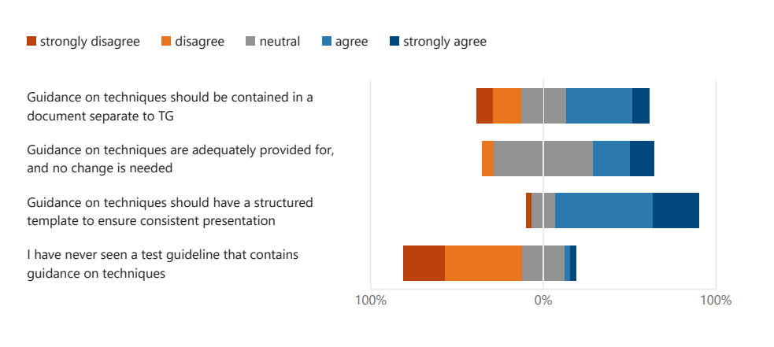
Follow-up actions

This summary will be collated with those from discussions at the 2025 sessions of the TWO, TWV, and TWF, along with other comments made during the discussions and presented to the Technical Committee for consideration at its sixty-first session.

TC SUB-GROUP ON TEST GUIDELINES
SUMMARY OF THE DISCUSSION AT THE 56TH SESSION OF THE TWF
(Report by the leading expert, Ms. Margaret Wallace (United Kingdom))

The TWF received a presentation from the leading expert of the subgroup, Margaret Wallace (United Kingdom), a copy of which is provided in document TWP/9/3. The group also submitted responses to an online questionnaire. There was limited time for discussion so the opinions of the TWF are captured in the responses to the questionnaire only.

A summary of the responses follows:

The Group had a mixed views on the complete revision of the standard wording. The average rating was 6.61, so slightly more for than against.

Of the 29 responses to the questionnaire, 22 said that they do print the Test Guidelines. Of those who print, 5 said they only print part(s) of the document, with the table of characteristics (section 7) and associated explanations (section 8) being the most printed section of the Test Guidelines.

The Group was split on the need for the four languages in the table of characteristics (16 “for” versus 13 “against”).

The summary of the group responses to the questionnaire indicated that illustrations, diagrams, or photographs was the preferred method of harmonising observations; followed by text explanations, then example varieties in the order of those agreed across the UPOV membership, then regional sets, and then National.

There was a positive response to the inclusion of video explanations.

The questionnaire included questions related to the use of the UPOV Technical Questionnaires.

The group had mixed opinions on whether the TQ should remain part of the Test Guideline (48%) or form a separate document (34%). The remaining responses were unsure and would have to check (17%).

The TWF did not agree on whether guidance on methods being contained in a separate document. They were in favour of having a structured template for guidance on techniques to ensure consistent presentation.

Some responded to indicate that links within the document could help usability, or to put the explanation of characteristics beside the characteristics.

Follow-up actions:

This summary of the discussion and the results of the online questionnaire will be collated with those from discussions at the 2025 sessions of the TWO, TWV, and TWA, along with other comments made during the discussions and presented to the Technical Committee for consideration at its sixty-first session.

[End of Annex II and of document]

TWF, fifty-sixth session, held in Bursa, Türkiye, from June 23 to 26, 2025. See document TWF/56/7 “Report”, paragraphs 55 and 56
TWO, fifty-seventh session, held in Roelofarendsveen, Kingdom of the Netherlands, from March 31 to April 3, 2025. See document TWO/57/10 “Report”, paragraphs 36 to 38.
TWV, fifty-ninth session, held via electronic means, from May 5 to 8, 2025. See document TWV/59/19 “Report”, paragraphs 36 to 39.
TWA, fifty-fourth session, held Arusha, United Republic of Tanzania, from May 19 to 22, 2025. See document TWA/54/7 “Report”, paragraphs 33 to 35.
TWF, fifty-sixth session, held Bursa, Türkiye, from June 23 to 26, 2025. See document TWF/56/7 “Report”, paragraphs 43 to 45.
TWV, fifty-ninth session, held via electronic means, from May 5 to 8, 2025. See document TWV/59/19 “Report”, paragraphs 38 and 39.
Technical Committee, sixtieth session, held in Geneva on October 21 and 22, 2024. See document TC/60/8 “Report”, paragraph 35
TWO, fifty-seventh session, held in Roelofarendsveen, Kingdom of the Netherlands, from March 31 to April 3, 2025. See document TWO/57/10 “Report”, paragraph 38.
TWV, fifty-ninth session, held via electronic means, from May 5 to 8, 2025. See document TWV/59/19 “Report”, paragraph 39.
TWA, fifty-fourth session, held Arusha, United Republic of Tanzania, from May 19 to 22, 2025. See document TWA/54/7 “Report”, paragraph 35.
TWF, fifty-sixth session, held Bursa, Türkiye, from June 23 to 26, 2025. See document TWF/56/7 “Report”, paragraph 45

