 |  | E
 |  | TG/MORUS(proj.7)  ORIGINAL: English  DATE: 2024-04-10
INTERNATIONAL UNION FOR THE PROTECTION OF NEW VARIETIES OF PLANTS
 | Geneva
 | DRAFT
 | MULBERRY  UPOV Code(s): MORUS  Morus L. | *
GUIDELINES
FOR THE CONDUCT OF TESTS
FOR DISTINCTNESS, UNIFORMITY AND STABILITY

prepared by an expert from Japan

to be considered by

the Technical Committee for adoption by correspondence

Disclaimer: this document does not represent UPOV policies or guidance
Alternative names:*

Botanical name | English | French | German | Spanish
Morus L. | Mulberry | Mûrier | Maulbeerbaum | Morera

The purpose of these guidelines (“Test Guidelines”) is to elaborate the principles contained in the General Introduction (document TG/1/3), and its associated TGP documents, into detailed practical guidance for the harmonized examination of distinctness, uniformity and stability (DUS) and, in particular, to identify appropriate characteristics for the examination of DUS and production of harmonized variety descriptions.
ASSOCIATED DOCUMENTS
These Test Guidelines should be read in conjunction with the General Introduction and its associated TGP documents.

TABLE OF CONTENTS | PAGE
1. | SUBJECT OF THESE TEST GUIDELINES.......................................................................................................... | 3
2. | MATERIAL REQUIRED......................................................................................................................................... | 3
3. | METHOD OF EXAMINATION................................................................................................................................ | 3
3.1 | Number of Growing Cycles........................................................................................................................ | 3
3.2 | Testing Place............................................................................................................................................. | 3
3.3 | Conditions for Conducting the Examination............................................................................................... | 3
3.4 | Test Design................................................................................................................................................ | 4
3.5 | Additional Tests......................................................................................................................................... | 4

4. | ASSESSMENT OF DISTINCTNESS, UNIFORMITY AND STABILITY................................................................. | 4
4.1 | Distinctness............................................................................................................................................... | 4
4.2 | Uniformity.................................................................................................................................................. | 5
4.3 | Stability...................................................................................................................................................... | 5

5. | GROUPING OF VARIETIES AND ORGANIZATION OF THE GROWING TRIAL................................................ | 6
6. | INTRODUCTION TO THE TABLE OF CHARACTERISTICS................................................................................ | 6
6.1 | Categories of Characteristics..................................................................................................................... | 6
6.2 | States of Expression and Corresponding Notes........................................................................................ | 6
6.3 | Types of Expression.................................................................................................................................. | 6
6.4 | Example Varieties...................................................................................................................................... | 6
6.5 | Legend....................................................................................................................................................... | 7

7. | TABLE OF CHARACTERISTICS/TABLEAU DES CARACTÈRES/MERKMALSTABELLE/TABLA DE CARACTERES...................................................................................................................................................... | 8
8. | EXPLANATIONS ON THE TABLE OF CHARACTERISTICS............................................................................... | 19
8.1 | Explanations covering several characteristics........................................................................................... | 19
8.2 | Explanations for individual characteristics................................................................................................. | 19

9. | LITERATURE......................................................................................................................................................... | 25
10. | TECHNICAL QUESTIONNAIRE............................................................................................................................ | 26

1. | Subject of these Test Guidelines
 | These Test Guidelines apply to all varieties of Morus L.

2. | Material Required
2.1 | The competent authorities decide on the quantity and quality of the plant material required for testing the variety and when and where it is to be delivered. Applicants submitting material from a State other than that in which the testing takes place must ensure that all customs formalities and phytosanitary requirements are complied with.
2.2 | The material is to be supplied in the form of plants on their own roots or on a rootstock specified by the competent authority.
2.3 | The minimum quantity of plant material, to be supplied by the applicant, should be:
5 plants for varieties resulting from crossing
10 plants for varieties resulting from mutation

2.4 | The plant material supplied should be visibly healthy, not lacking in vigor, nor affected by any important pest or disease.
2.5 | The plant material should not have undergone any treatment which would affect the expression of the characteristics of the variety, unless the competent authorities allow or request such treatment. If it has been treated, full details of the treatment must be given.

3. | Method of Examination
3.1 | Number of Growing Cycles
3.1.1 | The minimum duration of tests should normally be two independent growing cycles.
3.1.2 | The two independent growing cycles may be observed from a single planting, examined in two separate growing cycles.
3.1.3 | In particular, it is essential that the plants produce a satisfactory crop of fruit in each of the two growing cycles. In the case of male varieties, it is essential that the plants produce a satisfactory number of flowers in each of the two growing cycles.
3.1.4 | The growing cycle is considered to be the duration of a single growing season, beginning with the dormancy period, followed by bud burst (flowering and/or vegetative), flowering and fruit harvest and concluding when the following dormant period starts.
3.1.5 | The testing of a variety may be concluded when the competent authority can determine with certainty the outcome of the test.
3.2 | Testing Place
 | Tests are normally conducted at one place. In the case of tests conducted at more than one place, guidance is provided in TGP/9 “Examining Distinctness”.

3.3 | Conditions for Conducting the Examination
 | The tests should be carried out under conditions ensuring satisfactory growth for the expression of the relevant characteristics of the variety and for the conduct of the examination.

3.4 | Test Design
3.4.1 | In the case of varieties resulting from crossing, each test should be designed to result in a total of at least 5 plants.
3.4.2 | In the case of varieties resulting from mutation, each test should be designed to result in a total of at least 10 plants.

3.5 | Additional Tests
 | Additional tests, for examining relevant characteristics, may be established.

4. | Assessment of Distinctness, Uniformity and Stability
4.1 | Distinctness
4.1.1 | General Recommendations
 | It is of particular importance for users of these Test Guidelines to consult the General Introduction prior to making decisions regarding distinctness. However, the following points are provided for elaboration or emphasis in these Test Guidelines.
4.1.2 | Consistent Differences
 | The differences observed between varieties may be so clear that more than one growing cycle is not necessary. In addition, in some circumstances, the influence of the environment is not such that more than a single growing cycle is required to provide assurance that the differences observed between varieties are sufficiently consistent. One means of ensuring that a difference in a characteristic, observed in a growing trial, is sufficiently consistent is to examine the characteristic in at least two independent growing cycles.
4.1.3 | Clear Differences
 | Determining whether a difference between two varieties is clear depends on many factors, and should consider, in particular, the type of expression of the characteristic being examined, i.e. whether it is expressed in a qualitative, quantitative, or pseudo-qualitative manner. Therefore, it is important that users of these Test Guidelines are familiar with the recommendations contained in the General Introduction prior to making decisions regarding distinctness.
4.1.4 | Number of Plants or Parts of Plants to be Examined
 | Unless otherwise indicated, for the purposes of distinctness, all observations on single plants should be made on 3 plants or parts of plants taken from each of 3 plants and any other observations made on all plants in the test, disregarding any off-type plants.
 | In the case of observations of parts taken from single plants, the number of parts to be taken from each of the plants should be 2.
4.1.5 | Method of Observation
 | The recommended method of observing the characteristic for the purposes of distinctness is indicated by the following key in the Table of Characteristics (see document TGP/9 “Examining Distinctness”, Section 4 “Observation of characteristics”):
MG: single measurement of a group of plants or parts of plants
MS: measurement of a number of individual plants or parts of plants
VG: visual assessment by a single observation of a group of plants or parts of plants
VS: visual assessment by observation of individual plants or parts of plants

 | Type of observation: visual (V) or measurement (M)
 | “Visual” observation (V) is an observation made on the basis of the expert’s judgment. For the purposes of this document, “visual” observation refers to the sensory observations of the experts and, therefore, also includes smell, taste and touch. Visual observation includes observations where the expert uses reference points (e.g. diagrams, example varieties, side-by-side comparison) or non-linear charts (e.g. color charts). Measurement (M) is an objective observation against a calibrated, linear scale e.g. using a ruler, weighing scales, colorimeter, dates, counts, etc.
 | Type of record: for a group of plants (G) or for single, individual plants (S)
 | For the purposes of distinctness, observations may be recorded as a single record for a group of plants or parts of plants (G), or may be recorded as records for a number of single, individual plants or parts of plants (S). In most cases, “G” provides a single record per variety and it is not possible or necessary to apply statistical methods in a plant-by-plant analysis for the assessment of distinctness.
 | In cases where more than one method of observing the characteristic is indicated in the Table of Characteristics (e.g. VG/MG), guidance on selecting an appropriate method is provided in document TGP/9, Section 4.2.
4.2 | Uniformity
4.2.1 | It is of particular importance for users of these Test Guidelines to consult the General Introduction prior to making decisions regarding uniformity. However, the following points are provided for elaboration or emphasis in these Test Guidelines:
4.2.2 | These Test Guidelines have been developed for the examination of vegetatively propagated varieties. For varieties with other types of propagation, the recommendations in the General Introduction and document TGP/13 "Guidance for new types and species" Section 4.5 "Testing Uniformity" should be followed.
4.2.3 | For the assessment of uniformity of varieties resulting from crossing, a population standard of 1% and an acceptance probability of at least 95% should be applied. In the case of a sample size of 5 plants, no off-types are allowed.
4.2.4 | For the assessment of uniformity of varieties resulting from mutation, a population standard of 1% and an acceptance probability of at least 95% should be applied. In the case of a sample size of 10 plants, 1 off-type is allowed.
4.3 | Stability
4.3.1 | In practice, it is not usual to perform tests of stability that produce results as certain as those of the testing of distinctness and uniformity. However, experience has demonstrated that, for many types of variety, when a variety has been shown to be uniform, it can also be considered to be stable.
4.3.2 | Where appropriate, or in cases of doubt, stability may be further examined by testing a new plant stock to ensure that it exhibits the same characteristics as those shown by the initial material supplied.

5. | Grouping of Varieties and Organization of the Growing Trial
5.1 | The selection of varieties of common knowledge to be grown in the trial with the candidate varieties and the way in which these varieties are divided into groups to facilitate the assessment of distinctness are aided by the use of grouping characteristics.
5.2 | Grouping characteristics are those in which the documented states of expression, even where produced at different locations, can be used, either individually or in combination with other such characteristics: (a) to select varieties of common knowledge that can be excluded from the growing trial used for examination of distinctness; and (b) to organize the growing trial so that similar varieties are grouped together.
5.3 | The following have been agreed as useful grouping characteristics:
(a) |  | Leaf bud: shape (characteristic 11)
(b) |  | Leaf: phyllotaxis (characteristic 13)
(c) |  | Leaf blade: lobes (characteristic 23)
(d) |  | Plant: sex expression (characteristic 33)
(e) |  | Infructescence: color (characteristic 40)

5.4 | Guidance for the use of grouping characteristics, in the process of examining distinctness, is provided through the General Introduction and document TGP/9 “Examining Distinctness”.

6. | Introduction to the Table of Characteristics
6.1 | Categories of Characteristics
6.1.1 | Standard Test Guidelines Characteristics
 | Standard Test Guidelines characteristics are those which are approved by UPOV for examination of DUS and from which members of the Union can select those suitable for their particular circumstances.
6.1.2 | Asterisked Characteristics
 | Asterisked characteristics (denoted by *) are those included in the Test Guidelines which are important for the international harmonization of variety descriptions and should always be examined for DUS and included in the variety description by all members of the Union, except when the state of expression of a preceding characteristic or regional environmental conditions render this inappropriate.
6.2 | States of Expression and Corresponding Notes
6.2.1 | States of expression are given for each characteristic to define the characteristic and to harmonize descriptions. Each state of expression is allocated a corresponding numerical note for ease of recording of data and for the production and exchange of the description.
6.2.2 | All relevant states of expression are presented in the characteristic.
6.2.3 | Further explanation of the presentation of states of expression and notes is provided in document TGP/7 “Development of Test Guidelines”.
6.3 | Types of Expression

 | An explanation of the types of expression of characteristics (qualitative, quantitative and pseudo-qualitative) is provided in the General Introduction.
6.4 | Example Varieties
 | Where appropriate, example varieties are provided to clarify the states of expression of each characteristic.

6.5 | Legend
 |  | English |  | français |  | deutsch | español | Example Varieties  Exemples  Beispielssorten  Variedades ejemplo | Note/  Nota
1 | 2 | 3 | 4 | 5 | 6 | 7
 |  | Name of characteristics in English |  | Nom du caractère en français |  | Name des Merkmals auf Deutsch | Nombre del carácter en español
 |  | states of expression |  | types d’expression |  | Ausprägungsstufen | tipos de expresión

1 | Characteristic number
2 | (*) | Asterisked characteristic | – see Chapter 6.1.2
3 | Type of expression
 | QL | Qualitative characteristic | – see Chapter 6.3
 | QN | Quantitative characteristic | – see Chapter 6.3
 | PQ | Pseudo-qualitative characteristic | – see Chapter 6.3
4 | Method of observation (and type of plot, if applicable)
 | MG, MS, VG, VS |  | – see Chapter 4.1.5
5 | (+) | See Explanations on the Table of Characteristics in Chapter 8.2
6 | (a)-(d) | See Explanations on the Table of Characteristics in Chapter 8.1
7 | Not applicable

7. | Table of Characteristics/Tableau des caractères/Merkmalstabelle/Tabla de caracteres

 |  | English |  | français |  | deutsch | español | Example Varieties  Exemples  Beispielssorten  Variedades ejemplo | Note/  Nota
1. |  | QN | VG
 |  | Tree: vigor |  | Arbre : vigueur |  | Baum: Wuchsstärke | Árbol: vigor
 |  | weak |  | faible |  | gering | débil | Sekizaiso | 1
 |  | medium |  | moyenne |  | mittel | medio | Ichinose | 2
 |  | strong |  | forte |  | stark | fuerte | Kenmochi, Oyutaka, Senshin | 3
2. | (*) | PQ | VG | (+)
 |  | Tree: growth habit |  | Arbre : port |  | Baum: Wuchsform | Árbol: hábito de crecimiento
 |  | upright |  | dressé |  | aufrecht | erguido | Mitsuminami, Piramidale, Tokiyutaka | 1
 |  | semi-upright |  | demi-dressé |  | halbaufrecht | semierguido | Ichinose, Kenmochi | 2
 |  | spreading |  | étalé |  | breitwüchsig | extendido | Ayanobori, Hayatesakari, Platanoide, Yukishinogi | 3
 |  | drooping |  | retombant |  | überhängend | colgante | Sekizaiso | 4
 |  | weeping |  | pleureur |  | lang überhängend | llorón | Pendula, Shidareguwa | 5
3. |  | QN | VG |  | (a)
 |  | Tree: number of current year's shoots |  | Arbre : nombre de rameaux de l'année en cours |  | Baum: Anzahl diesjähriger Triebe | Árbol: número de ramas del año en curso
 |  | few |  | petit |  | gering | bajo | Shin-Ichinose | 1
 |  | few to medium |  | petit à moyen |  | gering bis mittel | bajo a medio |  | 2
 |  | medium |  | moyen |  | mittel | medio | Ichinose, Kenmochi | 3
 |  | medium to many |  | moyen à élevé |  | mittel bis hoch | medio a alto |  | 4
 |  | many |  | élevé |  | hoch | alto | Kairyo-Nezumigaeshi Yukishinogi | 5
4. |  | QN | VG |  | (a)
 |  | Current year's shoot: number of lateral shoots |  | Rameau de l'année en cours : nombre de rameaux latéraux |  | Diesjähriger Trieb: Anzahl Seitentriebe | Rama del año en curso: número de ramas laterales
 |  | absent or few |  | absent ou petit |  | fehlend oder gering | ausente o bajo | Ichinose, Kenmochi, Tokiyutaka | 1
 |  | medium |  | moyen |  | mittel | medio | Kairyo-Nezumigaeshi | 2
 |  | many |  | élevé |  | hoch | alto | Jumonji, Keikanso | 3
5. |  | QN | MG/MS/VG |  | (a)
 |  | Current year's shoot: length |  | Rameau de l'année en cours : longueur |  | Diesjähriger Trieb: Länge | Rama del año en curso: longitud
 |  | short |  | courte |  | kurz | corta | Negoyatakasuke | 1
 |  | short to medium |  | courte à moyenne |  | kurz bis mittel | corta a media |  | 2
 |  | medium |  | moyenne |  | mittel | media | Ichinose, Kenmochi | 3
 |  | medium to long |  | moyenne à longue |  | mittel bis lang | media a larga |  | 4
 |  | long |  | longue |  | lang | larga | Shin-Ichinose | 5
6. | (*) | QN | VG | (+) | (a)
 |  | Current year's shoot: zigzag |  | Rameau de l'année en cours : zigzag |  | Diesjähriger Trieb: Zickzack | Rama del año en curso: zigzag
 |  | absent or weak |  | absent ou faible |  | fehlend oder gering | ausente o débil | Ichinose, Yue Shen Da 10 | 1
 |  | medium |  | moyen |  | mittel | medio | He Ye Bai | 2
 |  | strong |  | fort |  | stark | fuerte | Hu Bei Wan Tiao, Unryu | 3
7. |  | QL | VG | (+) | (a)
 |  | Current year's shoot: twisting |  | Rameau de l'année en cours : torsion |  | Diesjähriger Trieb: Drehung | Rama del año en curso: torsión
 |  | absent |  | absente |  | fehlend | ausente |  | 1
 |  | present |  | présente |  | vorhanden | presente | Sinuense | 9
8. |  | PQ | VG |  | (a)
 |  | Current year's shoot: color |  | Rameau de l'année en cours : couleur |  | Diesjähriger Trieb: Farbe | Rama del año en curso: color
 |  | greyish brown |  | brun grisâtre |  | gräulichbraun | marrón grisáceo | Mizusawaguwa | 1
 |  | greenish brown |  | brun verdâtre |  | grünlichbraun | marrón verdoso | Shin-Ichinose | 2
 |  | yellowish brown |  | brun jaunâtre |  | gelblichbraun | marrón amarillento | Fukushimaoha | 3
 |  | reddish brown |  | brun rougeâtre |  | rötlichbraun | marrón rojizo | Ichibei | 4
 |  | medium brown |  | brun moyen |  | mittelbraun | marrón medio | Rohachi | 5
 |  | dark brown |  | brun foncé |  | dunkelbraun | marrón oscuro | Kenmochi | 6
 |  | light grey |  | gris clair |  | hellgrau | gris claro | Ichinose | 7
9. | (*) | QN | MG/MS/VG | (+) | (a)
 |  | Current year's shoot: length of internode |  | Rameau de l'année en cours : longueur de l'entre-nœud |  | Diesjähriger Trieb: Länge des Internodiums | Rama del año en curso: longitud del entrenudo
 |  | short |  | courte |  | kurz | corta | Sinuense, Tokiyutaka | 1
 |  | medium |  | moyenne |  | mittel | media | Ichinose, Kenmochi | 2
 |  | long |  | longue |  | lang | larga | Ichibei | 3
10. | (*) | QN | VG |  | (a)
 |  | Leaf bud: size |  | Bourgeon à feuilles : taille |  | Blattknospe: Größe | Yema foliar: tamaño
 |  | small |  | petite |  | klein | pequeño | Shin-Ichinose | 1
 |  | medium |  | moyenne |  | mittel | medio | Ichinose, Kenmochi | 2
 |  | large |  | grande |  | groß | grande | Yukishinogi | 3
11. | (*) | PQ | VG | (+) | (a)
 |  | Leaf bud: shape |  | Bourgeon à feuilles : forme |  | Blattknospe: Form | Yema foliar: forma
 |  | ovate |  | ovale |  | eiförmig | oval | Negoyatakasuke | 1
 |  | broad triangular |  | triangulaire large |  | breit dreieckig | triangular ancha | Atsubamidori, Filippine, Shin-Ichinose | 2
 |  | medium triangular |  | triangulaire moyenne |  | mittel dreieckig | triangular media | Cattaneo fem., Florio, Ichinose, Kenmochi, Morettiana | 3
 |  | narrow triangular |  | triangulaire étroite |  | schmal dreieckig | triangular estrecha | Wasemidori | 4
12. | (*) | PQ | VG |  | (a)
 |  | Leaf bud: color |  | Bourgeon à feuilles : couleur |  | Blattknospe: Farbe | Yema foliar: color
 |  | greyish brown |  | brun grisâtre |  | gräulichbraun | marrón grisáceo | Atsubamidori | 1
 |  | yellowish brown |  | brun jaunâtre |  | gelblichbraun | marrón amarillento | Kokuso 27 | 2
 |  | reddish brown |  | brun rougeâtre |  | rötlichbraun | marrón rojizo | Ichibei | 3
 |  | medium brown |  | brun moyen |  | mittelbraun | marrón medio | Ichinose | 4
 |  | dark brown |  | brun foncé |  | dunkelbraun | marrón oscuro | Kenmochi | 5
 |  | light grey |  | gris clair |  | hellgrau | gris claro | Shin-Ichinose, Shiromeroso | 6
13. | (*) | QL | VG | (+)
 |  | Leaf: phyllotaxis |  | Feuille : phyllotaxie |  | Blatt: Stellung | Hoja: filotaxis
 |  | two in one |  | deux en une |  | zwei in einer | dos en una | Chijimiguwa, Filippine, Negoyatakasuke | 1
 |  | three in one |  | trois en une |  | drei in einer | tres en una |  | 2
 |  | five in two |  | cinq en deux |  | fünf in zwei | cinco en dos | Cattaneo fem., Florio, Ichinose, Kenmochi | 3
 |  | eight in three |  | huit en trois |  | acht in drei | ocho en tres | Morettiana, Wasemidori | 4
 |  | thirteen in five |  | treize en cinq |  | dreizehn in fünf | trece en cinco |  | 5
14. | (*) | QN | VG | (+)
 |  | Leaf blade: attitude |  | Limbe : port |  | Blattspreite: Haltung | Limbo: porte
 |  | upwards |  | vers le haut |  | aufwärts gerichtet | ascendente | Jikunashi | 1
 |  | outwards |  | vers l'extérieur |  | abstehend | orientado hacia el exterior | Ichinose, Kenmochi | 2
 |  | downwards |  | vers le bas |  | abwärts gerichtet | orientado hacia abajo | Asayuki, Shin-Ichinose | 3
15. | (*) | QN | MG/MS/VG | (+) | (b)
 |  | Leaf blade: length |  | Limbe : longueur |  | Blattspreite: Länge | Limbo: longitud
 |  | very short |  | très courte |  | sehr kurz | muy corta |  | 1
 |  | very short to short |  | très courte à courte |  | sehr kurz bis kurz | muy corta a corta |  | 2
 |  | short |  | courte |  | kurz | corta | Kibajumonji,  Romana rabelaire | 3
 |  | short to medium |  | courte à moyenne |  | kurz bis mittel | corta a media |  | 4
 |  | medium |  | moyenne |  | mittel | media | Ichinose, Restelli | 5
 |  | medium to long |  | moyenne à longue |  | mittel bis lang | media a larga |  | 6
 |  | long |  | longue |  | lang | larga | Indiana, Platanoide, Popberry | 7
 |  | long to very long |  | longue à très longue |  | lang bis sehr lang | larga a muy larga |  | 8
 |  | very long |  | très longue |  | sehr lang | muy larga |  | 9
16. | (*) | QN | MG/MS/VG | (+) | (b)
 |  | Leaf blade: width |  | Limbe : largeur |  | Blattspreite: Breite | Limbo: anchura
 |  | very narrow |  | très étroite |  | sehr schmal | muy estrecha | Nervosa | 1
 |  | very narrow to narrow |  | très étroite à étroite |  | sehr schmal bis schmal | muy estrecha a estrecha |  | 2
 |  | narrow |  | étroite |  | schmal | estrecha | Indiana, Kibajumonji | 3
 |  | narrow to medium |  | étroite à moyenne |  | schmal bis mittel | estrecha a media |  | 4
 |  | medium |  | moyenne |  | mittel | media | Ichinose | 5
 |  | medium to broad |  | moyenne à large |  | mittel bis breit | media a ancha |  | 6
 |  | broad |  | large |  | breit | ancha | Popberry | 7
 |  | broad to very broad |  | large à très large |  | breit bis sehr breit | ancha a muy ancha |  | 8
 |  | very broad |  | très large |  | sehr breit | muy ancha | Platanoide | 9
17. |  | QN | MG/MS/VG |  | (b)
 |  | Leaf blade: ratio length/width |  | Limbe : rapport longueur/largeur |  | Blattspreite: Verhältnis Länge/Breite | Limbo: relación longitud/anchura
 |  | low |  | bas |  | klein | baja |  | 1
 |  | medium |  | moyen |  | mittel | media | Ichinose, Kenmochi | 2
 |  | high |  | élevé |  | groß | alta |  | 3
18. | (*) | QN | MG/MS/VG | (+) | (b)
 |  | Leaf blade: thickness |  | Limbe : épaisseur |  | Blattspreite: Dicke | Limbo: grosor
 |  | thin |  | mince |  | dünn | delgado | Kokuso 27, Shiwasuguwa, Yukishinogi | 1
 |  | medium |  | moyenne |  | mittel | medio | Ichinose, Kenmochi | 2
 |  | thick |  | épaisse |  | dick | grueso | Atsubamidori, Ayanobori, Shin-Kenmochi | 3
19. |  | PQ | VG | (+) | (b)
 |  | Leaf blade: shape of apex |  | Limbe : forme de l'apex |  | Blattspreite: Form des Apex | Limbo: forma del ápice
 |  | acute |  | aigue |  | spitz | aguda | Ichinose | 1
 |  | obtuse |  | obtuse |  | stumpf | obtusa | Jikunashi | 2
 |  | obcordate |  | obcordée |  | verkehrt herzförmig | obcordiforme | Niken | 3
20. | (*) | PQ | VG | (+) | (b)
 |  | Leaf blade: length of tip |  | Limbe : longueur de la pointe |  | Blattspreite: Länge der aufgesetzten Spitze | Limbo: longitud de la punta
 |  | absent or short |  | absente ou courte |  | fehlend oder kurz | ausente o corta | Romana rabelaire, Rougetto | 1
 |  | medium |  | moyenne |  | mittel | media | Indiana, Kenmochi, Limoncina | 2
 |  | long |  | longue |  | lang | larga | Ascolana, Florio, Fukayuki, Takinokawa | 3
21. |  | PQ | VG |  | (b)
 |  | Leaf blade: shape |  | Limbe : forme |  | Blattspreite: Form | Limbo: forma
 |  | triangular |  | triangulaire |  | dreieckig | triangular | Florio | 1
 |  | cordate |  | cordiforme |  | herzförmig | cordiforme | Arancina, Ascolana | 2
 |  | ovate |  | ovale |  | eiförmig | oval | Illinois Everbearing, Nervosa, Planifolia | 3
 |  | circular |  | circulaire |  | kreisförmig | circular | Kokka | 4
 |  | pentagonal |  | pentagonale |  | fünfeckig | pentagonal | Ichinose | 5
22. | (*) | PQ | VG | (+) | (b)
 |  | Leaf blade: shape of base |  | Limbe : forme de la base |  | Blattspreite: Form der Basis | Limbo: forma de la base
 |  | cuneate |  | cunée |  | keilförmig | cuneada | Nervosa, Popberry | 1
 |  | truncate |  | tronquée |  | gerade | truncada | Goshoerami, Jumonji, Kokuso 70, Negoyatakasuke | 2
 |  | slightly cordate |  | légèrement cordiforme |  | leicht herzförmig | ligeramente cordiforme | Kenmochi, Restelli,  Rosa di Lombardia | 3
 |  | strongly cordate |  | fortement cordiforme |  | stark herzförmig | fuertemente cordiforme | Arancina, Ichinose, Romana rabelaire | 4
23. | (*) | QL | VG |  | (b)
 |  | Leaf blade: lobes |  | Limbe : lobes |  | Blattspreite: Lappen | Limbo: lóbulos
 |  | absent |  | absente |  | fehlend | ausente | Arancina, Florio | 1
 |  | present |  | présente |  | vorhanden | presente |  | 9
24. | (*) | QN | VG | (+) | (b)
 |  | Only varieties with lobes present: Leaf blade: depth of sinus |  | Seulement variétés avec lobes présents : Limbe : profondeur du sinus |  | Nur Sorten mit Lappen: Blattspreite: Tiefe der Einbuchtung | Solo variedades con lóbulos presentes: Limbo: profundidad del seno
 |  | shallow |  | peu profonde |  | flach | poco profunda | Florio, Limoncina, Rohachi, Takinokawa | 1
 |  | shallow to medium |  | peu profonde à moyenne |  | flach bis mittel | poco profunda a media | Akagi, Shimanouchi, Shin-Ichinose | 2
 |  | medium |  | moyenne |  | mittel | media | Ichinose | 3
 |  | medium to deep |  | moyenne à profonde |  | mittel bis tief | media a profunda | Indiana, Kenmochi | 4
 |  | deep |  | profonde |  | tief | profunda | Platanoide | 5
25. |  | PQ | VG | (+) | (b)
 |  | Leaf blade: margin |  | Limbe : bord |  | Blattspreite: Rand | Limbo: borde
 |  | repand |  | onduleux |  | ausgeschweift | ondulado | Ichinose | 1
 |  | crenate |  | crénelé |  | gekerbt | crenado | Kairyo-Roso, Kanmasari, Limoncina, Rougetto, Shin-Ichinose | 2
 |  | dentate |  | denté |  | gezähnt | dentado | Ascolana, Fukushimaoha, Restelli | 3
 |  | serrulate |  | serrulé |  | fein gesägt | serrulado | Kenmochi, Oshimaso, Planifolia | 4
 |  | serrate |  | dentelé |  | gesägt | serrado | Akameroso, Hicks Fancy | 5
 |  | biserrate |  | bidentelé |  | doppelt gesägt | biserrado | Florio | 6
 |  | aristate |  | aristé |  | begrannt | aristado | Nervosa | 7
26. |  | QN | VG |  | (b)
 |  | Leaf blade: texture |  | Limbe : texture |  | Blattspreite: Textur | Limbo: textura
 |  | smooth |  | lisse |  | glatt | lisa | Florio, Indiana,  Kairyo-Roso, Muki | 1
 |  | medium |  | moyenne |  | mittel | media | Kokuso 27 | 2
 |  | rough |  | rugueuse |  | rauh | rugosa | Ichibei, Korin | 3
27. |  | QN | VG |  | (b)
 |  | Leaf blade: blistering |  | Limbe : cloqûre |  | Blattspreite: Blasigkeit | Limbo: abullonado
 |  | absent or weak |  | absente ou faible |  | fehlend oder gering | ausente o débil | Arancina,  Illinois Everbearing | 1
 |  | medium |  | moyenne |  | mittel | medio | Cattaneo fem., Florio | 2
 |  | strong |  | forte |  | stark | fuerte | Platanoide | 3
28. | (*) | PQ | VG |  | (b)
 |  | Leaf blade: color of upper side |  | Limbe : couleur de la face supérieure |  | Blattspreite: Farbe der Oberseite | Limbo: color del haz
 |  | light green |  | vert clair |  | hellgrün | verde claro | Hicks Fancy,  Kairyo-Roso,  Romana rabelaire | 1
 |  | medium green |  | vert moyen |  | mittelgrün | verde medio | Ichinose,  Illinois Everbearing | 2
 |  | dark green |  | vert foncé |  | dunkelgrün | verde oscuro | Florio, Indiana, Kenmochi, Shin-Kenmochi, Yukiasahi | 3
 |  | yellowish green |  | vert jaunâtre |  | gelblichgrün | verde amarillento | Goshoerami, Kibajumonji, Planifolia | 4
29. |  | QN | VG |  | (b)
 |  | Leaf blade: glossiness of upper side |  | Limbe : brillance de la face supérieure |  | Blattspreite: Glanz der Oberseite | Limbo: brillo del haz
 |  | absent or weak |  | absente ou faible |  | fehlend oder gering | ausente o débil | Ichibei, Keguwa | 1
 |  | medium |  | moyenne |  | mittel | medio | Ichinose, Kenmochi | 2
 |  | strong |  | forte |  | stark | fuerte | Shin-Kenmochi | 3
30. |  | QN | VG | (+) | (b)
 |  | Leaf blade: shape in cross section |  | Limbe : forme en section transversale |  | Blattspreite: Form im Querschnitt | Limbo: forma en sección transversal
 |  | concave |  | concave |  | konkav | cóncava | Lun Jian 109 | 1
 |  | flat |  | plate |  | flach | plana | Yue Shen Da 10 | 2
 |  | convex |  | convexe |  | konvex | convexa | Wan Nian Sang | 3
31. |  | QN | MG/MS/VG |  | (b)
 |  | Petiole: length |  | Pétiole : longueur |  | Blattstiel: Länge | Peciolo: longitud
 |  | absent or very short |  | absente ou très courte |  | fehlend oder sehr kurz | ausente o muy corta | Jikunashi | 1
 |  | very short to short |  | très courte à courte |  | sehr kurz bis kurz | muy corta a corta |  | 2
 |  | short |  | courte |  | kurz | corta | Queensland Black, Rougetto, Sanchutakasuke | 3
 |  | short to medium |  | courte à moyenne |  | kurz bis mittel | corta a media |  | 4
 |  | medium |  | moyenne |  | mittel | media | Arancina, Ascolana, Ichinose, Kenmochi | 5
 |  | medium to long |  | moyenne à longue |  | mittel bis lang | media a larga |  | 6
 |  | long |  | longue |  | lang | larga | Indiana, Kokka, Shiromekeiso | 7
 |  | long to very long |  | longue à très longue |  | lang bis sehr lang | larga a muy larga |  | 8
 |  | very long |  | très longue |  | sehr lang | muy larga | Nervosa | 9
32. |  | PQ | VG
 |  | Flower bud: color |  | Bouton floral : couleur |  | Blütenknospe: Farbe | Yema floral: color
 |  | light brown |  | brun clair |  | hellbraun | marrón claro | Indiana | 1
 |  | medium brown |  | brun moyen |  | mittelbraun | marrón medio | Florio | 2
 |  | dark brown |  | brun foncé |  | dunkelbraun | marrón oscuro | Cattaneo male | 3
 |  | reddish brown |  | brun rougeâtre |  | rötlichbraun | marrón rojizo | Kokuso 21, Kokuso 27, Muki | 4
33. | (*) | QL | VG |  | (c)
 |  | Plant: sex expression |  | Plante : expression du sexe |  | Pflanze: Geschlechtsverteilung | Planta: expresión del sexo
 |  | male |  | mâle |  | männlich | masculina | Akameroso,  Cattaneo male, Shimanouchi | 1
 |  | hermaphrodite |  | hermaphrodite |  | zwittrig | hermafrodita | Akagi, Filippine, Oshimaso | 2
 |  | female |  | femelle |  | weiblich | femenina | Cattaneo fem., Ichinose, Kenmochi | 3
34. | (*) | QN | VG |  | (c)
 |  | Excluding male varieties: Inflorescence: number of pistillate clusters |  | À l'exclusion des variétés mâles : Inflorescence : nombre de bouquets pistillés |  | Nicht für männliche Sorten: Blütenstand: Anzahl pistillater Dolden | Excluidas las variedades masculinas: Inflorescencia: número de racimos pistilados
 |  | few |  | petit |  | gering | bajo | Ichibei | 1
 |  | medium |  | moyen |  | mittel | medio | Ichinose | 2
 |  | many |  | élevé |  | groß | alto | Kenmochi | 3
35. | (*) | PQ | VG | (+) | (d)
 |  | Infructescence: shape |  | Infrutescence : forme |  | Fruchtstand: Form | Infrutescencia: forma
 |  | globose |  | globuleuse |  | kugelförmig | globosa | Piramidale | 1
 |  | ellipsoid |  | ellipsoïde |  | ellipsoid | elipsoide | Ascolana, Florio, Lalaberry | 2
 |  | cylindric |  | cylindrique |  | zylindrisch | cilíndrica | Cattaneo fem., Ichinose, Kenmochi, Kokka, Platanoide | 3
36. |  | QN | MG/MS/VG |  | (d)
 |  | Infructescence: length |  | Infrutescence : longueur |  | Fruchtstand: Länge | Infrutescencia: longitud
 |  | short |  | courte |  | kurz | corta | Piramidale | 1
 |  | short to medium |  | courte à moyenne |  | kurz bis mittel | corta a media | Akagi, Lhou | 2
 |  | medium |  | moyenne |  | mittel | media | Ichinose, Kenmochi, Morettiana | 3
 |  | medium to long |  | moyenne à longue |  | mittel bis lang | media a larga | Kokka, Muki | 4
 |  | long |  | longue |  | lang | larga | Lalaberry, Planifolia, Popberry, Restelli | 5
37. |  | QN | MG/MS/VG |  | (d)
 |  | Infructescence: width |  | Infrutescence : largeur |  | Fruchtstand: Breite | Infrutescencia: anchura
 |  | narrow |  | étroite |  | schmal | estrecha | Planifolia, Platanoide | 1
 |  | medium |  | moyenne |  | mittel | media | Filippine, Florio, Ichinose, Kenmochi | 2
 |  | broad |  | large |  | breit | ancha | Ascolana, Lalaberry, Piramidale, Popberry | 3
38. |  | QN | MG/MS/VG |  | (d) | (e)
 |  | Infructescence: ratio length/width |  | Infrutescence : rapport longueur/largeur |  | Fruchtstand: Verhältnis Länge/Breite | Infrutescencia: relación longitud/anchura
 |  | low |  | bas |  | klein | baja |  | 1
 |  | medium |  | moyen |  | mittel | media | Ichinose, Kenmochi | 2
 |  | high |  | élevé |  | groß | alta |  | 3
39. | (*) | QN | MG/MS |  | (d)
 |  | Infructescence: weight |  | Infrutescence : poids |  | Fruchtstand: Gewicht | Infrutescencia: peso
 |  | low |  | bas |  | gering | bajo | Piramidale | 1
 |  | medium |  | moyen |  | mittel | medio | Ichinose, Kenmochi | 2
 |  | high |  | élevé |  | hoch | alto | Lalaberry | 3
40. | (*) | PQ | VG |  | (d)
 |  | Infructescence: color |  | Infrutescence : couleur |  | Fruchtstand: Farbe | Infrutescencia: color
 |  | white |  | blanc |  | weiß | blanco | Ege Beyaz, Giazzola, Morettiana | 1
 |  | yellowish white |  | blanc jaunâtre |  | gelblichweiß | blanco amarillento | Ascolana | 2
 |  | pink |  | rose |  | rosa | rosa | Kokka, Muki, Piramidale | 3
 |  | reddish purple |  | pourpre rougeâtre |  | rötlichpurpurn | púrpura rojizo | Kozaemon, Restelli | 4
 |  | light purple |  | pourpre clair |  | hellpurpurn | púrpura claro | Tagowase | 5
 |  | dark purple |  | pourpre foncé |  | dunkelpurpurn | púrpura oscuro | Florio, Lhou | 6
 |  | blackish purple |  | pourpre noirâtre |  | schwärzlichpurpurn | negruzco púrpura | Cattaneo fem., Ichinose, Indiana, Kenmochi, Lalaberry | 7
41. | (*) | QN | MG/MS/VG |  | (d)
 |  | Infructescence: length of peduncle |  | Infrutescence : longueur du pédoncule |  | Fruchtstand: Länge des Blütenstandsstiels | Infrutescencia: longitud del pedúnculo
 |  | short |  | courte |  | kurz | corta | Ascolana, Giazzola, Lalaberry | 1
 |  | short to medium |  | courte à moyenne |  | kurz bis mittel | corta a media | Kokka | 2
 |  | medium |  | moyenne |  | mittel | media | Cattaneo fem., Ichinose, Kenmochi | 3
 |  | medium to long |  | moyenne à longue |  | mittel bis lang | media a larga | Filippine | 4
 |  | long |  | longue |  | lang | larga | Kozaemon, Platanoide | 5
42. | (*) | QN | MG/VG | (+)
 |  | Time of leaf bud burst |  | Époque de débourrement foliaire |  | Zeitpunkt des Öffnens der Blattknopse | Época de brotación de la yema foliar
 |  | early |  | précoce |  | früh | temprana | Ichibei, Wasemidori | 1
 |  | early to medium |  | précoce à moyenne |  | früh bis mittel | temprana a media |  | 2
 |  | medium |  | moyenne |  | mittel | media | Ichinose, Kenmochi | 3
 |  | medium to late |  | moyenne à tardive |  | mittel bis spät | media a tardía |  | 4
 |  | late |  | tardive |  | spät | tardía | Akagi, Shinjiro | 5
43. |  | QN | MG/VG | (+)
 |  | Time of flowering |  | Époque de floraison |  | Zeitpunkt der Blüte | Época de floración
 |  | early |  | précoce |  | früh | temprana |  | 1
 |  | early to medium |  | précoce à moyenne |  | früh bis mittel | temprana a media |  | 2
 |  | medium |  | moyenne |  | mittel | media | Ichinose, Kenmochi, Lalaberry | 3
 |  | medium to late |  | moyenne à tardive |  | mittel bis spät | media a tardía |  | 4
 |  | late |  | tardive |  | spät | tardía |  | 5
44. | (*) | QN | MG/VG | (+)
 |  | Time of fruit ripening |  | Époque de maturité des fruits |  | Zeitpunkt der Fruchtreife | Época de la madurez del fruto
 |  | early |  | précoce |  | früh | temprana |  | 1
 |  | early to medium |  | précoce à moyenne |  | früh bis mittel | temprana a media |  | 2
 |  | medium |  | moyenne |  | mittel | media | Ichinose, Kenmochi, Lalaberry | 3
 |  | medium to late |  | moyenne à tardive |  | mittel bis spät | media a tardía |  | 4
 |  | late |  | tardive |  | spät | tardía |  | 5

8. | Explanations on the Table of Characteristics
8.1 | Explanations covering several characteristics
 | Characteristics containing the following key in the Table of Characteristics should be examined as indicated below:
(a) | Observations should be made during winter dormancy.
(b) | Observations should be made on the largest leaf on the upper third of the shoot at harvest time.
(c) | Observations should be made at time of full flowering.
(d) | Observations should be made at time of full maturity.

8.2 | Explanations for individual characteristics
Ad. 2: Tree: growth habit

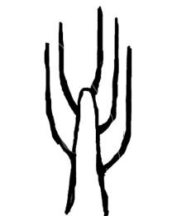 | 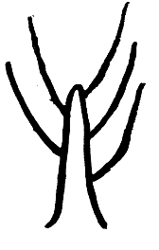 | 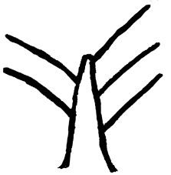 | 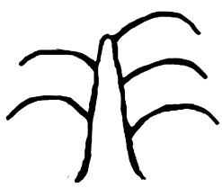 | 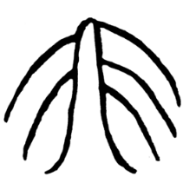
1 | 2 | 3 | 4 | 5
upright | semi-upright | spreading | drooping | weeping

Ad. 6: Current year's shoot: zigzag

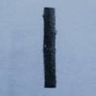 | 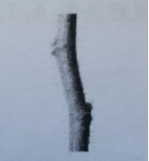 | 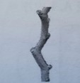
1 | 2 | 3
absent or weak | medium | strong

Ad. 7: Current year's shoot: twisting

Twisting is a three-dimensional characteristic whereby the shoot is bent, curled or has a distorted shape.

Ad. 9: Current year's shoot: length of internode

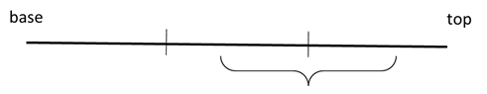
Tip
Base
Observations should be made on the middle of the top two thirds of the shoot.

Ad. 11: Leaf bud: shape

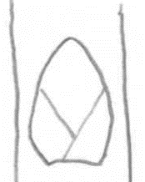 | 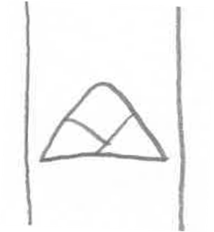 | 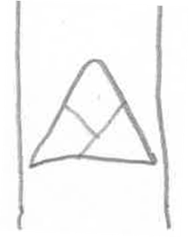 | 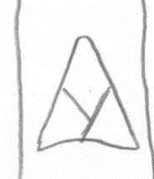
1 | 2 | 3 | 4
ovate | broad triangular | medium triangular | narrow triangular

Ad. 13: Leaf: phyllotaxis

Observations should be made on the upper third of the shoot. It is expressed by number of leaves in number of rotations until two leaves are located on the same vertical line.

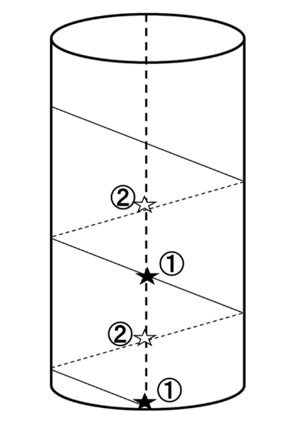 | 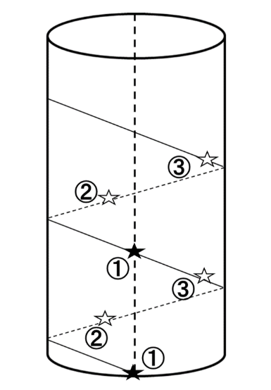 | 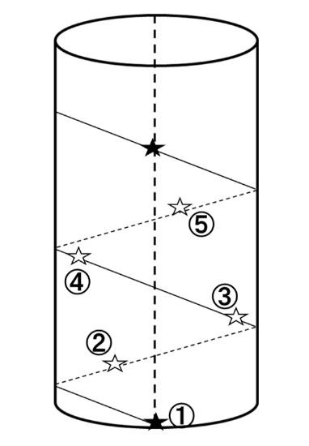
1 | 2 | 3
two in one | three in one | five in two

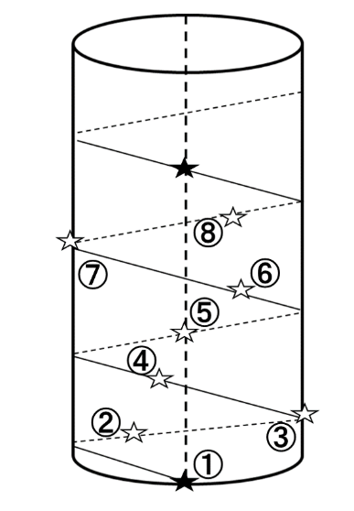 | 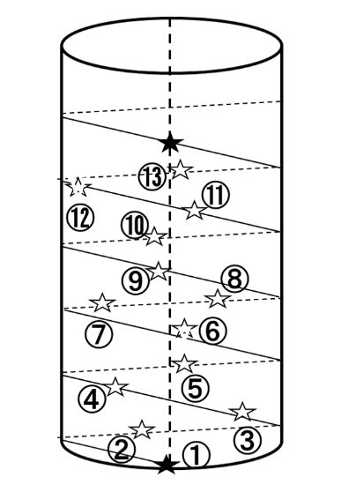
4 | 5
eight in three | thirteen in five

Ad. 14: Leaf blade: attitude

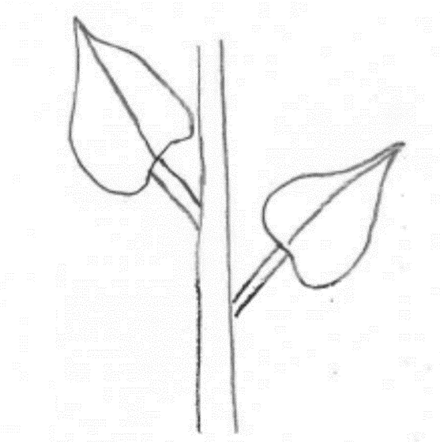 | 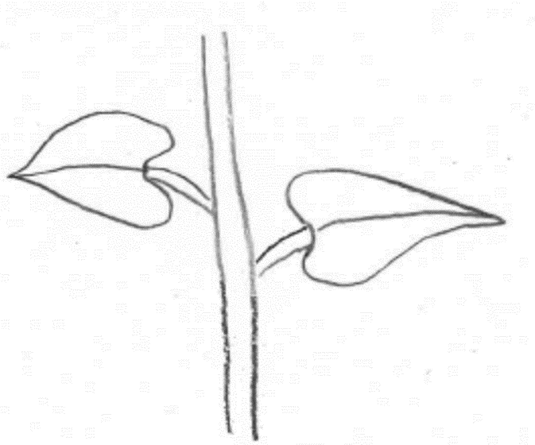 | 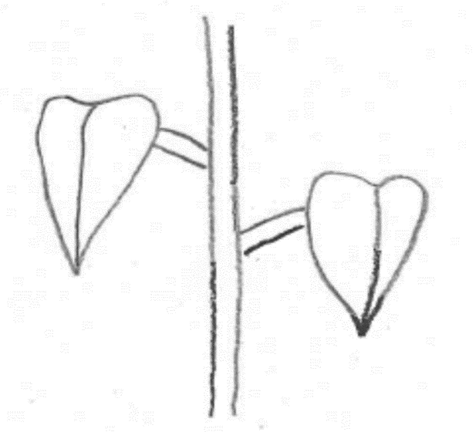
1 | 2 | 3
upwards | outwards | downwards

Ad. 15: Leaf blade: length

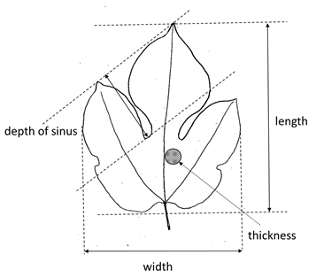
Width
Depth of sinus
Thickness
Length

Ad. 16: Leaf blade: width

See Ad. 15

Ad. 18: Leaf blade: thickness

See Ad. 15

Ad. 19: Leaf blade: shape of apex

Observations should be made excluding the tip.

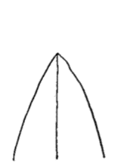 | 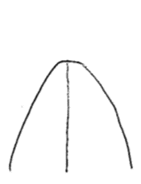 | 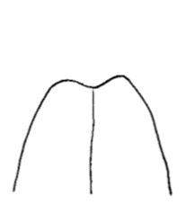
1 | 2 | 3
acute | obtuse | obcordate

Ad. 20: Leaf blade: length of tip

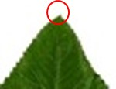 | 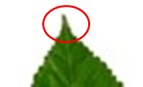 | 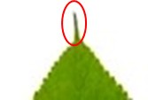
1 | 2 | 3
absent or short | medium | long

Ad. 22: Leaf blade: shape of base

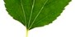 | 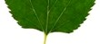 | 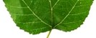 | 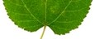
1 | 2 | 3 | 4
cuneate | truncate | slightly cordate | strongly cordate

Ad. 24: Only varieties with lobes present: Leaf blade: depth of sinus

See Ad. 15

Ad. 25: Leaf blade: margin
​
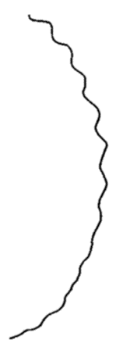 | 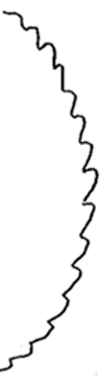 | 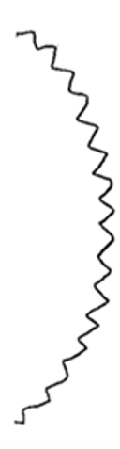 | 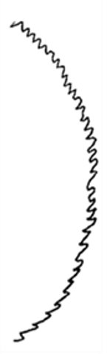 | 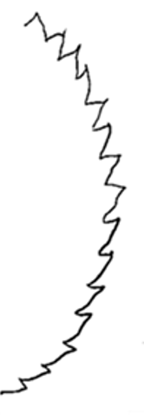 | 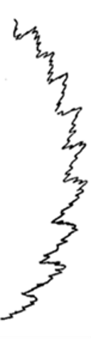 | 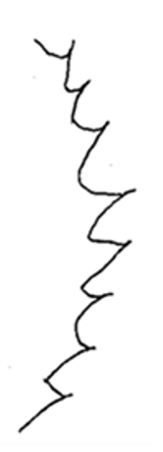
1 | 2 | 3 | 4 | 5 | 6 | 7
repand | crenate | dentate | serrulate | serrate | biserrate | aristate

Ad. 30: Leaf blade: shape in cross section

 |  | 
1 | 2 | 3
concave | flat | convex

Ad. 35: Infructescence: shape

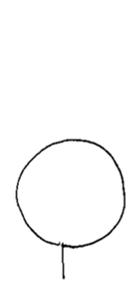 | 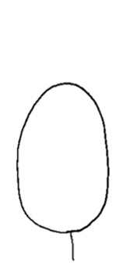 | 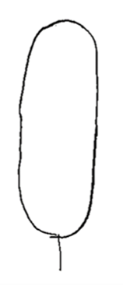
1 | 2 | 3
globose | ellipsoid | cylindric

Ad. 42: Time of leaf bud burst

The time of bud burst is when 10% of the buds show green points.

Ad. 43: Time of flowering

The time of flowering is when 50% of the flowers are fully open.

Ad. 44: Time of fruit ripening

Time of fruit ripening is reached when 50 % of the infructescences are suitable for consumption.

9. | Literature

Cappellozza, L., Corradazzi, A. T., Tornadore, N.,1995: Studies on the phenotypic variability of seven cvs of Morus alba L. and three of Morus multicaulis P. (Moraceae). Part I. Sericologia, 35 (2). Padova, IT, pp. 257 to 270.

Koyama, A., Yamanouchi, H. and Machii, H., 2001: Screening of mulberry genotypes suitable for fruit production and development of high-yielding strains with large fruits JARQ 35 (1). Ibaraki, JP, pp. 59 to 66

Machii, H., Koyama, A., and Yamanouchi, H., 2002: Mulberry Breeding, Cultivation and Utilization in Japan. In: Sánchez, M.D. (ed.) 2002. Mulberry for Animal Production. Animal Production and Health Paper 147. FAO, Rome, IT, pp. 63 to 71.

Yamanouchi, H., Koyama, A., Takyu, T., and Yoshioka, T., 2008: Flow cytometric analysis of various organs and cytochimeras of mulberry (Morus spp.) Journal of insect biotechnology and sericology 77(2). Ibaraki, JP, pp. 95 to 108

10. | Technical Questionnaire

TECHNICAL QUESTIONNAIRE | Page {x} of {y} | Reference Number:

Application date:
(not to be filled in by the applicant)
TECHNICAL QUESTIONNAIRE
to be completed in connection with an application for plant breeders' rights

1. | Subject of the Technical Questionnaire
 | 1.1 | Botanical name | Morus L.
 | 1.2 | Common name | Mulberry
 | 1.3 | Species (please indicate):

2. | Applicant
 | Name
 | Address
 | Telephone No.
 | Fax No.
 | E-mail address
 | Breeder (if different from
 | applicant)

3. | Proposed denomination and breeder's reference
 | Proposed denomination
 | (if available)
 | Breeder's reference

TECHNICAL QUESTIONNAIRE |  |  | Page {x} of {y} | Reference Number:
#4. | Information on the breeding scheme and propagation of the variety
 | 4.1 | Breeding scheme
 | Variety resulting from:
4.1.1 | Crossing
(a) | controlled cross | [ ]
(please state parent variety)

(…………………..……………..…) x (……………..…………………..…)

female parent male parent

(b) | partially known cross | [ ]
(please state known parent variety(ies))

(…………………..……………..…) x (……………..…………………..…)

female parent male parent

(c) | unknown cross | [ ]
4.1.2 | Mutation  (please state parent variety) | [ ]
4.1.3 | Discovery and development  (please state where and when discovered and how developed) | [ ]
4.1.4 | Other  (Please provide details) | [ ]

TECHNICAL QUESTIONNAIRE | Page {x} of {y} | Reference Number:

 | 4.2 | Method of propagating the variety
4.2.1 | Vegetative propagation
(a) | Budding or grafting | [ ]
(b) | Other (state method) | [ ]
4.2.2 | Other  (Please provide details) | [ ]

TECHNICAL QUESTIONNAIRE | Page {x} of {y} | Reference Number:

5. | Characteristics of the variety to be indicated (the number in brackets refers to the corresponding characteristic in Test Guidelines; please mark the note which best corresponds).

 | Characteristics | Example Varieties | Note
5.1  (2) | Tree: growth habit
 | upright | Mitsuminami, Piramidale, Tokiyutaka | 1 [ ]
 | semi-upright | Ichinose, Kenmochi | 2 [ ]
 | spreading | Ayanobori, Hayatesakari, Platanoide, Yukishinogi | 3 [ ]
 | drooping | Sekizaiso | 4 [ ]
 | weeping | Pendula, Shidareguwa | 5 [ ]
5.2  (13) | Leaf: phyllotaxis
 | two in one | Chijimiguwa, Filippine, Negoyatakasuke | 1 [ ]
 | three in one |  | 2 [ ]
 | five in two | Cattaneo fem., Florio, Ichinose, Kenmochi | 3 [ ]
 | eight in three | Morettiana, Wasemidori | 4 [ ]
 | thirteen in five |  | 5 [ ]
5.3  (20) | Leaf blade: length of tip
 | absent or short | Romana rabelaire, Rougetto | 1 [ ]
 | medium | Indiana, Kenmochi, Limoncina | 2 [ ]
 | long | Ascolana, Florio, Fukayuki, Takinokawa | 3 [ ]
5.4  (23) | Leaf blade: lobes
 | absent | Arancina, Florio | 1 [ ]
 | present |  | 9 [ ]
5.5  (28) | Leaf blade: color of upper side
 | light green | Hicks Fancy, Kairyo-Roso, Romana rabelaire | 1 [ ]
 | medium green | Ichinose, Illinois Everbearing | 2 [ ]
 | dark green | Florio, Indiana, Kenmochi, Shin-Kenmochi, Yukiasahi | 3 [ ]
 | yellowish green | Goshoerami, Kibajumonji, Planifolia | 4 [ ]

TECHNICAL QUESTIONNAIRE | Page {x} of {y} | Reference Number:

 | Characteristics | Example Varieties | Note
5.6  (33) | Plant: sex expression
 | male | Akameroso, Cattaneo male, Shimanouchi | 1 [ ]
 | hermaphrodite | Akagi, Filippine, Oshimaso | 2 [ ]
 | female | Cattaneo fem., Ichinose, Kenmochi | 3 [ ]
5.7  (35) | Infructescence: shape
 | globose | Piramidale | 1 [ ]
 | ellipsoid | Ascolana, Florio, Lalaberry | 2 [ ]
 | cylindric | Cattaneo fem., Ichinose, Kenmochi, Kokka, Platanoide | 3 [ ]
5.8  (39) | Infructescence: weight
 | low | Piramidale | 1 [ ]
 | medium | Ichinose, Kenmochi | 2 [ ]
 | high | Lalaberry | 3 [ ]
5.9  (40) | Infructescence: color
 | white | Ege Beyaz, Giazzola, Morettiana | 1 [ ]
 | yellowish white | Ascolana | 2 [ ]
 | pink | Kokka, Muki, Piramidale | 3 [ ]
 | reddish purple | Kozaemon, Restelli | 4 [ ]
 | light purple | Tagowase | 5 [ ]
 | dark purple | Florio, Lhou | 6 [ ]
 | blackish purple | Cattaneo fem., Ichinose, Indiana, Kenmochi, Lalaberry | 7 [ ]
5.10  (42) | Time of leaf bud burst
 | early | Ichibei, Wasemidori | 1 [ ]
 | early to medium |  | 2 [ ]
 | medium | Ichinose, Kenmochi | 3 [ ]
 | medium to late |  | 4 [ ]
 | late | Akagi, Shinjiro | 5 [ ]

TECHNICAL QUESTIONNAIRE | Page {x} of {y} | Reference Number:

6. | Similar varieties and differences from these varieties
Please use the following table and box for comments to provide information on how your candidate variety differs from the variety (or varieties) which, to the best of your knowledge, is (or are) most similar. This information may help the examination authority to conduct its examination of distinctness in a more efficient way.

Denomination(s) of variety(ies) similar to your candidate variety | Characteristic(s) in which your candidate variety differs from the similar variety(ies) | Describe the expression of the characteristic(s) for the similar variety(ies) | Describe the expression of the characteristic(s) for your candidate variety

Example | Tree: vigor | weak | strong

 | Comments:

TECHNICAL QUESTIONNAIRE | Page {x} of {y} | Reference Number:

#7. | Additional information which may help in the examination of the variety
7.1 | In addition to the information provided in sections 5 and 6, are there any additional characteristics which may help to distinguish the variety?
 | Yes | [ ] | No | [ ]
 | (If yes, please provide details)
7.2 | Are there any special conditions for growing the variety or conducting the examination?
 | Yes | [ ] | No | [ ]
 | (If yes, please provide details)
7.3 | Other information
7.3.1 Main use

(a) Fruit [ ]
(b) Ornamental [ ]
(c) Silk worm feed [ ]
(c) Other [ ]

7.3.2 Please indicate the rootstock used: .........................................................................

TECHNICAL QUESTIONNAIRE | Page {x} of {y} | Reference Number:

8. | Authorization for release
 | (a) | Does the variety require prior authorization for release under legislation concerning the protection of the environment, human and animal health?
 |  | Yes | [ ] | No | [ ]
 | (b) | Has such authorization been obtained?
 |  | Yes | [ ] | No | [ ]
 | If the answer to (b) is yes, please attach a copy of the authorization.

9. Information on plant material to be examined or submitted for examination

9.1 The expression of a characteristic or several characteristics of a variety may be affected by factors, such as pests and disease, chemical treatment (e.g. growth retardants or pesticides), effects of tissue culture, different rootstocks, scions taken from different growth phases of a tree, etc.
9.2 The plant material should not have undergone any treatment which would affect the expression of the characteristics of the variety, unless the competent authorities allow or request such treatment. If the plant material has undergone such treatment, full details of the treatment must be given. In this respect, please indicate below, to the best of your knowledge, if the plant material to be examined has been subjected to:

 | (a) | Microorganisms (e.g. virus, bacteria, phytoplasma) | Yes [ ] | No [ ]
 | (b) | Chemical treatment (e.g. growth retardant, pesticide) | Yes [ ] | No [ ]
 | (c) | Tissue culture | Yes [ ] | No [ ]
 | (d) | Other factors | Yes [ ] | No [ ]
 | Please provide details for where you have indicated “yes”.

10. | I hereby declare that, to the best of my knowledge, the information provided in this form is correct:
 | Applicant’s name
 | Signature |  | Date

[End of document]

