 |  | E
 |  | TG/181/4(proj.5)  ORIGINAL: English  DATE: 2024-05-17
INTERNATIONAL UNION FOR THE PROTECTION OF NEW VARIETIES OF PLANTS
 | Geneva
 | DRAFT
 | AMARYLLIS  UPOV Code(s): HIPPE  Hippeastrum Herb. | *
GUIDELINES
FOR THE CONDUCT OF TESTS
FOR DISTINCTNESS, UNIFORMITY AND STABILITY

prepared by an expert from the Netherlands

to be considered by

the Technical Committee for adoption by correspondence

Disclaimer: this document does not represent UPOV policies or guidance
Alternative names:*

Botanical name | English | French | German | Spanish
Hippeastrum Herb., Moldenkea Traub | Amaryllis | Amaryllis | Amaryllis, Ritterstern | Amarilis

The purpose of these guidelines (“Test Guidelines”) is to elaborate the principles contained in the General Introduction (document TG/1/3), and its associated TGP documents, into detailed practical guidance for the harmonized examination of distinctness, uniformity and stability (DUS) and, in particular, to identify appropriate characteristics for the examination of DUS and production of harmonized variety descriptions.
ASSOCIATED DOCUMENTS
These Test Guidelines should be read in conjunction with the General Introduction and its associated TGP documents.

TABLE OF CONTENTS | PAGE
1. | SUBJECT OF THESE TEST GUIDELINES.......................................................................................................... | 3
2. | MATERIAL REQUIRED......................................................................................................................................... | 3
3. | METHOD OF EXAMINATION................................................................................................................................ | 3
3.1 | Number of Growing Cycles........................................................................................................................ | 3
3.2 | Testing Place............................................................................................................................................. | 3
3.3 | Conditions for Conducting the Examination............................................................................................... | 3
3.4 | Test Design................................................................................................................................................ | 4
3.5 | Additional Tests......................................................................................................................................... | 4

4. | ASSESSMENT OF DISTINCTNESS, UNIFORMITY AND STABILITY................................................................. | 4
4.1 | Distinctness............................................................................................................................................... | 4
4.2 | Uniformity.................................................................................................................................................. | 5
4.3 | Stability...................................................................................................................................................... | 5

5. | GROUPING OF VARIETIES AND ORGANIZATION OF THE GROWING TRIAL................................................ | 6
6. | INTRODUCTION TO THE TABLE OF CHARACTERISTICS................................................................................ | 6
6.1 | Categories of Characteristics..................................................................................................................... | 6
6.2 | States of Expression and Corresponding Notes........................................................................................ | 6
6.3 | Types of Expression.................................................................................................................................. | 7
6.4 | Example Varieties...................................................................................................................................... | 7
6.5 | Legend....................................................................................................................................................... | 8

7. | TABLE OF CHARACTERISTICS/TABLEAU DES CARACTÈRES/MERKMALSTABELLE/TABLA DE CARACTERES...................................................................................................................................................... | 8
8. | EXPLANATIONS ON THE TABLE OF CHARACTERISTICS............................................................................... | 17
8.1 | Explanations covering several characteristics........................................................................................... | 17
8.2 | Explanations for individual characteristics................................................................................................. | 18

9. | LITERATURE........................................................................................................................................................ | 30
10. | TECHNICAL QUESTIONNAIRE............................................................................................................................ | 31

1. | Subject of these Test Guidelines
 | These Test Guidelines apply to all varieties of Hippeastrum Herb.

2. | Material Required
2.1 | The competent authorities decide on the quantity and quality of the plant material required for testing the variety and when and where it is to be delivered. Applicants submitting material from a State other than that in which the testing takes place must ensure that all customs formalities and phytosanitary requirements are complied with.
2.2 | The material is to be supplied in the form of bulbs.
2.3 | The minimum quantity of plant material, to be supplied by the applicant, should be:
 | 20 bulbs
2.4 | The plant material supplied should be visibly healthy, not lacking in vigor, nor affected by any important pest or disease.
2.5 | The plant material should not have undergone any treatment which would affect the expression of the characteristics of the variety, unless the competent authorities allow or request such treatment. If it has been treated, full details of the treatment must be given.

3. | Method of Examination
3.1 | Number of Growing Cycles
3.1.1 | The minimum duration of tests should normally be a single growing cycle.
3.1.2 | The testing of a variety may be concluded when the competent authority can determine with certainty the outcome of the test.
3.2 | Testing Place
 | Tests are normally conducted at one place. In the case of tests conducted at more than one place, guidance is provided in TGP/9 “Examining Distinctness”.
3.3 | Conditions for Conducting the Examination
3.3.1 | The tests should be carried out under conditions ensuring satisfactory growth for the expression of the relevant characteristics of the variety and for the conduct of the examination.
3.3.2 | Because daylight varies, color determinations made against a color chart should be made either in a suitable cabinet providing artificial daylight or in the middle of the day in a room without direct sunlight. The spectral distribution of the illuminant for artificial daylight should conform with the CIE Standard of Preferred Daylight D 6500 and should fall within the tolerances set out in the British Standard 950, Part I. These determinations should be made with the plant part placed against a white background. The color chart and version used should be specified in the variety description.

3.4 | Test Design
 | Each test should be designed to result in a total of at least 20 plants.
3.5 | Additional Tests
 | Additional tests, for examining relevant characteristics, may be established.

4. | Assessment of Distinctness, Uniformity and Stability
4.1 | Distinctness
4.1.1 | General Recommendations
 | It is of particular importance for users of these Test Guidelines to consult the General Introduction prior to making decisions regarding distinctness. However, the following points are provided for elaboration or emphasis in these Test Guidelines.
4.1.2 | Consistent Differences
 | The differences observed between varieties may be so clear that more than one growing cycle is not necessary. In addition, in some circumstances, the influence of the environment is not such that more than a single growing cycle is required to provide assurance that the differences observed between varieties are sufficiently consistent. One means of ensuring that a difference in a characteristic, observed in a growing trial, is sufficiently consistent is to examine the characteristic in at least two independent growing cycles.
4.1.3 | Clear Differences
 | Determining whether a difference between two varieties is clear depends on many factors, and should consider, in particular, the type of expression of the characteristic being examined, i.e. whether it is expressed in a qualitative, quantitative, or pseudo-qualitative manner. Therefore, it is important that users of these Test Guidelines are familiar with the recommendations contained in the General Introduction prior to making decisions regarding distinctness.
4.1.4 | Number of Plants or Parts of Plants to be Examined
 | Unless otherwise indicated, for the purposes of distinctness, all observations on single plants should be made on 10 plants or parts of plants taken from each of 10 plants and any other observations made on all plants in the test, disregarding any off-type plants.
4.1.5 | Method of Observation
 | The recommended method of observing the characteristic for the purposes of distinctness is indicated by the following key in the Table of Characteristics (see document TGP/9 “Examining Distinctness”, Section 4 “Observation of characteristics”):
MG: single measurement of a group of plants or parts of plants
MS: measurement of a number of individual plants or parts of plants
VG: visual assessment by a single observation of a group of plants or parts of plants
VS: visual assessment by observation of individual plants or parts of plants

 | Type of observation: visual (V) or measurement (M)

“Visual” observation (V) is an observation made on the basis of the expert’s judgment. For the purposes of this document, “visual” observation refers to the sensory observations of the experts and, therefore, also includes smell, taste and touch. Visual observation includes observations where the expert uses reference points (e.g. diagrams, example varieties, side-by-side comparison) or non-linear charts (e.g. color charts). Measurement (M) is an objective observation against a calibrated, linear scale e.g. using a ruler, weighing scales, colorimeter, dates, counts, etc.
Type of record: for a group of plants (G) or for single, individual plants (S)

For the purposes of distinctness, observations may be recorded as a single record for a group of plants or parts of plants (G), or may be recorded as records for a number of single, individual plants or parts of plants (S). In most cases, “G” provides a single record per variety and it is not possible or necessary to apply statistical methods in a plant-by-plant analysis for the assessment of distinctness.

In cases where more than one method of observing the characteristic is indicated in the Table of Characteristics (e.g. VG/MG), guidance on selecting an appropriate method is provided in document TGP/9, Section 4.2.

4.2 | Uniformity
4.2.1 | It is of particular importance for users of these Test Guidelines to consult the General Introduction prior to making decisions regarding uniformity. However, the following points are provided for elaboration or emphasis in these Test Guidelines:
4.2.2 | These Test Guidelines have been developed for the examination of vegetatively propagated varieties. For varieties with other types of propagation, the recommendations in the General Introduction and document TGP/13 "Guidance for new types and species" Section 4.5 "Testing Uniformity" should be followed.
4.2.3 | For the assessment of uniformity of vegetatively propagated varieties, a population standard of 1% and an acceptance probability of at least 95% should be applied. In the case of a sample size of 20 plants, 1 off-type is allowed.
4.3 | Stability
4.3.1 | In practice, it is not usual to perform tests of stability that produce results as certain as those of the testing of distinctness and uniformity. However, experience has demonstrated that, for many types of variety, when a variety has been shown to be uniform, it can also be considered to be stable.
4.3.2 | Where appropriate, or in cases of doubt, stability may be further examined by testing a new plant stock to ensure that it exhibits the same characteristics as those shown by the initial material supplied.

5. | Grouping of Varieties and Organization of the Growing Trial
5.1 | The selection of varieties of common knowledge to be grown in the trial with the candidate varieties and the way in which these varieties are divided into groups to facilitate the assessment of distinctness are aided by the use of grouping characteristics.
5.2 | Grouping characteristics are those in which the documented states of expression, even where produced at different locations, can be used, either individually or in combination with other such characteristics: (a) to select varieties of common knowledge that can be excluded from the growing trial used for examination of distinctness; and (b) to organize the growing trial so that similar varieties are grouped together.
5.3 | The following have been agreed as useful grouping characteristics:
(a) |  | Flower: type (characteristic 10)
(b) |  | Flower: width (characteristic 17)
(c) |  | Outer median tepal: main color of inner side (characteristic 22) with the following groups  Gr. 1: white  Gr. 2: yellow green  Gr. 3: orange  Gr. 4: light pink  Gr. 5: medium pink  Gr. 6: dark pink  Gr. 7: medium red  Gr: 8: dark red

5.4 | Guidance for the use of grouping characteristics, in the process of examining distinctness, is provided through the General Introduction and document TGP/9 “Examining Distinctness”.

6. | Introduction to the Table of Characteristics
6.1 | Categories of Characteristics
6.1.1 | Standard Test Guidelines Characteristics
 | Standard Test Guidelines characteristics are those which are approved by UPOV for examination of DUS and from which members of the Union can select those suitable for their particular circumstances.
6.1.2 | Asterisked Characteristics
 | Asterisked characteristics (denoted by *) are those included in the Test Guidelines which are important for the international harmonization of variety descriptions and should always be examined for DUS and included in the variety description by all members of the Union, except when the state of expression of a preceding characteristic or regional environmental conditions render this inappropriate.
6.2 | States of Expression and Corresponding Notes
6.2.1 | States of expression are given for each characteristic to define the characteristic and to harmonize descriptions. Each state of expression is allocated a corresponding numerical note for ease of recording of data and for the production and exchange of the description.
6.2.2 | All relevant states of expression are presented in the characteristic.

6.2.3 | Further explanation of the presentation of states of expression and notes is provided in document TGP/7 “Development of Test Guidelines”.
6.3 | Types of Expression
 | An explanation of the types of expression of characteristics (qualitative, quantitative and pseudo-qualitative) is provided in the General Introduction.
6.4 | Example Varieties
 | Where appropriate, example varieties are provided to clarify the states of expression of each characteristic.

6.5 | Legend
 |  | English |  | français |  | deutsch | español | Example Varieties  Exemples  Beispielssorten  Variedades ejemplo | Note/  Nota
1 | 2 | 3 | 4 | 5 | 6 | 7
 |  | Name of characteristics in English |  | Nom du caractère en français |  | Name des Merkmals auf Deutsch | Nombre del carácter en español
 |  | states of expression |  | types d’expression |  | Ausprägungsstufen | tipos de expresión

1 | Characteristic number
2 | (*) | Asterisked characteristic | – see Chapter 6.1.2
3 | Type of expression
 | QL | Qualitative characteristic | – see Chapter 6.3
 | QN | Quantitative characteristic | – see Chapter 6.3
 | PQ | Pseudo-qualitative characteristic | – see Chapter 6.3
4 | Method of observation (and type of plot, if applicable)
 | MG, MS, VG, VS |  | – see Chapter 4.1.5
5 | (+) | See Explanations on the Table of Characteristics in Chapter 8.2
6 | (a)-(e) | See Explanations on the Table of Characteristics in Chapter 8.1
7 | Not applicable

7. | Table of Characteristics/Tableau des caractères/Merkmalstabelle/Tabla de caracteres

 |  | English |  | français |  | deutsch | español | Example Varieties  Exemples  Beispielssorten  Variedades ejemplo | Note/  Nota
1. | (*) | QN | MS/VG | (+) | (a)
 |  | Leaf: width |  | Feuille : largeur |  | Blatt: Breite | Hoja: anchura
 |  | very narrow |  | très étroite |  | sehr schmal | muy estrecha |  | 1
 |  | narrow |  | étroite |  | schmal | estrecha | Balentino | 2
 |  | medium |  | moyenne |  | mittel | media | Coral Flame | 3
 |  | broad |  | large |  | breit | ancha | Peach Melba | 4
 |  | very broad |  | très large |  | sehr breit | muy ancha |  | 5
2. |  | QN | VG | (+) | (a)
 |  | Leaf: anthocyanin coloration at basal part |  | Feuille : pigmentation anthocyanique de la partie basale |  | Blatt: Anthocyanfärbung des basalen Teils | Hoja: pigmentación antociánica en la parte basal
 |  | absent or very weak |  | absente ou très faible |  | fehlend oder sehr gering | ausente o muy débil | White Garden | 1
 |  | weak |  | faible |  | gering | débil | Lovely Lady | 2
 |  | medium |  | moyenne |  | mittel | media | Floris Hekker | 3
 |  | strong |  | forte |  | stark | fuerte | Ferrari | 4
 |  | very strong |  | très forte |  | sehr stark | muy fuerte |  | 5
3. | (*) | QN | MS/VG | (+) | (b)
 |  | Peduncle: length |  | Pédoncule : longueur |  | Blütenstandsstiel: Länge | Pedúnculo: longitud
 |  | very short |  | très courte |  | sehr kurz | muy corta |  | 1
 |  | very short to short |  | très courte à courte |  | sehr kurz bis kurz | muy corta a corta |  | 2
 |  | short |  | courte |  | kurz | corta | Double Dragon,  Pink Rival | 3
 |  | short to medium |  | courte à moyenne |  | kurz bis mittel | corta a media |  | 4
 |  | medium |  | moyenne |  | mittel | media | Red Beauty, Red Garden | 5
 |  | medium to long |  | moyenne à longue |  | mittel bis lang | media a larga |  | 6
 |  | long |  | longue |  | lang | larga | Balentino, Scarlet Belle | 7
 |  | long to very long |  | longue à très longue |  | lang bis sehr lang | larga a muy larga |  | 8
 |  | very long |  | très longue |  | sehr lang | muy larga | Central Park | 9
4. | (*) | QN | MS/VG | (+) | (b)
 |  | Peduncle: thickness |  | Pédoncule : épaisseur |  | Blütenstandsstiel: Dicke | Pedúnculo: grosor
 |  | very thin |  | très mince |  | sehr dünn | muy delgado | Balentino | 1
 |  | thin |  | mince |  | dünn | delgado | Up Star | 2
 |  | medium |  | moyenne |  | mittel | medio | Coral Flame, KB111081 | 3
 |  | thick |  | épaisse |  | dick | grueso | NWK 8288, Scarlet Belle | 4
 |  | very thick |  | très épaisse |  | sehr dick | muy grueso | Ferrari | 5
5. |  | QN | VG | (+) | (b)
 |  | Peduncle: anthocyanin coloration |  | Pédoncule : pigmentation anthocyanique |  | Blütenstandsstiel: Anthocyanfärbung | Pedúnculo: pigmentación antociánica
 |  | absent or very weak |  | absente ou très faible |  | fehlend oder sehr gering | ausente o muy débil | Antarctica | 1
 |  | weak |  | faible |  | gering | débil | Double Dragon | 2
 |  | medium |  | moyenne |  | mittel | media | NWK 8288 | 3
 |  | strong |  | forte |  | stark | fuerte | Table Dance | 4
 |  | very strong |  | très forte |  | sehr stark | muy fuerte | Lovely Lady | 5
6. |  | PQ | VG | (+) | (b)
 |  | Peduncle: distribution of anthocyanin coloration |  | Pédoncule : distribution de la pigmentation anthocyanique |  | Blütenstandsstiel: Verteilung der Anthocyanfärbung | Pedúnculo: distribución de la pigmentación antociánica
 |  | at basal part |  | dans la partie basale |  | im basalen Teil | en la parte basal | Hyde Park | 1
 |  | at distal part |  | dans la partie distale |  | im distalen Teil | en la parte distal |  | 2
 |  | throughout |  | partout |  | überall | en la totalidad | Lovely Lady | 3
7. |  | QN | VG |  | (b)
 |  | Bracts: anthocyanin coloration |  | Bractées : pigmentation anthocyanique |  | Deckblätter: Anthocyanfärbung | Brácteas: pigmentación antociánica
 |  | absent or very weak |  | absente ou très faible |  | fehlend oder sehr gering | ausente o muy débil | Antarctica | 1
 |  | weak |  | faible |  | gering | débil | Cherry Bloss | 2
 |  | medium |  | moyenne |  | mittel | media | White Garden | 3
 |  | strong |  | forte |  | stark | fuerte | NWK 8288 | 4
 |  | very strong |  | très forte |  | sehr stark | muy fuerte | Lovely Lady | 5
8. |  | QN | VG |  | (b)
 |  | Only varieties with Bracts: anthocyanin coloration: absent or very weak to medium: Bracts: intensity of green color |  | Seulement variétés avec Bractées : pigmentation anthocyanique : absente ou très faible à moyenne: Bractées : intensité de la couleur verte |  | Nur Sorten mit Deckblättern: Anthocyanfärbung: fehlend oder sehr gering bis mittel: Deckblätter: Intensität der Grünfärbung | Solo variedades con Brácteas: pigmentación antociánica: ausente o muy débil a media: Brácteas: intensidad del color verde
 |  | very light |  | très claire |  | sehr hell | muy clara | White Amadeus | 1
 |  | light |  | claire |  | hell | clara |  | 2
 |  | medium |  | moyenne |  | mittel | media | Antarctica | 3
 |  | dark |  | foncée |  | dunkel | oscura |  | 4
 |  | very dark |  | très foncée |  | sehr dunkel | muy oscura | Lagoon | 5
9. | (*) | QN | MS/VG |  | (c)
 |  | Inflorescence: number of flowers |  | Inflorescence : nombre de fleurs |  | Blütenstand: Anzahl Blüten | Inflorescencia: número de flores
 |  | few |  | petit |  | gering | bajo | Pretnym | 1
 |  | medium |  | moyen |  | mittel | medio | Antarctica, Peach Melba | 2
 |  | many |  | élevé |  | hoch | alto | Red Garden | 3
10. | (*) | QL | VG | (+) | (c), (d)
 |  | Flower: type |  | Fleur : type |  | Blüte: Typ | Flor: tipo
 |  | single |  | simple |  | einzeln | sencillo | Antarctica, Peach Melba | 1
 |  | double |  | double |  | gefüllt | doble | Double Dragon,  Scarlet Belle | 2
11. |  | QL | VG | (+) | (c), (d)
 |  | Only varieties with flower type: double: Flower: shape of petaloid staminodes |  | Seulement variétés avec type de fleur : double : Fleur : forme des staminodes pétaloïdes |  | Nur Sorten mit Blütentyp: gefüllt: Blüte: Form der Nebenkronenstamino-dien | Solo variedades con tipo de flor: doble: Flor: forma de los estaminodios petaloides
 |  | regular |  | régulière |  | regelmäßig | regular | Double Dragon | 1
 |  | irregular |  | irrégulière |  | unregelmäßig | irregular | NWK 8288 | 2
12. |  | QN | VG | (+) | (c), (d)
 |  | Flower: attitude |  | Fleur : port |  | Blüte: Haltung | Flor: porte
 |  | erect |  | dressé |  | aufrecht | erecto | Up Star | 1
 |  | erect to horizontal |  | dressé à horizontal |  | aufrecht bis waagerecht | erecto a horizontal | Double Dragon | 2
 |  | horizontal |  | horizontal |  | waagerecht | horizontal | Antarctica | 3
 |  | horizontal to drooping |  | horizontal à pendant |  | waagerecht bis überhängend | horizontal a colgante | Balentino | 4
 |  | drooping |  | retombant |  | überhängend | colgante | Red Garden | 5
13. | (*) | QN | MS/VG | (+) | (c), (d)
 |  | Pedicel: length |  | Pédicelle : longueur |  | Blütenstiel: Länge | Pedicelo: longitud
 |  | very short |  | très courte |  | sehr kurz | muy corta | Up Star | 1
 |  | short |  | courte |  | kurz | corta | Peach Melba,  Table Dance | 2
 |  | medium |  | moyenne |  | mittel | media | Arnym, Balentino | 3
 |  | long |  | longue |  | lang | larga | Double Dragon,  Scarlet Belle | 4
 |  | very long |  | très longue |  | sehr lang | muy larga | NWK 8288 | 5
14. |  | QN | VG |  | (c), (d)
 |  | Pedicel: anthocyanin coloration |  | Pédicelle : pigmentation anthocyanique |  | Blütenstiel: Anthocyanfärbung | Pedicelo: pigmentación antociánica
 |  | absent or very weak |  | absente ou très faible |  | fehlend oder sehr gering | ausente o muy débil | Antarctica | 1
 |  | weak |  | faible |  | gering | débil | NWK 8288 | 2
 |  | medium |  | moyenne |  | mittel | media | Floris Hekker | 3
 |  | strong |  | forte |  | stark | fuerte | Lovely Lady | 4
 |  | very strong |  | très forte |  | sehr stark | muy fuerte | KB111081 | 5
15. | (*) | PQ | VG | (+) | (c), (d)
 |  | Flower: shape in front view |  | Fleur : forme en vue de face |  | Blüte: Form in Vorderansicht | Flor: forma en vista frontal
 |  | round |  | ronde |  | rund | redonda | Dancing Queen,  Scarlet Belle | 1
 |  | triangular |  | triangulaire |  | dreieckig | triangular | Antarctica, Peach Melba | 2
 |  | star-shaped |  | stelliforme |  | sternförmig | en forma de estrella | Balentino | 3
16. | (*) | QN | MS/VG | (+) | (c), (d)
 |  | Flower: length |  | Fleur : longueur |  | Blüte: Länge | Flor: longitud
 |  | very short |  | très courte |  | sehr kurz | muy corta | Orange Queen | 1
 |  | short |  | courte |  | kurz | corta | NWK 8288, White Garden | 2
 |  | medium |  | moyenne |  | mittel | media | Cherry Bloss,  Peach Melba | 3
 |  | long |  | longue |  | lang | larga | Lagoon, Tosca | 4
 |  | very long |  | très longue |  | sehr lang | muy larga |  | 5
17. | (*) | QN | MS/VG | (+) | (c), (d)
 |  | Flower: width |  | Fleur : largeur |  | Blüte: Breite | Flor: anchura
 |  | very narrow |  | très étroite |  | sehr schmal | muy estrecha | Red Beauty | 1
 |  | very narrow to narrow |  | très étroite à étroite |  | sehr schmal bis schmal | muy estrecha a estrecha | White Garden | 2
 |  | narrow |  | étroite |  | schmal | estrecha | Table Dance | 3
 |  | narrow to medium |  | étroite à moyenne |  | schmal bis mittel | estrecha a media | Pink Rival | 4
 |  | medium |  | moyenne |  | mittel | media | Cherry Bloss,  Coral Flame | 5
 |  | medium to broad |  | moyenne à large |  | mittel bis breit | media a ancha | Antarctica | 6
 |  | broad |  | large |  | breit | ancha | NWK 8288, Tosca | 7
 |  | broad to very broad |  | large à très large |  | breit bis sehr breit | ancha muy ancha | Arnym | 8
 |  | very broad |  | très large |  | sehr breit | muy ancha |  | 9
18. | (*) | PQ | VG | (+) | (c), (d)
 |  | Outer median tepal: shape |  | Tépale externe médian : forme |  | Äußeres mittleres Perigonblatt: Form | Tépalo medio externo: forma
 |  | broad ovate |  | ovale large |  | breit eiförmig | oval ancha | Peach Melba | 1
 |  | medium ovate |  | ovale moyenne |  | mittel eiförmig | oval media | Tosca | 2
 |  | narrow ovate |  | ovale étroite |  | schmal eiförmig | oval estrecha | Red Beauty | 3
 |  | broad elliptic |  | elliptique large |  | breit elliptisch | elíptica ancha | Antarctica, Coral Flame | 4
 |  | medium elliptic |  | elliptique moyenne |  | mittel elliptisch | elíptica media | Estella | 5
 |  | narrow elliptic |  | elliptique étroite |  | schmal elliptisch | elíptica estrecha | Balentino, Night Star | 6
 |  | broad obovate |  | obovale large |  | breit verkehrt eiförmig | oboval ancha | Mama Mia | 7
 |  | medium obovate |  | obovale moyenne |  | mittel verkehrt eiförmig | media oboval | Monaco | 8
 |  | narrow obovate |  | obovale étroite |  | schmal verkehrt eiförmig | oboval estrecha |  | 9
19. |  | PQ | VG | (+) | (c), (d)
 |  | Outer median tepal: shape of apex |  | Tépale externe médian : forme de l'apex |  | Äußeres mittleres Perigonblatt: Form des Apex | Tépalo medio externo: forma del ápice
 |  | acute |  | aiguë |  | spitz | aguda |  | 1
 |  | acuminate |  | acuminée |  | zugespitzt | acuminada |  | 2
 |  | rounded |  | arrondie |  | abgerundet | redondeada |  | 3
20. |  | QN | VG |  | (c), (d)
 |  | Outer median tepal: undulation of margin |  | Tépale externe médian : ondulation du bord |  | Äußeres mittleres Perigonblatt: Randwellung | Tépalo medio externo: ondulación del margen
 |  | absent or very weak |  | absente ou très faible |  | fehlend oder sehr gering | ausente o muy débil | Balentino | 1
 |  | weak |  | faible |  | gering | débil | Red Garden | 2
 |  | medium |  | moyenne |  | mittel | media | White Garden | 3
 |  | strong |  | forte |  | stark | fuerte | NWK 8288 | 4
 |  | very strong |  | très forte |  | sehr stark | muy fuerte | Central Park | 5
21. |  | QN | VG |  | (c), (d)
 |  | Outer median tepal: attitude |  | Tépale externe médian : port |  | Äußeres mittleres Perigonblatt: Haltung | Tépalo medio externo: porte
 |  | horizontal |  | horizontal |  | waagerecht | horizontal | Double Dragon | 1
 |  | slightly reflexed |  | légèrement réfléchi |  | leicht gebogen | ligeramente reflexo | White Garden | 2
 |  | moderately reflexed |  | modérément réfléchi |  | mäßig gebogen | moderadamente reflexo | Red Garden | 3
 |  | strongly reflexed |  | fortement réfléchi |  | stark gebogen | fuerte reflexo | Balentino | 4
22. | (*) | PQ | VG |  | (c), (d), (e)
 |  | Outer median tepal: main color of inner side |  | Tépale externe médian : couleur principale de la face interne |  | Äußeres mittleres Perigonblatt: Hauptfarbe der Innenseite | Tépalo medio externo: color principal de la cara interna
 |  | RHS Colour Chart (indicate reference number) |  | Code RHS des couleurs (indiquer le numéro de référence) |  | RHS-Farbkarte (Nummer angeben) | Carta de colores RHS (indíquese el número de referencia)
23. |  | PQ | VG |  | (c), (d), (e)
 |  | Outer median tepal: secondary color of inner side |  | Tépale externe médian : couleur secondaire de la face interne |  | Äußeres mittleres Perigonblatt: Sekundärfarbe der Innenseite | Tépalo medio externo: color secundario de la cara interna
 |  | RHS Colour Chart (indicate reference number) |  | Code RHS des couleurs (indiquer le numéro de référence) |  | RHS-Farbkarte (Nummer angeben) | Carta de colores RHS (indíquese el número de referencia)
24. | (*) | PQ | VG | (+) | (c), (d)
 |  | Outer median tepal: pattern of secondary color on inner side |  | Tépale externe médian : répartition de la couleur secondaire sur la face interne |  | Äußeres mittleres Perigonblatt: Muster der Sekundärfarbe der Innenseite | Tépalo medio externo: disposición del color secundario en la cara interna
 |  | none |  | aucune |  | keines | ninguna | Antarctica, Peach Melba | 1
 |  | veined |  | veinée |  | geadert | nervadura | Estella, Pretnym | 2
 |  | central stripe |  | bande centrale |  | Mittelstreifen | raya central | Balentino | 3
 |  | narrow marginate |  | au bord étroite |  | schmaler Rand | marginal estrecha | Picotee | 4
 |  | striped and speckled |  | striée et piquetée |  | gestreift und gesprenkelt | rayada y graneada | Mama Mia | 5
25. |  | QN | VG | (+) | (c), (d)
 |  | Only varieties with outer median tepal: pattern of secondary color on inner side: none: Outer median tepal: conspicuousness of veins |  | Seulement variétés avec tépale externe médian : répartition de la couleur secondaire sur la face interne : aucune : Tépale externe médian : netteté des nervures |  | Nur Sorten mit äußerem mittleren Perigonblatt: Muster der Sekundärfarbe der Innenseite: keines: Äußeres mittleres Perigonblatt: Ausprägung der Adern | Solo variedades con tépalo medio externo: disposición del color secundario en la cara interna: ninguna: Tépalo medio externo: visibilidad de las nervaduras
 |  | very weak |  | très faible |  | sehr gering | muy débil | Antarctica | 1
 |  | weak |  | faible |  | gering | débil | Arnym | 2
 |  | medium |  | moyenne |  | mittel | media | Red Garden | 3
 |  | strong |  | forte |  | stark | fuerte | Lovely Lady | 4
 |  | very strong |  | très forte |  | sehr stark | muy fuerte | Up Star | 5
26. |  | PQ | VG |  | (c), (d), (e)
 |  | Outer median tepal: main color of outer side |  | Tépale externe médian : couleur principale de la face externe |  | Äußeres mittleres Perigonblatt: Hauptfarbe der Außenseite | Tépalo medio externo: color principal de la cara externa
 |  | RHS Colour Chart (indicate reference number) |  | Code RHS des couleurs (indiquer le numéro de référence) |  | RHS-Farbkarte (Nummer angeben) | Carta de colores RHS (indíquese el número de referencia)
27. |  | PQ | VG |  | (c), (d), (e)
 |  | Outer median tepal: secondary color of outer side |  | Tépale externe médian : couleur secondaire de la face externe |  | Äußeres mittleres Perigonblatt: Sekundärfarbe der Außenseite | Tépalo medio externo: color secundario de la cara externa
 |  | RHS Colour Chart (indicate reference number) |  | Code RHS des couleurs (indiquer le numéro de référence) |  | RHS-Farbkarte (Nummer angeben) | Carta de colores RHS (indíquese el número de referencia)
28. |  | PQ | VG | (+) | (c), (d)
 |  | Inner median tepal: shape |  | Tépale interne médian : forme |  | Inneres mittleres Perigonblatt: Form | Tépalo medio interno: forma
 |  | broad ovate |  | ovale large |  | breit eiförmig | oval ancha |  | 1
 |  | medium ovate |  | ovale moyenne |  | mittel eiförmig | oval media |  | 2
 |  | narrow ovate |  | ovale étroite |  | schmal eiförmig | oval estrecha |  | 3
 |  | broad elliptic |  | elliptique large |  | breit elliptisch | elíptica ancha |  | 4
 |  | medium elliptic |  | elliptique moyenne |  | mittel elliptisch | elíptica media | Estella | 5
 |  | narrow elliptic |  | elliptique étroite |  | schmal elliptisch | elíptica estrecha | Night Star | 6
 |  | broad obovate |  | obovale large |  | breit verkehrt eiförmig | oboval ancha |  | 7
 |  | medium obovate |  | obovale moyenne |  | mittel verkehrt eiförmig | media oboval |  | 8
 |  | narrow obovate |  | obovale étroite |  | schmal verkehrt eiförmig | oboval estrecha |  | 9
29. |  | PQ | VG |  | (c), (d), (e)
 |  | Inner median tepal: main color of inner side |  | Tépale interne médian : couleur principale de la face interne |  | Inneres mittleres Perigonblatt: Hauptfarbe der Innenseite | Tépalo medio interno: color principal de la cara interna
 |  | RHS Colour Chart (indicate reference number) |  | Code RHS des couleurs (indiquer le numéro de référence) |  | RHS-Farbkarte (Nummer angeben) | Carta de colores RHS (indíquese el número de referencia)
30. |  | PQ | VG |  | (c), (d), (e)
 |  | Inner median tepal: secondary color of inner side |  | Tépale interne médian : couleur secondaire de la face interne |  | Inneres mittleres Perigonblatt: Sekundärfarbe der Innenseite | Tépalo medio interno: color secundario de la cara interna
 |  | RHS Colour Chart (indicate reference number) |  | Code RHS des couleurs (indiquer le numéro de référence) |  | RHS-Farbkarte (Nummer angeben) | Carta de colores RHS (indíquese el número de referencia)
31. |  | PQ | VG | (+) | (c), (d)
 |  | Inner median tepal: pattern of secondary color on inner side |  | Tépale interne médian : répartition de la couleur secondaire sur la face interne |  | Inneres mittleres Perigonblatt: Muster der Sekundärfarbe der Innenseite | Tépalo medio interno: disposición del color secundario en la cara interna
 |  | none |  | aucune |  | keines | ninguna | Antarctica, Peach Melba | 1
 |  | veined |  | veinée |  | geadert | nervadura | Estella, Pretnym | 2
 |  | central stripe |  | bande centrale |  | Mittelstreifen | raya central | Balentino | 3
 |  | narrow marginate |  | au bord étroite |  | schmaler Rand | marginal estrecha | Picotee | 4
 |  | striped and speckled |  | striée et piquetée |  | gestreift und gesprenkelt | rayada y graneada | Lieve, Table Dance | 5
32. |  | PQ | VG |  | (c), (d), (e)
 |  | Inner median tepal: main color of outer side |  | Tépale interne médian : couleur principale de la face externe |  | Inneres mittleres Perigonblatt: Hauptfarbe der Außenseite | Tépalo medio interno: color principal de la cara interna
 |  | RHS Colour Chart (indicate reference number) |  | Code RHS des couleurs (indiquer le numéro de référence) |  | RHS-Farbkarte (Nummer angeben) | Carta de colores RHS (indíquese el número de referencia)
33. |  | PQ | VG |  | (c), (d), (e)
 |  | Inner median tepal: secondary color of outer side |  | Tépale interne médian : couleur secondaire de la face externe |  | Inneres mittleres Perigonblatt: Sekundärfarbe der Außenseite | Tépalo medio interno: color secundario de la cara interna
 |  | RHS Colour Chart (indicate reference number) |  | Code RHS des couleurs (indiquer le numéro de référence) |  | RHS-Farbkarte (Nummer angeben) | Carta de colores RHS (indíquese el número de referencia)
34. |  | PQ | VG | (+) | (c), (d)
 |  | Inner lateral tepal: shape |  | Tépale interne lateral : forme |  | Inneres laterales Perigonblatt: Form | Tépalo lateral interno: forma
 |  | broad ovate |  | ovale large |  | breit eiförmig | oval ancha | Monaco | 1
 |  | medium ovate |  | ovale moyenne |  | mittel eiförmig | oval media | Red Beauty | 2
 |  | narrow ovate |  | ovale étroite |  | schmal eiförmig | oval estrecha |  | 3
 |  | broad elliptic |  | elliptique large |  | breit elliptisch | elíptica ancha |  | 4
 |  | medium elliptic |  | elliptique moyenne |  | mittel elliptisch | elíptica media | Estella | 5
 |  | narrow elliptic |  | elliptique étroite |  | schmal elliptisch | elíptica estrecha | Night Star | 6
 |  | broad obovate |  | obovale large |  | breit verkehrt eiförmig | oboval ancha |  | 7
 |  | medium obovate |  | obovale moyenne |  | mittel verkehrt eiförmig | media oboval |  | 8
 |  | narrow obovate |  | obovale étroite |  | schmal verkehrt eiförmig | oboval estrecha |  | 9
35. |  | QN | VG | (+) | (c), (d)
 |  | Inner lateral tepal: depth of incisions |  | Tépale interne lateral : profondeur des incisions |  | Inneres laterales Perigonblatt: Tiefe der Einschnitte | Tépalo lateral interno: profundidad de las incisiones
 |  | absent or shallow |  | absente ou peu profonde |  | fehlend oder flach | ausente o poco profunda | Balentino | 1
 |  | medium |  | moyenne |  | mittel | media | Central Park | 2
 |  | deep |  | profonde |  | tief | profunda | Lagoon | 3
36. |  | PQ | VG |  | (c), (d)
 |  | Filament: color |  | Filament : couleur |  | Staubfaden: Farbe | Filamento: color
 |  | RHS Colour Chart (indicate reference number) |  | Code RHS des couleurs (indiquer le numéro de référence) |  | RHS-Farbkarte (Nummer angeben) | Carta de colores RHS (indíquese el número de referencia)
37. |  | PQ | VG | (+) | (c)
 |  | Anther: color |  | Anthère : couleur |  | Staubbeutel: Farbe | Antera: color
 |  | yellowish |  | jaunâtre |  | gelblich | amarillento | Antarctica | 1
 |  | pinkish |  | rosâtre |  | blassrosa | rosáceo | Lovely Lady | 2
 |  | reddish |  | rougeâtre |  | rötlich | rojizo | Red Garden | 3
 |  | purplish |  | violacé |  | purpurn | purpúreo | Pink Rival | 4
38. |  | PQ | VG |  | (c), (d)
 |  | Style: color |  | Style : couleur |  | Griffel: Farbe | Estilo: color
 |  | RHS Colour Chart (indicate reference number) |  | Code RHS des couleurs (indiquer le numéro de référence) |  | RHS-Farbkarte (Nummer angeben) | Carta de colores RHS (indíquese el número de referencia)
39. |  | QN | VG | (+) | (c), (d)
 |  | Stigma: diameter |  | Stigmate : diamètre |  | Narbe: Durchmesser | Estigma: diámetro
 |  | very small |  | très petit |  | sehr klein | muy pequeño | Pink Panther | 1
 |  | small |  | petit |  | klein | pequeño | Balentino, Estella | 2
 |  | medium |  | moyen |  | mittel | medio | Antarctica, Peach Melba | 3
 |  | large |  | grand |  | groß | grande | Monaco, Pink Rival | 4
 |  | very large |  | très grand |  | sehr groß | muy grande | Albarino | 5

8. | Explanations on the Table of Characteristics
8.1 | Explanations covering several characteristics
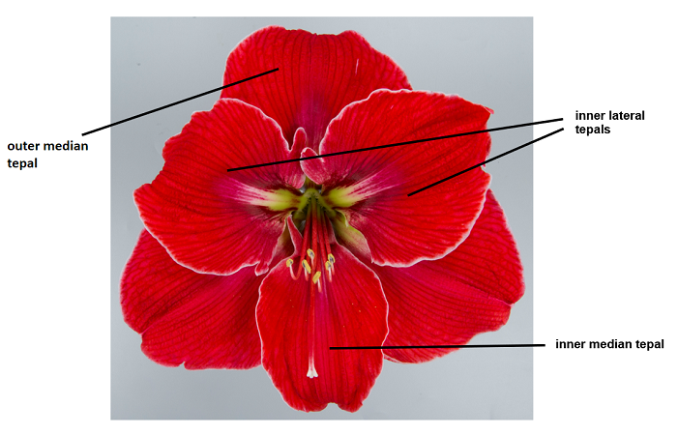
Outer median tepal
Inner median tepal
Inner lateral tepals

 | Characteristics containing the following key in the Table of Characteristics should be examined as indicated below:
(a) | Observations should be made on the largest fully expanded leaf. This is in most cases after the flowering period.
(b) | Observations should be made just before the flowers are open.
(c) | Observations should be made when all flowers on the firstly emerged peduncle are open.
(d) | Observations should be made when the anthers are open or at an equivalent flower stage for varieties without anthers.
(e) | The main color is the color with the largest surface area. In cases where the areas of the main and secondary color are too similar to reliably decide which color has the largest area, the darker color is considered to be the main color.

8.2 | Explanations for individual characteristics
Ad. 1: Leaf: width

Observations should be made on the widest part.

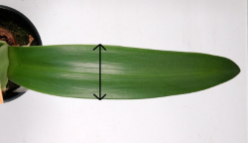

Ad. 2: Leaf: anthocyanin coloration at basal part

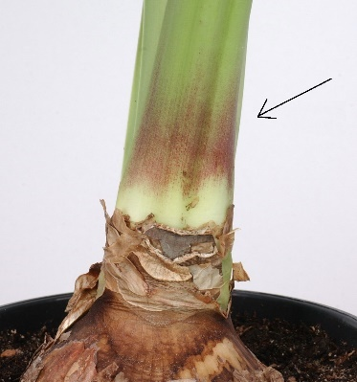

Ad. 3: Peduncle: length

Observations should be made from the top of the bulb to the base of the pedicels.

Ad. 4: Peduncle: thickness

Observations should be made in the middle of the peduncle.

Ad. 5: Peduncle: anthocyanin coloration

Observations should be made from the top of the bulb to the base of the pedicels. The strongest expression should be observed.

Ad. 6: Peduncle: distribution of anthocyanin coloration

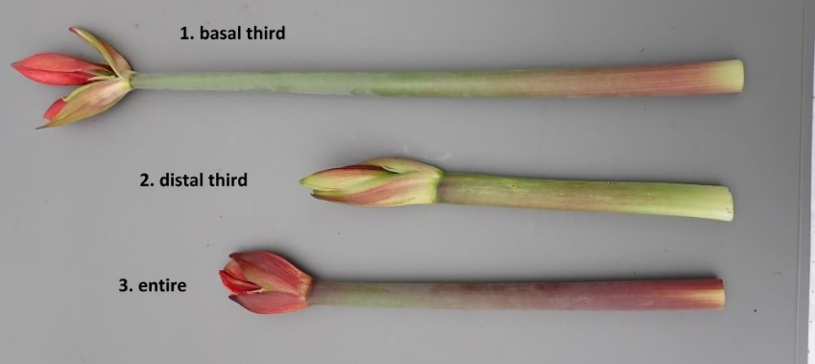
3. throughout
1. at basal part
2. at distal part

Ad. 10: Flower: type

Double flowers have more than 6 tepals.

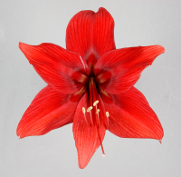 | 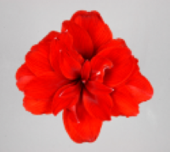
1 | 2
single | double

Ad. 11: Only varieties with flower type: double: Flower: shape of petaloid staminodes

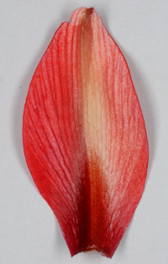 | 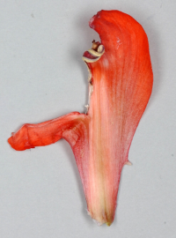
1 | 2
regular | irregular

Ad. 12: Flower: attitude

Observations should be made excluding the pedicel.

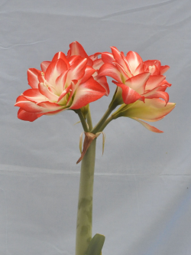 | 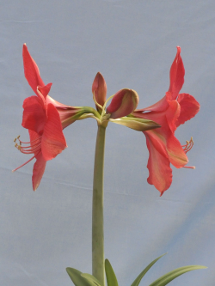 | 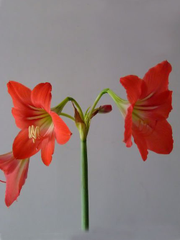
1 | 3 | 5
erect | horizontal | drooping

Ad. 13: Pedicel: length

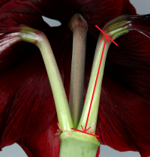

Ad. 15: Flower: shape in front view

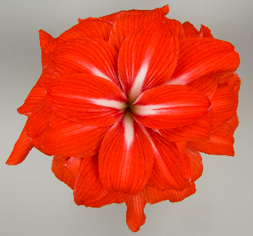 | 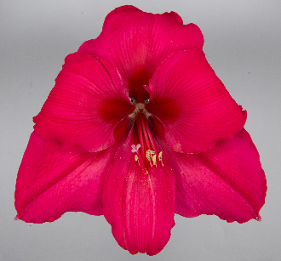 | 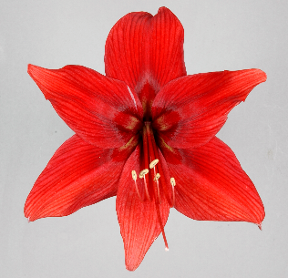
1 | 2 | 3
round | triangular | star-shaped

Ad. 16: Flower: length

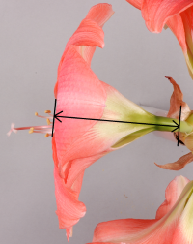

Ad. 17: Flower: width

Observations should be made on the maximum width of the flower.

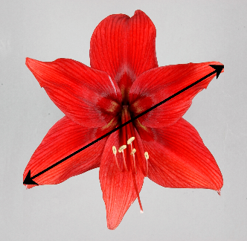

Ad. 18: Outer median tepal: shape

 |  |  |  |  | broadest part
 |  |  |  |  | below middle |  | at middle | above middle
 | narrow (elongated) |  |  | 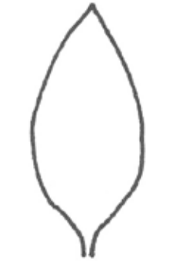  3  narrow ovate |  | 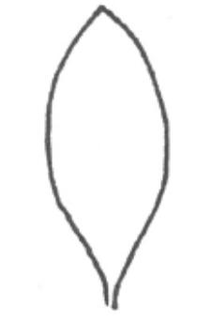  6  narrow elliptic |  | 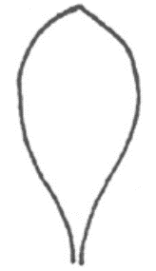  9  narrow obovate
 | width (ratio length/width) |  |  | 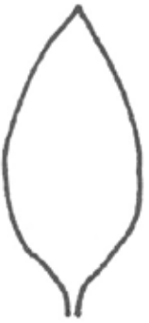  2  medium ovate |  | 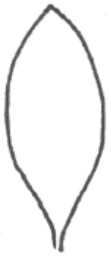  5  medium elliptic |  | 8  medium obovate
 | broad (compressed) |  |  | 1  broad ovate |  | 4  broad elliptic |  | 7  broad obovate

Ad. 19: Outer median tepal: shape of apex

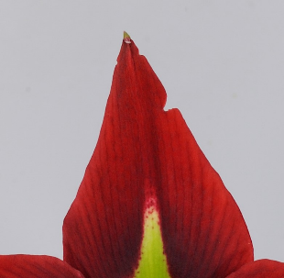 | 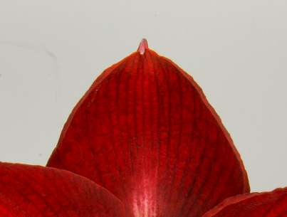 | 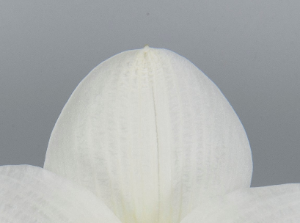
1 | 2 | 3
acute | acuminate | rounded

Ad. 24: Outer median tepal: pattern of secondary color on inner side

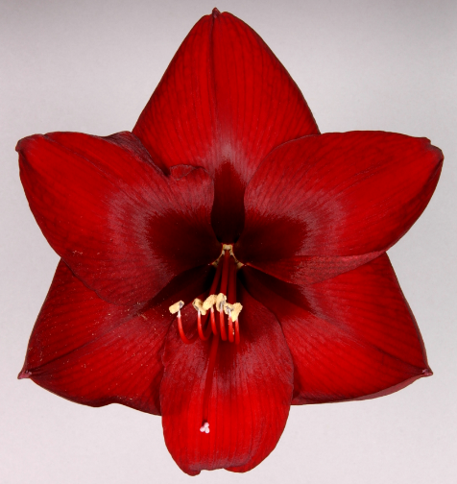 | 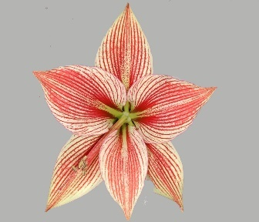 | 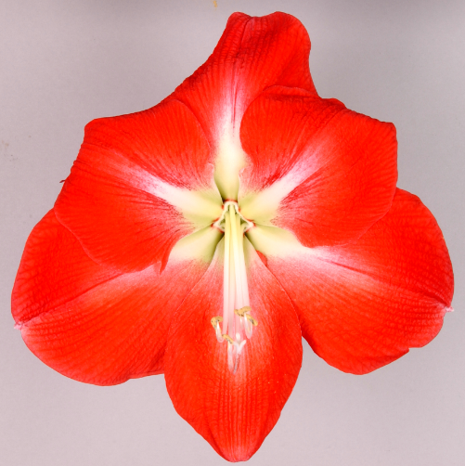
1 | 2 | 3
none | veined | central stripe

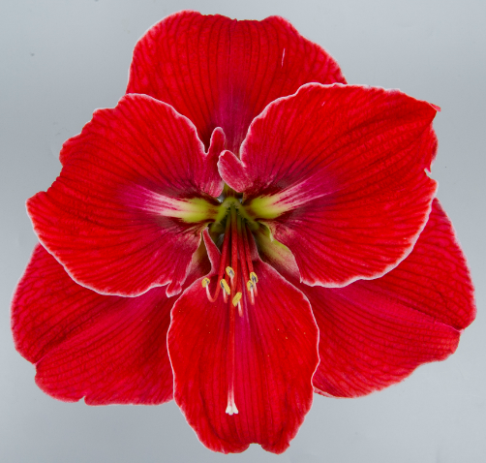 | 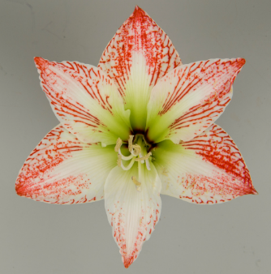
4 | 5
narrow marginate | striped and speckled

Ad. 25: Only varieties with outer median tepal: pattern of secondary color on inner side: none: Outer median tepal: conspicuousness of veins

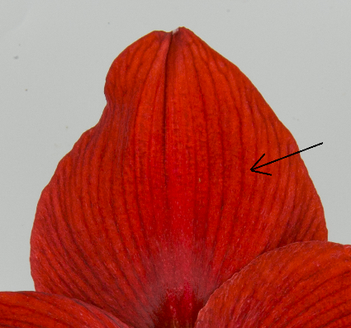

Ad. 28: Inner median tepal: shape

 |  |  |  |  | broadest part
 |  |  |  |  | below middle |  | at middle |  | above middle
 | narrow (elongated) |  |  | 3  narrow ovate |  | 6  narrow elliptic |  | 9  narrow obovate
 | width (ratio length/width) |  |  | 2  medium ovate |  | 5  medium elliptic |  | 8  medium obovate
 | broad (compressed) |  |  | 1  broad ovate |  | 4  broad elliptic |  | 7  broad obovate

Ad. 31: Inner median tepal: pattern of secondary color on inner side

1 | 2 | 3
none | veined | central stripe

4 | 5
narrow marginate | striped and speckled

Ad. 34: Inner lateral tepal: shape

 |  |  |  |  | broadest part
 |  |  |  |  | below middle |  | at middle | above middle
 | narrow (elongated) |  |  | 3  narrow ovate |  | 6  narrow elliptic |  | 9  narrow obovate
 | width (ratio length/width) |  |  | 2  medium ovate |  | 5  medium elliptic |  | 8  medium obovate
 | broad (compressed) |  |  | 1  broad ovate |  | 4  broad elliptic |  | 7  broad obovate

Ad. 35: Inner lateral tepal: depth of incisions

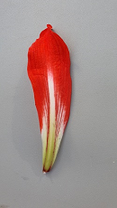 | 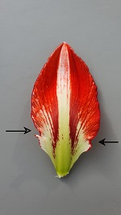 | 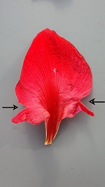
1 | 2 | 3
absent or shallow | medium | deep

Ad. 37: Anther: color

Observations should be made just before dehiscence.

Ad. 39: Stigma: diameter

​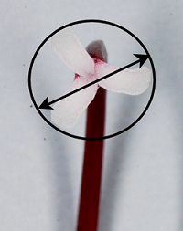

9. | Literature

No specific literature

10. | Technical Questionnaire

TECHNICAL QUESTIONNAIRE | Page {x} of {y} | Reference Number:

Application date:
(not to be filled in by the applicant)
TECHNICAL QUESTIONNAIRE
to be completed in connection with an application for plant breeders' rights

1. | Subject of the Technical Questionnaire
 | 1.1 | Botanical name | Hippeastrum Herb.
 | 1.2 | Common name | Amaryllis
 | 1.3 | Species (please indicate):

2. | Applicant
 | Name
 | Address
 | Telephone No.
 | Fax No.
 | E-mail address
 | Breeder (if different from
 | applicant)

3. | Proposed denomination and breeder's reference
 | Proposed denomination
 | (if available)
 | Breeder's reference

TECHNICAL QUESTIONNAIRE |  |  | Page {x} of {y} | Reference Number:
#4. | Information on the breeding scheme and propagation of the variety
 | 4.1 | Breeding scheme
 | Variety resulting from:
4.1.1 | Crossing
(a) | controlled cross | [ ]
(please state parent variety)

(…………………..……………..…) x (……………..…………………..…)

female parent male parent

(b) | partially known cross | [ ]
(please state known parent variety(ies))

(…………………..……………..…) x (……………..…………………..…)

female parent male parent

(c) | unknown cross | [ ]
4.1.2 | Mutation  (please state parent variety) | [ ]
4.1.3 | Discovery and development  (please state where and when discovered and how developed) | [ ]
4.1.4 | Other  (Please provide details) | [ ]

TECHNICAL QUESTIONNAIRE | Page {x} of {y} | Reference Number:

 | 4.2 | Method of propagating the variety
4.2.1 | Vegetative propagation
(a) | In vitro propagation | [ ]
(b) | Division | [ ]
(c) | Other (state method) | [ ]
4.2.2 | Other  (Please provide details) | [ ]

TECHNICAL QUESTIONNAIRE | Page {x} of {y} | Reference Number:

5. | Characteristics of the variety to be indicated (the number in brackets refers to the corresponding characteristic in Test Guidelines; please mark the note which best corresponds).

 | Characteristics | Example Varieties | Note
5.1  (10) | Flower: type
 | single | Antarctica, Peach Melba | 1 [ ]
 | double | Double Dragon, Scarlet Belle | 2 [ ]
5.2  (17) | Flower: width
 | very narrow | Red Beauty | 1 [ ]
 | very narrow to narrow | White Garden | 2 [ ]
 | narrow | Table Dance | 3 [ ]
 | narrow to medium | Pink Rival | 4 [ ]
 | medium | Cherry Bloss, Coral Flame | 5 [ ]
 | medium to broad | Antarctica | 6 [ ]
 | broad | NWK 8288, Tosca | 7 [ ]
 | broad to very broad | Arnym | 8 [ ]
 | very broad |  | 9 [ ]
5.3(i)  (22) | Outer median tepal: main color of inner side
 | RHS Colour Chart (indicate reference number)
5.3(ii)  (22) | Outer median tepal: main color of inner side
 | white |  | 1 [ ]
 | yellow green |  | 2 [ ]
 | orange |  | 3 [ ]
 | light pink |  | 4 [ ]
 | medium pink |  | 5 [ ]
 | dark pink |  | 6 [ ]
 | medium red |  | 7 [ ]
 | dark red |  | 8 [ ]
 | other (indicate) |  | 9 [ ]
5.4  (24) | Outer median tepal: pattern of secondary color on inner side
 | none | Antarctica, Peach Melba | 1 [ ]
 | veined | Estella, Pretnym | 2 [ ]
 | central stripe | Balentino | 3 [ ]
 | narrow marginate | Picotee | 4 [ ]
 | striped and speckled | Mama Mia | 5 [ ]

TECHNICAL QUESTIONNAIRE | Page {x} of {y} | Reference Number:

6. | Similar varieties and differences from these varieties
Please use the following table and box for comments to provide information on how your candidate variety differs from the variety (or varieties) which, to the best of your knowledge, is (or are) most similar. This information may help the examination authority to conduct its examination of distinctness in a more efficient way.

Denomination(s) of variety(ies) similar to your candidate variety | Characteristic(s) in which your candidate variety differs from the similar variety(ies) | Describe the expression of the characteristic(s) for the similar variety(ies) | Describe the expression of the characteristic(s) for your candidate variety

Example | Peduncle: length | short | medium

 | Comments:

TECHNICAL QUESTIONNAIRE | Page {x} of {y} | Reference Number:

#7. | Additional information which may help in the examination of the variety
7.1 | In addition to the information provided in sections 5 and 6, are there any additional characteristics which may help to distinguish the variety?
 | Yes | [ ] | No | [ ]
 | (If yes, please provide details)
7.2 | Are there any special conditions for growing the variety or conducting the examination?
 | Yes | [ ] | No | [ ]
 | (If yes, please provide details)
7.3 | Other information
A representative color photograph of the variety displaying its main distinguishing feature(s), should accompany the Technical Questionnaire. The photograph will provide a visual illustration of the candidate variety which supplements the information provided in the Technical Questionnaire.
The key points to consider when taking a photograph of the candidate variety are:
• Indication of the date and geographic location
• Correct labeling (breeder’s reference)
• Good quality printed photograph (minimum 10 cm x 15 cm) and/or sufficient resolution electronic format version (minimum 960 x 1280 pixels)”
Further guidance on providing photographs with the Technical Questionnaire is available in document TGP/7 "Development of Test Guidelines", Guidance Note 35 (http://www.upov.int/tgp/en/).
[The link provided may be deleted by members of the Union when developing authorities’ own test guidelines.]

Resistance to pests and diseases?

yes [ ] no [ ]
(If yes, please provide details)

TECHNICAL QUESTIONNAIRE | Page {x} of {y} | Reference Number:

8. | Authorization for release
 | (a) | Does the variety require prior authorization for release under legislation concerning the protection of the environment, human and animal health?
 |  | Yes | [ ] | No | [ ]
 | (b) | Has such authorization been obtained?
 |  | Yes | [ ] | No | [ ]
 | If the answer to (b) is yes, please attach a copy of the authorization.

9. Information on plant material to be examined or submitted for examination

9.1 The expression of a characteristic or several characteristics of a variety may be affected by factors, such as pests and disease, chemical treatment (e.g. growth retardants or pesticides), effects of tissue culture, different rootstocks, scions taken from different growth phases of a tree, etc.
9.2 The plant material should not have undergone any treatment which would affect the expression of the characteristics of the variety, unless the competent authorities allow or request such treatment. If the plant material has undergone such treatment, full details of the treatment must be given. In this respect, please indicate below, to the best of your knowledge, if the plant material to be examined has been subjected to:

 | (a) | Microorganisms (e.g. virus, bacteria, phytoplasma) | Yes [ ] | No [ ]
 | (b) | Chemical treatment (e.g. growth retardant, pesticide) | Yes [ ] | No [ ]
 | (c) | Tissue culture | Yes [ ] | No [ ]
 | (d) | Other factors | Yes [ ] | No [ ]
 | Please provide details for where you have indicated “yes”.

10. | I hereby declare that, to the best of my knowledge, the information provided in this form is correct:
 | Applicant’s name
 | Signature |  | Date

[End of document]

