 | E
International Union for the Protection of New Varieties of Plants

Technical Committee  Sixtieth Session  Geneva, October 21 and 22, 2024 | TC/60/6 Rev.  Original: English  Date: October 17, 2024
Measures to improve support provided for DUS examination
Document prepared by the Office of the Union
Disclaimer: this document does not represent UPOV policies or guidance

Executive summary

The purpose of this document is to report developments on the measures agreed by the Technical Committee, at its fifty-ninth session, to improve support provided for DUS examination.

Measures on Test Guidelines (TGs) and online tool for drafting TGs

The TC is invited to:

- consider the report from the subgroup on Test Guidelines;

- consider options to improve the Test Guidelines structure;

- consider options to improve the online tool for drafting Test Guidelines.

GENIE database and information on experience and cooperation in DUS examination

The TC is invited to:

(a) The TC is invited to consider how UPOV members can search for information on experience in DUS examination and whether to develop further guidance on the use of any of the available options.

(b) The TC is invited to consider how UPOV members can search information on cooperation in DUS examination and whether to develop further guidance on the use of any of the available options.

TGP documents: subgroups and leading experts

The TC is invited to:

(a) consider utilizing, as appropriate, guidance on the role of the leading expert in document TGP/7 for matters on amending or developing guidance in TGP documents, as set out in paragraph 66 of this document; and

(b) request the TWPs to invite experts from members of the Union to lead discussions on proposals for developing or amending guidance, including for TGP documents.

Training and distance learning

The TC is invited to:

- consider cooperation possibilities with UPOV members to resource the updating of the content format for the UPOV distance learning courses.

- support the development of new training courses on DUS examination by UPOV members, as set out in paragraphs 73 and 74 of this document;

- note that new training opportunities provided by UPOV members could also be included in the UPOV PVP Certificate program.

- to support UPOV members promoting training opportunities through the UPOV PVP Certificate program.

List of members willing to provide mentoring on drafting national test guidelines

The TC is invited to consider inviting the contact persons of members of the Union to the TC to provide information on members willing to provide mentoring on drafting national test guidelines for inclusion on the web page of contact persons for international cooperation in DUS examination.

Performance indicators

The TC is invited to:

- review the work of the TWPs on the basis of the performance indicators; and

- consider whether further performance indicators should established for measures to improve support provided for DUS examination.

2024 TWP Participants’ satisfaction survey

The TC is invited to note the satisfaction survey conducted with participants at the meetings of the TWPs in 2024, as presented in Annex V to this document.

The structure of this document is as follows:

Executive summary 1
Background 3
Measures for physical and virtual participation at TWP meetings 3
Survey on the needs of members and Working Group on DUS Support 3
Recommendations from the Working Group on DUS Support 3
Implementing measures 3
Measures to be implemented with the TC and TWP chairpersons 4
Measures to be implemented with the hosts of Technical Working Parties (TWPs) 4
Measures on Test Guidelines (TGs) and online tool for drafting TGs 4
Summary of outcomes of the consultation on UPOV Test Guidelines 4
Test Guidelines – format and content 4
TG Template Drafting Tool 5
Conclusions 5
Measures for the Office of the Union to develop proposals 6
GENIE database: Practical experience and cooperation in DUS examination 6
Cooperation in DUS examination 8
TGP Documents: subgroups and leading experts 10
Training and distance learning 11
Updating distance learning courses 11
Developing new courses 11
Promoting training opportunities 12
MATTERS FOR INFORMATION 12
Seminars / exhibitions for awareness of developments in testing methods and techniques 12
Documented DUS procedures in the UPOV DUS Report Exchange Platform 13
Performance Indicators 13
2024 TWP participants’ satisfaction survey 14
Annex I Measures to improve support for DUS examination
Annex II Subgroups and Leading Experts
Annex III information for Chairpersons of the Technical Working Parties
Annex IV Guidance Note: UPOV Technical Working Party arrangements
Annex V 2024 TWP meetings participant survey

The following abbreviations are used in this document:

TC: Technical Committee
TWA: Technical Working Party for Agricultural Crops
TWF: Technical Working Party for Fruit Crops
TWM: Technical Working Party on Testing Methods and Techniques
TWO: Technical Working Party for Ornamental Plants and Forest Trees
TWPs: Technical Working Parties
TWV: Technical Working Party for Vegetables
WG-DUS: Working Group on DUS Support

Background

Measures for physical and virtual participation at TWP meetings

The TC, at its fifty-seventh session, agreed a series of measures to increase physical and virtual participation at TWP meetings. In this regard, the TC agreed to request the Office of the Union to conduct a survey on the needs of members and observers in relation to TWPs and report to the TC at its fifty-eighth session (see document TC/57/25 “Report”, paragraphs 61 to 66).

Survey on the needs of members and Working Group on DUS Support

The TC, at its fifty-eight session, considered document TC/58/18 “Survey on the needs of members and observers in relation to TWPs” and the results of the interviews of members and observers on improving the technical support provided by UPOV for DUS examination. The TC considered the proposals to address the issues raised in the interviews and agreed to establish the Working Group on DUS Support (WG-DUS) to make recommendations on the proposals presented in document TC/58/18 (see document TC/57/25 “Report”, paragraphs 64).

Recommendations from the Working Group on DUS Support

The TC, at its fifty-ninth session, considered document TC/59/5 “Increasing participation of new members of the Union in work of the TC and restructuring the work of the TWPs”. The TC agreed with the recommendations in document TC/59/5, reproduced in Annex I to this document, including the amendments agreed during the session (see document TC/59/28 “Report”, paragraphs 56 to 62).

The TC, at its fifty-ninth session, agreed to assess the impact of the recommended proposals with a set of performance indicators (see “recommendation [43]”). The TC agreed that the efficiency of the performance indicators should be reviewed periodically along with the implementation of the recommendations in document TC/59/5 (see document TC/59/28 “Report”, paragraph 59).

Implementing measures

The TC, at its fifty-ninth session, agreed to group by affinity the recommendations to improve support for DUS examination to enable their implementing through similar measures. Annex I to this document provides the list of recommendations and their agreed implementing measures. The following sections of this document report on the four groups of measures agreed by the TC:

- Measures to be implemented with the TC and TWP chairpersons
- Measures to be implemented with the hosts of TWPs
- Measures on Test Guidelines (TGs) and the online tool for drafting TGs
- Measures for the Office of the Union to develop proposals

Measures to be implemented with the TC and TWP chairpersons

The series of recommendations to be implemented with the TC and TWP chairpersons were implemented at the TWPs in 2024. These measures were also reflected in the “Information for chairpersons of Technical Working Parties", a document used by the Office of the Union to explain the role of TWP chairpersons (see Annex III to this document).

Measures to be implemented with the hosts of Technical Working Parties (TWPs)

The measures agreed to be implemented with TWP hosts were included in the "Guidance note for hosts: UPOV Technical Working Party arrangements" (Annex IV to this document) and will be implemented from 2025. The “Guidance note for hosts” is a document used by the Office of the Union to explain meeting requirements for UPOV members hosting TWP sessions.

Measures on Test Guidelines (TGs) and online tool for drafting TGs

The TC agreed to establish a subgroup to develop options to address recommendations on Test Guidelines, including options on the online tool for drafting Test Guidelines (web-based TG template) (recommendations [21]; [22]; [23]; [24]; [25]; [26] and [28]). The terms of reference of the subgroup are provided in document TC/59/28 “Report”, paragraph 61.

The following sections provide a report from the leading expert, Ms. Margaret Wallace (United Kingdom).

Summary of outcomes of the consultation on UPOV Test Guidelines

Test Guidelines – format and content

The subgroup agreed that Test Guidelines (TG) are important for the harmonization of DUS testing. The majority uses the UPOV TG as a basis for their own National Protocol. In these cases, the UPOV document was not consulted after the production of the National document.

Some examiners use the full TG to set up the trial, while most only consult the table of characteristics and the associated explanations – the rest of the document is retained for reference should the need arise.

Some considered the information in sections one to seven of the TG unnecessary; some expressed that it was important to retain it. In general, the group considered that the information could be displayed in a simpler way to make the details easier to access.

The majority would also like to review what is contained in those sections and consider if there is a better way of presenting the information that is standard.

- For example, could information pertaining to all crops of a specific type be included in reference document e.g. refer to document for cross pollinated species instead of in the individual TGs.

The subgroup was divided in the requirements for the format of the document – even within the representatives from the same UPOV member:

- Some examiners take a printed paper copy to the test site (field, glasshouse, etc).
- Some examiners refer to the document on electronic devices. e.g. mobile phones, tablets, or laptops.

Everyone agreed that it would be useful to have the explanation of a characteristic more easily accessible – currently switching between sections is a pain point for paper and electronic users.

The opportunity for the use of videos or interactive images in the explanations was noted. This could result in better harmonization (and provide training for examiners) on the method of observation for specific characteristics. This was considered most useful for intricate characteristics where the part of the plant was not immediately obvious or the method particularly specific. However, it was noted that this could put an extra burden on the drafters so might restrict the participation of experts in the process.

It was highlighted that the table of characteristics does not need to contain all of the UPOV languages. This could free up space for the explanations.

The group generally felt that the Technical Questionnaire (TQ) could be separated from the TG. This would allow the revision of at TQ without a revision of the TG. The TQ should always be revised when a TG revision occurs.

Some people felt that there needs to be an easy way to update the TG to reflect changes in taxonomy.

The TG should include a link to the UPOV website where users can find the list of additional characteristics. This would provide easy access without confusing the status of such characteristics.

Example varieties were considered to be useful, but the difficulty in accessing material, and problems with expression in different environments were highlighted. There were no proposed solutions, but it is a topic that may warrant future consideration in addition to the current revision of Guidance Note 28.

It was wholly agreed that the format should facilitate automatic translation to allow easier access for the many members who work in languages other than English, French, German, or Spanish.

TG Template Drafting Tool

Some members of the Sub-Group had not used the drafting tool. Many agreed that the current drafting tool was a great improvement on the previous method of drafting in Word documents, however there were some opportunities for improvement.

The current template relies heavily on input from the UPOV Office. The group expressed particular appreciation for Romy Oertel, who is the main point of contact for issue resolution.

The pain points for the current template are the uploading of images, illustrations and diagrams, which are difficult to format and size correctly.

The Group requested that the template be more aligned with the finished document to be able to see changes in real time without the reliance on the preview function.

An easier chat function would be helpful for communication between experts. Notifications were highlighted as an additional tool, ideally with an option to mute them!

Contact details for named interested experts should be easily available, preferably in a contact list for easier communication by email e.g. to arrange online drafting sessions. Displaying the time zone of the experts would also be helpful when arranging discussions.

A better way of tracking changes during the UPOV TWP sessions would be helpful. If the drafting tool was used during the discussion to record directly into the drafting tool, it would save duplication of effort.

A tracking system should be visible to show the stages of the drafting process more clearly, so that people new to the discussion can see at a glance where the document is in the development.

Easy translation functions would be helpful to allow experts from all members to engage in the drafting process.

The drafting of national test guidelines was considered to be a good idea by many, if funding allows.

Conclusions

Things that should be considered for future test guidelines:

- Formatted in such a way:
  - to allow automatic translation
  - easier access to details
  - to allow the inclusion of information related to molecular techniques

- Separate the TQ from the TG
- Drafting tool should:
  - Be intuitive to use
  - facilitate the exchange of views between experts
  - record outcomes of discussions during the TWP sessions.

- The UPOV website should allow users to sign-up for notification if a new version of a TG is uploaded to the UPOV website.

Things that could be considered for future test guidelines:

- To include interactive images and videos.
- Incorporating a data entry function to record measurements or note observations. Which could lead to:
- Functionality to create final reports and variety descriptions.

The TC is invited to consider:

(a) the report from the subgroup on Test Guidelines;

(b) possible options to improve the Test Guidelines structure;

(c) possible options to improve the online tool for drafting Test Guidelines.

Measures for the Office of the Union to develop proposals

The following sections provide options on the matters where the Office of the Union was invited to develop proposals for consideration by the TC, at its sixtieth session.

GENIE database: Practical experience and cooperation in DUS examination

Recommendations 29 and 30 state as follows:

It is recommended [29] that the Office of the Union review the requesting of information on practical knowledge and cooperation in DUS examination. Information on practical experience can be derived by searching the PLUTO database for members receiving recent applications.

It is recommended [30] that guidance be developed to instruct users to use the PLUTO database to obtain that information.

Practical experience in DUS examination

Contact persons of members of the Union at the Technical Committee are invited every year to update the list of genera and species for which they have practical experience in DUS examination, using the following Excel template:

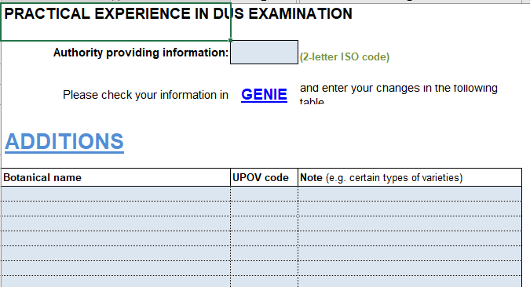

The information is compiled in the TC document “List of genera and species for which authorities have practical experience in DUS examination”. The document provides information as a list of genera and species with the respective authorities declaring experience examining the crop, as follows:

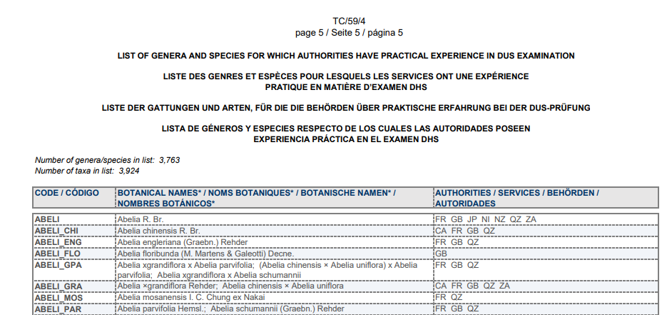

The same information provided in the TC document is made available on the GENIE database:

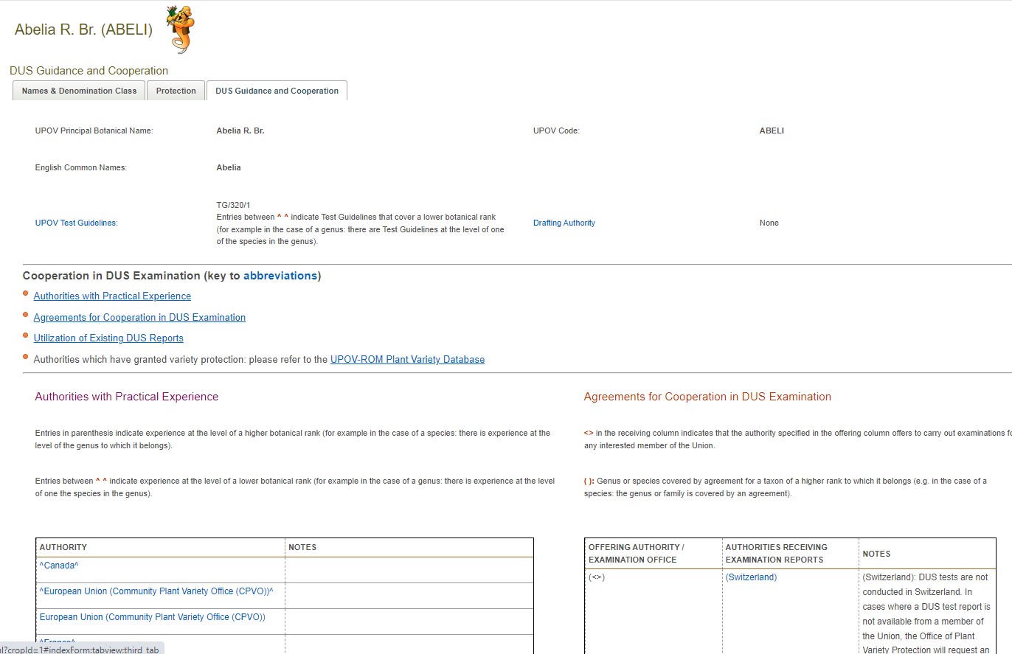

Since 2019, a total of 28 members provided information on practical experience in DUS examination. The largest number of contributions was received in 2024, when 14 members provided information.

Additional sources of information

PLUTO database

The PLUTO database allows searching for UPOV members receiving applications and granting titles for the different genera and species. Searches can be conducted for a defined period of time, such as over the last five or ten years.

Searches in the PLUTO database would enable identifying UPOV members with recent experience handling applications for particular crops. Nonetheless, it would not provide information whether the UPOV member has conducted DUS the examination itself or owns the test report. UPOV members would need to be contacted directly for further information on their practical experience with particular crops.

UPOV e-PVP DUS Report Exchange Platform

The UPOV e-PVP DUS Report Exchange Platform was launched in 2023 and is available for all UPOV members. It enables users to commission DUS examination and exchange existing test reports. Information is being progressively made available on DUS test reports for exchange and offers to conduct examination on behalf of authorities from other UPOV members. A report on developments will be provided at the sixtieth session of the TC.

Proposal

The TC may wish to consider how UPOV members search for information on experience in DUS examination and whether to promote the preferential use of any of the available options.

The TC is invited to consider how UPOV members can search for information on experience in DUS examination and whether to develop further guidance on the use of any of the available options.

Cooperation in DUS examination

UPOV members are periodically invited to provide and update information on cooperation in DUS examination. The information is to be provided in spreadsheets, as follows:

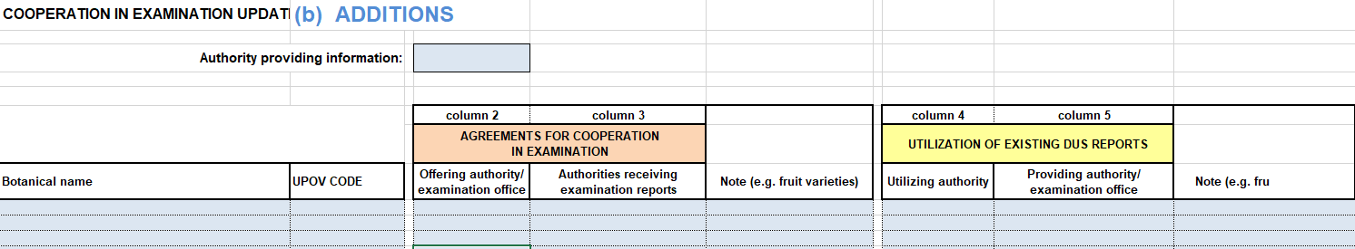

The information is compiled in the Council document “Cooperation in Examination”. The document provides “general notes” and a list of genera and species with the authorities that that carry out examination on behalf or utilize DUS reports provided by other authorities, as follows:
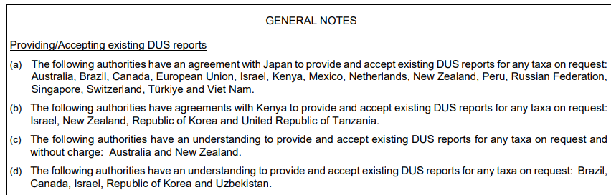

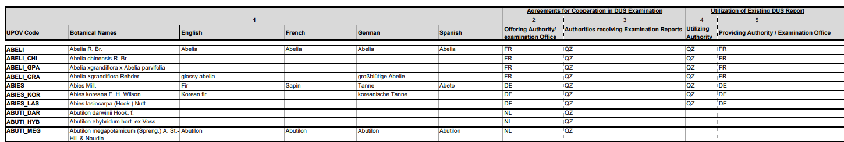

The same information provided in the Council document is made available on the GENIE database:

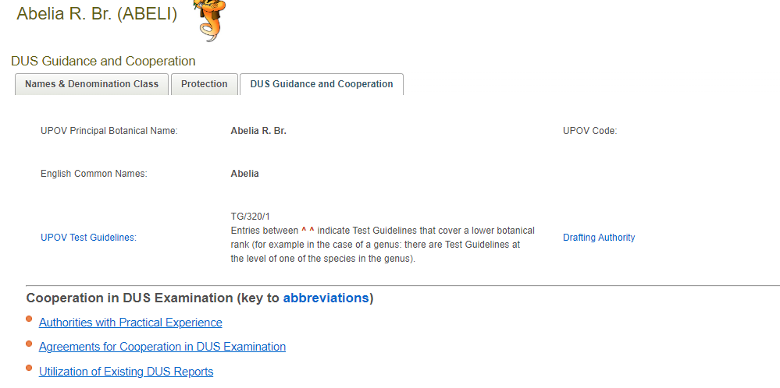

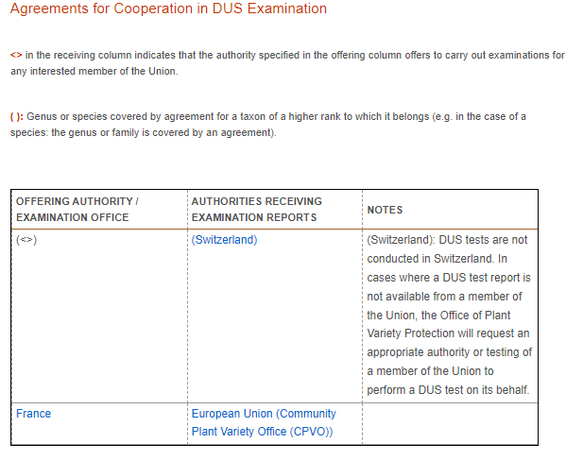 | 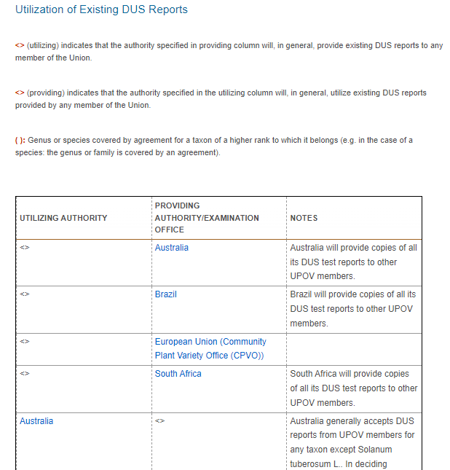

Since 2019, a total of 38 members provided information on cooperation in DUS examination. The largest number of contributions was received in 2024, when 14 members provided information.

Additional sources of information

PLUTO database

The PLUTO database does not provide information on cooperation in DUS examination.

UPOV e-PVP DUS Report Exchange Platform

The UPOV e-PVP DUS Report Exchange Platform enables users to commission DUS examination and exchange existing test reports. Information on the authorities offering DUS test reports can be derived directly from the UPOV e-PVP DUS Report Exchange Platform. A report on developments will be provided at the sixtieth session of the TC.

Proposal

The TC may wish to consider how UPOV members search and utilize information on cooperation in DUS examination and whether to promote the preferential use of any of the available options.

The TC is invited to consider how UPOV members can search information on cooperation in DUS examination and whether to develop further guidance on the use of any of the available options.

TGP Documents: subgroups and leading experts

Recommendations 31 and 32 state that:

“It is recommended [31] that matters that would require amending or developing guidance in TGP documents would be dealt with by subgroups established by the Technical Committee (TC). These subgroups would meet online and/or as hybrid meetings along with other UPOV meetings and would report to the TC any proposals.

“It is recommended [32] that the TGP subgroups established by the TC would have a leading expert that would chair the discussions. The leading expert would be in charge of presenting the findings of the subgroup and any proposals to the TC and TWPs.”

Document TGP/7 “Development of Test Guidelines” provides guidance on the procedures for preparing draft Test Guidelines and the role of the leading expert (see document TGP/7, Sections 2.2.3 and 2.2.4, also reproduced in Annex III to this document). The same guidance could be used for matters that would require amending or developing guidance in TGP documents, as appropriate, with the following general steps:

- The Technical Committee (TC) will decide which matters that would require amending or developing guidance in TGP documents would be dealt with by subgroups.
- The TC will agree on leading experts responsible for preparing draft documents and establish subgroups with the interested experts wishing to participate.
- The leading experts would prepare draft documents and present them at the TWP and TC meetings.
- Leading experts may enhance the consultation of interested experts by the arrangement of subgroup meetings in conjunction with UPOV meetings or as separate meetings, with or without the Office of the Union being present.
- The leading expert takes the results of the discussions in the subgroup meeting into account when preparing a new draft of the documents for consideration by the TWP and the TC.

The above procedure could be used in addition to the practice of inviting an expert from a UPOV member to draft a proposal and lead discussions with interested experts. For example, the current revision of document TGP/7, Guidance Note 28 “Example varieties”, was led by an expert from Germany and discussed with interested experts at the TWPs in 2024. These procedures would also take into consideration the remaining recommendations on TGP documents, as follows:

“It is recommended [33] that the TWPs are kept informed about subgroups established by the TC for amending or developing guidance in TGP documents and are provided opportunities to participate in discussions.

“It is recommended [34] that the Office of the Union provides administrative support for TGP subgroup meetings as follows:

- “For meetings arranged during the TWPs, the involvement of the Office of the Union would be agreed between the leading expert and the Office of the Union.

- “For meetings arranged outside the TWPs, administrative support would not be provided. The leading expert would facilitate the meetings and record any decisions. Participation by the Office of the Union would be agreed between the leading expert and the Office of the Union.”

The TC is invited to:

(a) consider utilizing, as appropriate, guidance on the role of the leading expert in document TGP/7 for matters on amending or developing guidance in TGP documents, as set out in paragraph 66 of this document; and

(b) request the TWPs to invite experts from members of the Union to lead discussions on proposals for developing or amending guidance, including for TGP documents.

Training and distance learning

Updating distance learning courses

Recommendation 37 states that:

It is recommended [37] to update the distance learning courses. Consideration could also be given to increasing awareness of distance learning courses by plant breeders and PVP applicants.

Updating the format for UPOV distance learning courses would require resourcing the development of multimedia files and interactive content formats. The Technical Committee may wish to consider cooperation possibilities with UPOV members to resource the updating of the content format for the UPOV distance learning courses.

The Technical Committee is invited to consider cooperation possibilities with UPOV members to resource the updating of the content format for the UPOV distance learning courses.

Developing new courses

Recommendation 38 states that:

It is recommended [38] to further investigate the development of a new course on using UPOV guidance for DUS examination (e.g. developing national test guidelines), including in which format could the content be offered (e.g. workshop; videos).

The TC identified opportunities for further training on using UPOV guidance for DUS examination, including developing national test guidelines in the absence of UPOV Test Guidelines. Different content formats such as webinars and video-recordings could be used to provide practical guidance from UPOV members’ experience and complement distance learning courses. Developing practical guidance would rely on UPOV members to provide expertise and content.

The UPOV communication channels (website, YouTube) could provide the platform for the training materials provided by UPOV members, as required. New training opportunities provided by UPOV members could also be included in the UPOV PVP Certificate program.

The Technical Committee is invited to:

(a) support the development of new training courses on DUS examination by UPOV members, as set out in paragraphs 73 and 74 of this document; and

(b) note that new training opportunities provided by UPOV members could also be included in the UPOV PVP Certificate program.

Promoting training opportunities

Recommendation 39 states that:

It is recommended [39] to provide further information on the UPOV website on possibilities for training provided by members and to use that training website to promote requests and offers for training and related cooperation, as proposed by members and relevant organizations.

Information on training opportunities is provided on the UPOV website at the following page: https://www.upov.int/resource/en/training.html. In addition, UPOV has launched the “UPOV PVP Certificate program” (UPOV PVP Certificate) to promote the acquisition of knowledge and recognition of expertise, as well as opportunities for continuous learning on PVP matters. Further information is available at: https://www.upov.int/resource/en/pvp_certificate.html

Training opportunities from UPOV members and academic entities could be promoted through their inclusion in the UPOV PVP Certificate program.

The Technical Committee is invited to support UPOV members promoting training opportunities through the UPOV PVP Certificate program.

List of members willing to provide mentoring on drafting national test guidelines

Recommendation 27 proposed expanding the list to contact persons for international cooperation in DUS to include information on members willing to provide mentoring to others on drafting national test guidelines. The list of contact persons for international cooperation in DUS examination is available on the UPOV website at: https://www.upov.int/databases/en/contact_cooperation.html

This recommendation could be implemented through periodically inviting the contact persons of members of the Union to the TC to provide information. Information on members willing to provide mentoring on drafting national test guidelines would be included on the web page of contact persons for international cooperation in DUS examination.

The TC is invited to consider inviting the contact persons of members of the Union to the TC to provide information on members willing to provide mentoring on drafting national test guidelines for inclusion on the web page of contact persons for international cooperation in DUS examination.

MATTERS FOR INFORMATION

Seminars / exhibitions for awareness of developments in testing methods and techniques

Recommendations 16 to 18 provide as follows:

It is recommended [16] to explore additional means of increasing awareness of developments in testing methods and techniques, such as through seminars and exhibitions (see “(f) Technical Committee”).

It is recommended [17] that seminars on testing methods and techniques and other developments in DUS examination might be organized along with meetings of the Technical Committee as a means to increase awareness of developments.

It is recommended [18] that exhibitions of research with poster sessions might be considered along with the seminars held in conjunction with the Technical Committee meetings as a means of increasing awareness of developments. Information from the poster sessions should also be made available to experts not physically present at the TC sessions.

In consultation with the chairpersons of the Technical Working Parties, it is proposed that a seminar on testing methods and techniques is organized every three years in the same week as the Technical Committee session. Representatives from members, observers and relevant experts would be invited to report developments. The seminar could be organized during a half- or a full-day, as appropriate. The organization of poster sessions would be considered along with the TC and TWP chairpersons for DUS experts and researchers to present information on the seminar topics.

Documented DUS procedures in the UPOV DUS Report Exchange Platform

Recommendation 41 states that:

It is recommended [41] that the DUS Report Exchange Platform also enable UPOV members to make their documented DUS procedures and information on their quality systems available.

The UPOV e-PVP DUS Report Exchange Platform was launched in 2023 and is available for all UPOV members. The Platform will be expanded with a possibility for UPOV members to provide information on their documented DUS procedures and information on their quality systems. A report on developments will be provided at the sixtieth session of the TC.

Performance Indicators

The TC, at its fifty-ninth session, agreed the following performance indicators to assess the impact of the recommended proposals:

Harmonized procedures

- Number of UPOV members using UPOV Technical Questionnaires (TQs)

As of September 2024, 24 out of 37 participating UPOV members are using UPOV TQs in UPOV PRISMA.

- Percentage of PVP applications in UPOV members covered by UPOV Test Guidelines

In 2023, 94% of all applications for plant variety protection in UPOV members were covered by UPOV Test Guidelines (374,534 out of 416,149 entries in the PLUTO database).

- Use of UPOV member test guidelines by other UPOV members to develop national test guidelines where there are no UPOV Test Guidelines

In 2024, 2 UPOV members used the test guidelines of another UPOV members to develop their national test guidelines in the absence of UPOV Test Guidelines (GB Technical Questionnaire for Sugar beet: utilized by MD, ZA).

- Number of DUS reports produced by UPOV members that are used by other members

90. As of September 2024, 7 DUS test reports had been exchanged through the UPOV e-PVP DUS Exchange Platform.

- Time required for TWPs to approve new TGs or revisions of TGs

Full draft TGs | Years since first TWP to submission to TC*
Lavender (Lavandula L.) | 3
Leucanthemum (Leucanthemum Mill.) | 2
Poinsettia (Euphorbia pulcherrima Willd. ex Klotzsch; Euphorbia pulcherrima Willd. ex Klotzsch × Euphorbia cornastra (Dressler) Radcl.-Sm.) (Revision) | 3
Hemp, Cannabis (Cannabis sativa L.) (Revision) | 3
Zoysia Grasses (Zoysia Willd.) | 5
Grapevine (Vitis L.) (Revision) | 6
Partial revisions | Years since first TWP to submission to TC*
Asparagus (Asparagus officinalis L.)  - Char. 16 “Type of flowering” | 1
Cucumber, Gherkin (Cucumis sativus L.)  - addition of resistance to Cucumber green mottle mosaic virus | 1
Lettuce (Lactuca sativa L.)  - Resistance to Bremia lactucae Races 16EU to 27EU (chars. 38 to 47, including grouping characteristics)  - revision of Fusarium oxysporum f. sp. lactucae Race 1  - addition of Resistance to Fusarium oxysporum f. sp. lactucae Race 4 | 1

Training

- Number of DUS examiners and administrators that have the UPOV International Certificate on Plant Variety Protection

As of September 2024, 41 DUS examiners and administrators were Certified.

Performance assessment

The TC, at its fifty-ninth session, agreed that :

- the work of the TWPs was periodically reviewed on the basis of the performance indicators.

- UPOV members and observer organizations were regularly surveyed on their satisfaction with the support for DUS examination provided by UPOV through the TC and TWPs.

- The development of further performance indicators could be considered along with the implementation of the recommendations in this document.

The Technical Committee is invited to:

(a) review the work of the TWPs on the basis of the performance indicators; and

(b) consider whether further performance indicators should established for measures to improve support provided for DUS examination.

2024 TWP participants’ satisfaction survey

The TC, at its fifty-ninth session, agreed that UPOV members and observers were regularly surveyed on their satisfaction with the support for DUS examination provided by UPOV through the TC and TWPs. The results of the participants’ satisfaction survey at 2024 sessions of the TWPs are provided as Annex III to this document.

The TC is invited to note the satisfaction survey conducted with participants at the meetings of the TWPs in 2024, as presented in Annex V to this document.

[Annex I follows]

ELEMENTS / ISSUES | RECOMMENDATIONS | IMPLEMENTING MEASURES
1. Technical Working Parties | Recommendation 1:  The UPOV Technical Working Parties should aim to deliver the following:  (a) Harmonized procedures;  (b) Information on developments;  (c) Interaction between experts and integration of new experts in UPOV’s work;  (d) Practical guidance on DUS examination procedures, including use of Test Guidelines. | Included in "Information for chairpersons of Technical Working Parties" and "Guidance note for hosts: UPOV Technical Working Party arrangements." Implemented with chairpersons in the TWPs.
1. Technical Working Parties | Recommendation 2:  It is recommended not to proceed with the proposal for replacing Technical Working Party meetings by a single Annual Technical Conference. | No action required. Proposal discontinued
1. Technical Working Parties | Recommendation 3:  It is recommended to take the following measures to address the issues raised in document TC/58/18 and the current arrangement of the technical work supporting DUS examination in UPOV (see recommendations 4 to 10). | Implementing measures listed below
1. Technical Working Parties  (a) Periodicity and duration of TWP meetings | Recommendation 4:  It is recommended to organize hybrid TWP meetings each year. The duration of the meetings should be four days. If no UPOV member offers to organize a hybrid meeting for a TWP in a given year, that meeting would be held electronically. | Included in "Guidance note for hosts: UPOV Technical Working Party arrangements"
1. Technical Working Parties  (b) Discussions on DUS Procedures | Recommendation 5  It is recommended that more time during TWP meetings should be dedicated to discussions on DUS procedures, including technical visits, calibration exercises and related discussions. | Included in "Information for chairpersons of Technical Working Parties" and "Guidance note for hosts: UPOV Technical Working Party arrangements"
1. Technical Working Parties  (b) Discussions on DUS Procedures | Recommendation 6  It is recommended that the guidance provided to hosts should be for one full day of technical visits to demonstrate the model and arrangements for DUS examination used by the UPOV member hosting the TWP meeting. | Included in "Guidance note for hosts: UPOV Technical Working Party arrangements"
1. Technical Working Parties  (b) Discussions on DUS Procedures | Recommendation 7  It is recommended that the following elements be considered for inclusion in discussions on DUS procedures, according to the crops, facilities and procedures in the member of the Union hosting the TWP:  • Visit to trials to see trial layout  • Plots created to demonstrate particular characteristics or issues  • Calibration exercises  • Ring-tests  • Management of variety collections (physical material, databases, selection of varieties or other)  • Method for analyzing distinctness and uniformity  • Using molecular marker techniques in variety examination  • Demonstration of trial design and data analysis methodologies  • Data recording methods and technology | Included in "Guidance note for hosts: UPOV Technical Working Party arrangements"
1. Technical Working Parties  (b) Discussions on DUS Procedures | Recommendation 8  It is recommended that any member of the Union should be eligible to host a TWP meeting. In particular, [see recommendation 9] | TWP meeting structure and flexibility for hosts safeguard this possibility in "Guidance note for hosts: UPOV Technical Working Party arrangements"
1. Technical Working Parties  (b) Discussions on DUS Procedures | Recommendation 9  It is recommended that there should be sufficient flexibility for hosts to organize technical visits according to local conditions. | Included in "Guidance note for hosts: UPOV Technical Working Party arrangements"
1. Technical Working Parties  (b) Discussions on DUS Procedures | Recommendation 10  It is recommended that hosts enable virtual participation at technical visits whenever possible. | Included in "Guidance note for hosts: UPOV Technical Working Party arrangements"
1. Technical Working Parties  (b) Discussions on DUS Procedures | Recommendation 11  It is recommended that, where virtual participation is not possible, the host record particular aspects of the visits and presentations about the DUS examination procedures discussed during the technical visits, to be made available on the UPOV website. | Included in "Guidance note for hosts: UPOV Technical Working Party arrangements"
1. Technical Working Parties  (c) Matters for information | Recommendation 12  It is recommended that matters for information be made available online on the UPOV website as documents or prerecorded videos and presented during the session as agreed by the chairperson. | Included in "Information for chairpersons of Technical Working Parties"
1. Technical Working Parties  (d) Presence of the Office of the Union | Recommendation 13  It is recommended that the Office of the Union be physically present at hybrid TWP meetings. | Included in "Guidance note for hosts: UPOV Technical Working Party arrangements"
1. Technical Working Parties  (d) Presence of the Office of the Union | Recommendation 14  It is recommended to acknowledge that the staff of the Office of the Union would not be involved in organizing the technical visits and their presence on-site for the visits would be agreed with the chair and the host of the TWP. | Included in "Guidance note for hosts: UPOV Technical Working Party arrangements"
1. (e) Technical Working Party on Testing Methods and Techniques | Recommendation 15  It is recommended to retain the TWM with its current terms of reference while providing the same meeting arrangement possibilities as the other TWPs. | Included in "Guidance note for hosts: UPOV Technical Working Party arrangements"
1. (e) Technical Working Party on Testing Methods and Techniques | Recommendation 16  While acknowledging that the increased time for technical visits will increase the awareness of developments in testing methods and techniques, it is recommended to explore additional means of increasing awareness of developments in testing methods and techniques, such as through seminars and exhibitions (see “1. (f) Technical Committee”). | UPOV Office will implement with TC and TWP chairpersons: see proposal in document TC/60/6
1. Technical Working Parties  (f) Technical Committee | Recommendation 17  It is recommended that seminars on testing methods and techniques and other developments in DUS examination might be organized along with meetings of the Technical Committee as a means to increase awareness of developments. | UPOV Office will implement with TC and TWP chairpersons: see proposal in document TC/60/6
1. Technical Working Parties  (f) Technical Committee | Recommendation 18  It is recommended that exhibitions of research with poster sessions might be considered along with the seminars held in conjunction with the Technical Committee meetings as a means of increasing awareness of developments. Information from the poster sessions should also be made available to experts not physically present at the TC sessions. | UPOV Office will implement with TC and TWP chairpersons: see proposal in document TC/60/6
2. UPOV Test Guidelines | Recommendation 19  It is recommended that discussions on Test Guidelines should continue as an important element of TWP meetings as a means of harmonizing DUS procedures and as a means of providing opportunities for interaction and sharing experiences between experts. | Implemented with TWP chairpersons. TWP agendas should provide sufficient time for discussion on Test Guidelines. Also included in "Information for chairpersons of Technical Working Parties"
2. UPOV Test Guidelines  (a) Commissioning the drafting and revision of Test Guidelines | Recommendation 20  It is recalled that the procedures to prioritize work and nominate leading experts in charge of revising and drafting new TGs is set out in document TGP/7 “Development of Test Guidelines” and continues to be appropriate. It is recommended that these procedures continue to be applied to ensure that the work of the TWPs on TGs is most effective (see document TGP/7, Section 2.2 “Procedure for the introduction of Test Guidelines”) | Implemented with TWP chairpersons. Included in "Information for chairpersons of Technical Working Parties"
2. UPOV Test Guidelines  (b) Procedure for the development of Test Guidelines - Web-based TG template | Recommendation 21  It is recommended to provide more flexibility for the leading expert to decide on the use of the web-based TG Template in the process of drafting TGs, while requiring that the draft for adoption by the TC would need to be prepared in the web-based TG template format, and to amend document TGP/7 as appropriate. | See document TC/60/6 for report on subgroup on Test Guidelines
2. UPOV Test Guidelines  (b) Procedure for the development of Test Guidelines - Subgroup meetings | Recommendation 22  While TG Subgroup meetings can continue to be arranged during TWP meetings, it is recommended that subgroup discussions should also be encouraged outside TWP meetings (e.g. online meetings, email) to increase the involvement of crop experts, broader participation of UPOV members and reducing the time required to complete Test Guidelines. | See document TC/60/6 for report on subgroup on Test Guidelines
2. UPOV Test Guidelines  (b) Procedure for the development of Test Guidelines - Subgroup meetings | Recommendation 23  It is recommended that leading experts have flexibility to agree the frequency and duration of TG subgroup meetings, while reporting discussions back at the respective TWP. | See document TC/60/6 for report on subgroup on Test Guidelines
2. UPOV Test Guidelines  (b) Procedure for the development of Test Guidelines - Subgroup meetings | Recommendation [23 bis]  It is recommended to develop guidance on the role of leading experts. | See document TGP/7 "Development of Test Guidelines", Section 2, paragraphs 2.2.4.1 to 2.2.4.6, also provided as an Annex to document TC/60/6
2. UPOV Test Guidelines  (c) Role of the Office of the Union | Recommendation 24  It is recommended that the Office of the Union provide administrative support of TG subgroup meetings as follows:  • For meetings arranged during TWP meetings, the involvement of the Office of the Union would be agreed between the leading expert and the Office of the Union (e.g. facilitating discussions and/or reporting decisions).  • For meetings arranged outside TWP meetings, administrative support would not be provided (leading experts to facilitate discussions and record decisions). Participation by the Office of the Union would be agreed between the leading expert and the Office of the Union. | See report on subgroup on Test Guidelines
3. UPOV members test guidelines | Recommendation 25  It is recommended to consider expanding the web-based TG template or another UPOV tool to enable drafting of individual authorities’ test guidelines. | See document TC/60/6 for report on subgroup on Test Guidelines
3. UPOV members test guidelines | Recommendation 26  It is recommended to direct members seeking assistance to develop their national test guidelines to the list of contact persons for international cooperation in DUS examination. | See document TC/60/6 for report on subgroup on Test Guidelines
3. UPOV members test guidelines | Recommendation 27  It is recommended to expand the list to include information on members willing to provide mentoring to others on drafting national test guidelines (see: https://www.upov.int/databases/en/contact_cooperation.html). | See proposal on document TC/60/6
3. UPOV members test guidelines | Recommendation 28  It is recommended that options for enabling UPOV members to make their national test guidelines available to other UPOV members would be investigated, including through the web-based TG Template or other options. The number of accesses to individual authorities’ test guidelines information could be monitored as an indicator for possible development of new UPOV Test Guidelines. | See document TC/60/6 for report on subgroup on Test Guidelines
3. UPOV members test guidelines | Recommendation 29  It is recommended that the Office of the Union review the requesting of information on practical knowledge and cooperation in DUS examination. Information on practical experience can be derived by searching the PLUTO database for members receiving recent applications. | See proposal on document TC/60/6
3. UPOV members test guidelines | Recommendation 30  It is recommended that guidance be developed to instruct users to use the PLUTO database to obtain that information. | See proposal on document TC/60/6
4. TGP documents | Recommendation 31  It is recommended that matters that would require amending or developing guidance in TGP documents would be dealt with by subgroups established by the Technical Committee (TC). These subgroups would meet online and/or as hybrid meetings along with other UPOV meetings and would report to the TC any proposals. | See proposal on document TC/60/6
4. TGP documents | Recommendation 32  It is recommended that the TGP subgroups established by the TC would have a leading expert that would chair the discussions. The leading expert would be in charge of presenting the findings of the subgroup and any proposals to the TC and TWPs. | See proposal on document TC/60/6
4. TGP documents | Recommendation 33  It is recommended that the TWPs are kept informed about subgroups established by the TC for amending or developing guidance in TGP documents and are provided opportunities to participate in discussions. | See proposal on document TC/60/6
4. TGP documents | Recommendation 34  It is recommended that the Office of the Union provides administrative support for TGP subgroup meetings as follows:  • For meetings arranged during the TWPs, the involvement of the Office of the Union would be agreed between the leading expert and the Office of the Union.  • For meetings arranged outside the TWPs, administrative support would not be provided. The leading expert would facilitate the meetings and record any decisions. Participation by the Office of the Union would be agreed between the leading expert and the Office of the Union. | UPOV Office will implement, in agreement with leading experts
5. Training | Recommendation 35  It is recommended to conduct training webinars to address topics of particular relevance, as defined by the TC in response to requests from members and/or observers, using a similar structure as the preparatory webinars held prior to TWP meetings. | UPOV Office will implement with TC and TWP chairpersons. See document TC/60/7 "TWP workshops and webinars"
5. Training | Recommendation 36  It is recommended that the Office of the Union organize the training webinars in conjunction with the members providing information. | UPOV Office will implement with TC and TWP chairpersons. See document TC/60/7 "TWP workshops and webinars"
5. Training | Recommendation 37  It is recommended to update the distance learning courses. Consideration could also be given to increasing awareness of distance learning courses by plant breeders and PVP applicants. | See proposal on document TC/60/6
5. Training | Recommendation 38  It is recommended to further investigate the development of a new course on using UPOV guidance for DUS examination (e.g. developing national test guidelines), including in which format could the content be offered (e.g. workshop; videos). | See proposal on document TC/60/6
5. Training | Recommendation 39  It is recommended to provide further information on the UPOV website on possibilities for training provided by members and to use that training website to promote requests and offers for training and related cooperation, as proposed by members and relevant organizations.  [It is recalled that the UPOV International Certificate on Plant Variety Protection will provide a basis to demonstrate the level of expertise on plant variety protection according to the UPOV principles.] | See proposal on document TC/60/6
6. DUS report exchange platform (UPOV e-PVP) | Recommendation 40  It is recommended that the development of a DUS report exchange platform (UPOV e-PVP) is supported to enable exchange of existing DUS reports for:  (1) UPOV members to make existing DUS reports available for download  (2) UPOV members to request DUS reports | Already implemented
6. DUS report exchange platform (UPOV e-PVP) | Recommendation 41  It is recommended that the DUS Report Exchange Platform also enable UPOV members to make their documented DUS procedures and information on their quality systems available. | A report will be provided at the sixtieth session of the TC on the development of the DUS Report Exchange Platform to provide information on documented DUS procedures
6. DUS report exchange platform (UPOV e-PVP) | Recommendation 42  It is recommended to propose not to pursue the development of a UPOV quality accreditation system at this time. | No action required
7. Performance Indicators | Recommendation 43  In relation to assessing the impact of the recommended proposals, the following performance indicators are recommended:  (a) Harmonized procedures  • Number of UPOV members using UPOV Technical Questionnaires  • Percentage of PVP applications in UPOV members covered by UPOV Test Guidelines  • Use of UPOV member test guidelines by other UPOV members to develop national test guidelines where there are no UPOV Test Guidelines  • Number of DUS reports produced by UPOV members that are used by other members  • Time required for TWPs to approve new TGs or revisions of TGs  (b) Training  • Number of DUS examiners and administrators that have the UPOV International Certificate on Plant Variety Protection  The development of further performance indicators could be considered along with the implementation of the recommendations. | UPOV Office to provide reports to TC on annual basis starting in 2024
7. Performance Indicators | Recommendation 44  It is recommended that the work of the TWPs is periodically reviewed on the basis of the performance indicators above. | UPOV Office to invite TC to consider on annual basis starting in 2024
7. Performance Indicators | Recommendation 45  It is recommended that UPOV members and observer organizations are regularly surveyed on their satisfaction with the support for DUS examination provided by UPOV through the TC and TWPs. | UPOV Office to invite TC to consider on annual basis starting in 2024

[Annex II follows]

SUBGROUPS AND LEADING EXPERTS
EXTRACT FROM DOCUMENT TGP/7 “DEVELOPMENT OF TEST GUIDELINES”

2.2.3 STEP 3 Allocation of Drafting Work

2.2.3.1 The Technical Committee will decide which Technical Working Party (TWP) or Parties (TWPs) should be responsible for the drafting of the Test Guidelines in question. In general, where the proposal is made by a TWP, the Technical Committee will commission the work from that same TWP, but it may decide to request the approval of another TWP before a draft is submitted for adoption.

[…]

2.2.4 STEP 4 Preparation of Draft Test Guidelines for the Technical Working Party

2.2.4.1 The Leading Expert
The TWP will agree on a Leading Expert who will be responsible for preparing all drafts of the Test Guidelines until a document is agreed by the TWP.

2.2.4.2 The Subgroup of Interested Experts (Subgroup)
The TWP will establish a subgroup consisting of the Leading Expert and the other interested experts wishing to participate in the drafting of the Test Guidelines in question.

2.2.4.3 Preliminary Work on Draft Test Guidelines
Pending the commissioning of the work by the Technical Committee, the TWP may establish the subgroup (see 2.2.4.2) and preliminary work on the preparation of the Test Guidelines may commence.

2.2.4.4 Preparation of the Draft(s) by the Leading Expert with the Subgroup
2.2.4.4.1 The web-based TG Template is to be used for preparing draft UPOV Test Guidelines (see: https://www3.wipo.int/upovtg/).

2.2.4.4.2 In advance of the TWP session, the Leading Expert should prepare a preliminary draft of the Test Guidelines (“Subgroup draft”) for comments by the subgroup using the web-based TG Template.

2.2.4.4.3 The subgroup of interested experts participating in the drafting of the Test Guidelines will be invited to provide comments to the Leading Expert using the web-based TG template.

2.2.4.4.4 On the basis of the comments received from the subgroup, the Leading Expert should establish a first draft for the TWP(s). This draft is provided to the Office, which will produce a document for distribution to the members of the TWP(s) concerned for discussion at their session(s). Prior to the TWP session, the Office will make a preliminary check that the draft has been prepared according to the guidance provided in document TGP/7. A result of that check will be provided to the Leading Expert at least one week before the session.

2.2.4.4.5 In the case of Test Guidelines which have been considered by the relevant TWP(s) and where the responsible TWP has requested amendment of the draft, the Leading Expert should, after consulting the members of the subgroup, establish a further draft for consideration at the following TWP meeting in the manner explained above. To assist Leading Experts in preparing draft Test Guidelines the following guidance information and materials are provided on the UPOV website (see http://www.upov.int/resource/en/dus_guidance.html):

- General Introduction to DUS;
- TGP Documents;
- Test Guidelines;
(iv) Practical Technical Knowledge;
(v) Cooperation in Examination;
(vi) Web-based TG Template;
(vii) Additional characteristics;
(viii) Test Guidelines under development (document TC/xx/2);
(ix) Summary information on quantity of plant material required on adopted Test Guidelines; and
(x) Document TGP/14 “Glossary of Terms Used in UPOV Documents”.

2.2.4.5 Subgroup Meetings
The relevant TWP may enhance the consultation of interested experts for certain Test Guidelines by the arrangement of Test Guidelines Subgroup meetings. These Subgroup meetings may be held in conjunction with other UPOV meetings or may be organized as a separate meeting, with or without the Office being present. The Leading Expert takes the results of the discussions in the Subgroup meeting into account when preparing a new draft of the Test Guidelines for consideration by the TWP.

[…]

[Annex III follows]

INFORMATION FOR CHAIRPERSONS OF THE TECHNICAL WORKING PARTIES

- TWP Chairpersons are invited to read the following documents in conjunction with this guidance:

• “Guidance Note: UPOV Technical Working Party Arrangements”:

• “Rules Governing the Granting of Observer Status to States, Intergovernmental Organizations and International Non-Governmental Organizations in UPOV Bodies”:
http://www.upov.int/members/en/pdf/rules_observer_status.pdf

• “Rules governing access to UPOV documents”:
http://www.upov.int/edocs/infdocs/en/upov_inf_20_1.pdf

Introduction

- The TC, at its fifty-ninth session, agreed that the UPOV Technical Working Parties should aim to deliver the following:

(a) Harmonized procedures;
(b) Information on developments;
(c) Interaction between experts and integration of new experts in UPOV’s work;
(d) Practical guidance on DUS examination procedures, including use of Test Guidelines

- The following issues to improve the technical support provided at TWPs:

(1) avoid unnecessary repetition of content across meetings;
(2) increasing interaction among TWM experts and those at TWPs and TC, including DUS examiners;
(3) time for members’ presentations on DUS procedures;
(4) visits to field trials with sufficient time for engagement (e.g. ring-tests);
(5) providing opportunities for experts to meet and exchange views;
(6) facilitating training;
(7) to ensure that the work of the TWPs on Test Guidelines (TGs) is most effective;
(8) TGs discussions as hybrid meetings during TWPs or as online meetings to increase the involvement of crop experts and members;
(9) facilitate drafting national test guidelines through access to other members’ test guidelines and experts who can assist drafting;
(10) other cross-cutting matters historically considered by Technical Working Parties (TWP) (e.g. TGP documents, UPOV Codes etc.).

- The possibility of online participation is offered for members not able to attend TWP sessions in person, as experts that would not attend otherwise. It is important that TWP chairpersons are aware of virtual participants and their contributions to the meetings.

Before the TWP Session

(a) Invitations

- The Office of the Union will prepare the draft participation and hotel reservation form (see “Guidance Note: UPOV Technical Working Party Arrangements”) in consultation with the host and the TWP Chairperson. In parallel, the Office of the Union will prepare the draft agenda in consultation with the TWP Chairperson, on the basis of the draft agenda agreed at the previous TWP session and any additional items determined by the TC or the Council. Once all elements are completed, which must be no later than 3 months before the TWP session, the TWP chairperson will be requested to approve the issuing of the letter of invitation, which will be issued (by e-mail) with the draft TWP agenda and the participation and hotel reservation form.

- Invitations will be sent to the designated experts of the members of the Union and observer States and Organizations. Where agreed by the relevant TWP Chairperson and the Office of the Union, an ad hoc invitation may be made to an intergovernmental or international non-governmental organization or a relevant expert to attend a particular session of a TWP (see “Rules Governing the Granting of Observer Status to States, Intergovernmental Organizations and International Non-Governmental Organizations in UPOV Bodies”, paragraph 2(e): http://www.upov.int/members/en/pdf/rules_observer_status.pdf). Such invitations will subsequently be reported to the Consultative Committee.

- To avoid confusion, the TWP Chairperson is encouraged to copy the Office of the Union with any communications which they may have with the hosts.

(b) Approval of documents

- The TWP Chairperson is invited to approve all documents, excluding draft Test Guidelines and TGP documents, before they are posted on the UPOV website. Therefore, to avoid delays in posting documents, it is important that the TWP Chairperson is available in the weeks before the TWP session. In particular, if any significant absences are planned in the 3 months before the TWP session, it would be very helpful to inform the Office of the Union.

TWP Preparatory Webinars and Workshops

- Preparatory webinars or workshops may be organized in preparation for the Technical Working Party sessions. The Chairpersons may be invited to make presentations on particular topics during the preparatory webinars or workshops.

The TWP Session

(a) Planning meeting between Chairperson, hosts and Office of the Union

- The Office of the Union will arrange for the TWP Chairperson, the host and the Office of the Union to meet together at the venue at least the day before the start of the TWP session in order to:

• finalize the detailed draft workplan (as a basis for discussion the Office of the Union will have prepared a detailed preliminary workplan in advance of the TWP session, in consultation with the host and the TWP Chairperson
• check the room layout and facilities (including electronic communication facilities);
• check when the host would like to make a presentation on its plant variety protection (PVP) system;
• check the protocol for the opening of the session and official dinner (names of dignitaries etc.);
• confirm domestic arrangements (e.g. coffee, lunch, dinner, official dinner, technical visit) etc.

- On the basis of these discussions, the Office of the Union will prepare the draft workplan for consideration by the TWP in conjunction with the adoption of the agenda.

(b) Organization of the TWP session

- The TWP Chairperson is invited to discuss with the Office of the Union the way in which (s)he would like to organize the session, for example concerning the introduction of documents, in particular those documents prepared by the Office of the Union.

- Matters for information will be made available online on the UPOV website before the meeting. The Chairperson should decide which information matters should be introduced and discussed during the session.

(c) Presentation of documents

- At the end of the discussion the Chairperson should provide an oral summary of the conclusion or should invite the Office of the Union to provide a summary of the conclusion.

(d) Sequence of the week and agenda

- The sequence of the week will be adjusted according to the importance of topics and priorities for the group. The draft agenda will be presented at the opening of the sessions.

(e) Opening of the session

- The opening of the TWP session will normally proceed as follows:

- Welcome by hosts;

- TWP Chairperson to:
• welcome participants, with particular welcome to States / Organizations participating for the first time (to be named) and new individual participants (it is not necessary to mention individuals by name). If there are participants from a State / Organization that has become a member of the Union since the last session, that should also be announced. The Office of the Union will provide that information;
• thank hosts and, as appropriate, say a few words about the member of the Union and the location (please bear in mind that the TWP Chairperson will also be called on to make a vote of thanks at the official dinner, which should not be identical to the opening). The Office of the Union can provide information about the history of the member of the Union in UPOV, e.g. date of becoming a member, previous TWP sessions hosted, key contributions to UPOV’s work, etc.
• welcome participants attending the meeting via electronic means (online). The Office of the Union may assist in monitoring their participation, such as requests for the floor.

- Adoption of agenda and approval of draft workplan. The workplan will subsequently be used to keep track of the discussions and periodically updated. This is particularly relevant for online participants to be aware of any changes on the program.

- TWP Chairperson and/or host to announce domestic arrangements (meal arrangements/ practical arrangements)

- Presentation by host on the PVP system in the member of the Union concerned (this is usually included as the first contribution to the agenda item “Short Reports on Developments in Plant Variety Protection: (a) Reports from members and observers”, but may be placed at another time during the week, e.g. in conjunction with the technical visit).

(f) Official Dinner

- The TWP Chairperson will be required to make a short speech of thanks during the official dinner. The protocol for the short speech should be discussed with the hosts.

(g) Technical Visit

- The main function of the TWP Chairperson is to make, or arrange for, a short speech of thanks at each location visited. If more than one location is visited, the TWP Chairperson may wish to nominate a different expert (perhaps starting with the incoming TWP Chairperson (if known)) to make a short speech of thanks at each location. In such cases, it is important to inform the experts concerned at the beginning of the visit to ensure that they have sufficient time to take notes during the visit (e.g. names and responsibilities of persons hosting the visit, points of interest etc.).

(h) Approval of Test Guidelines

- At its forty third session (2007), the TC noted that the TC-EDC had encountered problems in its work because some of the Test Guidelines submitted for adoption had not fulfilled the requirements for “final” draft Test Guidelines as set out in document TGP/7/7, Chapter 2.2.5.4 and were missing important information. The TC agreed that the TWPs should ensure that the requirements for Test Guidelines to be submitted to the TC were fulfilled and agreed that Test Guidelines which did not fulfill those requirements should be referred back to the relevant TWP.

- It was also agreed that, in order to establish a realistic workload, the TWPs should take into account the factors for prioritizing the commissioning of Test Guidelines, as set out in document TGP/7/1, Section 2.2.2.2.

o With respect to the request of the TC concerning Test Guidelines, the TWP Chairpersons may wish to review all “final” draft Test Guidelines before the TWP session and should attend the subgroup sessions at which “final” draft Test Guidelines are being discussed.

o To assist in prioritizing the commissioning of Test Guidelines, where requested sufficiently in advance, the Office of the Union would be able to provide relevant information from the PLUTO Plant Variety Database (e.g. number of applications) and the GENIE database (e.g. number of members of the Union with practical experience) (see recommendations in document TGP/7/3).

(i) Report preparation

- Where possible, during the evenings of the TWP session, the Office of the Union will prepare a draft report of the TWP session. The Office of the Union may seek the advice of the TWP Chairperson on the drafting of specific points; however, it is a matter for the TWP Chairperson to decide the extent to which they wish to approve the elements of the report as it develops during the week. In particular, priority should be given by the TWP Chairperson to being sufficiently rested and prepared for chairing the TWP session and not to overnight reading of the draft report. The TWP Chairperson will have an opportunity to read the draft report along with all other TWP participants on the final day.

Report

- The report will be made available in electronic format. The Office of the Union will not provide printed copies of the report.

Adoption of the report at the end of the TWP session

- The Chairperson will present the draft report item-by-item and moderate any discussions and/or amendments to the draft report. No particular agenda items should be reopened during the adoption of the report.

(j) Closing remarks

- The TWP Chairperson should thank the hosts and participants. Where particular facilities have been provided, e.g. interpretation, a particular mention should be made.

Term and selection of future TWP Chairpersons

- The term of chairmanship is three years, starting with the nomination by the Council and ending with the nomination of the subsequent chairperson. Chairpersons should consult the UPOV members at their respective TWP or TC for selecting the next chairperson.

- The procedure for nomination of Chairpersons is as follows:
(i) TWP recommendation to Technical Committee (TC)
(ii) TC recommendation to Council
(iii) Nomination of TWP Chairpersons by the Council

Future Venues of the Technical Working Party Session

- The Office of the Union will inform the Chairperson of offers which have been received for hosting of future TWP sessions and will seek your advice on the future schedule (year and date) of venues. The choice of year and date is likely to be indicated by the proposed hosting authority, but it should be noted that there may be other UPOV activities which may have a bearing on the scheduling. The Office of the Union will keep the Chairperson informed of any developments in a timely way. To avoid confusion, the TWP chairpersons are requested to inform the Office of the Union if they are approached, even tentatively, by any member of the Union expressing a wish to host a future TWP session.

- At the beginning of each TWP session, the host of the subsequent TWP session will be invited to announce its offer to host that TWP session. However, it should be noted that it is the UPOV Council, at its October session, which is responsible for approval of the venues of all TWPs.

Council, Technical Committee and Enlarged Editorial Committee (TC EDC)

(a) Participation

- The TWP Chairpersons are invited to make a report at the TC sessions (normally late October or November) and to participate in the meetings of the TC EDC (during the week of the TC session plus two additional meetings).

- The outgoing TWP Chairpersons are invited to attend the TC session in October immediately following their last session as Chairperson (e.g. 2023), because the documents will have been prepared by a TWP session under their chairmanship. The incoming TWP Chairpersons are also invited to attend. In general, the incoming TWP Chairpersons make the report on the work of the TWP at the TC session (see below).

(b) Reporting on the Work of the Technical Working Party to the Technical Committee and Council

- At the TC session, the TWP Chairperson will be required to make a presentation under the agenda item “Progress reports on the work of the Technical Working Parties.

- Subject to the TC meeting arrangements, the TWP Chairpersons will be requested to make an oral report focusing only on selected items of particular interest that arose in their respective TWP session. A visual support (e.g. PowerPoint) may be used.

- A written summary report containing all relevant information on the TWP session (see items (i) to (ix) below) should also be provided to the Office of the Union, for inclusion in a TC document.

- Information to be provided to the Office of the Union in a written summary report:

- Please specify the following in the report:

(i) date and place of session and Chairperson;
(ii) number of participants at TWP session and at the preparatory workshop (members of the Union, observer States, observer organizations: Office of the Union will provide);
[(iii) if there is a particular issue arising from the preparatory workshop this might be mentioned, although an overview of the preparatory workshops is presented in a TC document.]
(iv) mention of presentation on the PVP system in the hosting country;
(v) main topics covered, highlighting key issues (bearing in mind that those issues may be covered in detail under the relevant item of the TC agenda);
(vi) Test Guidelines agreed for submission to TC (plus any issues arising with regard to specific Test Guidelines);
(vii) number of Test Guidelines to be discussed at next session (no need to list them all as that information is provided in document TC/[session]/2, but it is useful to highlight any Test Guidelines of particular interest or importance;
(viii) proposed date and place of next session;
(ix) outline of items on the agenda.

- If required, examples of the TWP Chairpersons reports in previous years can be found in the TC document “Progress reports on the work of the Technical Working Parties”.

- A copy of the written report (covering items (i) to (ix)) is requested to be provided to the Office of the Union at least 3 weeks in advance of the meeting.

- The TWP Chairpersons report to the TC will also be used for the report to be included in the Council document “Progress report of the work of the Technical Committee, the Technical Working Parties.

(c) Technical Committee: Test Guidelines

- The TWP Chairperson is invited to examine the list of Test Guidelines being developed or revised by all TWPs, as set out in document TC/[session]/2, Annex II. As far as possible, the Office of the Union will try to identify Test Guidelines which may have relevance for TWPs other than the TWP by which it is proposed. However, the TWP Chairperson is requested to check if its TWP would wish to be involved in any of the Test Guidelines being developed or revised by other TWPs.

[Annex IV follows]

GUIDANCE NOTE: UPOV TECHNICAL WORKING PARTY ARRANGEMENTS

This guidance note has been developed to help the hosts of Technical Working Party (TWP) sessions to make the necessary arrangements for the TWP session and workshop for local participants.

The structure of this document is as follows:

A. OFFERS TO HOST A UPOV Technical Working Party SESSION 1
B. Hosting UPOV Technical Working Party SESSIONS 1
C. PRELIMINARY PLANNING 2
1. Meeting location 2
2. Session Schedule 2
(a) Workshop: 2
(b) Main TWP Session: 2
(c) Participation by electronic means (hybrid meeting): 2
3. Session Venue: 2
(a) Transportation from the hotel to the session room (if necessary) 3
(b) Session room arrangements: 3
(c) Test Guidelines subgroups: (TWA, TWF, TWO and TWV only) 3
(d) Printing and copying facilities: 3
(e) Coffee breaks: 3
(f) Internet and electronic communication facilities: 3
4. Working Languages 4
5. Selection of Designated Hotel(s) 4
D. ROOM RESERVATION: 4
E. PREPARING THE OFFICIAL INVITATION 4
F. Visit / Reception 5
Reception 5
Technical visit 5
G. WORKPLAN 5
H. FURTHER ARRANGEMENTS BEFORE THE SESSION 6
Annex I Session room arrangement
Annex II Draft Registration Form and additional information to participants
Annex III Model workplan for the meeting
Annex IV Example: electronic communication system setup

A. OFFERS TO HOST A UPOV Technical Working Party SESSION

Hybrid TWP meetings will be organized each year, according to the program of work approved by the Council. The duration of the meetings should be four days. If no UPOV member offers to organize a hybrid meeting for a TWP in a given year, that meeting would be held electronically.

Members of the Union who wish to offer to host a TWP session are requested, in the first instance, to contact the Office of the Union for information on the future planned schedule of the TWP concerned and how to proceed with their offer.

B. Hosting UPOV Technical Working Party SESSIONS

The host office is responsible for providing all the necessary facilities for the session to take place without a charge to the participants for attending the session itself. No financing is provided by the Office of the Union for the hosting of TWPs.

The host is expected to designate a suitable hotel or similar accommodation (“designated hotel(s)”) within the vicinity of the session venue, with the participants being responsible for paying for their accommodation. If transport from the designated hotel(s) to the session venue is required, it is expected that the host will provide this without a charge to participants.

The host may offer to provide, or make arrangements for, services beyond the basic session requirements, such as meals (e.g. lunch with special dietary provisions, if necessary), visits (including transport), etc. Where such additional services are to be offered, and where a charge would be made to participants choosing to take up these offers, these services and related costs must be specified in the participation and hotel reservation form, annexed to the invitation (Please see Section E “PREPARING THE OFFICIAL INVITATION”).

Protocol issues such as official country name, local responsibilities, etc. should be checked with the Office of the Union.

C. PRELIMINARY PLANNING

1. Meeting location

In cases where the meeting location does not have simple connections to an international airport, the host should arrange for safe and secure transport to the meeting venue from the airport. It should be borne in mind that international participants may arrive at any time during the day or night and may have linguistic difficulties both with the spoken and written language.

2. Session Schedule

The earliest date for a TWP to be organized should be eight (8) weeks after the session of the Technical Committee to allow sufficient time for preparation of meeting documents and for experts’ internal consultation in advance of the session.

(a) Workshop:

It is possible for the host to arrange with the Office of the Union to hold a workshop for local participants to benefits from the presence of international experts and staff of the Office of the Union. In such cases, the workshop is normally held on the day before the main TWP session.

(b) Main TWP Session:

In general, the TWP session starts at 8.30 or 9.00 a.m. and ends at 5.30 or 6.00 p.m. In practice, discussions may continue into the evening, and therefore meeting rooms should be available beyond 6.00 p.m., as necessary. The closing time of the session should be checked with the Office of the Union.

(c) Participation by electronic means (hybrid meeting):

The host should provide the necessary arrangements for participation via electronic means (hybrid meeting). The physical meeting should be integrated to a video conference organized by the host or the Office of the Union. The microphones in the meeting room should be connected to the video conference and vice-versa. A video feed from the meeting room should be provided to the video conference (e.g. webcam). The host should contact the Office of the Union for further practical arrangements.

Online participants may the session from different time zones. Flexibility should be applied in case meeting times should be adjusted, in particular for TG subgroups. In such case, access to facilities for videoconferencing may be required and organized in advance with the local hosts and online participants.

3. Session Venue:

The venue can be, for example, a suitable meeting room at the hotel where the participants will be accommodated, a DUS testing station, a government building, or at another suitable location. This is left to the host office to decide according to their circumstances. The following services should be available:

(a) Transportation from the hotel to the session room (if necessary)

(b) Session room arrangements:

It is recommended to arrange the session room according to Annex I.
- The proposed arrangement allows all participants to see each other clearly, which facilitates discussion.
- Name plates should be in place on the table in front of each participant’s place before the start of the meeting. The name plate should include the following information, according to the participants’ list, provided and checked by the Office of the Union:
    - Name of the participant
    - Official country or organization name (use the country / organization names as indicated in the draft participant list provided by the Office of the Union).
- Name badges for participants

The session room should have good acoustics and be equipped with:

- Video projection facilities (computer, projector, etc, for presentations and documents)
- the screen should be sufficiently large for all participants to see the presentations clearly. Multiple screens may be used to facilitate visualization.
- the computer-projector cable should be long enough to reach from the projector to the Chairperson’s and UPOV officer’s table. Please consider using signal boosters to avoid loss of signal when projecting from the computer.
- Whiteboard or Flipchart
- Microphone system and connection to the video conference (e.g. Zoom)
- Wi-Fi internet connection available in all meeting rooms
- Electric sockets for participants to connect to laptops

(c) Test Guidelines subgroups: (TWA, TWF, TWO and TWV only)

During certain parts of the session, the participants will be grouped into two subgroups which will discuss different Test Guidelines. An additional room will be needed at these times, which may be smaller than the main session room. Connectivity for online participation would be necessary, along with video projection facilities.

(d) Printing and copying facilities:

The Office of the Union will not bring paper copies of documents for the participants at the meeting. Participants should bring their own paper copies in case they wish. The Office of the Union will provide a list of documents relevant to the meeting, which will be made available on the UPOV website.

Only a few pages are expected to be printed during the meeting. A small printer could address this need.

(e) Coffee breaks:

During working days, two coffee breaks per day should be provided, one in the morning and one in the afternoon.

(f) Internet and electronic communication facilities:

Access to the internet is an important requirement for the meeting and the hosts are requested to ensure that internet facilities are provided at the hotel and at the meeting venue. An example of an electronic communication facility set up is provided in Annex IV.

4. Working Languages

In the invitation, it is said that the working languages of the session will be English, French, German and Spanish and no interpretation will be provided. In practice, the sessions are usually conducted in English.

5. Selection of Designated Hotel(s)

The following notes are intended to help the host in selecting an appropriate hotel:
- Where the chosen session venue is a hotel, experience has shown the practical convenience of having the session in the hotel where the participants are all accommodated. It is very helpful for a transfer service to be provided to the international airport at which the participants will be arriving;

- Most of the participants are government officials or researchers and may have budgetary restrictions in the authorized level of expenses. Therefore, a reasonably priced hotel is recommended. For security reasons, it is recommended to avoid hotels with a very large number of floors (skyscraper buildings) and/or to avoid reserving rooms above the seventh floor;

- It is requested to choose a hotel which has internet connection in the rooms. In particular, it is requested that the rooms for the Office of the Union staff have internet connection;

- Currency exchange facilities at the hotel, or nearby, would be an advantage;

- Experts may welcome the opportunity to have dinner outside the hotel, particularly if the session takes place in the hotel. A hotel with other restaurants nearby would therefore be an advantage;

- The hosts are requested to ensure that a suitable chair and desk/table are provided in the rooms of the Office of the Union staff and the Chairperson of the Technical Working Party, because they will need to work on the preparation of the meeting report in their room(s).

D. ROOM RESERVATION:

Once the hotel(s) has(have) been chosen, the host office should make an advance provisional reservation (“block booking”) to ensure that there will be enough rooms for all the participants.
The Office of the Union can provide an estimate of the number of participants expected to attend the session.

E. PREPARING THE OFFICIAL INVITATION

In order to finalize the invitations, to be sent six months in advance of the sessions, the host office should provide the Office of the Union with the highlighted missing information in the draft participation and hotel reservation form in Annex II, as follows:

(a) The name of the hotel(s), or office, at which the participants should make their reservations, together with the address, telephone numbers, e-mail and contact person if possible.

(b) The full price (including taxes etc.) per night of a single and of a double room, specifying if breakfast is included. (Currency to be clearly stated.)

(c) The deadline for making reservations and the cancellation policy.

(d) A list of credit cards accepted by the hotel(s).

(e) The name and address of the venue of the session.

(f) Information concerning travel arrangements and visa requirements.

The annex to the invitation should include information about activities, field visits, as well as information on accommodation (hotel, meals, diet, food restrictions), in order that participants can make the necessary travel plans.

In the official invitations issued by the Office of the Union, the participants are asked to send their hotel reservation request directly to the hotel, usually by e-mail, with a copy to the local organizer and the Office of the Union for information.

The host may offer to provide, or make arrangements for, services beyond the basic session requirements, such as meals (taking into account special dietary restrictions delegates may have) (e.g. lunch), social visits (including transport), etc. Where such additional services are to be offered, and where a charge would be made to participants choosing to take up these offers, these services and related costs must be specified in the participation and hotel reservation form.

F. Visit / Reception

According to their circumstances, the host usually offers:

Reception

A reception (generally a dinner) is usually offered to the participants and any companions.

Technical visit

A technical visit is customary (usually a one-day visit). Where a charge would be made to participants choosing to take part in the technical visit, the costs must be specified in the participation and hotel reservation form. Hosts are requested to ensure that the transport for the technical visit is safe and secure.

The following non-exclusive list of elements may be considered for inclusion in the technical visit, according to the crops, facilities and procedures in the member of the Union hosting the TWP:

- Visit to trials to see trial layout
- Plots created to demonstrate particular characteristics or issues
- Calibration exercises
- Ring-tests
- Management of variety collections (physical material, databases, selection of varieties or other)
- Method for analyzing distinctness and uniformity
- Using molecular marker techniques in variety examination
- Demonstration of trial design and data analysis methodologies
- Data recording methods and technology

The host should have sufficient flexibility to organize technical visits according to local conditions. The host is invited to enable virtual participation at technical visits whenever possible. Where virtual participation would not be possible, the host is invited to consider recording particular aspects of the visits and presentations about the DUS examination procedures discussed during the technical visits, which would be made available on the UPOV website.

G. WORKPLAN

A workplan for the meeting is prepared by the Office of the Union in conjunction with the Chairperson of the TWP and the host office. This workplan for the session is combined with information on the reception and technical visit to provide an overall program of activities, which will be circulated on the first morning of the session. A model workplan is included in Annex III for illustration purpose and could be adjusted according to local conditions.

H. FURTHER ARRANGEMENTS BEFORE THE SESSION

Additional useful information for the participants is welcome (for example, vaccination requirements for entry into the country, how to get from the airport to the hotel, electricity voltage and plug type, tourist information, weather, etc.). This is usually issued directly to participants by the host office and can be sent after the deadline for hotel reservations.

Some participants may need to obtain a visa to travel to the host country. In some cases, a personal note or invitation is requested, which, depending on the country, should be sent by the Office of the Union or by the organizer directly.

The hosts are requested to provide the Office of the Union with a list and contact details of all local participants, at least one week before the session, to enable the Office of the Union to prepare a list of participants.

I. ARRANGEMENTS AT THE SESSION

It is requested that the host office provide information for the participants at the time of their arrival at the hotel. This should include at least details of how to get to the session room and the start time of the main session.

It is particularly helpful for participants if the hosting office can provide a contact person for handling practical queries (within reasonable limits) and to arrange the reconfirmation of participants’ flights. A list of contact details for the relevant country Missions / Embassies would also be helpful.

It would be of particular interest to the participants if the hosting office could make a presentation on the plant breeders’ rights situation in the country. This is usually provided at the beginning of the session and further information may also be provided during the technical visit.

The Office of the Union will provide the platform for virtual participation at the TWP session, in agreement with the host.

[Appendix I to Annex IV follows]

GUIDANCE NOTE: TECHNICAL WORKING PARTY ARRANGEMENTS

SESSION ROOM ARRANGEMENT

Chairperson + UPOV Officers

GUIDANCE NOTE: TECHNICAL WORKING PARTY ARRANGEMENTS – ANNEX II
[Appendix II to Annex IV follows]
Video camera (e.g. webcam)
computer cable
Video signal booster
Image projector

MAIN SCREEN
(a second screen at the opposite end of the room and/or additional monitor screens should be provided in large rooms)
Participants
Participants
Participants
Participants

Annex to Circular U xxxx (*)

UPOV TECHNICAL WORKING PARTY FOR XXX

XXX (*) Session, City, Country, Month and Date to Date, Year

REGISTRATION FORM

Please return this form (first page only) by month date, year, at the latest to:

Host Office Information  Tel.: + xxx  Fax: + xxx  E-mail: xxx | and to:  UPOV  34, chemin des Colombettes  CH-1211 Geneva 20  Switzerland  Tel.: +41-22 338 xxxx (*)  Fax: +41-22 733 0336  E-mail: upov.mail@upov.int

State or organization:

Title: | Mr. Ms.

Name:
Job title:
Address:

Tel.:
E-mail:

I will attend the session: in person (City, Country) online

Hotel reservation

Information is available under Additional Information.

Visa

Please provide me with a personalized invitation letter for visa purposes (please attach a copy of passport information page).

Photographs

I agree that photographs at the session may be used for UPOV social media purposes
□ yes □ no

Signature: ………………………………………………. Date: …………………………..

Additional information to page 1 of Circular U xxxx: (*)

Meeting venue

The TWX session will be held in the xxxxxxxxxx Room of the Hotel xxxxxxxxxxxxxx [or the venue address if it is different from the hotel] and will start on [starting date] at 9 a.m. and end on [ending date] at [ending time].

[The preparatory workshop will take place on [date] at [venue], starting at [starting time] and end on [ending date] at [ending time]].

Hotel
[pro domo: hotel reservation should be made directly with secure site of hotel – in order to avoid security issues with credit card details]

Rooms can be reserved at:

Novotel Atria Nîmes Centre
5 Boulevard de Prague
30000 NIMES, France
Tel.: + 33 4 66 76 56 00
E-mail:h0985-sb1@accor.com

Hotel reservations must be made by the participants themselves by May 1, 2023, to benefit from special rates. The booking code TWF54 must be mentioned on the email.

Please note that each hotel reservation e-mail means a definite booking at the hotel in question and commits the participant vis-à-vis the hotel (note: please see Cancellation Policy below). Any further changes thereafter, i.e. changing of dates, prolongation or cancellation of stay by a participant, have to be negotiated and paid by the participant in question. Any bills sent to UPOV or the hosting office will be forwarded to the participant concerned.

The price (tax, buffet breakfast and internet wi-fi included) per night will be:

Single room: 120 €
Double room: 130 €

The hotel accepts VISA / MASTER CARD / AMEX

The Hotel has a restaurant with buffet for lunch and dinner. In addition, there are many restaurants around the hotel where participants will be able to find several options for lunch and dinner.

Cancellation policy

There will be no hotel charge for cancellations made 30 days prior to the arrival date.

Hotel reservation e-mail draft

To: [name and e-mail of hotel]

Reference: UPOV TWX/##

Dear Sir, Madam,

I will be attending the UPOV TWX/##meeting which will be held in your hotel from [dates], and would like to make a room reservation as follows:

Arrival date:
Departure date:
No. of nights:
Room type: Single [insert price] / Double [insert price] [breakfast included] (delete as necessary)
Name of guest(s):
e-mail for confirmation:
Please could you confirm payment instructions

[Add any meal options that need to be indicated to the hotel]. [delete as appropriate]

Travel arrangements

Frequent connections with bus or train are available from ………………… airport to ……………… [city name]. Further information concerning the hotel and [city name] will be sent later to each participant.

[Additional information to be added, as necessary]

Visas

Please check if you require a visa for [country]. If an official invitation issued by the host country is required for your visa, please indicate this by ticking a box on the registration form and attach a copy of your passport when you send your registration form to the [host institute and host email:).

Exchange rate

The currency in France is the Euro (EU). The currency exchange is approximately: 1USD = 0.9 € (as of January 3, 2023)

Climate

The month of July is characterized by temperatures of 31ºC (maximum) and 19ºC (minimum). July is in the beginning of summer and a dry season. The length of the day is around 15h12 of daylight (sunrise at 6:11am and sunset at 21:23pm). We will provide sunscreen lotion and mosquito repellent for the technical visit, do not forget your sun hat!

Electricity supply
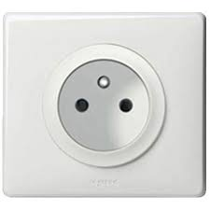 | The voltage in France is 230 volts, plug type E (fits to type C as well).
[Appendix III to Annex IV follows]

UPOV Technical Working Party for (TWA/TWF/TWM/TWO/TWV) xx^{th} Session,
place, country, date: Draft Workplan

 | Day 0 | Day 1 |  | Day 2 |  | Day 3 | Day 4
09.00 | [TECHNICAL WORKSHOP]  (optional) | Opening / Adoption of the agenda  Short reports on developments in PVP (items 3 and 4) |  | Documents and agenda items other than Test Guidelines |  | TECHNICAL VISIT*  Program:  Visit 1  Calibration exercise  Visit 2  EXAMPLE  Arrangements to be agreed with host  *(Reception and Technical Visit may be held on the same day) | [Documents and agenda items other than Test Guidelines]  Recommendations on draft Test Guidelines
10.30 |  | COFFEE |  | COFFEE |  |  | COFFEE
11.00 |  | Short reports (Continuation)  Documents and agenda items other than Test Guidelines |  | Documents and agenda items other than Test Guidelines |  |  | Room 1  Test Guidelines subgroup | Room 2  Test Guidelines subgroup
12.45 |  | LUNCH |  | LUNCH |  |  | LUNCH
14.00 |  | Room 1  Test Guidelines subgroup | Room 2  Test Guidelines subgroup | Room 1  Test Guidelines subgroup | Room 2  Test Guidelines subgroup |  | Recommendations on draft Test Guidelines  [Date and place of next session
15.30 |  | COFFEE |  | COFFEE |  |  | COFFEE
16.00 |  | Room 1  Test Guidelines subgroup | Room 2  Test Guidelines subgroup | Room 1  Test Guidelines subgroup | Room 2  Test Guidelines subgroup |  | Report on the Conclusions  Closing of the session]
18.00 |  |  |  |  |  |  | END OF SESSION
20.00 |  |  |  | RECEPTION

[Appendix IV to Annex IV follows]

Electronic communication system set up

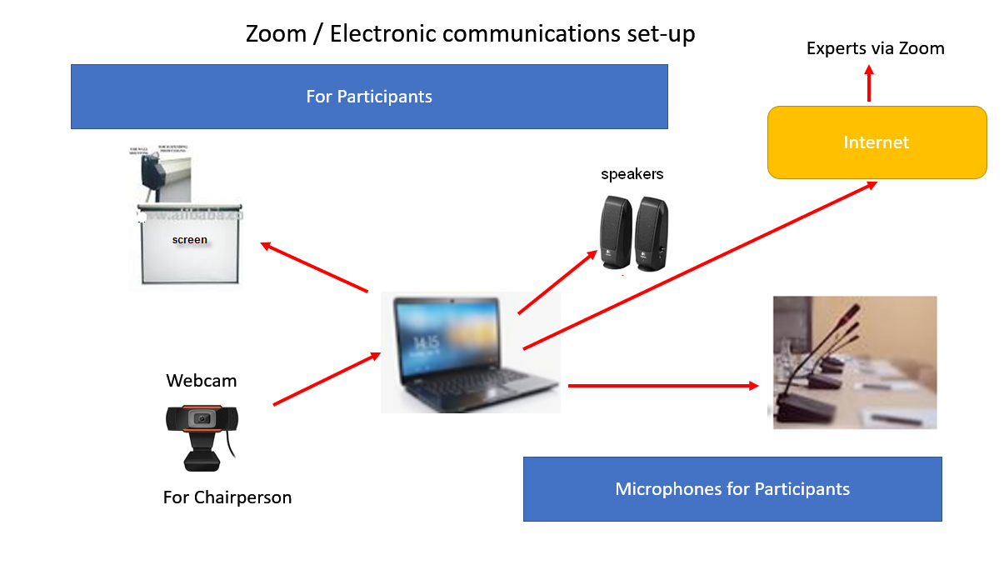
[Annex V follows]

2024 TWP MEETINGS PARTICIPANT SURVEY

How many persons took the survey?

 | TWM/2 | TWA/53 | TWF/55 | TWO/56 | TWV/58
Complete | 41 | 37 | 16 | 17 | 31
Partial | 13 | 3 | 4 | 5 | 12

- Overall, how satisfied were you with the meeting?

 | TWM/2 | TWA/53 | TWF/55 | TWO/56 | TWV/58
Very Satisfied | 40.0% | 40.0% | 42.1% | 37.0% | 25.0%
Satisfied | 37.8% | 52.5% | 36.8% | 58.0% | 47.2%
Neutral | 17.8% | 5.0% | 21.1% | 5.0% | 19.4%
Dissatisfied | 4.4% | 2.5% | 0.0% | 0.0% | 5.6%
Very Dissatisfied | 0.0% | 0.0% | 0.0% | 0.0% | 2.8%

- Why did you participate in the meeting?

 | TWM/2 | TWA/53 | TWF/55 | TWO/56 | TWV/58
Discuss Test Guidelines | 0.0% | 75.0% | 94.7% | 74.0% | 72.2%
Discuss meeting documents | 46.7% | 47.5% | 52.6% | 42.0% | 63.9%
Discuss cooperation with other participants | 31.1% | 32.5% | 21.1% | 26.0% | 27.8%
Receive practical guidance on DUS examination procedures | 46.7% | 50.0% | 47.4% | 37.0% | 50.0%
Receive information on developments in variety testing | 100.0% | 57.5% | 73.7% | 47.0% | 72.2%
Training | 20.0% | 30.0% | 0.0% | 26.0% | 22.2%
Other | 13.3% | 12.5% | 0.0% | 5.0% | 56.0%

TWM/2
- show our work to colleagues
- learn about new tools that EOs and Stakeholders are investigating
- To share information with other participants and get feedback on new ideas
- to get informed about the COYU-spline-method update progress in DUSTNT software
- observer status
- share perspective

TWV/58
- Observe how leading expects present.

TWO/56
- Participation as an observer

TWA/53
- Learn about TG to support botanical data as a taxonomist for PVP works in my country.
- to provide information on developments in variety testing

- Were you able to acquire information on specific subjects of your interest?

 | TWM/2 | TWA/53 | TWF/55 | TWO/56 | TWV/58
Yes | 57.8% | 87.5% | 89.5% | 58.0% | 63.9%
Partially | 42.2% | 12.5% | 5.5% | 37.0% | 36.1%
No | 0.0% | 0.0% | 5.3% | 5.0% | 0.0%

TWO/56
- : option "not applicable" missing

- Will you be able to attend the Technical Working Party meetings in person in the future?

 | TWM/2 | TWA/53 | TWF/55 | TWO/56 | TWV/58
Definitely | 26.8% | 36.8% | 43.8% | 53.0% | 38.7%
Probably | 43.9% | 26.3% | 25.0% | 18.0% | 32.3%
Unsure | 22.0% | 18.4% | 31.3% | 18.0% | 19.4%
Probably not | 4.9% | 18.4% | 0.0% | 12.0% | 9.7%
Definitely not | 2.4% | 0.0% | 0.0% | 0.0% | 0.0%

- Do you have suggestions to improve the work of the Technical Working Parties to support DUS examination?

TWM/2
- Not any so far. Everything runs perfectly well. Congratulations.
- I suggest that meetings be held in a hybrid format (in-person + virtual)
- Have a proper policy on the use of molecular markers and sharing of these data to maximize on the advantages of such technology in DUS
- I think the future DUS test model may be a combination of morphology and molecules, and the proportion of molecules will increase year by year. Therefore, more molecular biology experts are invited to attend the conference to promote the rapid development of DUS testing
- more detailed presentations with more background and better description of methods used
- maybe go on to encourage and produce more and more work/presentations, to share and to exchange with our community
- In-person meetings! If they must be online have a session to encourage conversation between participants. Over 200 people registered but only around 10% of them contributed. To help find hosts: Guidance for hosting meetings could be available online without the need to request it. Or the UPOV Office could inform the members and attach the info pack. Very few members will be able to extend an invitation at short notice, so a prompt from the office, well in advance of the meeting, would be helpful.
- We need greater discussion to enable interaction between experts in methods and DUS experts. This should be two way, covering how new ideas could be used in practice, gaining better understanding of the new ideas, etc. Time, structure and facilitation is required to encourage such discussions. They were largely lacking in this online meeting. It is a difficult objective but worthwhile.
- The online presentations are somehow missing the discussion & idea debate of the in-person meetings (a lot of which happened outside the formal meeting). As on-line and/or hybrid meetings continue maybe the format could change so member presentations have not only a summary of work but questions to ask. As the TWM covers a wide area of specialism, it would be good to have time to think about the presentations before needing to make comments.
- Make all meetings in hybrid fashion, or face to face only. Virtual meetings do not lead to the required interactions between the UPOV members.

TWV/58
- focus on harmonization among members
- I have noticed that the last 2 years (especially in 2023) agreed during the TWP documents are stuck in TC and TC-EDC. In some cases, it is not clear what happened to these documents (revisions of guidelines) and what their status is. It is also difficult for the LE to follow and understand the changes made by the TC/TC-EDC, especially if LE was not present during TC/TC-EDC meetings. How can we improve it?
- In person meeting will facilitate better discussions and flexibility in discussion of Technical Guidelines as well as some key topics like disease resistance
- Meetings on-line are less interactive than meetings live, therefore a suggestion to keep it a bit interactive: would it be an option to ask each year 1 or 2 countries/ participants, to prepare a short film, showing a chosen trial, from a chosen crop, just to illustrate how we are working and maybe explain a little about the climate, growing facilities, the collection in this country... we could learn more about different crops in different countries, just 5 min film, something like this? on voluntary basis
- Have "in person" Technical Working Parties. That is the best way to promote this type of exchanges.
- Maintain virtual meeting or both online and offline formats to allow more members to participate in the Technical Working Parties.
- We need hybrid meetings for all TWPs. This will allow for more exposure to DUS examination. The less experienced countries need to be enabled to learn from the more experienced countries. There should be a lot of time dedicated to sharing experiences on DUS examination. And trying to find out where are the bottle necks in less experienced countries.
- I think is better the online meeting than in person because in that way is more probably that expert, examiners and other people can attend the meeting.
- It is the first time Mauritius participating as an observer in the process and it was a very good experience as many experts provide different views. Certainly, it will be great if countries which went thru registration of new varieties to share their findings specially with respect to issues they got compared to existing varieties as it will be like an on-hand experience for new members.
- Information should be distributed on time to be reviewed. Clear drawing/illustrations should also be indicated and marked correctly.

TWO/56
- greater opportunities for face-to-face discussion and technical visits
- Offline meetings would better facilitate communication but would reduce the number of participants and the number of countries involved。
- having a specific trial to illustrate a crop and the characteristics proposed or under revision could be useful. (I remembered a lettuce trial, and turnip trial at TWV...).

TWA/53
- maybe more presentations to share about our facilities, our assessment techniques, our distinctness problems and improvement approaches...
- Visit the field trials
- In person meeting would be better and happy that UPOV TWA 2025 will be in person. This will further promote engagement
- Encourage the participation of new members. Perhaps, presenting a Test guideline with an expert from a more trained country or a presentation on their way of performing the DUS.
- How to harmonize the variation of QN, PQ is very important. Example variety is not right answer. UPOV have to find how to decide minimum difference of distinctness in measured data that has similar result with notes method. PQ has to be separated to several QN for accurate evaluation.
- According to the TWA/53 meeting, I found that this meeting gave room for everyone to share their knowledge, learning and receiving all information from the meeting. The meeting will produce valuable procedures including experts. So my suggestion is to keep doing this.
- On-site meetings allow for more human interaction. At such meetings, perhaps hands-on workshops on DUS practices could be organized, rather than just field excursions.
- For sub-groups, it would be useful to have the names of interested experts. Currently there is a footnote to direct to the list of participants. Members, observers and organizations often have more than one participant registered for a given TWP, which makes it difficult to contact the actual interested expert.
- I support TWAs in person, especially field trial visits would be very interesting. But also the online meetings are very fruitful, because it is very easy and cheap to take part in.
- At the end of the session, there was a discussion on how a Lead Expert or the UPOV Office would identify and contact interested experts from a particular country to participate in a subgroup discussion of a TG as the list of participants includes many more individuals from member countries. Maybe an easy way to do this would be to identify one expert per country for each TWP (this would typically be the main contact as the expert responsible for the DUS testing or examination in a member country).
- No, the discussions were clear and precise

TWF/55
- DUS practical guidance in the field for specific genus
- To try and carry out TWP meetings physically, exclusively, in order to improve discussions, and mutual understanding.
- Continue to have the technical webinar way to sharing the experiences of DUS examination of different species from UPOV members
- Continue to strive for harmonization & collaboration.
- as far as technically feasible plants (or parts) thereof could be brought to the meeting to discuss certain characteristics (e.g. for the discussion of guava TG: input was given from participants who know guava (almost) exclusively as a processed product and it was difficult for the leading expert to explain issues confronted with)
- I would very much appreciate a tool that allows for a comparison of TG versions (track changes). For instance, if a Lead Examiner decides to delete a characteristic from the list, then you are not aware of it until you put the new version together with the previous version, which is very labor some. (In theory this is possible by doing a comparison in word, but this often does not work due to the complex layout of the document.)

- Would you like to propose topics for future Trainings (Technical Webinars, Distance Learning or other)?
TWM/2
- I will discuss with ISTA the possibility of a joint workshop with UPOV and OECD in regards of method validation, evaluation of laboratory performance and accreditation.
- A webinar on Artificial intelligence technical aspects and the relationship with UPOV convention
- I consider it important to continue sharing members' experiences about the use of different software in image analysis. Also share if any member has experience in the use of artificial intelligence in DUS examination.
- Use and challenges of AI in DUS related examinations
- Elements from the TGP documents. Each of the subjects in them could become a training topic, focusing on basic DUS guidance.
- Technical Webinars have been good. More informal workshops on specific topics would also be good.
- I would like to receive trainings on the use of molecular markers for DUS assessment in grass and forage crops or in any other open-pollinated species that are more difficult to be evaluated than self-pollinated and hybrid varieties.
- Always good to include practical examination methods so we know how other members assess crops.
- I think AI-based talks were really good on the first day. More discussions on how AI, genomic information together with morphological characteristics will be great.
- Technical webinars - Image analysis in DUS testing Technical webinars - Uniformity and Distinctness assessment in the special cases, when COYU and COYD cannot be used (e.g. if DF is small). Further guidance for using Relative Variance Method, or ANOVA, or other statistical approaches for crops with small reference variety collection.
- Possible training or courses on how to make use of new technology Data collection methods during DUS examination by Member countries. This would be a great opportunity of sharing new technology not only by presentation but going through the new technology step by step. This could only be achieved if there is enough interest shown by member countries.

TWV/58
- learning with hypothetical cases, how markers can be used for the different aspects: 1) deciding on distinctness 2) deciding on uniformity 3) selecting trial varieties for the DUS trial
- VCU in vegetable crops DUS test in Asia/Africa/South America - just to share with us what are the problems/challenges etc. in DUS test in their countries.
- Increasing importance of disease resistance in Breeding and request for vegetable species
- Yes, on species that I have experience with.
- Perhaps helping countries to implement PRISMA and the e-PVP modules (DUS report exchange and so on)
- I would like to see more illustrated technical protocols for each character, like last year's pepper in Turkey.
- I think it would be a good idea to organize a distance learning with real examples about the entire process in order to register a variety from the point of view DUS test and it is very important to go deeper into the reference collection and the example varieties.

TWO/56
- Technical webinars
- It would be good to have training to develop testing guidelines.
- Process for developing TGs, and the role of the lead expert and the subgroup
- Data analysis in DUS testing 2. How to determine uniformity standards when using off-type method in guideline development.
- Due to the influence of objectivity and self-perception, the tester's decision criteria may be inconsistent, so how to harmonize the decision criteria and make the correct decision among UPOV member countries.

TWA/53
- use of molecular techniques in DUS; use of drone to assess some characteristics (es. green color of leaves).
- How to examine sensory characteristics.
- New techniques in DUS, including Artificial intelligence.
- Distance learning courses should continue, should be upgraded concerning to improve knowledge and practises of DUS experts.
- Technical webinar use of technology in DUS in the World
- It is a pity that I do not work on DUS examination, my task is just to support botanical data for researchers who work for the DUS examination.
- Use of molecular markers PBR and EDVs - a focus on genome editing How UPOV interacts with the WSP Training/guidance for lead experts - what is expected from them.
- I would like to congratulate on the new UPOV-Certificate program! The Webinars and Distance Learning courses are highly appreciated, especially for training of new colleagues on DUS-items. Every topic is welcome.
- As a new UPOV member and without much experience in the international area, are very important and necessary to have technical methodologies - standard procedures that will be needed to actually perform DUS examination in variety testing facilities. Taking into account that in the Republic of Armenia, the VCU (Value for Cultivation and Use) test are mainly carried out jointly with the DUS tests, also if possible, to provide technical methodologies/guidelines on the VCU tests as well or as an offer to conduct Technical Webinars, Distance Learning etc.
- Technical Webinars and Distance Learning courses are very welcome from our side, our topics of interest are agricultural crops

TWF/55
- Technical webinars and also in field support
- Distance learning courses like DL-205 or 305 on subjects specific for DUS testing activities.
- Show the process how to set the scales (3, 5, or 9 or more than 9) for one QN Characteristics in order to make it meaningful for distinctness, especially based on the investigated values by statistics or other way, during developing Test guidelines?

- Please add any further comments regarding the meeting, e.g: What did you like the most? What could be improved?

TWM/2
- Molecular marker for genotyping plant varieties. This topic needs to be developed
- Presentations were distributed well in advance and we're all very informative even so, I found not many questions from the participants, but the topics were very important.
- I consider that the format of the meeting should be hybrid (in-person + virtual)
- Participation was great showing the interest from UPOV members and I would propose to invite more speakers including researchers working on molecular markers and potential application to variety registration to broaden our scope. This year was good and can be better.
- I suggest that both online and offline meetings be held, and face-to-face communication can give us a deeper understanding of each other's research content.
- Providing a 1-2 page summary of the presented material with goals (e.g. practical relevance) and a list of the acronyms would be helpful for those, who are not experts on certain fields and may need some time to think about the topic to formulate questions and create a discussion at the time of the meeting. The online format has advantages and disadvantages. Some of them could be improved by e.g. requiring the speakers/presenters to have a headset to increase sound quality, or putting more emphasis on discussion, as the format is knowingly reducing it. Additionally, some documents were very late, e.g. the 2nd revision of the agenda to my knowledge was not shared on the UPOV website BEFORE it had to be accepted. The comments focus on possibilities for improvement, but this does not mean that the meeting did not have any positive aspects. I have learned a lot about ongoing projects and possibly future tools of DUS testing. Thank you very much, everyone, who has contributed to the TWM/2.
- the presentations were generally too superficial,
- interaction between participants was not satisfying - Documents provided by UK experts were very much appreciated. It is useful to have the PowerPoint presentation as an annex (possibly later) but the slides alone should not replace a document. The UK format should be requested as the standard. A clear document with a summary of the presentation allows better preparation of participants for the meeting in order to stimulate more discussion and exchange between participants. - audio and video quality of the chairperson and the office needs to be improved
- I think a hybrid solution between in person and distancial meeting should be envisaged to facilitate exchanges between participants
- like the most: quality et diversity of the presentations be improved: really it works of good means but it's always more constructive and friendly in person ;-)
- I liked the content of the presentations. The interaction with online participants could be improved. Breakout sessions or smaller "getting to know you" type events. I hate to say it (because I am one of the offenders), but stricter deadlines for papers and their publication, particularly where a change is being proposed or an opinion is sought.
- It was great to see a wide range of topics discussed, especially new methods, which may be of benefit for DUS examination, either soon or a little later. It is really important that the TWM does continue to act as a forum for discussion of research level ideas, even if the ideas may take some time to come to fruition. The TWM is a great place to get feedback on such ideas. There needs to be ,ore time for open discussion around topics, particularly around prospects for new methods in DUS examination. I note the time pressure due to the compacted schedule of the online meeting (due to time zones), perhaps coupled with late arrival of some papers. This did not encourage discussion around papers given. And perhaps this discussion needs to be facilitated. Rather than just questions about the content, there could be discussion about how the method might be used.
- Maybe to have an on-line coffee? Or a time for discussion of topics covered.
- The effectiveness of presentations in terms of content and duration, punctuality and adherence to the schedule.
- Compliments to the UPOV team for the preparation of this meeting and also to madam chair during the meeting, very efficient and pleasant to follow
- I missed background information about the presented talks. Perhaps a small intro on the purpose of the presentations in the program could help to guide the audience through.
- The meeting was well organized and very informative.

TWV/58
- open discussion less formal language
- I like that documents with proposed changes for discussion are presented on the screen and that all new changes are directly visible on the screen (Romy, thank you). Leontino's support is also greatly appreciated. 2) A point of improvement might be to try to limit the length of some participants' speeches. Maybe it's worth making some people realize that they talk too much, too long and tend to repeat topics.
- Discussions on Revisions of Test Guidelines, very useful. Promoting in person meetings to help discussions of some key topics like disease resistance. Breakout sessions are ok but they leave no room for breaks if one is to follow consistently.
- Guidelines in one language at UPOV level (ENG) will be for the future easier and I think no problem, at national level people may use their own translated guidelines.
- UPOV should actively seek the participation of members to organize Technical Working Parties and should take care to foster the interaction among all participants (members, observers and organizations) In person interaction has proven time and again that great solutions can be achieved to everybody's satisfaction. I'm also positive in thinking that this would be in benefit of PVP as applying companies might consider starting protecting their material in regions where they are directly acquainted with the registration panel. This is the reason why I scored a "Dissatisfied" rating for this TWV. It is quite disappointing to hear (again) "there were no offers"...
- Online session is comfortable and flexible, so It is OK to have.
- At present, the overall process is very good in the process of technical documents and TGs. It is hoped that more national testing techniques and experience would be gained through the Technical Working Parties, and the Technical Working Parties need to increase the motivation of members to participate in the report in some way.
- I feel that with the online version of the TWPs, there is a huge decrease of interaction. There were several topics (e.g. disease resistance) that required a face-to-face meeting, and a lot of time dedicated to it. We see that with online meetings, there are still only the same few (EU) countries interacting. And the large majority is silent. The benefit of face-to-face meetings is that the less experienced countries can be reached during the coffee breaks and so on. But with the virtual meetings, the less experienced countries are just silent, and do not learn much. It may seem flattering to see the higher numbers of participation, but the interaction between is less and impact on awareness raising is decreased. Also there is no possibility to improve the technical aspect through a technical visit. Last year in Turkey there were good interactions in the greenhouse, and less experienced countries could learn from those discussions. But online this is not possible.
- Everything was OK, thanks!
- the meeting was transcribed into English and it was easy to understand if you are Spanish speaking. I think is everything ok.
- I am not aware whether there is an online platform where you can comment on the TQs and propose changes throughout the year, thus when the time come for the TWP, it will be easier to gather all comments and few days before the TWP, ask the participants to provide additional details if required
- Discussion of Test Guidelines for different crops.
- I liked the robust discussions from different leading expects from different countries and how participants were given time to explain themselves, relating to any topic that was discussed.
- In many cases there was a good discussion on topics. But I was quite disappointed that in several cases UPOV seemed to discourage addition of disease resistance characteristics and other documents just because of cost considerations (manual translation necessary) . It seems very important that we add characteristics and documents to the UPOV system for harmonisation and clarification. But the considerations of UPOV seem to discourage this.
- In some topics, especially in disease resistance, it would be good to discuss thoroughly (not only technically). Such as harmonization.

TWO/56
- I really like the format of virtual meetings. It would be more kind if the guidelines draft could reflect the traces of each modification.
- In the workshop session for testing guidelines, the meeting can be shortened for guidelines that have been discussed multiple times or have fewer traits; the discussion time should be increased for guidelines that are discussed for the first time, have a lot of feedback, or have a lot of traits. In this way, it is ensured that each guideline has sufficient time for in-depth discussion.
- I wonder how to increase the active participation of delegations. Not their presence, but the fact that they express themselves or ask questions. This year, although there were more than thirty delegations (members, observers, organizations), i.e. around 90 people registered, it was still the same 7-8 people who expressed their views. Mostly Europeans, with the risk of a predominantly European-centric approach.
- It was very nice to receive all documents. This kept me updated, also if it was not discussed to save time, or if I was not able to follow that part of the meeting.

TWA/53
- Barley
- Every participant is to attend the TWA meeting. UPOV office should give a certificate of attendance at the meeting.
- I think, everybody could have better understanding on new characteristics or improvement characteristics with more explanations by shred presentations. But maybe it would be better in person
- Some audios of participants were no good.
- No much to improve since the Secretary has made a very efficient work. Test guidelines has the most interesting moments.
- keep online meetings
- Whether it is virtual or gathering meeting, there is limited person who speaks in the meeting. But virtual meeting lacks field experience. TWA needs to do in gathering meeting.
- Everything was okey.
- I learned in each discussion
- The presentations of new techniques used for DUS examination as well as part of the discussion on TG are perfectly useful.
- None.
- TG revisions part was very interesting
- Clarification on attending future meetings: The reason I probably will not attend future TWA meetings is that I moved to another position within my organization. Someone else will take over my TWA responsibilities.
- There was not enough time given to some discussions, which perhaps resulted in confusion over the outcomes when it came to finalizing the reports. Perhaps the in-person element will help with this next year. This session there was some engagement from some new faces, which was good. I think better use of the breakout rooms would be helpful. I only managed to join one over the week as the sessions overran and I prioritized a comfort break! But I did notice that people joined then left, so maybe more organized fun is required... or maybe I should have been more pro-active in announcing that I will be in the breakout room in a moment (opportunity for me to improve!) I really like the information for first time participants and new members... this was not my first meeting but I certainly learned a few bits and refreshed some things I had long forgotten. Perhaps an addition to that section would be the process for documents and TGs (unless it was already there and I have missed it). Overall I thought the meeting was good. The Chair did an excellent job (as expected) and was clearly well supported by the UPOV Office. Congratulations all round. Hope to see you next year!
- I found it great, how work was progressed, especially the direct work in the documents on the screen during the discussions (congratulations to that). It is also very appreciated, that the work followed the work plan, so it was possible to follow interesting guidelines and to skip others.
- Since all documents are discussed the 1st day, would it be useful to dedicate a RESERVE TIME (the next morning to recap and to discuss anything that we did not have enough time to discuss the 1st day). For example, Margaret summarized her work and progress on the TC subgroups on TGs; but, the group did not have time to comment or discuss this thoroughly. Although there will be an opportunity to discuss this further, a RESERVE TIME can also assist the Chair.
- To stimulate discussion about draft test guidelines before the meeting, it will be good to know why countries or experts have indicated that they are interested. Some experts/countries are mentioned as interested expert/country, but are not contributing to the discussion at all (not online during the preparation of draft test guideline and not during the discussion at the meeting). It is difficult to know which countries are actively testing the species mentioned in the test guideline. Some countries have experience, but are not actively testing the species. It will be an improvement when these countries are separated.
- Many valuable presentations were presented, which please also share with us electronically and the most interesting was the fact that DUS tests can be carried out one site in two years versus two sites in one year, about which it is requesting to have additional information.
- Native English speakers might proactively support the wording of new documents
- no any significant comments, the agenda was good, the timeline was good, discussions were good,
TWF/55
- Audio and microphone Guidelines to have a well standard listening
- I enjoyed interacting with top experts in pomological description, which helps me to improve my editing of the Register. There are very few Americans and Mexicans in these meetings; it would be great to have more. I prefer meeting in person!
- A real discussion with direct reply, or spontaneous reaction, to particular comments, was impossible; no non-verbal reaction (nodding, emotional support) possible. Providing virtual meeting rooms during the breaks are appreciated.
- I am interested in the Test guidelines discussion and also interested in technical field visit.
- Carole did a great job as Chair. She spoke clearly/concisely, was kind/polite and kept everyone on track. Also, Leontino and Romy did a fabulous job as always. Great & "fruitful" meeting!
- The virtual meetings are not easy but the TWF 2024 was very well done
- Allow for more time to submit comments to TG's, 1 month is not sufficient. Providing the agenda and the schedule much sooner, would allow experts on specific crops to only participate those sessions, without them having to block and entire week.

[End of Annex V and of document]

TC, fifty-seventh session, held via electronic means, on October 25 and 26, 2021
Held in Geneva, on October 24 and 25, 2022
TC, fifty-ninth session, held in Geneva on October 23 and 24, 2023

