E
International Union for the Protection of New Varieties of Plants

Technical Committee  Fifty-Ninth Session  Geneva, October 23 and 24, 2023 | TC/59/26  Original: English  Date: October 6, 2023
Partial revision of the Test Guidelines for ONCIDIUM
Document prepared by an expert from the Netherlands
Disclaimer: this document does not represent UPOV policies or guidance
The purpose of this document is to present a proposal for a partial revision of the Test Guidelines for Oncidium (document TG/283/1 Rev.).

The Technical Working Party for Ornamental Plants and Forest Trees (TWO), at its fifty-fifth session, considered a proposal for a partial revision of the Test Guidelines for Oncidium (Oncidium Sw.; ×Oncidesa Hort.; ×Ionocidium Hort.; ×Zelenkocidium J.M.H.Shaw.) on the basis of documents TG/283/1 Rev. and TWO/55/08 “Partial revision of the Test Guidelines for Oncidium” and proposed the following changes (see document TWO/55/11 “Report”, paragraph 52):

- Replace state 2 “moderate” by “medium” in characteristic 30, 50, 70 and 87;
- Revision of characteristic and explanation Ad. 27 “Dorsal sepal: shape”;
- Revision of characteristic and explanation Ad. 46 “Lateral sepal: shape”;
- Revision of characteristic and explanation Ad. 66 “Petal: shape”;
- Adjust spelling of two example varieties throughout whole document TG/238/1 Rev.

The proposed new wording is presented below. The proposed changes are presented in highlight and underline (insertion) and strikethrough (deletion) in the Annex to this document (in English only).

Proposal to replace note 2 ‘moderate’ by ‘medium’ for characteristic 30, 50, 70 and 87

 |  | English | français | deutsch | español | Example Varieties  Exemples  Beispielssorten  Variedades ejemplo | Note/  Nota
30.  (+) | VG | Dorsal sepal: undulation of margin | Sépale dorsal : ondulation du bord | Dorsales Kelchblatt: Wellung des Randes | Sépalo dorsal: ondulación del borde
QN | (c) | absent or weak | absente ou faible | fehlend oder gering | ausente o débil | Only You | 1
 |  | medium | moyenne | mittel | media | Yellow Days | 2
 |  | strong | forte | stark | fuerte |  | 3
50.  (+)  (*) | VG | Lateral sepal: undulation of margin | Sépale latéral : ondulation du bord | Seitliches Kelchblatt: Wellung des Randes | Sépalo lateral: ondulación del borde
QN | (c) | absent or weak | absente ou faible | fehlend oder gering | ausente o débil | Haruka,  Kaori no Izumi | 1
 |  | medium | moyenne | mittel | media | Monshirotyo no Cafe | 2
 |  | strong | forte | stark | fuerte |  | 3
70.  (+) | VG | Petal: undulation of margin | Pétale : ondulation du bord | Blütenblatt: Wellung des Randes | Pétalo: ondulación del borde
QN | (c) | absent or weak | absente ou faible | fehlend oder gering | ausente o débil | Haruka, Sunlight Siesta Ruru | 1
 |  | medium | moyenne | mittel | media | Yellow Days | 2
 |  | strong | forte | stark | fuerte |  | 3
87.  (+) | VG | Lip: undulation of margin | Labelle : ondulation du bord | Lippe: Wellung des Randes | Labio: ondulación del borde
QN | (c) | absent or weak | absente ou faible | fehlend oder gering | ausente o débil | Dancing Sunlight Ami | 1
 |  | medium | moyenne | mittel | media |  | 2
 |  | strong | forte | stark | fuerte |  | 3

Proposed revision of characteristic and explanation Ad. 27 “Dorsal sepal: shape”

 |  | English | français | deutsch | español | Example Varieties  Exemples  Beispielssorten  Variedades ejemplo | Note/  Nota
27.  (*)  (+) | VG | Dorsal sepal: shape | Sépale dorsal : forme | Dorsales Kelchblatt: Form | Sépalo dorsal: forma
PQ | (c) | ovate | ovale | eiförmig | oval | Ella Flambeau | 1
 |  | lanceolate | lancéolé | lanzettlich | lanceolada | Shell White | 2
 |  | elliptic | elliptique | elliptisch | elíptica | Misaki Wave Yurara, Yellow Days | 3
 |  | narrow elliptic | elliptique étroit | schmal elliptisch | elíptica estrecha | Dancing Sunlight Nancy, Haruka | 4
 |  | linear | linéaire | linear | lineal | Sunlight Siesta Ota | 5
 |  | obovate | obovale | verkehrt eiförmig | oboval | Kaori no Izumi | 6

Ad. 27: Dorsal sepal: shape”

 |  | broadest part
 |  | (below middle) | at middle | (above middle)
broad (compressed) width (ratio length/width) narrow (elongated)
 |  | 2 | 5
 |  | lanceolate | linear
 |  | 1 | 4
 |  | ovate | narrow elliptic
 |  |  |  | 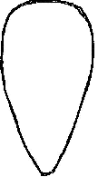
 |  |  | 3 | 6
 |  |  | elliptic | obovate
Proposed revision of characteristic and explanation Ad. 46 “Lateral sepal: shape”

 |  | English | français | deutsch | español | Example Varieties  Exemples  Beispielssorten  Variedades ejemplo | Note/  Nota
46.  (*)  (+) | VG | Lateral sepal: shape | Sépale latéral : forme | Seitliches Kelchblatt: Form | Sépalo lateral: forma
PQ | (c) | ovate | ovale | eiförmig | oval | Makali Gotoh | 1
 |  | lanceolate | lancéolé | lanzettlich | lanceolada | Dancing Sunlight Suzy | 2
 |  | elliptic | elliptique | elliptisch | elíptica |  | 3
 |  | broad obovate | obovale large | breit verkehrt eiförmig | oboval ancha | Kukoo YMC-2 | 4
 |  | medium obovate | obovale moyen | mittel verkehrt eiförmig | oboval media | Yasukasupa Koharu | 5
 |  | curving obovate | obovale courbé | gebogen verkehrt eiförmig | oboval curva | Only You | 6

Ad. 46: Lateral sepal: shape

 |  | broadest part
 |  | (below middle) | at middle | (above middle)
broad (compressed) width (ratio length/width) narrow (elongated)
 |  | 2
 |  | lanceolate
 |  | 1 | 3 | 5 | 6
 |  | ovate | elliptic | medium  obovate | curving  obovate
 |  |  |  | 4
 |  |  |  | broad obovate

Proposed revision of characteristic and explanation Ad. 66; “Petal: shape”

 |  | English | français | deutsch | español | Example Varieties  Exemples  Beispielssorten  Variedades ejemplo | Note/  Nota
66.  (*)  (+) | VG | Petal: shape | Pétale : forme | Blütenblatt: Form | Pétalo: forma
PQ | (c) | ovate | ovale | eiförmig | oval |  | 1
 |  | elliptic | elliptique | elliptisch | elíptica |  | 2
 |  | linear | linéaire | linear | lineal | Sunlight Siesta Ota | 3
 |  | broad obovate | obovale large | breit verkehrt eiförmig | oboval ancha | Yasukasupa Komachi | 4
 |  | oblanceolate | oblancéolé | verkehrt lanzettlich | oblanceolada | Dancing Sunlight Ami | 5

Ad. 66: Petal: shape

 |  | broadest part
 |  | (below middle) | at middle | (above middle)
broad (compressed) width (ratio length/width) narrow (elongated)
 |  |  | 3
 |  |  | linear
 |  | 1 | 2 | 5
 |  | ovate | elliptic | oblanceolate
 |  |  |  | 4
 |  |  |  | broad obovate

Proposed adjustment of spelling of two example varieties throughout whole document TG/238/1 Rev.

Char. 68,88,99: Monshirochono Cafe
Char. 7,14,19,36,50,56,76,85: Monshirochono Cafe

Char: 86, 89, 90: Shimizuparasol Papurikon
Char. 3, 7, 8, 20, 21, 49, 69, 98: Shimizuparasol Papurikon

[Annex follows]

PROPOSED CHANGES PRESENTED IN HIGHLIGHT
(in English only)

Proposal to replace note 2 ‘moderate’ by ‘medium’ for characteristic 30, 50, 70 and 87

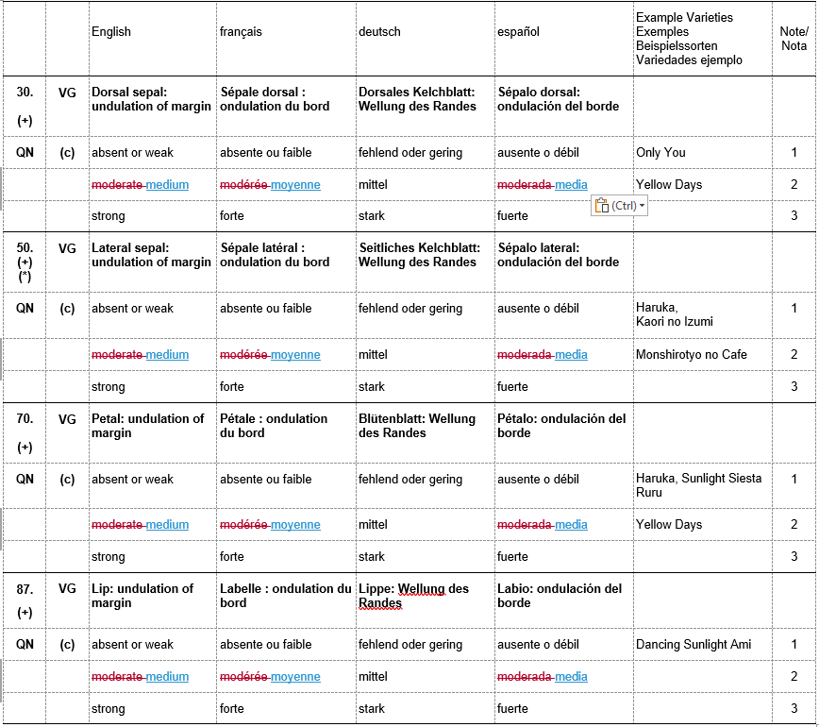

Proposed revision of characteristic and explanation Ad. 27 “Dorsal sepal: shape”

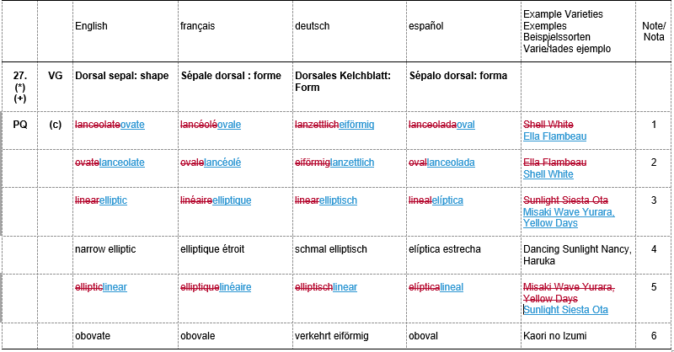
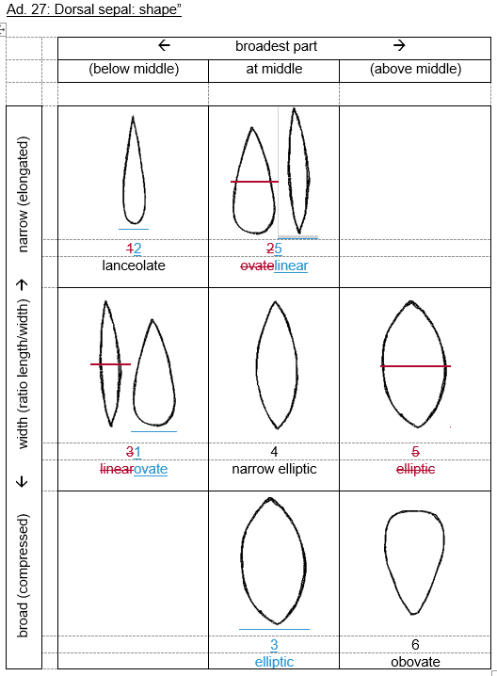
Proposed revision of characteristic and explanation Ad. 46 “Lateral sepal: shape”

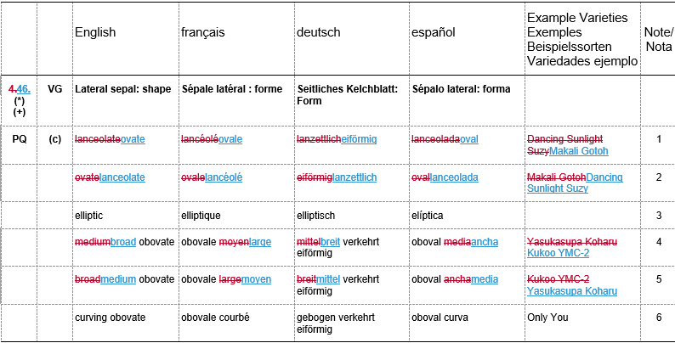

Ad. 46: Lateral sepal: shape

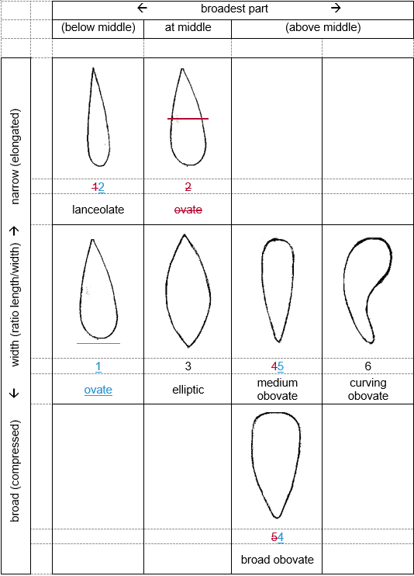

Proposed revision of characteristic and explanation Ad. 66 “Petal: shape”

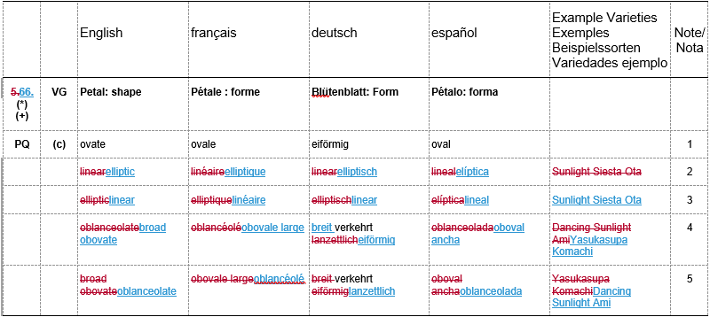

Ad. 66: Petal: shape

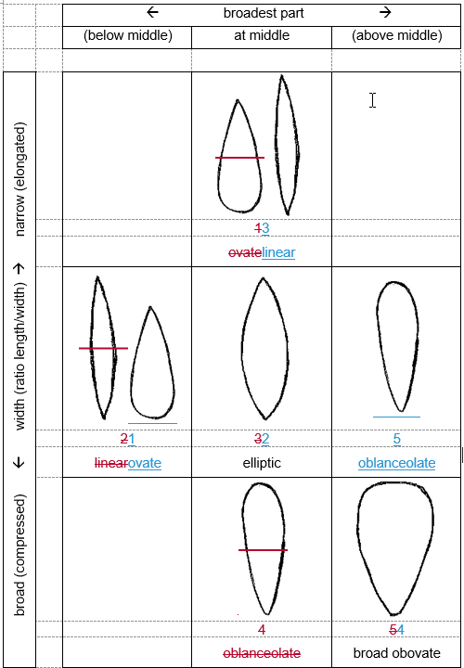
Proposed adjustment of spelling of two example varieties throughout whole document TG/238/1 Rev.

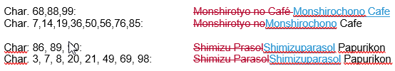

[End of Annex and of document]

organized by electronic means, from June 12 to 16, 2023

