|  |  |
| --- | --- |
|  | E |
| International Union for the Protection of New Varieties of Plants |  |

|  |  |
| --- | --- |
| Council Fifty-Sixth Ordinary Session Geneva, October 28, 2022  Administrative and Legal Committee  Seventy-Ninth Session Geneva, October 26, 2022  Technical Committee  Fifty-Eighth Session Geneva, October 24 and 25, 2022 | C/56/INF/2  CAJ/79/INF/2  TC/58/INF/5  Original: English Date: September 27, 2022 |

Report by the Vice Secretary-General on developments in UPOV

Document prepared by the Office of the Union

Disclaimer: this document does not represent UPOV policies or guidance

The Annex to this document contains a copy of a presentation “Report on developments in UPOV”   
made by the Vice Secretary-General, via video, for the fifty-sixth ordinary session of the Council, the seventy‑ninth session of the Administrative and Legal Committee (CAJ) and the fifty-eighth session of the Technical Committee.

The video is available in English, with subtitles in English, French, German and Spanish, at the [C/56](https://www.upov.int/meetings/en/details.jsp?meeting_id=67788), [CAJ/79](https://www.upov.int/meetings/en/details.jsp?meeting_id=67785) and [TC/58](https://www.upov.int/meetings/en/details.jsp?meeting_id=67786) webpages.

[Annex follows]



Developments in UPOV

*Peter Button*

*Vice Secretary-General, UPOV September 1, 2022*

International Union for the Protection of New Varieties of Plants

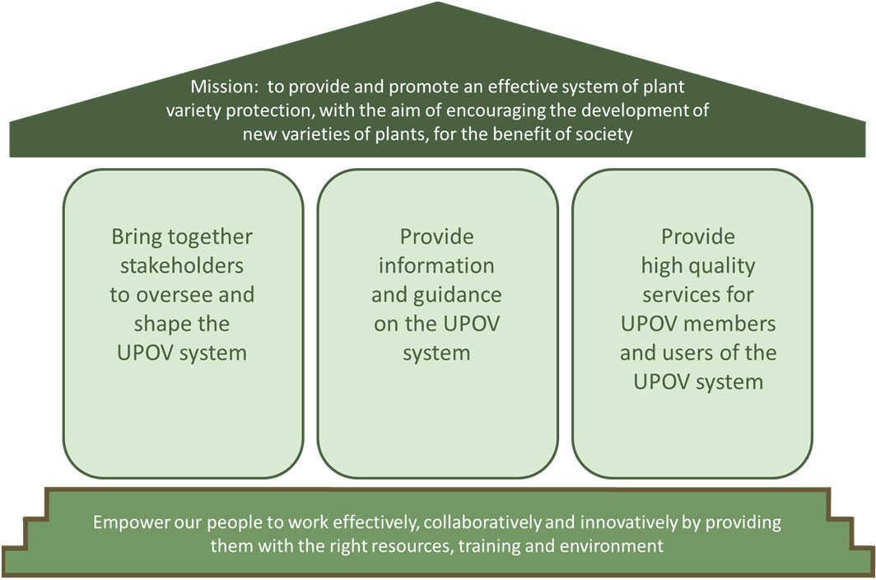

Building a UPOV Strategy House

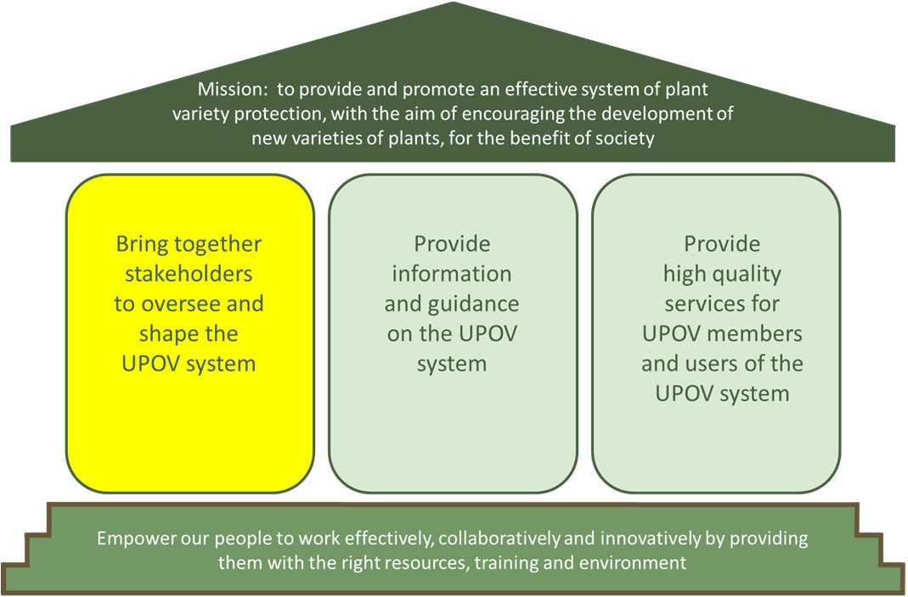

Building a UPOV Strategy House

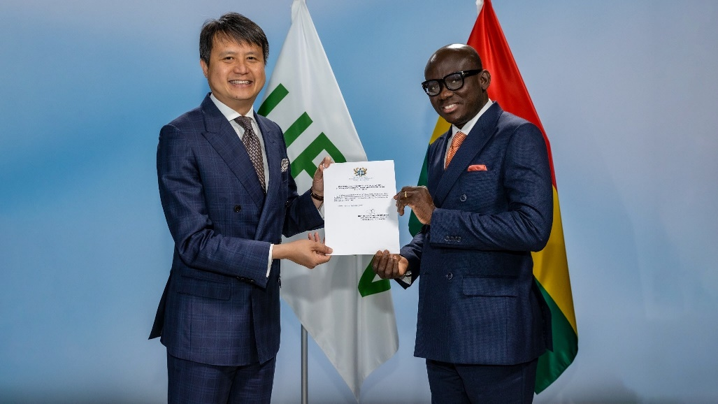

Ghana accedes to the UPOV Convention

December 3, 2021

UPOV now has 78 members   
covering 97 States

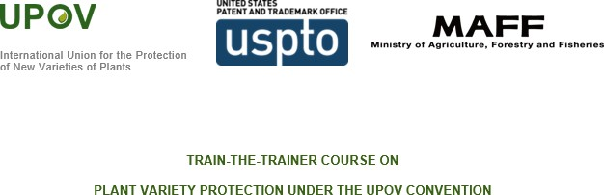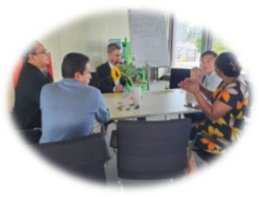

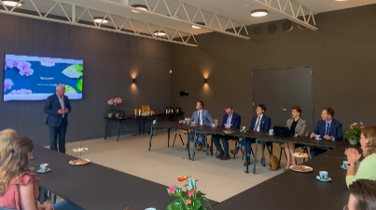

Visit to the Netherlands by Daren Tang, UPOV Secretary-General

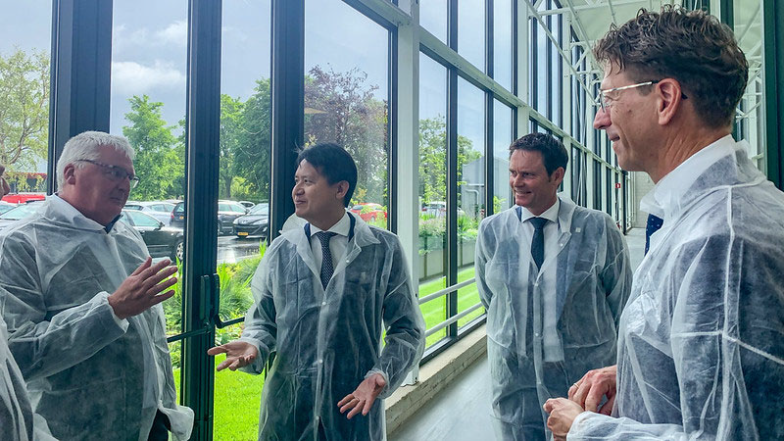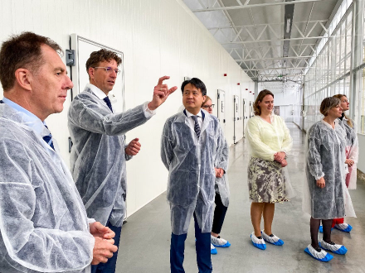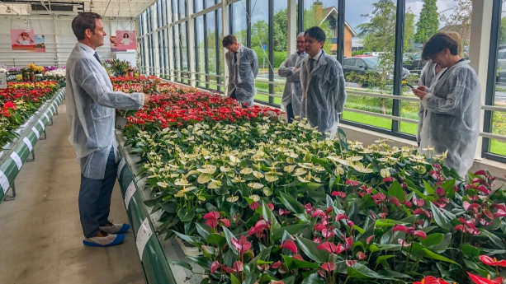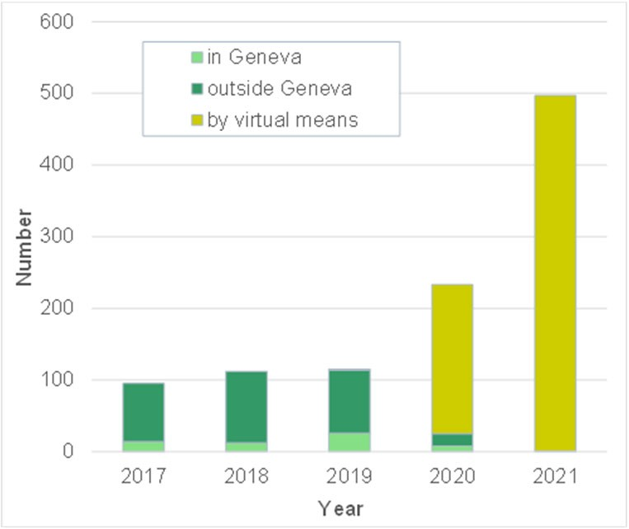

Number of missions, activities and meetings involving UPOV

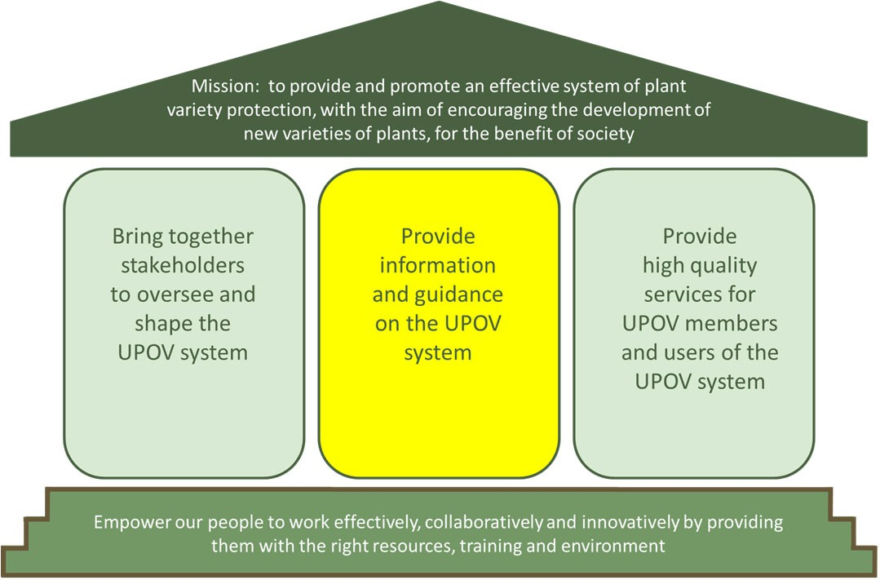

Building a UPOV Strategy House

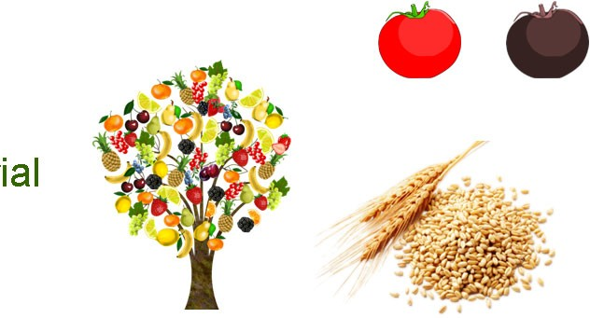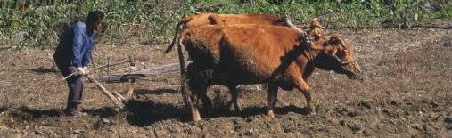

rial

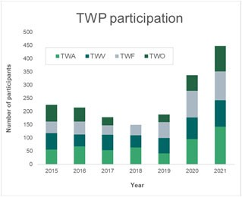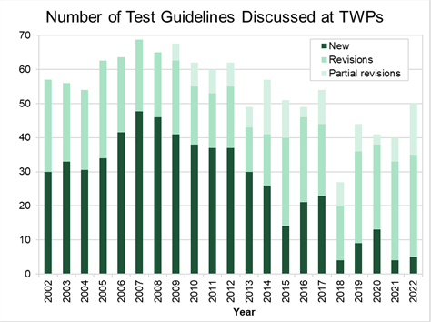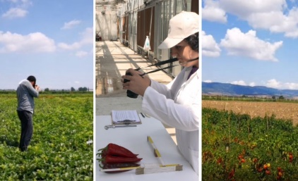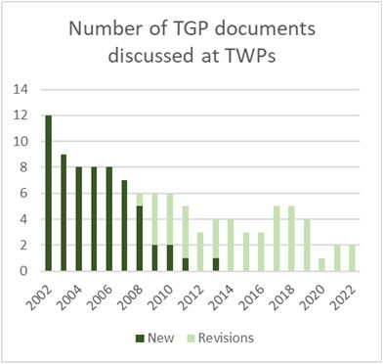

Survey on the needs in relation to Technical Working Parties (TWPs)

94% of PVP

applications covered by UPOV TGs

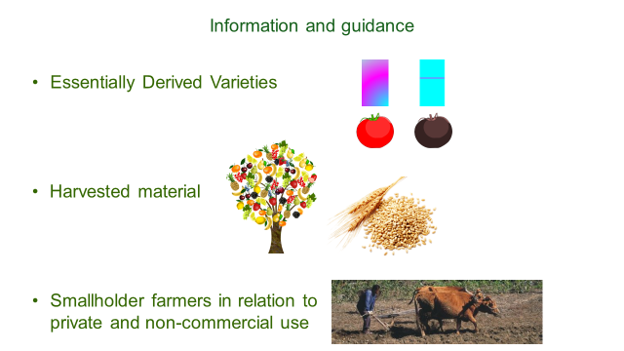



Information and guidance

* Essentially Derived Varieties 
* Harvested mate
* Smallholder farmers in relation to private and non-commercial use

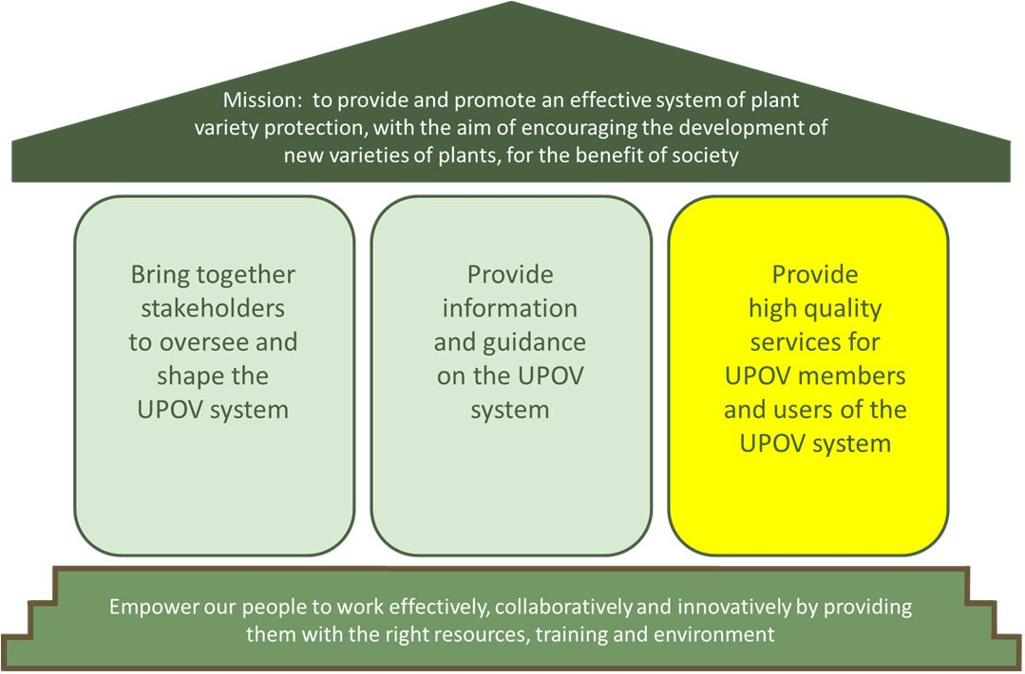

Building a UPOV Strategy House

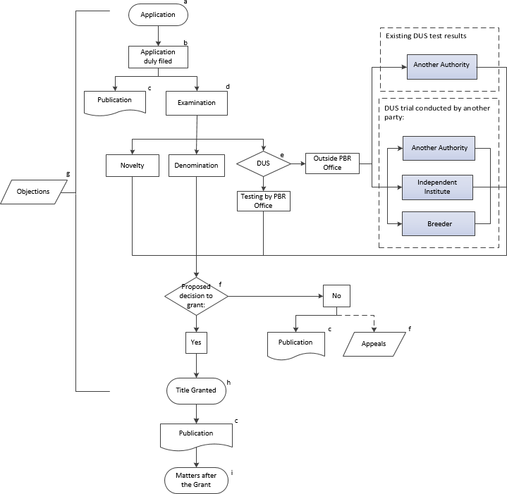

PLUTO database & GENIE database

UPOV

PVP Office

Applicant

e-PVP



Number of applications using

3000

2500

2000

1500 +27%

in

1000

2022

500 vs.

2021*

0

2017 2018 2019 2020 2021 2022

January to August

Year

*Excluding June figures in 2021 and 2022



Number of applications

+27% in 2022 vs. 2021*

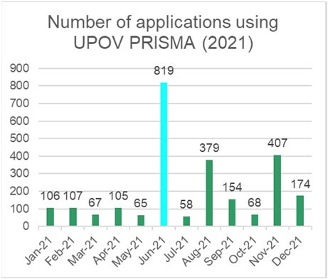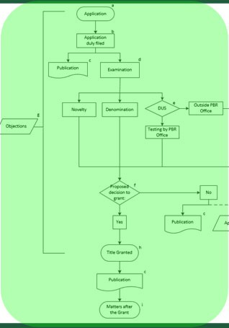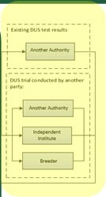

PLUTO database & GENIE database

UPOV

PVP

Administration Module

DUS Report

Exchange Platform

PVP Office

Applicant

e-PVP

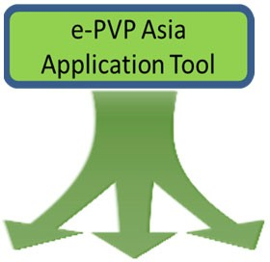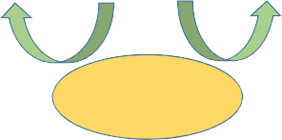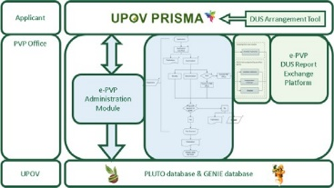

**DUS**

**examination report**

**Country X**

**Country B**

**Country A**

**Preliminary**

**examination (Novelty, Denomination)**

e-PVP Asia (EAPVP Forum Pilot Project)

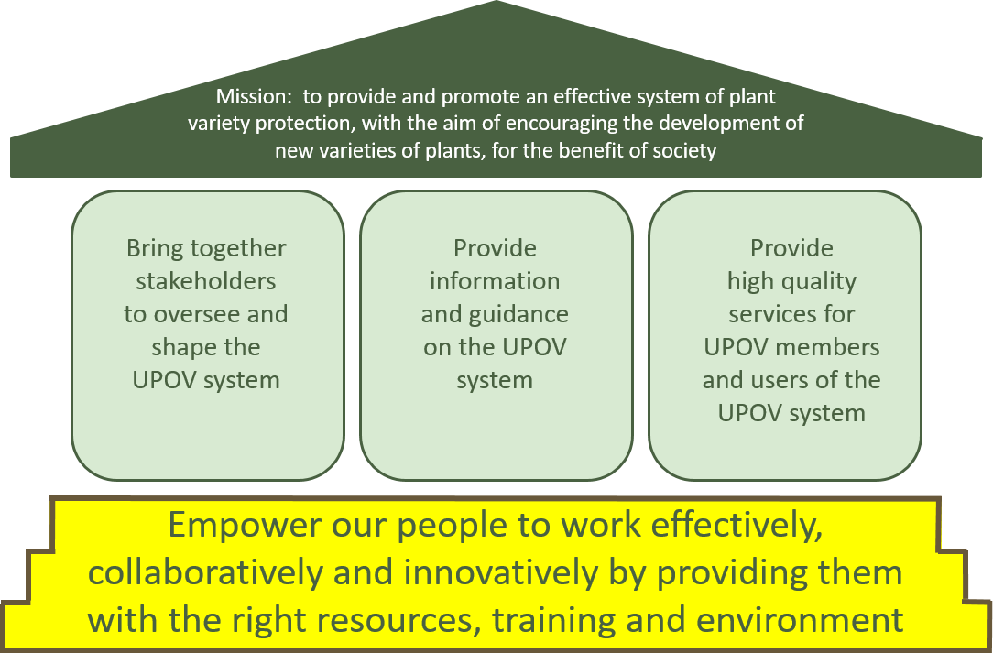

Building a UPOV Strategy House

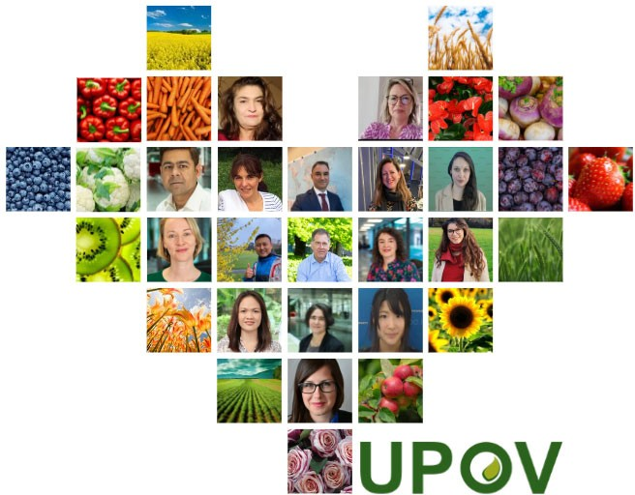

**Benchmark: 75**

**Overall**

**satisfaction**

**Participation**

**86%**

**79%**

Employee Engagement Survey 2022

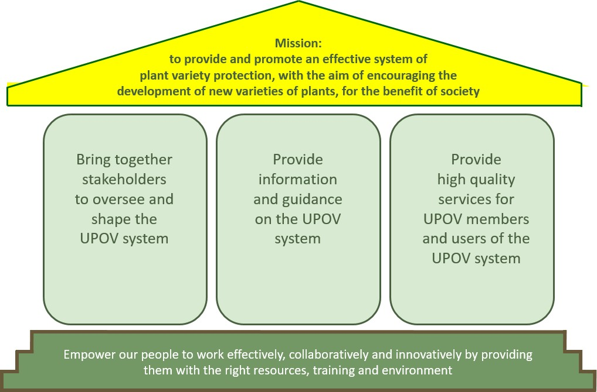

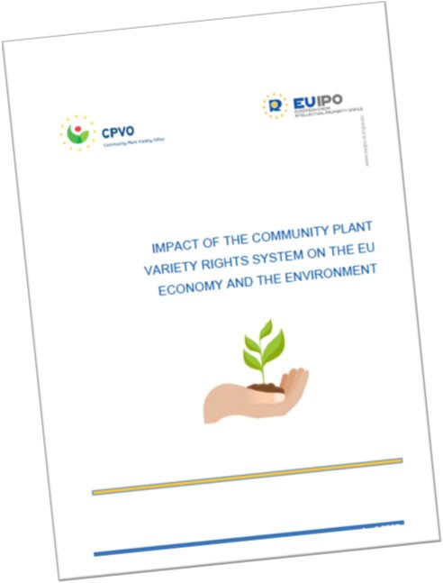

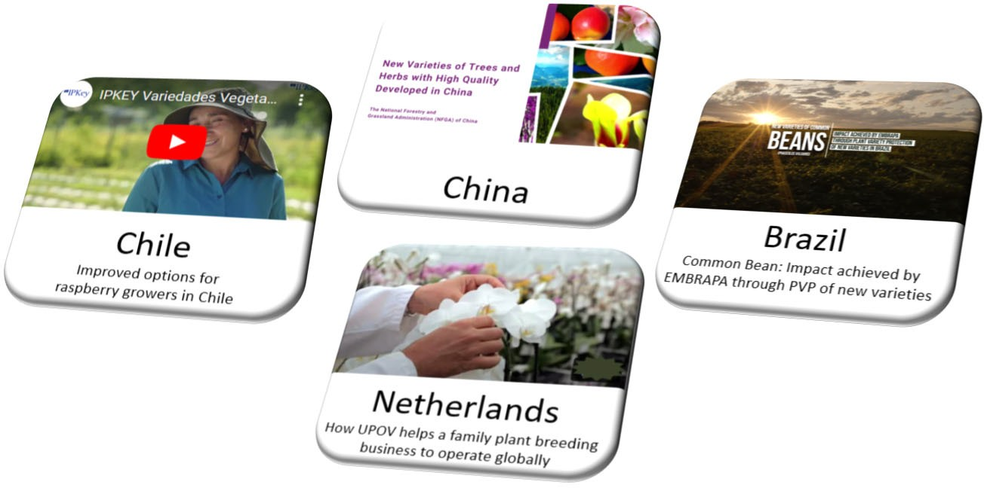

Benefits of the UPOV System: latest VIDEOS

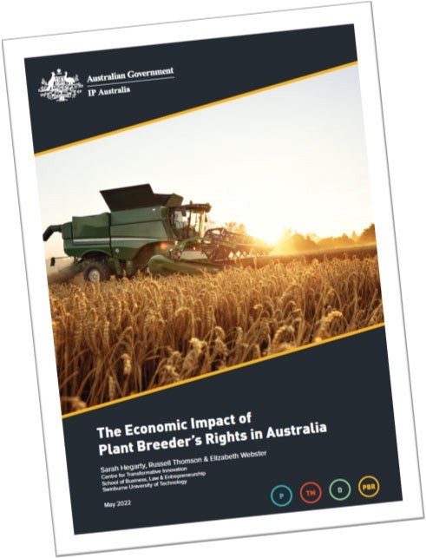

Benefits of the UPOV System: publications

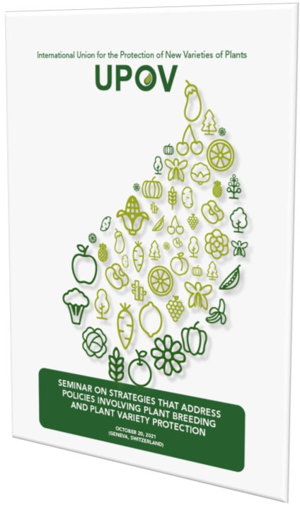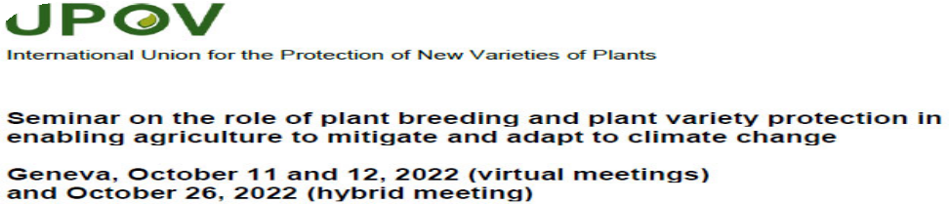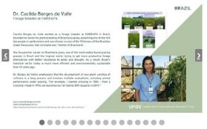

[peter.button@upov.int](mailto:peter.button@upov.int)

@vsgupov

@UPOVint

[www.upov.int](http://www.upov.int/)

UPOV on Twitter

[End of annex and of document]