E
International Union for the Protection of New Varieties of Plants

Technical Committee  Fifty-Eighth Session  Geneva, October 24 and 25, 2022 | TC/58/8.  Original: English  Date: October 11, 2022
Cooperation in examination
Document prepared by the Office of the Union
Disclaimer: this document does not represent UPOV policies or guidance

executive summary

The purpose of this document is to report discussions on possibilities to facilitate cooperation in DUS examination, including exchange and use of test reports, variety description information, procedures for testing, collections of varieties and a package of compatible IT tools to address technical and administrative concerns that prevent cooperation in examination (e-PVP).

The TC is invited to:

(a) note that members of the Union have the possibility to update information on a person(s) to be contacted for matters concerning international cooperation in DUS examination by:

(i) updating information when invited to provide information for document TC/[xx]/4 “List of genera and species for which authorities have practical experience in the examination of distinctness, uniformity and stability”; and/or

(ii) notifying the Office of the Union by sending an e-mail to upov.mail@upov.int;

(b) note the development of a package of compatible IT tools (e-PVP) as reported in paragraphs 9 to 13 of this document;

(c) note that e-PVP Asia is planned to be launched in early 2023;

(d) note that matters concerning the web-based TG template are reported in document TC/58/13;

(e) note that there have been no developments concerning databases containing variety description information that members of the Union wish to list in a UPOV platform;

(f) note that measures for increasing participation at TWP sessions are considered in document TC/58/9 “Increasing participation in the work of the TC and TWPs”;

(g) note that matters concerning a proposal on the revision of the GENIE database are presented in document TC/58/18 “Survey on the needs of members and observers in relation to the TWPs”;

(h) note that the CAJ, at its seventy-ninth session will be invited to consider:

(i) the proposed questions for the survey of members of the Union for information on their policies or legal barriers that could prevent international cooperation in DUS examination;

(ii) the information provided by breeders’ organizations to clarify the issues concerning the wish of breeders to use, or not to use, existing DUS reports; and

(iii) whether to postpone the development of explanatory notes of Article 12 of the UPOV Convention (“Examination of the Application”) until information from the survey of members of the Union and from breeders’ organizations is available and considered by the CAJ; and

(i) note that the impact of the proposed measures would be assessed on the basis of the number of cooperation agreements reported by members of the Union, as presented in document C/[xx]/INF/5 “Cooperation in examination”.

The structure of this document is as follows:

executive summary 1
Background 2
person(s) to be contacted for matters concerning international cooperation in DUS examination 2
IT tools to address the technical and related administrative concerns that prevent cooperation in DUS examination 3
Platform for UPOV member databases containing variety description information 4
Using the TWPs for increasing cooperation 4
Proposal for guidance on taking-over of DUS test reports 4
Consideration by the Administrative and Legal Committee (CAJ) 5
Impact assessment 5
ANNEX BACKGROUND TO PROPOSAL FOR GUIDANCE ON TAKING-OVER OF DUS TEST REPORTS

The following abbreviations are used in this document:

BMT: Working Group on Biochemical and Molecular Techniques, and DNA-Profiling in Particular
CAJ: Administrative and Legal Committee
TC: Technical Committee
TWA: Technical Working Party for Agricultural Crops
TWF: Technical Working Party for Fruit Crops
TWM: Technical Working Party on Testing Methods and Techniques
TWO: Technical Working Party for Ornamental Plants and Forest Trees
TWV: Technical Working Party for Vegetables
TWPs: Technical Working Parties

Background

The background to this matter, prior to the fifty-eighth session of the TC, is provided in document TC/57/9 “Cooperation in examination”.

person(s) to be contacted for matters concerning international cooperation in DUS examination

The list of persons to be contacted for matters concerning international cooperation in DUS examination is available on the UPOV website at the following address: https://www.upov.int/databases/en/contact_cooperation.html.

Members of the Union are invited to update information on a person(s) to be contacted for matters concerning international cooperation in DUS examination every year when invited to provide information for document TC/[xx]/4 “List of genera and species for which authorities have practical experience in the examination of distinctness, uniformity and stability”.

Updates on the list of person(s) to be contacted for matters concerning international cooperation provided on the UPOV website can be implemented at any time, at the request of the member of the Union concerned, by sending an e-mail to upov.mail@upov.int

IT tools to address the technical and related administrative concerns that prevent cooperation in DUS examination

E-PVP is a package of compatible IT tools that will provide coherent and comprehensive assistance in the implementation of the UPOV system of plant variety protection, some or all of which could be used by members of the Union, as considered appropriate. E-PVP will:

- Provide PVP offices with an electronic administration system for tasks from application to after granting PVP titles (e-PVP Administration Module)
- Provide applicants with information on DUS cooperation between UPOV members (DUS Arrangement Tool – DART)
- Provide a platform for the exchange of DUS reports between UPOV members (DUS Report Exchange Platform)
- Provide the possibility for a single online combined Application Form applicable for multiple UPOV members on the basis of UPOV PRISMA, as agreed by the UPOV members concerned
- Provide a secure system, with flexible adaptation to each members’ existing systems, using blockchain technology
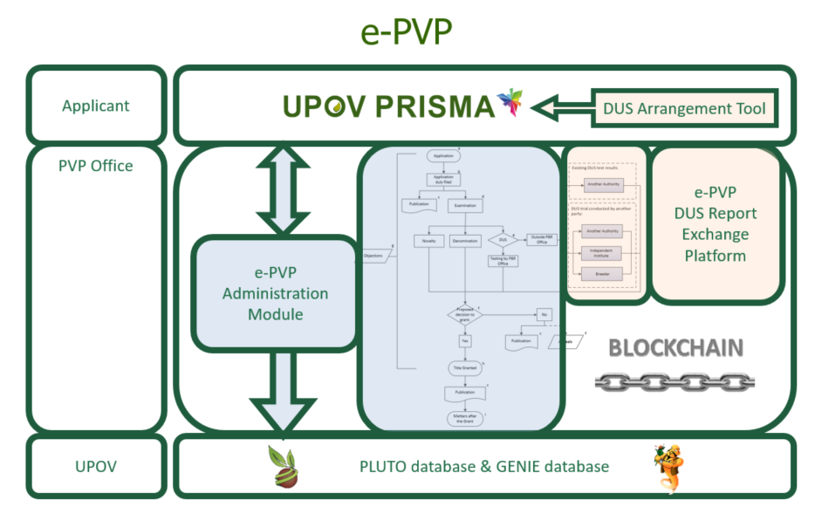

E-PVP modules are currently being developed in conjunction with the e-PVP Asia Pilot Project to establish e-PVP Asia, which is supported by the Japan Funds-in-Trust. E-PVP Asia is a cooperation arrangement to provide online services via a platform to enhance the efficiency of the administration of breeders’ rights applications and grants in e-PVP Asia participating countries. E-PVP Asia will also enhance cooperation in DUS examination between participating countries. E-PVP Asia is planned to launch in early 2023.

The tests of the e-PVP modules by the UPOV members that have been willing to share their experiences in developing and operating electronic application systems have been conducted and the feedback have been used for the improvement of the e-PVP modules. The test of the e-PVP modules by the applicants is planned in November 2022 (e-PVP Application Module and Application Monitoring Module).

The CAJ, at its seventy-ninth session, will consider whether to expand the scope of the EAF meetings to cover the reporting of e-PVP developments (see documents CAJ/79/10 “Meetings on the Development of an Electronic Application Form (EAF) (UPOV PRISMA)”, paragraphs 40 to 43 and TC/58/INF/2 “UPOV PRISMA”, paragraphs 40 to 42).

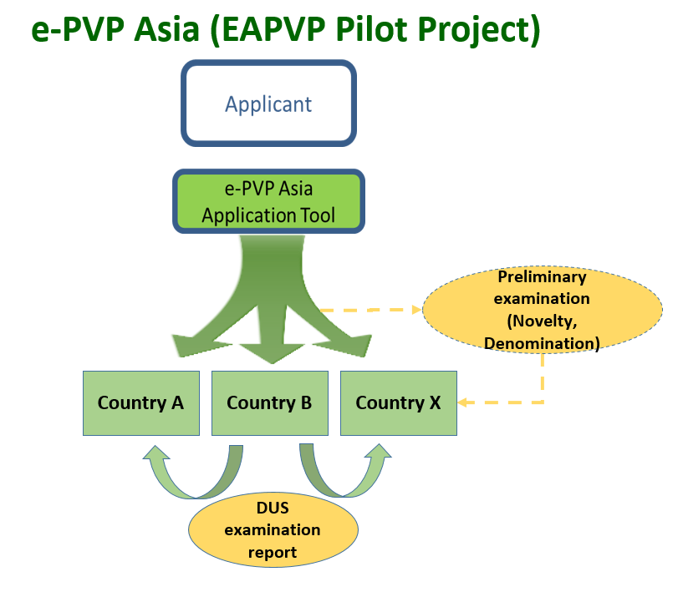

A presentation on e-PVP Asia was made by the Office of the Union at the 2022 sessions of each Technical Working Party (see documents TWV/56/22 “Report”, paragraph 69, TWA/51/11 “Report”, paragraph 11, TWO/54/6 “Report”, paragraph 16, TWF/53/14 “Report”, paragraph 68 and TWM/1/26 “Report”, paragraph 20).

Platform for UPOV member databases containing variety description information

The TC, at its fifty-seventh session, noted that the development of a platform for UPOV member databases containing variety description information would depend on UPOV members indicating which databases they would wish to share. The Office of the Union has not received any expressions of interest from members of the Union to share their databases (see document TC/57/25, “Report”, paragraph 57).

Matters concerning the availability of information about webpages with variety descriptions on the UPOV website are presented in document TC/58/12 “Variety description databases”.

Using the TWPs for increasing cooperation

The TC, at its fifty-fifth session, noted that TWP sessions could provide an opportunity for experts to enhance collaboration and exchange of information and agreed that TWP sessions should be used to develop cooperation among members to a greater extent (see document TC/55/25 Corr., “Report”, paragraph 205).

The TWA, at its fifty-first session, noted the procedures described by Canada, Czech Republic, Germany and Slovakia to identify experience and cooperation in DUS examination. These countries complement information provided in the GENIE database with that provided in the PLUTO database. The TWA agreed to propose that information available in both databases was further integrated to provide a single entry point to identify cooperation (see document TWA/51/11 “Report”, paragraph 16).

The matters concerning a proposal on the revision on the GENIE database are presented in document TC/58/18 “Survey on the needs of members and observers in relation to the TWPs”.

Measures for increasing cooperation among experts at TWP sessions are discussed in document TC/58/9 “Increasing participation in the work of the TC and TWPs”.

Proposal for guidance on taking-over of DUS test reports

The background to this matter, prior to the fifty-eighth session of the TC, is provided in the Annex to this document.

Consideration by the Administrative and Legal Committee (CAJ)

The CAJ, at its seventy-ninth session, to be held in Geneva on October 26, 2022, will be invited to:

(a) consider the proposed questions for the survey of members of the Union for information on their policies or legal barriers that could prevent international cooperation in DUS examination;

(b) note the request for breeders’ organizations to clarify the issues concerning the wish of breeders to use, or not to use, existing DUS reports; and

(c) postpone the development of explanatory notes of Article 12 of the UPOV Convention (“Examination of the Application”) until information from the survey of members of the Union and from breeders’ organizations is available and considered by the CAJ.

Impact assessment

The TC, at its fifty-sixth session, agreed to assess the impact of the proposed measures on the basis of the number of cooperation agreements reported by members of the Union, as presented in document C/[xx]/INF/5 “Cooperation in examination” (see document TC/56/22, “Outcome of consideration of documents by correspondence”, paragraph 44).

The TC is invited to:

(a) note that members of the Union have the possibility to update information on a person(s) to be contacted for matters concerning international cooperation in DUS examination by:

(i) updating information when invited to provide information for document TC/[xx]/4 “List of genera and species for which authorities have practical experience in the examination of distinctness, uniformity and stability”; and/or

(ii) notifying the Office of the Union by sending an e-mail to upov.mail@upov.int;

(b) note the development of a package of compatible IT tools (e-PVP) as reported in paragraphs 9 to 13 of this document;

(c) note that e-PVP Asia is planned to be launched in early 2023;

(d) note that matters concerning the web-based TG template are reported in document TC/58/13;

(e) note that there have been no developments concerning databases containing variety description information that members of the Union wish to list in a UPOV platform;

(f) note that measures for increasing participation at TWP sessions are considered in document TC/58/9 “Increasing participation in the work of the TC and TWPs”;

(g) note that matters concerning a proposal on the revision of the GENIE database are presented in document TC/58/18 “Survey on the needs of members and observers in relation to the TWPs”;

(h) note that the CAJ, at its seventy-ninth session will be invited to consider:

(i) the proposed questions for the survey of members of the Union for information on their policies or legal barriers that could prevent international cooperation in DUS examination;

(ii) the information provided by breeders’ organizations to clarify the issues concerning the wish of breeders to use, or not to use, existing DUS reports; and

(iii) whether to postpone the development of explanatory notes of Article 12 of the UPOV Convention (“Examination of the Application”) until information from the survey of members of the Union and from breeders’ organizations is available and considered by the CAJ; and

(i) note that the impact of the proposed measures would be assessed on the basis of the number of cooperation agreements reported by members of the Union, as presented in document C/[xx]/INF/5 “Cooperation in examination”.

[Annex follows]

BACKGROUND TO PROPOSAL FOR GUIDANCE ON TAKING-OVER OF DUS TEST REPORTS

- The TC, at its fifty-sixth session, agreed to propose to the CAJ the development of guidance to encourage UPOV members, on a voluntary basis, to take-over DUS test reports when the applicants could not submit plant material due to phytosanitary or other related issues where acceptable to the UPOV members concerned.

- The TC agreed that this proposal should be presented for consideration by the CAJ in document CAJ/77/2 “Report on developments in the Technical Committee” (see document TC/56/23 “Report”, paragraphs 57 to 63).

- The TC noted the comment provided by Japan in response to Circular E-20/119, of August 21, 2020, on difficulties to submit plant material to the authority receiving an application due to phytosanitary, quarantine or other related matters, as reported in document TC/56/22, paragraphs 47 and 48.

- The TC noted that plant material was required as a condition for granting breeders’ rights in some members of the Union.

- The TC, at its fifty-sixth session, agreed to propose to the CAJ the development of guidance to encourage UPOV members, on a voluntary basis, to take-over DUS test reports when the applicants could not submit plant material due to phytosanitary or other related issues where acceptable to the UPOV members concerned. The TC agreed that this proposal should be presented for consideration by the CAJ in document CAJ/77/2 “Report on developments in the Technical Committee” (see document TC/56/23 “Report”, paragraphs 57 to 63).

- The CAJ, at its seventy-seventh session, noted the measures agreed by TC to overcome barriers that prevented international cooperation in DUS examination (see document CAJ/77/10 “Report”, paragraphs 13 to 15).

- In response to the request of the TC, the CAJ requested the Office of the Union to prepare a document for consideration, at its seventy-eighth session, held on October 27, 2021, concerning the following policy or legal barriers that the TC had identified as preventing international cooperation in DUS examination and possible measures to address those barriers:

(i) Requirement of formal agreement for cooperation;
(ii) Obligation for DUS examination to be conducted by the authority granting the rights;
(iii) Non-acceptance of breeder-based DUS test reports;
(iv) Wish from breeders to use (or not) existing DUS reports;

- In response to the request of the TC, the CAJ further requested the Office of the Union to prepare a document for consideration, at its seventy-eighth session, with proposals for developing guidance to encourage members of the Union, on a voluntary basis, to take-over DUS test reports when the applicants could not submit plant material due to phytosanitary or other related issues where acceptable to the members of the Union concerned.

- The CAJ, at its seventy-eighth session, considered document CAJ/78/10 “Possible guidance on take-over of DUS reports when the applicants cannot submit plant material” (see document CAJ/78/13, paragraphs 37 to 39).

- The CAJ noted that proposals for enhancing cooperation and take-over of DUS test reports were provided in document CAJ/78/9 “Measures to enhance cooperation in examination”.

- The CAJ agreed to include possible “guidance to encourage members of the Union, on a voluntary basis, to take over DUS test reports when the applicants could not submit plant material due to phytosanitary or other related issues where acceptable to the members of the Union concerned” as part of the work to be agreed by the CAJ under document CAJ/78/9.

- The CAJ, at its seventy-eighth session, considered document CAJ/78/9 (see document CAJ/78/13, paragraphs 40 to 43).

- The CAJ agreed the following measures to address policy or legal barriers that the TC had identified as preventing international cooperation in DUS examination:

(a) survey members of the Union for information on their policies or legal barriers that could prevent international cooperation in DUS examination;

(b) develop explanatory notes to Article 12 of the UPOV Convention (“Examination of the Application”); and

(c) request breeders’ organizations to clarify the issues concerning the wish of breeders to use, or not to use, existing DUS reports.

- The CAJ agreed that the survey should include the taking-over of test reports where the variety descriptions did not match the UPOV Test Guidelines characteristics.

- In response to the comment from the European Union, the CAJ noted that the Explanatory Notes on “Examination of the Application” should explain all options for examination of varieties, as set out in the UPOV Convention.

[End of Annex and of document]

Held in Cambridge, United Kingdom, from May 23 to 27, 2022
Held via electronic means on October 26 to October 27, 2020
Held via electronic means on October 28, 2020
Held via electronic means on October 27, 2021

