E
International Union for the Protection of New Varieties of Plants

Technical Committee  Fifty-Eighth Session  Geneva, October 24 and 25, 2022 | TC/58/25  Original: English  Date: October 5, 2022
MATTERS TO BE RESOLVED CONCERNING TEST GUIDELINES PUT FORWARD FOR ADOPTION BY THE TECHNICAL COMMITTEE: TOMATO ROOTSTOCKS
Document prepared by an expert from the Netherlands
Disclaimer: this document does not represent UPOV policies or guidance
The Enlarged Editorial Committee (TC-EDC), at its meeting held in Geneva, October 25 to 26, 2021, considered a proposal for a partial revision of the Test Guidelines for Tomato Rootstocks (document TC/57/18). The TC-EDC agreed that the technical issues raised on the proposed partial revision should be addressed by the Technical Working Party for Vegetables (TWV) (see document TC/57/25 “Report”, Annex II).

The TWV, at its fifty-sixth session, considered document TWV/56/8 “Matters to be resolved concerning Test Guidelines put forward for adoption by the Technical Committee: Tomato Rootstocks” including the technical issues identified by the TC-EDC (indicated below by “#”). The proposed responses by the Leading Expert, Ms. Cécile Marchenay (Netherlands), and the conclusions of the TWV were as follows (see document TWV/56/2 “Report”, paragraph 81:

#Char. 22,  Ad. 22 | to check whether to reduce the scale to 3 notes or to improve the explanation about scoring the characteristic using all notes on the scale of 5 notes.  Leading Expert: Scale 1 to 5 has been kept for the moment, including extra explanation about all notes.  TWV:  Char. 22 to read as follows:  22. (*) (+) VG Resistance to Meloidogyne incognita (Mi)  QN susceptible Bruce 1  intermediate resistant 2  highly resistant Emperador 3  Ad. 22, 4. reference to INIA to read “INIA – CSIC”  Ad. 22, 8.5 to read “deposit of piece of inoculated roots…”  Ad. 22, 9.1 to add "It is recommended to include in the test, 10 non-inoculated plants, to be able to identified a possible lack of germination or a delay in plant growth, due to the material."  Ad. 22, 10.2 to read "The aggressiveness of the test depends on the quantity of inoculum and the growing conditions (e.g. between 30g to 60g of inoculated roots "  Ad. 22, 10.4 to read “Seeds are sown in non-inoculated soil and inoculation of soil…”  Ad. 22, 12. to read “[1] Susceptible: variety very similar to susceptible control [2] Intermediate resistant: variety very similar to intermediate resistant control [3] Highly resistant: variety very similar to highly resistant control If results are not clear, statistical analysis is advised. If significantly different from the controls, a retest is advised to check if the result is stable.”
#Ad. 22, 9.1, 9.4, 11.3 | to improve the explanation clarifying how would germination effect the scoring of the characteristic  Leading Expert: see Annex to this document  TWV: agreed
Ad. 22, 9.1 | to read “… due to nematode or not”  Leading expert: see Annex to this document (covered by comment above)  TWV: agreed
Ad. 22, 9.2 | to read “at least 2, preferably 3 to allow statistical analysis”  Leading Expert: prefer to keep “to allow statistical analysis”  TWV: agreed
Ad. 22, 9.6 | to read “20-26°C, the temperature may should be …”  Leading Expert: agreed  TWV: agreed
Ad. 22, 10.2 | to read “the ratio is depending of Quantity of inoculum depends on aggressiveness of test and lab’s growing conditions (e.g. between 30 g to 60 g of infested roots, for 100 plants in a tray of 45*30 cm containing approximately 5.5 kg of substrate);, galls should be homogeneously mixed with soil.”  Leading Expert: agreed  TWV: agreed
Ad. 22, 10.4 | to read “plants seed sown in soil contaminated with galls.”  Leading Expert: agreed  TWV: agreed
Ad. 22, 11.4 | to be deleted  Leading Expert: agreed  TWV: agreed
Ad. 22, 12. | in the figure, blue text: “Tyonoc” should read “Tyonic”  Leading Expert: figure removed, not applicable  TWV: agreed
Ad. 24, 12. | - to add the following wording:  “Absent [1] distribution of plants in the classes comparable with the susceptible controls.  “Present [9] distribution of plants in the classes comparable with the resistant controls.”  Leading Expert: agreed  TWV: agreed

The Annex to this document presents a new proposal for the explanation Ad. 22, based on the information above.

Changes previously agreed to the Test Guidelines of Tomato Rootstocks, presented in document TC/57/18, will be incorporated in the final adopted version of the partial revision of the Test Guidelines for Tomato Rootstocks.

[Annex follows]

Proposed changes to the explanation Ad. 22 “Resistance to Meloidogyne incognita (Mi)”

Ad. 22: Resistance to Meloidogyne incognita (Mi)

1. | Pathogen | Meloidogyne incognita
2. | Quarantine status | -
3. | Host species | Tomato - Solanum lycopersicum
4. | Source of inoculum | GEVES (FR) or INIA – CSIC (ES) or Naktuinbouw (NL)
5. | Isolate | non-resistance breaking
6. | Establishment isolate identity | use tomato standards
7 | Establishment pathogenicity | use susceptible rootstock or tomato standard
8. | Multiplication inoculum
8.1 | Multiplication medium | living plant
8.2 | Multiplication variety | susceptible variety, preferably resistant to powdery mildew
8.3 | Plant stage at inoculation | see 10.3 2nd leaf stage
8.5 | Inoculation method | see 10.4  deposit of piece of inoculated roots in soil (around 5-10g near each plant, to adapt depending on the population aggressivity)
8.6 | Harvest of inoculum | 6 to 10 weeks after inoculation, root systems are cut with scissors into pieces of about 1 cm length
8.7 | Check of harvested inoculum | visual check for presence of root knots and ripe egg masses
8.8 | Shelf life/viability inoculum | 1 day
9. | Format of the test
9.1 | Number of plants per genotype | 20 plants 30 plants  Remark: knowing that germination in rootstocks might be low and/or irregular it is recommended to sow more seeds to be sure to get at least 30 plants.  It is recommended to include in the test, 10 non-inoculated plants, to be able to identify a possible lack of germination or a delay in plant growth, due to the material.
9.2 | Number of replicates | 1 replicate  at least 2, preferably 3 to allow statistical analysis
9.3 | Control varieties | Susceptible: Bruce and (Solanum lycopersicum) Clairvil, Casaque Rouge  Moderately Intermediate resistant: (Solanum lycopersicum)  Madyta, Campeon, Madyta, Vinchy, Tyonic  Highly resistant: Emperador and (Solanum lycopersicum) “Anahu x Casaque Rouge”, Anahu, Anabel
9.4 | Test design | include standard varieties  3 replicates of 10 plants in different trays by variety, non-inoculated plants in a separate tray
9.5 | Test facility | greenhouse or climate room
9.6 | Temperature | not over 28° C  20-26°C, the temperature should be adapted, depending on the aggressiveness of the test, to obtain the expected response of the controls, but should not exceed 26°C. Higher temperatures will cause breakdown of resistance.
9.7 | Light | at least 12 h per day
10 | Inoculation
10.1 | Preparation inoculum | small pieces of diseased roots mixed with soil  mix soil and infested root pieces
10.2 | Quantification inoculum | soil: root ratio = 8:1, or depending on experience  Quantity of inoculum depends on aggressivness of test and growing conditions (e.g. between 30g to 60g of inoculated roots for 100 plants in a tray of 45*30 cm containing approximately 5.5 kg of substrate); galls should be homogeneously mixed with soil.
10.3 | Plant stage at inoculation | seed, or cotyledons
10.4 | Inoculation method | plants are sown in infested soil or contamination of soil after sowing when plantlets are at cotyledon stage  Seeds are sown in non-inoculated soil and inoculation of soil and inoculation of soil is done after sowing when plantlets are at cotyledon stage.
10.7 | End of test | 28 to 45 days after inoculation depending on test conditions (temperature, season)
11. | Observations
11.1 | Method | root inspection per plant
11.2 | Observation scale
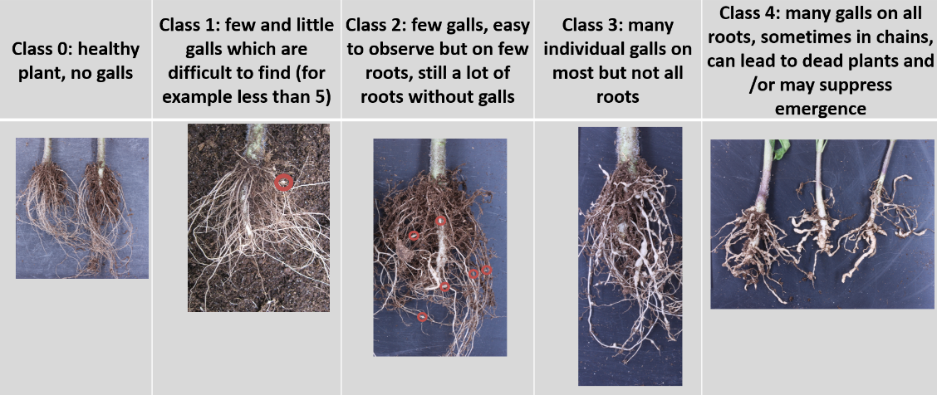

11.3 | Validation of test | evaluation of variety resistance should be calibrated with results of resistant and susceptible controls on standards  Validation on controls. Expected reactions of controls:  Susceptible control: most plants at classes 3 and 4.  Highly resistant: most plants at classes 0 and 1.  Intermediate resistant: clearly different from other controls with majority of plants around class 2.
11.4 | Off-types | resistant varieties may have a few plants with a few galls
12. | Interpretation of test results in comparison with control varieties data in terms of UPOV characteristic states | [1] Susceptible: variety very similar to susceptible control  [2] Intermediate resistant: variety very similar to intermediate resistant control  [3] Highly resistant: variety very similar to highly resistant control  If results are not clear, statistical analysis is advised.  If significantly different from the controls, a retest is advised to check if the result is stable.
To consider that resistant varieties may have a few plants with falls. These are not considered as off-types.
absent (susceptible)………… [1] growth strongly reduced, high gall count
intermediate
(moderately resistant)………… [2] medium growth reduction, medium gall count
present (highly resistant)……… [3] no growth reduction, no galls
13. | Critical control points | Avoid rotting of roots; high temperature causes breakdown of resistance  Avoid overwatering. This may result in rotting of roots.  In case of aggressive test, decrease the quantity of inoculum.

[End of Annex and of document]

organized by electronic means, from April 18 to 22, 2022
GEVES; matref@geves.fr
INIA; resistencias@inia.es
Naktuinbouw; resistentie@naktuinbouw.nl

