E
International Union for the Protection of New Varieties of Plants

Technical Committee  Fifty-Eighth Session  Geneva, October 24 and 25, 2022 | TC/58/23  Original: English  Date: October 5, 2022
PARTIAL REVISION OF THE TEST GUIDELINES FOR PEA
Document prepared by an expert from France
Disclaimer: this document does not represent UPOV policies or guidance
The purpose of this document is to present a proposal for a partial revision of the Test Guidelines for Pea (document TG/7/10 Rev. 2).

The Technical Working Party for Vegetables (TWV), at its fifty-sixth session, considered a proposal for a partial revision of the Test Guidelines for Pea (Pisum sativum L.) on the basis of documents TG/7/10 Rev. 2 and TWV/56/17 “Partial revision of the Test Guidelines for Pea” and proposed the following changes (see document TWV/56/22 “Report”, paragraph 92):

- Revision of Characteristic 58 “Resistance to Fusarium oxysporum f. sp. pisi Race 1”;
- Revision of explanation Ad. 58 “Resistance to Fusarium oxysporum f. sp. pisi Race 1” in Chapter 8.2 “Explanations for individual characteristics”;
- Revision of Characteristic 59 “Resistance to Erysiphe pisi Syd.”;
- Revision of explanation Ad. 59 “Resistance to Erysiphe pisi Syd.” in Chapter 8.2 “Explanations for individual characteristics”;
- Revision of explanation Ad. 60 “Resistance to Ascochyta pisi, Race C (Ascochyta Leaf and Pod Spot)” in Chapter 8.2 “Explanations for individual characteristics”.

The proposed changes to are presented below in highlight and underline (insertion) and strikethrough (deletion).

Proposed revision of Characteristic 58 “Resistance to Fusarium oxysporum f. sp. pisi.”

 |  | English | français | deutsch | español | Example Varieties/  Exemples/  Beispielssorten/  Variedades ejemplo | Note/  Nota
58.  (+) | VG | Resistance to Fusarium oxysporum f. sp. pisi  Race 1 | Résistance à Fusarium oxysporum f. sp. pisi  Race 1 | Resistenz gegen Fusarium oxysporum f. sp. pisi  Pathotyp 1 | Resistencia a Fusarium oxysporum f. sp. pisi  Raza 1
QL |  | absent | absente | fehlend | ausente | Aviron, Bartavelle, Curling, Digit | 1
 |  | present | présente | vorhanden | presente | Austronaute, Bingo, Foudre, Kristoff, Namrata, New Era, Nina, Roitelet | 9

Proposed revision of explanation Ad. 58 “Resistance to Fusarium oxysporum f. sp. pisi Race 1” in Chapter 8.2 “Explanations for individual characteristics”

Ad. 58: Resistance to Fusarium oxysporum f. sp. pisi Race 1 (Near wilt)

1. | Pathogen | Fusarium oxysporum f. sp. pisi (race 1)
2. | Quarantine status | No
3. | Host species | Pea – Pisum sativum L.
4. | Source of inoculum | GEVES (FR), INIA (ES) or SASA (GB)
5. | Isolate | Fusarium oxysporum f. sp. pisi race 1 strain MATREF 04-02-01-01 (the test protocol has been validated with this isolate/race.)  E.g. Reference strain validated in an inter laboratory test:  = MAT/REF 04-02-01-01²
6. | Establishment isolate identity | genetically defined pea controls  See ISF website  https://www.worldseed.org/our-work/plant-health/differential-hosts/  Version July 2019

Differentials host
susceptible: | M410, Bartavelle, Little Marvel
resistant: | New Era, Mini 93, Dark Skin Perfection, Vantage, WSU 23, New Season, WSU 31, 74SN5, Sundance II, Grant

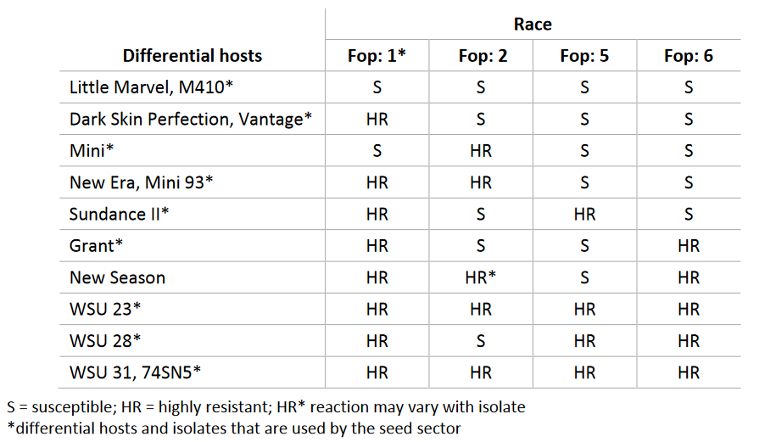
Courtesy of International Seed Federation.

7. | Establishment pathogenicity | Test on susceptible plants
8. | Multiplication inoculum
8.1 | Multiplication medium | Multiplication on agar medium: malt Agar or PDA for example
8.4 | Inoculation medium | Multiplication on agar medium: water for scraping agar plates.  Multiplication on liquid medium: Potato Dextrose Broth, Kerrs broth or Czapek-Dox (3 to 7 days old aerated culture) for example.
8.6 | Harvest of inoculum | see 10.1
8.7 | Check of harvested inoculum | see 10.2
8.8 | Shelf life/viability inoculum | Between 4 and 8 hours, keep cool to prevent germination of spores. Viability of spores should be more than 3 years if stored at -20°C. The spores can be stored more than 3 years at -20°C.
9. | Format of the test
9.1 | Number of plants per genotype | At least 20 inoculated plants and 5 non inoculated plants per variety per genotype to be able to judge growth reduction.
9.2 | Number of replicates | -
9.3 | Control varieties | Susceptible controls: Bartavelle  Resistant controls: New Era and Nina
9.5 | Test facility | Climate room or greenhouse.
9.6 | Temperature | 20-25°C
9.7 | Light | 12 hours or longer
9.9 | Special measures | It is important to compare the inoculated plants with the negative non inoculated control plants of the same sample. This allows interpretation of symptoms of root rot, senescence or 'wilting' caused by the stress of having roots cut and not symptoms caused by F. oxysporum infection.
10. | Inoculation
10.1 | Preparation inoculum | For agar plates, remove hyphen fragments by filtering solution through muslin.  Initial fungal growth on agar plates (Malt or PDA). This is then used as liquid medium inoculum after removing hyphal fragments by filtering solution through muslin cloth.  For liquid medium, filter through muslin cloth to remove large hyphal fragments.
10.2 | Quantification inoculum | 10⁶ spores/ml
10.3 | Plant stage at inoculation | seeds or 2 weeks old seedlings (2-3 nodes stage).
10.4 | Inoculation method | For seeds:  sowing in contaminated substrate (soil-based substrate), 750 ml of suspension of spores at 10⁶ sp/ml for 5 l of substrate.  For 2 weeks seedlings:  Sowing in a mix of vermiculite + soil or soil-based substrate  Cut the apical 2/3 of the roots with scissors, dip the root of the seedling in the spores suspension for 1 to 5 minutes and transplant in clean soil based substrate in a new tray.
10.7 | Final observations | 28 days post-inoculation.
11. | Observations
11.1 | Method | Visual
11.2 | Observation scale | resistant:  Class 0: No symptoms or equivalent to non-inoculated negative control, 1 or 2 senesced (wilted/dried) lower leaves and slight reduction in growth compared to non-inoculated negative control of same variety are acceptable.  Class 1: Range from a few chlorotic or wilted/dried/senesced leaves not present on, or more than on the negative non-inoculated control, up to many leaves with symptoms of senescence or wilting, some leaf drop, upper part of the plant still green and growing.  susceptible:  Class 2: Range from most of the plant wilted/dried or senesced but still alive, to plants brown and dead with stem collapsed.  Classes 0 and 1 are generally resistant. Class 2 is generally susceptible.

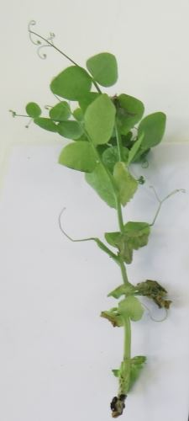 | 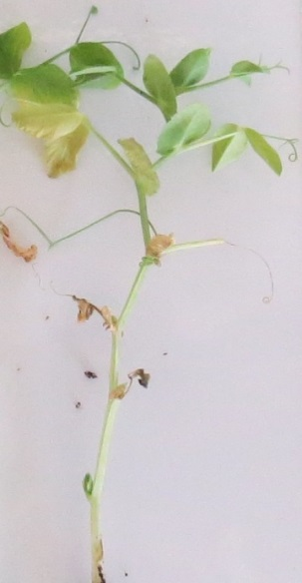 | 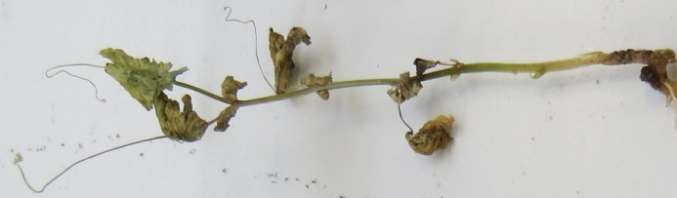 | 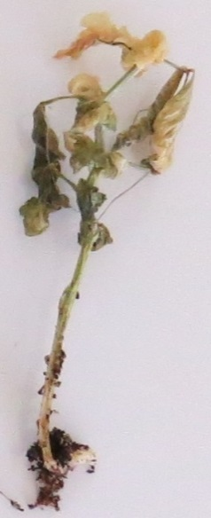
Class 0  resistant | Class 1  resistant | Class 2  susceptible
Courtesy of GEVES-SNES in the framework of CPVO Harmores project.

 |  | Varieties with the same or higher level of resistance as New Era will be interpreted as resistant. Varieties with a lower level of resistance than New Era will be interpreted as susceptible. Nina will be highly resistant, Bartavelle will be highly susceptible. New Era expresses weak symptoms and variation can occur in these weak symptoms depending on the agressivity of the test conditions.
11.3 | Validation of test | Evaluation of variety resistance should be calibrated with results of resistant and susceptible controls (distribution of plants per symptoms classes, eventually completed by a disease index).  New Era expresses weak symptoms and variations can occur in these weak symptoms depending on the aggressiveness of the test conditions.  Susceptible: lower level of resistance than New Era (Bartavelle is highly susceptible)  Resistant: same or higher level of resistance than New Era (Nina is highly resistant)
12. | Interpretation of data in terms of UPOV characteristic states
 | absent [1] | Susceptible
 | present [9] | Resistant
13. | Critical control points | Each lab has to define the best method of inoculation in its lab depending on controls results.  Inoculation by sowing in contaminated soil can in some cases lead to germination problems, particularly if the humidity of the soil is too high during the test. No conclusion can be done in this case, and the test should be repeated.

Proposal to revise Characteristic 59 “Resistance to Erysiphe pisi Syd.”

Proposed new wording

 |  | English | français | deutsch | español | Example Varieties/  Exemples/  Beispielssorten/  Variedades ejemplo | Note/  Nota
59.  (+) | VG | Resistance to Erysiphe pisi Syd. | Résistance à Erysiphe pisi Syd. | Resistenz gegen Erysiphe pisi Syd. | Resistencia a Erysiphe pisi Syd.
QL |  | absent | absente | fehlend | ausente | Cabro, Aladin, Astronaute, Aviron, Cabree, Dexter, Ottoman | 1
 |  | present | présente | vorhanden | presente | Stratford, Alezan, Boogie, Ema, LG Amigo, Stratagem (JI2302),  Sugar Bon, Vivaldi, | 9

Proposed revision of explanation Ad. 59 “Resistance to Erysiphe pisi Syd.” in Chapter 8.2 “Explanations for individual characteristics”

Ad. 59: Resistance to Erysiphe pisi Syd. (Powdery Mildew)

1. | Pathogen | Powdery mildew – Erysiphe pisi
2. | Quarantine status | No
3. | Host species | Pea – Pisum sativum L
4. | Source of inoculum | GEVES (FR)
5. | Isolate | Erysiphe pisi  e.g. Reference strain validated in an inter laboratory test  isolate 2430  =MAT/REF/ 04-17-01⁶
6. | Establishment isolate identity | Validation by use specific EryF/EryR primers to validate the species of Erysiphe (use ITS primers from Attanayake et al, 2010.)
7. | Establishment pathogenicity | use susceptible variety (e.g. Aladin, Cabree or Ottoman)
8. | Multiplication inoculum
8.1 | Multiplication medium | Living plant
8.2 | Multiplication variety | See 7
8.3 | Plant stage at inoculation | See 10.3
8.4 | Inoculation medium
8.5 | Inoculation method | See 10.4
8.6 | Harvest of inoculum | For spraying by washing off with demineralized water  For dry sprinkling by detaching leaves of a susceptible host plant
8.7 | Check of harvested inoculum | Visual check for presence of sporulation
8.8 | Shelf life/viability inoculum | 1-2 hours
9. | Format of the test
9.1 | Number of plants per genotype | 20 plants
9.2 | Number of replicates | -
9.3 | Control varieties | Susceptible:  For vegetable crops: Cabree  For agricultural crops: Aladin, Ottoman  Resistant:  For vegetable crop: Ema, Sugar Bon, Vivaldi, Stratagem (JI2302),  For agricultural crop: Alezan
9.4 | Test design | Exclude non-inoculated control plants of the same sample as it is impossible to place them exactly in the same conditions (due to risk of contamination)
9.5 | Test facility | green house or climatic room
9.6 | Temperature | It is advised to perform the test at 20°C, but depending on laboratory conditions, test can be performed at temperature as high as 25°C. It is advised not to go below 18°C.
9.7 | Light | at least 12h per day
9.8 | Season
9.9 | Special measures
10. | Inoculation
10.1 | Preparation inoculum | By spraying:  Washing off from leaves by vigorous shaking in a closed container containing water. Sieve the suspension through muslin cloth.  By sprinkling:  Selection of leaves with strong sporulation.
10.2 | Quantification inoculum | By spraying:  Counting spores; spores density should be 1x105 to 1x106 spores/mL  By sprinkling:  An estimated proportion of one diseased plant (with a strong sporulation) can be used to inoculate 10 plants.
10.3 | Plant stage at inoculation | 3-4 leaf stage
10.4 | Inoculation method | By spraying:  Spraying of the suspension of spores on leaves  By sprinkling of the spores from the susceptible control plants used for multiplication:  To detach the spores for inoculation, the multiplication control plants are shaken above the tray of tested plants.
10.5 | First observation
10.6 | Second observation
10.7 | Final observations | Between 14-21 dpi, when sporulation is well expressed on the  susceptible control.
11. | Observations
11.1 | Method | Visual
11.2 | Observation scale
Courtesy of GEVES-SNES in the framework of CPVO Harmores project.

11.3 | Validation of test | Evaluation of variety resistance should be calibrated with results of resistant and susceptible controls.  Susceptible:  sporulation on leaves. These symptoms can be observed on stem and tendril (not always on the whole plant).  Resistant:  No sporulation or few mycelial pustules only on the lower leaves in case of high disease pressure, no evolution of the symptoms
11.4 | Off-types | -
12. | Interpretation of data in terms of UPOV characteristic states | Absent (susceptible) [1]  Present (resistant) [9]
13. | Critical control points | Watering for plant growth on the substrate (no spraying) to avoid washing the spores off the surface of the leaves.  It is not possible to revive frozen spores. This pathogen is an obligate biotroph and cannot survive outside a living plant.

Proposed revision of explanation Ad. 60 “Resistance to Ascochyta pisi, Race C (Ascochyta Leaf and Pod Spot)” in Chapter 8.2 “Explanations for individual characteristics”

Ad. 60: Resistance to Ascochyta pisi, Race C (Ascochyta Leaf and Pod Spot)

1. | Pathogen | Ascochyta pisi
2. | Quarantine status | No
3. | Host species | Pea – Pisum sativum L.
4. | Source of inoculum | GEVES (FR) or SASA (UK)
5. | Isolate | Ascochyta pisi race C strain 21A.13.  The test protocol has been validated in a European CPVO co-funded project with this isolate.  E.g.: Reference strain validated in an inter-laboratory test  - strain 21A.13.  = MAT/REF/ 04-17-01⁹
6. | Establishment isolate identity | Genetically defined on Pea controls (Physiological races of A. pisi and differentials, adapted from Gallais et Bannerot, 1992)  see ISF website  https://www.worldseed.org/our-work/plant-health/differential-hosts/  Version July 2019
Physiological race  (Dr Hubbeling)  Strain | C  Tézier  21A.13
Gullivert | S
Rondo | R
Finale | R
Kelvedon Wonder | S
Dark Skin Perfection | S
Arabal, Cobri, Starcovert, Sucovert, Vitalis | S
R = resistant; S = susceptible

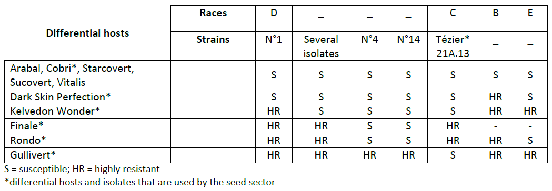
Courtesy of International Seed Federation.

7. | Establishment pathogenicity | Test on susceptible plants
8. | Multiplication inoculum
8.1 | Multiplication medium | V8 agar or Mathur medium or Potato Dextrose Agar or a synthetic  medium.
8.2 | Multiplication variety | -
8.3 | Plant stage at inoculation | -
8.4 | Inoculation medium | water, option: add Tween 80 (wetting agent to aid dispersal of spores, e.g. 0.4%)
8.5 | Inoculation method | -
8.6 | Harvest of inoculum | See 10.1
8.7 | Check of harvested inoculum | See 10.2
8.8 | Shelf life/viability inoculum | 4/8h Between 4 and 8 hours, keep cool to prevent spores’ germination
9. | Format of the test
9.1 | Number of plants per genotype | At least 20 inoculated plants and 5 non-inoculated plants per variety.
9.2 | Number of replicates | -
9.3 | Control varieties | Susceptible controls: Crecerelle, Kelvedon Wonder  Resistant controls: Madonna or Rondo (lower resistance thresholds) and Nina (higher resistance control)
9.4 | Test design | -
9.5 | Test facility | Climatic room or greenhouse.
9.6 | Temperature | 20°C
9.7 | Light | 12 hours or longer
9.8 | Season | -
9.9 | Special measures | High humidity or watering by spraying 2 or 3 times per day.
10. | Inoculation
10.1 | Preparation inoculum | Remove hyphenal fragments by straining solution through muslin cloth.
10.2 | Quantification inoculum | 10⁶ spores/mL (to adapt depending on conditions of tests).
10.3 | Plant stage at inoculation | 2 weeks old seedlings (i.e. 2-3 node stage).
10.4 | Inoculation method | Spraying on green leaves without surface moisture.
10.5 | First observation
10.6 | Second observation
10.7 | Final observations | 10-18 days post-inoculation.
11. | Observations
11.1 | Method | Visual
11.2 | Observation scale | Class 0: no symptoms  Class 1: few small superficial necrosis  Class 2: bigger darker and deep necrosis  Class 3: necrosis at each level of the plant or serious symptoms surrounding the stem  Madonna, Rondo, and Nina are resistant controls. Varieties with the same or higher level of resistance than Madonna or Rondo will be interpreted as resistant.  Crecerelle or Kelvedon Wonder are susceptible controls. Varieties with a lower level of resistance than Nina as well as Madonna or Rondo will be interpreted as susceptible.
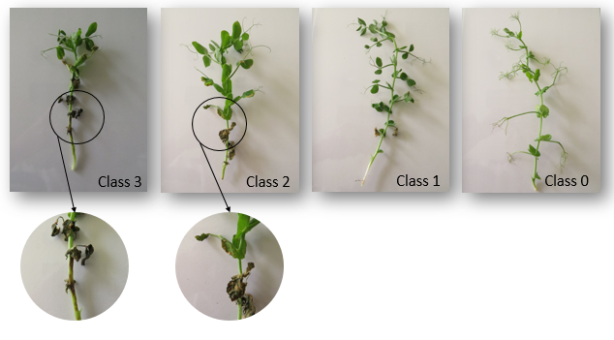
Courtesy of GEVES-SNES in the framework of CPVO Harmores project.

11.3 | Validation of test | Evaluation of variety resistance should be calibrated with results of  resistant and susceptible controls.
11.4 | Off-types
12. | Interpretation of data in terms of UPOV characteristic states | Susceptible:  Crecerelle or Kelvedon Wonder are susceptible controls. Varieties with a lower level of resistance than Madonna or Rondo will be interpreted as susceptible.  Resistant:  Madonna, Rondo, and Nina are resistant controls. Varieties with the same or higher level of resistance than Madonna or Rondo will be interpreted as resistant.  absent .............................. [1] susceptible (classes 2 and 3)  present ............................. [9] resistant (classes 0 and 1)
13. | Critical control points | -

[End of document]

organized by electronic means, from April 18 to 22, 2022
matref@geves.fr
resistencias@inia.es
Marian.McEwan@sasa.gov.scot
Harmores 2 CPVO project: https://cpvo.europa.eu/sites/default/files/documents/vem15_7_b_harmores_2_final_report.pdf
GEVES; matref@geves.fr
Harmores 2 CPVO project: https://cpvo.europa.eu/sites/default/files/documents/vem15_7_b_harmores_2_final_report.pdf
matref@geves.fr
Marian.McEwan@sasa.gov.scot
Harmores 2 CPVO project: (https://cpvo.europa.eu/sites/default/files/documents/vem15_7_b_harmores_2_final_report.pdf
Harmores 2 CPVO project: https://cpvo.europa.eu/sites/default/files/documents/vem15_7_b_harmores_2_final_report.pdf

