 |  | E
 | INCLUDEPICTURE "wordml://75.png" \* MERGEFORMATINET INCLUDEPICTURE "wordml://75.png" \* MERGEFORMATINET INCLUDEPICTURE "wordml://75.png" \* MERGEFORMATINET INCLUDEPICTURE "wordml://75.png" \* MERGEFORMATINET INCLUDEPICTURE "wordml://75.png" \* MERGEFORMATINET INCLUDEPICTURE "wordml://75.png" \* MERGEFORMATINET INCLUDEPICTURE "wordml://75.png" \* MERGEFORMATINET INCLUDEPICTURE "wordml://75.png" \* MERGEFORMATINET 
  TG/95/4(proj.5)
  ORIGINAL: English
  DATE: 2020-09-15
INTERNATIONAL UNION FOR THE PROTECTION OF NEW VARIETIES OF PLANTS
 | Geneva
  DRAFT
  LAGERSTROEMIA
  UPOV Code(s): LAGER
  Lagerstroemia L.
  *
GUIDELINES
FOR THE CONDUCT OF TESTS
FOR DISTINCTNESS, UNIFORMITY AND STABILITY

prepared by an expert from France

to be considered by the

Technical Committee at its fifty-seventh session
to be held in Geneva on October 25 and 26, 2021

Disclaimer: this document does not represent UPOV policies or guidance
Alternative names:*

Botanical name | English | French | German | Spanish
  Lagerstroemia L.
  Lagerstroemia,
  Crape Myrtle,
  Crepe Myrtle
  Lagerstroemia
  Lagerstroemia
  Lagerstroemia, Lagestroemia

The purpose of these guidelines (“Test Guidelines”) is to elaborate the principles contained in the General Introduction (document TG/1/3), and its associated TGP documents, into detailed practical guidance for the harmonized examination of distinctness, uniformity and stability (DUS) and, in particular, to identify appropriate characteristics for the examination of DUS and production of harmonized variety descriptions.
ASSOCIATED DOCUMENTS
These Test Guidelines should be read in conjunction with the General Introduction and its associated TGP documents.

TABLE OF CONTENTS | PAGE
1. | SUBJECT OF THESE TEST GUIDELINES.......................................................................................................... | 3
2. | MATERIAL REQUIRED......................................................................................................................................... | 3
3. | METHOD OF EXAMINATION................................................................................................................................ | 3
3.1 | Number of Growing Cycles........................................................................................................................ | 3
3.2 | Testing Place............................................................................................................................................. | 3
3.3 | Conditions for Conducting the Examination............................................................................................... | 3
3.4 | Test Design................................................................................................................................................ | 3
3.5 | Additional Tests......................................................................................................................................... | 3

4. | ASSESSMENT OF DISTINCTNESS, UNIFORMITY AND STABILITY................................................................. | 4
4.1 | Distinctness............................................................................................................................................... | 4
4.2 | Uniformity.................................................................................................................................................. | 5
4.3 | Stability...................................................................................................................................................... | 5

5. | GROUPING OF VARIETIES AND ORGANIZATION OF THE GROWING TRIAL................................................ | 5
6. | INTRODUCTION TO THE TABLE OF CHARACTERISTICS................................................................................ | 6
6.1 | Categories of Characteristics..................................................................................................................... | 6
6.2 | States of Expression and Corresponding Notes........................................................................................ | 6
6.3 | Types of Expression.................................................................................................................................. | 6
6.4 | Example Varieties...................................................................................................................................... | 6
6.5 | Legend....................................................................................................................................................... | 7

7. | TABLE OF CHARACTERISTICS/TABLEAU DES CARACTÈRES/MERKMALSTABELLE/TABLA DE CARACTERES...................................................................................................................................................... | 8
8. | EXPLANATIONS ON THE TABLE OF CHARACTERISTICS............................................................................... | 19
8.1 | Explanations covering several characteristics........................................................................................... | 19
 | Explanations for individual characteristics................................................................................................. | 19
  8.2

9. | LITERATURE......................................................................................................................................................... | 25
10. | TECHNICAL QUESTIONNAIRE............................................................................................................................ | 26

1. | Subject of these Test Guidelines
  These Test Guidelines apply to all varieties of Lagerstroemia L.

2. | Material Required
2.1
  The competent authorities decide on the quantity and quality of the plant material required for testing the variety and when and where it is to be delivered. Applicants submitting material from a State other than that in which the testing takes place must ensure that all customs formalities and phytosanitary requirements are complied with.
2.2
  The material is to be supplied in the form of plants capable of flowering and expressing all relevant characteristics of the variety during the first growing cycle.
2.3
  The minimum quantity of plant material, to be supplied by the applicant, should be:
  6 plants
2.4
  The plant material supplied should be visibly healthy, not lacking in vigor, nor affected by any important pest or disease.
2.5
  The plant material should not have undergone any treatment which would affect the expression of the characteristics of the variety, unless the competent authorities allow or request such treatment. If it has been treated, full details of the treatment must be given.

3. | Method of Examination
3.1 | Number of Growing Cycles
3.1.1 | The minimum duration of tests should normally be two independent growing cycles.
3.1.2 | The two independent growing cycles may be observed from a single planting, examined in two separate growing cycles.
 | The testing of a variety may be concluded when the competent authority can determine with certainty the outcome of the test.
  3.1.3
3.2 | Testing Place
 | Tests are normally conducted at one place. In the case of tests conducted at more than one place, guidance is provided in TGP/9 “Examining Distinctness”.
3.3 | Conditions for Conducting the Examination
 | The tests should be carried out under conditions ensuring satisfactory growth for the expression of the relevant characteristics of the variety and for the conduct of the examination.
  3.3.1
 | Because daylight varies, color determinations made against a color chart should be made either in a suitable cabinet providing artificial daylight or in the middle of the day in a room without direct sunlight. The spectral distribution of the illuminant for artificial daylight should conform with the CIE Standard of Preferred Daylight D 6500 and should fall within the tolerances set out in the British Standard 950, Part I. These determinations should be made with the plant part placed against a white background. The color chart and version used should be specified in the variety description.
  3.3.2

3.4 | Test Design
  Each test should be designed to result in a total of at least 6 plants.
3.5 | Additional Tests
 | Additional tests, for examining relevant characteristics, may be established.

4. | Assessment of Distinctness, Uniformity and Stability
4.1 | Distinctness
4.1.1 | General Recommendations
 | It is of particular importance for users of these Test Guidelines to consult the General Introduction prior to making decisions regarding distinctness. However, the following points are provided for elaboration or emphasis in these Test Guidelines.
4.1.2 | Consistent Differences
 | The differences observed between varieties may be so clear that more than one growing cycle is not necessary. In addition, in some circumstances, the influence of the environment is not such that more than a single growing cycle is required to provide assurance that the differences observed between varieties are sufficiently consistent. One means of ensuring that a difference in a characteristic, observed in a growing trial, is sufficiently consistent is to examine the characteristic in at least two independent growing cycles.
4.1.3 | Clear Differences
 | Determining whether a difference between two varieties is clear depends on many factors, and should consider, in particular, the type of expression of the characteristic being examined, i.e. whether it is expressed in a qualitative, quantitative, or pseudo-qualitative manner. Therefore, it is important that users of these Test Guidelines are familiar with the recommendations contained in the General Introduction prior to making decisions regarding distinctness.
4.1.4
  Number of Plants or Parts of Plants to be Examined
  Unless otherwise indicated, for the purposes of distinctness, all observations on single plants should be made on 5 plants or parts of plants taken from each of 5 plants and any other observations made on all plants in the test, disregarding any off-type plants.
  In the case of observations of parts taken from single plants, the number of parts to be taken from each of the plants should be 5.
4.1.5 | Method of Observation
 | The recommended method of observing the characteristic for the purposes of distinctness is indicated by the following key in the Table of Characteristics (see document TGP/9 “Examining Distinctness”, Section 4 “Observation of characteristics”):
MG: single measurement of a group of plants or parts of plants
MS: measurement of a number of individual plants or parts of plants
VG: visual assessment by a single observation of a group of plants or parts of plants
VS: visual assessment by observation of individual plants or parts of plants

 | Type of observation: visual (V) or measurement (M)

“Visual” observation (V) is an observation made on the basis of the expert’s judgment. For the purposes of this document, “visual” observation refers to the sensory observations of the experts and, therefore, also includes smell, taste and touch. Visual observation includes observations where the expert uses reference points (e.g. diagrams, example varieties, side-by-side comparison) or non-linear charts (e.g. color charts). Measurement (M) is an objective observation against a calibrated, linear scale e.g. using a ruler, weighing scales, colorimeter, dates, counts, etc.
Type of record: for a group of plants (G) or for single, individual plants (S)

For the purposes of distinctness, observations may be recorded as a single record for a group of plants or parts of plants (G), or may be recorded as records for a number of single, individual plants or parts of plants (S). In most cases, “G” provides a single record per variety and it is not possible or necessary to apply statistical methods in a plant-by-plant analysis for the assessment of distinctness.

 | In cases where more than one method of observing the characteristic is indicated in the Table of Characteristics (e.g. VG/MG), guidance on selecting an appropriate method is provided in document TGP/9, Section 4.2.
4.2 | Uniformity
4.2.1 | It is of particular importance for users of these Test Guidelines to consult the General Introduction prior to making decisions regarding uniformity. However, the following points are provided for elaboration or emphasis in these Test Guidelines:
  4.2.2
  These Test Guidelines have been developed for the examination of vegetatively propagated varieties. For varieties with other types of propagation, the recommendations in the General Introduction and document TGP/13 "Guidance for new types and species" Section 4.5 "Testing Uniformity" should be followed.
4.2.3
  For the assessment of uniformity of vegetatively propagated varieties, a population standard of 1% and an acceptance probability of at least 95% should be applied. In the case of a sample size of 6 plants, 1 off-type is allowed.
4.3 | Stability
4.3.1 | In practice, it is not usual to perform tests of stability that produce results as certain as those of the testing of distinctness and uniformity. However, experience has demonstrated that, for many types of variety, when a variety has been shown to be uniform, it can also be considered to be stable.
4.3.2 | Where appropriate, or in cases of doubt, stability may be further examined by testing a new plant stock to ensure that it exhibits the same characteristics as those shown by the initial material supplied.

5. | Grouping of Varieties and Organization of the Growing Trial
5.1 | The selection of varieties of common knowledge to be grown in the trial with the candidate varieties and the way in which these varieties are divided into groups to facilitate the assessment of distinctness are aided by the use of grouping characteristics.
5.2 | Grouping characteristics are those in which the documented states of expression, even where produced at different locations, can be used, either individually or in combination with other such characteristics: (a) to select varieties of common knowledge that can be excluded from the growing trial used for examination of distinctness; and (b) to organize the growing trial so that similar varieties are grouped together.
5.3 | The following have been agreed as useful grouping characteristics:
  (a)
  Plant: height (characteristic 1)
  (b)
  Leaf blade: distribution of anthocyanin coloration (characteristic 7)
  (c)
  Leaf blade: intensity of anthocyanin coloration (characteristic 8)
  (d)
  Petal: main color of inner side (characteristic 24) with the followings groups:
  Gr. 1: white
  Gr. 2: light pink
  Gr. 3: dark pink
  Gr. 4: red
  Gr. 5: purple
  (e)
  Time of beginning of flowering (characteristic 37)

5.4 | Guidance for the use of grouping characteristics, in the process of examining distinctness, is provided through the General Introduction and document TGP/9 “Examining Distinctness”.

6. | Introduction to the Table of Characteristics
6.1 | Categories of Characteristics
6.1.1 | Standard Test Guidelines Characteristics
 | Standard Test Guidelines characteristics are those which are approved by UPOV for examination of DUS and from which members of the Union can select those suitable for their particular circumstances.
6.1.2 | Asterisked Characteristics
 | Asterisked characteristics (denoted by *) are those included in the Test Guidelines which are important for the international harmonization of variety descriptions and should always be examined for DUS and included in the variety description by all members of the Union, except when the state of expression of a preceding characteristic or regional environmental conditions render this inappropriate.
6.2 | States of Expression and Corresponding Notes

6.2.1 | States of expression are given for each characteristic to define the characteristic and to harmonize descriptions. Each state of expression is allocated a corresponding numerical note for ease of recording of data and for the production and exchange of the description.
6.2.2 | All relevant states of expression are presented in the characteristic.
6.2.3 | Further explanation of the presentation of states of expression and notes is provided in document TGP/7 “Development of Test Guidelines”.
6.3 | Types of Expression
 | An explanation of the types of expression of characteristics (qualitative, quantitative and pseudo-qualitative) is provided in the General Introduction.
6.4 | Example Varieties
 | Where appropriate, example varieties are provided to clarify the states of expression of each characteristic.

6.5 | Legend
 |  | English |  | français |  | deutsch | español | Example Varieties  Exemples  Beispielssorten  Variedades ejemplo | Note/  Nota
  1
  2
  3
  4
  5
  6
  7
  Name of characteristics in English
  Nom du caractère en français
  Name des Merkmals auf Deutsch
  Nombre del carácter en español
  states of expression
  types d’expression
  Ausprägungsstufen
  tipos de expresión

1 | Characteristic number
2 | (*) | Asterisked characteristic | – see Chapter 6.1.2
3 | Type of expression
 | QL | Qualitative characteristic | – see Chapter 6.3
 | QN | Quantitative characteristic | – see Chapter 6.3
 | PQ | Pseudo-qualitative characteristic | – see Chapter 6.3
4 | Method of observation (and type of plot, if applicable)
 | MG, MS, VG, VS |  | – see Chapter 4.1.5
5
  (+)
  See Explanations on the Table of Characteristics in Chapter 8.2
6
  (a)-(g)
  See Explanations on the Table of Characteristics in Chapter 8.1
7
  Not applicable

7. | Table of Characteristics/Tableau des caractères/Merkmalstabelle/Tabla de caracteres

 |  | English |  | français |  | deutsch | español | Example Varieties  Exemples  Beispielssorten  Variedades ejemplo | Note/  Nota
1. | (*) | QN | MS/VG |  | (a)
  Plant: height
  Plante : hauteur
  Pflanze: Höhe
  Planta: altura
 |  | short |  | courte |  | niedrig | baja | DABLAGE01 | 1
 |  | short to medium |  | courte à moyenne |  | niedrig bis mittel | baja a media |  | 2
 |  | medium |  | moyenne |  | mittel | media | Desal 173 | 3
 |  | medium to tall |  | moyenne à haute |  | mittel bis hoch | media a alta |  | 4
 |  | tall |  | haute |  | hoch | alta | Watermelon | 5
2. | (*) | PQ | VG | (+) | (a)
  Plant: growth habit
  Plante : port
  Pflanze: Wuchsform
  Planta: hábito de crecimiento
 |  | upright |  | dressé |  | aufrecht | erecto | Lucas Red, Whit II | 1
 |  | semi-upright |  | demi-dressé |  | halbaufrecht | semierecto | Desber 102 | 2
 |  | spreading |  | étalé |  | breitwüchsig | extendido | Houston,  Petit' Canaille Blanc | 3
3. | (*) | QN | VG | (+)
  Stem: anthocyanin coloration
  Tige : pigmentation anthocyanique
  Trieb: Anthocyanfärbung
  Tallo: pigmentación antociánica
 |  | very weak |  | très faible |  | sehr gering | muy débil |  | 1
 |  | very weak to weak |  | très faible à faible |  | sehr gering bis gering | muy débil a débil |  | 2
 |  | weak |  | faible |  | gering | débil | Deskim, Grand Cru | 3
 |  | weak to medium |  | faible à moyenne |  | gering bis mittel | débil a media |  | 4
 |  | medium |  | moyenne |  | mittel | media | Coral Filli, INDYFUS, MILAPERL | 5
 |  | medium to strong |  | moyenne à forte |  | mittel bis stark | media a fuerte |  | 6
 |  | strong |  | forte |  | stark | fuerte | Lucas Red | 7
 |  | strong to very strong |  | forte à très forte |  | stark bis sehr stark | fuerte a muy fuerte |  | 8
 |  | very strong |  | très forte |  | sehr stark | muy fuerte |  | 9
4. | (*) | QN | MS/VG |  | (b)
  Leaf blade: length
  Limbe : longueur
  Blattspreite: Länge
  Limbo: longitud
 |  | very short |  | très courte |  | sehr kurz | muy corta |  | 1
 |  | very short to short |  | très courte à courte |  | sehr kurz bis kurz | muy corta a corta |  | 2
 |  | short |  | courte |  | kurz | corta | Coral Filli | 3
 |  | short to medium |  | courte à moyenne |  | kurz bis mittel | corta a media |  | 4
 |  | medium |  | moyenne |  | mittel | media | Desper | 5
 |  | medium to long |  | moyenne à longue |  | mittel bis lang | media a larga |  | 6
 |  | long |  | longue |  | lang | larga | Burgundy Cotton | 7
 |  | long to very long |  | longue à très longue |  | lang bis sehr lang | larga a muy larga |  | 8
 |  | very long |  | très longue |  | sehr lang | muy larga |  | 9
5. | (*) | QN | MS/VG |  | (b)
  Leaf blade: width
  Limbe : largeur
  Blattspreite: Breite
  Limbo: anchura
 |  | very narrow |  | très étroite |  | sehr schmal | muy estrecha |  | 1
 |  | very narrow to narrow |  | très étroite à étroite |  | sehr schmal bis schmal | muy estrecha a estrecha |  | 2
 |  | narrow |  | étroite |  | schmal | estrecha | Petit' Canaille Blanc | 3
 |  | narrow to medium |  | étroite à moyenne |  | schmal bis mittel | estrecha a media |  | 4
 |  | medium |  | moyenne |  | mittel | media | INDYBRA | 5
 |  | medium to broad |  | moyenne à large |  | mittel bis breit | media a ancha |  | 6
 |  | broad |  | large |  | breit | ancha | Hopi | 7
 |  | broad to very broad |  | large à très large |  | breit bis sehr breit | ancha muy ancha |  | 8
 |  | very broad |  | très large |  | sehr breit | muy ancha |  | 9
6. | (*) | PQ | VG |  | (b)
  Leaf blade: shape
  Limbe : forme
  Blattspreite: Form
  Limbo: forma
 |  | only elliptic |  | uniquement elliptique |  | nur elliptisch | solo elíptica | Whit IV | 1
 |  | mainly elliptic |  | principalement elliptique |  | überwiegend elliptisch | principalmente elíptica | Royal Velvet, Violet Filli | 2
 |  | mainly obovate |  | principalement obovale |  | überwiegend verkehrt eiförmig | principalmente oboval | INDYCAM, Red Filli | 3
 |  | only obovate |  | uniquement obovale |  | nur verkehrt eiförmig | solo oboval | CAP11 | 4

 |  | English |  | français |  | deutsch | español | Example Varieties  Exemples  Beispielssorten  Variedades ejemplo | Note/  Nota
7. | (*) | PQ | VG | (+) | (b)
  Leaf blade: distribution of anthocyanin coloration
  Limbe : distribution de la pigmentation anthocyanique
  Blattspreite: Verteilung der Anthocyanfärbung
  Limbo: distribución de la pigmentación antociánica
 |  | absent |  | absente |  | fehlend | ausente | Petit' Canaille Blanc | 1
 |  | on margin |  | au bord |  | am Rand | en el borde | Main Little Chief, Whit IV | 2
 |  | irregular |  | irrégulière |  | unregelmäßig | irregular | Burgundy Cotton | 3
 |  | throughout |  | partout |  | überall | en la totalidad | Lucas Red | 4
8. | (*) | QN | VG |  | (b)
  Leaf blade: intensity of anthocyanin coloration
  Limbe : intensité de la pigmentation anthocyanique
  Blattspreite: Intensität der Anthocyanfärbung
  Limbo: intensidad de la pigmentación antociánica
 |  | absent or very weak |  | nulle ou très faible |  | fehlend oder sehr gering | ausente o muy débil |  | 1
 |  | very weak to weak |  | très faible à faible |  | sehr gering bis gering | muy débil a débil |  | 2
 |  | weak |  | faible |  | gering | débil | Coral Filli | 3
 |  | weak to medium |  | faible à moyenne |  | gering bis mittel | débil a media |  | 4
 |  | medium |  | moyenne |  | mittel | media | Royal Velvet | 5
 |  | medium to strong |  | moyenne à forte |  | mittel bis stark | media a fuerte |  | 6
 |  | strong |  | forte |  | stark | fuerte | Whit II | 7
 |  | strong to very strong |  | forte à très forte |  | stark bis sehr stark | fuerte a muy fuerte |  | 8
 |  | very strong |  | très forte |  | sehr stark | muy fuerte |  | 9
9. | (*) | QN | VG |  | (b)
  Leaf blade: intensity of green color
  Limbe : intensité de la couleur verte
  Blattspreite: Intensität der Grünfärbung
  Limbo: intensidad del color verde
 |  | very light |  | très claire |  | sehr hell | muy clara | CAP18 | 1
 |  | very light to light |  | très claire à claire |  | sehr hell bis hell | muy clara a clara |  | 2
 |  | light |  | claire |  | hell | clara | Desyan, Nana Lavender | 3
 |  | light to medium |  | claire à moyenne |  | hell bis mittel | clara a media |  | 4
 |  | medium |  | moyenne |  | mittel | media | Tonto | 5
 |  | medium to dark |  | moyenne à foncée |  | mittel bis dunkel | media a oscura |  | 6
 |  | dark |  | foncée |  | dunkel | oscura | Desemi 103 | 7
 |  | dark to very dark |  | foncée à très foncée |  | dunkel bis sehr dunkel | oscura a muy oscurs |  | 8
 |  | very dark |  | très foncée |  | sehr dunkel | muy oscura |  | 9
10. | (*) | QN | VG | (+) | (b)
  Leaf blade: undulation
  Limbe : ondulation
  Blattspreite: Wellung
  Limbo: ondulación
 |  | absent or very weak |  | nulle ou très faible |  | fehlend oder sehr gering | ausente o muy débil | Deschin,  Petit' Canaille Blanc | 1
 |  | weak |  | faible |  | gering | débil | INDYFUS | 2
 |  | medium |  | moyenne |  | mittel | media | Superviolacea | 3
 |  | strong |  | forte |  | stark | fuerte | Descha | 4
 |  | very strong |  | très forte |  | sehr stark | muy fuerte |  | 5
11. | (*) | QN | VG |  | (b)
  Leaf blade: glossiness of upper side
  Limbe : brillance de la face supérieure
  Blattspreite: Glanz der Oberseite
  Limbo: brillo del haz
 |  | absent or very weak |  | nulle ou très faible |  | fehlend oder sehr gering | ausente o muy débil | Desper | 1
 |  | weak |  | faible |  | gering | débil | Petit' Canaille Blanc | 2
 |  | medium |  | moyenne |  | mittel | medio | INDYVIO | 3
 |  | strong |  | forte |  | stark | fuerte | INDYBRA | 4
 |  | very strong |  | très forte |  | sehr stark | muy fuerte |  | 5
12. | (*) | QL | VG | (+) | (b)
  Leaf blade: variegation
  Limbe : panachure
  Blattspreite: Panaschierung
  Limbo: variegación
 |  | absent |  | absente |  | fehlend | ausente | Whit II | 1
 |  | white and grey green |  | blanche et gris-vert |  | weiß und graugrün | blanca y verde grisácea | Shirohakekomifu | 2
 |  | yellow |  | jaune |  | gelb | amarilla | Kibotafu | 3
13. |  | QN | MG/VG |  | (c)
  Flower bud: length
  Bouton floral : longueur
  Blütenknospe: Länge
  Botón floral: longitud
 |  | very short |  | très courte |  | sehr kurz | muy corta |  | 1
 |  | very short to short |  | très courte à courte |  | sehr kurz bis kurz | muy corta a corta |  | 2
 |  | short |  | courte |  | kurz | corta | Coral Filli | 3
 |  | short to medium |  | courte à moyenne |  | kurz bis mittel | corta a media |  | 4
 |  | medium |  | moyenne |  | mittel | media | Deschin | 5
 |  | medium to long |  | moyenne à longue |  | mittel bis lang | media a larga |  | 6
 |  | long |  | longue |  | lang | larga | Desmou 083 | 7
 |  | long to very long |  | longue à très longue |  | lang bis sehr lang | larga a muy larga |  | 8
 |  | very long |  | très longue |  | sehr lang | muy larga |  | 9
14. |  | QN | MG/VG |  | (c)
  Flower bud: width
  Bouton floral : largeur
  Blütenknospe: Breite
  Botón floral: anchura
 |  | very narrow |  | très étroite |  | sehr schmal | muy estrecha |  | 1
 |  | very narrow to narrow |  | très étroite à étroite |  | sehr schmal bis schmal | muy estrecha a estrecha |  | 2
 |  | narrow |  | étroite |  | schmal | estrecha | Petite Red | 3
 |  | narrow to medium |  | étroite à moyenne |  | schmal bis mittel | estrecha a media |  | 4
 |  | medium |  | moyenne |  | mittel | media | Dessoi 062,  Petit' Canaille Rouge | 5
 |  | medium to broad |  | moyenne à large |  | mittel bis breit | media a ancha |  | 6
 |  | broad |  | large |  | breit | ancha | Desemi 103, Watermelon | 7
 |  | broad to very broad |  | large à très large |  | breit bis sehr breit | ancha muy ancha |  | 8
 |  | very broad |  | très large |  | sehr breit | muy ancha |  | 9
15. | (*) | PQ | VG | (+) | (c)
  Flower bud: shape
  Bouton floral : forme
  Blütenknospe: Form
  Botón floral: forma
 |  | circular |  | circulaire |  | kreisförmig | circular | Desemi 103, Despan 001 | 1
 |  | broad oblong |  | oblongue large |  | breit rechteckig | oblonga ancha | Dessoi 062, Petite Orchid | 2
 |  | narrow oblong |  | oblongue étroite |  | schmal rechteckig | oblonga estrecha | Red Imperator | 3
 |  | narrow obovate |  | obovale étroite |  | schmal verkehrt eiförmig | oboval estrecha | Desber 102, Seminole | 4
 |  | broad obovate |  | obovale large |  | breit verkehrt eiförmig | oboval ancha | Potomac | 5
16. |  | QN | VG | (+) | (c)
  Flower bud: prominence of ridges
  Bouton floral : proéminence des cannelures
  Blütenknospe: Ausprägung von Rippen
  Botón floral: prominencia de las aristas
 |  | absent or weak |  | absente ou faible |  | fehlend oder gering | ausente o débil | Deskim | 1
 |  | weak to medium |  | faible à moyenne |  | gering bis mittel | débil a media |  | 2
 |  | medium |  | moyenne |  | mittel | media | Desyan | 3
 |  | medium to strong |  | moyenne à forte |  | mittel bis starl | media a fuerte |  | 4
 |  | strong |  | forte |  | stark | fuerte | Majestic Orchid,  Petit' Canaille Blanc | 5
17. | (*) | QN | VG | (+) | (c)
  Flower bud: area of anthocyanin coloration
  Bouton floral : surface de la pigmentation anthocyanique
  Blütenknospe: Fläche der Anthocyanfärbung
  Botón floral: superficie de la pigmentación antociánica
 |  | absent or small |  | absente ou petite |  | fehlend oder klein | ausente o pequeña | Near East | 1
 |  | small to medium |  | petite à moyenne |  | klein bis mittel | pequeña a media |  | 2
 |  | medium |  | moyenne |  | mittel | media | INDYVIO | 3
 |  | medium to large |  | moyenne à grande |  | mittel bis groß | media a grande |  | 4
 |  | large |  | grande |  | groß | grande | Lucas Red | 5
18. |  | QN | VG |  | (c)
  Flower bud: glossiness
  Bouton floral : brillance
  Blütenknospe: Glanz
  Botón floral: brillo
 |  | weak |  | faible |  | gering | débil | La Valette | 1
 |  | medium |  | moyenne |  | mittel | medio | Margaux | 2
 |  | strong |  | forte |  | stark | fuerte | INDYBRA | 3
19. | (*) | QN | VG |  | (d)
  Thyrse : number
  Thyrse : nombre
  Thyrsus: Anzahl
  Tirso: número
 |  | very few |  | très petit |  | sehr gering | muy bajo |  | 1
 |  | very few to few |  | très petit à petit |  | sehr gering bis gering | muy bajo a bajo |  | 2
 |  | few |  | petit |  | gering | bajo | Lucas Red, Nivea | 3
 |  | few to medium |  | petit à moyen |  | gering bis mittel | bajo a medio |  | 4
 |  | medium |  | moyen |  | mittel | medio | INDYFUS, Orlando | 5
 |  | medium to many |  | moyen à élevé |  | mittel bis groß | medio a alto |  | 6
 |  | many |  | élevé |  | groß | alto | Desal 173, Petite Orchid | 7
 |  | many to very many |  | élevé à très élevé |  | groß bis sehr groß | alto a muy alto |  | 8
 |  | very many |  | très élevé |  | sehr groß | muy alto |  | 9
20. | (*) | PQ | VG | (+) | (d)
  Thyrse: shape
  Thyrse : forme
  Thyrsus: Form
  Tirso: forma
 |  | globose |  | globuleux |  | kugelförmig | globosa | Nivea | 1
 |  | conic |  | conique |  | kegelförmig | cónica | Desmon | 2
 |  | sagittate |  | sagittée |  | pfeilspitzenförmig | sagitada | Royal Velvet | 3
 |  | irregular |  | irrégulière |  | unregelmäßig | irregular | Desjac 124 | 4
21. | (*) | QN | VG | (+) | (d)
  Thyrse: length
  Thyrse : longueur
  Thyrsus: Länge
  Tirso: longitud
 |  | very short |  | très courte |  | sehr kurz | muy corta |  | 1
 |  | very short to short |  | très courte à courte |  | sehr kurz bis kurz | muy corta a corta |  | 2
 |  | short |  | courte |  | kurz | corta | Provence, Tonto | 3
 |  | short to medium |  | courte à moyenne |  | kurz bis mittel | corta a media |  | 4
 |  | medium |  | moyenne |  | mittel | media | Desper | 5
 |  | medium to long |  | moyenne à longue |  | mittel bis lang | media a larga |  | 6
 |  | long |  | longue |  | lang | larga | Seminole | 7
 |  | long to very long |  | longue à très longue |  | lang bis sehr lang | larga a muy larga |  | 8
 |  | very long |  | très longue |  | sehr lang | muy larga |  | 9
22. | (*) | QN | VG |  | (d)
  Thyrse: number of flowers
  Thyrse : nombre de fleurs
  Thyrsus: Anzahl Blüten
  Tirso: número de flores
 |  | very few |  | très petit |  | sehr gering | muy bajo |  | 1
 |  | very few to few |  | très petit à petit |  | sehr gering bis gering | muy bajo a bajo |  | 2
 |  | few |  | petit |  | gering | bajo | Despan 001, Pink Blush | 3
 |  | few to medium |  | petit à moyen |  | gering bis mittel | bajo a medio |  | 4
 |  | medium |  | moyen |  | mittel | medio | Deskim | 5
 |  | medium to many |  | moyen à élevé |  | mittel bis groß | medio a alto |  | 6
 |  | many |  | élevé |  | groß | alto | Deschin, Desjac 124 | 7
 |  | many to very many |  | élevé à très élevé |  | groß bis sehr groß | alto a muy alto |  | 8
 |  | very many |  | très élevé |  | sehr groß | muy alto |  | 9
23. | (*) | QN | VG |  | (e)
  Flower: diameter
  Fleur : diamètre
  Blüte: Durchmesser
  Flor: diámetro
 |  | very small |  | très petit |  | sehr klein | muy pequenõ |  | 1
 |  | very small to small |  | très petit à petit |  | sehr klein bis klein | muy pequenõ a pequenõ |  | 2
 |  | small |  | petit |  | klein | pequenõ | Petit' Canaille Rouge, Superviolacea | 3
 |  | small to medium |  | petit à moyen |  | klein bis mittel | pequenõ a medio |  | 4
 |  | medium |  | moyen |  | mittel | medio | Desal 173, Seminole | 5
 |  | medium to large |  | moyen à grand |  | mittel bis groß | medio a grande |  | 6
 |  | large |  | grand |  | groß | grande | Deskim, Desmou 083 | 7
 |  | large to very large |  | grand à très grand |  | groß bis sehr groß | grande a muy grande |  | 8
 |  | very large |  | très grand |  | sehr groß | muy grande |  | 9
24. | (*) | PQ | VG |  | (e), (f)
  Petal: main color of inner side
  Pétale : couleur principale de la face interne
  Blütenblatt: Hauptfarbe der Innenseite
  Pétalo: color principal de la cara interna
 |  | RHS Colour Chart (indicate reference number) |  | Code RHS des couleurs (indiquer le numéro de référence) |  | RHS-Farbkarte (Nummer angeben) | Carta de colores RHS (indíquese el número de referencia)
25. | (*) | PQ | VG |  | (e), (f)
  Petal: secondary color of inner side
  Pétale : couleur secondaire de la face interne
  Blütenblatt: Sekundärfarbe der Innenseite
  Pétalo: color secundario de la cara interna
 |  | RHS Colour Chart (indicate reference number) |  | Code RHS des couleurs (indiquer le numéro de référence) |  | RHS-Farbkarte (Nummer angeben) | Carta de colores RHS (indíquese el número de referencia)
26. | (*) | QN | VG | (+) | (e)
  Petal: undulation
  Pétale : ondulation
  Blütenblatt: Wellung
  Pétalo: ondulación
 |  | weak |  | faible |  | gering | débil | Desber 102, Orlando | 1
 |  | medium |  | moyenne |  | mittel | media | Hopi, Houston | 2
 |  | strong |  | forte |  | stark | fuerte | MILAVIO, Piilag VII | 3
27. |  | QN | VG | (+) | (e)
  Petal claw: length
  Onglet du pétale : longueur
  Blütenblattnagel: Länge
  Uña del pétalo: longitud
 |  | short |  | courte |  | kurz | corta | Berlingot Menthe | 1
 |  | medium |  | moyenne |  | mittel | media | Catawba, Descha | 2
 |  | long |  | longue |  | lang | larga | Potomac | 3
28. |  | PQ | VG |  | (e), (f)
  Petal claw: color
  Onglet du pétale: couleur
  Blütenblattnagel: Farbe
  Uña del pétalo: color
 |  | white |  | blanc |  | weiß | blanco | Enduring Summer White | 1
 |  | light pink |  | rose clair |  | hellrosa | rosa claro | Near East | 2
 |  | medium pink |  | rose moyen |  | mittelrosa | rosa medio | Catawba, Deskim, MILAPERL | 3
 |  | dark pink |  | rose foncé |  | dunkelrosa | rosa oscuro | La Valette, Lucas Red | 4
 |  | red |  | rouge |  | rot | rojo | Watermelon | 5
29. | (*) | QL | VG | (+) | (e)
  Stamen: conspicuousness
  Étamine : netteté
  Staubgefäß: Ausprägung
  Estambres: visibilidad
 |  | inconspicuous |  | peu nette |  | unauffällig | poco visible | Red Imperator, Rocamadour | 1
 |  | conspicuous |  | nette |  | auffällig | claramente visible | Desber 102, Grand Cru | 2

 |  | English |  | français |  | deutsch | español | Example Varieties  Exemples  Beispielssorten  Variedades ejemplo | Note/  Nota
30. |  | QN | VG |  | (g)
  Plant: number of fruits
  Plante : nombre de fruits
  Pflanze: Anzahl Früchte
  Planta: número de frutos
 |  | very few |  | très petit |  | sehr gering | muy bajo |  | 1
 |  | very few to few |  | très petit à petit |  | sehr gering bis gering | muy bajo a bajo |  | 2
 |  | few |  | petit |  | gering | bajo | Petite Red, Rocamadour | 3
 |  | few to medium |  | petit à moyen |  | gering bis mittel | bajo a medio |  | 4
 |  | medium |  | moyen |  | mittel | medio | Orlando, Potomac | 5
 |  | medium to many |  | moyen à élevé |  | mittel bis groß | medio a alto |  | 6
 |  | many |  | élevé |  | groß | alto | Violet Filli | 7
 |  | many to very many |  | élevé à très élevé |  | groß bis sehr groß | alto a muy alto |  | 8
 |  | very many |  | très élevé |  | sehr groß | muy alto |  | 9
31. | (*) | QN | VG |  | (g)
  Fruit: length
  Fruit : longueur
  Frucht: Länge
  Fruto: longitud
 |  | short |  | courte |  | kurz | corta | Coral Filli | 1
 |  | medium |  | moyenne |  | mittel | media | INDYCAM | 2
 |  | long |  | longue |  | lang | larga | MILAVIO | 3
32. | (*) | QN | VG |  | (g)
  Fruit: diameter
  Fruit : diamètre
  Frucht: Durchmesser
  Fruto: diámetro
 |  | small |  | petit |  | klein | pequeño | Margaux | 1
 |  | medium |  | moyen |  | mittel | medio | Royal Velvet | 2
 |  | large |  | grand |  | groß | grande | INDYFUS | 3
33. | (*) | QN | VG | (+) | (g)
  Fruit: ratio length/diameter
  Fruit : rapport longueur/diamètre
  Frucht: Verhältnis Länge/Durchmesser
  Fruto: relación longitud/diámetro
 |  | low |  | bas |  | klein | baja | INDYFUS | 1
 |  | medium |  | moyen |  | mittel | media | INDYCAM | 2
 |  | high |  | élevé |  | groß | alta | MILAVIO | 3
34. | (*) | QN | VG | (+) | (g)
  Fruit: intensity of green color
  Fruit : intensité de la couleur verte
  Frucht: Intensität der Grünfärbung
  Fruto: intensidad del color verde
 |  | very light |  | très claire |  | sehr hell | muy clara | CAP18 | 1
 |  | very light to light |  | très claire à claire |  | sehr hell bis hell | muy clara a clara |  | 2
 |  | light |  | claire |  | hell | clara | Catawba, Powhatan | 3
 |  | light to medium |  | claire à moyenne |  | hell bis mittel | clara a media |  | 4
 |  | medium |  | moyenne |  | mittel | media | Desyan | 5
 |  | medium to dark |  | moyenne à foncée |  | mittel bis dunkel | media a oscura |  | 6
 |  | dark |  | foncée |  | dunkel | oscura | Desand 081 | 7
 |  | dark to very dark |  | foncée à très foncée |  | dunkel bis sehr dunkel | oscura a muy oscurs |  | 8
 |  | very dark |  | très foncée |  | sehr dunkel | muy oscura |  | 9
35. |  | QN | VG |  | (g)
  Fruit: anthocyanin coloration
  Fruit : pigmentation anthocyanique
  Frucht: Anthocyanfärbung
  Fruto: pigmentación antociánica
 |  | absent or very weak |  | absente ou très faible |  | fehlend oder sehr gering | ausente o muy débil | Potomac | 1
 |  | very weak to weak |  | très faible à faible |  | sehr gering bis gering | muy débil a débil |  | 2
 |  | weak |  | faible |  | gering | débil | Milarosso | 3
 |  | weak to medium |  | faible à moyenne |  | gering bis mittel | débil a media |  | 4
 |  | medium |  | moyenne |  | mittel | media | Pure white | 5
 |  | medium to strong |  | moyenne à forte |  | mittel bis stark | media a fuerte |  | 6
 |  | strong |  | forte |  | stark | fuerte | CAP18 | 7
 |  | strong to very strong |  | forte à très forte |  | stark bis sehr stark | fuerte a muy fuerte |  | 8
 |  | very strong |  | très forte |  | sehr stark | muy fuerte | Red Hot | 9
36. | (*) | QN | VG | (+)
  Time of vegetative bud burst
  Époque du débourrement végétatif
  Zeitpunkt des Aufbruchs der vegetativen Knospe
  Época de brotación de las yemas vegetativas
 |  | very early |  | très précoce |  | sehr früh | muy temprana | MILAVIO | 1
 |  | very early to early |  | très précoce à précoce |  | sehr früh bis früh | muy temprana a temprana |  | 2
 |  | early |  | précoce |  | früh | temprana | Petite Red | 3
 |  | early to medium |  | précoce à moyenne |  | früh bis mittel | temprana a media |  | 4
 |  | medium |  | moyenne |  | mittel | media | Despan 001, Dessoi 062 | 5
 |  | medium to late |  | moyenne à tardive |  | mittel bis spät | media a tardía |  | 6
 |  | late |  | tardive |  | spät | tardía | Berlingot Menthe, Deskim | 7
 |  | late to very late |  | tardive à très tardive |  | spat bis sehr spät | tardía a muy tardía |  | 8
 |  | very late |  | très tardive |  | sehr spät | muy tardía |  | 9
37. | (*) | QN | MG/VG | (+)
  Time of beginning of flowering
  Époque de début de floraison
  Zeitpunkt des Blühbeginns
  Época de inicio de la floración
 |  | very early |  | très précoce |  | sehr früh | muy temprana | MILAROSA | 1
 |  | very early to early |  | très précoce à précoce |  | sehr früh bis früh | muy temprana a temprana |  | 2
 |  | early |  | précoce |  | früh | temprana | Desper, Near East | 3
 |  | early to medium |  | précoce à moyenne |  | früh bis mittel | temprana a media |  | 4
 |  | medium |  | moyenne |  | mittel | media | Tonto | 5
 |  | medium to late |  | moyenne à tardive |  | mittel bis spät | media a tardía |  | 6
 |  | late |  | tardive |  | spät | tardía | Whit IV | 7
 |  | late to very late |  | tardive à très tardive |  | spat bis sehr spät | tardía a muy tardía |  | 8
 |  | very late |  | très tardive |  | sehr spät | muy tardía | Crimson red | 9

8. | Explanations on the Table of Characteristics
8.1 | Explanations covering several characteristics
 | Characteristics containing the following key in the Table of Characteristics should be examined as indicated below:
  (a)
  Observations should be made just before flowering.
  (b)
  Observations should be made on fully expanded leaves from the middle third of the stem.
  (c)
  Observations should be made on the broadest flower bud from the top of the primary thyrse, just before opening of the flower bud.
  (d)
  Observations should be made on fully developed thyrse when all flowers are open.
  (e)
  Observations should be made on just opened flower.
  (f)
  The main color is the color with the largest surface area. The secondary color is the color with the second largest surface area. The tertiary color is the color with the third largest surface area. In cases where the areas of the main and secondary color are too similar to reliably decide which color has the largest area, the darker color is considered to be the main color. In cases where the areas of the secondary color and tertiary color are too similar to reliably decide which color has the largest area, the darker color is considered to be the secondary color.
  (g)
  Observations should be made on well-developed fruit, from the top of the primary thyrse, at maturity.

 | Explanations for individual characteristics
  8.2
Ad. 2: Plant: growth habit

INCLUDEPICTURE "wordml://76.png" \* MERGEFORMATINET INCLUDEPICTURE "wordml://76.png" \* MERGEFORMATINET INCLUDEPICTURE "wordml://76.png" \* MERGEFORMATINET INCLUDEPICTURE "wordml://76.png" \* MERGEFORMATINET INCLUDEPICTURE "wordml://76.png" \* MERGEFORMATINET INCLUDEPICTURE "wordml://76.png" \* MERGEFORMATINET INCLUDEPICTURE "wordml://76.png" \* MERGEFORMATINET INCLUDEPICTURE "wordml://76.png" \* MERGEFORMATINET 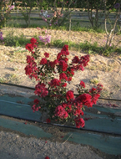 | INCLUDEPICTURE "wordml://77.png" \* MERGEFORMATINET INCLUDEPICTURE "wordml://77.png" \* MERGEFORMATINET INCLUDEPICTURE "wordml://77.png" \* MERGEFORMATINET INCLUDEPICTURE "wordml://77.png" \* MERGEFORMATINET INCLUDEPICTURE "wordml://77.png" \* MERGEFORMATINET INCLUDEPICTURE "wordml://77.png" \* MERGEFORMATINET INCLUDEPICTURE "wordml://77.png" \* MERGEFORMATINET INCLUDEPICTURE "wordml://77.png" \* MERGEFORMATINET 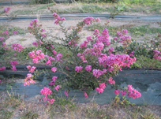 | INCLUDEPICTURE "wordml://78.png" \* MERGEFORMATINET INCLUDEPICTURE "wordml://78.png" \* MERGEFORMATINET INCLUDEPICTURE "wordml://78.png" \* MERGEFORMATINET INCLUDEPICTURE "wordml://78.png" \* MERGEFORMATINET INCLUDEPICTURE "wordml://78.png" \* MERGEFORMATINET INCLUDEPICTURE "wordml://78.png" \* MERGEFORMATINET INCLUDEPICTURE "wordml://78.png" \* MERGEFORMATINET INCLUDEPICTURE "wordml://78.png" \* MERGEFORMATINET 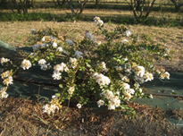
1 | 2 | 3
upright | semi-upright | spreading

Ad. 3: Stem: anthocyanin coloration

Observations should be made on the middle third of the stem, just before flowering.

Ad. 7: Leaf blade: distribution of anthocyanin coloration

INCLUDEPICTURE "wordml://79.png" \* MERGEFORMATINET INCLUDEPICTURE "wordml://79.png" \* MERGEFORMATINET INCLUDEPICTURE "wordml://79.png" \* MERGEFORMATINET INCLUDEPICTURE "wordml://79.png" \* MERGEFORMATINET INCLUDEPICTURE "wordml://79.png" \* MERGEFORMATINET INCLUDEPICTURE "wordml://79.png" \* MERGEFORMATINET INCLUDEPICTURE "wordml://79.png" \* MERGEFORMATINET INCLUDEPICTURE "wordml://79.png" \* MERGEFORMATINET 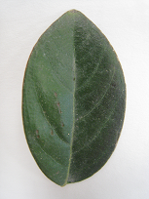 | INCLUDEPICTURE "wordml://80.png" \* MERGEFORMATINET INCLUDEPICTURE "wordml://80.png" \* MERGEFORMATINET INCLUDEPICTURE "wordml://80.png" \* MERGEFORMATINET INCLUDEPICTURE "wordml://80.png" \* MERGEFORMATINET INCLUDEPICTURE "wordml://80.png" \* MERGEFORMATINET INCLUDEPICTURE "wordml://80.png" \* MERGEFORMATINET INCLUDEPICTURE "wordml://80.png" \* MERGEFORMATINET INCLUDEPICTURE "wordml://80.png" \* MERGEFORMATINET 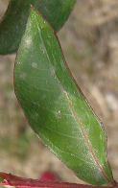 | INCLUDEPICTURE "wordml://81.png" \* MERGEFORMATINET INCLUDEPICTURE "wordml://81.png" \* MERGEFORMATINET INCLUDEPICTURE "wordml://81.png" \* MERGEFORMATINET INCLUDEPICTURE "wordml://81.png" \* MERGEFORMATINET INCLUDEPICTURE "wordml://81.png" \* MERGEFORMATINET INCLUDEPICTURE "wordml://81.png" \* MERGEFORMATINET INCLUDEPICTURE "wordml://81.png" \* MERGEFORMATINET INCLUDEPICTURE "wordml://81.png" \* MERGEFORMATINET 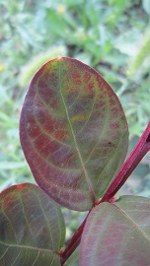 | INCLUDEPICTURE "wordml://82.png" \* MERGEFORMATINET INCLUDEPICTURE "wordml://82.png" \* MERGEFORMATINET INCLUDEPICTURE "wordml://82.png" \* MERGEFORMATINET INCLUDEPICTURE "wordml://82.png" \* MERGEFORMATINET INCLUDEPICTURE "wordml://82.png" \* MERGEFORMATINET INCLUDEPICTURE "wordml://82.png" \* MERGEFORMATINET INCLUDEPICTURE "wordml://82.png" \* MERGEFORMATINET INCLUDEPICTURE "wordml://82.png" \* MERGEFORMATINET 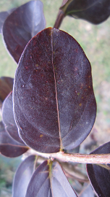
1 | 2 | 3 | 4
absent | on margin | irregular | throughout

Ad. 10: Leaf blade: undulation
INCLUDEPICTURE "wordml://83.png" \* MERGEFORMATINET INCLUDEPICTURE "wordml://83.png" \* MERGEFORMATINET INCLUDEPICTURE "wordml://83.png" \* MERGEFORMATINET INCLUDEPICTURE "wordml://83.png" \* MERGEFORMATINET INCLUDEPICTURE "wordml://83.png" \* MERGEFORMATINET INCLUDEPICTURE "wordml://83.png" \* MERGEFORMATINET INCLUDEPICTURE "wordml://83.png" \* MERGEFORMATINET INCLUDEPICTURE "wordml://83.png" \* MERGEFORMATINET INCLUDEPICTURE "wordml://83.png" \* MERGEFORMATINET INCLUDEPICTURE "wordml://83.png" \* MERGEFORMATINET INCLUDEPICTURE "wordml://83.png" \* MERGEFORMATINET INCLUDEPICTURE "wordml://83.png" \* MERGEFORMATINET | INCLUDEPICTURE "wordml://85.png" \* MERGEFORMATINET INCLUDEPICTURE "wordml://85.png" \* MERGEFORMATINET INCLUDEPICTURE "wordml://85.png" \* MERGEFORMATINET INCLUDEPICTURE "wordml://85.png" \* MERGEFORMATINET INCLUDEPICTURE "wordml://85.png" \* MERGEFORMATINET INCLUDEPICTURE "wordml://85.png" \* MERGEFORMATINET INCLUDEPICTURE "wordml://85.png" \* MERGEFORMATINET INCLUDEPICTURE "wordml://85.png" \* MERGEFORMATINET INCLUDEPICTURE "wordml://85.png" \* MERGEFORMATINET INCLUDEPICTURE "wordml://85.png" \* MERGEFORMATINET INCLUDEPICTURE "wordml://85.png" \* MERGEFORMATINET INCLUDEPICTURE "wordml://85.png" \* MERGEFORMATINET 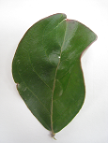 | INCLUDEPICTURE "wordml://86.png" \* MERGEFORMATINET INCLUDEPICTURE "wordml://86.png" \* MERGEFORMATINET INCLUDEPICTURE "wordml://86.png" \* MERGEFORMATINET INCLUDEPICTURE "wordml://86.png" \* MERGEFORMATINET INCLUDEPICTURE "wordml://86.png" \* MERGEFORMATINET INCLUDEPICTURE "wordml://86.png" \* MERGEFORMATINET INCLUDEPICTURE "wordml://86.png" \* MERGEFORMATINET INCLUDEPICTURE "wordml://86.png" \* MERGEFORMATINET INCLUDEPICTURE "wordml://86.png" \* MERGEFORMATINET INCLUDEPICTURE "wordml://86.png" \* MERGEFORMATINET INCLUDEPICTURE "wordml://86.png" \* MERGEFORMATINET INCLUDEPICTURE "wordml://86.png" \* MERGEFORMATINET 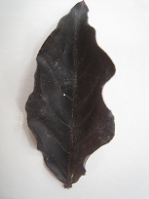
1 | 3 | 5
absent or very weak | medium | very strong

Ad. 12: Leaf blade: variegation

Observations should be made excluding anthocyanin coloration.

Ad. 15: Flower bud: shape

INCLUDEPICTURE "wordml://87.png" \* MERGEFORMATINET INCLUDEPICTURE "wordml://87.png" \* MERGEFORMATINET INCLUDEPICTURE "wordml://87.png" \* MERGEFORMATINET INCLUDEPICTURE "wordml://87.png" \* MERGEFORMATINET INCLUDEPICTURE "wordml://87.png" \* MERGEFORMATINET INCLUDEPICTURE "wordml://87.png" \* MERGEFORMATINET INCLUDEPICTURE "wordml://87.png" \* MERGEFORMATINET INCLUDEPICTURE "wordml://87.png" \* MERGEFORMATINET 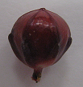 | INCLUDEPICTURE "wordml://88.png" \* MERGEFORMATINET INCLUDEPICTURE "wordml://88.png" \* MERGEFORMATINET INCLUDEPICTURE "wordml://88.png" \* MERGEFORMATINET INCLUDEPICTURE "wordml://88.png" \* MERGEFORMATINET INCLUDEPICTURE "wordml://88.png" \* MERGEFORMATINET INCLUDEPICTURE "wordml://88.png" \* MERGEFORMATINET INCLUDEPICTURE "wordml://88.png" \* MERGEFORMATINET INCLUDEPICTURE "wordml://88.png" \* MERGEFORMATINET 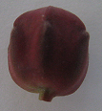 | INCLUDEPICTURE "wordml://89.png" \* MERGEFORMATINET INCLUDEPICTURE "wordml://89.png" \* MERGEFORMATINET INCLUDEPICTURE "wordml://89.png" \* MERGEFORMATINET INCLUDEPICTURE "wordml://89.png" \* MERGEFORMATINET INCLUDEPICTURE "wordml://89.png" \* MERGEFORMATINET INCLUDEPICTURE "wordml://89.png" \* MERGEFORMATINET INCLUDEPICTURE "wordml://89.png" \* MERGEFORMATINET INCLUDEPICTURE "wordml://89.png" \* MERGEFORMATINET 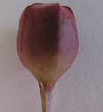 | INCLUDEPICTURE "wordml://90.png" \* MERGEFORMATINET INCLUDEPICTURE "wordml://90.png" \* MERGEFORMATINET INCLUDEPICTURE "wordml://90.png" \* MERGEFORMATINET INCLUDEPICTURE "wordml://90.png" \* MERGEFORMATINET INCLUDEPICTURE "wordml://90.png" \* MERGEFORMATINET INCLUDEPICTURE "wordml://90.png" \* MERGEFORMATINET INCLUDEPICTURE "wordml://90.png" \* MERGEFORMATINET INCLUDEPICTURE "wordml://90.png" \* MERGEFORMATINET 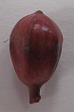 | INCLUDEPICTURE "wordml://91.png" \* MERGEFORMATINET INCLUDEPICTURE "wordml://91.png" \* MERGEFORMATINET INCLUDEPICTURE "wordml://91.png" \* MERGEFORMATINET INCLUDEPICTURE "wordml://91.png" \* MERGEFORMATINET INCLUDEPICTURE "wordml://91.png" \* MERGEFORMATINET INCLUDEPICTURE "wordml://91.png" \* MERGEFORMATINET INCLUDEPICTURE "wordml://91.png" \* MERGEFORMATINET INCLUDEPICTURE "wordml://91.png" \* MERGEFORMATINET 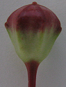
1 | 2 | 3 | 4 | 5
circular | broad oblong | narrow oblong | narrow obovate | broad obovate

Ad. 16: Flower bud: prominence of ridges
INCLUDEPICTURE "wordml://92.png" \* MERGEFORMATINET INCLUDEPICTURE "wordml://92.png" \* MERGEFORMATINET INCLUDEPICTURE "wordml://92.png" \* MERGEFORMATINET INCLUDEPICTURE "wordml://92.png" \* MERGEFORMATINET INCLUDEPICTURE "wordml://92.png" \* MERGEFORMATINET INCLUDEPICTURE "wordml://92.png" \* MERGEFORMATINET INCLUDEPICTURE "wordml://92.png" \* MERGEFORMATINET INCLUDEPICTURE "wordml://92.png" \* MERGEFORMATINET 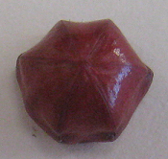 | INCLUDEPICTURE "wordml://93.png" \* MERGEFORMATINET INCLUDEPICTURE "wordml://93.png" \* MERGEFORMATINET INCLUDEPICTURE "wordml://93.png" \* MERGEFORMATINET INCLUDEPICTURE "wordml://93.png" \* MERGEFORMATINET INCLUDEPICTURE "wordml://93.png" \* MERGEFORMATINET INCLUDEPICTURE "wordml://93.png" \* MERGEFORMATINET INCLUDEPICTURE "wordml://93.png" \* MERGEFORMATINET INCLUDEPICTURE "wordml://93.png" \* MERGEFORMATINET 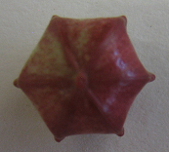 | INCLUDEPICTURE "wordml://94.png" \* MERGEFORMATINET INCLUDEPICTURE "wordml://94.png" \* MERGEFORMATINET INCLUDEPICTURE "wordml://94.png" \* MERGEFORMATINET INCLUDEPICTURE "wordml://94.png" \* MERGEFORMATINET INCLUDEPICTURE "wordml://94.png" \* MERGEFORMATINET INCLUDEPICTURE "wordml://94.png" \* MERGEFORMATINET INCLUDEPICTURE "wordml://94.png" \* MERGEFORMATINET INCLUDEPICTURE "wordml://94.png" \* MERGEFORMATINET 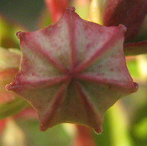
1 | 3 | 5
absent or weak | medium | strong

Ad. 17: Flower bud: area of anthocyanin coloration

INCLUDEPICTURE "wordml://95.png" \* MERGEFORMATINET INCLUDEPICTURE "wordml://95.png" \* MERGEFORMATINET INCLUDEPICTURE "wordml://95.png" \* MERGEFORMATINET INCLUDEPICTURE "wordml://95.png" \* MERGEFORMATINET INCLUDEPICTURE "wordml://95.png" \* MERGEFORMATINET INCLUDEPICTURE "wordml://95.png" \* MERGEFORMATINET INCLUDEPICTURE "wordml://95.png" \* MERGEFORMATINET INCLUDEPICTURE "wordml://95.png" \* MERGEFORMATINET 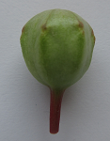 INCLUDEPICTURE "wordml://96.png" \* MERGEFORMATINET INCLUDEPICTURE "wordml://96.png" \* MERGEFORMATINET INCLUDEPICTURE "wordml://96.png" \* MERGEFORMATINET INCLUDEPICTURE "wordml://96.png" \* MERGEFORMATINET INCLUDEPICTURE "wordml://96.png" \* MERGEFORMATINET INCLUDEPICTURE "wordml://96.png" \* MERGEFORMATINET INCLUDEPICTURE "wordml://96.png" \* MERGEFORMATINET INCLUDEPICTURE "wordml://96.png" \* MERGEFORMATINET 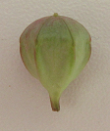 | INCLUDEPICTURE "wordml://97.png" \* MERGEFORMATINET INCLUDEPICTURE "wordml://97.png" \* MERGEFORMATINET INCLUDEPICTURE "wordml://97.png" \* MERGEFORMATINET INCLUDEPICTURE "wordml://97.png" \* MERGEFORMATINET INCLUDEPICTURE "wordml://97.png" \* MERGEFORMATINET INCLUDEPICTURE "wordml://97.png" \* MERGEFORMATINET INCLUDEPICTURE "wordml://97.png" \* MERGEFORMATINET INCLUDEPICTURE "wordml://97.png" \* MERGEFORMATINET | INCLUDEPICTURE "wordml://98.png" \* MERGEFORMATINET INCLUDEPICTURE "wordml://98.png" \* MERGEFORMATINET INCLUDEPICTURE "wordml://98.png" \* MERGEFORMATINET INCLUDEPICTURE "wordml://98.png" \* MERGEFORMATINET INCLUDEPICTURE "wordml://98.png" \* MERGEFORMATINET INCLUDEPICTURE "wordml://98.png" \* MERGEFORMATINET INCLUDEPICTURE "wordml://98.png" \* MERGEFORMATINET INCLUDEPICTURE "wordml://98.png" \* MERGEFORMATINET
1 | 3 | 5
absent or small | medium | large

Ad. 20: Thyrse: shape

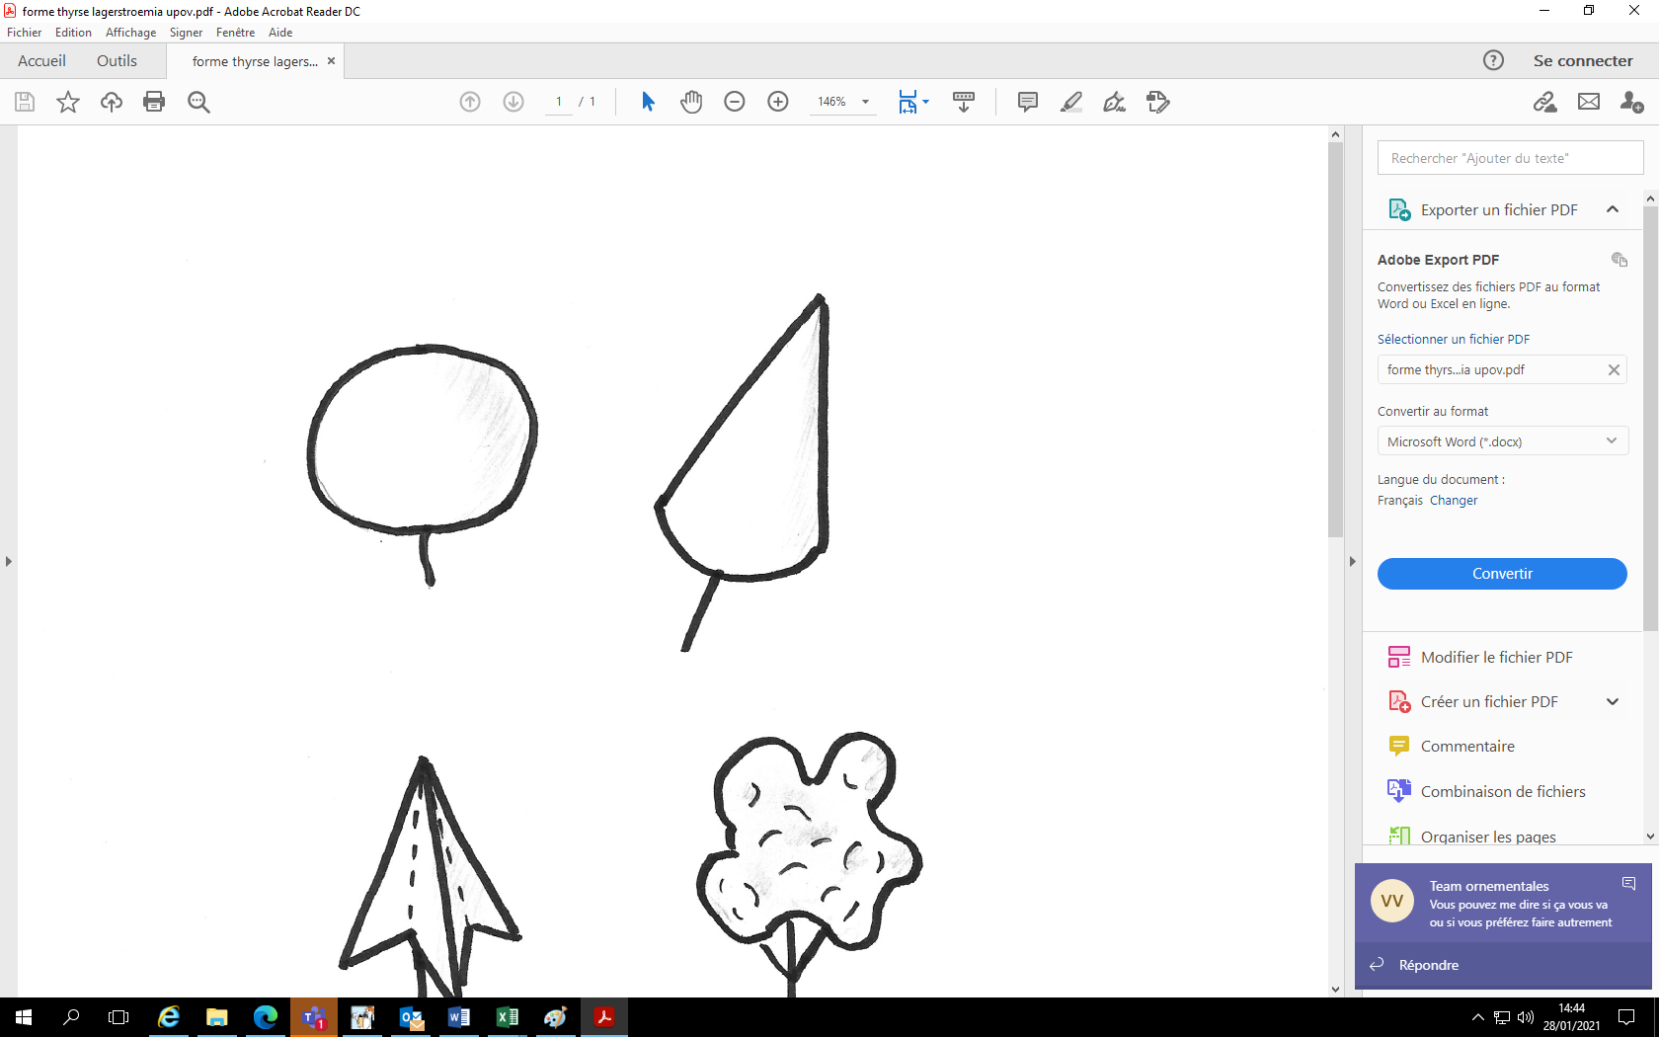 |  | 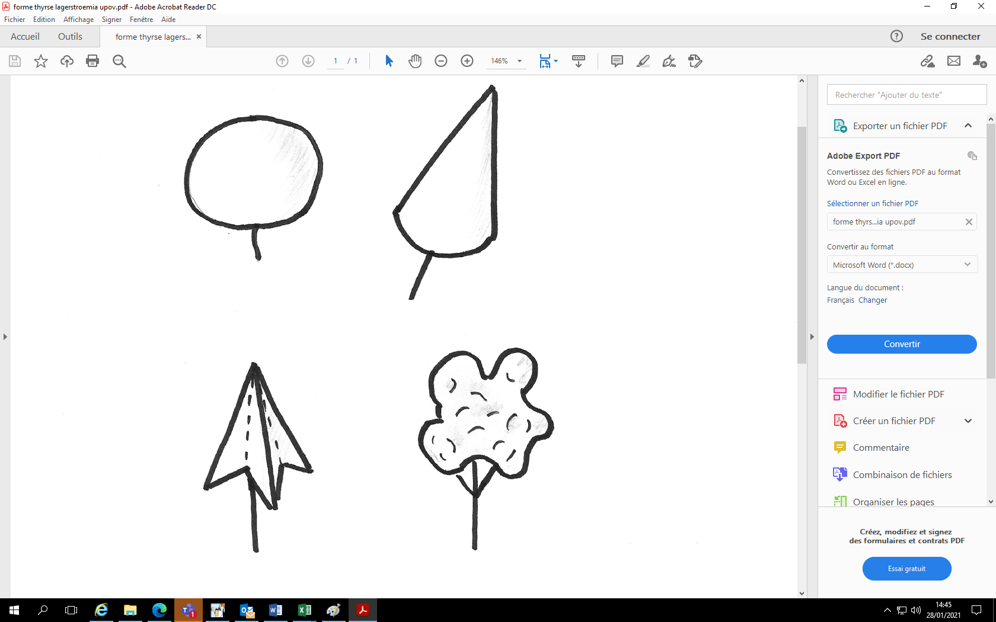
1 | 2 | 3 | 4
globose | conic | sagittate | irregular

Ad. 21: Thyrse: length

INCLUDEPICTURE "wordml://103.png" \* MERGEFORMATINET INCLUDEPICTURE "wordml://103.png" \* MERGEFORMATINET INCLUDEPICTURE "wordml://103.png" \* MERGEFORMATINET INCLUDEPICTURE "wordml://103.png" \* MERGEFORMATINET INCLUDEPICTURE "wordml://103.png" \* MERGEFORMATINET INCLUDEPICTURE "wordml://103.png" \* MERGEFORMATINET INCLUDEPICTURE "wordml://103.png" \* MERGEFORMATINET INCLUDEPICTURE "wordml://103.png" \* MERGEFORMATINET 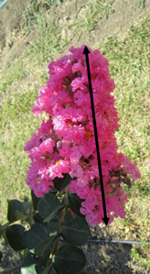

Ad. 26: Petal: undulation

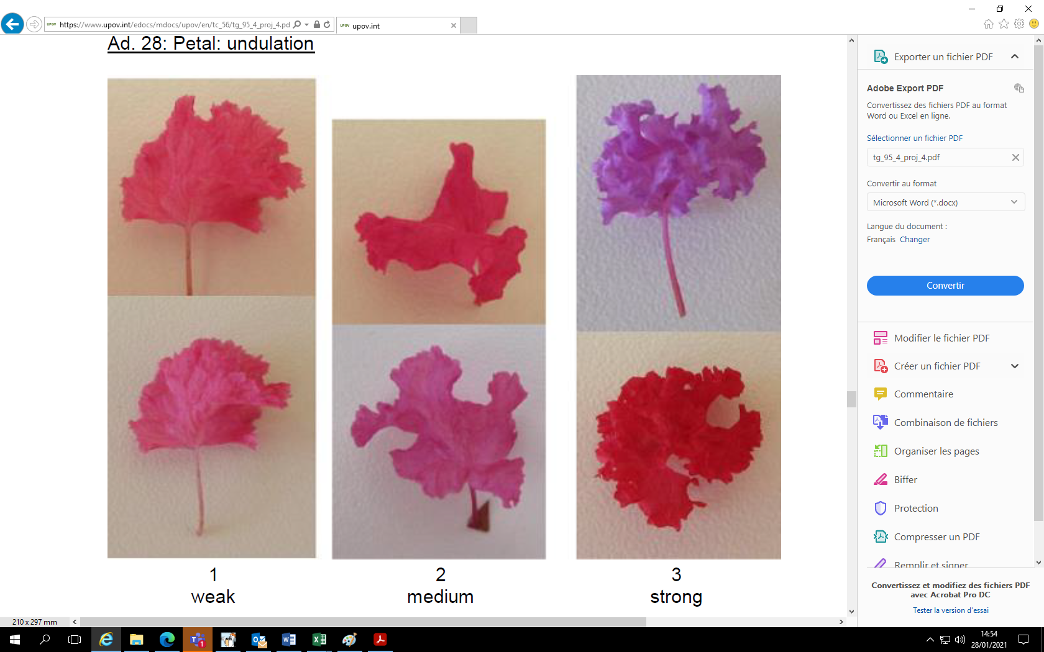
1 | 2 | 3
weak | medium | strong

Ad. 27: Petal claw: length

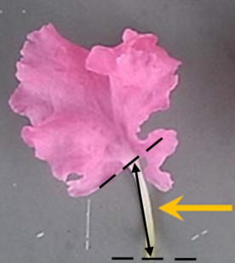

Ad. 29: Stamen: conspicuousness

INCLUDEPICTURE "wordml://107.png" \* MERGEFORMATINET INCLUDEPICTURE "wordml://107.png" \* MERGEFORMATINET INCLUDEPICTURE "wordml://107.png" \* MERGEFORMATINET INCLUDEPICTURE "wordml://107.png" \* MERGEFORMATINET INCLUDEPICTURE "wordml://107.png" \* MERGEFORMATINET INCLUDEPICTURE "wordml://107.png" \* MERGEFORMATINET INCLUDEPICTURE "wordml://107.png" \* MERGEFORMATINET INCLUDEPICTURE "wordml://107.png" \* MERGEFORMATINET 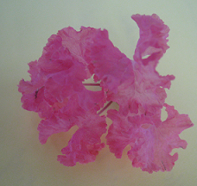 | INCLUDEPICTURE "wordml://108.png" \* MERGEFORMATINET INCLUDEPICTURE "wordml://108.png" \* MERGEFORMATINET INCLUDEPICTURE "wordml://108.png" \* MERGEFORMATINET INCLUDEPICTURE "wordml://108.png" \* MERGEFORMATINET INCLUDEPICTURE "wordml://108.png" \* MERGEFORMATINET INCLUDEPICTURE "wordml://108.png" \* MERGEFORMATINET INCLUDEPICTURE "wordml://108.png" \* MERGEFORMATINET INCLUDEPICTURE "wordml://108.png" \* MERGEFORMATINET 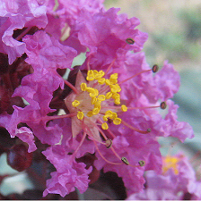
1 | 2
inconspicuous | conspicuous

Ad. 33: Fruit: ratio length/diameter

INCLUDEPICTURE "wordml://109.png" \* MERGEFORMATINET INCLUDEPICTURE "wordml://109.png" \* MERGEFORMATINET INCLUDEPICTURE "wordml://109.png" \* MERGEFORMATINET INCLUDEPICTURE "wordml://109.png" \* MERGEFORMATINET INCLUDEPICTURE "wordml://109.png" \* MERGEFORMATINET INCLUDEPICTURE "wordml://109.png" \* MERGEFORMATINET INCLUDEPICTURE "wordml://109.png" \* MERGEFORMATINET INCLUDEPICTURE "wordml://109.png" \* MERGEFORMATINET 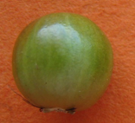 | INCLUDEPICTURE "wordml://110.png" \* MERGEFORMATINET INCLUDEPICTURE "wordml://110.png" \* MERGEFORMATINET INCLUDEPICTURE "wordml://110.png" \* MERGEFORMATINET INCLUDEPICTURE "wordml://110.png" \* MERGEFORMATINET INCLUDEPICTURE "wordml://110.png" \* MERGEFORMATINET INCLUDEPICTURE "wordml://110.png" \* MERGEFORMATINET INCLUDEPICTURE "wordml://110.png" \* MERGEFORMATINET INCLUDEPICTURE "wordml://110.png" \* MERGEFORMATINET 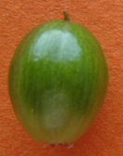
1 | 3
low | high

Ad. 34: Fruit: intensity of green color

Not possible to be observed when fully covered by anthocyanin over color.

Ad. 36: Time of vegetative bud burst

The time of vegetative bud burst is reached when the first leaves appear on all plants.

Ad. 37: Time of beginning of flowering

The time of beginning of flowering is reached when all plants have some open flowers on approximately 10% of thyrses.

9.
Literature

Byers, MD., 1997: Crape Myrtle. Owl Bay Pub. Cornell University, Ithaca, New York State 14850, US, 180pp.

Edwards, AD., 1994: Freezing Tolerance of Lagerstroemia Indica X Fauriei Cultivars in USDA Zones 7 and 8. Mississippi State University. Department of Plant and Soil Sciences. US, 66 pp.

10.
Technical Questionnaire

TECHNICAL QUESTIONNAIRE | Page {x} of {y} | Reference Number:

Application date:
(not to be filled in by the applicant)
TECHNICAL QUESTIONNAIRE
to be completed in connection with an application for plant breeders' rights

1. | Subject of the Technical Questionnaire
 |  | Botanical name
  1.1
  Lagerstroemia L.
 |  | Common name
  1.2
  Lagerstroemia, Crape Myrtle, Crepe Myrtle
  1.3
  Species (please specify):

2. | Applicant
 | Name
 | Address
 | Telephone No.
 | Fax No.
 | E-mail address
 | Breeder (if different from
 | applicant)

3. | Proposed denomination and breeder's reference
 | Proposed denomination
 | (if available)
 | Breeder's reference

TECHNICAL QUESTIONNAIRE |  |  | Page {x} of {y} | Reference Number:
 | Information on the breeding scheme and propagation of the variety
  #4.
 | 4.1 | Breeding scheme
 | Variety resulting from:
  4.1.1
  Crossing
 |  | [ ]
  (a)
  controlled cross
(please state parent variety)

(…………………..……………..…) x (……………..…………………..…)

female parent male parent

 |  | [ ]
  (b)
  partially known cross
(please state known parent variety(ies))

(…………………..……………..…) x (……………..…………………..…)

female parent male parent

 |  | [ ]
  (c)
  unknown cross
 |  | [ ]
  4.1.2
  Mutation
  (please state parent variety)
 |  | [ ]
  4.1.3
  Discovery and development
  (please state where and when discovered and how developed)
 | Other  (Please provide details) | [ ]
  4.1.4

TECHNICAL QUESTIONNAIRE  Page {x} of {y} | Reference Number:

 | 4.2 | Method of propagating the variety
  4.2.1
  Vegetative propagation
 |  | [ ]
  (a)
  Cuttings
 |  | [ ]
  (b)
  In vitro propagation
 |  | [ ]
  (c)
  Other (state method)
 | Other  (Please provide details) | [ ]
  4.2.2

TECHNICAL QUESTIONNAIRE | Page {x} of {y} | Reference Number:

5. | Characteristics of the variety to be indicated (the number in brackets refers to the corresponding characteristic in Test Guidelines; please mark the note which best corresponds).

 | Characteristics | Example Varieties | Note
  5.1
  (1)
  Plant: height
  short
  DABLAGE01
  1 [ ]
  short to medium
  2 [ ]
  medium
  Desal 173
  3 [ ]
  medium to tall
  4 [ ]
  tall
  Watermelon
  5 [ ]
  5.2
  (2)
  Plant: growth habit
  upright
  Lucas Red, Whit II
  1 [ ]
  semi-upright
  Desber 102
  2 [ ]
  spreading
  Houston, Petit' Canaille Blanc
  3 [ ]
  5.3
  (3)
  Stem: anthocyanin coloration
  very weak
  1 [ ]
  very weak to weak
  2 [ ]
  weak
  Deskim, Grand Cru
  3 [ ]
  weak to medium
  4 [ ]
  medium
  Coral Filli, INDYFUS, MILAPERL
  5 [ ]
  medium to strong
  6 [ ]
  strong
  Lucas Red
  7 [ ]
  strong to very strong
  8 [ ]
  very strong
  9 [ ]
  5.4
  (7)
  Leaf blade: distribution of anthocyanin coloration
  absent
  Petit' Canaille Blanc
  1 [ ]
  on margin
  Main Little Chief, Whit IV
  2 [ ]
  irregular
  Burgundy Cotton
  3 [ ]
  throughout
  Lucas Red
  4 [ ]

TECHNICAL QUESTIONNAIRE
Page {x} of {y} | Reference Number:

 | Characteristics | Example Varieties | Note
  5.5
  (8)
  Leaf blade: intensity of anthocyanin coloration
  absent or very weak
  1 [ ]
  very weak to weak
  2 [ ]
  weak
  Coral Filli
  3 [ ]
  weak to medium
  4 [ ]
  medium
  Royal Velvet
  5 [ ]
  medium to strong
  6 [ ]
  strong
  Whit II
  7 [ ]
  strong to very strong
  8 [ ]
  very strong
  9 [ ]
  5.6
  (12)
  Leaf blade: variegation
  absent
  Whit II
  1 [ ]
  white and grey green
  Shirohakekomifu
  2 [ ]
  yellow
  Kibotafu
  3 [ ]
  5.7
  (20)
  Thyrse: shape
 | globose
  Nivea
  1 [ ]
 | conic
  Desmon
  2 [ ]
  sagittate
  Royal Velvet
  3 [ ]
  irregular
  Desjac 124
  4 [ ]
  5.8(i)
  (24)
  Petal: main color of inner side
  RHS Colour Chart (indicate reference number)
  5.8(ii)
  (24)
  Petal: main color of inner side
  white
  1 [ ]
  light pink
  2 [ ]
  dark pink
  3 [ ]
  red
  4 [ ]
  purple
  5 [ ]
  other (please indicate)
  6 [ ]

TECHNICAL QUESTIONNAIRE
Page {x} of {y} | Reference Number:

 | Characteristics | Example Varieties | Note
  5.9
  (37)
  Time of beginning of flowering
  very early
  MILAROSA
  1 [ ]
  very early to early
  2 [ ]
  early
  Desper, Near East
  3 [ ]
  early to medium
  4 [ ]
  medium
  Tonto
  5 [ ]
  medium to late
  6 [ ]
  late
  Whit IV
  7 [ ]
  late to very late
  8 [ ]
  very late
  Crimson red
  9 [ ]

TECHNICAL QUESTIONNAIRE | Page {x} of {y} | Reference Number:

6. | Similar varieties and differences from these varieties
Please use the following table and box for comments to provide information on how your candidate variety differs from the variety (or varieties) which, to the best of your knowledge, is (or are) most similar. This information may help the examination authority to conduct its examination of distinctness in a more efficient way.

  Denomination(s) of variety(ies) similar to your candidate variety
  Characteristic(s) in which your candidate variety differs from the similar variety(ies)
  Describe the expression of the characteristic(s) for the similar variety(ies)
  Describe the expression of the characteristic(s) for your candidate variety

Example
  Flower bud: shape
  circular
  narrow obovate

 | Comments:

TECHNICAL QUESTIONNAIRE
Page {x} of {y}
Reference Number:

#7. | Additional information which may help in the examination of the variety
7.1 | In addition to the information provided in sections 5 and 6, are there any additional characteristics which may help to distinguish the variety?
 | Yes | [ ] | No | [ ]
 | (If yes, please provide details)
7.2 | Are there any special conditions for growing the variety or conducting the examination?
 | Yes | [ ] | No | [ ]
 | (If yes, please provide details)
7.3 | Other information
A representative color photograph of the variety displaying its main distinguishing feature(s), should accompany the Technical Questionnaire. The photograph will provide a visual illustration of the candidate variety which supplements the information provided in the Technical Questionnaire.
The key points to consider when taking a photograph of the candidate variety are:
• Indication of the date and geographic location
• Correct labeling (breeder’s reference)
• Good quality printed photograph (minimum 10 cm x 15 cm) and/or sufficient resolution electronic format version (minimum 960 x 1280 pixels)”
Further guidance on providing photographs with the Technical Questionnaire is available in document TGP/7 "Development of Test Guidelines", Guidance Note 35 (http://www.upov.int/tgp/en/).
[The link provided may be deleted by members of the Union when developing authorities’ own test guidelines.]

TECHNICAL QUESTIONNAIRE
Page {x} of {y} | Reference Number:

8. | Authorization for release
 | (a) | Does the variety require prior authorization for release under legislation concerning the protection of the environment, human and animal health?
 |  | Yes | [ ] | No | [ ]
 | (b) | Has such authorization been obtained?
 |  | Yes | [ ] | No | [ ]
 | If the answer to (b) is yes, please attach a copy of the authorization.

9. Information on plant material to be examined or submitted for examination

9.1 The expression of a characteristic or several characteristics of a variety may be affected by factors, such as pests and disease, chemical treatment (e.g. growth retardants or pesticides), effects of tissue culture, different rootstocks, scions taken from different growth phases of a tree, etc.
9.2 The plant material should not have undergone any treatment which would affect the expression of the characteristics of the variety, unless the competent authorities allow or request such treatment. If the plant material has undergone such treatment, full details of the treatment must be given. In this respect, please indicate below, to the best of your knowledge, if the plant material to be examined has been subjected to:

 | (a) | Microorganisms (e.g. virus, bacteria, phytoplasma) | Yes [ ] | No [ ]
 | (b) | Chemical treatment (e.g. growth retardant, pesticide) | Yes [ ] | No [ ]
 | (c) | Tissue culture | Yes [ ] | No [ ]
 | (d) | Other factors | Yes [ ] | No [ ]
 | Please provide details for where you have indicated “yes”.

10. | I hereby declare that, to the best of my knowledge, the information provided in this form is correct:
 | Applicant’s name
 | Signature |  | Date

[End of document]

