E
International Union for the Protection of New Varieties of Plants

Technical Committee  Fifty-Seventh Session  Geneva, October 25 and 26, 2021 | TC/57/INF/2  Original: English  Date: October 15, 2021
UPOV PRISMA – matters for information
Document prepared by the Office of the Union
Disclaimer: this document does not represent UPOV policies or guidance

EXECUTIVE SUMMARY

The purpose of this document is to report on developments concerning UPOV PRISMA, since the fifty-sixth session of the Technical Committee (TC), held in Geneva on October 26 and 27, 2020.

The structure of this document is as follows:
EXECUTIVE SUMMARY 1
Background 2
Developments 2
Sixteenth Meeting on the Development of an Electronic Application Form (“EAF/16 meeting) in October 2020 2
Technical Committee (TC) in October 2020 2
Use of UPOV PRISMA (as of September 30, 2021) 2
Number of submissions via UPOV PRISMA 2
Submissions in UPOV PRISMA by crop type 3
Number of submissions by participating Authority in UPOV PRISMA 4
Version 2.5 5
Functionalities 5
Coverage 5
Meeting on the development of an electronic application form (EAF/17) 6
Launch of Version 2.6 7
UPOV members 7
Crops/ species 7
New functionalities 7
Other developments 7
IT Quality Software Audit 7
UPOV PRISMA “Task Force” Group 8
CPVO Synchronization 8
Workshop with Users to Improve user-friendliness of UPOV PRISMA 8
Requests for new developments 8
PVP offices 8
Registered Users 8
Plans for Version 2.7 9
UPOV member coverage: 9
Functionalities: 9
Release of Version 2.7: 9
Possible FUTURE developments 9
Coverage 9
User-friendliness of the tool 9
New functionalities 9
IT improvements 10
FURTHER DEVELOPMENTS 10
Eighteenth meeting on the development of the electronic application form (EAF/18) 10

Background

The background and previous developments concerning UPOV PRISMA (formerly the Electronic Application Form project) are reported in document TC/56/INF/2 “UPOV PRISMA”.

Developments

Sixteenth Meeting on the Development of an Electronic Application Form (“EAF/16 meeting) in October 2020

The sixteenth meeting on the Development of an Electronic Application Form (“EAF/16 meeting”) was held via electronic means on October 23, 2020. The report of the meeting is provided in document EAF/16/3 “Report” available at: https://www.upov.int/edocs/mdocs/upov/en/upov_eaf_16/upov_eaf_16_3.pdf .

Technical Committee (TC) in October 2020

The Technical Committee (TC), at its fifty-sixth session, organized via electronic means on October 26 and 27, 2020, noted the information provided in document TC/56/INF/2 in relation to recent developments in UPOV PRISMA (see document TC/56/23 “Report”, paragraph 80).

Use of UPOV PRISMA (as of September 30, 2021)

Information on the use of UPOV PRISMA is provided below:

Number of submissions via UPOV PRISMA

 | 2017 | 2018 | 2019 | 2020 | 2021
January | 1 | - | 7 | 18 | 107
February | - | 3 | 9 | 5 | 107
March | 2 | 3 | 6 | 21 | 67
April | - | 3 | 22 | 11 | 105
May | 1 | 1 | 33 | 11 | 65
June | - | 7 | 10 | 18 | 822
July | - | 7 | 3 | 9 | 58
August | - | 1 | 7 | 11 | 379
September | 3 | 8 | 16 | 29 | 154
October | 1 | 19 | 29 | 16
November | 3 | 16 | 26 | 41
December | 3 | 9 | 51 | 32
Total | 14 | 77 | 219 | 222 | 1864

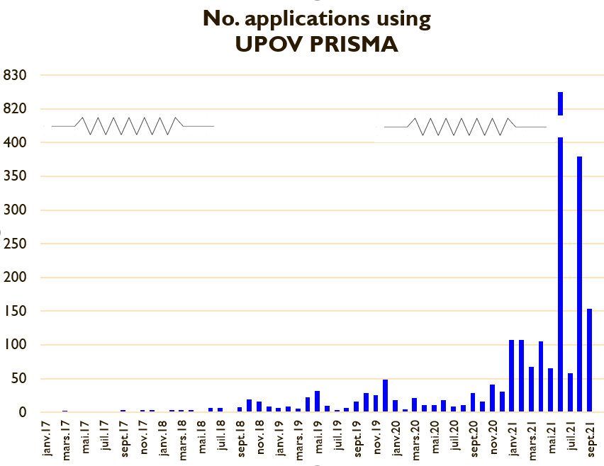

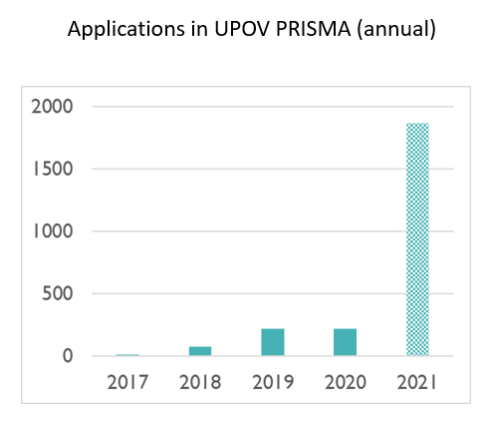

Submissions in UPOV PRISMA by crop type

Number of submissions by participating Authority in UPOV PRISMA

Authority |  | Number of submissions in UPOV PRISMA in 2017 | Number of submissions in UPOV PRISMA in 2018 | Number of submissions in UPOV PRISMA in 2019 | Number of submissions in UPOV PRISMA in 2020 | Number of submissions in UPOV PRISMA in 2021  (as of 30/09/2021) | Total Number of submissions in UPOV PRISMA  (as of 30/09/2021)
African Intellectual Property Organization (OAPI) | OA |  |  | 3 | 1 |  | 4
Argentina* | AR |  |  |  |  |  | -
Australia | AU |  | 10 | 17 | 36 | 23 | 86
Bolivia (Plurinational State of)* | BO |  |  | 2 |  |  | 2
Canada | CA |  | 6 | 27 | 17 | 19 | 69
Chile | CL | 3 |  | 3 | 1 | 8 | 12
China | CN |  |  |  |  |  | -
Colombia | CO |  |  | 4 | 2 | 2 | 5
Costa Rica | CR |  |  | 4 | 1 |  | 5
Dominican Republic | DO |  |  | 2 | 2 | 1 | 5
Ecuador | EC |  |  |  | 2 | 2 | 4
European Union | QZ |  | 8 | 38 | 13 | 20 | 79
France | FR |  |  | 20 | - | 3 | 23
Georgia | GE |  |  | 2 | 1 | 3 | 6
Kenya | KE |  | 13 | 6 | 14 | 10 | 43
Morocco | MA |  |  |  |  |  | -
Mexico | MX |  | 7 | 7 | 13 | 11 | 38
Netherlands | NL | 1 | 8 | 12 | 6 |  | 27
New Zealand | NZ | 5 | 3 | 8 | 5 | 18 | 39
Norway | NO | 1 |  | 5 | 7 |  | 13
Paraguay* | PY |  |  |  |  |  | -
Peru | PE |  |  |  | 2 | 1 | 3
Republic of Moldova | MD |  |  | 2 |  |  | 2
Republic of Korea | KR |  |  | 1 | 1 |  | 2
Serbia | RS |  |  | 2 | 1 | 3 | 6
South Africa | ZA |  | 2 | 3 | 2 | 4 | 11
Sweden | SE |  |  | 1 |  |  | 1
Switzerland | CH | 2 | 3 | 4 | 16 | 6 | 31
Trinidad and Tobago | TT |  |  |  |  |  | -
Tunisia | TN |  | 2 | 4 |  | 1 | 7
Turkey | TR |  | 6 | 23 | 54 | 43 | 126
United Kingdom | GB |  | 3 | 18 | 22 | 1683 | 1726
United States of America | US |  | 6 | 1 | 3 | 4 | 14
Uruguay | UY |  |  |  |  | 3 | 3
Viet Nam | VN |  |  |  |  |  | -
Total | 35 | 14 | 77 | 219 | 222 | 1864 | 2392
*Until required information is provided, applicants will not be able to submit application data

Number of Registered Users

Version 2.5

Functionalities

Version 2.5 of UPOV PRISMA was fully deployed on February 1, 2021, with the following new functionalities:

- New version of payment interface (Epay V2) to facilitate payment by PayPal, China Union Pay and Bulk payment;
- National Listing for United Kingdom;
- Bulk upload functionality (Proof Of Concept on a limited scope for restricted users);
- Automatically save the application data in case of a period of inactivity;
- Improve system performance for dashboard (further improvement for the generation of the forms performance is planned in Version 2.6);
- Avoid simultaneous access to the same application data by colleagues from the same organization (application data lock functionality);
- Allow co-agents to appear in the public list of agents available for breeders;
- Allow uploading of large attachments;
- When a PBR authority ask for a revision to the applicant, allow the possibility to attach documents.

Coverage

In Version 2.5, application or technical questionnaire forms were updated for the following participating PBR authorities:

- Chile
- European Union
- Switzerland

No members of the Union were added in Version 2.5. Maize was added as new crop for the European Union.

The coverage of UPOV PRISMA in Version 2.5 was as follows:
Authority |  | Crop coverage in Version 2.5
African Intellectual Property Organization (OAPI) | OA | All genera and species
Argentina* | AR | Apple (Fruit Varieties), Barley, Black Radish, Broad Bean, Brussels Sprouts, Cauliflower, Chili, Chinese Cabbage, Cotton, Egg Plant, Fig, Grapevine, Green onion, Grey Shallot, Hot Pepper, Indian mustard, Japanese Bunching Onion, Maize, Melon, Oriental Radish, Papaya, Paprika, Potato, Rose, Salvia, Shallot, Soya Bean, Spinach, Sugarcane, Sweet Pepper, Tomato Rootstocks, Watermelon, Welsh Onion, Wheat, Witloof Chicory
Australia | AU | All genera and species
Bolivia (Plurinational State of) * | BO | All genera and species
Canada | CA | All genera & species excluding algae, bacteria and fungi
Chile | CL | All genera and species
China | CN | Lettuce
Colombia | CO | All genera and species
Costa Rica | CR | All genera and species
Dominican Republic | DO | All genera and species
Ecuador | EC | All genera and species
European Union | QZ | All genera & species excluding agricultural crops apart from Bent, Cocksfoot, Fescue, Maize, Meadow Fescue, Potato, Soya Bean, Ryegrass, Timothy
France | FR | All genera & species
Georgia | GE | Apple (Fruit Varieties), Barley, Blackberry, Blueberry, Cherry (Sweet Cherry), Chick-Pea, Field Bean, French Bean, Hazelnut, Lentil, Maize, Oats, Peach, Pear, Potato, Raspberry, Soya Bean, Sunflower, Tomato, Walnut, Wheat
Kenya | KE | All genera and species
Morocco | MA | Melon
Mexico | MX | All genera and species
Netherlands | NL | All genera and species
New Zealand | NZ | All genera and species
Norway | NO | All genera and species
Paraguay * | PY | Soya Bean
Peru | PE | All genera and species
Republic of Moldova | MD | Apple (Fruit Varieties), Barley, Blackberry, Chili, European Plum, Grapevine, Hot Pepper, Lettuce, Maize, Oats, Onion, Paprika, Pea, Pear, Potato, Raspberry, Rose, Rye, Sour cherry, Soya Bean, Strawberry, Sunflower, Sunflower, Sweet Pepper, Tomato, Walnut, Wheat
Republic of Korea | KR | Apple (Fruit Varieties), Lettuce, Potato, Rose, Soya Bean
Serbia | RS | Apple (Fruit Varieties), Blueberry, Raspberry, Rose
South Africa | ZA | All genera and species
Sweden | SE | All genera and species
Switzerland | CH | All genera and species
Trinidad and Tobago | TT | Anthuriums , Bromeliaceae, Heliconiaceae, Orchidaceae, Sterculiaceae, Cajanus cajans, Vigna sp., Theobroma cacao L.
Tunisia | TN | All genera and species
Turkey | TR | All genera and species
United Kingdom | GB | All genera and species
United States of America | US | 192 crops including Lettuce, Potato, Soya Bean, Wheat
Uruguay | UY | All genera & species
Viet Nam | VN | Anthurium, Carnation, Chrysanthemum, Cucumber, Dahlia, Dragon Fruit, Japanese Bunching, Onion, Kohlrabi, Maize, Mango, Oranges (Citrus L. - Group 2), Peanut, Poinsettia, Potato, Rice, Rose, Soya Bean, Sunflower, Tomato, Welsh Onion, White-Red and Savoy Cabbage
Total | 35
*Until required information is provided, applicants will not be able to submit application data for the concerned authorities

Meeting on the development of an electronic application form (EAF/17)

The seventeenth meeting on the Development of an Electronic Application Form (“EAF/17 meeting”), was held by electronic means on March 25, 2021. The Report of EAF/17 meeting (document UPOV/EAF/17/3) is available at: https://www.upov.int/edocs/mdocs/upov/en/upov_eaf_17/upov_eaf_17_3.pdf .

Launch of Version 2.6

5. UPOV PRISMA Version 2.6 was deployed in July 2021.

UPOV members

No new additional participating PBR authorities were introduced in Version 2.6.

Crops/ species

The crop coverage in UPOV PRISMA has been changed in Version 2.6, as follows:

Authority |  | Anticipated new crop coverage
Morocco | MA | Blackberry, blueberry, raspberry, strawberry,

Forms have been updated for the following participating PBR authorities: Mexico, Norway and the United Kingdom.

New functionalities

The following new functionalities were introduced in Version 2.6:

- Addition of Technical Questionnaires for parental lines (Winter Oil Seed Rape , Barley, Maize and Field Bean);
- Improvement of auto-save functionality;
- Possibility to make bulk payments by introducing “Add to Basket” functionality.

Other developments

IT Quality Software Audit

It was noted at the EAF/17 meeting that in order to reduce the risk of problems when introducing new versions and/ or new functionalities, the following steps would be taken (see document UPOV/EAF/17/3 “Report”):

- Appoint an external company to perform a software quality audit;
- Organize user acceptance testing (UAT) before going live with any new functionalities.

The Office of the Union appointed an external company to perform a software quality audit.

According to the test maturity model, UPOV PRISMA has reached maturity level 2: “the organization has a fundamental test approach where some common test practices are implemented such as planning, monitoring and control over test activities”. The following recommendations were provided to move to maturity level 3: “the organization is rather proactive and the test approach is documented and described in standards, procedures, tools and methods”:

- Know the users and how UPOV PRISMA is used;
- Focus on what is important and urgent: Automate test cases for regression on the functionalities mostly used and the functionalities that generate 80% of the bugs;
- Define a clear Test strategy document;
- For each new requirement, an impact analysis should be made;
- Define a standard process for test case creation;
- Use a test repository tool.

The above 6 recommendations have been implemented. In particular, to limit the risk of negative impacts when introducing new functionalities, regression tests are being automated.

UPOV PRISMA “Task Force” Group

The plan to work with a “Task Force” of users to be identified by CIOPORA and ISF was reported at the EAF/17 meeting. In 2021, the following online meetings/ testing campaigns were organized:

- March 12, 2021 a first Task Force meeting was held;
- A User Acceptance Test campaign was organized for the new Auto-save function (March 22 to 26, 2021 and April 6 to 16, 2021) with the participation of the Task Force;
- A User Acceptance Test campaign was organized for the new addition of Technical Questionnaires for parental lines, especially in the scope of applications for Winter Oil Seed Rape and Barley (July 5 to 7, 2021) with the participation of the Task Force; and
- Meetings with the Task Force and the CPVO on CPVO participation in UPOV PRISMA were held on April 30, 2021 and September 19, 2021, with interim meetings between CPVO and UPOV.

CPVO Synchronization

In order to achieve and maintain synchronization of TQs between UPOV PRISMA and CPVO (see document EAF/16/3 “Report” paragraph 18 and document UPO/EAF/17/3 paragraph 32) the following projects have been agreed with CPVO:

- Project 1: “Audit” (current issues/ states of affairs) for exchange of data between UPOV PRISMA and CPVO in both directions (Status: completed)
- Project 2: Part A: Resolving current issues; Part B: Synchronizing changes by UPOV/CPVO (Status: ongoing on the basis of information provided in Project 1)
- Project 3: Implementation of Project 2 outcome: Bi-directional exchange of application data (lettuce, tomato, rose) (Status: ongoing on the basis of information provided in Project 1)
- Project 4: Bulk upload of Maize applications from UPOV to CPVO (Status: ongoing on the basis of information provided in Project 1)
- Project 5: “Transitional arrangements”, to communicate to applicants about the situations in which they can use UPOV PRISMA for applications at the CPVO and the measures that need to be taken until all issues have been resolved (Status: ongoing)

Workshop with Users to Improve user-friendliness of UPOV PRISMA

As a first step to identify ways to improve the user-friendliness of UPOV PRISMA (see document UPOV/EAF/17/3, paragraph 21), online workshops will be organized with users to review certain current existing functionalities (e.g. copy functionality, assignment of roles).

Users were consulted in September 2021 on functionalities that should be improved on the “Start New Application and Copy Functionality”. 96 responses were received as of October 11, 2021.

Requests for new developments

PVP offices

Since the EAF/17 meeting, the following requests have been received from PVP Offices:

- Add the possibility to download the list of applications as displayed in the dashboard for PVP office in Excel format;
- Update of forms for Netherlands, France and European Union.

Registered Users

Since the EAF/17 meeting, the following requests have been received from users for new functionalities:

- The possibility to access the basket anytime when the user is in UPOV PRISMA. This will be achieved when introducing the WIPO IP Portal navigation bar in the next release (Version 2.7).
- The possibility to use a different billing addresses for the same company. An interim solution has been developed.

It is planned to address these issues by the end of 2021, subject to available resources.

Plans for Version 2.7

UPOV member coverage:

The following new UPOV member coverage is anticipated for Version 2.7:

- Saint Vincent and Grenadines (New);
- Update of forms for European Union, France, and the Netherlands.

Functionalities:

The following functionalities are planned to be introduced in Version 2.7:

- Bulk Upload (for maize , European Union);
- Provide the Co-agent with the right to view applications of other colleagues.

Release of Version 2.7:

It is planned to release Version 2.7 of UPOV PRISMA in December 2021.

Possible FUTURE developments

Coverage

The Office of the Union will consult relevant participating PBR authorities concerning their requirements and timeline to:

- include National Listing in UPOV PRISMA (see document EAF/15/3 “Report” paragraph 12);
- introduce machine-to-machine links/ communication to UPOV PRISMA (see document EAF/15/3 “Report” paragraph 12).

The following members of the Union have expressed an interest to join UPOV PRISMA in the future: Bosnia and Herzegovina, Brazil, Japan, Nicaragua, Singapore, United Republic of Tanzania and Uzbekistan. The Office of the Union will consult the members of the Union concerned to discuss their requirements and timeline for joining UPOV PRISMA.

User-friendliness of the tool

It was agreed at the EAF/17 meeting that the following elements would be considered after 2021 to increase the user-friendliness of UPOV PRISMA:

- Addition of non UPOV TQ characteristics in TQ Section 7 instead of TQ Section 5 (see document EAF/17/3 “Report” paragraph 19);
- Crop-specific TQs beyond Test Guidelines (see document EAF/16/3 “Report” paragraph 18).
- TQ Synchronization between UPOV PRISMA and CPVO (see document EAF/16/3 “Report” paragraph 18);
- Improvement of the copy functionality and Start New application (according to the outcomes of the workshops organized with users).

New functionalities

The following new functionalities will be considered for possible development:

- Machine translation (see document EAF/16/3 “Report” paragraph 18);
- Information on DUS cooperation (DUS Arrangement Recommendation Tool (DART)) (see document EAF/16/3 “Report” paragraph 18).

IT improvements

The following IT improvements will be considered for possible development after Version 2.7:

- Improve the performance of form generation.

FURTHER DEVELOPMENTS

Eighteenth meeting on the development of the electronic application form (EAF/18)

The eighteenth meeting of the EAF (EAF/18 meeting) will be organized via electronic means on October 21, 2021.

[End of document]

