E
International Union for the Protection of New Varieties of Plants

Technical Committee  Fifty-Seventh Session  Geneva, October 25 and 26, 2021 | TC/57/9.  Original: English  Date: September 7, 2021
Cooperation in examination
Document prepared by the Office of the Union
Disclaimer: this document does not represent UPOV policies or guidance

executive summary

The purpose of this document is to report discussions on possibilities to facilitate cooperation in DUS examination, including exchange and use of test reports, variety description information, procedures for testing and collections of varieties.

The TC is invited to note:

(a) that members of the Union have the possibility to update information on a person(s) to be contacted for matters concerning international cooperation in DUS examination by:

(i) updating information when invited to provide information for document TC/[xx]/4 “List of genera and species for which authorities have practical experience in the examination of distinctness, uniformity and stability”; and/or

(ii) notifying the Office of the Union by sending an e-mail to upov.mail@upov.int;

(b) the development of a package of compatible IT tools to address the technical and related administrative concerns that prevent cooperation in DUS examination, as reported in paragraphs 9 to 14 of this document;

(c) that a presentation on e-PVP Asia will be made to the TC, at its fifty-seventh session;

(d) that developments concerning the web-based TG template to enable the drafting individual authorities’ test guidelines (IATG) are reported in document TC/57/12;

(e) that the development of a platform for UPOV member databases containing variety description information will depend on UPOV members indicating which databases they would wish to share;

(f) that matters concerning the revision of document TGP/5, Section 6, are addressed in document TC/57/5 “Development of guidance and information materials”;

(g) that the use of machine translation technology is being considered within a review of UPOV’s policy on translation;

(h) that measures for increasing cooperation among experts at TWP sessions are considered in document TC/57/10 “Increasing participation in the work of the TC and TWPs”;

(i) note that the CAJ, at its seventy-eighth session will consider:

(i) the policy or legal barriers identified by the TC as preventing international cooperation in DUS examination and possible measures to address those barriers; and

(ii) proposals for developing guidance to encourage members of the Union, on a voluntary basis, to take-over DUS test reports when the applicants could not submit plant material due to phytosanitary or other related issues; and

(j) that the impact of the proposed measures will be assessed on the basis of the number of cooperation agreements reported by members of the Union, as presented in document C/[xx]/INF/5 “Cooperation in examination”.

The structure of this document is as follows:

executive summary 1
Background 2
person(s) to be contacted for matters concerning international cooperation in DUS examination 2
digitalization in upov to provide a package of compatible IT tools to address the technical and related administrative concerns that prevent cooperation in DUS examination 3
Web-based TG Template module to develop individual authorities’ test guidelines (IATG) 4
Platform for UPOV member databases containing variety description information 4
Machine translation technology 5
Using the TWPs for increasing cooperation 5
Information to be provided in conjunction with DUS reports 5
Proposal for guidance on taking-over of DUS test reports 5
Impact assessment 6

The following abbreviations are used in this document:

BMT: Working Group on Biochemical and Molecular Techniques, and DNA-Profiling in Particular
CAJ: Administrative and Legal Committee
TC: Technical Committee
TWA: Technical Working Party for Agricultural Crops
TWC: Technical Working Party on Automation and Computer Programs
TWF: Technical Working Party for Fruit Crops
TWO: Technical Working Party for Ornamental Plants and Forest Trees
TWV: Technical Working Party for Vegetables
TWPs: Technical Working Parties

Background

The background to this matter, prior to the fifty-seventh session of the TC, is provided in document TC/56/11 “Cooperation in examination”.

person(s) to be contacted for matters concerning international cooperation in DUS examination

The list of persons to be contacted for matters concerning international cooperation in DUS examination is available on the UPOV website at the following address: https://www.upov.int/databases/en/contact_cooperation.html

Members of the Union are invited to update information on a person(s) to be contacted for matters concerning international cooperation in DUS examination every year when invited to provide information for document TC/[xx]/4 “List of genera and species for which authorities have practical experience in the examination of distinctness, uniformity and stability”.

Updates on the list of person(s) to be contacted for matters concerning international cooperation provided on the UPOV website can be implemented at any time, at the request of the member of the Union concerned, by sending an e-mail to upov.mail@upov.int

digitalization in upov to provide a package of compatible IT tools to address the technical and related administrative concerns that prevent cooperation in DUS examination

The TC, at its fifty-sixth session, considered by correspondence document TC/56/11 “Cooperation in examination” (see document TC/56/22 “Outcome of consideration of documents by correspondence”, paragraphs 39 to 44).

The TC, at its fifty-sixth session, agreed to propose the development of a package of compatible IT tools to address the technical and related administrative concerns that prevented cooperation in DUS examination with the following elements (see document TC/56/22, “Outcome of consideration of documents by correspondence”, paragraph 41):

  - Platform for:

    - exchange of existing DUS reports for:
      - UPOV members to post and receive existing DUS reports and arrange payment, as appropriate
      - PVP applicants to request use of existing DUS reports and make payments, as appropriate
    - UPOV members to make their documented DUS procedures and information on their quality management systems available to other members of the Union

  - Tool to provide information on cooperation in DUS examination between UPOV members to PVP applicants in a user-friendly form, using information contained in the GENIE database

  - Module for UPOV members to use the web-based TG Template and database of characteristics to develop individual authorities’ test guidelines (IATG) in their language

  - Platform for UPOV member databases containing variety description information

The above tools would be developed in conjunction with UPOV PRISMA and the GENIE and PLUTO databases.

The TC, at its fifty-sixth session, noted the comment provided by the European Union in response to Circular E-20/119, of August 21, 2020, on the proposal to develop a package of compatible IT tools with the elements indicated in document TC/56/11, paragraph 19. The TC agreed to request the Office of the Union to present plans for the development of a package of compatible IT tools, for consideration by the TWPs and TC, at their sessions in 2021 (see document TC/56/23 “Report”, paragraph 60).

A platform for exchanging DUS reports and documenting DUS procedures (“DUS Report Exchange Platform”) and a tool to provide information on cooperation in DUS examination for PVP applicants (“DUS Arrangement Tool – DART”) are currently being developed in conjunction with the e-PVP Asia Pilot Project. A presentation on the developments will be made at the fifty-seventh session of the TC.

The following figure provides a graphic overview of the ‘e-PVP’ project to provide coherent and comprehensive assistance in the implementation of the UPOV system and how the tools could be integrated in relation to the “Functions and structure of a PBR Office” as identified in document UPOV/INF/15 “Guidance for Members of UPOV”. E-PVP will:

- Provide PVP offices with an electronic administration system for tasks from application to after grant (e-PVP Administration Module)
- Provide applicants with information on DUS cooperation between UPOV members (DUS Arrangement Tool – DART)
- Provide a platform for the exchange of DUS reports between UPOV members (DUS report exchange module)
- Provide the possibility for a single online combined Application Form applicable for multiple UPOV members on the basis of UPOV PRISMA, as agreed by the UPOV members concerned
- Provide a secure system, with flexible adaptation to each members’ existing systems, using blockchain technology

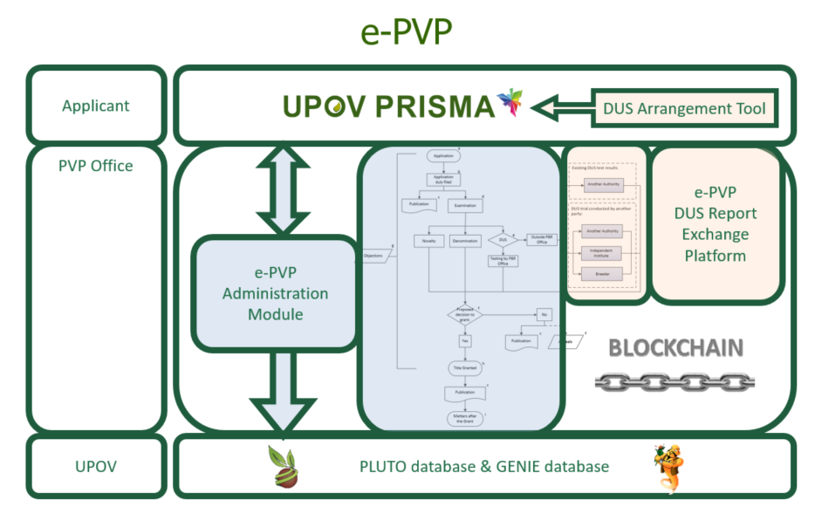

Web-based TG Template module to develop individual authorities’ test guidelines (IATG)

The web-based TG template and database of approved characteristics will be migrated to cloud servers by 2022. The migration will include a restructuring of the program to address issues reported by users. Once this is complete, the web-based TG template will enable the online database of characteristics to be used for drafting individual authorities’ test guidelines (IATG) in different languages. Matters concerning the web-based TG template are reported in document TC/57/12 “Web-based TG template”.

Platform for UPOV member databases containing variety description information

A platform for UPOV member databases containing variety description information will depend on UPOV members indicating which databases they would wish to share. The Office of the Union has not received any expressions of interest from members of the Union to share their databases.

Machine translation technology

The TC, at its fifty-sixth session, noted the potential for machine translation technology to reduce translation costs for UPOV documents in UPOV languages and to make UPOV materials in a wider range of languages (see document TC/56/22, “Outcome of consideration of documents by correspondence”, paragraph 42).

Rapid advances in machine translation technology provide new opportunities, to reduce translation costs for UPOV documents in UPOV languages and to make UPOV materials available in a wider range of languages, within available resources. The use of machine translation technology is being considered within a review of UPOV’s policy on translation.

Using the TWPs for increasing cooperation

The TC, at its fifty-fifth session, noted that TWP sessions could provide an opportunity for experts to enhance collaboration and exchange of information and agreed that TWP sessions should be used to develop cooperation among members to a greater extent.

Measures for increasing cooperation among experts at TWP sessions are discussed in document TC/57/10 “Increasing participation in the work of the TC and TWPs”.

Information to be provided in conjunction with DUS reports

The TC, at its fifty-sixth session, agreed to revise document TGP/5, Section 6: “UPOV Report on Technical Examination and UPOV Variety Description”, to include additional information in DUS test reports, to (see document TC/56/22, “Outcome of consideration of documents by correspondence”, paragraph 43):

- provide information on varieties included in the variety collection
- report the varieties considered in the examination (not only similar varieties)
- provide data from field observations with the DUS test report for each variety
- provide information on environment in which the DUS examination was conducted
Matters concerning the revision of document TGP/5, Section 6, are addressed in document TC/57/5 “Development of guidance and information materials”.

Proposal for guidance on taking-over of DUS test reports

The TC, at its fifty-sixth session, considered document TC/56/22 “Outcome of consideration of documents by correspondence” (see document TC/56/23 “Report”, paragraphs 57 to 63).

The TC noted the comments received during the procedure of consideration of documents by correspondence on document TC/56/11 “Cooperation in examination”, as reported in document TC/56/22, paragraphs 45 to 48.

The TC noted the comment provided by Japan in response to Circular E-20/119, of August 21, 2020, on difficulties to submit plant material to the authority receiving an application due to phytosanitary, quarantine or other related matters, as reported in document TC/56/22, paragraphs 47 and 48.

The TC noted that plant material was required as a condition for granting breeders’ rights in some members of the Union.

The TC, at its fifty-sixth session, agreed to propose to the CAJ the development of guidance to encourage UPOV members, on a voluntary basis, to take-over DUS test reports when the applicants could not submit plant material due to phytosanitary or other related issues where acceptable to the UPOV members concerned. The TC agreed that this proposal should be presented for consideration by the CAJ in document CAJ/77/2 “Report on developments in the Technical Committee” (see document TC/56/23 “Report”, paragraphs 57 to 63).

The CAJ, at its seventy-seventh session noted the measures agreed by TC to overcome barriers that prevented international cooperation in DUS examination (see document CAJ/77/10 “Report”, paragraphs 13 to 15).

In response to the request of the TC, the CAJ requested the Office of the Union to prepare a document for consideration, at its seventy-eighth session, to be held on October 27, 2021, concerning the following policy or legal barriers that the TC had identified as preventing international cooperation in DUS examination and possible measures to address those barriers:

(i) Requirement of formal agreement for cooperation;
(ii) Obligation for DUS examination to be conducted by the authority granting the rights;
(iii) Non-acceptance of breeder-based DUS test reports;
(iv) Wish from breeders to use (or not) existing DUS reports;

In response to the request of the TC, the CAJ further requested the Office of the Union to prepare a document for consideration, at its seventy-eighth session, with proposals for developing guidance to encourage members of the Union, on a voluntary basis, to take-over DUS test reports when the applicants could not submit plant material due to phytosanitary or other related issues where acceptable to the members of the Union concerned.

Impact assessment

The TC, at its fifty-sixth session, agreed to assess the impact of the proposed measures on the basis of the number of cooperation agreements reported by members of the Union, as presented in document C/[xx]/INF/5 “Cooperation in examination” (see document TC/56/22, “Outcome of consideration of documents by correspondence”, paragraph 44).

The TC is invited to note:

(a) that members of the Union have the possibility to update information on a person(s) to be contacted for matters concerning international cooperation in DUS examination by:

(i) updating information when invited to provide information for document TC/[xx]/4 “List of genera and species for which authorities have practical experience in the examination of distinctness, uniformity and stability”; and/or

(ii) notifying the Office of the Union by sending an e-mail to upov.mail@upov.int;

(b) the development of a package of compatible IT tools to address the technical and related administrative concerns that prevent cooperation in DUS examination, as reported in paragraphs 9 to 14 of this document;

(c) that a presentation on e-PVP Asia will be made to the TC, at its fifty-seventh session;

(d) that developments concerning the web-based TG template to enable the drafting individual authorities’ test guidelines (IATG) are reported in document TC/57/12;

(e) that the development of a platform for UPOV member databases containing variety description information will depend on UPOV members indicating which databases they would wish to share;

(f) that matters concerning the revision of document TGP/5, Section 6, are addressed in document TC/57/5 “Development of guidance and information materials”;

(g) that the use of machine translation technology is being considered within a review of UPOV’s policy on translation;

(h) that measures for increasing cooperation among experts at TWP sessions are considered in document TC/57/10 “Increasing participation in the work of the TC and TWPs”;

(i) note that the CAJ, at its seventy-eighth session will consider:

(i) the policy or legal barriers identified by the TC as preventing international cooperation in DUS examination and possible measures to address those barriers; and

(ii) proposals for developing guidance to encourage members of the Union, on a voluntary basis, to take-over DUS test reports when the applicants could not submit plant material due to phytosanitary or other related issues; and

(j) that the impact of the proposed measures will be assessed on the basis of the number of cooperation agreements reported by members of the Union, as presented in document C/[xx]/INF/5 “Cooperation in examination”.

[End of document]

Held via electronic means on October 26 and 27, 2020
https://www.upov.int/edocs/infdocs/en/upov_inf_15.pdf.
Held via electronic means on October 28, 2020

