E
International Union for the Protection of New Varieties of Plants

Technical Committee  Fifty-Sixth Session  Geneva, October 26 and 27, 2020 | TC/56/INF/2  Original: English  Date: October 14, 2020
UPOV PRISMA – matters for information
Document prepared by the Office of the Union
Disclaimer: this document does not represent UPOV policies or guidance

EXECUTIVE SUMMARY

The purpose of this document is to report on developments concerning UPOV PRISMA, since the fifty-fifth session of the Technical Committee, held in Geneva on October 28 and 29, 2019.

The structure of this document is as follows:

EXECUTIVE SUMMARY 1
Background 2
Developments in 2019 2
Developments in the Technical Committee (TC) 2
Developments in the fourteenth Meeting on the Development of an Electronic Application Form (“EAF/14 meeting) 2
Developments in the Administrative and Legal Committee (CAJ) 3
Developments in the Consultative Committee and the Council 3

Developments in 2020 3
Meeting on the development of the electronic application form (EAF/15) 3
Launch of UPOV PRISMA Version 2.4 3
Use of UPOV PRISMA (as of September 30, 2020) 4
Number of PBR submissions via UPOV PRISMA: 4
Number of National Listing* submissions via UPOV PRISMA 5
Number of submissions (PBR + NLI) per month via UPOV PRISMA 5
Number of submissions (PBR + NLI) via UPOV PRISMA chronologically 5
Submissions (PBR + NLI) by crop type in UPOV PRISMA 6
Number of PBR submissions per participating Authority in UPOV PRISMA 6
Communication and promotion 7
Feedback 7
IT matters 7
Information in UPOV PRISMA 7
Analysis of Technical Questionnaires 8
VERSION 2.5 8
Timetable for release 8
Coverage 8
Communication and Promotion plans 9

Future Versions 9
Coverage 9
Next developments 9
Addition of non UPOV TQ characteristics 9

FURTHER DEVELOPMENTS 10

Background

The background and previous developments concerning UPOV PRISMA (formerly the Electronic Application Form project) are reported in document TC/55/INF/5 “UPOV PRISMA”.

Developments in 2019

Developments in the Technical Committee (TC)

The Technical Committee (TC), at its fifty-fifth session in Geneva on October 28 and 29, 2019, noted the information provided in document TC/55/INF/5 in relation to recent developments in UPOV PRISMA (see document TC/55/25 Corr. “Report”, paragraph 257).

Developments in the fourteenth Meeting on the Development of an Electronic Application Form (“EAF/14 meeting)

At the fourteenth Meeting on the Development of an Electronic Application Form (“EAF/14 meeting”), held in Geneva on October 28, 2019, the participants considered document UPOV/EAF/14/2 “Developments concerning UPOV PRISMA” and received a presentation from the Office of the Union. The report of the meeting is provided in document EAF/14/3 “Report”.

At the EAF/14 meeting it was agreed to update the UPOV PRISMA Terms of Use (https://www.upov.int/upovprisma/en/termsuse.html) by introducing the following elements, under the “Specific acknowledgment for PVP Offices” section (see document EAF/14/3 “Report”, paragraph 15):

“In particular, the PBR authority agrees to the following:
  - Be part of UPOV PRISMA
  - Provide the Office of the Union with the most recent and updated application forms (including Technical Questionnaire)
  - Provide the Office of the Union with relevant verified translations (if applicable)
  - Complete the “Information for applicants” (PVP Office procedures) to be made available for applicants and provide updates as necessary
  - Test and check the output forms during the relevant Test campaigns
  - Specify all documents required for accepting a completed application and ensure all required information can be provided in UPOV PRISMA (with an exception for the electronic signature, if appropriate)
  - Accept application data submitted via UPOV PRISMA without the need for further data or information (except for signature)
  - Accept application data by machine-to-machine data transfer or as provided and presented in the output format (PDF), or provide a stylesheet or information that should be displayed on the PDF to be acceptable (e.g. logo)
  - Inform the Office of the Union of any changes or updates in the application forms (including Technical Questionnaire) and accept data according to the earlier version until UPOV PRISMA is updated - UPOV PRISMA will be updated at the next release or within 6 months following notification thereof, whatever is the sooner
  - Acknowledge receipt in UPOV PRISMA of any application data submitted via UPOV PRISMA within 7 days
  - PVP Office not to charge a higher application fee when receiving application data through UPOV PRISMA
  - Communicate information to applicants on the possibility to use UPOV PRISMA
  - Permit UPOV to disclose data about the number and crop types of applications received via UPOV PRISMA (no data on individual application will be disclosed)”

The EAF/14 meeting agreed that participation in UPOV PRISMA would require agreement to the new Terms of Use (see document EAF/14/3 “Report”, paragraph 17).

At the EAF/14 meeting it was agreed that the proposal to indicate the filing date in UPOV PRISMA within 7 days after it is duly filed with the participating PVP Office, should be discussed at a future EAF meeting.

Developments in the Administrative and Legal Committee (CAJ)

The Administrative and Legal Committee (CAJ), at its seventy-sixth session on October 30, 2019, noted the information provided in document CAJ/76/INF/2 in relation to recent developments in UPOV PRISMA (see document CAJ/76/9 “Report”, paragraph 54).

Developments in the Consultative Committee and the Council

The Council at its fifty-third ordinary session in Geneva on November 1, 2019, noted the work of the Consultative Committee at its ninety-sixth session, as reported in document C/53/9 “Report by the President on the work of the ninety-sixth session of the Consultative Committee”, which included the following information concerning UPOV PRISMA (see document C/53/15 “Report”, paragraph 23):

“The Council noted the developments concerning UPOV PRISMA and decided to re-introduce a UPOV PRISMA fee per application at 90 Swiss Francs, starting in January 2020, subject to resolution of the technical issues and improvements being made to the user experience, before a fee was introduced, as presented in document C/53/9. It further agreed that, where the same variety was submitted for both plant breeders’ rights and national listing in the same participating member of the Union, a single fee would be charged at the time of the first submission for the variety (see document C/53/15 “Report”, paragraph 23 (e)).”

Developments in 2020

Meeting on the development of the electronic application form (EAF/15)

The Fifteenth Meeting on the Development of an Electronic Application Form (“EAF/15 meeting”) was organized via electronic means on March 26, 2020. The report of the meeting is provided in document EAF/15/3 “Report”.

Launch of UPOV PRISMA Version 2.4

The current version of UPOV PRISMA (Version 2.4) was released on February 24, 2020 with the following new functionalities:

- new interface, making it easier to navigate through the forms and with a direct communication tool to the UPOV PRISMA team;
- re-introduction of UPOV PRISMA fee (90 Swiss francs per PVP application made using UPOV PRISMA). This fee is in addition to the PVP application fee(s) for the UPOV member concerned. In the case of the United Kingdom, the UPOV PRISMA fee is paid by the United Kingdom PVP Office.

The current coverage of UPOV PRISMA (Version 2.4) is the following:

Authority |  | Crop coverage in Version 2.4
African Intellectual Property Organization (OAPI) | OA | All genera and species
Argentina | AR | Apple (Fruit Varieties), Barley, Black Radish, Broad Bean, Brussels Sprouts, Cauliflower, Chili, Chinese Cabbage, Cotton, Egg Plant, Fig, Grapevine, Green onion, Grey Shallot, Hot Pepper, Indian mustard, Japanese Bunching Onion, Maize, Melon, Oriental Radish, Papaya, Paprika, Potato, Rose, Salvia, Shallot, Soya Bean, Spinach, Sugarcane, Sweet Pepper, Tomato Rootstocks, Watermelon, Welsh Onion, Wheat, Witloof Chicory
Australia | AU | All genera and species
Bolivia (Plurinational State of) * | BO | All genera and species
Canada | CA | All genera & species excluding algae, bacteria and fungi
Chile | CL | All genera and species
China | CN | Lettuce
Colombia | CO | All genera and species
Costa Rica | CR | All genera and species
Dominican Republic | DO | All genera and species
Ecuador | EC | All genera and species
European Union | QZ | All genera & species excluding agricultural crops apart from Bent, Cocksfoot, Fescue, Meadow Fescue, Potato, Soya Bean, Ryegrass, Timothy
France | FR | All genera & species
Georgia | GE | Apple (Fruit Varieties), Barley, Blackberry, Blueberry, Cherry (Sweet Cherry), Chick-Pea, Field Bean, French Bean, Hazelnut, Lentil, Maize, Oats, Peach, Pear, Potato, Raspberry, Soya Bean, Sunflower, Tomato, Walnut, Wheat
Kenya | KE | All genera and species
Morocco | MA | Melon
Mexico | MX | All genera and species
Netherlands | NL | All genera and species
New Zealand | NZ | All genera and species
Norway | NO | All genera and species
Paraguay * | PY | Soya Bean
Peru | PE | All genera and species
Republic of Moldova | MD | Apple (Fruit Varieties), Barley, Blackberry, Chili, European Plum, Grapevine, Hot Pepper, Lettuce, Maize, Oats, Onion, Paprika, Pea, Pear, Potato, Raspberry, Rose, Rye, Sour cherry, Soya Bean, Strawberry, Sunflower, Sunflower, Sweet Pepper, Tomato, Walnut, Wheat
Republic of Korea | KR | Apple (Fruit Varieties), Lettuce, Potato, Rose, Soya Bean
Serbia | RS | Apple (Fruit Varieties), Blueberry, Raspberry, Rose
South Africa | ZA | All genera and species
Sweden | SE | All genera and species
Switzerland | CH | All genera and species
Trinidad and Tobago | TT | Anthuriums , Bromeliaceae, Heliconiaceae, Orchidaceae, Sterculiaceae, Cajanus cajans, Vigna sp., Theobroma cacao L.
Tunisia | TN | All genera and species
Turkey | TR | All genera and species
United Kingdom | GB | All genera and species
United States of America | US | 192 crops including Lettuce, Potato, Soya Bean, Wheat
Uruguay | UY | All genera & species
Viet Nam | VN | Anthurium, Carnation, Chrysanthemum, Cucumber, Dahlia, Dragon Fruit, Japanese Bunching, Onion, Kohlrabi, Maize, Mango, Oranges (Citrus L. - Group 2), Peanut, Poinsettia, Potato, Rice, Rose, Soya Bean, Sunflower, Tomato, Welsh Onion, White-Red and Savoy Cabbage
Total | 35
*Until required information is provided, applicants will not be able to submit application data for the concerned authorities

Use of UPOV PRISMA (as of September 30, 2020)

Information on the use of UPOV PRISMA, is provided below:

Number of PBR submissions via UPOV PRISMA:

 | 2017 | 2018 | 2019 | 2020
January | 1 |  | 7 | 18
February |  | 3 | 9 | 5
March | 2 | 3 | 6 | 21
April |  | 3 | 23 | 11
May | 1 | 1 | 33 | 11
June |  | 7 | 10 | 18
July |  | 7 | 3 | 9
August |  | 1 | 6 | 11
September | 3 | 8 | 14 | 29
October | 1 | 19 | 29
November | 3 | 16 | 26
December | 3 | 9 | 49
Total | 14 | 77 | 215 | 133

Number of National Listing* submissions via UPOV PRISMA

 | 2019 | 2020
January |  | -
February |  | -
March |  | -
April |  | -
May |  | -
June |  | -
July |  | -
August | 1 | -
September | 2 | -
October | -
November | -
December | 2
Total | 5 | 0
*functionality introduced in Version 2.2- June 2019

Number of submissions (PBR + NLI) per month via UPOV PRISMA

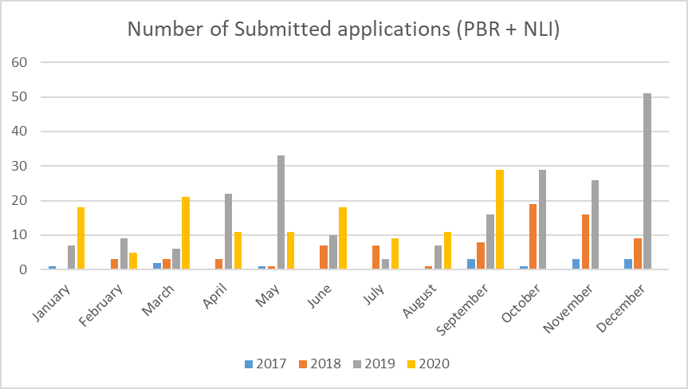

Number of submissions (PBR + NLI) via UPOV PRISMA chronologically

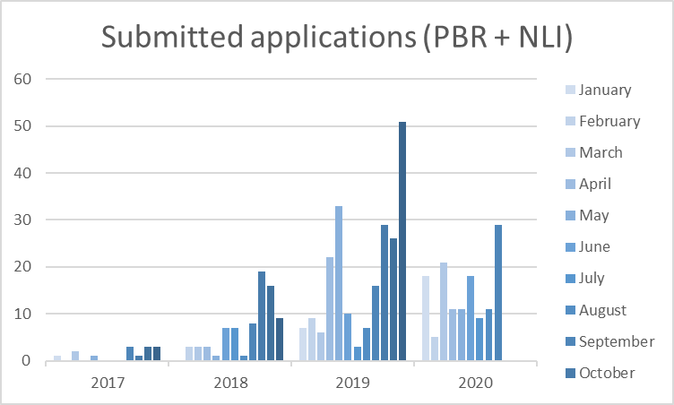

Submissions (PBR + NLI) by crop type in UPOV PRISMA

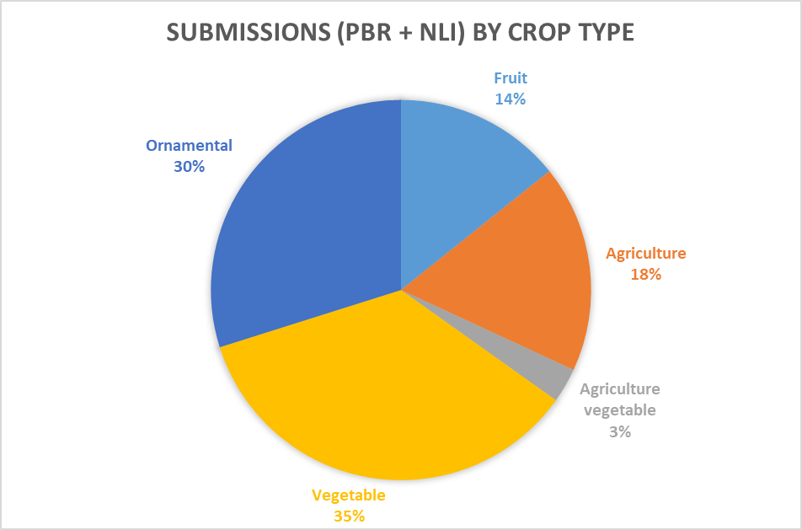

Number of PBR submissions per participating Authority in UPOV PRISMA

Authority |  | Total Number of PBR submissions in UPOV PRISMA | Number of PBR submissions in UPOV PRISMA in 2020  (as of 30/09/2020)
African Intellectual Property Organization (OAPI) | OA | 3
Argentina | AR | -
Australia | AU | 50 | 21
Bolivia (Plurinational State of)* | BO | 2
Canada | CA | 42 | 9
Chile | CL | 6
China | CN | -
Colombia | CO | 5 | 1
Costa Rica | CR | 4
Dominican Republic | DO | 2
Ecuador | EC | 1 | 1
European Union | QZ | 49 | 4
France | FR | 20
Georgia | GE | 3 | 1
Kenya | KE | 31 | 12
Morocco | MA | -
Mexico | MX | 22 | 8
Netherlands | NL | 23 | 2
New Zealand | NZ | 20 | 4
Norway | NO | 11 | 5
Paraguay* | PY | -
Peru | PE | 1 | 1
Republic of Moldova | MD | 2
Republic of Korea | KR | 2 | 1
Serbia | RS | 2
South Africa | ZA | 6 | 1
Sweden | SE | 1
Switzerland | CH | 12 | 3
Trinidad and Tobago | TT | -
Tunisia | TN | 6
Turkey | TR | 65 | 36
United Kingdom | GB | 42 | 21
United States of America | US | 9 | 2
Uruguay | UY | -
Viet Nam | VN | -
Total | 35 | 442 | 133
*Until required information is provided, applicants will not be able to submit application data for the concerned authorities

Communication and promotion

In response to the results of the survey conducted in 2019 (see document EAF/14/03 “Report” paragraphs 10 and 11), it was concluded that resources should be focused on meeting the needs of existing users of UPOV PRISMA in 2020 rather than focusing on increasing the number of users, until users had full confidence in the system. Therefore, since the beginning of 2020, UPOV PRISMA communication and promotion was focused on individual support via direct contacts and training sessions with individuals and companies (breeders and agents) that were using, or had expressed an intention to use, UPOV PRISMA.

Feedback

IT matters

The following requests were received by users:

- Need to automatically save application data in case of inactivity period in the system/session;
- Improve the speed of response of the system;
- Increase the maximum size of attachments (e.g. for pictures);
- Implement machine-to-machine communication with all PVP Offices that have electronic application systems.

Items (a) to (c) will be addressed in Version 2.5. In relation to machine-to-machine communication, it will be a matter for each participating PBR authority to decide when to proceed and will be subject to available resources.

Information in UPOV PRISMA

The following requests were received in relation to the information provided in UPOV PRISMA:

- Priority should be placed on working with participating PBR authorities to ensure that all related information is complete and updated in a timely way before extending UPOV PRISMA to additional UPOV members (see UPOV PRISMA Terms of Use available at: https://www.upov.int/upovprisma/en/termsuse.html “Provide the Office of the Union with the most recent and updated application forms”);
- Need to increase coverage for important crops in participating PBR authorities that do not cover all crops/species in UPOV PRISMA;
- Ensure that all participating PBR authorities in UPOV PRISMA acknowledge receipt of the application data submission within a reasonable amount of time (see UPOV PRISMA Terms of Use available at: https://www.upov.int/upovprisma/en/termsuse.html “Acknowledge receipt in UPOV PRISMA of any application data submitted via UPOV PRISMA within 7 days”);
- Ensure that all requirements of participating PBR authorities are specified in UPOV PRISMA to avoid requests for additional information after data submission via UPOV PRISMA (see UPOV PRISMA Terms of Use available at: https://www.upov.int/upovprisma/en/termsuse.html “Specify all documents required for accepting a completed application and ensure all required information can be provided in UPOV PRISMA”);
- Avoid loss of confidence in UPOV PRISMA by withdrawing PBR authority participation where the UPOV PRISMA Terms of Use are not fulfilled.
In order to ensure confidence in UPOV PRISMA, the Office of the Union plans to contact, individually, all participating PBR authorities to check the information currently available in UPOV PRISMA and to inform the Office of the Union on any need to update the forms and/or requirements before December 31, 2020.

Analysis of Technical Questionnaires

A report on variation between the technical questionnaires of participating authorities in UPOV PRISMA and the UPOV model application form will be presented at the EAF/16 meeting. The report will be made available to participating PBR authorities and UPOV PRISMA users.

VERSION 2.5

Timetable for release

Version 2.5 is anticipated to be released in December 2020.

Coverage

UPOV members

The following participating PBR authorities have informed the Office of the Union of updates of their application or technical questionnaire forms, which will be implemented in Version 2.5, or earlier according to available resources:

- Chile
- European Union
- Mexico
- Switzerland

Crops/ species

Anticipated changes in Version 2.5:

Authority |  | Anticipated new crop coverage in Version 2.5
European Union | QZ | Maize

New Functionalities

The following new functionalities are planned to be introduced in Version 2.5:

- New version of payment interface (Epay V2) to facilitate payment by PayPal, China Union Pay and Bulk payment;
- National Listing for United Kingdom;
- Bulk upload functionality;
- Customization of OAPI form layout (already made available).

On the basis of feedback received from Users, the following new functionalities are planned to be introduced in Version 2.5:

- Automatically save the application data in case of a period of inactivity;
- Improve system performance;
- Avoid simultaneous access to the same application data by colleagues from the same organization (application data lock functionality);
- Allow co-agents to appear in the public list of agents available for breeders;
- Allow uploading of large attachments;
- Allow the possibility to attach documents as an interim solution when a PBR authority revises its application or technical questionnaire forms;
- Improve user interface for copy functionality.

Communication and Promotion plans

The focus for UPOV PRISMA communication in the first half of 2021 will continue to be on individual support via direct contacts and training sessions for existing UPOV PRISMA users.

UPOV PRISMA promotional material (leaflets, infographics, quick guides, PowerPoint slides) remain available in different languages (see document UPOV/EAF/15/2 “Developments concerning UPOV PRISMA”). Participating PBR authorities are invited to contact the Office of the Union to obtain promotional material, in order to diffuse the information to their applicants.

Future Versions

Coverage

The following UPOV members have expressed an interest to join UPOV PRISMA at a future date: Bosnia and Herzegovina, Japan, Nicaragua, Singapore, United Republic of Tanzania and Uzbekistan. The Office of the Union will discuss with those UPOV Members their latest plans to join UPOV PRISMA and expected timeline.

Next developments

In a future version, it is proposed to work on the following:

- Addition of non UPOV TQ characteristics in TQ Section 7 instead of TQ Section 5;
- Synchronization between UPOV PRISMA and CPVO for TQ changes;
- Information on DUS cooperation (DUS Arrangement Recommendation Tool (DART));
- More PBR authorities with machine-to-machine links/ communication to UPOV PRISMA;
- Machine translation;
- Additional participating PBR authorities with National Listing;
- Crop-specific TQs beyond Test Guidelines.

Addition of non UPOV TQ characteristics

The efficiency of UPOV PRISMA is greatly enhanced for applicants where participating UPOV members follow the UPOV Test Guidelines, particularly the Technical Questionnaire in the Test Guidelines (TGs), because this means that the same information can be used in other applications. Furthermore, this also greatly reduces the cost of operating UPOV PRISMA by reducing the need for customized TQs and subsequent translation in all UPOV PRISMA supported languages. At present, information on characteristics that are not included in UPOV TQs is requested in a customized version of TQ5 which requires more work for the Office of the Union because it diverges from the TQ in the adopted UPOV TGs and therefore cannot be generated automatically.

Currently, 22 of the 35 UPOV members participating in UPOV PRISMA indicate that they follow the UPOV Test Guidelines. However, it has become apparent that, for certain crops/species, the Technical Questionnaires in the TGs do not always reflect the Technical Questionnaires being used by the UPOV members concerned, indicating that a review and possible revision of the Technical Questionnaires in the TGs concerned might be appropriate to meet the objectives of the TGs, to improve the efficiency of UPOV PRISMA for applicants and to reduce UPOV’s costs in maintaining UPOV PRISMA.

At their sessions in 2020, the members of the Union present at the TWPs were invited to provide information on differences between their technical questionnaires and the Technical Questionnaires in the adopted TGs. The information will be presented to the Technical Committee at its fifty-sixth session to be held on October 26 and 27, 2020 by electronic means, to assist in the planning of Test Guidelines revisions (see document TC/56/2 “Test Guidelines” paragraphs 23 to 26).

In future versions of UPOV PRISMA (from 2021 on), for participating PBR authorities in UPOV PRISMA, which require information on characteristics that are not included in the UPOV TQ to be included in UPOV PRISMA (e.g. Netherlands), it is proposed to include them in Section 7 of the UPOV PRISMA TQ instead of Section 5 (Option 2 below), on the basis of the following analysis:

Option 1: To include characteristics that are not included in the UPOV TQ in Section 5 (i.e. Characteristics of the variety) of the UPOV PRISMA TQ:

Advantages:
  - The information provided will be reusable in subsequent applications (crop-dependent data reusability)
  - The output form will be similar to the current forms (Forms display in line with national TQ forms)

Disadvantages:
- The UPOV PRISMA data structure would need to be updated (PVP-XML should include the standard structure (i.e. Characteristic name + States of Expression))
- Additional development costs are foreseen (Code generation)
- A new deployment of the system would be required for each update

Option 2: To include characteristics that are not included in the UPOV TQ in Section 7 (i.e. Additional Information) of the UPOV PRISMA TQ:

Advantages:
  - The UPOV PRISMA data structure (PVP-XML) does not need to be updated
  - No additional development costs are foreseen on the UPOV side but work is required on the PVP Office side (preparation of data in a predefined excel template is required (to be done by PVP office))
  - No new deployment of the system would be required
  - Rapid response to request for inclusion (Fast integration of new/updated characteristics)
  - The output forms will remain similar to the current forms in the case of machine-to-machine communication or customized layout (No impact on the form layout)
  - The concerned PBR Authority will have the possibility for their applicants to use UPOV PRISMA for all genera & species, thereby remaining in Approach 1 (i.e. the TQ in UPOV PRISMA would be identical to the TQ in the adopted UPOV TGs) (see document EAF/10/3 “Report” paragraphs 12 and 13)

Disadvantages:
- The information provided by the applicant would not be reusable in a subsequent application, as it would be inserted as free text (no data reusability between different authorities). However, this is not considered to be a major disadvantage because the characteristics are not harmonized with other UPOV members
- The display of output forms might be different from the PBR authority TQ forms (i.e. the numbering or the order of the sections).

FURTHER DEVELOPMENTS

The Sixteenth meeting of the EAF (EAF/16 meeting) will be organized via electronic means on October 23, 2020.

[End of document]

