|  |  |
| --- | --- |
|  | E |
| International Union for the Protection of New Varieties of Plants |  |

|  |  |
| --- | --- |
| Technical Committee  Fifty-Sixth Session Geneva, October 26 and 27, 2020 | TC/56/7  Original: English  Date: October 16, 2020 |

Molecular techniques

Document prepared by the Office of the Union

Disclaimer: this document does not represent UPOV policies or guidance

# Executive summary

The purpose of this document is to present matters for consideration by the Technical Committee (TC) on the use of biochemical and molecular techniques in DUS examination and molecular techniques.

Matters concerning the revision of document UPOV/INF/17 “Guidelines for DNA-Profiling: Molecular Marker Selection and Database Construction (‘BMT Guidelines’)” are reported in document TC/56/13.

Matters for information only, concerning the use of biochemical and molecular techniques in DUS examination and molecular techniques in relation to the TWPs and the BMT are presented in document TC/56/INF/6 “Molecular techniques – matters for information.”

Cooperation between international organizations

*Inventory on the use of molecular marker techniques, by crop*

The TC is invited to note that:

(a) on October 16, 2020, the Office of the Union issued Circular E-20/189 inviting members to complete the survey on the use of molecular marker techniques, per crop, by December 15, 2020; and

(b) that the results of the survey will be presented to the Technical Committee, at its fifty‑seventh session, to be held in 2021.

*Lists of possible joint initiatives with OECD and ISTA in relation to molecular techniques*

The TC is invited to consider whether to schedule another joint OECD, UPOV, ISTA workshop on molecular techniques in the near future.

*Joint document explaining the principal features of the systems of OECD, UPOV and ISTA*

The TC is invited to note that developments on a joint document explaining the principal features of the systems of OECD, UPOV and ISTA will be reported to the TC at its fifty-sixth session, with the aim of proposing a draft joint document explaining the principal features of the systems of OECD, UPOV and ISTA for consideration by the TC at its fifty-seventh session.

*Session to facilitate cooperation in relation to the use of molecular techniques*

The TC is invited to:

(a) note the information provided by participants at the nineteenth session of the BMT on their work on biochemical and molecular techniques and areas for cooperation, as reproduced in Annex to this document; and

(b) invite the TWPs and BMT to form discussion groups to allow participants to exchange information on their work on biochemical and molecular techniques and explore areas for cooperation.

The following abbreviations are used in this document:

BMT: Working Group on Biochemical and Molecular Techniques, and DNA-Profiling in Particular

ISTA: International Seed Testing Association

OECD: Organization for Economic Co-operation and Development

TC: Technical Committee

TWA: Technical Working Party for Agricultural Crops

TWC: Technical Working Party on Automation and Computer Programs

TWF: Technical Working Party on Fruit Crops

TWO: Technical Working Party on Ornamental Plants and Forest Trees

TWPs: Technical Working Parties

TWV: Technical Working Party for Vegetables

The structure of this document is as follows:

Executive summary 1

Cooperation between international organizations 2

Background 2

Inventory on the use of molecular marker techniques, by crop 3

Lists of possible joint initiatives with OECD and ISTA in relation to molecular techniques 4

Background 4

Joint document explaining the principal features of the systems of OECD, UPOV and ISTA 4

Background 4

Draft joint document 4

Session to facilitate cooperation in relation to the use of molecular techniques 5

Background 5

Developments at the TWPs and BMT at their sessions in 2020 5

ANNEX INFORMATION PROVIDED BY PARTICIPANTS AT THE NINETEENTH SESSION OF THE BMT (IN ENGLISH ONLY)

# Cooperation between international organizations

## Background

The background to this matter is provided in document TC/55/7 “Molecular Techniques”.

The TC, at its fifty-fourth session[1], agreed that UPOV and OECD should make progress on the matters previously agreed by the TC, namely (see document TC/54/31 “Report”, paragraphs 267 to 271):

(a) to develop a joint document explaining the principal features of the systems of the OECD, UPOV and ISTA;

(b) to develop an inventory on the use of molecular marker techniques, by crop, with a view to developing a joint OECD/UPOV/ISTA document containing that information, in a similar format to UPOV document UPOV/INF/16 “Exchangeable Software”, subject to the approval of the Council and in coordination with OECD and ISTA; and

(c) the BMT to develop lists of possible joint initiatives with OECD and ISTA in relation to molecular techniques for consideration by the TC.

The TC, at its fifty-fourth session, agreed to invite ISTA to join the initiatives when in position to do so.

Developments concerning the matters above are as follows:

## Inventory on the use of molecular marker techniques, by crop

The TC, at its fifty-fifth session[2], agreed the following elements for the inventory on the use of molecular marker techniques, by crop (see document TC/55/25 “Report”, paragraphs 184 and 185):

* Country or Intergovernmental Organization using molecular marker technique
* Whether the Authority uses molecular marker techniques
* Source [name of the Authority] and Contact details [email address]
* Type of molecular marker technique [AFLP, Capillary electrophoresis fragment analysis, MNP, RAPD-STS, SSR, SNPs, Taqman, Whole genome sequencing, other technique (please specify)] [more than one answer allowed]
* Source of the molecular marker and contact details [email address]
* Availability of the marker [publicly available or a proprietary marker]
* Status (i.e. in current use or under development)
* Crop(s) for which the molecular marker technique is used and characteristic concerned [botanical name(s) and UPOV code(s) to be provided]
* Purpose of the use of the molecular technique [UPOV model “Characteristic-Specific Molecular Markers”, UPOV model “Combining Phenotypic and Molecular Distances in the Management of Variety Collections”, Purity, Identity, Verification of conformity of plant material to a protected variety for the exercise of breeders’ rights, Verification of hybridity]
* Whether the molecular marker technique was used as part of Seed Certification in the last two years [National certification, OECD certification] [relevant for OECD seed schemes]
* Number of times the Authority used the molecular marker technique in the last 2 years [routine, occasional] [e.g. 1 to 5, 6 to 20, 21 to 100, more than 100]
* Whether the molecular marker technique is covered by [UPOV Test Guideline(s), UPOV TGP document(s), other UPOV document(s)] (please specify)
* Whether the molecular technique is validated/recognized/authorized [yes to specify a particular organization or authority] [relevant for OECD seed schemes]
* Whether the Authority created databases with information obtained from use of the molecular marker technique

The TC agreed that a circular should be issued to request members of the Union to complete a survey as a basis to develop an inventory on the use of molecular marker techniques, by crop, in coordination with the OECD.

On October 16, 2020, the Office of the Union issued Circular E-20/189 inviting members to complete the survey on the use of molecular marker techniques, per crop, by December 15, 2020. The results of the survey will be presented to the Technical Committee, at its fifty-seventh session, to be held in 2021.

The TC is invited to note that:

(a) on October 16, 2020, the Office of the Union issued Circular E-20/189 inviting members to complete the survey on the use of molecular marker techniques, per crop, by December 15, 2020; and

(b) that the results of the survey will be presented to the Technical Committee, at its fifty‑seventh session, to be held in 2021.

## Lists of possible joint initiatives with OECD and ISTA in relation to molecular techniques

### Background

The BMT, at its eighteenth session[3], considered document BMT/18/4 “Cooperation between International Organizations” and the request to develop lists of possible joint initiatives with OECD and ISTA, in relation to molecular techniques. The BMT agreed to propose the repeating of joint workshops with ISTA and OECD in future. The BMT agreed to propose a joint initiative that each organization inform the others about use of molecular markers in their work (see document BMT/18/21 “Report”, paragraph 34).

The TC, at its fifty-fifth session[4], considered possible joint initiatives with OECD and ISTA in relation to molecular techniques and agreed with the proposal made by the BMT, at its eighteenth session, for joint workshops to be repeated in future (see document TC/55/25 “Report”, paragraphs 189 to 191).

The TC agreed with the BMT to propose a joint initiative that each organization inform the others about use of molecular markers in their work.

The TC noted there were no definitions on biochemical and molecular techniques in UPOV. The TC agreed that information from the survey on the techniques could help to clarify techniques that were considered to be biochemical or molecular.

The following joint UPOV/OECD/ISTA workshops on molecular techniques have been organized:

(a) hosted by UPOV and held in Seoul, Republic of Korea, on November 12, 2014, in conjunction with fourteenth session of the BMT;

(b) hosted by OECD and held in Paris, France, on June 8, 2016, prior to the Annual Meeting of the OECD Seed Schemes;

(c) hosted by ISTA and held in Hyderabad, India, on June 29, 2019, in conjunction with the 2019 ISTA Congress.

The TC is invited to consider whether to schedule another joint OECD, UPOV, ISTA workshop on molecular techniques in the near future.

## Joint document explaining the principal features of the systems of OECD, UPOV and ISTA

### Background

The TC, at its fifty-fifth session, agreed with the BMT, at its eighteenth session, that relevant elements from the World Seed Partnership and the FAQ on the use of molecular techniques in the examination of DUS, would be a suitable basis for the Office of the Union to develop a draft of a joint document explaining the principal features of the systems of OECD, UPOV and ISTA, in consultation with OECD (see document TC/55/25 “Report”, paragraph 182).

### Draft joint document

The Office of the Union has been in contact with ISTA and OECD to develop a text to be included in a draft joint document. Developments on this matter will be reported to the TC at its fifty-sixth session, with the aim of proposing a draft joint document explaining the principal features of the systems of OECD, UPOV and ISTA for consideration by the TC at its fifty-seventh session.

The TC is invited to note that developments on a joint document explaining the principal features of the systems of OECD, UPOV and ISTA will be reported to the TC at its fifty-sixth session, with the aim of proposing a draft joint document explaining the principal features of the systems of OECD, UPOV and ISTA for consideration by the TC at its fifty-seventh session.

# 

# Session to facilitate cooperation in relation to the use of molecular techniques

## Background

The background to this matter is provided in document TC/55/7 “Molecular Techniques”.

The TC, at its fifty-fourth session[5], noted that discussion groups had been formed at the sixteenth session of the BMT for: agricultural crops; fruit crops; ornamental plants and forest trees; and vegetables, for BMT participants to exchange information on their work and explore areas for cooperation (see document TC/54/31 “Report”, paragraphs 278 and 281).

The TC, at its fifty-fourth session, agreed that the results of the coordination session in the BMT be reported to the TWPs. The TC agreed to invite the TWPs to undertake a similar session to build on the BMT outcomes and feed into the future work of the BMT. The TC agreed that discussion groups should be formed for the main crops at each TWP to allow participants to exchange information on their work and explore areas for cooperation.

## Developments at the TWPs and BMT at their sessions in 2020

At their sessions in 2020, the TWV[6], TWO[7], TWA[8], TWF[9] and TWC[10] considered document TWP/4/7 “Molecular techniques” (see documents TWV/54/9 “Report”, paragraphs 19 and 20; TWO/52/11 “Report”, paragraphs 90 and 91; TWA/49/7 “Report”, paragraphs 64 and 65; TWF/51/10 “Report”, paragraphs 19 and 20 and TWC/38/11 “Report”, paragraphs 72 and 73). The BMT[11] considered document BMT/19/10 “Session to facilitate cooperation” (see document BMT/19/15 “Report”, paragraphs 24 to 28).

The TWPs and BMT noted that, at their sessions in 2019, discussion groups had been formed at the TWPs and BMT to allow participants to exchange information on their work on biochemical and molecular techniques and explore areas for cooperation.

The TWPs and BMT noted the outcomes of discussions on facilitating cooperation in relation to the use of molecular techniques at the TWPs and BMT, as presented in documents TC/55/7, TC/55/7 Add. and TC/55/7 Add 2.

The participants at the nineteenth session of the BMT were invited to report on their work on biochemical and molecular techniques and to explore areas for cooperation. The information provided by participants is reproduced in the Annex to this document.

The BMT noted the information by the Seed Association of the Americas about the recently released paper on "Single nucleotide polymorphisms facilitate distinctness-uniformity-stability testing of soybean cultivars for plant variety protection”, which was freely available via at following link: <https://acsess.onlinelibrary.wiley.com/doi/full/10.1002/csc2.20201>.

The TC is invited to:

(a) note the information provided by participants at the nineteenth session of the BMT on their work on biochemical and molecular techniques and areas for cooperation, as reproduced in the Annex to this document; and

(b) invite the TWPs and BMT to form discussion groups to allow participants to exchange information on their work on biochemical and molecular techniques and explore areas for cooperation.

[Annex follows]

INFORMATION PROVIDED BY PARTICIPANTS AT THE BMT/19 SESSION (ENGLISH ONLY)

1. Where do you work?

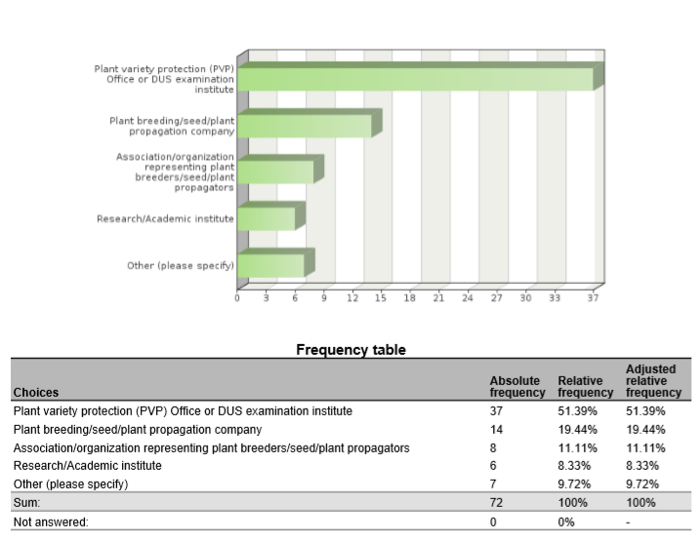

1. Are you cooperating with (other) UPOV members in the use of biochemical and molecular techniques?



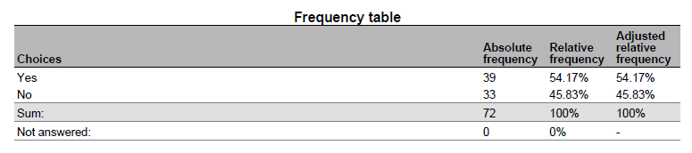

1. Please indicate which UPOV members you are cooperating on biochemical and molecular techniques

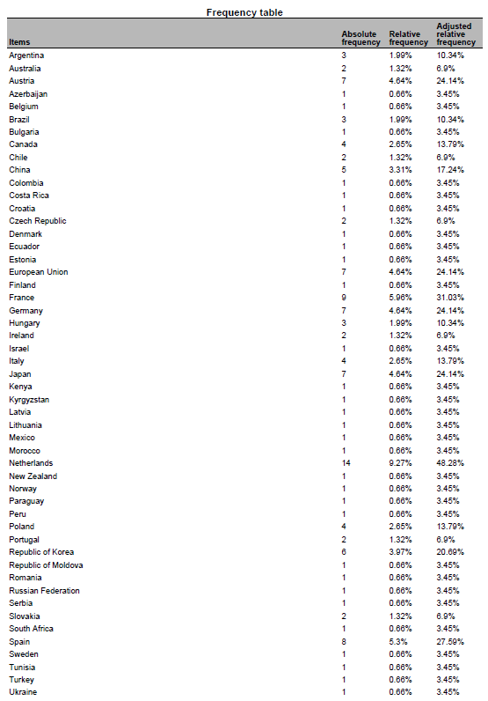

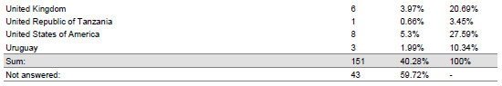

1. What are the objectives of the cooperation with the indicated UPOV members?

* validation and harmonization of crop-specific SNP sets My colleagues are also involved in projects to help with setting up a DUS examination procedures and facilities
* data base of tomato and wheat to improve the choose of comparators for DUS test
* Partner in Tomato project.
* tomato SNP project
* Associated partner in the OSR SNP research project.
* Use of SNP to varietal description
* Development of molecular tools for management of reference collection and assessment of specific traits
* gain knowledge
* Tomato SNP project
* Management of Reference collection; Quality management
* International harmonisation and validation of a SNP set for the management of tomato reference collection
* molecular markers panel and method validation, molecular marker selection to describe varieties collection
* IMODDUS project of Tomato
* selection and validation of a molecular markers panel for genotyping core collection and varieties
* We are a member of the group involved in the use of SSR markers for potato DUS in Europe
* CPVO project
* Some research project are crop specific and are looking at identifying markers, some are more horizontal such as exchange on possible ideas for the use of molecular markers in DUS (within the IMODDUS group).
* expand use of SNP markers in DUS for soybeans
* developing SNP panels for soybean and barley
* Harmonization of marker sets
* identification of BMTs which can be applied in varietal identity and purity certification
* Build capacity for establishing distinction among varieties, based on genotype parameters.
* DUS, Infringements

5. Have you presented a paper on your cooperation with UPOV members at this BMT?

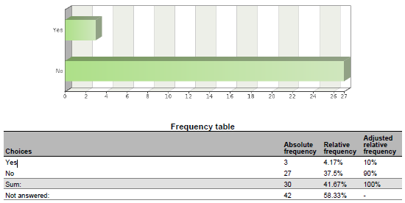

6. If you have not presented the paper, why not?

* I did in previous BMT sessions to introduce these cooperations. The projects we are working on are not yet in the phase to report on the results. Hopefully next year.
* The work is in progress and we are no acting as coordinators
* United Kingdom have not presented because France presented earlier in today.
* Because the work is in progress
* This project just starts from this year.
* This project just starts from this year.
* Because the project is not progressing.
* work is in progress
* There have been no significant changes in the work since the last BMT.
* involved with INVITE project
* I'm DUS expert
* Because the CPVO made a presentation, not necessary for breeders to do. ISF will present the outcome of a survey to which we (Euroseeds) also contributed.
* I have presented many in the past, but did contribute to a presentation this year.
* Cooperation with OECD was included into the Secretariat’s document on cooperation with IOs

7. In what areas would cooperation with UPOV members be valuable to you?

* harmonization of MM sets and also harmonized use of these MM sets in DUS examination. Common databases with variety descriptions and genotyping data to be used by all Examination offices world wide.
* fruit varieties
* Share markers used and platforms, and experience on the species.
* Interested in the development of a DNA reference database for potato.
* The use of DNA markers in DUS testing
* The use of biochemical and molecular techniques for management of reference collections
* Molecular techniques in variety identification, Variety description databases including databases containing molecular data
* Development of molecular tools to support DUS testing. Exploration of new markers (e.g. NGS) and new models (e.g. vmDUS)
* Obtaining information details on some specific procedures, if needed; Exchange of data; etc
* MODEL 1
* methods for analysis of molecular data and data management in database , molecular technique for varieties identification
* Share experience, platforms used and marker's set.
* Language barriers and general contact introductions.
* Developing new markers, sharing research cost, ring test to harmonize protocol between offices
* not main part of my work so wouldn't lead in this area
* Use of markers in creating efficiencies in DUS testing, organization of reference collection.
* standardized method, agreed marker sets agreement on molecular data access rules
* Standardization of methods and markers
* We perform variety identification by using SSR markers for grapevine, wheat and maize. 1) In future we would like to perform variety identification for rye, triticale and soybean - if someone has experience with applicable method. 2) DUS examination office is interested in molecular technique in relation to DUS for more effective management of ref. coll. for barley and wheat.
* Expand use of markers in DUS
* exchange of DUS examination reports, PVP statistics
* Exchange information on techniques/methods, molecular data of specific varieties.
* ISO seeks UPOV input for their use of ISO standards in Agriculture
* cannabis and hemp SNP panel development. Soybean and Barley.
* Give input from industry point of view
* Harmonization of MM techniques, including marker sets and distinctness thresholds.
* varietal identity
* Molecular techniques for identifying plant varieties
* Build capacity
* Representing ISTA
* DUS, Infringements

8. Please indicate which UPOV members you would wish to cooperate on biochemical and molecular techniques

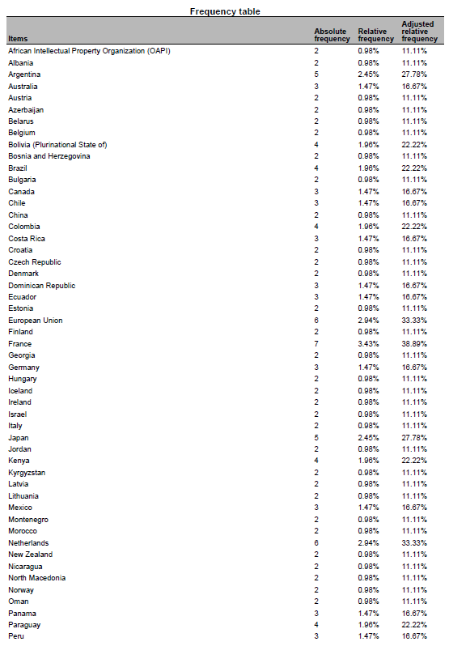

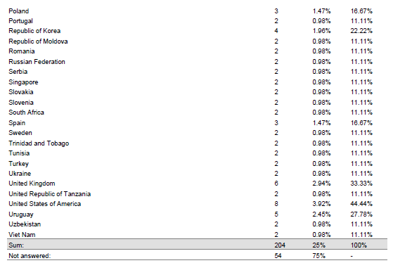

9. Please indicate the crops for which you would like to develop cooperation with UPOV members

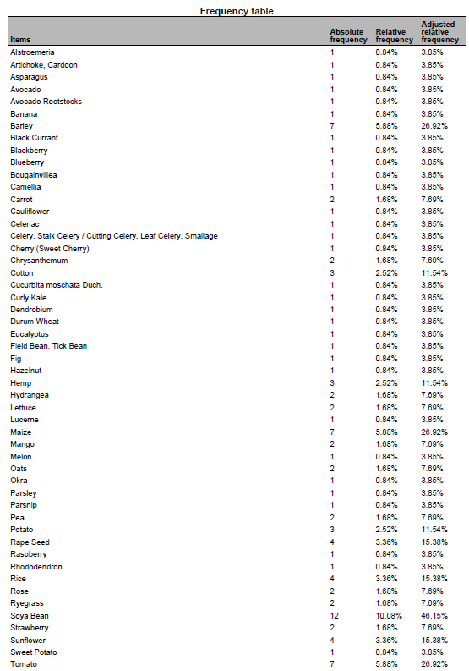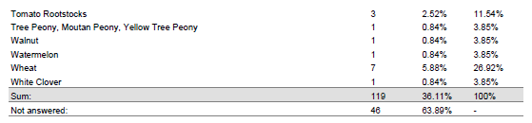

10. Please indicate the techniques for which you would like to develop cooperation with UPOV members

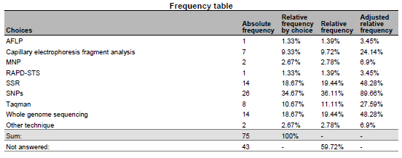

11. Please indicate the objectives of the cooperation:

* harmonization of SNP sets; common DNA databases
* To develop a potato reference collection including morphological and molecular info
* The use DNA markers in DUS testing
* A possibility to buy testing/pre-screening services from a testing authority
* Varietal description, Validation of protocols for the use of molecular markers in varietal description, collaboration to facilitate the exchange of knowledge in the use of new methodologies, Facilitate the acquisition of innovative processes
* Explore new approaches to solve Distinctness issues or test the potentialities of new markers
* To obtain a common database of MM for interested species in order to have better quality in the analysis of DUS (specially model 1)
* gathering information
* Varieties description, exchange of data and material, molecular technique in DUS examination, methods for integrating molecular and DUS and VCU data
* For DUS testing
* We have a lot of experience in potato but wish to broaden our work into other avenues particularly sweet potato, raspberry, strawberry, blackberry, pea
* sharing research cost, harmonization of methods
* harmonization of methods
* Standardisation of methods and open source markers
* to have an overview of available methods, ring trials participation if it's within the capabilities of our lab
* Expand use of markers in DUS
* Speed up DUS examination
* ISO provides methods across business and government. The methods provide a clear platform for their use.
* developing services useful for commercial protection
* Harmonization of MM techniques, including marker sets and distinctness thresholds.
* To train molecular techniques
* Build capacity
* Representing ISTA

12. What are the main obstacles to cooperation with UPOV members?

* Money; the agreement of the breeders to use their varieties for these purposes
* financing
* Development of internal and external MoU for accessing or generating DNA profiles
* The main obstacles are lack of experiences in introducing promised technologies to plant examination and some disadvantages in national legislation
* Lack of resources available for this kind of work
* Funding of non-EU members
* harmonization of methods and selected markers
* we do not have the clear vision
* Different level of expertise and available resources (technical and financial)
* lack of mechanisms and procedures to do so.
* UPOV acceptance of expanded marker use
* Not accepting to take over an existing DUS examination report
* UPOV is legislative, ISO is voluntary
* lack of contact information
* Time. Mutual interest. Organization/facilitation of interaction.
* Shared platform

13. What could UPOV do to help you to cooperate with UPOV members?

* research funds (similar to the IMODDUS by CPVO) agreement of the breeding industry
* For Canada to participate in any exercise for the development of an Agreement template
* We would like to participate in international projects and methodology testing
* Provide opportunities to exchange and establish concrete contacts.
* These forums at the BMT are a great way of putting researchers form different countries in contact. Maybe some kind of database with common interest could be created to facilitate new co-operation.
* Funding research project. Give information on the uses of Upov models by other members
* Provide agreed standards and protocols, alignment among PVP offices on the used methods, capacity building.
* establish liaison with ISO/TC34/SC16
* Make sure that a DUS examination report is accepted by another country. This would save both the applicant and the DUS offices time & money
* Save time in screening primers and share data on varieties
* Continue to observe ISO proceedings
* Cooperation between PVPOs and Breeders allows for expedited validation of MM use for PVP/PBR
* introducing upov members interested in the crops pointed above
* Organization/facilitation of interaction.
* Facilitate sharing methodology

[End of Annex and of document]

1. held in Geneva, on October 29 and 30, 2018
2. held in Geneva, on October 28 and 29, 2019
3. held in Hangzhou, China, from October 16 to 18, 2019
4. held in Geneva, on October 28 and 29, 2019
5. at its fifty-fourth session, held in Geneva on October 29 and 30, 2018
6. at its fifty-fourth session, held from May 11 to 15, 2020.
7. at its fifty-second session, held from June 8 to 12, 2020.
8. at its forty-ninth session, held from June 22 to 26, 2020.
9. at its fifty-first session, held from July 6 to 10, 2020.
10. at its thirty-eighth session, held from September 21 to 23, 2020.
11. at its nineteenth session, held from September 23 to 25, 2020.