|  |  |
| --- | --- |
|  | E |
| International Union for the Protection of New Varieties of Plants |  |

|  |  |
| --- | --- |
| Technical Committee  Fifty-Sixth Session Geneva, October 26 and 27, 2020 | TC/56/12  Original: English  Date: October 6, 2020 |

Increasing participation of new members of the Union in the work of the TC and the TWPs

Document prepared by the Office of the Union

Disclaimer: this document does not represent UPOV policies or guidance

# Executive summary

The purpose of this document is to assist the Technical Committee (TC) in its discussions on possibilities to increase participation of members of the Union in the work of the TC and the Technical Working Parties (TWPs).

The TC is invited to:

(a) note the information provided in relation to the TWPs in 2020;

(b) consider whether to invite the TWPs to consider the possible measures for physical and virtual participation at TWP meetings, as set out in paragraph 21 of this document.

The structure of this document is as follows:

Executive summary 1

Developments at the fifty-fifth session of the Technical Committee 2

Invitation letters 2

Organization of a seminar in Geneva 2

Participation at the TC and TWP meetings by electronic means 2

DevelopmentS since the fifty-fifth session of the Technical Committee 2

Invitation letters 2

Participation at the TC and TWP meetings by electronic means 2

Proposals as next steps to encourage the participation in TWPS AND TC IN the future 4

Annex I UPOV Members participation in TWPs 2020 compare to 2019 to 2015 (per years and per TWPs)

Annex II TWPs 2020 Evaluation survey

The following abbreviations are used in this document:

TC: Technical Committee

TWA: Technical Working Party for Agricultural Crops

TWC: Technical Working Party on Automation and Computer Programs

TWF: Technical Working Party for Fruit Crops

TWO: Technical Working Party for Ornamental Plants and Forest Trees

TWPs: Technical Working Parties

TWV: Technical Working Party for Vegetables

# Developments at the fifty-fifth session of the Technical Committee

The TC, at its fifty-fifth session, held in Geneva on October 28 and 29, 2019, considered document TC/55/24 “Increasing participation of new members of the union in the work of the TC and TWPs” and agreed the following in relation to the different proposals made (see document TC/55/25 Corr. “Report”, paragraphs 233 to 237).

## Invitation letters

The TC agreed that TWP invitations letters should be sent earlier than the current three months and agreed that the “Guidance note for hosts of TWPs” should indicate six months in advance of the sessions.

The TC agreed to invite the UPOV Office to draft a short description on the importance of the work of the TWPs to accompany the invitation letters to the TWP sessions.

## Organization of a seminar in Geneva

The TC considered the organization of a seminar to communicate the importance of the technical work conducted in UPOV and agreed that further consideration would be needed on the aim and target audience before pursuing the idea further.

## Participation at the TC and TWP meetings by electronic means

The TC noted that the invitations to the 2019 sessions of the TWPs invited recipients to indicate particular topics in which they would wish to participate by electronic means.

# DevelopmentS since the fifty-fifth session of the Technical Committee

## Invitation letters

The Guidance note for hosts of TWPs has been updated to indicate that invitation letters should be sent at least six months in advance of the sessions. For 2020, the TWP invitation letters were all sent as follows.

|  |  |  |  |  |
| --- | --- | --- | --- | --- |
| TWPs | Date of meeting | Hosted by | Invitation sent | #months before the meeting |
| Technical Working Party for Vegetables (TWV) | May 11 to 15 | Brazil | 09/01/2020 | 4 |
| Technical Working Party for Ornamental Plants and Forest Trees (TWO) | June 8 to 12 | Netherlands | 19/02/2020 | 4 |
| Technical Working Party for Agricultural Crops (TWA) | June 22 to 26 | Canada | 19/02/2020 | 4 |
| Technical Working Party for Fruit Crops (TWF) | July 6 to 10 | France | 09/03/2020 | 4 |
| Joint session of the Technical Working Party on Automation and Computer Programs (TWC) and the Working Group on Biochemical and Molecular Techniques, and DNA-Profiling in Particular (BMT) | September 21 to 25 | United States of America | 08/01/2020 | 8 |

## Participation at the TC and TWP meetings by electronic means

As a part of the measures taken in response to the COVID 19 pandemic, it was agreed by the Chairpersons of the TWPs, after consultation with the TWP hosts and the TC Chairperson, to hold the TWP sessions in 2020 (see paragraph 10 of this document) by electronic means.

In order to assess the impact of the organizing TWP sessions by electronic means, the level of participation and participant satisfaction was monitored.

The results on the level of participation were as follows:

*Table: Total number of participants (members of the Union + observers) in TWPs (2015-2020)*

|  |  |  |  |  |
| --- | --- | --- | --- | --- |
|  | TWV | TWO | TWA | TWF |
| 2015 | 62 | 63 | 56 | 44 |
| 2016 | 45 | 53 | 68 | 49 |
| 2017 | 58 | 30 | 54 | 36 |
| 2018 | 46 | no TWO in 2018 | 64 | 40 |
| 2019 | 58 | 28 | 42 | 60 |
| Average 2015-2019 | 54 | 44 | 57 | 46 |
| 2020 | 81 | 59 | 96 | 101 |
| Change (%) | +50% | +34% | +68% | +120% |
|  | | | | | |
| *Figure: Number of TWP participants 2015-2020* | | | | | |

*Table: Number of UPOV members participating in TWPs (2015-2020)*

|  |  |  |  |  |
| --- | --- | --- | --- | --- |
|  | TWV | TWO | TWA | TWF |
| 2015 | 20 | 16 | 17 | 16 |
| 2016 | 15 | 14 | 19 | 23 |
| 2017 | 18 | 14 | 28 | 19 |
| 2018 | 15 | no TWO in 2018 | 23 | 18 |
| 2019 | 15 | 12 | 20 | 19 |
| Average 2015-2019 | 17 | 14 | 21 | 19 |
| 2020 | 27 | 20 | 28 | 26 |
| Change (%) | +59% | +43% | +33% | +37% |

The tables in Annex I provide more details about the participation in TWPs over the last 6 years (2015 to 2020).

To assess the level of satisfaction of participants at the virtual meetings, the Office of the Union conducted surveys of participants after each TWP session. The following chart illustrates the overall satisfaction of the week from the participants that replied to the survey. Overall, 91% of participants replied that they were satisfied or very satisfied. The full set of responses is reproduced in the Annex II to this document.

*Figure: General satisfaction of TWP participants in virtual meetings (2020)*

|  |
| --- |
|  |

The TWC and BMT sessions, to be held from September 21 to 25, 2020, will also be held electronically. An oral report will be made to the TC/56 on the attendance and the result of the evaluation survey.

The TC is invited to note the information provided in relation to the TWPs in 2020.

# Proposals as next steps to encourage the participation in TWPS AND TC IN the future

A positive aspect of the virtual TWP sessions was the significant increase in the number of participants (increase ranging from 34-120%) and number of participating members of the Union (increase ranging from 33-59%), compared to previous years (see paragraph 13 of this document).

Although the surveys revealed a high level of overall satisfaction with the virtual meetings (see paragraph 15 of this document) under the given circumstances, participants identified disadvantages in not having a physical meeting. The surveys identified the following limitations for virtual meetings (full set of responses is reproduced in the Annex II):

* limited opportunities for in-depth discussions;
* reduced opportunities for bilateral/ small group discussions at the fringes of the session;
* reduced opportunities to network and meet other crop experts in DUS examination.

The TWF, at its fifty-first session, agreed to propose that meetings via electronic means could be considered for advancing discussions on Test Guidelines during the period between TWPs sessions (see document TWF/51/10 “Report”, paragraph 27).

On the above basis, the TC may wish to invite the TWPs to consider the following possible measures for physical and virtual participation at meetings:

* To organize Test Guidelines subgroup discussions by electronic means prior to the TWPs instead of during the TWPs. The conclusions from the subgroups would be reported to the TWP session in the same way as the current procedure.
* To organize virtual preparatory workshops prior to the TWPs. Those preparatory workshops to be recorded and be made available on the UPOV website.
* To offer the possibility to provide comments and questions on documents in advance of the meeting.
* To organize electronic participation during the TWPs, using one of the following options, according to host facilities:
  + The host to provide the platform for virtual participants (with integrated audio/video on site), in addition to onsite participation in the meeting.
  + The UPOV Office to provide the platform for virtual participants. All participants (present on site or remotely) would be invited to join to the platform using their personal equipment.
* To have virtual meeting sessions for part of the day (e.g. 2 sessions of 2 hours per day) with sessions for onsite participants for the following:
  + visits to DUS trials or related facilities;
  + pre-organized bilateral discussions/ meetings on cooperation;
  + sessions to facilitate discussion or exchange of knowledge for DUS examination.

The TC is invited to consider whether to invite the TWPs to consider the possible measures for physical and virtual participation at TWP meetings, as set out in paragraph 21 of this document.

[Annexes follow]



*Footnote: non-listed authorities did not participate in a TWP in the last 6 years*

**Per Years**



**Per TWPs**

*Footnote: non-listed authorities did not participate in a TWP in the last 6 years*

[Annex II follows]

EVALUATION SURVEY - COMPARISON REPORT ON TWPs (2020)

The following questions were asked via an online survey to the registered participants of each TWPs:

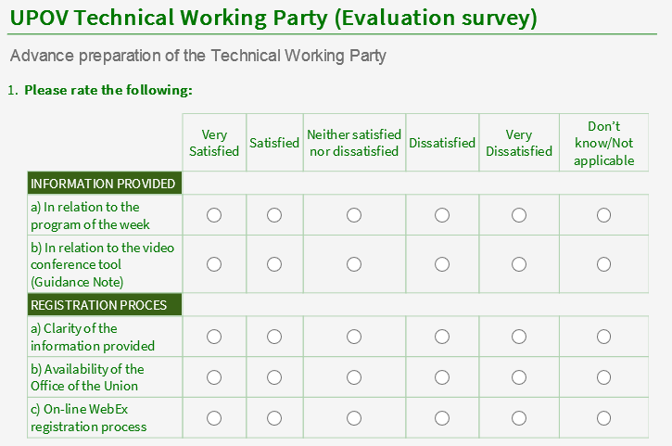

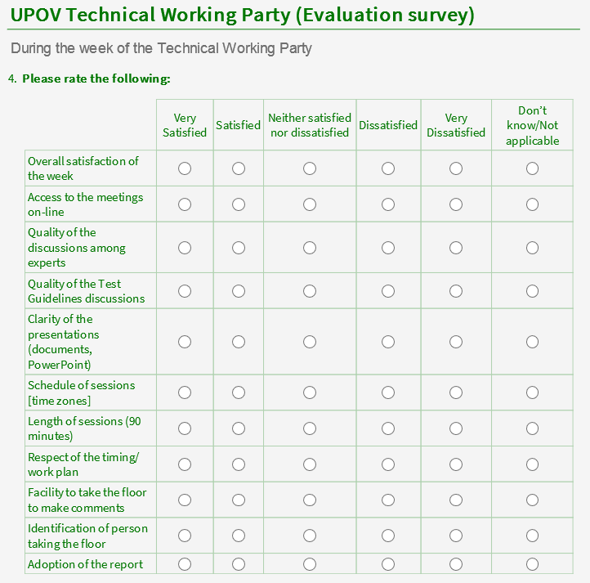

GENERAL LEVEL OF SATISFACTION

INDIVIDUAL QUESTIONS

COMMENTS

TWV:

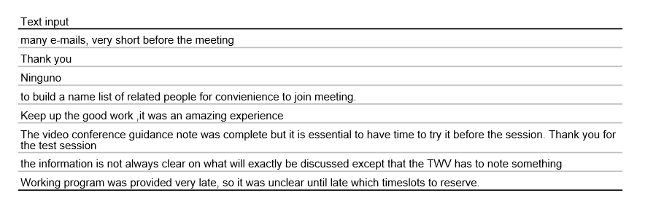

TWO:

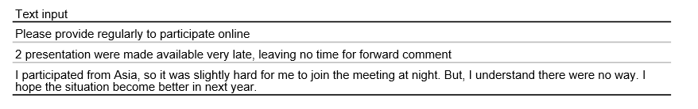

TWA:

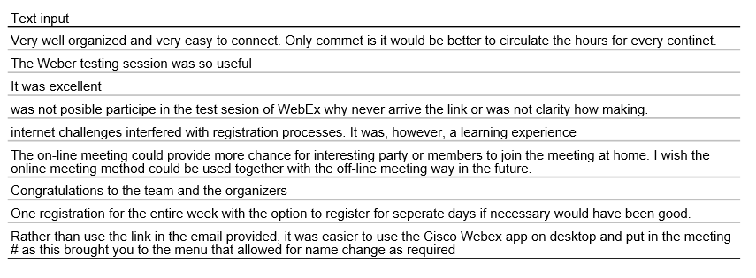

TWF:

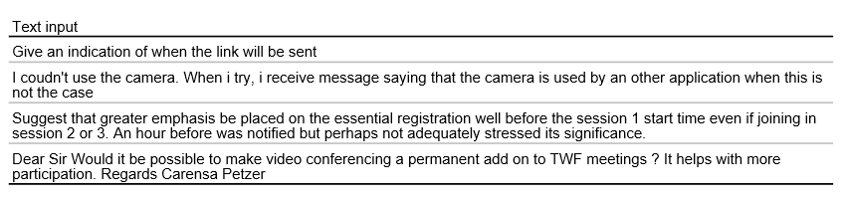

TWV:

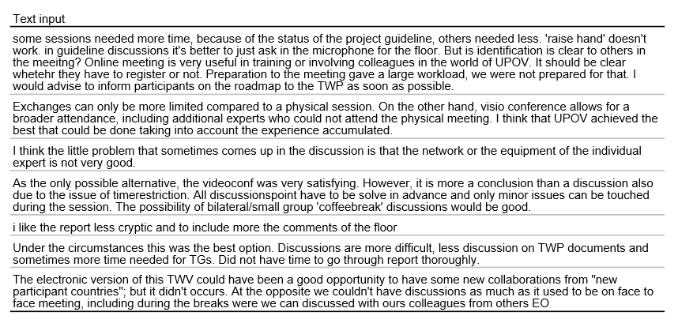

TWO:

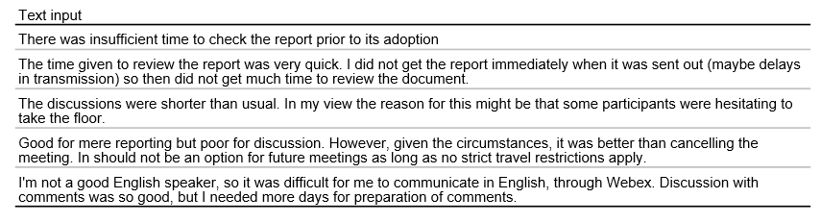

TWA:

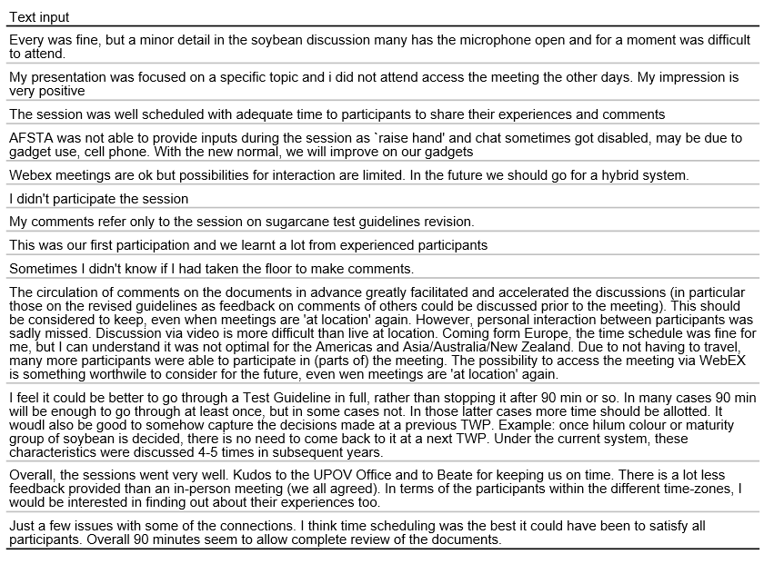

TWF:

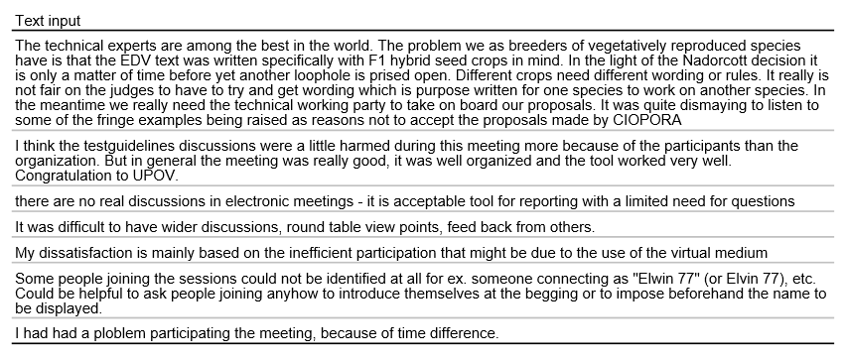

TEHNICAL PROBLEMS:

Participants reported were invited to report on any technical problems, ex. internet issues or audio issues.

In TWF:

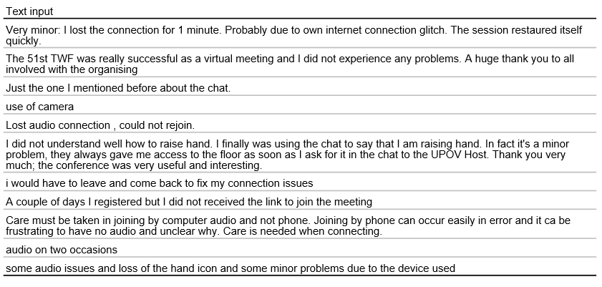

[End of Annex II and of document]