E
International Union for the Protection of New Varieties of Plants

Technical Committee  Fifty-Fifth Session  Geneva, October 28 and 29, 2019 | TC/55/INF/9  Original: English  Date: October 11, 2019
Differences in notes for the assessment of distinctness
Document prepared by the Office of the Union
Disclaimer: this document does not represent UPOV policies or guidance

EXECUTIVE SUMMARY

The purpose of this document is to present guidance from TGP documents on how differences in notes can be used for the assessment of distinctness for PQ and QN characteristics.

The following abbreviations are used in this document:

TC: Technical Committee
TC-EDC: Enlarged Editorial Committee
TWA: Technical Working Party for Agricultural Crops
TWC: Technical Working Party on Automation and Computer Programs
TWF: Technical Working Party for Fruit Crops
TWO: Technical Working Party for Ornamental Plants and Forest Trees
TWV: Technical Working Party for Vegetables
TWPs: Technical Working Parties

The structure of this document is as follows:

EXECUTIVE SUMMARY 1
BACKGROUND 1
Existing guidance on differences in notes for the assessment of distinctness 2
Consideration by the Technical Working Partiers 4
ANNEX I Extracts from document TG/1 “General Introduction to the Examination of Distinctness, Uniformity and Stability and the Development of Harmonized Descriptions of new Varieties of Plants”
ANNEX II Extracts from document TGP/8 “Trial design and techniques used in the examination of Distinctness, Uniformity and Stability.”
ANNEX III Extracts from document TGP/9 “Examining Distinctness”
ANNEX IV Extracts from document TGP/14 “Glossary of terms used in UPOV documents”

BACKGROUND

The TC, at its fifty-fourth session, held in Geneva on October 29 and 30, 2018, considered document TC/54/21 “Illustration for shape and ratio characteristics” (see document TC/54/31 “Report”, paragraphs 235 to 239).

The TC noted that grids could be used to clarify the states of expression and the differences between states of expression and to describe the range of expression for shape characteristics.

The TC noted the discussions on whether to identify situations when grids should and should not be used to explain states of expression in shape characteristics and agreed that the TWPs should decide on a case-by-case for each Test Guidelines according to the guidance in document TGP/14 “Glossary of Terms Used in UPOV Documents”. The TC recalled that, if grids were not used, it was necessary for Test Guidelines to explain the differences between shapes by another clear and objective way.

The TC noted the discussions on whether to provide guidance on how grids could clarify how differences in notes can be used for the assessment of distinctness, in accordance with the guidance in the General Introduction and document TGP/9.

The TC noted that the GAIA software was an example on how differences in notes could be used for the assessment of distinctness. The TC agreed to request the UPOV Office to prepare a document for discussion at the TWPs providing explanations on QN and PQ characteristics from document TG/1/3 “General Introduction to the Examination of Distinctness, Uniformity and Stability and the Development of Harmonized Descriptions of new Varieties of Plants”. The TC agreed that such discussions should be dissociated from the discussions on the use of grids to illustrate shape and ratio characteristics.

Existing guidance on differences in notes for the assessment of distinctness

Document TGP/8 “Trial design and techniques used in the examination of Distinctness, Uniformity and Stability” describes the GAIA methodology. The principle is to compute a phenotypic distance between each pair of varieties, this distance being the sum of distances on each individual observed characteristic. The following example is provided in section 1.3.5.2.5:

“1.3.5.2.5 “Length of husks”, observed on a 1 to 9 scale, the crop expert has defined the following weighting matrix:
 |  | Variety ‘i’
 |  | 1 | 2 | 3 | 4 | 5 | 6 | 7 | 8 | 9
Variety ‘j’ | 1 | 0 | 0 | 0 | 2 | 2 | 2 | 2 | 2 | 2
 | 2 |  | 0 | 0 | 0 | 2 | 2 | 2 | 2 | 2
 | 3 |  |  | 0 | 0 | 0 | 2 | 2 | 2 | 2
 | 4 |  |  |  | 0 | 0 | 0 | 2 | 2 | 2
 | 5 |  |  |  |  | 0 | 0 | 0 | 2 | 2
 | 6 |  |  |  |  |  | 0 | 0 | 0 | 2
 | 7 |  |  |  |  |  |  | 0 | 0 | 0
 | 8 |  |  |  |  |  |  |  | 0 | 0
 | 9 |  |  |  |  |  |  |  |  | 0

1 = very short
2 = very short to short
3 = short
4 = short to medium
5 = medium
6 = medium to long
7 = long
8 = long to very long
9 = very long

“1.3.5.2.6 The weighting between a variety ‘i’ with very short husks (note 1) and a variety ‘j’ with short husks (note 3) is 0. The expert considers a difference of 3 notes is the minimum difference in order to recognise a non-zero distance between two varieties. Even if the difference in notes is greater than 3, the expert keeps the distance weight to 2 while in very reliable characteristics a difference of 1 is given a weight of 6.”

Document TG/1/3 “General introduction to the examination of distinctness, uniformity and stability and the development of harmonized descriptions of new varieties of plants” provides the following explanation on the general approach for the assessment of distinctness on quantitative characteristics:

“5.4.3 For quantitative characteristics, a difference of two Notes often represents a clear difference, but that is not an absolute standard for assessment of distinctness. Depending on factors, such as the testing place, the year, environmental variation or range of expression in the variety collection, a clear difference may be more or less than two Notes. Guidance is provided in document TGP/9, ‘Examining Distinctness.’”

The following examples from document TGP/14 “Glossary of terms used in UPOV documents” are used to illustrate how the approach for QN characteristics may or may not be applicable for PQ characteristics:

Example 1: The rules for QN characteristics are applicable to the shapes displayed following the dashed arrows

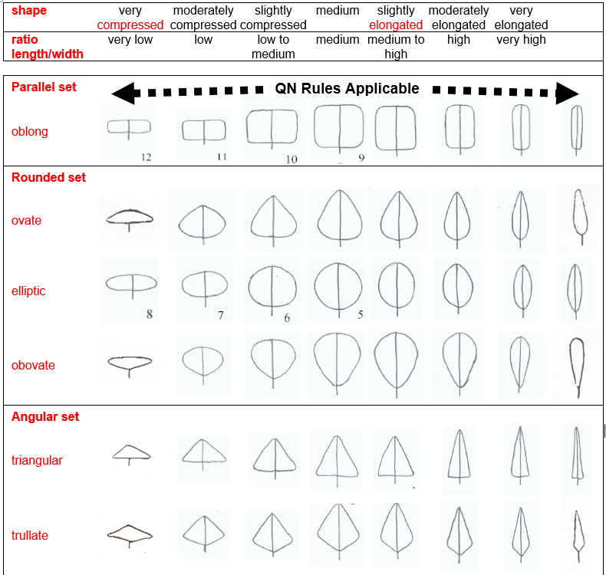

Example 2: The rules for QN characteristics are applicable to the shapes displayed following the dashed arrows

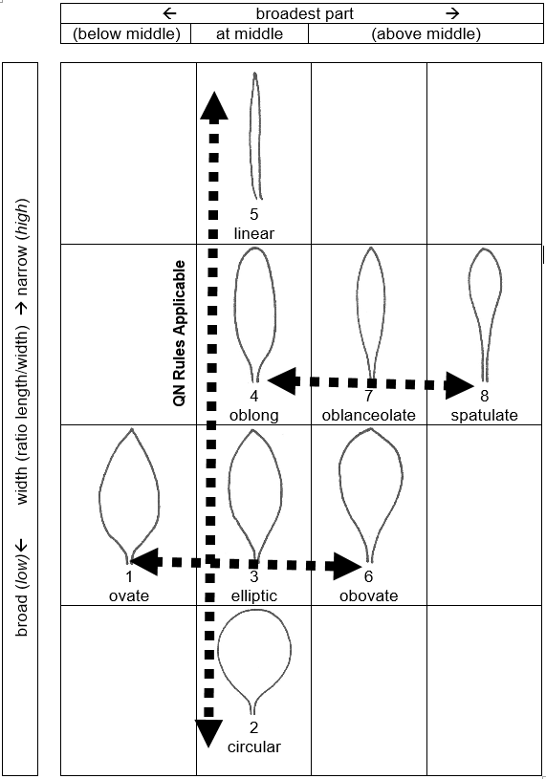

Example 3: The rules for QN characteristics are applicable to the shapes displayed following the dashed arrow and are not applicable to the shapes displayed following the solid line

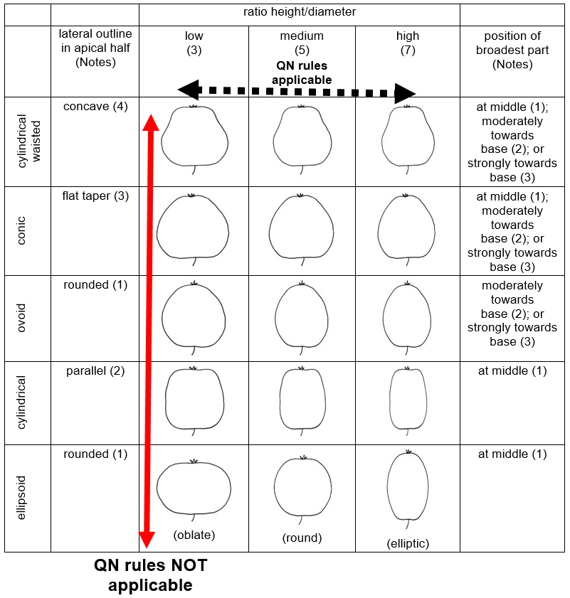

The Annex to this document reproduces relevant extracts from documents TG/1/3 “General Introduction to the Examination of Distinctness, Uniformity and Stability and the Development of Harmonized Descriptions of new Varieties of Plants,” TGP/9 “Examining Distinctness” and TGP/8 “Trial design and techniques used in the examination of Distinctness, Uniformity and Stability.”

Consideration by the Technical Working Partiers

The TWO, TWV, TWF and TWA, at their sessions in 2019, considered document TWP/3/13 “Differences in notes for the assessment of distinctness” (see documents TWO/51/12 “Report”, paragraphs 80 to 82, TWF/50/13 “Report”, paragraphs 127 to 129, TWV/53/14 “Report”, paragraphs 79 to 82 and TWA/48/9 “Report”, paragraphs 83 to 86).

The TWPs noted existing guidance in the General Introduction and documents TGP/8, TGP/9 and TGP/14 on differences in notes for the assessment of distinctness.

The TWO and TWV noted the clarification provided in document TWP/3/13 on how the approach for QN characteristics could be applicable for certain states of expression in some PQ characteristics.

The TWF agreed with the clarification provided in document TWP/3/13, paragraphs 10 to 13, as reproduced in paragraphs 9 to 12 of this document.

The TWA noted that the GAIA method was a pre-selection tool and was not used to compare data in the growing trial and agreed that explanations for certain shape and color characteristics could be provided in the form of a matrix indicating which state of expression could be considered as distinct from one another.

[Annexes follow]

EXTRACT FROM DOCUMENT TG/1/3 “GENERAL INTRODUCTION TO THE EXAMINATION OF DISTINCTNESS, UNIFORMITY AND STABILITY AND THE DEVELOPMENT OF HARMONIZED DESCRIPTIONS OF NEW VARIETIES OF PLANTS”

CHAPTER 4 – CHARACTERISTICS USED IN DUS TESTING

4.4 Types of Expression of Characteristics

4.4.1 Qualitative Characteristics

“Qualitative characteristics” are those that are expressed in discontinuous states (e.g. sex of plant: dioecious female (1), dioecious male (2), monoecious unisexual (3), monoecious hermaphrodite (4)). These states are self-explanatory and independently meaningful. All states are necessary to describe the full range of the characteristic, and every form of expression can be described by a single state. The order of states is not important. As a rule, the characteristics are not influenced by environment.

4.4.2 Quantitative Characteristics

“Quantitative characteristics” are those where the expression covers the full range of variation from one extreme to the other. The expression can be recorded on a one-dimensional, continuous or discrete, linear scale. The range of expression is divided into a number of states for the purpose of description (e.g. length of stem: very short (1), short (3), medium (5), long (7), very long (9)). The division seeks to provide, as far as is practical, an even distribution across the scale. The Test Guidelines do not specify the difference needed for distinctness. The states of expression should, however, be meaningful for DUS assessment.

4.4.3 Pseudo-Qualitative Characteristics

In the case of “pseudo-qualitative characteristics,” the range of expression is at least partly continuous, but varies in more than one dimension (e.g. shape: ovate (1), elliptic (2), circular (3), obovate (4)) and cannot be adequately described by just defining two ends of a linear range. In a similar way to qualitative (discontinuous) characteristics – hence the term “pseudo-qualitative” – each individual state of expression needs to be identified to adequately describe the range of the characteristic.

CHAPTER 5 – EXAMINING DISTINCTNESS

5.3 Clearly Distinguishing a New Variety

5.3.3 The Criteria for Distinctness Using Characteristics

5.3.3.2 Clear Differences
[…]
5.3.3.2.2 Quantitative Characteristics

Quantitative characteristics are considered for distinctness according to the method of observation and the features of propagation of the variety concerned. The different approaches are considered later in this Chapter.

5.3.3.2.3 Pseudo-Qualitative Characteristics

A different state in the Test Guidelines may not be sufficient to establish distinctness (see also section 5.5.2.3). However, in certain circumstances, varieties described by the same state of expression may be clearly distinguishable.
[…]
5.4 Interpretation of Observations for the Assessment of Distinctness Without the Application of Statistical Methods
[…]
5.4.3 For quantitative characteristics, a difference of two Notes often represents a clear difference, but that is not an absolute standard for assessment of distinctness. Depending on factors, such as the testing place, the year, environmental variation or range of expression in the variety collection, a clear difference may be more or less than two Notes. Guidance is provided in document TGP/9, “Examining Distinctness.”

[Annex II follows]
EXTRACT FROM DOCUMENT TGP/8/3 “TRIAL DESIGN AND TECHNIQUES USED IN THE EXAMINATION OF DISTINCTNESS, UNIFORMITY AND STABILITY”

PART II: Selected TECHNIQUES used in DUS examination

1. THE GAIA METHODOLOGY

The GAIA method has been developed to optimize trials, by avoiding the growing of some of the varieties in the variety collection. The principle is to compute a phenotypic distance between each pair of varieties, this distance being a sum of distances on each individual observed characteristic. The background of the method relies on the possibility given to the crop expert to express his confidence on the differences observed, by giving weights to the difference for each observed characteristic.
[…]

1.3 Detailed information on the GAIA methodology

1.3.1 Weighting of characteristics
[…]
1.3.1.2 Weighting is defined as the contribution in a given characteristic to the total distance between a pair of varieties. For each species, this system must be calibrated to determine the weight which can be given to each difference and to evaluate the reliability of each characteristic in a given environment and for the genetic variability concerned. For that reason the role of the crop expert is essential.

1.3.1.3 Weighting depends on the size of the difference and on the individual characteristic. The weightings are defined by the crop expert on the basis of his expertise in the crop and on a “try-and-check” (see Diagram 3 at the end of this annex) learning process. The expert can give zero weighting to small differences, thus, even if two varieties have different observed values in many characteristics, the overall distance might be zero. For a given difference, the same weighting is attributed to any pair of varieties for a given characteristic.

1.3.1.4 The weighting should be simple and consistent. For instance the crop expert can base the weights for a characteristic only with integer values, i.e. 0, 1, 2, 3, (or more).

If so,

- a weight of 0 is given to observed differences which for this characteristic are considered by the crop expert as possibly caused by environment effects or lack of precision in measure.
- a weight of 1 is the minimum weight which can contribute as a non zero distance
- a weight of 3 is considered to be about 3 times greater in term of confidence or distance than a weight of 1.

1.3.1.5 The distinctness plus threshold will be defined as a value for which the sum of the differences with a non zero weight is great enough to ensure a reliable obvious distinction.
[…]
1.3.1.7 The following simple example on Zea mays shows the computation of the distance between two varieties:

Example: taking the characteristic “Weighting matrix shape of ear”, observed on a 1 to 3 scale, the crop expert has attributed weighting to differences which they consider significant:

Shape of ear:
1 = conical
2 = conico-cylindrical
3 = cylindrical

Comparison between difference in notes and weighting
 | Different in notes | Weighting
conical (1) vs. conical (1) | 0 | 0
conical (1) vs. conico-cylindrical (2) | 1 | 2
conical (1) vs. cylindrical (3) | 2 | 6
conico-cylindrical (2) vs. conico-cylindrical (2) | 0 | 0
conico-cylindrical (2) vs. cylindrical (3) | 1 | 2
cylindrical (3) vs. cylindrical (3) | 0 | 0

When the crop expert compares a variety ‘i’ with conical ear (note 1) to a variety ‘j’ with cylindrical ear (note 3), he attributes a weighting of 6 etc. The weightings are summarized in the form of a weighting matrix:

Weighting matrix
‘i’
 | Variety ‘i’
Variety ‘j’ |  | 1 | 2 | 3
 | 1 | 0 | 2 | 6
 | 2 |  | 0 | 2
 | 3 |  |  | 0

When the crop expert compares a variety i with conical ear (note 1) to a variety j with cylindrical ear (note 3), he attributes a weighting of 6.
[…]
1.3.5.2.5 “Length of husks”, observed on a 1 to 9 scale, the crop expert has defined the following weighting matrix:

 |  | Variety ‘i’
 |  | 1 | 2 | 3 | 4 | 5 | 6 | 7 | 8 | 9
Variety ‘j’ | 1 | 0 | 0 | 0 | 2 | 2 | 2 | 2 | 2 | 2
 | 2 |  | 0 | 0 | 0 | 2 | 2 | 2 | 2 | 2
 | 3 |  |  | 0 | 0 | 0 | 2 | 2 | 2 | 2
 | 4 |  |  |  | 0 | 0 | 0 | 2 | 2 | 2
 | 5 |  |  |  |  | 0 | 0 | 0 | 2 | 2
 | 6 |  |  |  |  |  | 0 | 0 | 0 | 2
 | 7 |  |  |  |  |  |  | 0 | 0 | 0
 | 8 |  |  |  |  |  |  |  | 0 | 0
 | 9 |  |  |  |  |  |  |  |  | 0

1 = very short
2 = very short to short
3 = short
4 = short to medium
5 = medium
6 = medium to long
7 = long
8 = long to very long
9 = very long

1.3.5.2.6 The weighting between a variety ‘i’ with very short husks (note 1) and a variety ‘j’ with short husks (note 3) is 0. The expert considers a difference of 3 notes is the minimum difference in order to recognise a non-zero distance between two varieties. Even if the difference in notes is greater than 3, the expert keeps the distance weight to 2 while in very reliable characteristics a difference of 1 is given a weight of 6.

[Annex III follows]

EXTRACT FROM DOCUMENT TGP/9/2 “EXAMINING DISTINCTNESS”

SECTION 5: ASSESSING DISTINCTNESS BASED ON the growing TRIAL

5.2 Approaches for assessing distinctness

5.2.3 Assessment by Notes / Single variety records (“Notes”)

5.2.3.2 Assessment by Notes
[…]
5.2.3.2.2 Pseudo-qualitative (PQ) characteristics

5.2.3.2.2.1 The difference in Notes which may establish distinctness for a pseudo-qualitative characteristic is influenced by factors such as location, year and environmental variation within the trial. Also, as with quantitative characteristics, the range of the scale (number of Notes) varies. However, an important additional factor with pseudo-qualitative characteristics is that, whilst a part of the range is continuous, there is not an even distribution across the scale and the range varies in more than one dimension (e.g. shape: ovate (1), elliptic (2), circular (3), obovate (4): there is a variation in the length/width ratio and in the position of the widest point). This means that it is difficult to define a general rule on the difference in Notes to establish distinctness within a characteristic.
[…]
5.2.3.2.2.3 The following examples illustrate why deciding on the difference in the number of Notes required between varieties to establish distinctness needs particular care:

Example 1:

Type of mottling: only diffuse (Note 1); diffuse and in patches (2); diffuse, in patches and linear bands (3); diffuse and in linear bands (4).

Example 2:

Shape: broad elliptic (Note 1), medium elliptic (2), narrow elliptic (3), ovate (4)

Example 3:

Color: green (Note 1), yellow green (2), green yellow (3), yellow (4), orange (5), red (6)

In the case of Examples 1 and 2, it is not appropriate to say that the “difference” between varieties with Notes 1 and 2 is less than between varieties with Notes 1 and 4, although they are respectively 1 and 3 Notes “different”. In some cases, for example, the difference between Notes 2 and 3 may be greater than between Notes 1 and 4. However, Example 3 demonstrates that, in some parts of the range of some pseudo-qualitative characteristics, it might be possible to follow a similar approach to that used for quantitative characteristics, e.g. varieties with states 2 and 3 (1 Note difference) have less difference than those with states 1 and 4 (3 Notes difference).

[Annex IV follows]
EXTRACT FROM DOCUMENT TGP/14 “GLOSSARY OF TERMS USED IN UPOV DOCUMENTS”

Subsection 2. Shapes and Structures

- Shape
[…]
2. Developing Shape-Related Characteristics
[…]
2.2 Full plane shape characteristics
[…]

Example 1: variation in ratio length/width only.

Alternative 1
Plant [part]: ratio length/width (low to high) (QN)

Alternative 2
Plant [part]: shape (broad obovate (1); medium obovate (2); narrow obovate (3)) (QN)

with the following illustration:

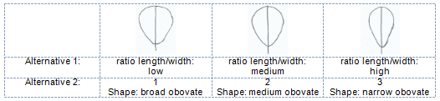

[…]

Example 2: variation in position of the broadest part only.

Alternative 1
Plant [part]: position of broadest part (towards base to towards apex) (QN)

Alternative 2
Plant [part]: shape (ovate (1); elliptic (2); obovate (3)) (QN)

with the following illustration:
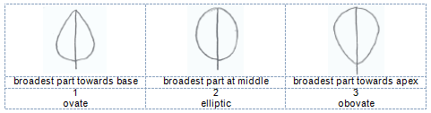

[…]

Example 3: variation in ratio length/width, shape of base and lateral outline

Alternative 1
Plant [part]: ratio length/width (low to high) (QN)
Plant [part]: shape of base (acute, obtuse, rounded) (PQ)
Plant [part]: lateral outline (clearly rounded to clearly triangular) (QN)

Alternative 2
Plant [part]: shape (broad ovate (1); medium ovate (2); medium trullate (3); narrow ovate (4); narrow trullate (5)) (PQ)

with the following illustration:
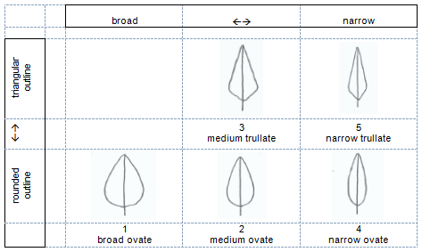

[End of Annex IV and of document]

