E
International Union for the Protection of New Varieties of Plants

Technical Committee  Fifty-Fourth Session  Geneva, October 29 and 30, 2018 | TC/54/29  Original: English  Date: August 27, 2018
Development of calculated thresholds for excluding varieties of common knowledge from the second growing cycle when COYD is used
Document prepared by the Office of the Union
Disclaimer: this document does not represent UPOV policies or guidance

EXECUTIVE SUMMARY

The purpose of this document is to report on developments concerning the development of calculated thresholds for excluding varieties of common knowledge from the second growing cycle when COYD is used.

The TC is invited to note that the TWC, at its thirty-fifth session, noted:

(a) the recent developments and the indications of COYD thresholds for excluding varieties of common knowledge from the second growing cycle on the basis of data sets of meadow fescue, red clover, timothy, perennial ryegrass, pea (semi-leafless) and pea (conventional), as set out in paragraphs 9 and 10 and the Annex to this document;

(b) the method was most applicable to crops with large numbers of varieties of common knowledge and where current trial sizes were large; and

(c) the plans of the United Kingdom to test the method on two large data set of oilseed rape.

The structure of this document is as follows:

EXECUTIVE SUMMARY 1
Background 1
Developments in 2017 2
Technical Committee 2
Technical Working Party on Automation and Computer Programs 2
Developments in 2018 2

ANNEX THRESHOLDS FOR EXCLUDING VARIETIES OF COMMON KNOWLEDGE FROM THE SECOND GROWING CYCLE WHEN COYD IS USED

The following abbreviations are used in this document:

TC: Technical Committee
TWC: Technical Working Party on Automation and Computer Programs

Background

The background to this matter is provided in document TC/53/23 “Development of calculated thresholds for excluding varieties of common knowledge from the second growing cycle when COYD is used”, paragraphs 9 to 13 and document TC/53/23 Add. “Addendum to document TC/53/23”.

Developments in 2017

Technical Committee

The TC, at its fifty-third session, held in Geneva, from April 3 to 5, 2015, considered document TC/53/23 “Development of calculated thresholds for excluding varieties of common knowledge from the second growing cycle when COYD is used” (see document TC/53/31 “Report”, paragraphs 190 to 192).

The TC received a presentation by the experts from the United Kingdom on excluding varieties of common knowledge from the second growing cycle when COYD was used, a copy of which is reproduced in document TC/53/23 Add..

The TC noted that further developments on calculated thresholds for excluding varieties of common knowledge from the second growing cycle when COYD was used would be reported to the TWC, at its thirty-fifth session.

Technical Working Party on Automation and Computer Programs

The TWC, at its thirty-fifth session, held in Buenos Aires, Argentina, from November 14 to 17, 2017, considered documents TWP/1/22 “Development of calculated thresholds for excluding varieties of common knowledge from the second growing cycle when COYD is used” and TWC/35/13 “Thresholds for Excluding Varieties of Common Knowledge from the Second Growing Cycle when COYD is used” and received a presentation by an expert from the United Kingdom, a copy of which is reproduced in the Annex to this document (see document TWC/35/21 “Report”, paragraphs 73 to 76).

The TWC noted the recent developments and the indications of COYD thresholds for excluding varieties of common knowledge from the second growing cycle on the basis of data sets of meadow fescue, red clover, timothy, perennial ryegrass, pea (semi-leafless) and pea (conventional).

The TWC noted that the method was most applicable to crops with large numbers of varieties of common knowledge and where current trial sizes were large. The TWC noted the plans of the United Kingdom to test the method on large data sets of oilseed rape.

The TWC noted that the code had been developed using “R” software and that it might be possible to link this to the GAIA software to support determining the thresholds for excluding varieties from the second growing cycle when COYD was used.

Developments in 2018

The TWC, at its thirty-sixth session, held in Hanover, Germany, from July 2 to 6, 2018, did not receive a document on this matter.

On July 24, 2018, the Office of the Union received information that the expert from the United Kingdom expects to be able to report on progress at the thirty-seventh session of the TWC, to be held in Hangzhou, China, from October 14 to 16, 2019.

The TC is invited to note that the TWC, at its thirty-fifth session, noted:

(a) the recent developments and the indications of COYD thresholds for excluding varieties of common knowledge from the second growing cycle on the basis of data sets of meadow fescue, red clover, timothy, perennial ryegrass, pea (semi-leafless) and pea (conventional), as set out in paragraphs 9 and 10 and the Annex to this document;

(b) the method was most applicable to crops with large numbers of varieties of common knowledge and where current trial sizes were large; and

(c) the plans of the United Kingdom to test the method on two large data set of oilseed rape.
[Annex follows]

THRESHOLDS FOR EXCLUDING VARIETIES OF COMMON KNOWLEDGE FROM THE SECOND GROWING CYCLE WHEN COYD IS USED

Presentation prepared by experts from the United Kingdom

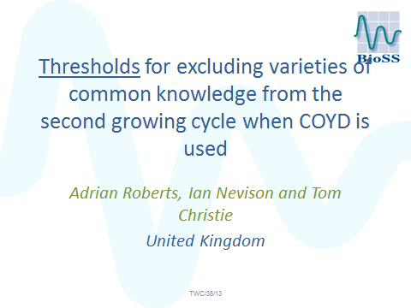

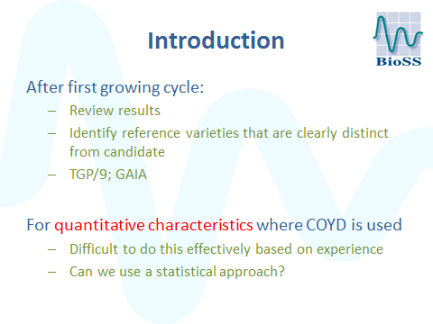

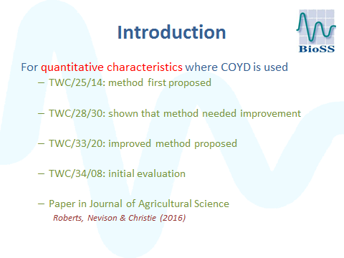

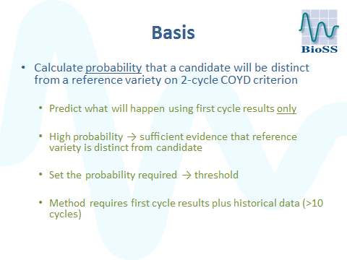

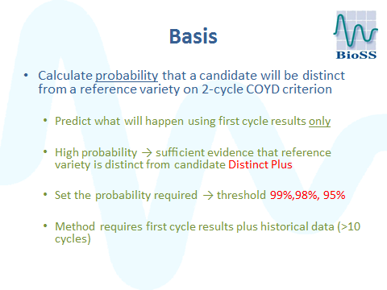

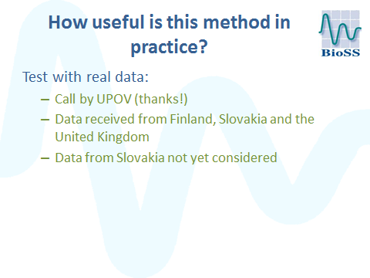

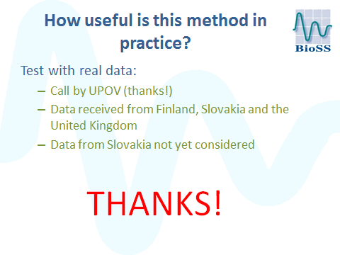

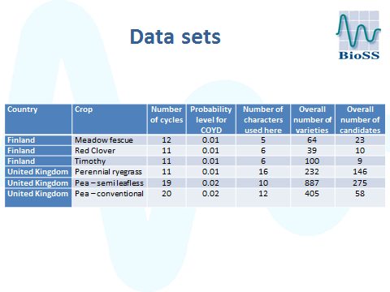

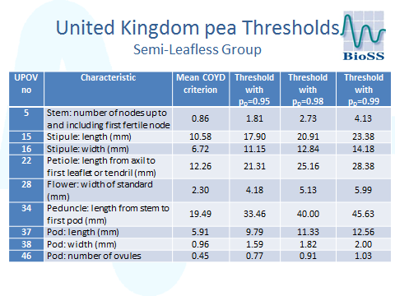

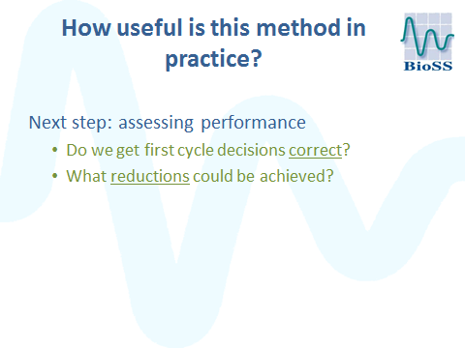

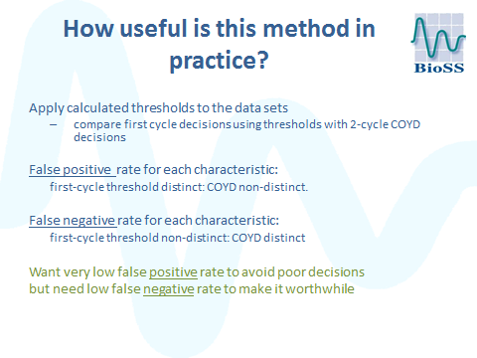

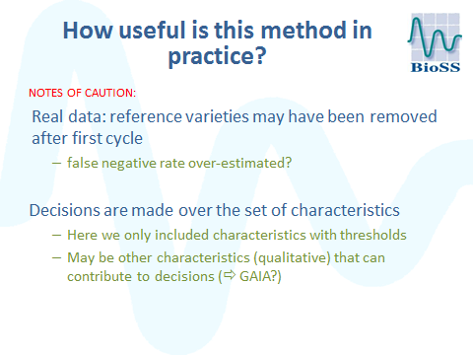

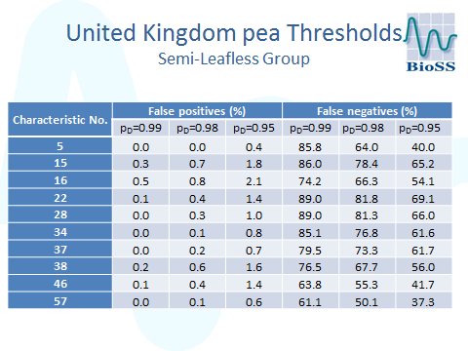

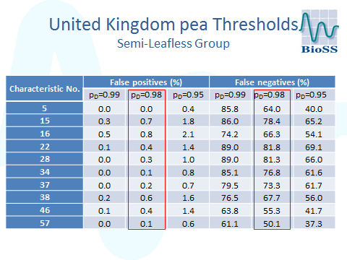

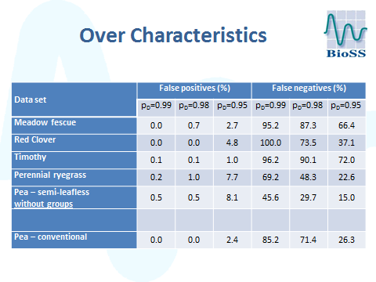

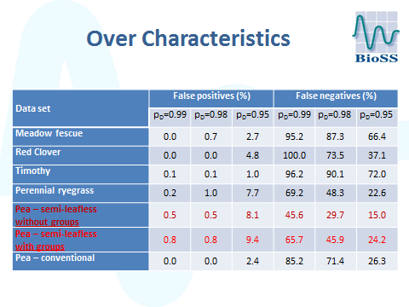

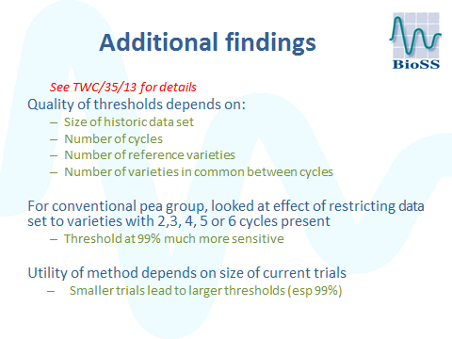

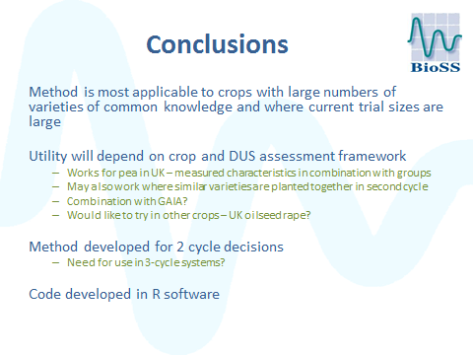

[End of Annex and of document]

