E
International Union for the Protection of New Varieties of Plants

Technical Committee  Fifty-Fourth Session  Geneva, October 29 and 30, 2018 | TC/54/23  Original: English  Date: September 27, 2018
REVISION OF DOCUMENT TGP/15
Document prepared by the Office of the Union
Disclaimer: this document does not represent UPOV policies or guidance

Executive summary

The purpose of this document is to report developments concerning document TGP/15 “Guidance on the Use of Biochemical and Molecular Markers in the Examination of Distinctness, Uniformity and Stability (DUS)”.

The TC is invited to:

(a) agree that the Model “Combining Phenotypic and Molecular Distances in the Management of Variety Collections” of document TGP/15, Section 2.2, be revised at a later stage once an additional threshold level has been implemented in France, as set out in paragraph 17 of this document;

(b) note that the BMT and TWV agreed to propose a new model “Genetic selection of similar varieties for the first growing cycle: example French Bean” for inclusion in document TGP/15 on the basis of a simplified version of the draft text presented in document TGP/15/2 Draft 1, as set out in paragraphs 24 and 26 of this document; and

(c) consider the inclusion of a new model “Genetic selection of similar varieties for the first growing cycle” and the example French Bean” in document TGP/15 on the basis of document TGP/15/2 Draft 1, subject to any revisions proposed by the TC-EDC in order to reflect the comments of the BMT and TWV.

The following abbreviations are used in this document:

BMT: Working Group on Biochemical and Molecular Techniques, and DNA-Profiling in Particular
TC: Technical Committee
TWA: Technical Working Party for Agricultural Crops
TWV: Technical Working Party for Vegetables

The structure of this document is as follows:

Executive summary 1
revision of the model “Combining phenotypic and molecular distances in the management of variety collections” 2
Background 2
Comments by the TWA in 2018 2
Comments by the BMT in 2018 2
Proposal for inclusion of a new model “genetic selection of similar varieties for the first growing cycle” 2
Background 2
Comments by the BMT in 2018 2
Comments by the TWV in 2018 2

revision of the model “Combining phenotypic and molecular distances in the management of variety collections”

Background

The BMT, at its sixteenth session, held in La Rochelle, France, from November 7 to 10, 2017, considered documents BMT/16/8 “The use of molecular markers (SNP) for maize DUS testing in France (2013 to 2016)” and BMT/16/8 Add. and received a presentation by an expert from France (see document BMT/16/29 “Report”, paragraphs 8 to 10).

The BMT agreed that France should propose a revision to document TGP/15 “Guidance on the Use of Biochemical and Molecular Markers in the Examination of Distinctness, Uniformity and Stability (DUS)”, Annex II, “Example: Parent Lines in Maize”, to reflect the refinements that had been made in France on the basis of its experience in the application of the Model “Combining Phenotypic and Molecular Distances in the Management of Variety Collections”, for consideration by the Technical Committee at its fifty-fourth session.

The BMT agreed that it would be advantageous if the draft revision of document TGP/15, to be considered by the TC at its fifty-fourth session, could be published sufficiently before the forty-seventh session of the Technical Working Party for Agricultural Crops (TWA), to be held in Naivasha, Kenya, from May 21 to 25, 2018, and before the seventeenth session of the BMT, in order that any comments of the TWA and BMT on the draft revision could be reported to the TC at its fifty-fourth session.

Document TGP/15/2 Draft 1 was prepared on the above basis.

Comments by the TWA in 2018

The TWA, at its forty-seventh session, considered documents TWP/2/7 Rev. “Molecular Techniques” and document TGP/15/2 Draft 1.

The TWA received a presentation by an expert from France on the refinements that had been made on the basis of experience in the application of the Model “Combining Phenotypic and Molecular Distances in the Management of Variety Collections”. A copy of the presentation is provided in document BMT/16/8 Add. “Addendum to the use of molecular markers (SNP) for maize DUS testing in France (2013 to 2016)” (see document TWA/47/7 “Report”, paragraphs 44 to 49).

The TWA noted that the studies for the refinement of the model used in France were still ongoing and that a final conclusion on the threshold level to be used had not yet been reached (e.g. Rogers distance = 0.2). The TWA noted that this would mean that a new proposal would need to be presented to the BMT and TWA at future sessions as a basis to propose a revision of TGP/15 for this model.

The TWA noted that the new slide introduced in document TGP/15/2 Draft 1, to illustrate the refinement in the approach used by France did not reflect a final decision on the genetic distance threshold to be used in parent lines of maize (below).

The TWA agreed that the following extract from document BMT/16/8/Add. slide 16, should be included in the proposed revision of document TGP/15:

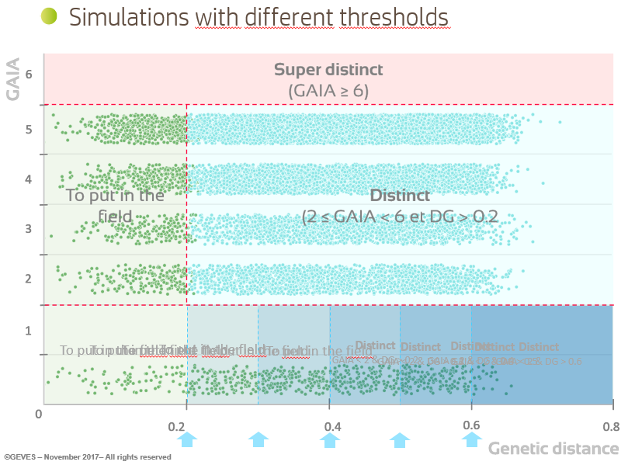

The TWA noted the refinements being made to the model used in France on the following basis:

- a “parameter setting step” analyzing several growing cycles was being used to established the threshold value;

- any threshold value would be crop-specific and should be determined by crop experts.

The TWA noted that the method used in France only rejected a candidate variety after the third growing cycle.

Comments by the BMT in 2018

The BMT, at its seventeenth session, held in Montevideo, Uruguay, from September 10 to 13, 2018, considered documents BMT/17/7 “Revision of document TGP/15 ‘Guidance on the Use of Biochemical and Molecular Markers in the Examination of Distinctness, Uniformity and Stability (DUS)’” and TGP/15/2 Draft 1. Document BMT/17/7 contained a revised proposal from France for the revision of document TGP/15, Section 2.2, in response to the comments made by the TWA at its forty-seventh session.

The BMT considered the revision of the example of parent lines in maize prepared by the experts from France. The BMT noted that the establishment of an additional threshold for genetic distance below GAIA distance 2 had not been implemented in France at that time. The BMT noted that the nature of document TGP/15 was to present examples of the use of molecular markers in DUS examination among UPOV members. The BMT agreed to recommend that the example in document TGP/15, Section 2.2, be revised at a later stage once the additional threshold level had been implemented in France (see document BMT/17/25 “Report”, paragraph 58).

The TC is invited to agree that the Model “Combining Phenotypic and Molecular Distances in the Management of Variety Collections” of document TGP/15, Section 2.2, be revised at a later stage once an additional threshold level has been implemented in France, as set out in paragraph 17 of this document.

Proposal for inclusion of a new model “genetic selection of similar varieties for the first growing cycle”

Background

The BMT, at its sixteenth session, held in La Rochelle, France, from November 7 to 10, 2017, considered documents BMT/16/19 “Genetic selection of similar varieties for the first growing cycle: example French Bean” and BMT/16/19 Add. and received a presentation by an expert from the Netherlands (see document BMT/16/29 “Report”, paragraphs 18 to 20).

The BMT agreed that the approach presented in document BMT/16/19 “Genetic selection of similar varieties for the first growing cycle: example French Bean” and BMT/16/19 Add. “Addendum to Genetic selection of similar varieties for the first growing cycle: example French Bean” was a suitable use of molecular techniques in the examination of DUS and should be proposed for inclusion in document TGP/15. Therefore, it was agreed that the Netherlands should prepare an explanation of the method as a basis for a revision of document TGP/15 to be considered by the Technical Committee at its fifty-fourth session.

The BMT agreed that it would be advantageous if the draft revision of document TGP/15, to be considered by the TC at its fifty-fourth session, could be published sufficiently before the fifty-second session of the Technical Working Party for Vegetables (TWV), to be held in Beijing, China, from September 17 to 21, 2018, and before the seventeenth session of the BMT, in order that any comments of the TWV and BMT on the draft revision could be reported to the TC at its fifty-fourth session.

Document TGP/15/2 Draft 1 incorporates the proposal from the Netherlands on a revision to document TGP/15.

Comments by the BMT in 2018

The BMT, at its seventeenth session, considered documents BMT/17/7 “Revision of document TGP/15 ‘Guidance on the Use of Biochemical and Molecular Markers in the Examination of Distinctness, Uniformity and Stability (DUS)’” and TGP/15/2 Draft 1.

The BMT considered the new application model “Genetic Selection of Similar Varieties for the First Growing Cycle” and agreed that it should be proposed for inclusion in document TGP/15 on the basis of a simplified version of draft text presented in document TGP/15/2 draft 1. The BMT agreed that the proposal to be put forward for approval by the TC should contain the description of the method without comparison to other approaches. The BMT also agreed to invite the Netherlands to review whether the schematic explaining the process was necessary and/or might be simplified (see document BMT/17/25 “Report”, paragraph 59).

Comments by the TWV in 2018

The TWV, at its fifty-second session, held in Beijing, China, from September 17 to 21, 2018, considered documents TWP/2/7 Rev. “Molecular Techniques” and TGP/15/2 Draft 1 and noted the report on developments in the TWPs and BMT, as set out in paragraphs 6 to 37 of document TWP/2/7 Rev. and in document TWV/52/18.

The TWV agreed with the proposal of the BMT, at its seventeenth session, that the new application model “Genetic Selection of Similar Varieties for the First Growing Cycle” should be proposed for inclusion in document TGP/15 on the basis of a simplified version of draft text presented in document TGP/15/2 Draft 1. The TWV agreed to propose that the Netherlands review the schematic explaining the process and to simplify it, and recommended to clarify in the guidance the basis on which the comparing varieties are selected on the basis of genetic selection. The TWV agreed with the BMT that the new application model to be put forward for approval by the TC should contain the description of the method without comparison to other approaches.

The Netherlands has offered to provide a revised draft text of the new model “Genetic selection of similar varieties for the first growing cycle” and the example of French Bean in document TGP/15 for consideration by the Enlarged Editorial Committee (TC-EDC) prior to presentation to the Technical Committee at its fifty-fourth session.

The TC, at its fifty-fourth session, will be invited to consider the inclusion of the new model “Genetic selection of similar varieties for the first growing cycle” and the example of French Bean in document TGP/15 on the basis of document TGP/15/2 Draft 1, subject to any revisions proposed by the TC-EDC in order to reflect the comments of the BMT and TWV.

The TC is invited to:

(a) note that the BMT and TWV agreed to propose a new model “Genetic selection of similar varieties for the first growing cycle: example French Bean” for inclusion in document TGP/15 on the basis of a simplified version of the draft text presented in document TGP/15/2 Draft 1, as set out in paragraphs 24 and 26 of this document; and

(b) consider the inclusion of a new model “Genetic selection of similar varieties for the first growing cycle” and the example French Bean” in document TGP/15 on the basis of document TGP/15/2 Draft 1, subject to any revisions proposed by the TC-EDC in order to reflect the comments of the BMT and TWV.

[End of document]

