|  |  |
| --- | --- |
|  | E |
| International Union for the Protection of New Varieties of Plants |  |

|  |  |
| --- | --- |
| Technical Committee  Fifty-Fourth Session Geneva, October 29 and 30, 2018 | TC/54/21  Original: English  Date: July 24, 2018 |

**Illustrations for shape and ratio characteristics**

*Document prepared by the Office of the Union*

*Disclaimer: this document does not represent UPOV policies or guidance*

EXECUTIVE SUMMARY

The purpose of this document is to report on developments concerning the revision of guidance available in document TGP/14 on providing illustrations for shape and ratio characteristics.

The TC is invited to:

(a) note that grids could be used to clarify the states of expression and the differences between states of expression and to describe the range of expression for shape characteristics;

(b) consider whether to identify situations when grids should and should not be used to explain states of expression in shape characteristics;

(c) consider whether to develop harmonized approaches to illustrate states of expression using grids;

(d) consider whether to provide guidance on how grids can clarify how differences in notes can be used for the assessment of distinctness, in accordance with the guidance in the General Introduction and document TGP/9;

(e) consider whether to establish a sub‑group to discuss the above matters.

The following abbreviations are used in this document:

TC: Technical Committee

TC-EDC: Enlarged Editorial Committee

TWA: Technical Working Party for Agricultural Crops

TWC: Technical Working Party on Automation and Computer Programs

TWF: Technical Working Party for Fruit Crops

TWO: Technical Working Party for Ornamental Plants and Forest Trees

TWV: Technical Working Party for Vegetables

TWPs: Technical Working Parties

The structure of this document is as follows:

EXECUTIVE SUMMARY 1

BACKGROUND 2

consideration by the technical working parties 2

developments in 2018 3

Enlarged Editorial Committee 3

Proposals by the group of TWF experts coordinated by New Zealand 3

Technical Working Party for Agricultural Crops 4

NEXT STEPS 4

annex guidance on shape characteristics

BACKGROUND

The TC, at its fifty-third session, held in Geneva from April 3 to 5, 2017, agreed to improve the guidance in document TGP/14 on providing illustrations for shape and ratio characteristics by the inclusion of additional examples. The TC agreed to invite the TWPs, at their sessions in 2017, to consider the issue and report to the TC at its session in 2018 (see document TC/53/31 “Report”, paragraph 253).

consideration by the technical working parties

The TWA, TWV, TWO, TWF and TWC, at their sessions in 2017, considered document TWP/1/18 “Illustrations for shape and ratio characteristics”, which invited the TWPs to consider whether additional examples could be provided to improve guidance in document TGP/14 (see documents TWA/46/10 “Report”, paragraphs 53 and 54; TWV/51/16 “Report”, paragraphs 48 and 49; TWO/50/14 “Report”, paragraphs 40 to 42; TWF/48/13 “Report”, paragraphs 49 to 53; and TWC/35/21 “Report”, paragraphs 43 to 44).

The TWA, TWV, TWF and TWC agreed that no additional examples were available at this time for improving the guidance on providing illustrations for shape and ratio characteristics in document TGP/14. The TWO noted the examples of illustrations for shape and ratio characteristics provided in document TGP/14 and agreed that no further examples were necessary to improve the guidance.

The TWF agreed with the TWO that guidance on providing illustrations for shape and ratio characteristics in document TGP/14 should be amended to clarify that the base of a structure was at the point of attachment. The TWF further agreed that the example 6 of Shape-Related Characteristics in document TGP/14: “Variation between range of shapes indicated by the illustrations”, reproduced in document TWP/1/18, may be put upside-down in order to make clear that the base on shape illustrations should preferably be represented the same way, and as follows:

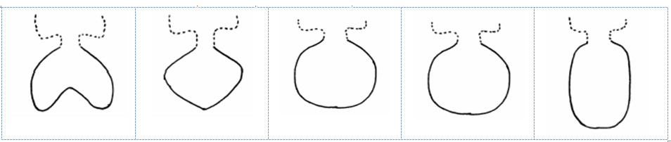

The TWO noted that characteristics with very few states of expression could be displayed in a single row as in the first two examples in document TWP/1/18, provided that the basis for the different states of expression was clear to readers. The examples are reproduced below:

*“Example 1: variation in ratio length/width only.*

[…]

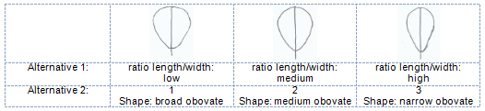

*“Example 2: variation in position of the broadest part only.”*

[…]

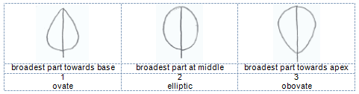

The TWF agreed that clarification might be needed on the reasons to produce a grid when illustrating shape. The TWF invited the experts of New Zealand and Germany to check whether to develop a wording to explain when it is appropriate to use a grid in Test Guidelines, and to circulate a proposal by correspondence by end of December 2017 to the TWF for its approval. The proposal would be then presented to the TC‑EDC, at its session in March 2018, for consideration by the TC at its session in October 2018.

developments in 2018

## Enlarged Editorial Committee

The TC-EDC, at its meeting held in Geneva on March 26 and 27, 2018, considered document TC‑EDC/Mar18/18 “Illustrations for shape and ratio characteristics” (see document TC‑EDC/Mar18/11 “Report”, paragraphs 36 to 40).

The TC-EDC noted that some leading experts of Test Guidelines had difficulty to provide explanations on shape characteristics using grids. The TC-EDC also noted that grids provided useful information for DUS examiners with less experience on a particular crop.

The TC-EDC agreed that explanations for shape characteristics should facilitate establishing distinctness on the basis of notes. The TC-EDC agreed that there should be flexibility for presenting explanations on shape characteristics using grids.

The TC-EDC agreed to invite the TWPs to consider the usefulness of grids under particular situations.

## Proposals by the group of TWF experts coordinated by New Zealand

On April 30, 2018, the UPOV Office received a proposal by the expert from New Zealand to consider establishing a sub-group to meet prior to the TC session in October 2018, as well as to continue discussions in the TWPs and the TC recalling the original objective of the TWF to clarify that “a grid should not be compulsory and could be used when the sub-group discussing the Test Guidelines considered it useful”.

The expert from New Zealand also reported that other issues had been identified and were proposed for further discussion:

* The usefulness of grids and when to apply them; and if applied what would be the best harmonized approach;
* How to clarify distinctness levels between the different states of expression in PQ characteristics.

The expert from New Zealand also reported that the following improvement to the definition of “base” was considered:

“A fruit, when looking along its longitudinal axis, consists of a proximal end, where the fruit was earlier attached to the plant, and a distal end, the most distant point from the attachment. Drawings in Technical Guidelines for fruit shapes may not always be presented with their distal end upwards and their proximal end downwards. There may be good reasons to orientate the diagram in a different way. Irrespective of the orientation used for a fruit shape diagram, the base is the point of attachment to the plant, the proximal point.”

Document TGP/14, Subsection 2 “Shapes and structures”, provides the following information and illustration on the term “base”:

“1.3 The apex (apical or distal part) of an organ or plant part is the end furthest from the point of attachment. The base (proximal part) of a plant part is the end nearest to the point of attachment. However, it should be noted that the illustrations of shapes in the Test Guidelines might not always be orientated with the point of attachment (base) at the bottom if that is not the natural orientation of the organ on the plant.”

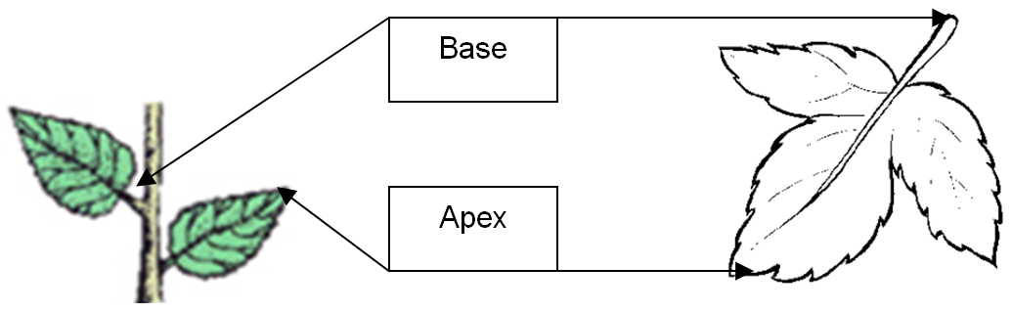

## Technical Working Party for Agricultural Crops

The TWA, at its forty-seventh session, held in Naivasha, Kenya, from May 21 to 25, 2018, considered document TWP/2/11 “Illustrations for shape and ratio characteristics” (see document TWA/47/7 “Report”, paragraphs 39 to 42).

The TWA considered the usefulness of grids under particular situations and agreed that grids could provide useful information to describe the range of a characteristic. The TWA noted that some leading experts of Test Guidelines had difficulty to provide explanations on shape characteristics using grids. The TWA agreed with the TC-EDC that there should be flexibility for presenting explanations on shape characteristics using grids, provided the states of expression were clearly explained.

The TWA considered the possible next steps, as set out in paragraphs 17 to 19 of document TWP/2/11, and agreed with the proposal to establish a sub-group to meet prior to the TC session, in October 2018. The TWA agreed with the proposal that the sub-group discuss the approaches to presenting information using grids and agreed that it could be difficult to define a general rule on the difference in Notes to establish distinctness within a characteristic.

# NEXT STEPS

It is proposed that the TC consider the proposals by the TWPs and TC-EDC on improving guidance in document TGP/14 on using grids to illustrate shape related characteristics on the following basis:

* grids could be used to:
  + clarify the states of expression;
  + clarify differences between states of expression;
  + describe the range of expression;
* consider whether to identify situations when grids should and should not be used to explain states of expression in shape characteristics;
* consider whether to develop harmonized approaches to illustrate states of expression using grids;
* consider whether to provide guidance on how grids can clarify how differences in notes can be used for the assessment of distinctness, in accordance with the guidance in the General Introduction and document TGP/9
* consider whether to establish a sub-group to discuss the above matters.

*The TC is invited to:*

*(a) note that grids could be used to clarify the states of expression and the differences between states of expression and to describe the range of expression for shape characteristics;*

*(b) consider whether to identify situations when grids should and should not be used to explain states of expression in shape characteristics;*

*(c) consider whether to develop harmonized approaches to illustrate states of expression using grids;*

*(d) consider whether to provide guidance on how grids can clarify how differences in notes can be used for the assessment of distinctness, in accordance with the guidance in the General Introduction and document TGP/9;*

*(e) consider whether to establish a sub‑group to discuss the above matters.*

[Annex follows]

Guidance on SHAPE CHARACTERISTICS

Pseudo-qualitative characteristics

1. Document TG/1/3 “General Introduction to the Examination of Distinctness, Uniformity and Stability and the Development of Harmonized Descriptions of New Varieties of Plants” (General Introduction) explains that shape can be considered in terms of a pseudo‑qualitative characteristic when each individual state of expression can be identified to adequately describe the range of the characteristic.

2. Document TGP/9 “Examining Distinctness” explains that the use of pseudo‑qualitative characteristics has limitations due to the difficulty to define a general rule on the difference in Notes to establish distinctness within a characteristic.

Components of shape

3. Document TGP/14 explains that it can be useful to develop quantitative or qualitative characteristics related to shape, rather than considering shape as a single pseudo qualitative characteristic. In that respect, document TGP/14 defines a plane shape using the following components:

(a) Ratio length/width (or ratio width/length, thickness/length, diameter/length, thickness/width);

(b) Position of broadest part;

(c) Shape of base;

(d) Shape of apex;

(e) Lateral outline.

Illustrating shape characteristics

4. To ensure that the ratio length/width is clearly understood, document TGP/14 recommends to present the characteristic as a shape with states such as “very compressed” to “very elongated”, or to present the characteristic as “ratio length/width” with states such as “very low” to “very high” and to provide an illustration. Both alternative characteristics are placed as headers in the following “Chart for simple symmetric plane shapes” (partially reproduced). The position of broadest part is presented in different rows:

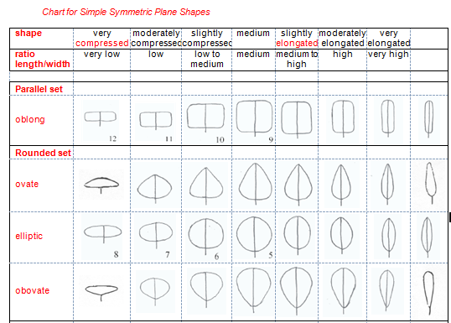

5. Document TGP/14 proposes the development of charts for other types of plane shapes by describing the ranges for ratio length/width and position of broadest, in a similar way to that shown in the Chart for Simple Symmetric Plane Shapes. The following are shapes used as example in document TGP/14:

|  |  |  |  |  |
| --- | --- | --- | --- | --- |
|  |  |  | New Picture |  |
| auriculiform | hastiform | sagittate | alate | trapezoidal |

Developing Shape-Related Characteristics

6. Document TGP/14 explains that “in general, it can be most useful to consider the variation in shape between varieties in the variety collection using the following steps”:

Step 1: Ratio length/width;

Step 2: Position of broadest part;

Step 3: Shape of base;

Step 4: Shape of apex;

Step 5: Lateral outline.

Examples of Shape-Related Characteristics

7. Document TGP/14 provides 6 examples of variation in full plane shape components (ratio length/width, position of broadest part and lateral outline) for the development of characteristics, either as characteristics for the individual components or as a single overall shape characteristic:

*Example 1: variation in ratio length/width only.*

Alternative 1

Plant [part]: ratio length/width (low to high) (QN)

Alternative 2

Plant [part]: shape (broad obovate (1); medium obovate (2); narrow obovate (3)) (QN)

with the following illustration:



*Example 2: variation in position of the broadest part only.*

Alternative 1

Plant [part]: position of broadest part (towards base to towards apex) (QN)

Alternative 2

Plant [part]: shape (ovate (1); elliptic (2); obovate (3)) (QN)

with the following illustration:



*Example 3: variation in ratio length/width, shape of base and lateral outline*

Alternative 1

Plant [part]: ratio length/width (low to high) (QN)

Plant [part]: shape of base (acute, obtuse, rounded) (PQ)

Plant [part]: lateral outline (clearly rounded to clearly triangular) (QN)

Alternative 2

Plant [part]: shape (broad ovate (1); medium ovate (2); medium trullate (3); narrow ovate (4); narrow trullate (5)) (PQ)

with the following illustration:

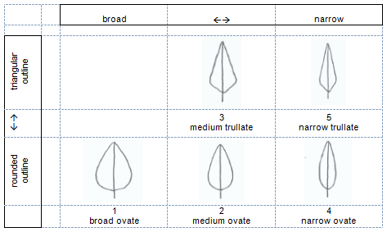

*Example 4: variation in ratio height/diameter, position of broadest part and lateral outline in apical half*

Alternative 1

(a) ratio height/diameter (QN): very low (1); low (3); medium (5); high (7); very high (9);

(b) position of broadest part (QN): at middle (1); moderately towards base (2); strongly towards base (3);

(c) lateral outline in apical half (PQ): rounded (1); parallel (2); flat taper (3); concave (4)

Alternative 2

(a) ratio height/diameter (QN): very low (1); low (3); medium (5); high (7); very high (9);

(b) general shape (PQ): cylindrical waisted (1); conic (2); ovate (3); cylindric (4); elliptic (5)

with the following illustration:

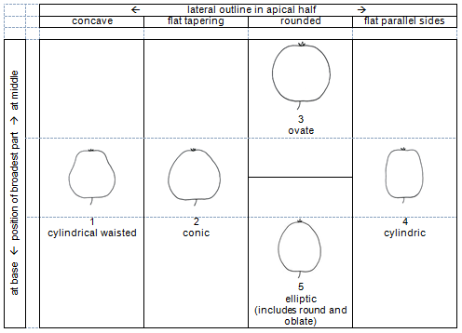

*Example 5: variation between the range of shapes indicated by the illustrations:*

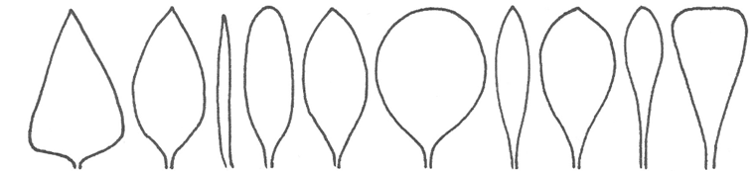

|  |  |
| --- | --- |
| Alternative 1 | with the following illustration: |
| (a) position of broadest part (QN): strongly towards base (1); moderately towards base (3); at middle (5); moderately towards apex (7); strongly towards  apex (9) |  |
| (b) ratio length/width (QN): very low (1); low (3); medium (5); high (7); very high (9); |
| Alternative 2 |
| General shape (PQ): triangular (1); ovate (2); circular (3); elliptic (4); oblong (5); linear (6); obovate (7); oblanceolate (8); spatulate (9); obtriangular (10) |
|  |

*Example 6: variation between range of shapes indicated by the illustrations:*



|  |  |
| --- | --- |
| Alternative 1 | with the following illustration: |
| (a) lateral outline (QL): e.g. reniform (1); rhombic (2); elliptic (3) |  |
| (b) ratio length/width (QN): e.g. low (1); medium (2); high (3); |
|  |
| Alternative 2 |
| General shape (PQ): reniform (1); rhombic (2); oblate (3); circular (4); elliptic (5) |
|  |

[End of Annex and of document]